SOUTH CAROLINA STUDIES Unit 1; Day 4
THEME = SOUTH CAROLINA STATEWIDE OVERVIEW  MATH – PRE-ALGEBRA

LESSON TITLE: How Do We Measure Earthquakes?

OBJECTIVES: Students will be able to explain how to use and interpret the Richter and Mercalli Scales.

PRIMARY STANDARDS ADDRESSED: Math 8th – N.I.E.1; N.III.B.1; N.III.D.I; A.I.C.1; M.II.F.1

PRIOR SKILLS REQUIRED: ability to apply the concept of proportions to a scale drawing

TEACHER BACKGROUND INFO: South Carolina Geological Survey Bulletin #40 (Earthquakes in
South Carolina 1698 – 1975); United States Geological Survey earthquake hazards center website
<http://earthquake.usgs.gov/learning/searchresults.php> ; National Earthquake Info Center website
<http://earthquake.usgs.gov/4teachers/>;IRIS website <http://www.iris.edu/edu/10.5/lessonPlan.htm>

LOGISTICS: 1 @ 50-minute class – large tables or other work area – students work in cooperative groups

MATERIALS: Copies of Figures 2, 4, 10, 12, 14, 15, 19, 20 in South Carolina Geological Survey Bulletin #40 (Earthquakes in South Carolina 1698 – 1975); graph paper; [optional] access to California State University at Los Angeles Virtual Earthquake site <http://cdl-flylab.sonoma.edu/VirtualEarthquake/>

PROCEDURES:
1. Ask students what a volume knob or button really does on a radio, TV, computer, etc. Discuss ways you could measure the loudness at each volume setting. Ask questions like “What’s the lowest volume you can get on a radio?”, “What’s the highest volume?” “Is the top volume the loudest sound you can get, or is it possible to create sounds louder than the radio can produce?” Ask students for ideas on how to graph the relationship between ‘amount of knob turn’ and ‘loudness level of radio’, discussing ideas about independent and dependent variables. Use suggestions to draw a graph showing this relationship.
2. Ask students to consider the same types of questions about earthquakes. Discuss ways that you could measure the strength of an earthquake. Ask questions like “What’s the lowest amount of energy you can release in an earthquake?” “What’s the highest amount?” “Is it possible to release more energy than an earthquake could produce?” Ask for ideas on how to graph the relationship between ‘amount of energy released’ and ‘earthquake strength’. Draw one or more graphs to illustrate this relationship.
3. Explain the differences between the Mercalli Scale (Bulletin #40, Appendix 2) and the Richter Scale. Hand out the Student Work Sheet and ask students to examine the diagram and answer the questions.
4. Divide the class into small groups. Give each group a piece of graph paper and a copy of one of the earthquake maps from Bulletin #40 (we recommend Figures 4, 19, and 20 – but Figures 2, 10, 12, 14, & 15 may also be used). Instruct groups to construct a data chart in which they express the earthquake intensity data points as ordered pairs [‘x’ = distance from epicenter (in km) and ‘y’ = Mercalli Number]. Tell groups to plot points on their graph paper and make observations about the point distribution.
5. Go over the answers to the questions on the Student Work Sheet to make sure students understand the mathematical basis for the Richter Scale. Have the student reporter from each group hold up their group’s graph and give an explanation of the pattern they observed. Ask each reporter to describe their pattern using mathematical terms. Summarize the generally linear pattern of the Mercalli Scale.
6. [optional] Have students access California State University’s Virtual Earthquake site.

SAMPLE CULMINATING ASSESSMENT:
- Give students the following multiple choice question on a unit test
Earthquake A has a Richter magnitude of 2; Earthquake B has a Richter magnitude of 4. Which is true?
a. B released about twice as much energy as A c. B released about 900 times as much energy as A
b. A released about twice as much energy as B d. A released about 900 times as much energy as B
SOUTH CAROLINA STUDIES Unit 1; Day 4
THEME = SOUTH CAROLINA STATEWIDE OVERVIEW  MATH – PRE-ALGEBRA

STUDENT WORK SHEET

LESSON TITLE: How Do We Measure Earthquakes?

A. Examine the diagram and answer the questions that follow.
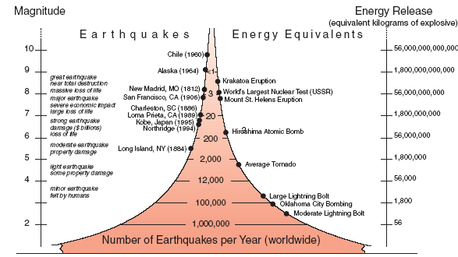

3
Diagram taken from IRIS website <http://www.iris.edu/edu/10.5/lessonPlan.htm>

a. How much energy is released by a Richter magnitude 4 earthquake?
[Write your answer in scientific notation.] _____________________

How much energy is released by a Richter magnitude 3 earthquake?
[Write your answer in scientific notation.] _____________________

b. The energy released by a Richter magnitude 4 earthquake is ______ times greater than the energy released by a Richter magnitude 3 earthquake. Show how you figured this out.

c. Do you think there is there such a thing as Richter magnitude number 0? __________
Explain your answer.

d. Is it possible to have an earthquake with a Richter magnitude number above 10? __________
Explain your answer.

e. For a difference in magnitude of 0.5, the change in energy released
is by a factor of 5.5. Use this information to approximate the
amount of energy released by an earthquake of Richter magnitude 3.5. ______________________

Show your work.

f. Calculate the difference in the amount of energy released from a Richter
magnitude 3 earthquake as compared to a Richter magnitude 3.5 earthquake. __________________

Now calculate the difference in the amount of energy released from a Richter
magnitude 3.5 earthquake as compared to a Richter magnitude 4 earthquake. __________________

Compare your two answers. Did you get the type of answers you expected? Why or why not?

g. What energy level (approximately) do you think
would be associated with Richter magnitude 12? ___________________________

Explain your answer.
SOUTH CAROLINA STUDIES Unit 1; Day 4
THEME = SOUTH CAROLINA STATEWIDE OVERVIEW  MATH – PRE-ALGEBRA

TEACHER ANSWER KEY

LESSON TITLE: How Do We Measure Earthquakes?

1. Ask students what a volume knob . . . ways that you could measure the loudness at each volume setting.
Most students will know enough about electronics that they could imagine an electronic sensor that detects sound. Others may realize that louder sounds would travel farther, or that louder sounds could be heard over background noise.
Ask questions like “What’s the lowest volume you can get on a radio?”
Assuming the radio is on, even at lowest volume setting, you might be picking up sounds even if you couldn’t hear them.
“What’s the highest volume you can get on a radio?”
Every amplifier/speaker system has a limit determined by its electronics. Louder sounds will damage the equipment.
“Is top volume the loudest sound, or is it possible to create sounds louder than radio can produce?”
Sounds that are louder than the radio can handle can be imagined, but they would destroy the amplifier/speaker system.
Ask students for ideas on how to graph relationship between ‘amount knob turn’ and ‘loudness level’.
Answers may vary. Students don’t have enough information to produce an accurate graph, but should realize the basic relationship that turning up the knob (or pushing the button repeatedly) will cause the volume to increase. Here, the amount of knob turn is the independent variable and the loudness level is the dependent variable. The relationship is a positive (or increasing) one. However, it is impossible to say whether the relationship is linear.

2. Discuss ways that you could measure the strength of an earthquake.
Answers may vary. Electronic sensors that detect vibration would probably be the most common answer.
Ask questions like “What’s the lowest amount of energy you can release in an earthquake?”
The earth is actually ‘shaking’ all the time, just at such a low level that it’s difficult to detect. 0 is impossible.
“What’s the highest amount of energy you can release in an earthquake?”
The limit is actually determined by the type of rock. Rock won’t hold together long enough for forces to exceed Richter 10.
“Is it possible to release more energy than an earthquake could produce?”
We can imagine greater energy releases – for example a meteorite impact could release much more energy than an earthquake
Ask how to graph relationship ‘amount of energy released’ & ‘numerical measure earthquake strength’.
Answers may vary. At this point, all they can reasonably conclude is that there is a positive (increasing) relationship between energy released and Richter numbers. There is not enough information to tell if it’s linear or not.

3. Explain the Richter Scale . . . . ask students to examine the diagram and answer the questions . . . .
Scientists need a way to express the strength of an earthquake numerically so data can be analyzed statistically and so that earthquake strengths can be compared. Tell them that the standard numerical system we use is called the Richter Scale and that it is based on the equivalent energy released by a specific number of kilograms of high explosive (like TNT).

a. How much energy is released by a Richter magnitude 4 earthquake? __5.6 x 10⁴ kg explosive equivalents_

How much energy is released by a Richter magnitude 3 earthquake? _1.8 x 10³ kg explosive equivalents_

b. The energy released by magnitude 4 quake is approximately 31.1 times greater than magnitude 3 quake.

Show how you figured this out. Magnitude 4 generates an energy release of 56,000 equivalent kg explosive units. Magnitude 3 generates a release of 1,800 kg equivalents. Here students should find the ratio of the magnitudes (i.e. divide), with1,800 into 56,000 giving a multiplication factor of approximately 31.1. The real scale factor is 31.6 but the numbers in the chart have all been rounded off to facilitate easy calculations. For example, using magnitudes 2 and 3 gives a multiplication factor of approximately 32.1.
c. Do you think there is there such a thing as Richter magnitude number 0? ____No______
Explain your answer. Technically, a Richter Number of 0 is impossible because the earth is never completely still.

d. Is it possible to have an earthquake with a Richter magnitude number above 10? ____Maybe______
Explain your answer. Possible in theory, but rocks won’t stand the internal strain – they rupture before that stress level is reached. Meteorite impacts provide the best chance of producing an earthquake that exceeds magnitude 10.

e. . . . approximate the amount of energy released by an earthquake of Richter magnitude 3.5 __9.9 x 10³___
Show your work. To find the energy released at a magnitude of 3.5, students simply multiply the energy released at magnitude 3 by 5.5: (1.8 x 10³)(5.5) = 9.9 x 10³

f. Calculate difference in energy released from magnitude 3 quake as compared to 3.5 quake. 8,100

calculate difference in energy released from magnitude 3.5 quake as compared to 4 quake. 46,100

Compare your two answers. Did you get the type of answers you expected? Why or why not?
Students should notice that the difference in the amount of energy between a magnitude 3 and magnitude 4 earthquake is not "evenly" divided and that the energy released from a magnitude 3.5 earthquake is not the "halfway" point. Students may need more explanation on the concept, but the idea is that for increasing amounts of change between magnitudes on the Richter scale, the amount of energy released continues to increase by greater factors. At the very least, every student should understand that this tells us the relationship is not linear.

g. What energy level (approximately) do you think would be associated with magnitude 12? __5.6 x 10¹⁶___
Explain your answer. Answers may vary. Because the ‘multiplier’ is 31.6 (or if you use 32.1 or 31.1 – see comment on part b), for each increase of one in Richter Number, an earthquake should release 31.6 times as much energy as the previous number. So a Richter 12 earthquake would generate 31.6 times as much energy as a magnitude 11 which in turn would generate 31.6 times as much energy as a magnitude 10; (5.6 x 10¹³) x 31.6 x 31.6 = 5.6 x 10¹⁶.

4. Instruct groups to construct a data chart to express the earthquake intensity data points as ordered pairs
Answers may vary depending on which point is selected as the ‘epicenter’. All 8 graphs are shown on the next page with accompanying data tables. Some discussion as to why ‘x’ should represent the distance and ‘y’ the Mercalli Number would be helpful. Here we might want to predict the Mercalli number if we know how far a place is from the center of the earthquake. All the graphs should indicate a ‘step function’ and an approximately linear decline with distance.
Notes: Students may need guidance in picking an epicenter from the maps when there are multiple locations labeled with the highest Mercalli number. In the sample graphs below, an effort was made to pick an epicenter point central to the majority of the points with the next greatest Mercalli number. Charts will vary if students choose different epicenters, but this also provides interesting discussion when students present their graphs. You may also want to direct students to measure from the epicenter to each location using the centers of each icon for consistency. Further, it is helpful for students to label icons representing a range of Mercalli numbers with the midpoint of that range.
Students may also need guidance in setting up the proportion to use after converting their measurements to km using the scale on the map. For Figures 4, 19, and 20, the following proportion can be used: 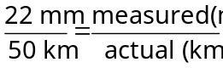.
You may decide to have students round to the nearest tenth or nearest whole number when completing their conversions, because the numbers are usually not "neat."

5. Go over the answers to the questions . . . . Summarize the more linear pattern of the Mercalli Scale.
You may or may not wish to deal with the concept of exponential curves, depending on the class level, but you should make sure students realize Richter is NOT a linear relationship.

6. [optional] Have students access California State University’s Virtual Earthquake site.
A variety of interactive problems are available here. None of them address South Carolina directly, but they are useful aids in understanding the behavior of earthquakes and the areal distribution of earthquake magnitudes.

SOUTH CAROLINA STUDIES Unit 1; Day 4
THEME = SOUTH CAROLINA STATEWIDE OVERVIEW  MATH – PRE-ALGEBRA

TEACHER ANSWER KEY - continued

LESSON TITLE: How Do We Measure Earthquakes?

SAMPLE CULMINATING ASSESSMENT:
- Give students the following multiple choice question on a unit test Answer = c
Earthquake A has a Richter magnitude of 2; Earthquake B has a Richter magnitude of 4. Which is true?
a. B released about twice as much energy as A c. B released about 900 times as much energy as A
b. A released about twice as much energy as B d. A released about 900 times as much energy as B

4. (continued) Data tables and graphs for Figures 2, 4, 10, 12, 14, 15, 19, and 20 in Bulletin #40.

Fig. 12 - June 12, 1912 |  |  | Fig. 14 - September 22, 1914 |  |  | Fig. 15 - October 20, 1924 |  |  | Fig. 19 - March 12, 1960
0 | 6.5 |  | 0 | 5 |  | 0 | 5 |  | 0 | 5
65 | 4 |  | 59.09091 | 5 |  | 25 | 4 |  | 11.3636 | 5
105 | 4 |  | 40.90909 | 4 |  | 65 | 4 |  | 65.9091 | 5
50 | 3 |  | 25 | 0 |  | 60 | 4 |  | 47.7273 | 5
105 | 6.5 |  | 140.9091 | 3 |  | 45 | 0 |  | 104.545 | 4
140 | 4 |  | 172.7273 | 3 |  | 85 | 3 |  | 134.091 | 4
95 | 4 |  | 152.2727 | 4 |  | 25 | 4 |  | 68.1818 | 4
165 | 3 |  | 143.1818 | 3 |  | 35 | 3 |  | 129.545 | 4
200 | 5 |  | 131.8182 | 3 |  | 75 | 4 |  | 163.636 | 2
310 | 4 |  | 109.0909 | 4 |  | 35 | 4 |  | 159.091 | 2
110 | 4 |  |  |  |  | 125 | 3 |  | 179.545 | 2
85 | 4 |  |  |  |  | 190 | 3 |  | 147.727 | 4
115 | 5 |  |  |  |  | 130 | 3 |  | 172.727 | 4
135 | 5 |  | Fig. 20 - May 19, 1971 |  |  | 75 | 0 |  | 186.364 | 2
100 | 3 |  | 0 | 4 |  | 165 | 3 |  | 209.091 | 2
245 | 4 |  | 9.090909 | 4 |  | 85 | 0 |  | 218.182 | 4
280 | 5 |  | 29.54545 | 4 |  | 195 | 3
95 | 3 |  | 20.45455 | 4 |  | 125 | 0
245 | 1.5 |  | 9.090909 | 4 |  | 245 | 0 |  | Fig. 10 - January 23, 1903
90 | 4 |  | 45.45455 | 2 |  |  |  |  | 0 | 4
120 | 3 |  | 22.72727 | 2 |  |  |  |  | 31.8182 | 4
60 | 3 |  | 36.36364 | 2 |  | Fig. 4 - January 19, 1860 |  |  | 56.8182 | 0
45 | 1.5 |  | 11.36364 | 2 |  | 0 | 5 |  | 140.909 | 2
 |  |  | 22.72727 | 2 |  | 134.091 | 1.5 |  | 170.455 | 0
 |  |  | 18.18182 | 2 |  | 95.4545 | 0 |  | 197.727 | 0
Fig. 2 - January 8, 1817 |  |  | 25 | 2 |  | 215.909 | 4 |  | 238.636 | 0
0 | 5 |  | 27.27273 | 2 |  | 131.818 | 4 |  | 177.273 | 2
129.412 | 4 |  | 38.63636 | 0 |  | 175 | 4 |  | 165.909 | 2
241.176 | 4 |  | 45.45455 | 2 |  | 168.182 | 4 |  | 168.182 | 2
123.529 | 0 |  | 72.72727 | 2 |  | 206.818 | 3 |  | 175 | 0
317.647 | 4 |  | 95.45455 | 2 |  | 275 | 3 |  | 188.636 | 0
376.471 | 2 |  | 75 | 2 |  | 304.545 | 3 |  | 186.364 | 0
323.529 | 2 |  | 95.45455 | 0 |  | 268.182 | 3
423.529 | 0 |  | 106.8182 | 2 |  | 218.182 | 3
517.647 | 2 |  |  |  |  | 209.091 | 3
605.882 | 0
700 | 0
770.588 | 2
835.294 | 2
876.471 | 2
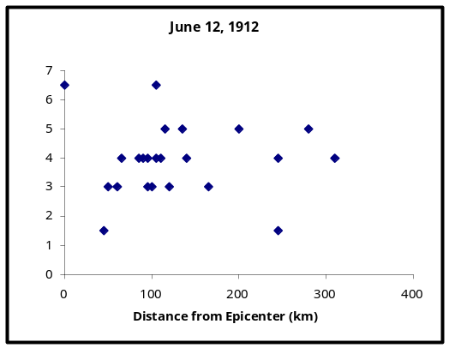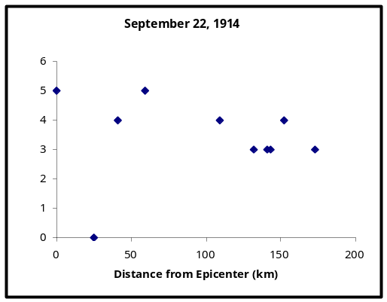
Figure 12 Figure 14
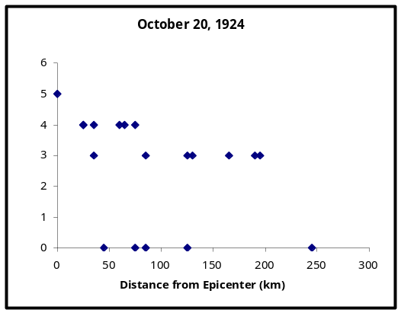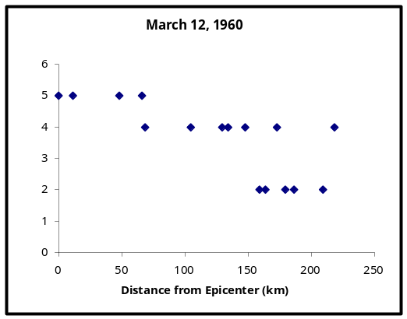
Figure 15 Figure 19
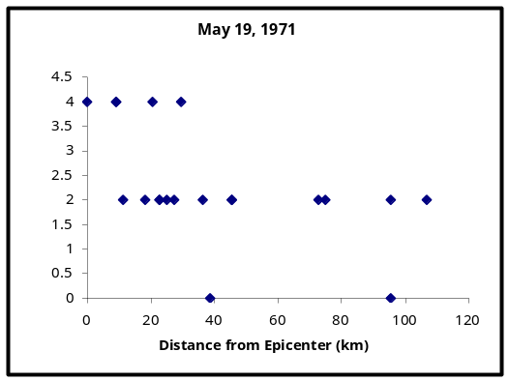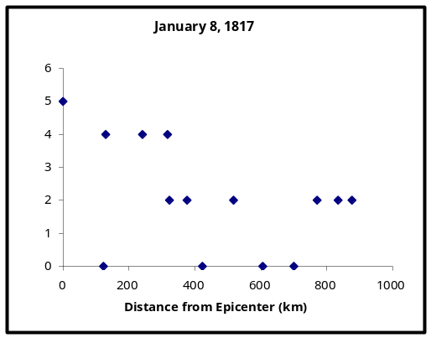
Figure 20 Figure 2
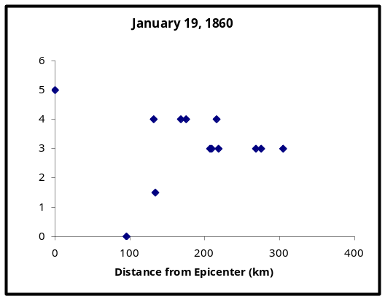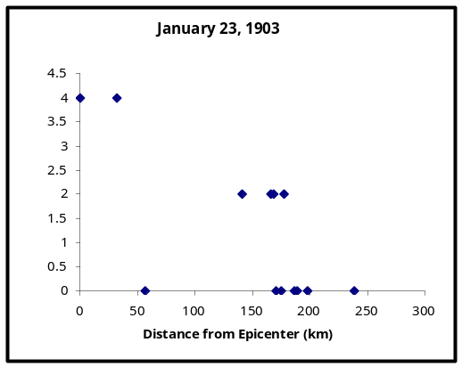
Figure 4 Figure 10
SOUTH CAROLINA STUDIES Unit 1; Day 4
THEME = SOUTH CAROLINA STATEWIDE OVERVIEW  MATH – PRE-ALGEBRA

ADDITIONAL BACKGROUND RESOURCES

LESSON TITLE: How Do We Measure Earthquakes?

Information copied & modified from USGS website <http://earthquake.usgs.gov/learning/searchresults.php>

Earthquake magnitude [Richter Scale] is quantitative and exact and is a measurement of the size of the earthquake as revealed by the study of seismograph records (called seismograms) – it is expressed as a number

Earthquake intensity [Mercalli Scale] is qualitative and more subjective and is a measurement of the physical effects of the earthquake – it is expressed as a Roman numeral.

The Severity of an Earthquake
The severity of an earthquake can be expressed in terms of both intensity and magnitude. However, the two terms are quite different, and they are often confused.
Intensity is based on the observed effects of ground shaking on people, buildings, and natural features. It varies from place to place within the disturbed region depending on the location of the observer with respect to the earthquake epicenter.
Magnitude is related to the amount of seismic energy released at the hypocenter of the earthquake. It is based on the amplitude of the earthquake waves recorded on instruments which have a common calibration. The magnitude of an earthquake is thus represented by a single, instrumentally determined value.
Earthquakes are the result of forces deep within the Earth's interior that continuously affect the surface of the Earth. The energy from these forces is stored in a variety of ways within the rocks. When this energy is released suddenly, for example by shearing movements along faults in the crust of the Earth, an earthquake results. The area of the fault where the sudden rupture takes place is called the focus or hypocenter of the earthquake. The point on the Earth's surface directly above the focus is called the epicenter of the earthquake.

The Richter Magnitude Scale
Seismic waves are the vibrations from earthquakes that travel through the Earth; they are recorded on instruments called seismographs. Seismographs record a zig-zag trace that shows the varying amplitude of ground oscillations beneath the instrument. Sensitive seismographs, which greatly magnify these ground motions, can detect strong earthquakes from sources anywhere in the world. The time, location, and magnitude of an earthquake can be determined from the data recorded by seismograph stations.
The Richter magnitude scale was developed in 1935 by Charles F. Richter of the California Institute of Technology as a mathematical device to compare the size of earthquakes. The magnitude of an earthquake is determined from the logarithm of the amplitude of waves recorded by seismographs. Adjustments are included in the magnitude formula to compensate for the variation in the distance between the various seismographs and the epicenter of the earthquakes. On the Richter Scale, magnitude is expressed in whole numbers and decimal fractions. For example, a magnitude of 5.3 might be computed for a moderate earthquake, and a strong earthquake might be rated as magnitude 6.3. Because of the logarithmic basis of the scale, each whole number increase in magnitude represents a tenfold increase in measured amplitude; as an estimate of energy, each whole number step in the magnitude scale corresponds to the release of about 31 times more energy than the amount associated with the preceding whole number value.
At first, the Richter Scale could be applied only to the records from instruments of identical manufacture. Now, instruments are carefully calibrated with respect to each other. Thus, magnitude can be computed from the record of any calibrated seismograph.
Earthquakes with magnitude of about 2.0 or less are usually called microearthquakes; they are not commonly felt by people and are generally recorded only on local seismographs. Events with magnitudes of about 4.5 or greater--there are several thousand such shocks annually--are strong enough to be recorded by sensitive seismographs all over the world. Great earthquakes, such as the 1964 Good Friday earthquake in Alaska, have magnitudes of 8.0 or higher. On the average, one earthquake of such size occurs somewhere in the world each year. Although the Richter Scale has no upper limit, the largest known shocks have had magnitudes in the 8.8 to 8.9 range. Recently, another scale called the moment magnitude scale has been devised for more precise study of great earthquakes.
The Richter Scale is not used to express damage. An earthquake in a densely populated area which results in many deaths and considerable damage may have the same magnitude as a shock in a remote area that does nothing more than frighten the wildlife. Large-magnitude earthquakes that occur beneath the oceans may not even be felt by humans.

