SOUTH CAROLINA STUDIES Unit 2; Day 3
THEME = FOLKLORE & FOLK ART IN THE UPSTATE  MATH – ALGEBRA

LESSON TITLE: A Mathematical Model of Geological Fracture Zones

OBJECTIVES: Students will be able to analyze data in a rose plot and determine preferred orientations.

PRIMARY STANDARDS ADDRESSED: Algebra I – I.A.2; I.A.4; I.A.5; I.D.5

PRIOR SKILLS REQUIRED: The ability to construct and interpret rose plots would help, but is not essential. It would also help if the science teacher has covered faults and fractures in rocks prior to this lesson.

TEACHER BACKGROUND INFO: SC MAPS Teaching Manual, page 2-4

LOGISTICS: 1 @ 50-minute class – large tables or other work area – students work in cooperative groups

MATERIALS: 6 @ Lake Jocassee Region topographic map (SC MAPS); wet-erase pens; protractors; rulers; photocopies of Student Work Sheet

PROCEDURES:
1. Ask students if they have covered the topic of faults and fractures in rocks in their science class. If so, ask a few students to provide definitions and descriptions. If not, give students a very brief and simple definition of faults and fractures in the earth and point out that such breaks are usually caused by large scale geologic forces accompanying mountain building. These can also have an impact on the direction and size of rivers. What we will be concerned about in this lesson is the direction of rivers in the Blue Ridge Mountain region. Review the basic directions (N, S, E, W) along with the four easily made combinations (NE, SE, SW, NW). Discuss the angles involved for these directions, using due east as 0 degrees and north as 90 degrees. If necessary, also review how to use a protractor.
2. Divide students into six small groups and give each group a Lake Jocassee map, wet-erase pens, rulers, protractors, and photocopies of the Student Work Sheet. Ask students to construct a blank rose plot template on a separate piece of paper following the instructions in ‘part a’ of the Student Work Sheet and also answer the questions posed on the Work Sheet for that section.
3. Assign a specific river (treat the Toxaway River in NC separately from the Toxaway in SC) to each group. Ask groups to follow the instructions in ‘parts b, c, and d’ of the Student Work Sheet and to construct a data table and a rose plot (on the template they drew in ‘part a’) that expresses the distribution of straight-line segments of their assigned river.
4. Ask one person from each group to hold up their rose plot and present to the class any general conclusions they have formulated about fracture patterns in the rocks underlying Lake Jocassee. Refer to the questions students answered in ‘part d’ of the Student Work Sheet. After each group has done its presentation, comment on the use of mathematical models to predict future geologic behaviors based on the analysis of current data. Also ask what they think the advantages of a rose plot are and the contexts for which a rose plot might be helpful.

SAMPLE CULMINATING ASSESSMENT:
- South Carolina is considered to be in the Southeastern part of the United States. Why do you think that the rivers mostly flow towards the Southeastern direction?
- If you lived in California on the West coast, which way would you expect the rivers and streams to flow? Why?
- Do you think it’s true that rivers in the Northeast flow northeast, that rivers in the West flow west, that rivers in any geographic area flow in the direction of their geographic identity?

SOUTH CAROLINA STUDIES Unit 2; Day 3
THEME = FOLKLORE & FOLK ART IN THE UPSTATE  MATH – ALGEBRA

STUDENT WORK SHEET

LESSON TITLE: A Mathematical Model of Geological Fracture Zones

a. Construct a blank rose plot sheet.
On a blank sheet of paper, construct horizontal and vertical axes so that the origin is near the center of the paper. Also draw diagonal lines that divide each of the four quadrants exactly in half, and label the compass directions (North, Northeast, East, Southeast, South, Southwest, Northwest and West) as appropriate. Be sure the North Axis points toward the top of the page. Mark due east as 0 degrees and due north as 90 degrees. This type of graph is known as a polar graph.

How many degrees of arc would be contained in each of the eight sections? _______________

Explain how you determined this number? __________________________________________________

_____________________________________________________________________________________

How would you get the graph to straddle the 0, 90, 180 and 270 degree marks evenly? _______________

_____________________________________________________________________________________

b. Trace the assigned river.
Trace with a wet-erase pen the Keowee, Whitewater, Thompson, Toxaway, and Horsepasture Rivers on the LAKE JOCASSEE TOPOGRAPHIC MAP. Take special notice of the right angle bends in each of the rivers. Divide into groups to analyze each of these rivers in detail by following the directions below.

Group 1 Keowee River Group 4 Horsepasture River (Transylvania Co.)
Group 2 Whitewater River Group 5 Toxaway River in North Carolina
Group 3 Thompson River Group 6 Toxaway River in South Carolina

Re-trace your assigned river with a different color wipe-off pen, so that the river is represented by a series of straight-line segments and angular bends (no curves or smooth bends allowed). This new tracing will not exactly match the actual path of the river channel, but it should be a close approximation. Do not try to trace every little bend of your river, but use between 10 and 20 line segments to map the river.

c. Measure and create a table.
Use a ruler and a protractor to measure the length of each line segment (in centimeters) and its compass direction (degrees away from east rounding to the nearest degree). To measure the compass direction, align your protractor so that zero degrees is due east and the protractor origin point is at the lowest point of the segment. If the segment is flowing in some southerly direction, simply read the degrees on the protractor. However, if the segment is flowing toward the north, add 180 degrees to it. For example, if a segment is flowing from north to south at an angle of 120 degrees from east, then you would record the angle as 120 degrees. However if the flow of this same segment is toward the north, then you would record this segment as 300 degrees (120 + 180). Similarly, a segment flowing due south is recorded as 90 degrees, while a segment flowing due north is recorded as 270 degrees. Transfer this information onto your Data Table. Once you have completed the first two columns, fill in the “For Graphing” portion of the table. Be sure the Total Frequency and the number of segments agree with what you have measured.

d. Create a rose plot. Analyze the results.
Turn to your blank rose plot sheet (constructed in part a). Determine an appropriate scale for your polar graph and label it. SCALE = __________________________________________________________

Once you have labeled your graph with a scale, shade in each of the eight directions according to the total length of all the segments flowing in that direction. Use different colors to help show the differences.

Compare your finished graph to those of other groups. How are all the plots similar? _______________

_____________________________________________________________________________________

How are they different? _________________________________________________________________

_____________________________________________________________________________________

What conclusions about the Lake Jocassee Region can you derive from the plots, and how would this relate to the geologic history of the Blue Ridge Landform Region? ______________________________

_____________________________________________________________________________________

DATA TABLE for part ‘c’

Assigned River =
 |  |  |  |  | For Graphing
Segment | Length (cm) | angle (degrees) |  | Direction | angle  (in degrees) | frequency | total length
1 |  |  |  | East | 337.5 - 22.5
2 |  |  |  | Northeast | 22.5 - 67.5
3 |  |  |  | North | 67.5 - 112.5
4 |  |  |  | Northwest | 112.5 - 157.5
5 |  |  |  | West | 157.5 - 202.5
6 |  |  |  | Southwest | 202.5 - 247.5
7 |  |  |  | South | 247.5 - 292.5
8 |  |  |  | Southeast | 292.5 - 337.5
9
10 |  |  |  |  | Totals
11
12
13
14
15
16
17
18
19
20
21
22
23
24
Total Length
SOUTH CAROLINA STUDIES Unit 2; Day 3
THEME = FOLKLORE & FOLK ART IN THE UPSTATE  MATH – ALGEBRA

TEACHER ANSWER KEY

LESSON TITLE: A Mathematical Model of Geological Fracture Zones

Part 1
Some students may be accustomed to labeling compass north as ‘zero’ degrees instead of using due east as in this activity. Explain to students that the placement of the ‘zero’ point is arbitrary, but that in math, we almost always label a coordinate graph system with ‘zero’ on the positive ‘x’ axis, which in this case is due east.

Part 2
a. Construct a blank rose plot sheet.
The students should either be given or should produce themselves a basic polar grid with no scaling on it. In this first step they will divide the 4 quadrants into 8 equal sections and label them the appropriate directions with North at the top of their paper. In each of the 8 sections there will be 45 degrees, and in order to straddle the 0, 90, 180 and 270 degree lines, they will need to put 22.5 degrees on each side.

- How many degrees of arc . . . .? Each of the 8 sections (N, S, E, W, NE, SE, NW, SW) will contain 45 degrees.

- Explain . . . this number? There are 360 degrees in a circle. Dividing 360 into 8 equal portions gives 45 degrees.

- How would you get the graph to straddle the 0, 90, 180 and 270 degree marks evenly? In order to split the graph up equally into 8 parts, but with each direction (e.g., North) in the middle of one of these eight parts, we put a ray 22.5 degrees on each side of the direction. Moving 22.5 degrees on each of the two sides of the direction leaves 45 degrees for each of the 8 parts. As students do this, there may be some small error in their measures, but it should be less than 2 degrees for each ray. Consequently, the plots may be slightly different but should still look similar.

Part 3
b. Trace the assigned river.
Walk around making sure the students are making straight line segments and breaking the river into between 10 and 20 of these segments. The students should cover the whole river from where it begins to where it ends. Once the river converges with another and changes names, that is the point at which their river ends. The straight line segments should be a fairly close approximation of a river’s path.

c. Measure and create a table.
Measuring should be done in centimeters (to the nearest tenth). Compass directions of the river segments should be expressed numerically and rounded to the nearest degree, though answers may vary by as much as 3 degrees. Students should use the first two rows of data from each segment and combine them to get the 8 categories they will be graphing on the rose plots. You can start to walk around with the answer keys checking to be sure each group is relatively close to your key. For the few segments flowing toward the north, verify that degree measures are between 180 and 360 degrees.

d. Create a rose plot. Analyze the results.
- . . . . Determine an appropriate scale for your polar graph and label it. SCALE =
The students should be able to determine a scale for their rose plots, one that fits on the graph provided but also allows for the graph to take up as much space as possible. The scale should not go any higher than 35-40. Most of the graphs should use scales up to 20 or 25.

- . . . . How are all the plots similar?
When students compare graphs, they should see most of the data appearing on the top half of the rose diagrams. They should all agree that it is because the rivers flow from the North to the South. [Actually, the most common flow is from the Northwest to the Southeast, and the second most common is from the Northeast to the Southwest.] Note that a river that backtracks on itself and flows from south to north will cause students to have some data on the bottom half of their rose plots. This occurs on the Horsepasture and both of the Toxaway segments (NC and SC).

- How are they different?
Differences in rose plots are attributable to variations in stream segment lengths, and in the number of river segments that flow in other directions in addition to the predominant directions. The students should be able to understand that some variation in the answers is acceptable. The fact that they chose how many segments to split up the river can account for significant differences. However, they should also recognize that similar tables should result in similar rose plots. They should also be able to understand that only a certain margin of error is allowable and should become suspicious if they see large differences.

- What conclusions about the Lake Jocassee Region can you derive from the plots, and how would this relate to the geologic history of the Blue Ridge Landform Region?
From here the students should start to relate this information to science, where they learned about the formation of the mountains and the faults, which break at 90 degree angles causing the river to zig-zag from the North to the South.

Part 4
Use the answers that are provided in Part 3 of the Teacher Answer Key as a springboard for discussion. Note that mathematical models are not perfect, because the physical world always contains imperfections and variations that are not reflected in the mathematical formulae. But they provide good generalizations and approximations. Rose plots are used in other science areas as well. For example, rose plots would be valuable in determining the predominant wind patterns in a particular area.

SAMPLE CULMINATING ASSESSMENT:
- South Carolina is considered to be in the Southeastern part of the United States. Why do you think that the rivers mostly flow towards the Southeastern direction?
With the Atlantic Ocean on the east necessarily being lower in altitude and higher mountains to the west, we would expect rivers to flow in general to the east. The reason the rivers flow southeast is because of the mountain ranges’ structural orientation, as represented by the fault lines, which cause the rivers to zigzag. Water flows downhill, seeking the lowest spot, which just happens to lead it southeast towards the coast where it can flow into the ocean.

- If you lived in California on the West coast, which way would you expect the rivers and streams to flow? Why?
Most likely the rivers in California flow from East to West because the ocean is on the West coast and the Rockies are on the Eastern side of California. Knowing that water only flows downhill, it would make sense that the rivers would flow West.
- Do you think it’s true that rivers in the Northeast flow northeast, that rivers in the West flow west, that rivers in any geographic area flow in the direction of their geographic identity?
No, this is not true for every location. In the Northeast, it is not necessarily true that the water mostly flows in the Northeast direction. Another example would be the Midwest. Just because it is named the Midwest, does not mean the water all flows in that direction across the plains. Rivers will flow from higher altitudes to lower altitudes, no matter the direction. Gravity is the controlling force.

DATA TABLE AND POLAR GRAPH FOR PARTS ‘c’ AND ‘d’
Toxaway River (NC)
 |  |  |  |  | For Graphing
Segment | Length (cm) | angle (degrees) |  | Direction | angle  (in degrees) | frequency | total length
1 | 3 | 80 |  | East | 337.5 - 22.5 | 2 | 2.5
2 | 2.3 | 115 |  | Northeast | 22.5 - 67.5 | 1 | 1.6
3 | 2.4 | 84 |  | North | 67.5 - 112.5 | 5 | 10.7
4 | 1.6 | 178 |  | Northwest | 112.5 - 157.5 | 5 | 14.3
5 | 1.8 | 130 |  | West | 157.5 - 202.5 | 2 | 2.6
6 | 1.3 | 110 |  | Southwest | 202.5 - 247.5 | 0 | 0
7 | 1 | 175 |  | South | 247.5 - 292.5 | 1 | 1.5
8 | 3.6 | 135 |  | Southeast | 292.5 - 337.5 | 0 | 0
9 | 1.5 | 275
10 | 3.1 | 134 |  |  | Totals | 16 | 33.2
11 | 3.5 | 154
12 | 0.4 | 81
13 | 0.5 | 18
14 | 3.6 | 88
15 | 2 | 17
16 | 1.6 | 64
Total Length | 33.2
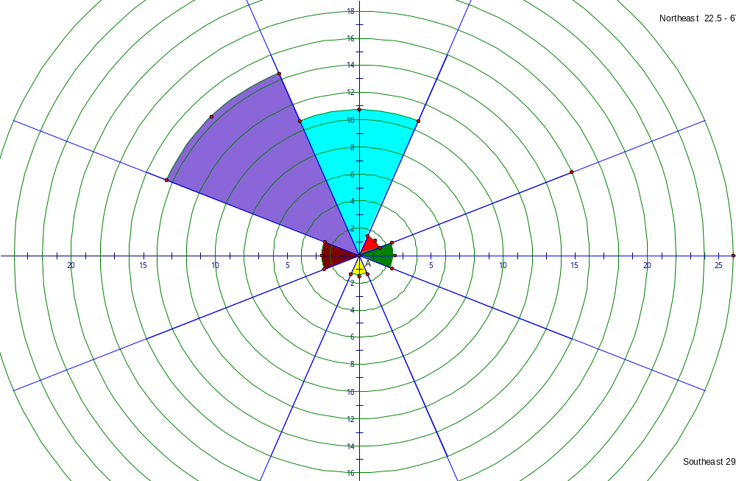

DATA TABLE AND POLAR GRAPH FOR PARTS ‘c’ AND ‘d’
Toxaway River (SC)
 |  |  |  |  | For Graphing
Segment | Length (cm) | angle (degrees) |  | Direction | angle  (in degrees) | frequency | total length
1 | 2.4 | 77 |  | East | 337.5 - 22.5 | 4 | 5.6
2 | 2 | 358 |  | Northeast | 22.5 - 67.5 | 4 | 17.2
3 | 1.5 | 122 |  | North | 67.5 - 112.5 | 5 | 9
4 | 5.4 | 39 |  | Northwest | 112.5 - 157.5 | 4 | 9.1
5 | 2.4 | 120 |  | West | 157.5 - 202.5 | 2 | 2.8
6 | 1.3 | 350 |  | Southwest | 202.5 - 247.5 | 0 | 0
7 | 1.9 | 104 |  | South | 247.5 - 292.5 | 0 | 0
8 | 2 | 48 |  | Southeast | 292.5 - 337.5 | 1 | 3.7
9 | 1.7 | 135
10 | 1.3 | 0 |  |  | Totals | 20 | 47.4
11 | 3.5 | 146
12 | 2.4 | 40
13 | 3.7 | 336
14 | 7.4 | 63
15 | 0.8 | 164
16 | 0.7 | 70
17 | 1 | 350
18 | 0.7 | 72
19 | 2 | 168
20 | 3.3 | 100
Total Length | 47.4
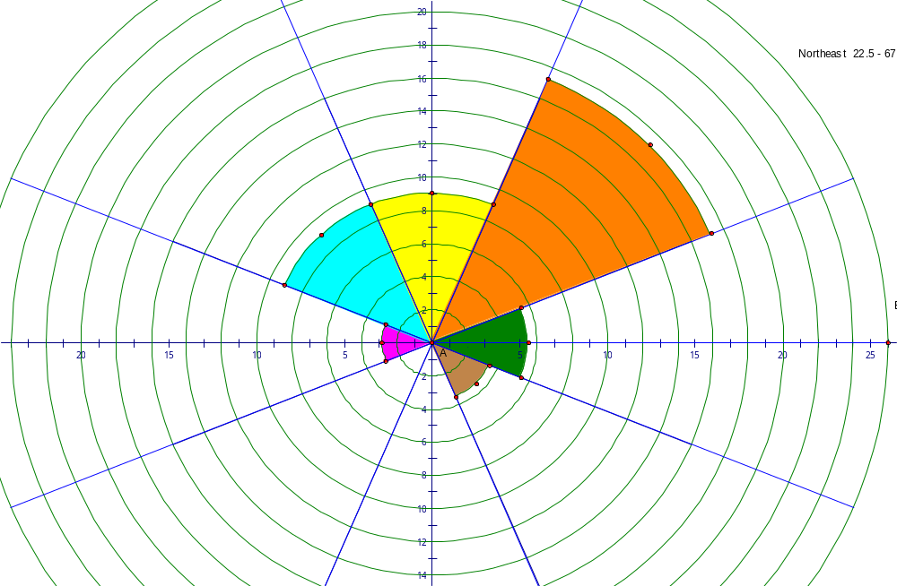

DATA TABLE AND POLAR GRAPH FOR PARTS ‘c’ AND ‘d’
Whitewater River
 |  |  |  |  | For Graphing
Segment | Length (cm) | angle (degrees) |  | Direction | angle  (in degrees) | frequency | total length
1 | 2 | 127 |  | East | 337.5 - 22.5 | 0 | 0
2 | 0.8 | 186 |  | Northeast | 22.5 - 67.5 | 0 | 0
3 | 2.8 | 118 |  | North | 67.5 - 112.5 | 3 | 3.8
4 | 1.4 | 149 |  | Northwest | 112.5 - 157.5 | 9 | 25.7
5 | 0.6 | 98 |  | West | 157.5 - 202.5 | 4 | 6.5
6 | 1.3 | 171 |  | Southwest | 202.5 - 247.5 | 0 | 0
7 | 1.4 | 90 |  | South | 247.5 - 292.5 | 0 | 0
8 | 1.8 | 80 |  | Southeast | 292.5 - 337.5 | 0 | 0
9 | 3.6 | 119
10 | 5.2 | 149 |  |  | Totals | 16 | 36
11 | 1.7 | 122
12 | 1.4 | 165
13 | 2 | 136
14 | 5.5 | 155
15 | 3 | 178
16 | 1.5 | 125
Total Length | 36
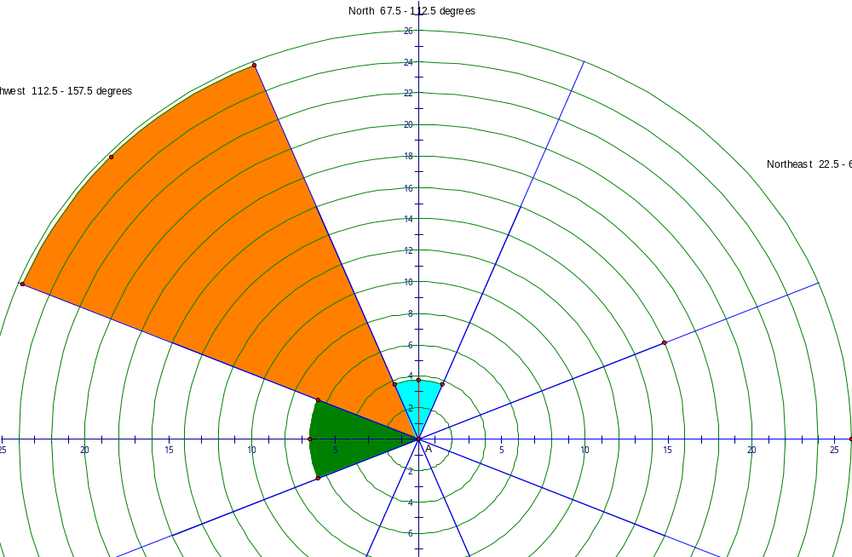

DATA TABLE AND POLAR GRAPH FOR PARTS ‘c’ AND ‘d’
Thompson River
 |  |  |  |  | For Graphing
Segment | Length (cm) | angle (degrees) |  | Direction | angle  (in degrees) | frequency | total length
1 | 3.9 | 159 |  | East | 337.5 - 22.5 | 0 | 0
2 | 1.3 | 61 |  | Northeast | 22.5 - 67.5 | 3 | 7.2
3 | 1.1 | 115 |  | North | 67.5 - 112.5 | 5 | 13.4
4 | 1.9 | 91 |  | Northwest | 112.5 - 157.5 | 4 | 7.2
5 | 3.3 | 111 |  | West | 157.5 - 202.5 | 1 | 3.9
6 | 5.6 | 86 |  | Southwest | 202.5 - 247.5 | 0 | 0
7 | 2 | 100 |  | South | 247.5 - 292.5 | 0 | 0
8 | 2.3 | 114 |  | Southeast | 292.5 - 337.5 | 0 | 0
9 | 0.6 | 69
10 | 1.2 | 118 |  |  | Totals | 13 | 31.7
11 | 3 | 54
12 | 2.6 | 148
13 | 2.9 | 50
Total length | 31.7
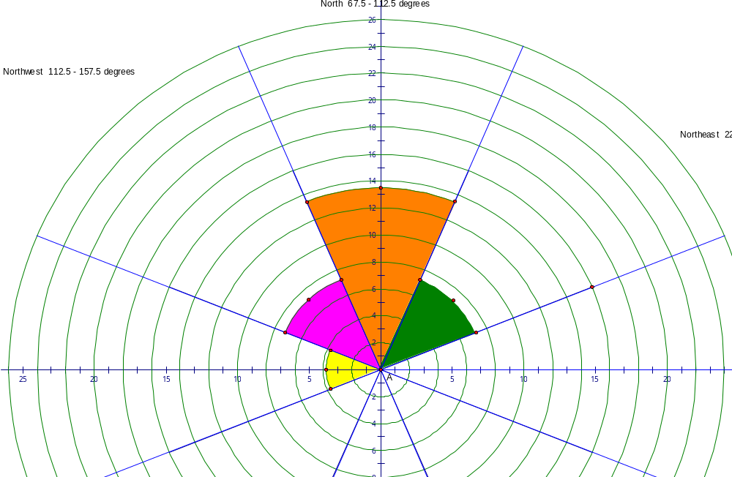

DATA TABLE AND POLAR GRAPH FOR PARTS ‘c’ AND ‘d’
Keowee River
 |  |  |  |  | For Graphing
Segment | Length (cm) | angle (degrees) |  | Direction | angle  (in degrees) | frequency | total length
1 | 4.7 | 160 |  | East | 337.5 - 22.5 | 1 | 2.8
2 | 4.3 | 75 |  | Northeast | 22.5 - 67.5 | 5 | 12.8
3 | 3.9 | 152 |  | North | 67.5 - 112.5 | 2 | 11
4 | 3.4 | 48 |  | Northwest | 112.5 - 157.5 | 6 | 18.4
5 | 5.7 | 134 |  | West | 157.5 - 202.5 | 1 | 4.7
6 | 1.9 | 50 |  | Southwest | 202.5 - 247.5 | 0 | 0
7 | 1.9 | 130 |  | South | 247.5 - 292.5 | 0 | 0
8 | 2.8 | 58 |  | Southeast | 292.5 - 337.5 | 0 | 0
9 | 3 | 142
10 | 3 | 60 |  |  | Totals | 15 | 49.7
11 | 2.8 | 142
12 | 1.7 | 58
13 | 1.1 | 146
14 | 2.8 | 0
15 | 6.7 | 100
Total Length | 49.7
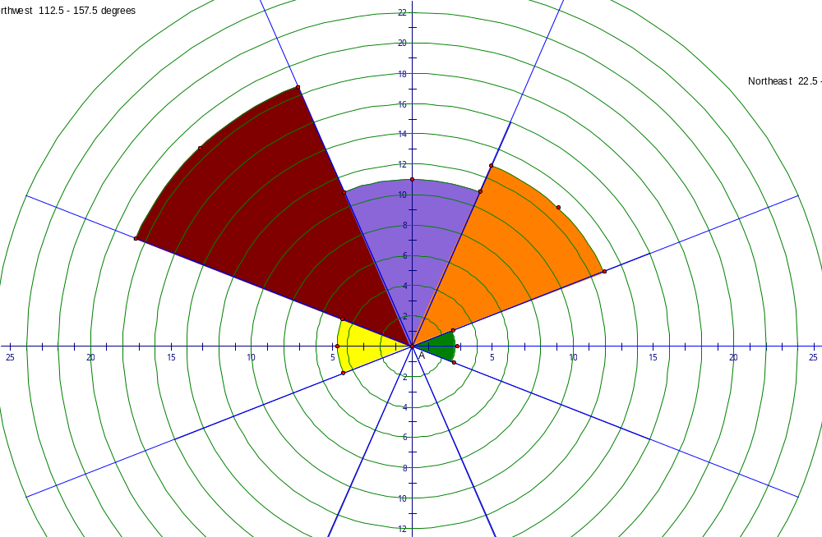

DATA TABLE AND POLAR GRAPH FOR PARTS ‘c’ AND ‘d’
Horsepasture River
 |  |  |  |  | For Graphing
Segment | Length (cm) | angle (degrees) |  | Direction | angle  (in degrees) | frequency | total length
1 | 0.9 | 201 |  | East | 337.5 - 22.5 | 1 | 0.7
2 | 1.2 | 130 |  | Northeast | 22.5 - 67.5 | 3 | 4
3 | 1.1 | 56 |  | North | 67.5 - 112.5 | 5 | 10.5
4 | 2.6 | 100 |  | Northwest | 112.5 - 157.5 | 5 | 18.1
5 | 1.4 | 175 |  | West | 157.5 - 202.5 | 5 | 6.8
6 | 1.3 | 252 |  | Southwest | 202.5 - 247.5 | 0 | 0
7 | 4.8 | 142 |  | South | 247.5 - 292.5 | 1 | 1.3
8 | 1.6 | 70 |  | Southeast | 292.5 - 337.5 | 0 | 0
9 | 0.7 | 352
10 | 4.3 | 100 |  |  | Totals | 20 | 41.4
11 | 8.1 | 142
12 | 0.5 | 88
13 | 0.8 | 161
14 | 1.5 | 80
15 | 1 | 170
16 | 1.3 | 62
17 | 0.8 | 125
18 | 1.6 | 50
19 | 3.2 | 136
20 | 2.7 | 164
Total Length | 41.4


