SOUTHEASTERN MAPS

AND

AERIAL PHOTOGRAPHIC SYSTEMS

SE MAPS

Teaching Manual

June, 2003
[updated September 2020]

Edited by
John R. Wagner – Professor of Geology
Clemson University, Clemson, South Carolina

This project was supported, in part, by the National Science Foundation. Opinions expressed are those of the authors and not necessarily those of the Foundation.

[SE MAPS is based on concepts developed by Dr. Peggy W. Cain at the South Carolina Department of Education]

SOUTHEASTERN MAPS AND AERIAL PHOTOGRAPHIC SYSTEMS

Acknowledgments

SE MAPS was made possible by assistance from the following grants:

Title II Dwight D. Eisenhower Mathematics and Science Education Act

The National Science Foundation (Instructional Materials Development Program)

Opinions expressed in this document are those of the authors
and not necessarily those of any of the granting agencies which supported this work

To obtain additional copies of the SE MAPS Teaching Manual, contact

SE MAPS PROJECT OFFICE
Department of Environmental Engineering and Earth Sciences
445 Brackett Hall, Clemson University
Clemson, South Carolina 29634-0919
864-656-5024
864-656-1041 (fax)
jackieg@clemson.edu

To purchase any of the cartographic products, contact:

SE MAPS Distribution Center
Department of Environmental Engineering and Earth Sciences
445 Brackett Hall, Clemson University
Clemson, S.C. 29634-0919
864-656-5024
864-656-1041 (fax)
jackieg@clemson.edu

WEBSITE
http://www.cecas.clemson.edu/geolk12/semaps/index.html

Copyright 2003 (pending)

The SE MAPS Teaching Manual is copyrighted material. Photocopying
of individual pages for classroom use is permitted so long as credit is given.

TECHNICAL CONSULTANTS

Burgess Howell, University of Alabama – Huntsville Carl W. Helms, Clemson University

CONTRIBUTING AUTHORS

ALABAMA

GREGORY N. COX (state coordinator)
University of Alabama - Huntsville

G. MICHAEL CLARK
University of Tennessee - Knoxville

DAVID KOPASKA-MERKEL

Geological Survey of Alabama

JOHN R. WAGNER

Clemson University

FLORIDA

JAMES R. ANDERSON (co-state coordinator)
Florida State University

JON ARTHUR (co-state coordinator)
Florida Geological Survey

ALICE BAMBERGER
Florida Department of Education

ED LANE
Florida Geological Survey

GAIL FOSTER
Environmental Education Consultant

JOE MAY
Florida Department of Environmental Protection

CAROL SNELL-PATTON
University of Central Florida

GEORGIA

NANCY HUEBNER (state coordinator)
Fernbank Science Center

PAMELA J.W. GORE
Georgia Perimeter College

TOM HANLEY
Columbus College

JIM HENRY
GSU-ACRL

LOUISIANA

WILLIAM CRAIG (state coordinator)
University of New Orleans

PAM BLANCHARD
LA Sea Grant Program

MARY ALICE CAIN
Jefferson Parish Schools

DONALD DAVIS
Louisiana State University

JANET GRAF
Louisiana Earth Science Teachers Association

LARRY HANDLEY
National Wetlands Research Center

NATHAN HANDLEY
NASA Regional Application Center

JEAN MAY-BRETT
Louisiana Science Teachers Association

JOHN TROWBRIDGE
Southeastern Louisiana University
MISSISSIPPI

GAIL RUSSELL (state coordinator)
University of Southern Mississippi

JOHN R. WAGNER
Clemson University

JOHN WILSON

Stennis Space Center

NORTH CAROLINA

FRED BEYER (state coordinator)
Cumberland County Schools (retired)

ERIK CALDWELL
Clemson University

G. MICHAEL CLARK

University of Tennessee - Knoxville

PATRICK HENRICKS
Clemson University

REBECCA LAMB
Colburn Gem and Mineral Museum

MARG McKINNEY
Appalachian State University

THOMAS ROSS
University of North Carolina - Pembroke

JOHN R. WAGNER
Clemson University

RICHARD D. WHITE
Clemson University

SOUTH CAROLINA

PEGGY W. CAIN (state coordinator)
South Carolina Dept. of Education (retired)

M. SCOTT HARRIS
Coastal Carolina University

LAWRENCE GREER
Beck Academy

ARLA JESSEN
Dewees Island Environmental Center

MARK MUSSELMAN
Social Studies Curriculum Consultant

REBECCA PUGH
Newberry Country Schools (retired)

MARK ROBERTS
Schofield Middle School

JOSEPH TINSLEY

Clemson University

JOHN R. WAGNER
Clemson University

ALAN F. WEEKES
Pickens Middle School

TENNESSEE

G. MICHAEL CLARK (state coordinator)
University of Tennessee - Knoxville

MICHAEL A. GIBSON
University of Tennessee – Martin

HUGH H. MILLS
Tennessee Technological University

PROJECT EVALUATORS

Philip M. Astwood, University of South Carolina C.Q. Brown, East Carolina University (retired)

CHAPTER TITLES
HOW TO USE SE MAPS 1

INTERPRETATION OF MAPS AND REMOTELY SENSED IMAGES 2

SOUTHEASTERN UNITED STATES REGIONAL OVERVIEW 3

APPALACHIAN PLATEAUS REGION 4

VALLEY AND RIDGE REGION 5

BLUE RIDGE REGION 6

PIEDMONT REGION 7

COASTAL PLAIN REGION 8

COASTAL ZONE REGION 9

FLORIDA PENINSULA 10
SPECIAL ACKNOWLEDGEMENTS

ALABAMA
Susan Cameron, Global Hydrology and Climate Center
Priscilla Holland, University of North Alabama, Geology Department

FLORIDA
Robin Denson, Gulf Archeological Research Institute
Genny Healy, RSMAS
Marvin L. Ivey, Educator, Largo, FL
Chris Sack, Teacher – DCPS
Sandi Schlichting, University of South Florida

GEORGIA
Kemberly C. Carter, Teacher – Matt Wilson Middle School
Fred Hay, Educator, Sapelo Island, Georgia
Amy R. Heidt, Northeast Middle School

LOUISIANA
Tony Mergist, LA Geography Education Alliance
Tamra Rogers, Helen Cox Middle School
Suzanne Tansey, John Ehret High School
Shannon Thibodeaux, John Ehret High School

MISSISSIPPI
Todd Becklenberger, Laboratory Coordinator, LRSGIS
Rosalina V. Hairston, University of Southern Mississippi

NORTH CAROLINA
Martha Campbell, NCDPI
Brenda Evans, NCDPI
Marie McBride, NCDPI
Katherine Richter, Educator, Raleigh, NC
Betty Welch, Educator, Wake Forest, NC

SOUTH CAROLINA
Bobbie Adams, SC Department of Natural Resources
Norma Adams, Clemson University
Sholto Bevis, Clemson University
Chip Berry, SC Department of Natural Resources
Jennifer Brunson, Bates Middle School
April Childress, Educator, Anderson, SC
Marjorie Claytor, SC Department of Education
Lori Csintyan, Furman Middle School
Sharon Mosley, Schofield Middle School
Carolyn Murphy, Blythewood Middle School
Allison Nix, Clemson University
Tracy O’Connor, Chapin Middle School
Rich Scharf, SC Department of Natural Resources
Mannetta Shusterman, Clemson University
Linda Sinclair, SC Department of Education
Johnny Spears, Schofield Middle School
Marie Thomas, Hillcrest Middle School
Rhet Wilson, South Carolina Aquarium

TENNESSEE
Sandy Adams, Del Rio Elementary
H.G. Churnet, University of Tennessee, Chattanooga
Gil Highlander, Educator, Chattanooga, TN
Jim Hunt, Chattanooga School for the Arts and Sciences
Linda Jordan, Tennessee Department of Education
Kristi McCord, Seymour High School
Jim Metcalfe, John Sevier Middle School
Kristi Oakes, Seymour High School
Franklin Odom, Cleveland Middle Schools
Jim Watson, Soddy-Daisy High School

SOUTHEASTERN MAPS AND AERIAL PHOTOGRAPHIC SYSTEMS

MASTER INDEX TO LANDFORM REGIONS AND STUDY SITES

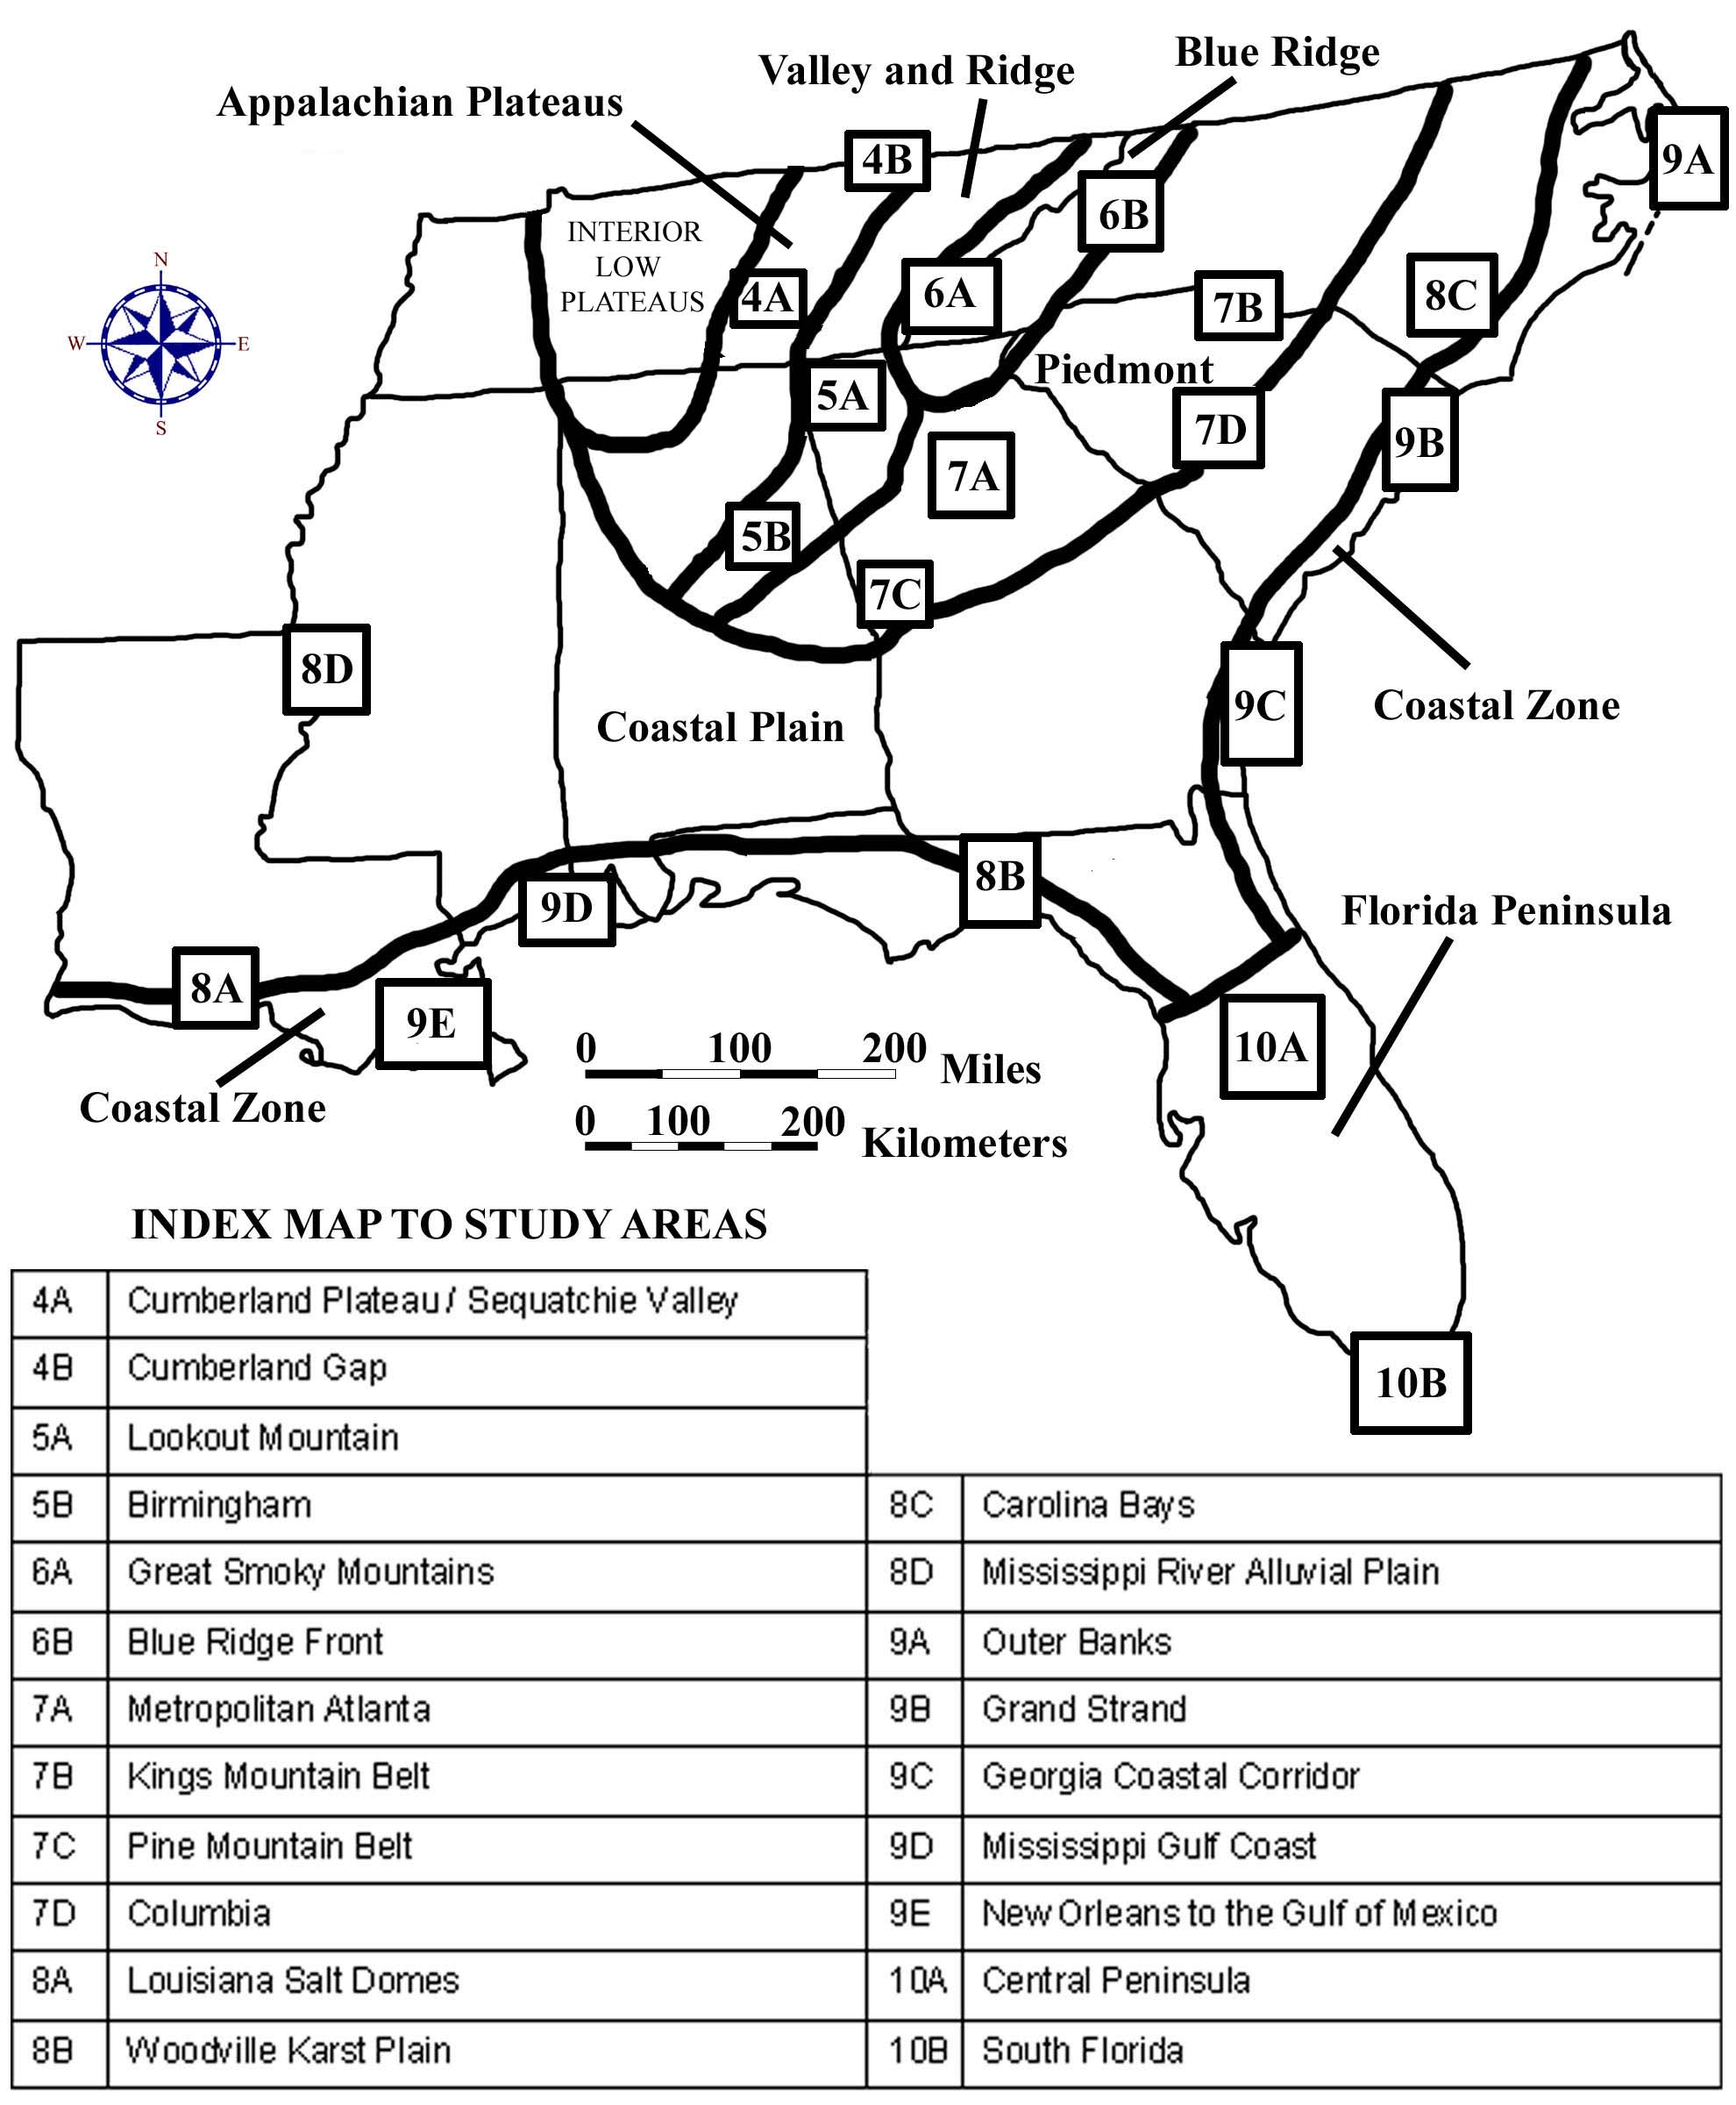

PREFACE

Very few middle school students have had the opportunity to view their local landscape from a high altitude aircraft, and virtually none have had an opportunity to see first hand what their state looks like from an orbiting satellite platform. As the name suggests, SouthEastern Maps and Aerial Photographic Systems provides these students with a fresh look at their state and region by using sets of infrared aerial photographs, satellite imagery, side-looking airborne radar (SLAR) and other specialized remotely sensed images matched with topographic and special purpose maps including three-dimensional anaglyph maps and a variety of regional base maps. Hands-on activities keyed to these cartographic products have been chosen to assist students in making connections between the Southeast’s geological framework, natural resources, land use, and environmental concerns.

SE MAPS presents a true interdisciplinary curriculum, in which students learn to make connections among the traditional middle school core disciplines. The Southeast’s complex geologic and geographic setting offers students both a scientific and historical context for the study of local legends, stories, and anecdotes, and other events recounted in primary source diaries. By using reading, writing, and other communication skills, language arts students learn to appreciate regional customs and cultural diversity. Aerial photographs, satellite images, and other remotely sensed data enhance science students’ understanding of the geologic events that produced the modern landscape and help explain patterns of distribution of various natural resources. Mathematics students’ skills are enhanced by applying problem-solving techniques involving probability, estimation, geometry, graphing, and measuring. Such activities mirror the real-life critical thinking skills needed to interpret the Southeastern landscape and manage its natural resources. Social studies students relate a variety of Southeastern historical events to the influence of particular landscape features associated with each landform region. These types of classroom activities are tied to national and state curriculum standards and help students make connections between disciplines rather than simply memorizing isolated facts. Other broad themes, covering topics like transportation, land-use changes through time, and environmental protection, are woven throughout the SE MAPS Teaching Manual.

As a collaborative effort, SE MAPS has drawn on the diverse talents of scientists, educators, historians, and others throughout the eight participating Southeastern states to bring to the forefront the most important topics and natural features of the region. It is much more meaningful for a South Carolina student to study the sandhills near that state’s capital city, Columbia, than the sandhills of Nebraska or the African Sahara Desert. Likewise, a student in Tennessee is more likely to be interested in local caves their family might have visited than caves in New Mexico or China. By allowing students to see familiar landscapes from a different perspective, the authors of SE MAPS hope to raise not only the literacy level of middle school students in all disciplines, but also their ability to comprehend and contribute meaningfully to the continuing dialog on how best to both utilize and preserve the abundant natural heritage that we all share.

The authors of SE MAPS owe a great debt of gratitude to Dr. Peggy Cain, retired from the South Carolina Department of Education, whose vision created the first incarnation of this project, SC MAPS (South Carolina Maps and Aerial Photographic Systems). The success of SC MAPS in South Carolina provided a model that has been closely followed by SE MAPS. In turn, SE MAPS has been an effective model for the development of several state versions of the curriculum that will further enhance the learning experience for students in those states.

John R. Wagner, Editor
June, 2003

