CHAPTER 3

SOUTHEASTERN UNITED STATES REGIONAL OVERVIEW

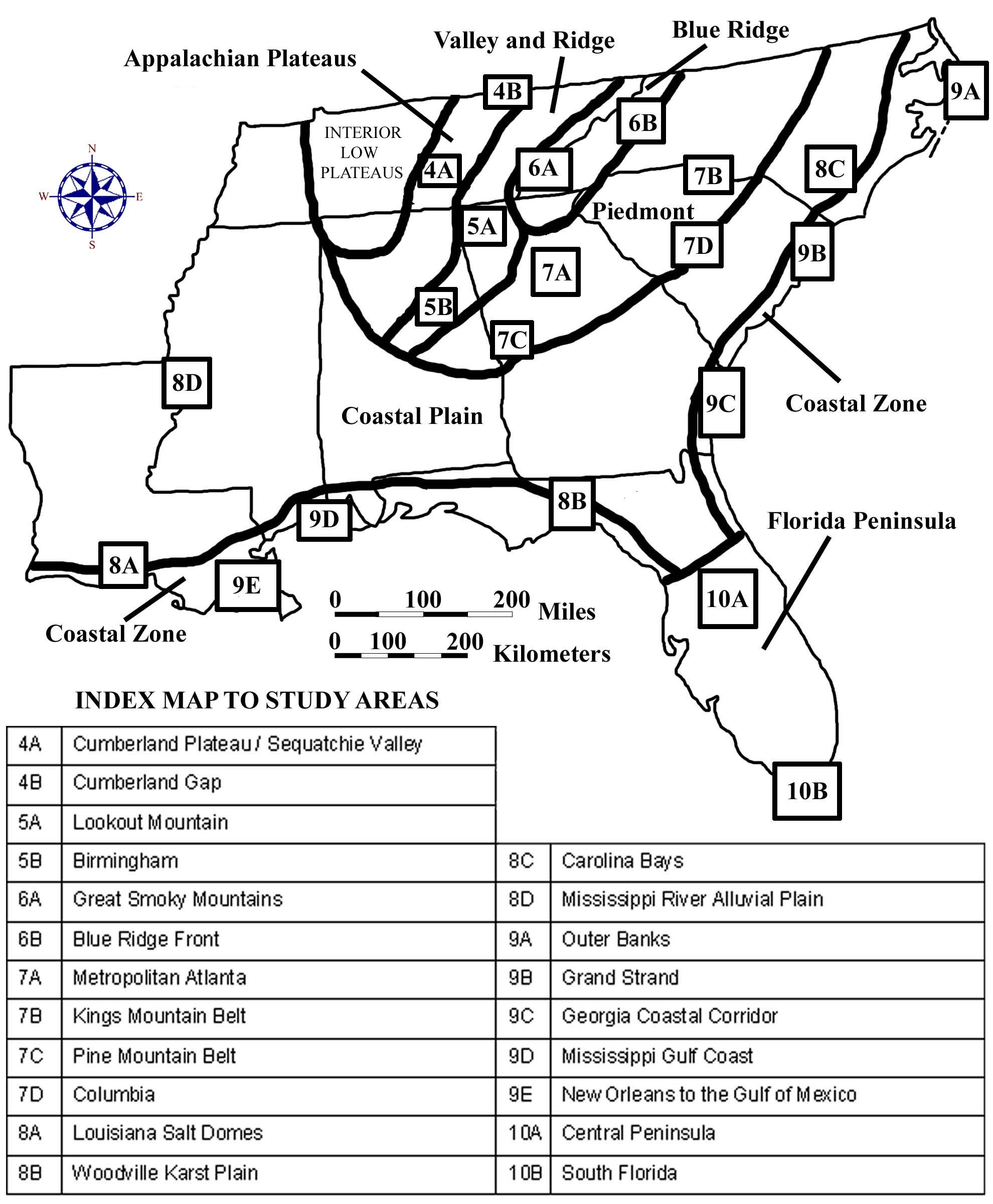

DRAFT VERSION 9/06/20

TABLE OF CONTENTS FOR CHAPTER 3

SOUTHEASTERN UNITED STATES REGIONAL OVERVIEW

John R. Wagner

INDEX MAP TO SOUTHEASTERN REGIONAL STUDY AREA
TABLE OF CONTENTS FOR CHAPTER 3
BACKGROUND INFORMATION
- Description of Landforms, Drainage Patterns, and Geologic Processes
p. 3-1 . . . . - Characteristic Landforms of the Southeastern USA
p. 3-1 . . . . . . . . - figure 3-1 – “Landform Regions of the Southeast”
p. 3-2 . . . . . . . . - figure 3-2 – “Major Drainage Basins in the Southeast”
p. 3-3 . . . . - Geographic Features and Localities of Special Interest
p. 3-4 . . . . - Rock Types and Geologic History
p. 3-4 . . . . . . . . - figure 3-3 – “Simplified Geologic Map of the Southeast”
p. 3-7 . . . . . . . . - figure 3-4 – “A Short Geologic History of the Southeast”
p. 3-8 . . . . . . . . - figure 3-5 – “Geologic Cross-Section through the Southeast”
- Influence of Topography on Historical Events and Cultural Trends
p. 3-9 . . . . - Folklore
p. 3-9 . . . . . . . . - story – “Legend of Little Deer”
p. 3-10 . . . . . . . . - story – “The Rooster and the Fox”
p. 3-11 . . . . . . . . - story – “The Ballad of Casey Jones”
p. 3-11 . . . - Historical Events
p. 3-13 . . . . . . . - figure 3-6 – “The Tennessee Valley Authority System”
p. 3-15 . . . - Influence of Topography on Commerce, Culture, and Tourism
p. 3-16 . . . . . . . - figure 3-7 – “Time Zones in the Southeast”
- Natural Resources, Land Use, and Environmental Concerns
p. 3-18 . . . - Climate and Water Resources
p. 3-18 . . . . . . . - figure 3-8 – “Average Annual Precipitation in the Southeast”
p. 3-19 . . . . . . . - figure 3-9 – “Average Annual Temperature in the Southeast”
p. 3-20 . . . - Soils and Agriculture
p. 3-22 . . . . . . . - figure 3-10 – “Agriculture in the Southeast”
p. 3-23 . . . - Mining and Resource Extraction
p. 3-24 . . . . . . . - figure 3-11 – “Mineral and Energy Resources in the Southeast”

PLACES TO VISIT
REFERENCES AND RESOURCES

STUDY AREA 3A = LANDSCAPES AND LANDFORMS
- Newspaper Article
p. 3A-1 . . . . . . . - story – “Canals Near Okeechobee Date 300 A.D.”
- Rationale
- Performance Objectives
- Sample Assessment Rubrics
- Cartographic Product Information
p. 3A-3 . . . - MAP 3A: Landscapes and Landforms
- Study Area Description
p. 3A-4 . . . - Landform Regions of the Southeast
p. 3A-5 . . . - Stream Systems and Flow Characteristics
p. 3A-6 . . . - Drainage Patterns and Watersheds
p. 3A-8 . . . . . . . - figure 3A-1 – “River Name Changes in a Carolina Watershed”
p. 3A-9 . . . . . . . - figure 3A-2 – “Common Drainage Network Patterns”
- Activity 3A-1: Landform Regions of the Southeastern USA
(ICONS) Overview = Science = Math = Soc Stud = Lang Arts =
p. 3A-10 . . . - Power Thinking Exercise “Scenic Search”
p. 3A-10 . . . - Materials
p. 3A-10 . . . - Performance Tasks
p. 3A-10 . . . . . . 1. Trace landform region boundaries.
p. 3A-11 . . . . . . 2. Distinguish between erosional and depositional landforms.
p. 3A-11 . . . . . . 3. Determine latitude / longitude coordinates for selected study areas.
p. 3A-12 . . . . . . 4. Identify obstacles to transportation.
p. 3A-12 . . . . . . 5. Tell story about building Okeechobee Canal.
p. 3A-13 . . - Enrichment
p. 3A-13 . . . . . . 1. Research official and unofficial state songs.
p. 3A-13 . . . . . . 2. Compare southeast landform regions with rest of USA.
- Activity 3A-2: Drainage Patterns and Watersheds
(ICONS) Overview = Science = Math = Soc Stud = Lang Arts =
p. 3A-14 . . . - Power Thinking Exercise “Hydrophobic Horse”
p. 3A-14 . . . - Materials
p. 3A-14 . . . - Performance Tasks
p. 3A-14 . . . . . . 1. Trace major river drainage basins (watersheds).
p. 3A-15 . . . . . . 2. Trace pathway of industrial pollutant.
p. 3A-16 . . . . . . 3. Calculate gradients of stream systems.
p. 3A-16 . . . . . . 4. Explain use of multiple names of major rivers.
p. 3A-16 . . . . . . 5. Write a story about salamander’s river journey.
p. 3A-17 . . - Enrichment
p. 3A-17 . . . . . . 1. Research information on reservoirs in your state.
p. 3A-17 . . . . . . 2. Identify and locate “Wild and Scenic” rivers.

STUDY AREA 3B = GEOLOGICAL SETTING
- Newspaper Article
p. 3B-1 . . . . . . . - story – “Family Seeks to Expand Oil Drilling in Preserve”
- Rationale
- Performance Objectives
- Sample Assessment Rubrics
- Cartographic Product Information
p. 3B-3 . . . - MAP 3B: Geological Setting
- Study Area Description
p. 3B-4 . . . - Geological Patterns in the Southeast
p. 3B-5 . . . - Tectonic Terranes of the Southeast
p. 3B-6 . . . - Fossils and Ancient Environments
p. 3B-7 . . . . . . . - figure 3B-1 – “Paleogeography During the Cretaceous Period”
p. 3B-7 . . . - Distribution of Geological Resources
p. 3B-8 . . . . . . . - figure 3B-2 – “Resource Production by State”
- Activity 3B-1: Interpreting Geologic History
(ICONS) Overview = Science = Math = Soc Stud = Lang Arts =
p. 3B-10 . . . - Power Thinking Exercise “Fossil Find”
p. 3B-10 . . . - Materials
p. 3B-10 . . . - Performance Tasks
p. 3B-10 . . . . . . 1. Make chart listing age and geologic features of landform regions.
p. 3B-11 . . . . . . 2. Locate position of former shoreline.
p. 3B-11 . . . . . . 3. Determine rate of change in shoreline position.
p. 3B-12 . . . . . . 4. Examine relationship between surface geology / state boundaries.
p. 3B-12 . . . . . . 5. Write an adventure story about the geologic past.
p. 3B-12 . . - Enrichment
p. 3B-12 . . . . . . 1. Research state rock and state fossil.
p. 3B-13 . . . . . . 2. Compile list of stories or films that use time machines.
- Activity 3B-2: Geologic Resources
(ICONS) Overview = Science = Math = Soc Stud = Lang Arts =
p. 3B-14 . . . - Power Thinking Exercise “Industrial Initiative”
p. 3B-14 . . . - Materials
p. 3B-14 . . . - Performance Tasks
p. 3B-14 . . . . . . 1. Investigate distribution of geologic resources
p. 3B-15 . . . . . . 2. Explain distribution of oil and gas deposits.
p. 3B-15 . . . . . . 3. Construct pie chart showing resource production by state
p. 3B-16 . . . . . . 4. Evaluate appropriate land uses for wildlife preserves
p. 3B-16 . . . . . . 5. Create slogan highlighting city’s geologic resource.
p. 3B-17 . . - Enrichment
p. 3B-17 . . . . . . 1. Trace economic impact of mining through time.
p. 3B-17 . . . . . . 2. Research origin of mineral deposits.

STUDY AREA 3C = LANDSCAPE PATTERNS
- Newspaper Article
p. 3C-1 . . . . . . . - story – “Smokies, Everglades Make List of All Threatened Parks.”
- Rationale
- Performance Objectives
- Sample Assessment Rubrics
- Cartographic Product Information
p. 3C-3 . . . - MAP 3C: Landscape Patterns
- Study Area Description
p. 3C-4 . . . - Satellite Imagery
p. 3C-4 . . . - Advanced Very High Resolution Radiometer
p. 3C-5 . . . . . . . - figure 3C-1 – “Color Interpretation Chart for AVHRR Images ”
p. 3C-6 . . . - Digital Shaded Relief Maps
- Activity 3C-1: Erosional and Depositional Surface Features
(ICONS) Overview = Science = Math = Soc Stud = Lang Arts =
p. 3C-7 . . . - Power Thinking Exercise “Alien Assignment”
p. 3C-7 . . . - Materials

p. 3C-7 . . . - Performance Tasks
p. 3C-7 . . . . . . . 1. Investigate relative prominence of seven landform regions.
p. 3C-8 . . . . . . 2. Recognize erosional and depositional patterns of rivers.
p. 3C-8 . . . . . . 3. Estimate numerical value of surface area of Southeast.
p. 3C-9 . . . . . . 4. Detect human activity visible on satellite image.
p. 3C-9 . . . . . . 5. Write set of directions using references to landscape patterns.
p. 3C-9 . . - Enrichment
p. 3C-9 . . . . . . 1. Research how DEM generates shaded relief image.
p. 3C-9 . . . . . . 2. Research how AVHRR satellite system works.
- Activity 3C-2: Structural Geology Influences Topography
(ICONS) Overview = Science = Math = Soc Stud = Lang Arts =
p. 3C-11 . . . - Power Thinking Exercise “Poster Pick”
p. 3C-11 . . . - Materials
p. 3C-11 . . . - Performance Tasks
p. 3C-11 . . . . . . 1. Compare and contrast representation of structural features.
p. 3C-12 . . . . . . 2. Explain why pollution is trapped in Smoky Mountains.
p. 3C-12 . . . . . . 3. Estimate time of day by examining cloud shadows.
p. 3C-12 . . . . . . 4. Describe alignment of state boundaries with structural features.
p. 3C-12 . . . . . . 5. Describe characteristics of a mosaic.
p. 3C-13 . . - Enrichment
p. 3C-13 . . . . . . 1. Compare Space Shuttle photographs with satellite image.
p. 3C-13 . . . . . . 2. Analyze astronaut descriptions of earth.

STUDY AREA 3D = TOPOGRAPHY AND CLIMATE
- Newspaper Article
p. 3D-1 . . . . . . . - story – “From King Cotton to King Pine.”
- Rationale
- Performance Objectives
- Sample Assessment Rubrics
- Cartographic Product Information
p. 3D-3 . . . - MAP 3D: Topography and Climate
- Study Area Description
p. 3D-4 . . . - Elevation and Climate Patterns
p. 3D-5 . . . . . . . - figure 3D-1 – “Major Escarpments in the Southeast”
p. 3D-5 . . . - Topography, Soils, and Agriculture
p. 3D-7 . . . - Surveying and Global Positioning Systems
p. 3D-7 . . . . . . . - figure 3D-2 – “Basic Surveying Methodology”
p. 3D-9 . . . . . . . - figure 3D-3 – “Triangulation with Global Positioning Systems”
- Activity 3D-1: Elevation Patterns and Landscapes
(ICONS) Overview = Science = Math = Soc Stud = Lang Arts =
p. 3D-10 . . . - Power Thinking Exercise “Drastic Detour”
p. 3D-10 . . . - Materials
p. 3D-10 . . . - Performance Tasks
p. 3D-10 . . . . . . 1. Correlate elevation data with landform regions.
p. 3D-11 . . . . . . 2. Speculate about straightness of escarpment.
p. 3D-11 . . . . . . 3. Evaluate appropriateness of statistical analysis.
p. 3D-11 . . . . . . 4. Explain why highest point in Florida has no name.
p. 3D-11 . . . . . . 5. Propose name for highest point in Florida.
p. 3D-12 . . - Enrichment
p. 3D-12 . . . . . . 1. Research famous people for whom mountains were named.
p. 3D-12 . . . . . . 2. Investigate how mountaintop elevations are determined.
- Activity 3D-2: Climate and Agriculture
(ICONS) Overview = Science = Math = Soc Stud = Lang Arts =
p. 3D-13 . . . - Power Thinking Exercise “Legend Logic”
p. 3D-13 . . . - Materials
p. 3D-13 . . . - Performance Tasks
p. 3D-14 . . . . . . 1. Correlate major agricultural regions with elevation changes.
p. 3D-14 . . . . . . 2. Relate average rainfall / temperature data to elevation differences.
p. 3D-15 . . . . . . 3. Calculate slope from highest elevation to lowest
p. 3D-16 . . . . . . 4. Relate size and shape of county (parish) to topography.
p. 3D-16 . . . . . . 5. Examine use of metaphorical language in land use terminology.
p. 3D-17 . . - Enrichment
p. 3D-17 . . . . . . 1. Explain pixilation pattern on map.
p. 3D-17 . . . . . . 2. Locate historical references to topography of farmland.

STUDY AREA 3E = POLITICAL SETTING
- Newspaper Article
p. 3E-1 . . . . . . . - story – “Bullet Train Decision Delayed a Year.”
- Rationale
- Performance Objectives
- Sample Assessment Rubrics
- Cartographic Product Information
p. 3E-3 . . . - MAP 3E: Political Setting
- Study Area Description
p. 3E-4 . . . - Natural Features as Effective Political Boundaries
p. 3E-5 . . . - Historical Reasons for Placement of State Boundaries
p. 3E-6 . . . - Early Transportation Systems
p. 3E-6 . . . . . . . - figure 3E-1 – “Major Canals and Waterway Projects”
p. 3E-7 . . . . . . . - figure 3E-2 – “Major Roadways, 1800”
p. 3E-8 . . . - President George Washington’s Southern Tour
p. 3B-12 . . . - The Coming of the Railroads
p. 3E-13 . . . - Modern Transportation
p. 3E-13 . . . . . . . - figure 3E-3 – “Interstate Highways in the Southeast, 2000”
p. 3E-15 . . . . . . . - figure 3E-4 – “Passenger Rail Lines in the Southeast, 2000”
- Activity 3E-1: Transportation Systems
(ICONS) Overview = Science = Math = Soc Stud = Lang Arts =
p. 3E-16 . . . - Power Thinking Exercise “Canal Connections”
p. 3E-16 . . . - Materials
p. 3E-16 . . . - Performance Tasks
p. 3E-16 . . . . . . . 1. Analyze distribution of transportation routes.
p. 3E-18 . . . . . . 2. Identify landscapes that present obstacles to travel.
p. 3E-18 . . . . . . 3. Compare travel times for Washington’s trip versus today.
p. 3E-18 . . . . . . 4. Trace routes of early roads.
p. 3E-19 . . . . . . 5. Analyze President George Washington’s writing style.
p. 3E-19 . . - Enrichment
p. 3E-19 . . . . . . 1. Research famous people mentioned in Washington’s diary.
p. 3E-19 . . . . . . 2. Compare passenger rail routes in mid 1900’s to today.
- Activity 3E-2: Establishment of Political Boundary Lines
(ICONS) Overview = Science = Math = Soc Stud = Lang Arts =
p. 3E-20 . . . - Power Thinking Exercise “Querulous Quandry”
p. 3E-21 . . . - Materials
p. 3E-21 . . . - Performance Tasks
p. 3E-21 . . . . . . . 1. Determine categories of state boundary lines.
p. 3E-21 . . . . . . 2. Investigate use of drainage divide as state boundary.
p. 3E-22 . . . . . . 3. Locate the center of a state.
p. 3E-22 . . . . . . 4. Explain reasons for moving capital.
p. 3E-22 . . . . . . 5. Invent name for border city.
p. 3E-23 . . - Enrichment
p. 3E-23 . . . . . . 1. Research boundary line disputes.
p. 3E-23 . . . . . . 2. Document location of capital cities along Fall Line Zone.

STUDY AREA 3F = CULTURAL SETTING
- Newspaper Article
p. 3F-1 . . . . . . . - story – “Historic Indian Mounds in Way of Macon Development.”
- Rationale
- Performance Objectives
- Sample Assessment Rubrics
- Cartographic Product Information
p. 3F-3 . . . - MAP 3F: Cultural Setting
- Study Area Description
p. 3F-4 . . . - How Places Get Their Names
p. 3F-5 . . . - Native Americans
p. 3F-6 . . . - Early Explorers and Settlements
p. 3F-7 . . . . . . . - figure 3F-1 – “Early Exploration Routes”
p. 3F-8 . . . . . . . - figure 3F-2 – “First Settlements in the Southeast”
p. 3F-9 . . . - Impact of Wars and Regional Conflicts
p. 3F-9 . . . . . . . - figure 3F-3 – “Major Battlegrounds (Pre-Civil War) in the Southeast”
p. 3F-10 . . . . . . . - figure 3F-4 – “Major Civil War Battlegrounds in the Southeast”
p. 3F-10 . . . - Ethnic and Racial Distribution
- Activity 3F-1: Place Names and Geography
(ICONS) Overview = Science = Math = Soc Stud = Lang Arts =
p. 3F-12 . . . - Power Thinking Exercise “Nebulous Name”
p. 3F-12 . . . - Materials
p. 3F-12 . . . - Performance Tasks
p. 3F-12 . . . . . . . 1. Classify city names into categories.
p. 3F-13 . . . . . . 2. Correlate city names with landform regions.
p. 3F-13 . . . . . . 3. Analyze city name category distribution.
p. 3F-13 . . . . . . 4. Correlate place names with Native American titles.
p. 3F-14 . . . . . . 5. Evaluate information provided by suffix.
p. 3F-14 . . - Enrichment
p. 3F-14 . . . . . . 1. Determine reasons for names of local features.
p. 3F-14 . . . . . . 2. Conduct name survey of all cities in your state.
- Activity 3F-2: Ethnic Diversity and Patterns of Settlement
(ICONS) Overview = Science = Math = Soc Stud = Lang Arts =
p. 3F-15 . . . - Power Thinking Exercise “Contentious Claim”
p. 3F-15 . . . - Materials
p. 3F-15 . . . - Performance Tasks
p. 3F-15 . . . . . . . 1. Analyze geographic distribution of battlefields.
p. 3F-16 . . . . . . 2. Identify features associated with settlement limits.
p. 3F-16 . . . . . . 3. Analyze census of Native American Nations.
p. 3F-17 . . . . . . 4. Investigate disappearance of Native American culture.
p. 3F-17 . . . . . . 5. Examine changes in word meanings over time.
p. 3F-18 . . - Enrichment
p. 3F-18 . . . . . . 1. Contact nearest Native American (Indian) Reservation.
p. 3F-18 . . . . . . 2. Analyze census data.

BACKGROUND INFORMATION

Description of Landforms, Drainage Patterns, and Geological Processes

Characteristic Landforms of the Southeastern USA

The southeastern region is defined geographically by SE MAPS to include Alabama, Florida, Georgia, Louisiana, Mississippi, North Carolina, South Carolina, and Tennessee. In addition to their proximity to each other, these states share a great deal of common culture, history, geology, and natural resources. Tennessee and Louisiana are not always categorized as Southeastern states, but are included in this grouping for geographic completeness because several classic Southeastern landscape study areas overlap into these border states and most distinctive landform features rarely end at state boundaries.

Figure 3-1: Landform Regions of the Southeast
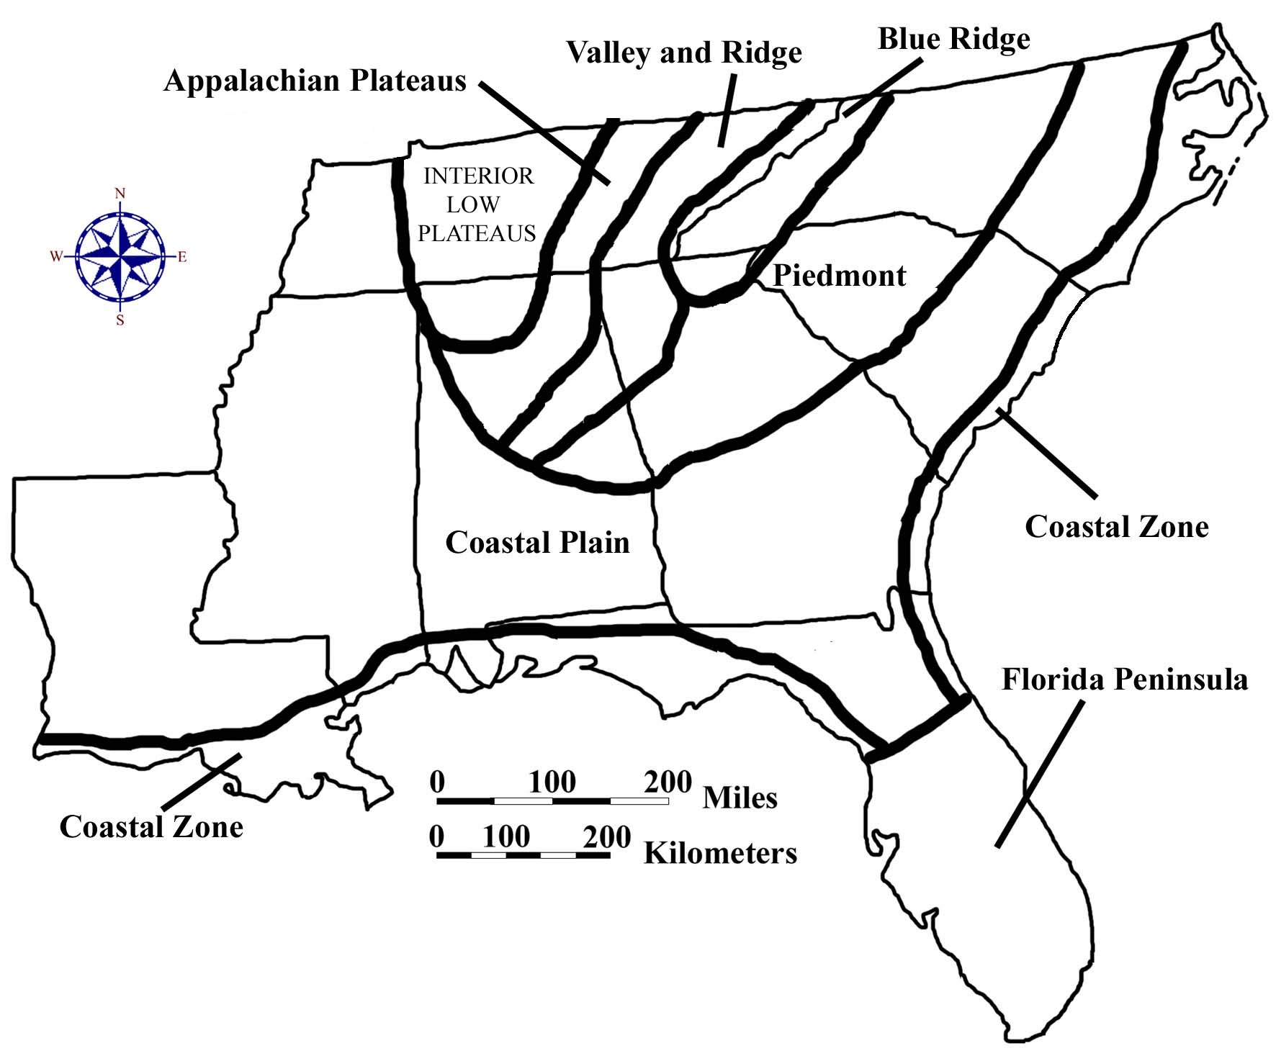

There are many different classification schemes which can be used to categorize the landscape regions of North America. The most widely accepted version today is based on the work of Nevin Melancthon Fenneman (1865-1945) who was associated with the United States Geological Survey for many years as well as serving as professor of geology and geography at the University of Cincinnati. Fenneman accurately outlined the positions of the Atlantic and Gulf Coastal Plains, the Piedmont, the Blue Ridge, the Valley and Ridge, and the Appalachian Plateaus physiographic provinces. He separated those regions from one another on the basis of rock type, structural features, and topography.

SE MAPS establishes two other landform regions in the southeastern United States, based primarily on land use characteristics. The Coastal Zone is geologically part of the Coastal Plain physiographic province, but the human impact of geologically active shorelines makes this region distinctive enough to warrant having separate status. The Florida Peninsula likewise technically belongs to the Coastal Plain province, but the variety of unique environments it contains, such as the Florida Keys, the Everglades, and the Central Lakes region, makes it reasonable to treat this area as a separate landform region.

The region of central Tennessee and northern Alabama that is labeled as the Interior Low Plateaus is outside of the formal coverage area of SE MAPS. However, some natural and historical features within this region have important connections to the Appalachian Plateaus region and even to the entire Southeast and so are included in the text as needed.

Figure 3-2: Major Drainage Basins in the Southeast
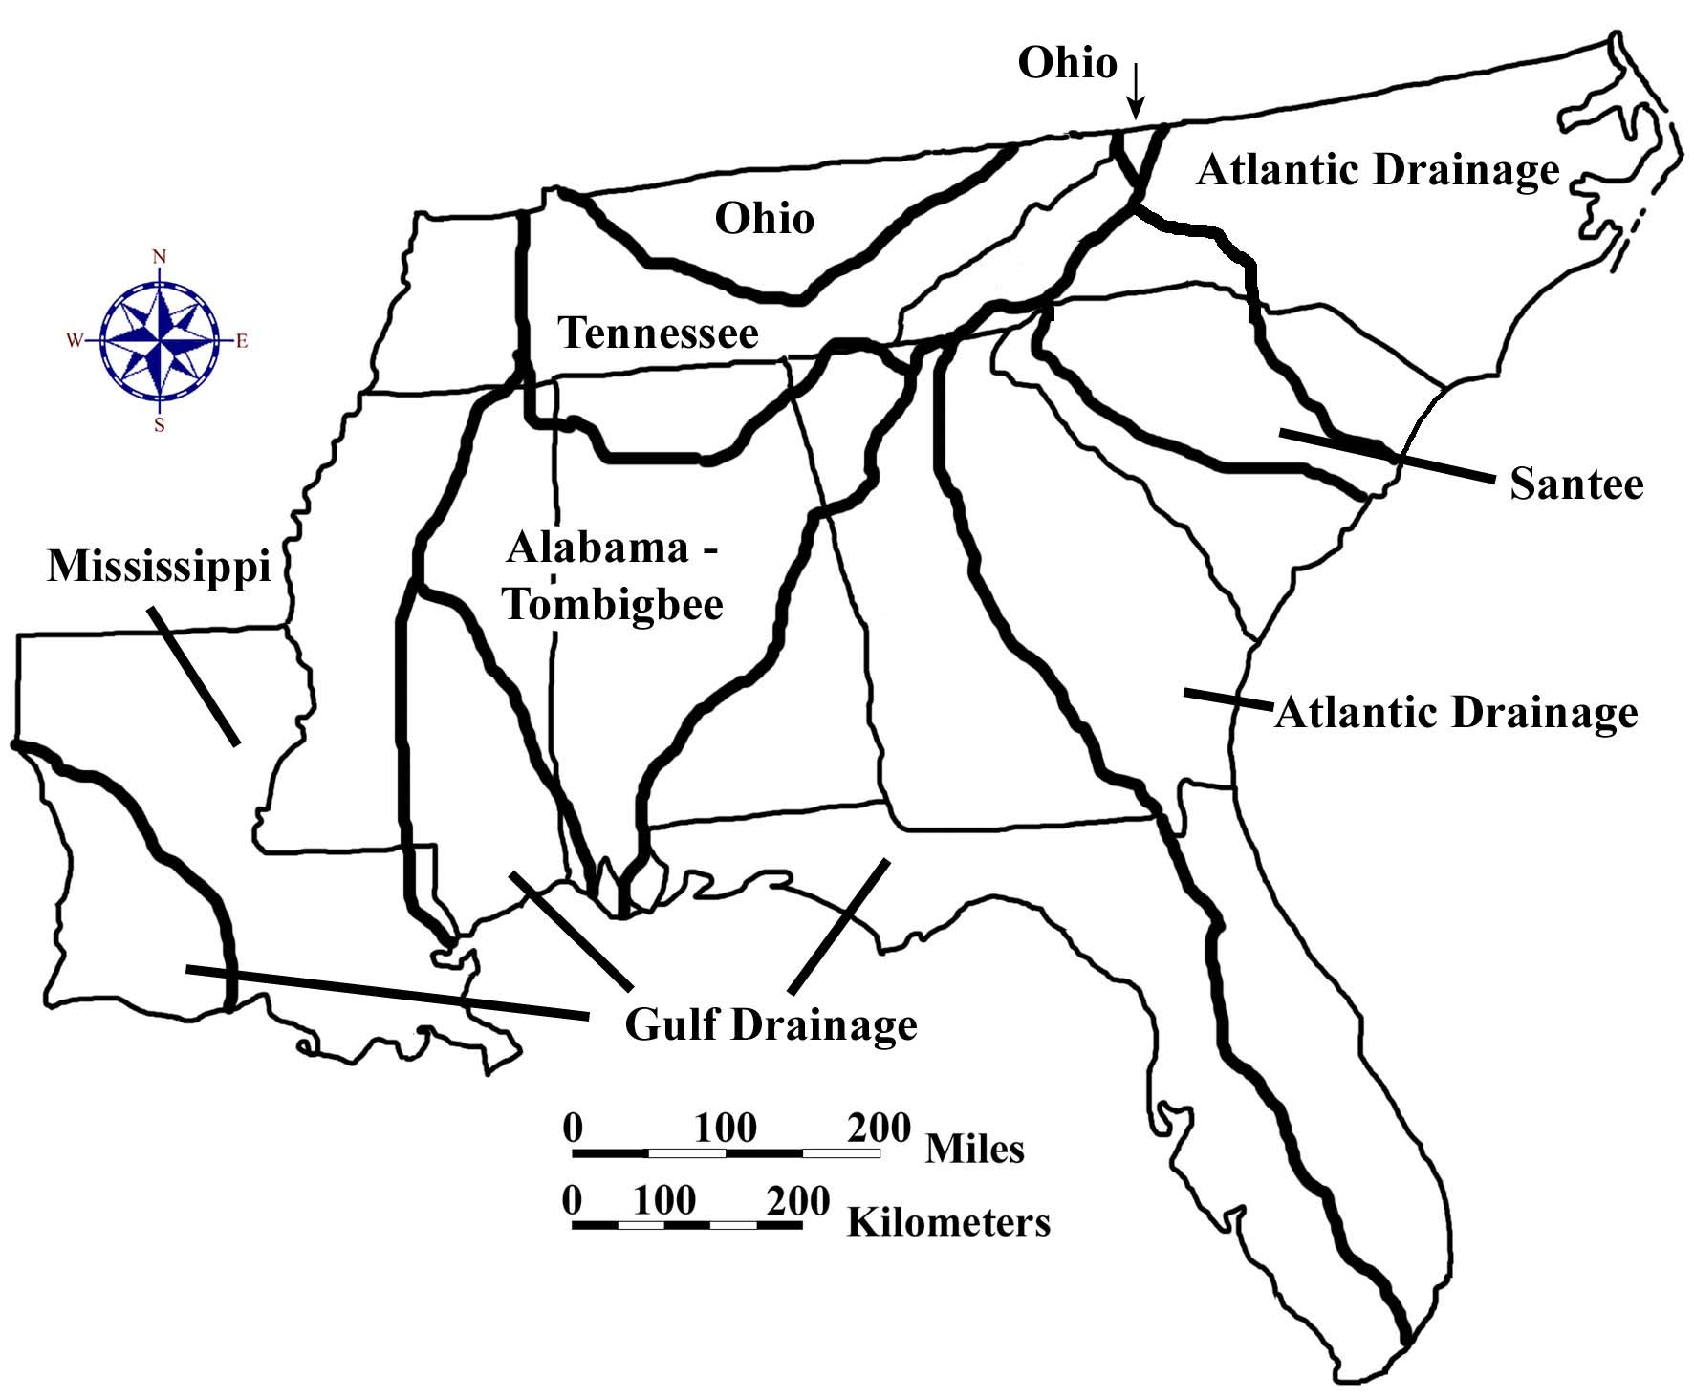
The single most obvious and dominant landscape feature in the Southeast, outside of the Florida peninsula, is the Appalachian Mountain range. Stretching from Alabama all the way to Maine and beyond into Canada, the Appalachians rise high above the surrounding lands and are therefore susceptible to great amounts of erosion by wind and especially water. The resulting sediments eventually find their way to the Atlantic Ocean or the Gulf of Mexico through a complex network of river systems. Streams draining to the east of the high mountains have a relatively short distance to travel to the ocean, while westward flowing water must follow the Tennessee River to the Ohio River before finally entering the Mississippi River and heading for the Gulf of Mexico. As a rule, smaller stream systems carry less water and have smaller watersheds (drainage basins), while larger stream systems carry great volumes of water and have much larger watersheds.

Geographic Features and Localities of Special Interest

One of the most diverse landform regions is the Coastal Zone. Both the Atlantic and Gulf of Mexico shorelines vary in shape and style from one location to another. Barrier islands are common in places like the Outer Banks of North Carolina and the Gulf Coast of Mississippi. Straight, eroding shorelines occur along the Grand Strand of South Carolina and parts of the Gulf Coast of Florida. The Mississippi Delta dominates the coastline of Louisiana and influences shoreline features for hundreds of miles on each side. Famous beaches include Miami Beach, Pensacola, the Jacksonville Beaches, and Panama City Beach in Florida, Myrtle Beach and Hilton Head Island in South Carolina, and Cape Hatteras in North Carolina. Further inland, swamps and other wetlands provide unique habitats for a variety of rare and endangered species. The Okeefenokee Swamp in Georgia, the Dismal Swamp in North Carolina, the Atchafalaya Basin in Louisiana, and the Everglades in Florida are prime examples. Carolina Bay lakes, oxbow lakes, and sinkhole lakes dot certain portions of the Coastal Plain landform region, but these features are dwarfed in size by the much larger Lake Ponchartrain in Louisiana and Lake Okeechobee in Florida.

Several areas in the Southeast containing unique and/or endangered habitats have been set aside as International Biosphere Preserves, encompassing relatively pristine areas that contain prime examples of some of the more specialized ecosystems on our continent. The Great Smoky Mountains National Park of Tennessee and North Carolina, the Congaree Swamp National Park in South Carolina, and the Everglades National Park in Florida are three of the most well known of these areas. Other national and state parks preserve a wide variety of spectacular landscapes and historical features such as Stone Mountain in Georgia, the Cape Hatteras National Seashore in North Carolina, the Vicksburg National Military Park in Mississippi, several antebellum mansions and gardens in Louisiana, the Kings Mountain Revolutionary War Battlefield in South Carolina, the Big South Fork National River in Tennessee, and the Russell Cave National Monument in Alabama. Two national Parkways, the Blue Ridge Parkway in North Carolina, and the Natchez Trace Parkway in Alabama, Mississippi, and Tennessee, attract many visitors to the region.
Rock Types and Geologic History

The primary factor determining the location and extent of landscape features in the southeastern United States is the underlying geology. Differences in rock types and rock structures are responsible for most of the surface differences we see in the seven major landform regions. Crystalline igneous and metamorphic rocks are essentially limited to the Blue Ridge and Piedmont landform regions along the eastern portion of the Appalachian Mountain chain. Sporadic occurrences of various rock types and seemingly random distribution patterns create a jumbled landscape of mountains and valleys. Folded and faulted sedimentary rocks of varying resistance characterize the Valley and Ridge and Appalachian Plateaus regions to the west. The simpler and more uniform structures in these areas produce more orderly and predictable land surfaces. The Coastal Plain and Coastal Zone regions consist of relatively flat-lying sedimentary rocks that extend beneath the ocean, away from the original sediment source. The resulting landscape surface forms a slightly inclined plane, broken only by rough terrace edges representing the different geologic episodes of erosion that have affected these areas as the land emerged from beneath the ocean. The Florida peninsula is essentially a carbonate (limestone) platform, originally formed under the ocean, which has since risen slightly above sea level.

Figure 3-3: Simplified Geologic Map of the Southeast

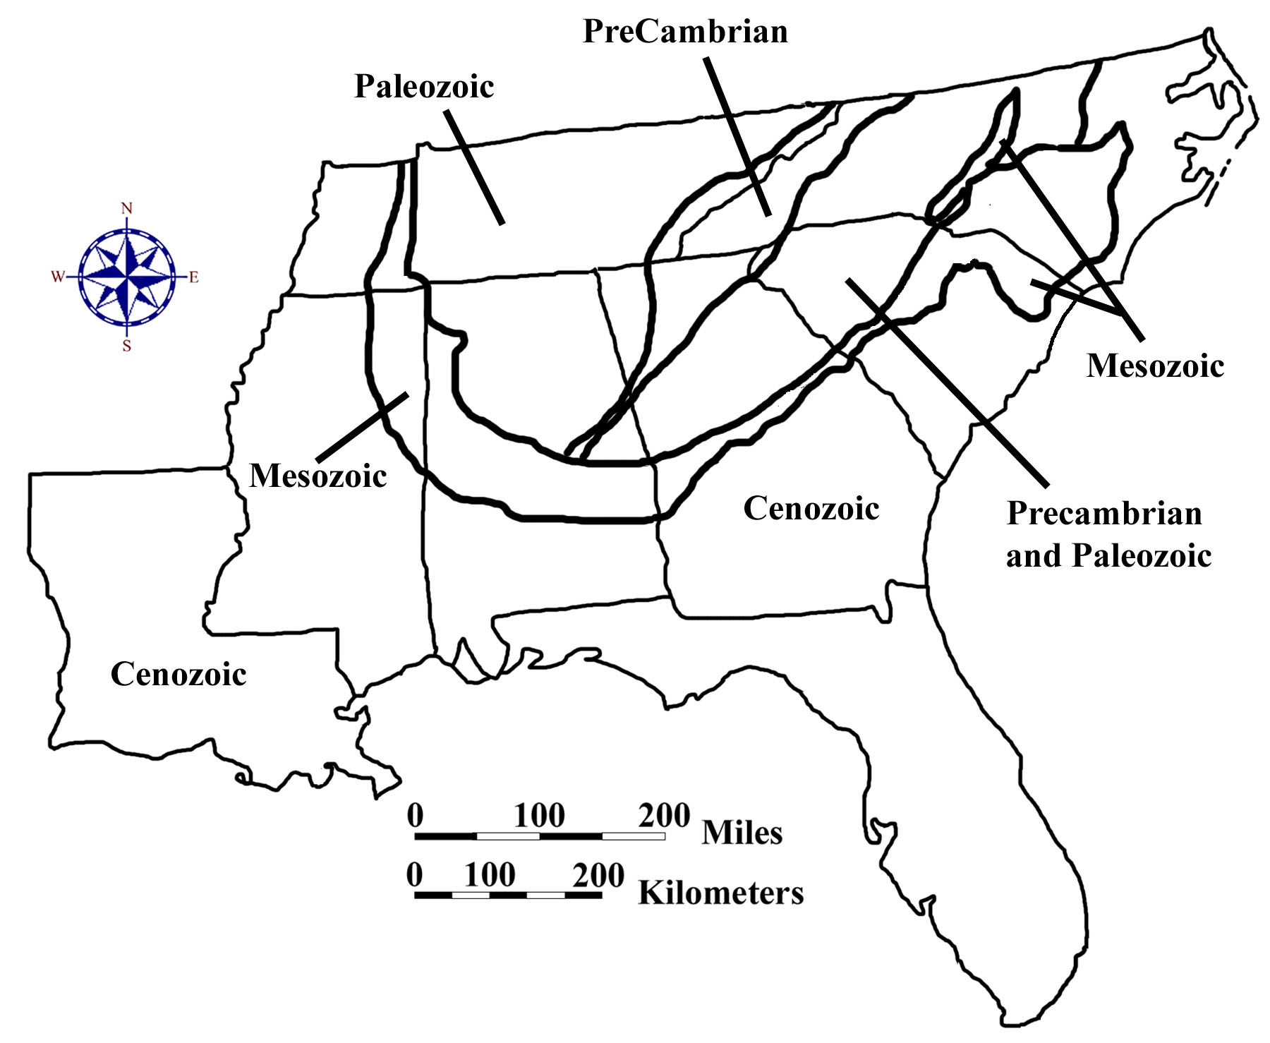
The effects of plate tectonic forces within the earth’s crust, and the relentless assault of weathering and erosion on the land surface, built the basic framework of the southeastern United States progressively through geologic time. The original North American continent, as it existed about one billion years ago, ended near the present eastern and southern boundaries of the state of Tennessee, with ancient oceans extending eastward and southward from the old land surface. The Appalachian Mountains did not yet exist. Throughout the Paleozoic Era of geologic history, sea-floor spreading and continental drift brought many small continental fragments known as exotic terranes from other parts of the globe crashing into North America, gradually enlarging the continent. In addition to generating localized volcanic mountain ranges, this tectonic activity also created large areas of igneous and metamorphic rock in areas that today are considered part of the Piedmont region. The culminating event of the Paleozoic Era was the closing of the ancient Iapetus Ocean as the joined continents of Africa and South America collided with an expanded North America. The resulting mega-forces raised a new Appalachian Mountain range, possibly as high as the modern Himalayas, and generated lots of folds and faults within the surrounding rocks. Entire sections of the Piedmont and Blue Ridge regions were thrust westward over themselves onto the continental interior. The most highly metamorphosed areas were concentrated along the collision zone. This new mountain range formed the backbone of the newly formed super-continent, Pangea.

During the Mesozoic Era, South America and Africa began to move away from each other as well as away from North America itself as new oceans began to separate different segments of the super-continent. This rifting occurred fairly close to the original continental collision zone and caused the formation of extensional fractures, particularly within the Piedmont region. Tectonic activity along the developing rift zone caused a series of downfaulted basins to form along a line from Georgia to New England. These basins contain river and lake sediments of Triassic and Jurassic age as well as intrusive basaltic sills and dikes (layers of igneous rock injected within other rock types). A few of these so-called Triassic Basins have survived in the Southeast, exposed at the surface in several places in North Carolina and buried beneath Coastal Plain sediments along the Savannah River in South Carolina and Georgia. As the Atlantic Ocean continued to grow, sediments from the eroding Appalachian Mountains began to fill the deepening basin near the coastline and build up a long, wide continental shelf. The Gulf of Mexico likewise began accumulating thick sedimentary deposits of both continental and marine origin. Shoreline positions at the end of the Mesozoic ran through the upstate regions of most of the southeastern states along the approximate position of the Fall Line Zone that marks the northern boundary of today’s Coastal Plain.

The retreat of the ocean from the flanks of the Appalachian Mountains to its present position along the Atlantic and Gulf coasts occurred in gradual stages, leaving behind a series of marine terraces as evidence of periodic deposition of marine sediment on the continental shelf. As extensive river systems continued to bring huge quantities of eroded rock from the mountains to the sea, the unloading of that much total mass from mountains and other upland areas caused the entire Appalachian Mountain range to rise in response, pulling the western edge of the Coastal Plain up with it. This tilting effect was enhanced by the subsidence of the ocean floor under the weight of millions of tons of new sediment that was piled on top of the oceanic crust. As a result, the older Coastal Plain rocks are normally exposed nearer to the mountains, while younger rocks appear closer to the modern coastline. These sedimentary formations intersect the land surface in bands of various thickness which parallel the Atlantic Ocean shoreline before wrapping around the southern end of the Appalachian Mountains to form the Mississippi Embayment. All of these rock layers dip towards the ocean as they cover over the older rock layers and are in turn covered over by more recent deposits.

The final global event that shaped the landscape of the Southeastern United States was the great Pleistocene ice age at the end of the Cenozoic Era. Geologists now recognize that the ‘Ice Age’ actually represents a series of ice advances and retreats that occurred over a time period of more than two million years. Although a few geologists have speculated about the existence of small glaciers in the Great Smoky and Blue Ridge Mountain chains, this is highly unlikely, and the rest of the Southeast almost certainly escaped direct contact with the advancing ice sheets. Nevertheless, climate changes in the area were significant, and some river systems, such as the Mississippi, carried many times their normal volume of water because of the diversion of rivers around ice sheets that blocked normal drainage routes to the north. As the ice sheets grew larger and then finally retreated, a significant portion of the earth’s total water budget was first stored as glacial ice, then released as heavy runoff from glacial meltwater. During times of ice advance, ocean levels dropped about 300 feet (approximately 100 meters) below their current levels. As a result, rivers extended their courses outward onto the newly exposed continental shelf and carved deep channels into the Coastal Plain sediments. During times of extreme ice melting, such as during interglacial warm periods, sea level could have risen close to 200 feet (60 meters) above the current level, flooding the old river channels to form long, wide estuaries and leaving behind parallel bands of old sand dunes to mark the position of ancient beach ridges.

Figure 3-4: A Short Geologic History of the Southeast

Age (m.y.) | Era | Period | Epoch | Southeastern Events
.01 | Cenozoic | Quaternary | Holocene | barrier islands form along coast --continued deposition of sediments into Mississippi and Santee deltas
1.6 |  |  | Pleistocene | rise and fall of sea level due to ice ages produces beach ridges along coast
5.3 |  | Tertiary | Pliocene | terraces and Carolina Bays form in Coastal Plain
22.7 |  |  | Miocene | gentle uplift --long resistant ridges and water gaps form in Appalachians
36.8 |  |  | Oligocene | Antarctic ice cap forms causing sea level to drop --Coastal Plain erodes
57.8 |  |  | Eocene | rising sea level deposits marine sediments, notably, limestone in Coastal Plain
66.4 |  |  | Paleocene | Cape Fear Arch is formed --tectonic subsidence along Georgia border --carbonate deposition in Florida peninsula
144 | Mesozoic | Cretaceous |  | higher sea level, extensive Coastal Plain sedimentation --prograding deltas
208 |  | Jurassic |  | Atlantic Ocean forms as rifting continues --diabase dikes form along east coast in association with rift basins
245 |  | Triassic |  | rifting occurs pulling Pangea apart --Triassic Rift Basins form along east coast
286 | Paleozoic | Permian |  | Appalachians actively uplifted and eroded --Blue Ridge is thrust faulted and pushed westward
320 |  | Pennsylvanian |  | sandstones, shales and coal beds deposited west of newly formed Appalachian Mountains
360 |  | Mississippian |  | widespread deposition of limestones in warm shallow seas over much of the continent
408 |  | Devonian |  | mountain building in the north causing uplift --emplacement of igneous intrusions in Piedmont
438 |  | Silurian |  | uplift and erosion --deposition of clastic sediment into epeiric sea
505 |  | Ordovician |  | Iapetus Ocean closing --island arc collides with North American continent
570 |  | Cambrian |  | erosion of the craton --current Blue Ridge area is continental margin accumulating sediment
Precambrian |  |  |  | multiple mountain building episodes produce Precambrian crystalline and sedimentary rocks

Figure 3-5: Geologic Cross-Section through the Southeast

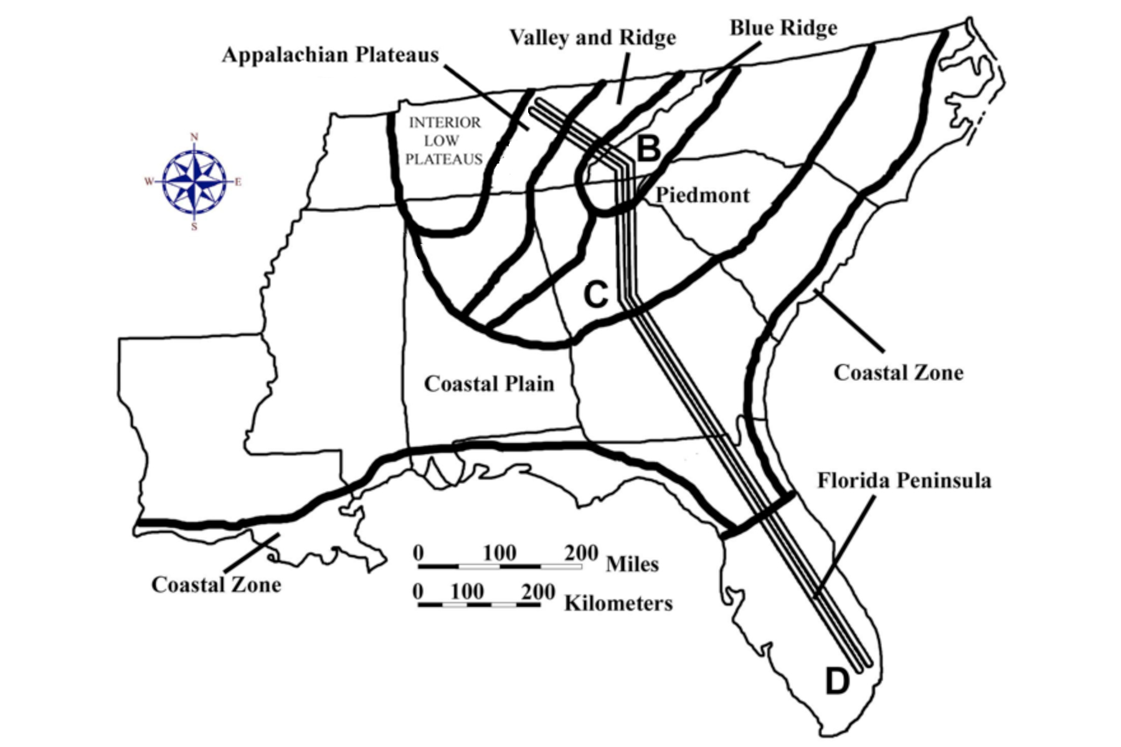

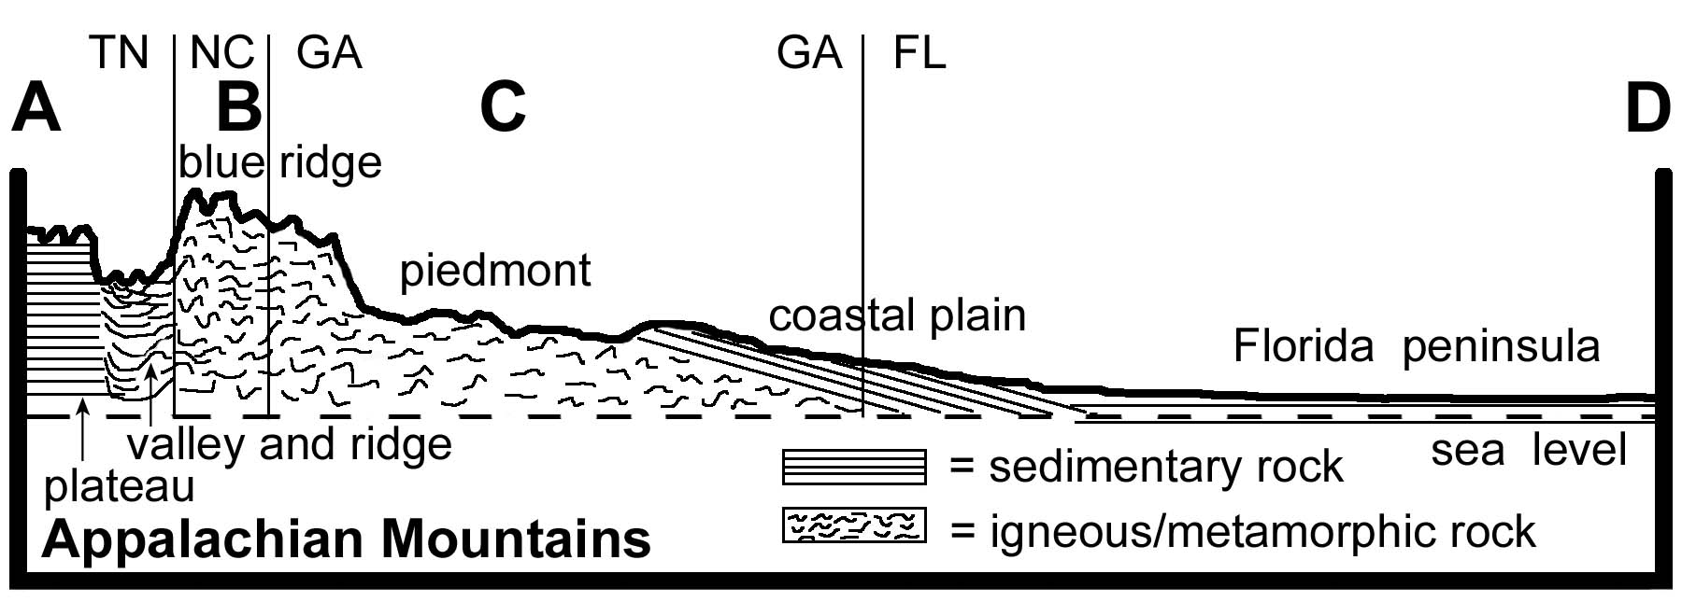

Influence of Topography on Historical Events and Cultural Trends

Folklore

Every part of the country has its own particular brand of folk legends and popular mythology, and the Southeastern states are no exception. In many cases, references to familiar landscapes and landforms reinforce the attraction of songs, poems and stories to generations of people who lived in these lands. Although this region of the United States is frequently referred to as “Dixie” and has often been stereotyped as representing an aristocratic plantation lifestyle, in reality there are many different cultural identities that make up this diverse population. Many of these cultures are tied to specific geographic localities or particular landform regions, and their literature and music reflects that connection.

Native Americans, mistakenly called “Indians” by early European explorers, did not function as a single cultural group, but instead practiced a wide variety of customs and traditions. Storytelling was one way a community could bond together under the umbrella of a common history and pass its values and rituals on to the next generation. Many of these stories explained how the world came to be the way it is and how each animal and plant had its own special place in the natural order of things. The “Legend of Little Deer” is one example of a legend designed to teach young hunters to respect the land and its animal inhabitants and to hunt only when necessary.

Legend of Little Deer
Adapted from Richard Mancini, Indians of the Southeast

Long ago the Cherokee people lived peacefully with all the animals. They hunted only when they needed food or skins for clothing. Later, the hunters learned to make bows and arrows, and hunting was much easier. They hunted all the time, even when they did not need food or clothes. The deer held a council to find a way to make the people stop killing so many of their family. Little Deer was the leader. He spoke wisely and told the other deer that the people must hunt only to live and not kill for sport. They must respect the deer and hunt only when they are in need. Little Deer told the Cherokee people that they must prepare themselves for the hunt. They must ask permission before killing one of the deer family. After they kill a deer, they must respect its spirit and ask to be pardoned--if they do not, then they will be crippled. To this very day when a Cherokee hunter kills a deer, he must go to the deer and ask for pardon. If he does not, then Little Deer returns to punish him. For this reason, the Cherokee respect and thank the deer and all other animals they hunt.

African Americans are also well known for their rich heritage of oral traditions, especially Porquoi Tales (taken from the French word for “why”). This literary style uses encounters between animals and natural events to explain how the world came to be the way it is. A particularly unique variant is the trickster tale, in which a smaller, weaker animal or person triumphs over a more powerful creature by using his wits. Such stories were often interpreted by African Americans as allegories in which slaves outwitted their masters. As slaves, it could have been dangerous to pass along stories glamorizing the exploits of human heroes, but animal stories were considered harmless.

The Rooster and the Fox
A trickster tale as retold by Libby W. Carnohan from notes of Bob Ward

Rooster was feeding up in a tree one day when along came Fox. “Come on down,” said Fox. “Don’t be scared of me. I won’t hurt you. Haven’t you heard that peace has been declared between all birds and animals?” “Why, no,” said Rooster. “Nobody told me.” “Well, it’s true,” said Fox. “The news has gone around and I thought everybody had heard, so come on down.” From up in the tree, Rooster could see a pack of dogs coming following Fox’s trail. He said, “Well, if that’s true, I’ll be down directly. Then you and me and that pack of dogs headed this way can sit down peacefully and talk.” With that, Fox saw the dogs coming over the hill and ran away. I guess you might say Rooster out foxed him.

Almost all cultures tell stories about favorite folk heroes whose exploits were well known in the local area. Most of these legends were originally based on historical facts, but have taken on larger-than-life attributes over the years as the stories spread to a wider audience. Davy Crockett and Daniel Boone are honored as heroic wilderness explorers by some folks in the Appalachian Mountains. Stonewall Jackson, Francis Marion (the Swamp Fox), and Robert E. Lee, are revered as famous military heroes by many southerners. The exploits of Evangeline, as chronicled in the poem by Henry Wadsworth Longfellow, recount the founding of the Acadian, or Cajun, culture of Louisiana. Osceola, who achieved notoriety during the Indian Wars in Florida, was the most famous Native American leader of the Seminole Nation.

An example of a more recent legend is that of John Luther (Casey) Jones, a colorful railroad engineer who died in 1900 in a famous train wreck in Vaughan, Mississippi, 30 miles (50 km) north of the city of Jackson. He got his nickname from the town of Cayce, Kentucky, near which he was born, and was well known among his fellow railroad workers for his outgoing personality and his unusual skill in sounding a steam engine’s whistle. The Erie Railroad Magazine (Volume 24, April 1928) described it as a “kind of long-drawn-out note that he created, beginning softly, then rising, then dying away almost to a whisper. People living along the Illinois Central right of way between Jackson and Water Valley would turn over in their beds late at night and say: ‘There goes Casey Jones,’ as he roared by.” Casey had a reputation for running trains fast and hard, making up time that other engineers had lost. He is credited with boasting, “I’m going to run her till she leaves the rail or make it on time with the southbound mail.” Although there is no proof Casey made this particular statement, it, and many others like it, ended up as a series of verses in several ballads commemorating the life and tragic death of Casey Jones.

The Ballad of Casey Jones
Selected verses from Wallace Saunders and others

Come all you rounders if you want to hear,
A story ‘bout a brave engineer.
Casey Jones was the rounder’s name,
Twas on the Illinois Central that he won his fame.

Casey Jones, mounted the cabin; Casey Jones, with the orders in his hand.
Casey Jones, he mounted the cabin; Started on his journey to the promised land.

Pulled out of Memphis nearly two hours late,
Soon they were speeding at a terrible rate.
And the people knew by the whistle’s moan,
That the man at the throttle was Casey Jones.

Need more coal there, fireman Sim,
Open that door and heave it in.
Give that shovel all you got,
And we’ll reach Canton on the dot.

On April 30, 1900, that rainy morn,
Down in Mississippi near the town of Vaughan.
Sped the Cannonball Special only two minutes late,
Traveling 70 miles an hour when they saw a freight.

Casey Jones, he died at the throttle; Casey Jones, with the whistle in his hand.
Casey Jones, he died at the throttle, but we’ll all see Casey in the promised land.

Casey’s body lies buried in Jackson, Tennessee,
Close beside the tracks of the old I.C.
May his spirit live forever throughout the land,
As the greatest of all heroes of a railroad man.

Historical Events

The history of the Southeastern United States is as diverse as its geography. Even the region’s first inhabitants, the Native Americans, did not represent a monolithic culture, but included at least seven different linguistic families and over 15 major tribal affiliations. Although all of these nations are officially classified as Woodland Indians, their hunting habits, food sources, and living habits differed to some extent based on the topography, land cover, and land resources of the areas they called home. The arrival of the European colonists in the 16th century had a dramatic impact upon these Native American peoples and their cultures. Wars and the introduction of new diseases greatly reduced their numbers. However, many natural areas and other places in the southeast still carry the names and perpetuate the memories of these long-vanished communities.

Beginning in the 16th century, European explorers from several different nations began to divide up the land that would one day become the United States of America. Several nations set up temporary military outposts along the Atlantic coast in order to add legitimacy to their claims. In 1562 the French established a fort at Port Royal Sound in present-day South Carolina. In 1564 they established a second fort in Florida at the mouth of the St. John’s River near the present location of St. Augustine. The Spanish response was to send a military expedition to establish permanent settlements on Florida’s east coast and drive out the French influence. The plan succeeded quickly and led, in 1565, to the founding of St. Augustine, the oldest continuously occupied settlement founded by Europeans in the United States. The earliest English colony was not founded until 1585, when Sir Walter Raleigh organized an expedition to Roanoke Island, in North Carolina. After three years, however, the colony was abandoned. Twenty years later the first permanent English settlement was started at Jamestown, Virginia.

Exploration efforts were not limited to the coast. Several French expeditions headed south from the Great Lakes and the St. Lawrence River valley to follow the course of the Mississippi River all the way to the Gulf of Mexico. Several Spanish parties, most notably under Hernando de Soto, headed northward from Florida in search of gold and other riches. By the year 1700, the English controlled Carolina, the Spanish controlled Florida, and the French controlled an extensive Louisiana territory, which included most of the Mississippi River drainage basin. The Appalachian Mountains acted as an informal boundary and barrier between the areas of French and English control.

The American Revolution brought new challenges to the Southeast. Most of the fighting actually took place between American citizens of different political persuasion, not against the British. In many areas of the southeast, loyalists (Tories) who supported England actually outnumbered the patriots. After the Revolutionary War, the United States gained control of all lands east of the Mississippi River with the exception of Florida and part of Louisiana. Many of the thirteen original states, including North Carolina, South Carolina, and Georgia, claimed westward extensions of their territories all the way to the Mississippi River. The Louisiana Territory was acquired from France in 1803, and Florida was acquired from Spain in 1819 to complete the consolidation of United States territory in the southeast. Tennessee became a state in 1796, Louisiana in 1812, Mississippi in 1817, Alabama in 1819, and Florida in 1845.

During the Civil War, all of the southeastern states seceded from the United States and joined the Confederacy. Shortly after the outbreak of hostilities in 1861, the Union forces managed to gain a foothold in western Tennessee as well as several important port cities, including New Orleans, Louisiana; Pensacola and St. Augustine, Florida; Port Royal, South Carolina; and most of the Outer Banks of North Carolina. The famous battle between the iron-clad Union ship Monitor and the iron-clad Confederate ship Merrimack in 1862 changed the way naval warfare was waged, even though neither side could claim a conclusive victory. By 1863 the Union controlled the entire Mississippi River corridor, several coastal strongholds, and most of the state of Tennessee. The march of General William T. Sherman through Atlanta to the sea in 1864, and later through Columbia, South Carolina in 1865, left a wide path of destruction through major towns as well as the countryside and effectively ended the conflict in the southeast.

The Reconstruction Period was a time of turmoil as one by one, the states of the Confederacy were re-admitted back into the Union. While westward expansion and population growth benefited states across the Mississippi River, and industrial growth propelled the economy of the northeast and midwest, the South remained primarily agrarian, poor, and heavily segregated. Immigration, especially from European countries, peaked around the time of World War I, but only a small percentage of immigrants found their way to the southeastern states. A single crop, cotton, ruled the economy of much of the region. Seeing little future for themselves in the South, large numbers of African Americans migrated to urban areas in the North to fill many of the low-wage industrial and manufacturing jobs that were plentiful in the early 1900s. Both North and South were affected by the Great Depression of the 1930s during which reliance on Works Project Administration (WPA) and Civilian Conservation Corps (CCC) projects provided much needed paychecks for many out-of-work families and kept the economy functioning.

Figure 3-6: The Tennessee Valley Authority System

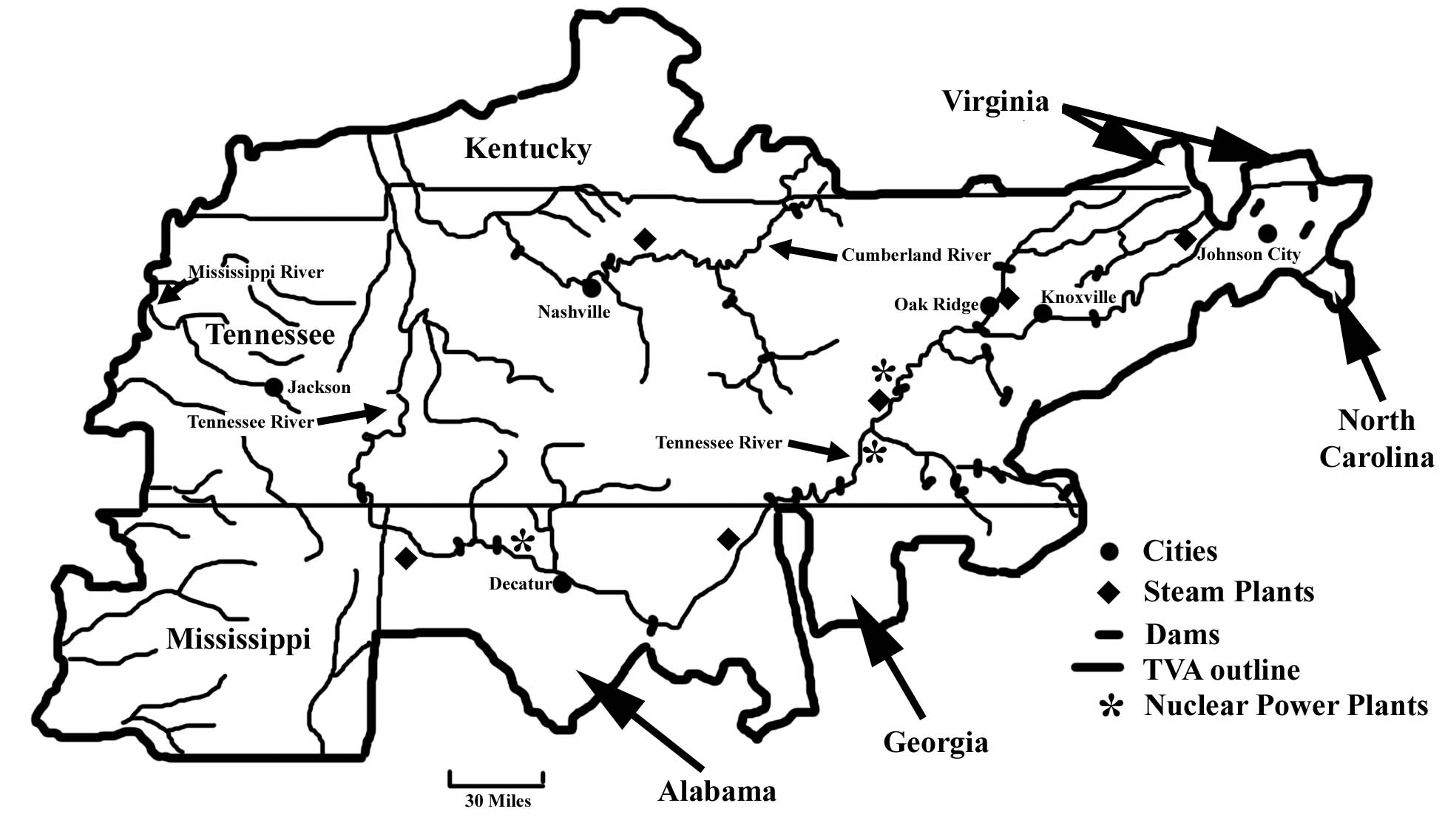

One of the largest public works efforts organized during the Depression years was the Tennessee Valley Authority (TVA) project, authorized on May 18, 1933. President Franklin D. Roosevelt envisioned TVA as a different type of agency, a corporation with access to the vast resources of the Federal government but with the flexibility and initiative of a private business. The project focused on building a series of dams and power plants along the Tennessee River and its tributaries to provide electricity, flood control, barge navigation, and recreation for citizens in seven states: Alabama, Georgia, Kentucky, Mississippi, North Carolina, Tennessee, and Virginia. The TVA system now controls navigation along the Tennessee River for 652 miles and is recognized as America’s largest public power company. Several dams and power plants were built along the Cumberland River in Tennessee and Kentucky as well. The total system includes 20 dams for flood control and 29 for hydroelectric power generation as well as 11 fossil plants, 4 combustion-turbine plants, three nuclear plants, and a pumped-storage facility. The resulting abundance of electricity produced dramatic changes in the lives of most communities in the TVA area and brought much needed industry and jobs to the region even before the economic resurgence associated with World War II. Flood prevention and erosion control measures instituted by TVA also improved crop yields, wildlife and fish habitat, and aided reforestation and other conservation efforts.

For many years after World War II, most of the southeastern states remained racially segregated, even though the armed forces and other federal agencies had already been opened to African Americans and other minorities. In most places, the legally mandated “separate but equal” doctrine did not live up to its name, and Black communities routinely received inferior services and opportunities. This inequality was particularly widespread in school systems throughout the South. Finally, on May 17, 1954, a court case known as Brown vs. Board of Education ended segregation in public schools. The United States Supreme Court ruled that legal segregation was in violation of the 14th Amendment, which gives all United States citizens “equal protection of the laws.” Shortly thereafter, on December 1, 1955 Rosa Parks in Montgomery, Alabama changed history when she refused to give up her bus seat to a white man, as required by state law. As an African American, she felt it unjust to have to give up her seat simply because of the color of her skin. Her arrest, trial and the ensuing organization of a 381-day boycott of the Montgomery city bus system brought on the November 1956 Supreme Court decision that ended segregation on trains, buses, or any other form of public transportation.

The Civil Rights movement continued to gain momentum and support from some influential Whites in the South as well as so-called “freedom riders” from the North. In 1963, as political pressures on both sides mounted, Dr. Martin Luther King, Jr. organized a huge march on Washington D.C. during which he delivered probably his most famous speech. The “I have a dream” speech envisioned a day when segregation would end and equal rights would be applied to all people. Two years later, King led a protest march in Alabama, from Selma to Montgomery, which was broken up violently by the local police. The resulting national outrage set the stage for President Lyndon B. Johnson to bring a controversial Voting Rights bill to Congress. This Voting Rights Act, passed in 1965, represented landmark legislation because it prohibited states from imposing poll taxes or other regulations that made it difficult for Blacks to register and vote. Dr. King was involved in many other non-violent demonstrations and protests while trying to insure that the new civil rights laws were enforced. He was assassinated in Memphis, Tennessee on April 4, 1968 while supporting a labor strike by Black sanitation workers. Racial unrest during the 1950s and 1960s, along with protests against United States involvement in the war in Vietnam, resulted in riots in some cities and generally hostile social conditions for much of the United States.

The final decades of the twentieth century brought another time of rapid change to the southeastern states. Along with continued progress on the racial front, new industries and businesses moved into the area from other parts of the nation as well as from foreign countries. The shift away from textiles and agriculture fueled the rapid growth of major urban areas, such as Atlanta and Charlotte. Improved roads and new transportation options opened up formerly remote areas to a variety of uses, including retirement communities that have attracted thousands of northerners to their more favorable climate. Tourism continues to be the economic heart of Florida and most of the big cities of the South now possess all of the cultural features and other amenities necessary to compete for business with similar large cites around the United States or the world.

Many rural localities, though, especially in the more remote Appalachian Mountain areas, have lagged behind the rest of the region in terms of economic development and health and public welfare issues. A special agency, named the Appalachian Regional Commission (ARC), was established by an Act of Congress in 1965. This federal/state partnership funds projects to improve the quality of life in both Appalachia and adjacent rural areas and encourage self-sustaining economic development.

Influence of Topography on Commerce, Culture, and Tourism

For as long as people have been creating political divisions among themselves, for governmental or other purposes, a major point of controversy has always been where to place the boundary lines for the town, county, state, or nation. For centuries, countries have argued and even gone to war over disputed territory and borders. Within the United States of America, states have occasionally taken each other to court over questions of political jurisdiction. A portion of the Georgia - Florida border was not identified precisely until 1872. A more recent dispute between South Carolina and Georgia over an island in the Savannah River not far from the city of Savannah, Georgia, was not finally settled until the 1980s, with South Carolina winning most of its claim. Boundaries along meandering rivers, such as the Mississippi River boundary between Louisiana and Mississippi, constantly encounter problems as the main channel shifts position.

Whether state and county boundaries are drawn to follow natural features like rivers or mountain ranges, or whether they are politically drawn and cut through the various landform regions, the intent is usually to gather people with something in common into the same political jurisdiction. Hundreds of years ago, this was especially true, as communities tended to expand their influence along drainage networks and didn’t have a lot of interaction with folks living in different watershed regions. Large rivers and mountain ranges were also effective barriers that separated different cultural regions. When political boundaries cut across such features, they may introduce conflict or competition between regions of a state. In both North and South Carolina, for example, old power struggles continue to surface between up-country and low-country interests. Northern and southern Florida also show cultural differences that result in very different political agendas and concerns. Occasionally a metropolitan area, like Charlotte, North Carolina, will grow so much that the city effectively expands into a neighboring state.
Because of the curvature of the earth and the large geographic area occupied by the southeastern states, the sun appears to rise over an hour later in Louisiana than it does in North Carolina. It is therefore impractical for these two states to operate on the same standard time. Before uniform time zones were established in 1883, each city and town kept its own local standard time, based on the sun’s position at noon. Once railroad travel became widespread, the need for a common time frame between distant locations became much more important. Time Zone boundaries follow state lines or geographic barriers whenever possible in order to minimize situations where closely tied neighboring communities end up on different sides of the line, with different work and school schedules. The states of North Carolina, South Carolina, and Georgia lie totally within the Eastern Time Zone. Louisiana, Mississippi, and Alabama are completely within the Central Time Zone. Tennessee and Florida each have part of the state in each of these time zones, but the boundary intentionally passes through sparsely populated regions.

Figure 3-7: Time Zones in the Southeast
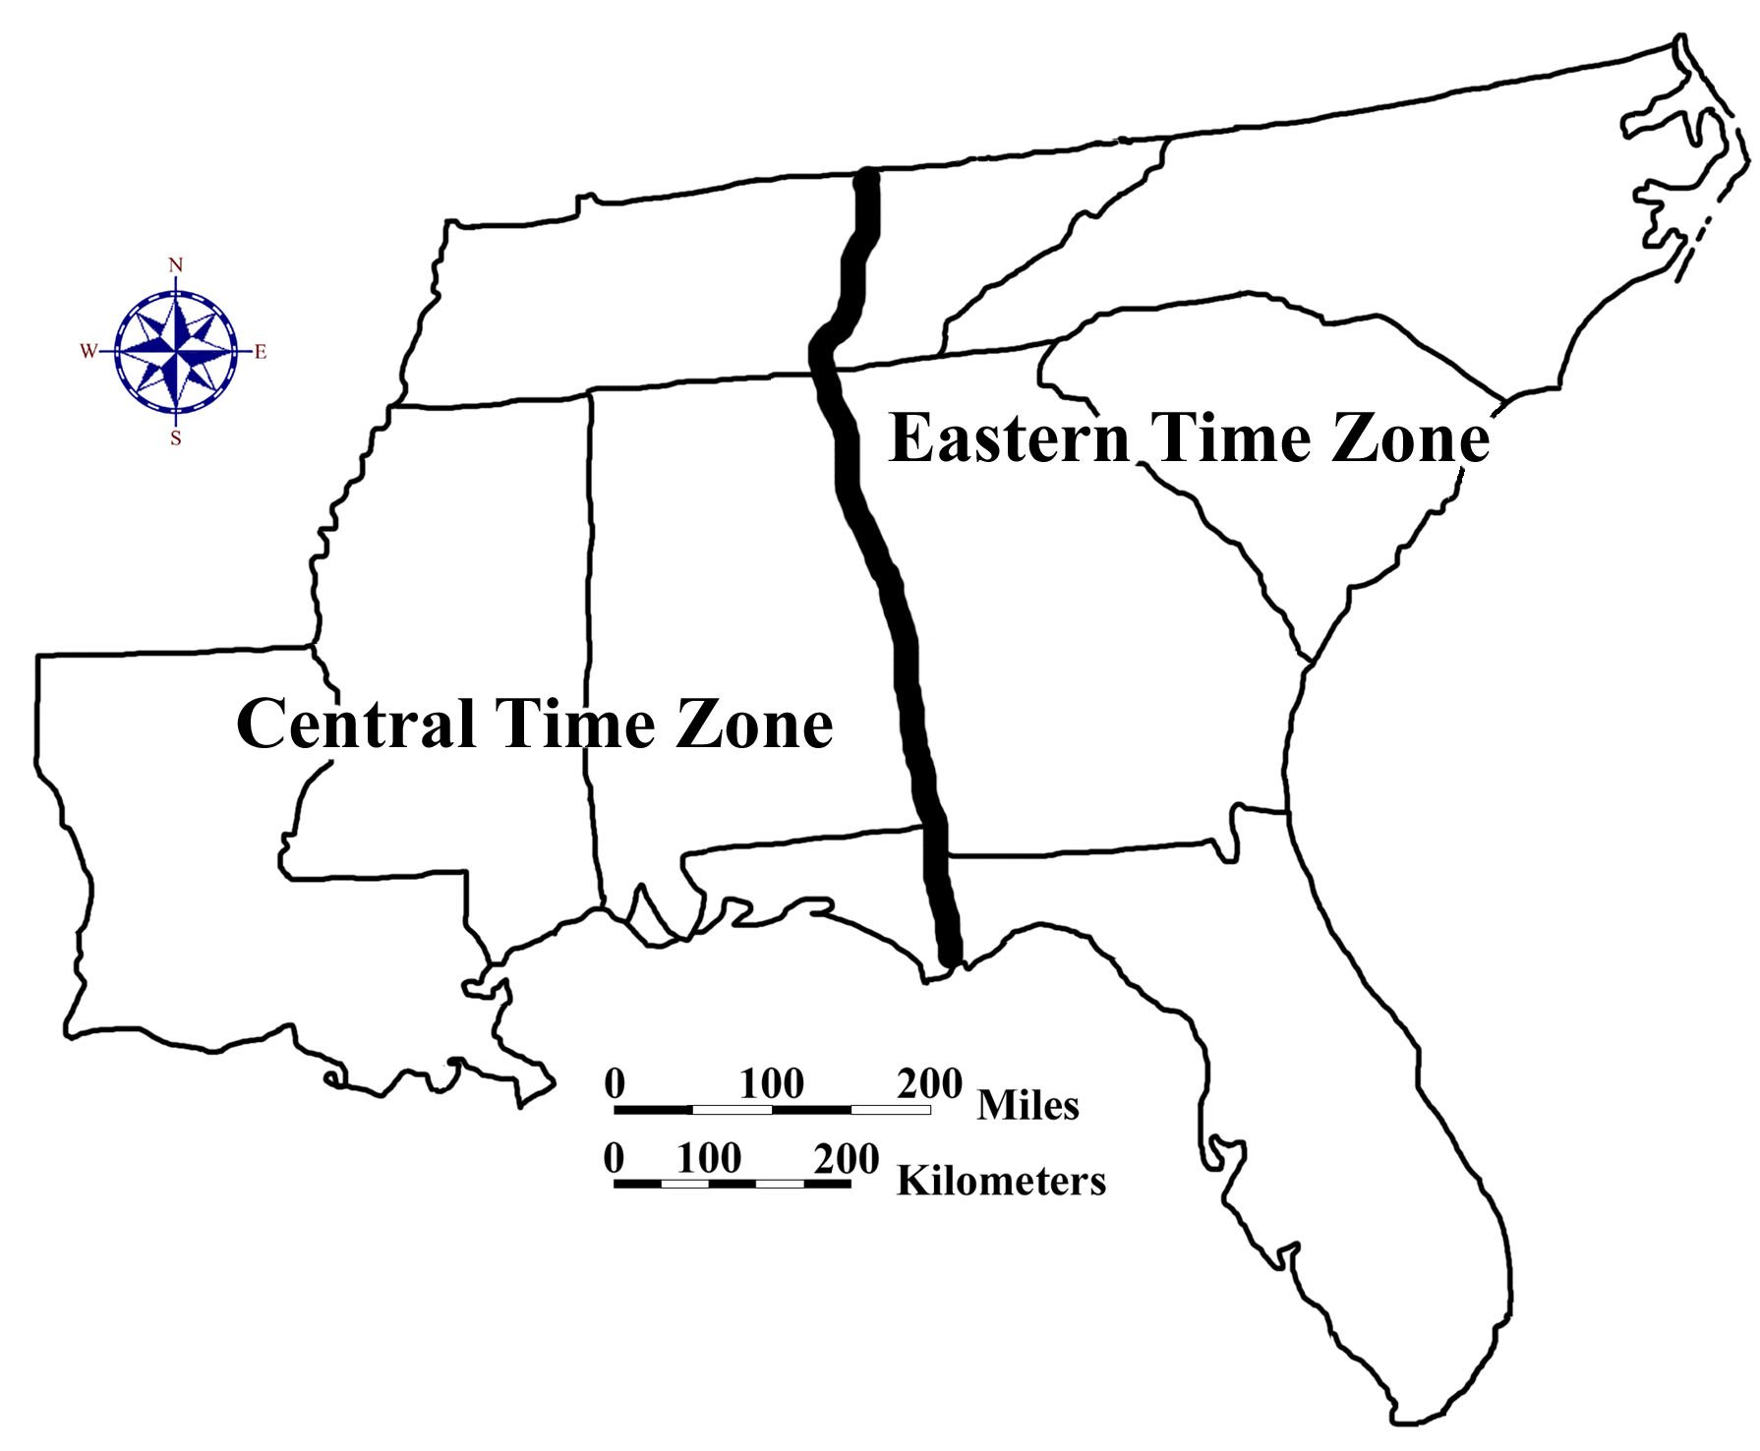

Commerce and transportation have always been heavily affected by topography and landscape features. Native Americans, as well as early European settlers, relied heavily on rivers for travel and trade. Most of the early colonial cities were located along the coast and were centers of trade with Europe, Africa, and the Caribbean Islands. Inland, most trading occurred within the confines of that drainage basin, and manufactured items were usually sold locally. Early roads were nothing more than wide paths through forests or fields and were designed primarily for local travel by horse and wagon. Even in major cities, most streets were nothing more than unpaved narrow paths. Nevertheless, many of these roads played major roles in opening up parts of the wilderness to settlement and in moving large amounts of trade goods to build a thriving economy for both the port cities and the backcountry. Many of these routes are still in use today, having been upgraded to modern state, federal, or interstate highway standards.

During colonial times, river transportation had widespread use within the Coastal Plain, but barriers such as rapids and shallow rocky areas called shoals limited boat travel farther inland. The upstream limit of navigation, usually defined by the first rapids encountered, is called the Fall Line Zone. Many important cities in the southeast started here as loading and unloading centers for the shipping industry. At first, there was a concerted effort to build canals around rapids to expand the navigability of rivers. But most rivers proved to be unpredictable in their behavior; water levels sometimes changed dramatically from one season to the next. In South Carolina, the Santee Canal was connected to large reservoirs that could be used to increase water flow in the canal during times of drought. Nevertheless, the coming of railroads to the southeast in the early 1800s quickly captured most of the cargo transport business and put most of the canal companies into bankruptcy.

As railroad lines spread across the southeast, many towns sprang up at junction points and as way stations along main lines. Most major rail lines were concentrated in the Piedmont, usually along drainage divides, avoiding various topographic obstacles common in both the Appalachian Mountains and the coastal swamps. Cities such as Atlanta, Birmingham, New Orleans, and Charlotte all owe much of their rapid growth in the late 1800s to new trade and business opportunities brought about by the railroad industry. Trade and business opportunities within major southeastern port cities like Charleston, Savannah, Jacksonville, Miami, Tampa, Mobile, New Orleans, and Lake Charles have declined somewhat, but these cities still generate significant amounts of coastal and overseas trade for the southeastern economy. Even though most personal long-distance travel is now taken by airplane or private automobile, freight railroads still haul the majority of bulk goods, fuel, and construction materials.

Most southeastern states advertise tourist attractions that promote scenic landmarks, historical sites, theme parks, and recreational areas. Mountainous areas usually offer wilderness opportunities and scenic panoramas. Piedmont reservoirs usually emphasize boating and fishing. Coastal resorts offer spectacular sandy beaches. Theme parks such as Disney World in Orlando, Florida attract visitors from all over the world. In order to provide a significant economic boost to the state, tourist areas must include a nearby infrastructure offering food, lodging, and other amenities desired by travelers. Attractions clustered along natural transportation routes are easier for tourists to access and for states to promote.
Natural Resources, Land Use, and Environmental Concerns

Climate and Water Resources

Climate is a major influence on land use in the southeastern states. Factors such as precipitation, temperature, cloud cover, and wind can vary significantly with latitude, elevation, exposure, and proximity to the ocean. Spatial distribution of land and bodies of water, and the orientation of mountain ranges and coastlines can also have a noticeable effect. Much of the southeast enjoys a humid subtropical climate, with abundant rainfall and a long growing season. Precipitation is fairly well distributed throughout the seasons, but hurricanes often bring torrential downpours in late Summer and early Fall, and droughts occasionally create problems over a period of years. The region is well supplied with abundant surface water resources through large numbers of streams, rivers, and reservoirs. Groundwater reserves seem more than adequate for most normal land uses, except in some rapidly growing areas of the Piedmont. The only potential shortage of fresh water is likely to be in Piedmont cities and along some coastal areas where rates of pumping of wells exceed the recharge capacity of the rocks. The resulting salt water incursion into coastal wells may pose a serious water supply problem in the near future.

Figure 3-8: Average Annual Precipitation in the Southeast
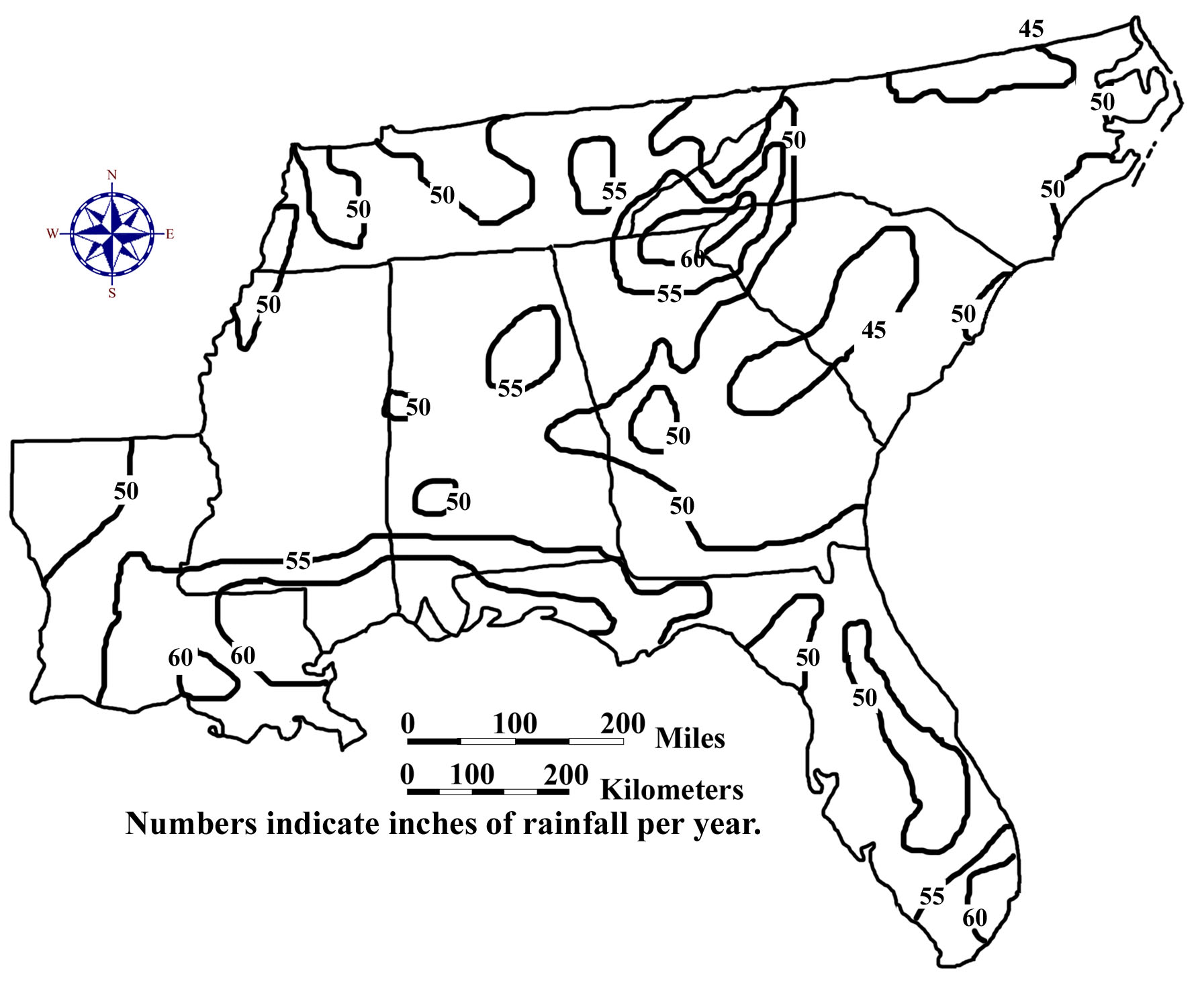
The Appalachian Mountains receive greater rainfall amounts because of their high elevations that cause warm, moist air masses to rise, cool, and then release their stored water as precipitation. Florida and other Gulf Coast states see frequent thunderstorm activity during the summer because moist air masses again rise as they move from the cooler ocean to hotter land areas. Surface temperatures determine the amount of moisture the air can hold as well as the amount of evaporation and transpiration that takes place from the ground and the trees. Hotter areas generally require more rainfall to grow the same amount of crops as in cooler climates. Temperature also determines the number of frost-free days in a year, which influences the types of crops grown in the area. Other than portions of the Florida Peninsula, all southeastern states expect to experience some sub-freezing temperatures during the winter months. Mild, sunny winters are particularly important to the tourism industry in Florida and also allow this state to produce citrus crops and other subtropical fruits and vegetables all year round.

Figure 3-9: Average Annual Temperature in the Southeast

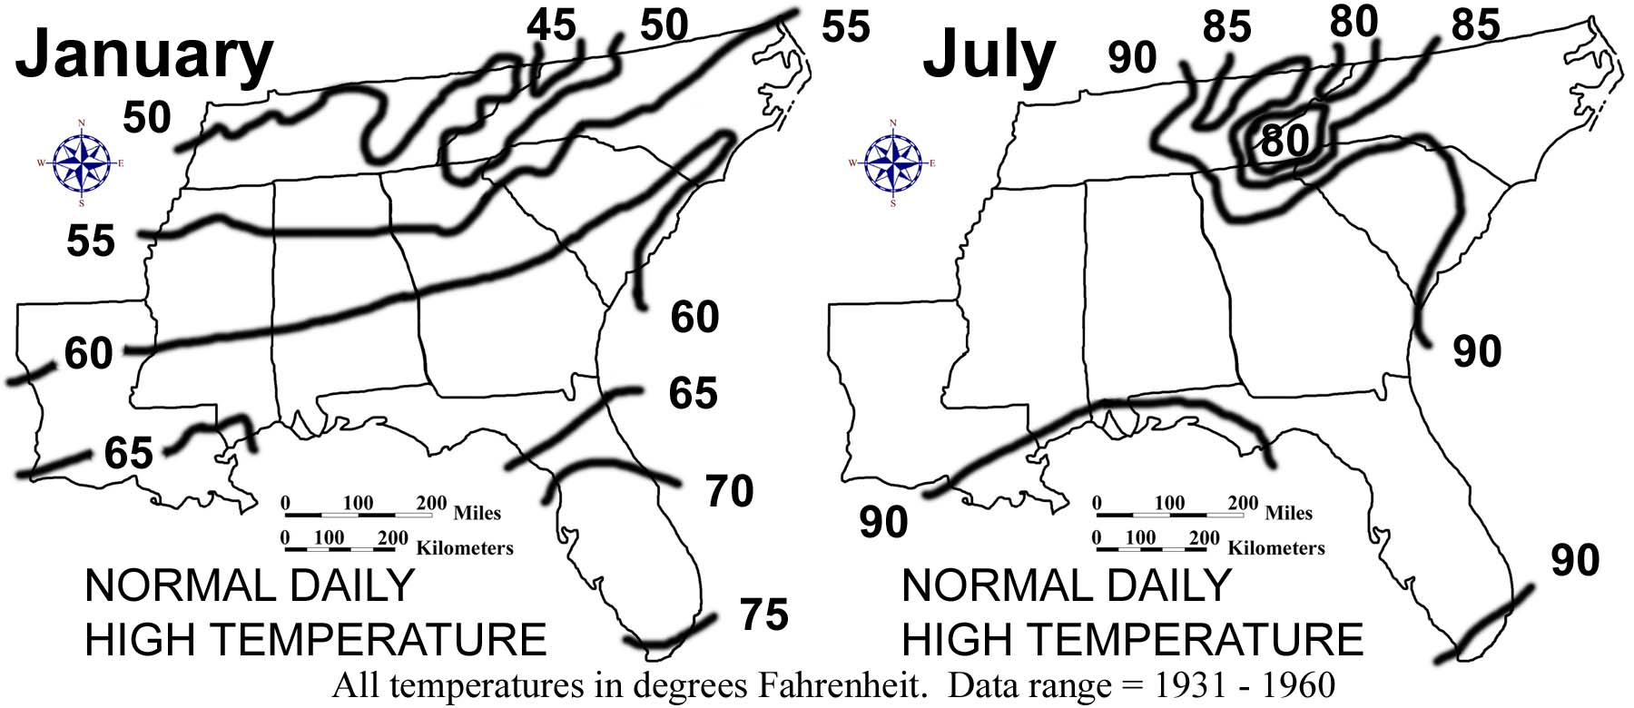

Water pollution is one of the most pressing ongoing natural resource issues in the southeast. The region’s high growth rate, coupled with increasing pressures on rural lands for food and fiber, have elevated these issues to the forefront of priorities set forth by natural resource managers. Water pollution can be categorized as either "point source" or "non-point source," depending on its origin. If a river is being contaminated through a discharge pipe or drainage way by waste discharged from a sewage treatment plant, factory or oil refinery, the problem is called point source pollution (because the source of the pollution can be traced back to a single point). On the other hand, contaminants such as exhaust from automobile engines or water pollution from the over-use of lawn chemicals, problems which have no single source, are referred to as non-point source pollution. Point source pollution is generally easier to remedy. If only one easily identifiable culprit is responsible for contaminating a waterway, steps can usually be taken quickly to reduce or eliminate the problem.

Non-point source pollution is somewhat more difficult to deal with because there are usually many sources, each responsible for relatively small amounts of contamination. For example, the lawn care industry has for many years recommended very high rates of nitrogen fertilizer to homeowners. Much of that fertilizer is not taken up by the grass, but instead leaches through the soil into the groundwater and into streams and rivers. If only a few people did this, the pollution would be dilute enough so that it would not be much of a problem. Since many people do this it is a problem.

By observing land use patterns, we can predict the type of non-point source contaminants that might be found in a waterway. When a significant portion of land is used to grow row crops (corn, soybeans, tobacco, etc.), eroded soil, sediments, and agricultural chemicals may become a possible problem. Forest clearcuts also lay soil bare to erosion and create sedimentation problems. In more populated areas, runoff from roads and parking lots can introduce chemicals used by and for automobiles. Residential areas with significant amounts of land dedicated to lawns and gardens, and especially the presence of golf courses, can indicate the possible existence of excess fertilizers, herbicides and insecticides in local waterways.

Certain landscape conditions can help reduce the problem of non-point source pollution. The presence of undisturbed vegetated land immediately adjacent to waterways creates a buffer zone that can remove these contaminants from both surface runoff and groundwater. Eroded sediment is also trapped through physical filtration. In addition, when vegetation slows the flow of surface runoff water, the water loses its capacity to hold and carry sediment. The live plants in these buffer zones can also take up excess fertilizers, pesticides and other chemicals through their roots. (Trees have been found to do this even better than grass.) Wetland ecosystems have a unique ability to remove certain non-point source pollutants, especially hydrocarbons, due to the active chemical nature of the organic matter that is usually present.

Soils and Agriculture

When a soil scientist looks at a soil, he or she is not just considering the near surface, but a series of layers called horizons that can extend six feet or more below the surface. The presence or absence of these horizons and their physical and chemical characteristics are used to classify soils in terms of land use capability for both agricultural and urban uses. Different environmental conditions can produce very different soils, even from the same original material. The factors most responsible for these differences are listed below:

1. Parent Material - original material that was there before soil formation began (can be mud deposited by a river, sand deposited by the ocean, rock that weathers and breaks down, etc.).
2. Organisms (mostly vegetation, microorganisms).
3. Climate (both large and small scale).
4. Topography (including slope, landform shape, and landscape position).
5. Time.

The list above is referred to by soil scientists as The Five Factors of Soil Formation and was first postulated in 1941 by soil scientist extraordinaire Hans Jenny. Over 15,000 different soil types have been identified throughout the United States and over 1,000 of these exist in the southeast. Altering one or more of these factors will result in a different soil profile with different properties which can make the soils behave quite differently. These factors are not always independent of each other. Landscape position can affect soil organisms and local climate. Both climate and parent material can affect organisms, etc. Jenny’s model of soil formation is still a good way of understanding the variation of soils found across a landscape.

Almost all of the southeastern landscape was forested when European colonists first arrived. A few notable exceptions were the tall grass prairies of southern Florida, the dry soils of the sandy uplands of Mississippi, Alabama, and Georgia, and the Louisiana coast west of the Mississippi Delta. Native Americans had also cleared some areas for agriculture, through the use of fire. Various pine tree species blanketed the Coastal Plain, except for some poorly drained wetland areas where cypress and other hardwoods dominated. Hardwood forests of oak, hickory, and chestnut characterized the Piedmont and the Appalachian Mountains. Early settlers saw this unending forest as an enemy to expansion, and after years of attack with ax, fire, and plow, the original forests virtually disappeared. Forested areas today consist mostly of second or third growth hardwoods or pine trees planted for pulpwood. In addition to providing lumber, southern pine forests were also an abundant source of naval stores, such as pitch and tar, which were used for caulking seams and preserving rope, and resin, from which turpentine could be distilled.

The first major agricultural efforts in the English colonies of the southeast focused on rice, indigo, sugar cane, tobacco, and long-fiber Sea Island cotton. All of these crops required slave labor and the farming expertise of African Americans to make them successful. The coastal areas of South Carolina and Georgia were centers of the rice culture until after the Civil War, when Louisiana and Texas took over as the nation’s prime rice-growing area. Indigo likewise was grown in Louisiana, South Carolina, and Georgia until after the Revolutionary War, when England was no longer willing to pay a bounty for its production. The leaves and stems of the indigo plant were processed to produce a dark blue dye prized by British cloth makers. Sugar cane came to Louisiana in 1751, and the first successful sugar mill was built shortly thereafter on a plantation near New Orleans. After 1900, sugar cane production began around Lake Okeechobee in Florida, but despite its success, Louisiana still accounts for over three-quarters of the sugar cane produced in the United States. Colonies in North Carolina experimented with several different crops for trade purposes, but they were unsuccessful until they began growing tobacco. Tobacco was in great demand in Europe and brought high value per unit of weight. North and South Carolina produce most of the tobacco grown in America.

Cotton is probably the single most important agricultural product that defines the southeastern United States. All eight southeastern states have been involved in growing cotton at some time, although most production today is focused in South Carolina, Georgia, Northeast Alabama, and the Mississippi River bottomlands of the Yazoo Valley. The invention of the cotton gin by Eli Whitney in 1793 led to the spread of cotton from the Coastal Zone to inland areas like the Black Belt of Mississippi and Alabama. The growing, processing, selling, and transporting of cotton by so many people created a “cotton culture” that dominated the lives of most of the inhabitants of the southeast. Even after the Civil War, many freed slaves stayed in the cotton fields as sharecroppers, working the only job they ever knew. In the late 1900s, soybeans replaced cotton as the primary crop in many agricultural areas.

Figure 3-10: Agriculture in the Southeast

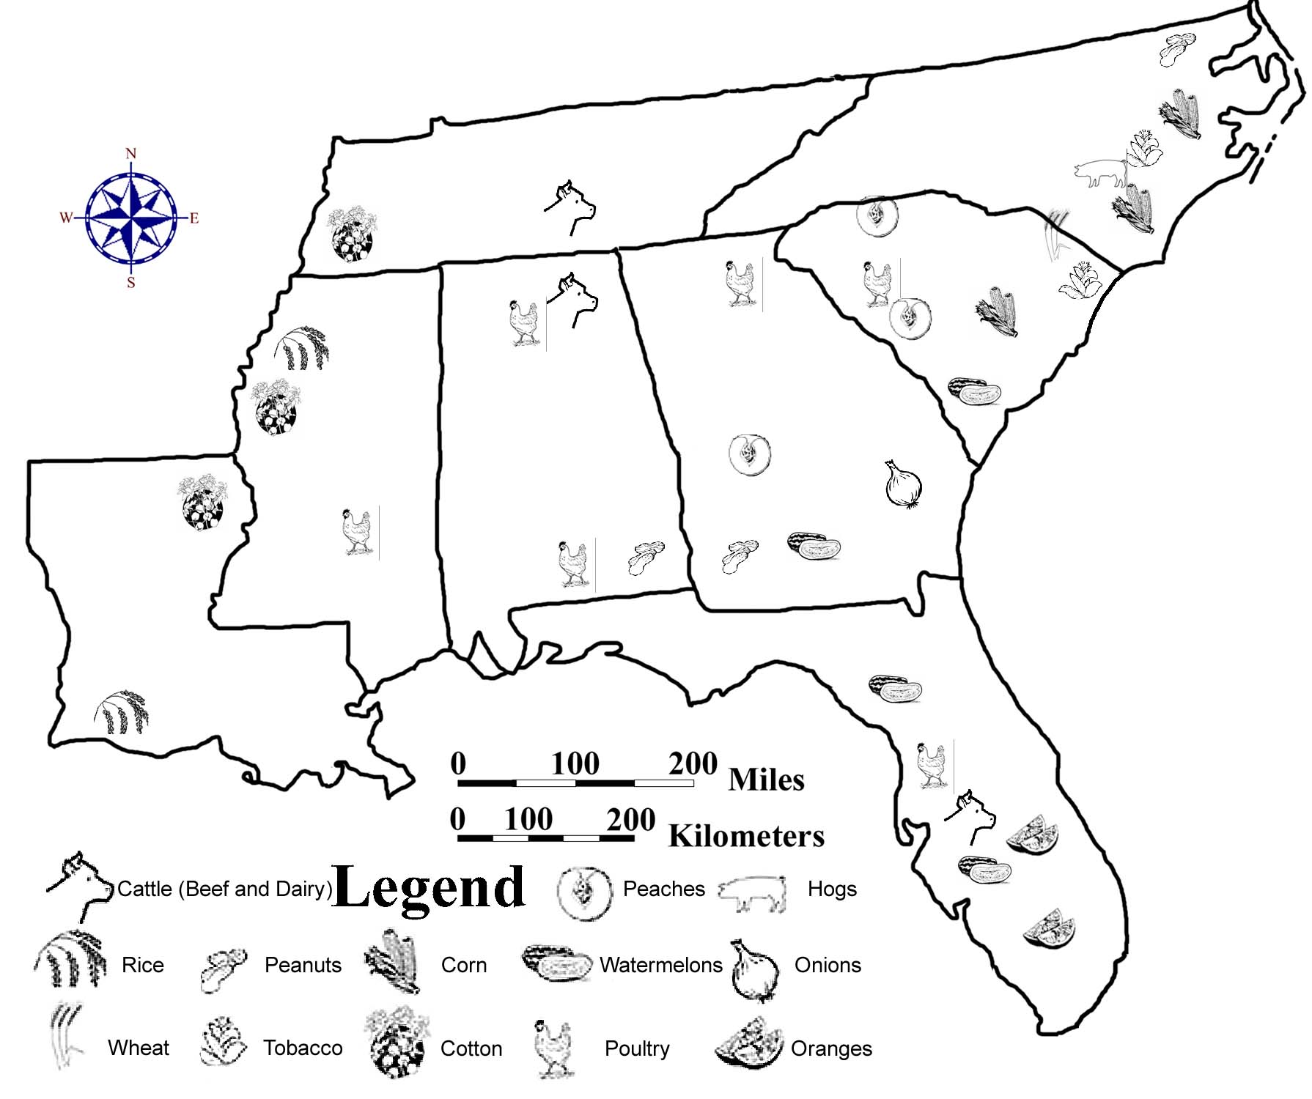

Although cotton is no longer ‘King’ in the southeast, its legacy remains in the exhausted fields and severely eroded gullies found in many parts of the region, especially the Piedmont. If not properly cultivated, cotton will quickly deplete soil fertility and can easily promote erosion on rolling and hilly areas. When the land became too gullied and exhausted to support another cotton crop, early farmers simply picked up their belongings and moved westward to clear more land and start over. The introduction of a foreign pest, the boll weevil, created additional problems by limiting crop yield. By the early 1900s, much of the old cotton lands in the southeast consisted only of abandoned farmland or subsistence farms that could barely support the families living on that land.

Reforestation and soil conservation programs, started by the New Deal in the 1930s, permanently changed the appearance of forests and farmlands in the southeast. The Federal Soil Conservation Service was established in 1935. This government agency provided technical assistance to farmers in terracing, strip cropping, crop rotation, pond construction, and the planting of legumes such as soybeans and kudzu. An important discovery made by Dr. Charles Herty, a Georgia chemist, in 1930, also had a major impact upon the forestry industry. Dr. Herty invented a method for making paper from loblolly pine. The promise of profits from pine trees has encouraged farmers to plant their worn-out cotton lands in pine seedlings and has spawned a new industry that has revitalized the economy in many sections of the southeast.

Mining and Resource Extraction

Iron ore was about the only mineral other than salt, and of course gold, that had value to early colonists, although neither of those other resources were overly abundant in the southeast. Iron ores of reasonable quality could be found locally in most landform regions and iron smelting was probably the first industrial activity to occur in this region. Early furnaces were usually located along streams next to a hillside. Water wheels worked a bellows mechanism to blow air into the furnace and heat the charcoal and iron ore mixture to a temperature that would melt the iron. The charcoal was produced locally by covering huge piles of sticks with soil or sod, leaving a chimney opening in the center, and then setting fire to the wood. In three to ten days, the wood was charred enough to become charcoal. The presence of piles of rock called slag, a by-product of the smelting process, often marks the former locations of these old iron furnaces.

Bessemer City, near Kings Mountain, North Carolina, was one of the early centers of iron manufacturing. Later, the Birmingham, Alabama area became the major steel- producing center of the southeast. Other metal ores of importance include the copper and zinc mines of eastern Tennessee, and the gold mines of northern Georgia and the Carolinas. A small amount of bauxite for aluminum production is mined in Alabama and Georgia. Decorative building stones such as limestone, marble, and granite are mined in the Piedmont. Kaolin and phosphate minerals are major Coastal Plain resources found in the Carolinas, Georgia, and Florida. But one of the most important resources in the region, in terms of total economic value, is ordinary sand and gravel, primarily for use in the construction industry.

The bituminous coal deposits in the Appalachian Plateaus region are the largest in the world. In the southeast, these deposits cover significant portions of Tennessee and Alabama, but only in the Birmingham, Alabama area has coal mining grown to be a major economic force. Lignite, a form of low-grade coal, is mined locally in Louisiana, Mississippi, and North Carolina. Strip mines are the most common method used for extracting the coal because many of the layers are close to the surface of the ground. Limited underground mining is sometimes carried out on hillsides where horizontal coal seams intersect the sloping land surface. Several environmental problems are associated with coal mining, most notably acid mine drainage. Water coming in contact with either fresh coal or spoils piles of waste rock from mining operations oxidizes exposed sulfide minerals and generates sulfuric acid as a by-product. If this highly acidic water gets into local streams, it can kill fish and other aquatic life for miles downstream.

Petroleum products were originally used as lubricants and for preservation of leather items, such as belts and harnesses. Merchants placed blankets over oil seeps or springs to soak up the liquid, which they then bottled for sale. The Industrial Revolution changed the entire perception of the worth of petroleum and started an economic boom in several Gulf Coast states. Although a few oil wells were drilled in Texas around 1900, the real beginning of commercial oil production in the southeast was the discovery of the East Texas oil field in 1930. Since then, huge reserves have been found underneath Louisiana and Mississippi as well as offshore beneath the Gulf of Mexico. Originally, much of the natural gas that was discovered while drilling for oil was burned off and wasted. Today, natural gas is used in many parts of the country as an alternative clean fuel and is in great demand. Sulfur and rock salt are also found in great quantities in Louisiana and Texas in association with oil field operations. Tennessee and Alabama also produce small amounts of oil and natural gas. Oil spills and pipeline leaks, particularly offshore, are the most significant environmental hazards associated with drilling for oil.

Figure 3-11: Mineral and Energy Resources in the Southeast

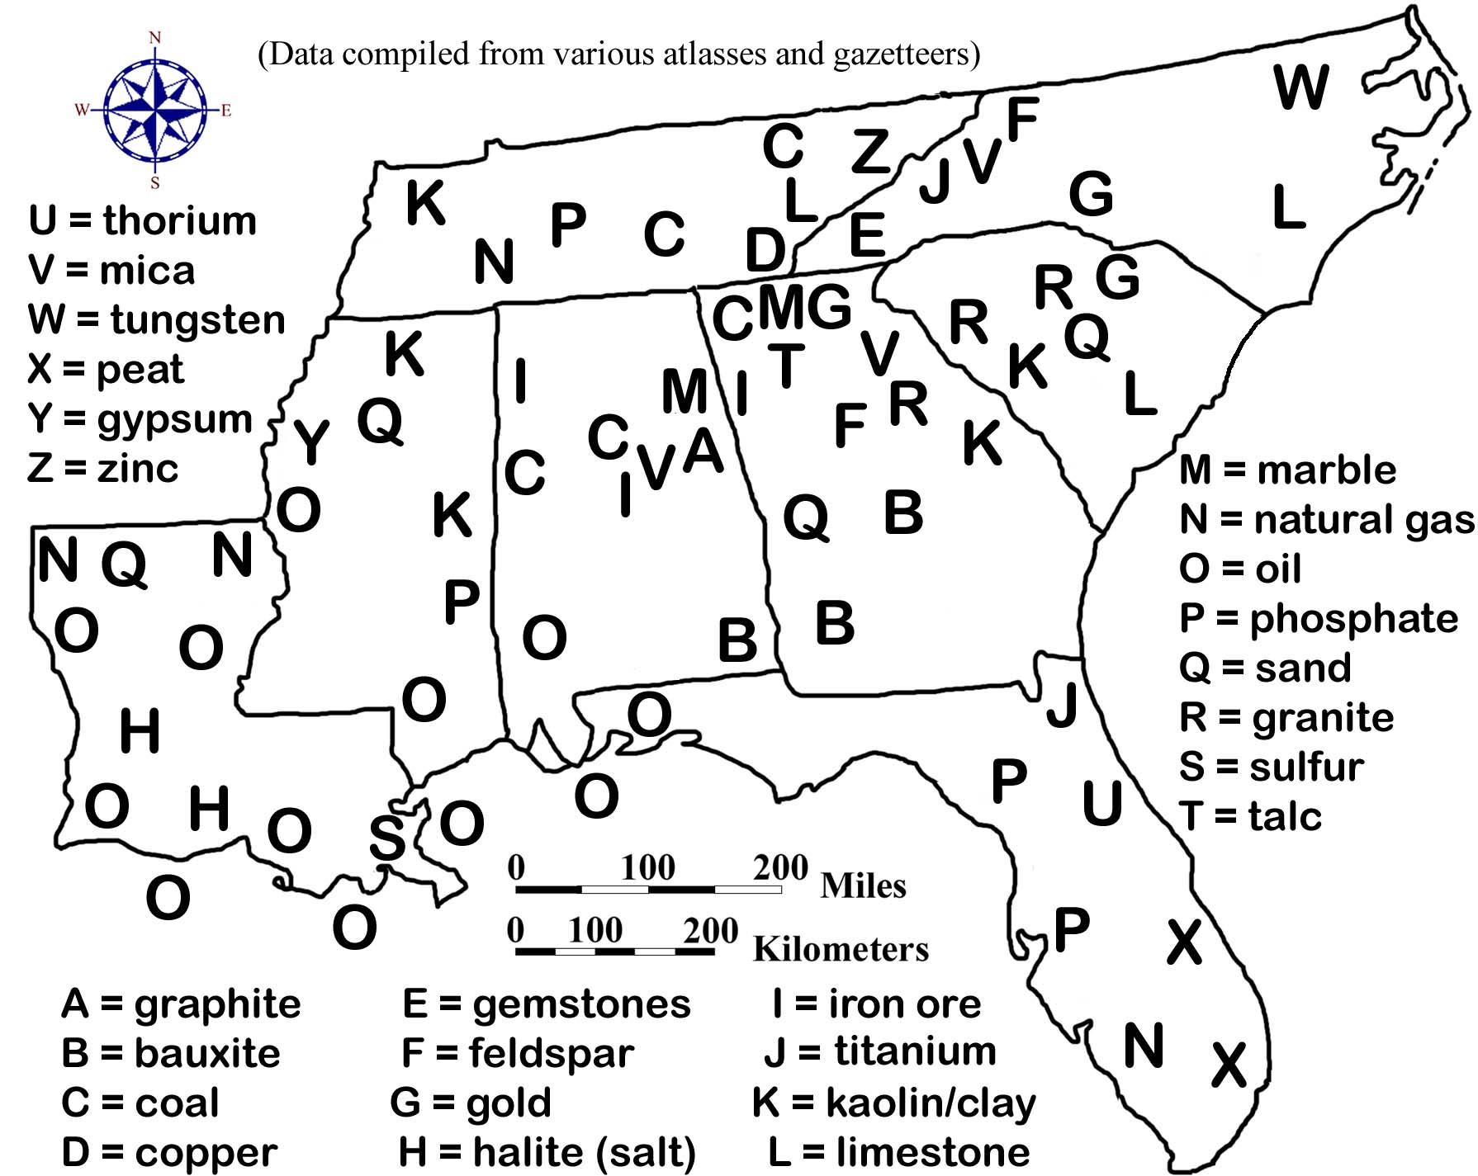

PLACES TO VISIT IN THE SOUTHEAST 

Biscayne National Park. 9700 SW 328 Street, Homestead, FL 33033-5634. For information call 305-230-1144 or search online at http://www.nps.gov/bisc/.

Blue Ridge Parkway 199 Hemphill Knob Road, Asheville, NC 28801-3417. For information call 828-348-3400 or search online at http://www.nps.gov/blri/.

Canaveral National Seashore. 212 S. Washington Ave, Titusville, FL 32796-3521. For information call 321-267-1110 or search online at http://www.nps.gov/cana/.

Cape Hatteras National Seashore . 1401 National Park Drive, Maneto, NC 27954. For information call 252-473-2111 or search online at http://www.nps.gov/caha/.

Cape Lookout National Seashore. 131 Charles Street, Harkers Island, NC 28531. For information call 252-728-2250 or search online at http://www.nps.gov/calo/.

Congaree National Park. 100 National Park Road, Hopkins, SC 29061-9118. For information call 803-776-4396 or search online at http://www.nps.gov/cong.

Cumberland Island National Seashore. 101 Wheeler Street, Saint Marys, GA 31558. For information call 912-882-4336 or search online at http://www.nps.gov/cuis/.

Dry Tortugas National Park. 40001 State Road 9336, Homestead, FL 33034. For information call 305-242-7700 or search online at http://www.nps.gov/drto/.

Everglades National Park. 40001 State Road 9336, Homestead, FL 33034-6733. For information call 305-242-7700 or search online at http://www.nps.gov/ever/.

Great Smoky Mountain National Park. 107 Park Headquarters Road, Gatlinburg, TN 37738. For information call 865-436-1200 or search online at http://www.nps.gov/grsm/.

Gulf Islands National Seashore. 1801 Gulf Breeze Parkway, Gulf Breeze, FL 32563-5000. For information call 850-934-2600 or search online at http://www.nps.gov/guis/.

Gulf Islands National Seashore. 3500 Park Road, Ocean Springs, MS 39564-9109. For information call 228-230-4100 or search online at http://www.nps.gov/guis/.

Natchez Trace Parkway. 2680 Natchez Trace Parkway, Tupelo, MS 38804. For information call 800-305-7417 or search online at http://www.nps.gov/natr/.

(Three visitor centers - see https://www.nps.gov/natr/planyourvisit/basicinfo.htm.)

TVA System. 400 W. Summit Hill Drive, Knoxville, TN 37902-1499. For information call 865-632-2101 or search online at http://www.tva.gov.
REFERENCES AND RESOURCES

SELECTED PRINT RESOURCES

Bennett, Hugh H. (1921). The Soils and Agriculture of the Southern States. New York,
NY: the Macmillan Co.

Curran, H.A, Young II, Drew M., Justus, Philip S., Graver Jr, John B. (1984). Atlas of
Landforms (Third Edition). West Point, NY: John Wiley and Sons, Inc.

Churnet, Habte Giorgis. (1997). Seeing Southeastern Geology Through Chattanooga.
Red Bank, TN: HGC Publishers.

Fenneman, Nevin M.,. (1928). Physiographic Divisions of the United States, 3rd edition.
Annals of the Association of American Geographers, volume 18, p. 261-353..

Hillard, Sam B. (1984). Atlas of Antebellum Southern Agriculture. Baton Rouge, LA:
Louisiana State University Press.

Jenny, Hans. (1941). Shared.
Chicago, IL: University of Illinois Press.

Joyner, Charles. (1999). Shared Traditions: Southern History and Folk Culture.
Chicago, IL: University of Illinois Press.

Keener-Chavis, Paula and Sautter, Leslie Reynolds. (2000). Of Sand and Sea: Teachings
From the Southeastern Shoreline. Charleston, SC: S.C. Sea Grant Consortium.

Krug, J.A. (1948). Mineral Resources of the United States. Washington, D.C: Public
Affairs Press.

Lobeck, A.K. (1932). Atlas of American Geology. Columbia University, New York:
The Geographical Press.

Mancini, Richard E. (1992). Indians of the Southeast. Facts on File.

Morris, Willie. (1965). The South Today: 100 Years After Appomattox. New York,
NY: Harper and Row Publishers.

Salley, A.S. (1932). President Washington’s Tour through South Carolina in 1791.
Bulletins of the Historical Commission of South Carolina, #12. Columbia, SC.

Symonds, Craig L. (1985). A Battlefield Atlas of the Civil War. Baltimore, MD: The
Nautical and Aviation Publishing Company of America.

Thurman, Sybil. (1986). A History of the Tennessee Valley Authority. Daisy, TN:
The Tennessee Valley Authority Information Center.

SELECTED INTERNET RESOURCES (all sites were functional and accessible in 2020)

http://www.priweb.org/ed/TFGuide/SE/se_main.htm
The Teacher Friendly Guide to the Geology of the Southeast contains information about geologic history, rocks, fossils, resources, and environmental issues and virtual field trips.

http://fermi.jhuapl.edu/states/states.html
This site gives the user access to maps of any state in the United States. Users can access Shaded relief maps, Satellite images, state maps with counties, and historical maps.

http://www.arc.gov/
The Appalachian Regional Commission is a federal-state partnership that works with the people of Appalachia to create opportunities for self-sustaining economic development and improved quality of life. The site provides regional data, news, and research reports.

https://www.groundwater.org/get-informed/basics/
This page gives a basic but detailed description on groundwater, including what it is, how much we depend on it, the hydrologic cycle, and how to preserve groundwater resources.

http://capp.water.usgs.gov/gwa/gwa.html
This website is full of information that allows the user to look at a regional summary of aquifers. The user can also access various maps and figures that show the location of the aquifer on a standard map. All states in the SE MAPS region are covered on the site.

http://www.main.nc.us/sams/blueridge.html
This website gives us an easily understood series of events that led to the formation of the Appalachian Mountains. Topics include plate tectonics, uplift and erosion, and rocks.

https://ala-choice.libguides.com/c.php?g=405244&p=2758889
This website gives a summary of resources dealing with the geology of the Southeastern States. Title: “State and Regional Geology: A Guide to Resources (June 2014): Southeastern United States” by Linda R. Zellmer .

https://native-american-indian-facts.com/Southeast-American-Indian-Facts/Southeast-American-Indian-Facts.shtml
This website provides a list of facts about Southeastern Native Americans including a general overview of who they were, where they lived, their culture, and traditions.

https://sercc.com/ClimateoftheSoutheastUnitedStates.pdf
This website summarizes the variability, change, and societal impact of the climate of the southeastern USA.

http://www.infoplease.com/ce6/history/A0848169.html
This provides a history of the TVA project and an overview of what the TVA does.

https://www.nass.usda.gov/Publications/AgCensus/2017/Online_Resources/Ag_Census_Web_Maps/index.php
This website allows maps of various census and agricultural statistics to be viewed.

STUDY AREA 3A: LANDSCAPES AND LANDFORMS

Seneca Journal
June 7, 2002
Canals Near Okeechobee Date 300 A.D.
Ortona, FL. About 1,700 years ago, American Indians dug out millions of yards of soil and sand by hand to create a sophisticated canal system that allowed them to fish and navigate rapids on the Caloosahatchee River.  Measuring seven miles, the two canals represent the longest and oldest prehistoric canals in North America, said Robert Carr, director of the Archaeological Historical Conservancy in Davie.  "This suggests one level of technological achievement that really has never been honored before," Carr said.  Surveyors described the canals in 1842 but believed Europeans built them as military structures. Radio-carbon tests indicate the canals date to the year 300. | In addition to the new details about the canals, Carr announced the discovery of a large pond constructed in the shape of a sacred baton in this rural community near Lake Okeechobee.  American Indians probably created the 450-foot long pond for their gods to see from the heavens prior to the year 700. The pond's purpose could be related to the burial mounds previously discovered in nearby Ortona Indian Mound Park, 95 miles west of West Palm Beach.  The name of the people who built the canals and pond is unknown, though they likely were related to the Calusa Indians. They depended on the river, which runs into the Gulf of Mexico at Fort Myers. | Carr estimates that hundreds of American Indians lived in the village in Ortona and used handmade tools, such as baskets, wood pieces and shells, to dig the canals, a project that could have taken years.  To the untrained eye, the discovery isn't much -- only a small piece of one canal can be recognized on the site, which was converted from the dump to Indian Mound Park after 1988. Hidden among lush tropical habitat, it looks like a ditch about ten feet across.  "It isn't very impressive until it's interpreted," Beriault says. "This site is a little like Marilyn Monroe before she became famous.".

RATIONALE
Landforms include all naturally formed physical features found on the surface of the earth. Some landforms are classified as constructional, being built up or deposited above the general land surface level, while others are classified as destructional, created by erosion into an older land surface. Each type of landform contains clues about the geologic processes and earth surface conditions that produced it. Groups of landforms that commonly occur together define broader categories called landscapes, which characterize the general topography of large expanses of land. Locations and drainage patterns of rivers, lakes, and streams can be explained by referring to localized distributions of landforms within a particular geographic region. The division of any large geographic area, such as the Southeastern United States, into separate landform regions serves as a convenient framework for referencing and correlating all of the natural and human processes that take place within its boundaries.

PERFORMANCE OBJECTIVES

1. Locate landform region boundaries and describe geologic features found within them.
2. Classify landforms and regions as either primarily erosional or depositional in nature.
3. Estimate latitude and longitude values for various locations.
4. Analyze landscape features to locate and identify barriers to transportation.
5. Describe region’s scenic beauty by composing a song or poem that communicates it.
6. Compare and contrast characteristics of drainage basins found in various regions.
7. Find cities in danger of water supply contamination from pollution or chemical spills.
8. Calculate gradients of stream systems.
9. Explain reasons why river name changes occur in many southeastern river systems.
10. Illustrate changes in landscape from the mountains to the sea by writing a short story.

SAMPLE ASSESSMENT RUBRICS
EXAMPLE #1 (relates to Performance Objective #1)
Give students an outline map (showing only the state boundaries) and ask them to draw in and label the approximate boundaries of the seven major landform regions (Appalachian Plateaus, Valley and Ridge, Blue Ridge, Piedmont, Coastal Plain, Coastal Zone, and Florida Peninsula) as presented in the SE MAPS lessons.

A (level 4) – All regions drawn in properly and labeled correctly (see Figure 3-1)
B (level 3) – All regions drawn in and labeled in correct sequence but some boundary lines are somewhat out of position, but not seriously wrong.
C (level 2) – All regions drawn in and labeled. Most (not all) are in correct sequence, and/or some boundary lines are significantly out of position
D (level 1) – Most regions drawn in and labeled but several are mislabeled or in wrong sequence and/or boundary lines are significantly out of position.
F (level 0) – Many regions either not labeled or mislabeled and most boundary lines are significantly out of position or not drawn in at all.

EXAMPLE #2 (relates to Performance Objective #7)

Give students the map diagram below and ask them to identify the cities that are in danger of river water contamination and rank their selection(s) from most affected (first listed) to least affected (last listed).
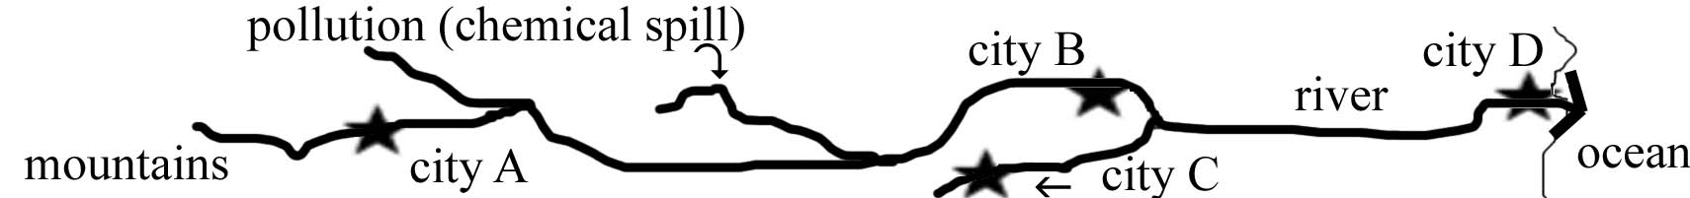

A (level 4) – Cities identified correctly (B,D) and in correct rank (B,D).
B (level 3) – Cities identified correctly (B,D) but ranking is incorrect.
C (level 2) – Correct cities listed along with at least one incorrect city.
D (level 1) – Only one correct city listed.
F (level 0) – No correct cities listed.

Cartographic Product Information

MAP 3A: Landscapes and Landforms

TITLE: Landforms of the Southeastern United States
DATA SOURCE: “Landforms of the United States”, sixth revised edition, Erwin Raisz. Reproduced with permission by GEOPLUS, Danvers, Massachusetts
DATE: 1957
SCALE: approximately 1:2,650,000 [1 inch ~ 42 miles] [1 cm ~ 28 kilometers]
OTHER IMPORTANT DATA:
- This map is a detailed artistic rendering of the region, not an exact precision map.
- Only the major rivers are shown, and not all of these are named.
- Reservoirs are not shown in blue, but are still part of the river drainage network.
- Landscape features are shown diagrammatically in their approximate location.
- Major cities are marked with “#” and named fully, other cities are marked with “#” and only the first letter of the name is printed, or the name is abbreviated.
- The legend does not include every symbol used on the map, and the map does not show every symbol included in the legend.
POINTS OF SPECIAL INTEREST:
- Mount Mitchell (western North Carolina) is shown (although it is hard to find) because it is the highest peak in the Appalachian Mountain Range (6,684 ft.).
- The Caloosahatchee River (referred to in Newspaper Article on page 3A-1) drains Lake Okeechobee in far Southern Florida, northwest of the Everglades.
OTHER FEATURES TO LOOK FOR:
- The Appalachian Mountains contain the headwaters for most of the rivers that drain the Southeastern United States.
- The majority of major river systems in the Southeastern United States have at least one dam and reservoir somewhere within their drainage network.
- Many linear landscape features have orientations parallel to the coastline.

TITLE: Physiographic Divisions
DATA SOURCE: After Nevin M. Fenneman and others, Association of American Geographers – Reproduced with permission from GEOPLUS, Danvers, MA.
DATE: 1957
SCALE: approximately 1:19,650,000 [1 inch ~ 315 miles] [1 cm ~ 198 kilometers]
OTHER IMPORTANT DATA:
- The Interior Low Plateaus region (labeled as region #12) is not included officially in SE MAPS even though it covers a significant portion of Tennessee and northern Alabama. Some features in this region are mentioned in chapters that cover the Appalachian Plateaus, but they are not technically part of that region.
POINTS OF SPECIAL INTEREST:
- Most of the landform regions in the Southeastern United States continue beyond state boundary lines into other regions of the country (e.g. Coastal Plain).
OTHER FEATURES TO LOOK FOR:
- The Continental Shelf (located just offshore) is actually part of the Coastal Plain,
Study Area Description

Landform Regions of the Southeast

Each of the seven major landform regions defined in the Southeast contains a particular set of characteristic geologic landscape features that distinguishes it from all the other landform regions. Sometimes, the occurrence of a specific type of landscape feature may be diagnostic of a single landform region, as in the case of the Carolina Bays in the Coastal Plain or water gaps in the Valley and Ridge. But more often than not, individual landforms can be observed and recognized in more than one region, so it usually requires the analysis of a combination of geologically related features to properly identify or classify a landform region. The sinkholes that occur in the Florida Peninsula, for example, have counterparts in both the Valley and Ridge and the Appalachian Plateaus regions, but the surrounding topography is quite different in each case.

In some places in the Southeast, boundaries between landform regions are well defined and obvious due to abrupt changes in dominant landform features from one side of the boundary to the other. The Blue Ridge escarpment in North Carolina is a noteworthy example of a clearly identifiable boundary between the Blue Ridge and Piedmont regions. Land elevation rises nearly 2,000 feet (609 meters) at the escarpment and ground slopes become much steeper on the Blue Ridge side. In other areas, the drawing of boundary lines is almost totally arbitrary because the change in landform features occurs very subtly or gradually over a long distance. The boundary between the Coastal Plain and the Coastal Zone regions is a prime example, as is part of the boundary in Mississippi between the Coastal Plain and the Appalachian Plateaus regions. Geomorphologists often use dashed lines on maps to represent such indistinct borders and to express their uncertainty over the exact location of the true boundary line. This uncertainty is one of the reasons that different physiographic, or landform, maps often have some of their landform region boundaries located in slightly different places.

The most admired physiographic maps are the shaded relief maps drawn by Erwin Raisz, a Harvard University geographer who taught cartography at the Harvard Institute for Geographical Exploration from 1931 to 1950. He was one of the last pen-and-ink map makers and was so meticulous in his drawings of mountains, rivers, and other landform features that his work is widely regarded as fine art. Raisz used a variety of finely detailed symbols to represent erosional and depositional features and found new and improved ways of conveying a three-dimensional quality to a two-dimensional map. Latitude and longitude lines on these maps provide an easy reference system to locate specific sites and features using the standard global coordinate system. It is important to note that the grid system is slightly curved to reflect the curvature of the earth. While the spacing of latitude lines remains constant, longitude lines become closer together toward the northern edge of the map.

The Raisz Physiographic Map shows a higher density of markings where topography is irregular or steeply sloped. Flatter areas look almost white because very few marks are drawn. Elevations are not specifically shown on this map, but clusters of bold markings indicate clearly where mountains or hills are present. Most scenic natural attractions and distinctive landforms are labeled on the map, but cities and other man-made features are de-emphasized. Patterns of landform symbols mark features that impose barriers to transportation as well as corridors along which travel would be easier.

It is important to note that many of the significant landform regions of the Southeast are not restricted to this one specific region of the country, but extend to other geographic sections of the United States as well. For example, the Coastal Plain region stretches southward from Long Island, New York all the way to the Mexican border. Similarly, the Appalachian Plateaus region stretches northward from Mississippi all the way to the Catskill Mountains of New York State. Geographic sections of the country that have experienced a common geologic history often display similar sets of landforms and fit within closely related physiographic regions. In general practice, all landscapes can be fully defined and characterized by examining the underlying geology, the current topography, and the prevailing climate within the region.

Stream Systems and Flow Characteristics

All precipitation reaching the earth’s surface either soaks into the ground to form groundwater, runs downhill as runoff, evaporates back into the air as water vapor, is taken up by plant roots, or remains ponded in temporary storage. Most runoff water flows overland until it finds its way into local stream systems, which start as individual tributaries, which then in turn merge into larger streams and rivers. Surface water and groundwater maintain a dynamic equilibrium with each other over time. During very wet or flood conditions, some excess surface water flows into the ground raising the level of the ground water table. During drought conditions, groundwater seeps back into surface streams enabling them to keep flowing despite the lack of rainfall.

All stream sediment is formed originally from the disintegration of solid rock by chemical, biochemical, and physical weathering processes. Physical processes, such as the freezing of water and the growth of plant roots into cracks, tend to break rocks into smaller and smaller fragments. Chemical and biochemical processes alter the original minerals and produce soluble products, which are carried off in solution. Runoff from rainfall carries these products (rock fragments, sand, clay, and dissolved ions) across the ground into streams where water currents can transport the material for great distances.

The largest sediment grain sizes are normally found in the mountains where stream energy and stream slope (gradient) are the highest. As grains move downstream, they are progressively rounded, sorted and made smaller until they reach silt or clay size. Larger grains roll or slide along the stream bottom, while finer sediment is carried in suspension. The dissolved materials eventually are carried to the ocean, where they add to the total salt content of the ocean. In elevated or mountainous regions characterized by extensive erosion, such as the Blue Ridge, Appalachian Plateaus, and Piedmont, every rainstorm adds more silt and mud to the stream system to be carried farther towards the ocean. Rivers in these regions have enough energy both to erode and downcut the landscape and therefore occupy relatively narrow valleys with small floodplains and fairly straight channel paths. Stream courses are fairly constant through time and are usually underlain by solid rock, which may be exposed in places as shoals or rapids.

In contrast, streams which originate in low-lying regions such as the Coastal Plain, the Coastal Zone, and the Florida Peninsula, generally have much less energy available to them and flow more slowly. As a result, they are able to carry much less sediment, and any sediment they do carry is likely to be very fine grained. Rainfall also runs off the land more slowly because land slopes are generally low, a fact that limits the total amount of local erosion which can occur. Any sediment which is introduced into these streams usually gets deposited very rapidly into sandbars or mudflats associated with very wide, swampy floodplains. River courses are usually meandering and tend to change position frequently within the floodplain. It is very unusual to find rocks along the river bank or anywhere else on the floodplain. Such rivers are often stained a dark color by tannic acid derived from the decomposition of organic materials within the channel and along the river banks.

With the exception of oxbow lakes, sinkhole lakes, and Carolina Bay lakes, all of which are small in area, all lakes in the Southeast are actually man-made reservoirs. Not one of the major river systems has remained a free-flowing stream throughout the 20th century. Multiple dams and reservoirs can be found along most stream courses in all parts of the region. They provide hydroelectric power, water for municipal systems and agricultural irrigation, and opportunities for recreation and tourism. Dams and reservoirs can also have adverse effects on a region by causing an increase in water loss due to evaporation, changing local climates, and acting as sediment traps which greatly reduce the transport of sand to coastal regions. As a result, parts of the Atlantic coast and the Mississippi Delta are literally starved for sand and are experiencing severe beach erosion.

Rivers have always provided an interesting setting for storytelling. Such classics as “Huckleberry Finn,” by Mark Twain use the Mississippi River as a constant backdrop for the tale. Stories about life on the Mississippi Delta are by necessity very different from those about life along the mountain streams of Tennessee. River systems have great historical significance as well. Early inhabitants of the Southeast settled along stream courses as a matter of convenience and made use of the rivers for transportation and trade. Rivers also can be scenic attractions, drawing tourists and outdoor recreation buffs. Several Southeastern rivers are included in the National Wild and Scenic Rivers Program administered by the National Park Service.

Drainage Patterns and Watersheds

All land areas that drain into a particular river system are said to be part of that river's drainage basin, or watershed. Each watershed is separated from other surrounding watersheds by higher elevation ridgelines called drainage divides. Every stream, no matter how small, has its own drainage basin from which it gathers water from runoff and sediment from erosion. Larger rivers with many tributaries have larger watersheds that consist not only of lands that drain directly into the river, but also all of the watershed lands of all the tributary streams that flow into that river. The Mississippi River has by far the largest combined watershed area in the United States, covering almost half of the country.

Southeastern rivers, in contrast to those in many other parts of the country, often undergo name changes as they travel from the mountains towards the sea. For example, in the Santee River drainage system of North and South Carolina, the Broad and Saluda rivers flow southward to join at the city of Columbia to form the Congaree River. Another major tributary, the Catawba River, changes its name to the Wateree River at the North Carolina/South Carolina state line. The Congaree and Wateree rivers then merge below Columbia to form the Santee River, which continues on to the Atlantic Ocean. In actuality, this river system is the second longest on the Atlantic coast, and the delta it produces is second only to the Mississippi River in terms of the amount of total sediment brought to the ocean. But these facts are relatively unknown outside of South Carolina because of the many name changes the river experiences.

Many large and small river systems in the Southeast carry sediment eroded from the Appalachian Mountains and the Piedmont and deposit it on the beaches and barrier islands along the coast. Figure 3-2 identifies some of the largest watersheds in the region. The Santee River system, along with most other rivers in North Carolina, South Carolina, and eastern Georgia, flows into the Atlantic Ocean. The Mississippi River drainage network, through the Tennessee and Ohio river watersheds, drains most of the land west of the Blue Ridge in North Carolina, Tennessee and the northernmost parts of Alabama, Georgia, and Mississippi. The Alabama-Tombigbee watershed, along with a few smaller stream systems, drains southward into the Gulf of Mexico. All of these rivers undergo a dramatic shift in flow behavior and erosional and depositional dynamics as they pass through the Fall Line Zone from the Piedmont into the Coastal Plain.

Numerous smaller rivers originate in the lower Coastal Plain and Coastal Zone regions, where they are associated with comparatively small watersheds that tend to drain into the ocean rather than into other rivers. A few of these rivers may be quite wide and impressive looking, but in general tend to be very short. Some are essentially glorified tidal channels that have no real drainage basin other than the surrounding marsh.

Rivers flowing consistently over a uniform land surface will tend to generate a network of tributaries that resemble the branches of a tree. This dendritic pattern will always form, even in erosional areas, unless there exists some geologic structure in the path of drainage that can influence and alter the direction of water flow. Examples include fault lines and rock fractures that are exposed at the surface. Rocks in fracture zones are less resistant to erosion than the surrounding rocks and therefore break down faster, providing a lower elevation pathway for drainage to follow. Because fractures usually occur in parallel sets, and because these sets tend to intersect at high angles, the resulting drainage pattern, called rectangular, displays a high percentage of parallel, linear stream channels with frequent right angle bends.

Figure 3A-1: River Name Changes in a Carolina Watershed
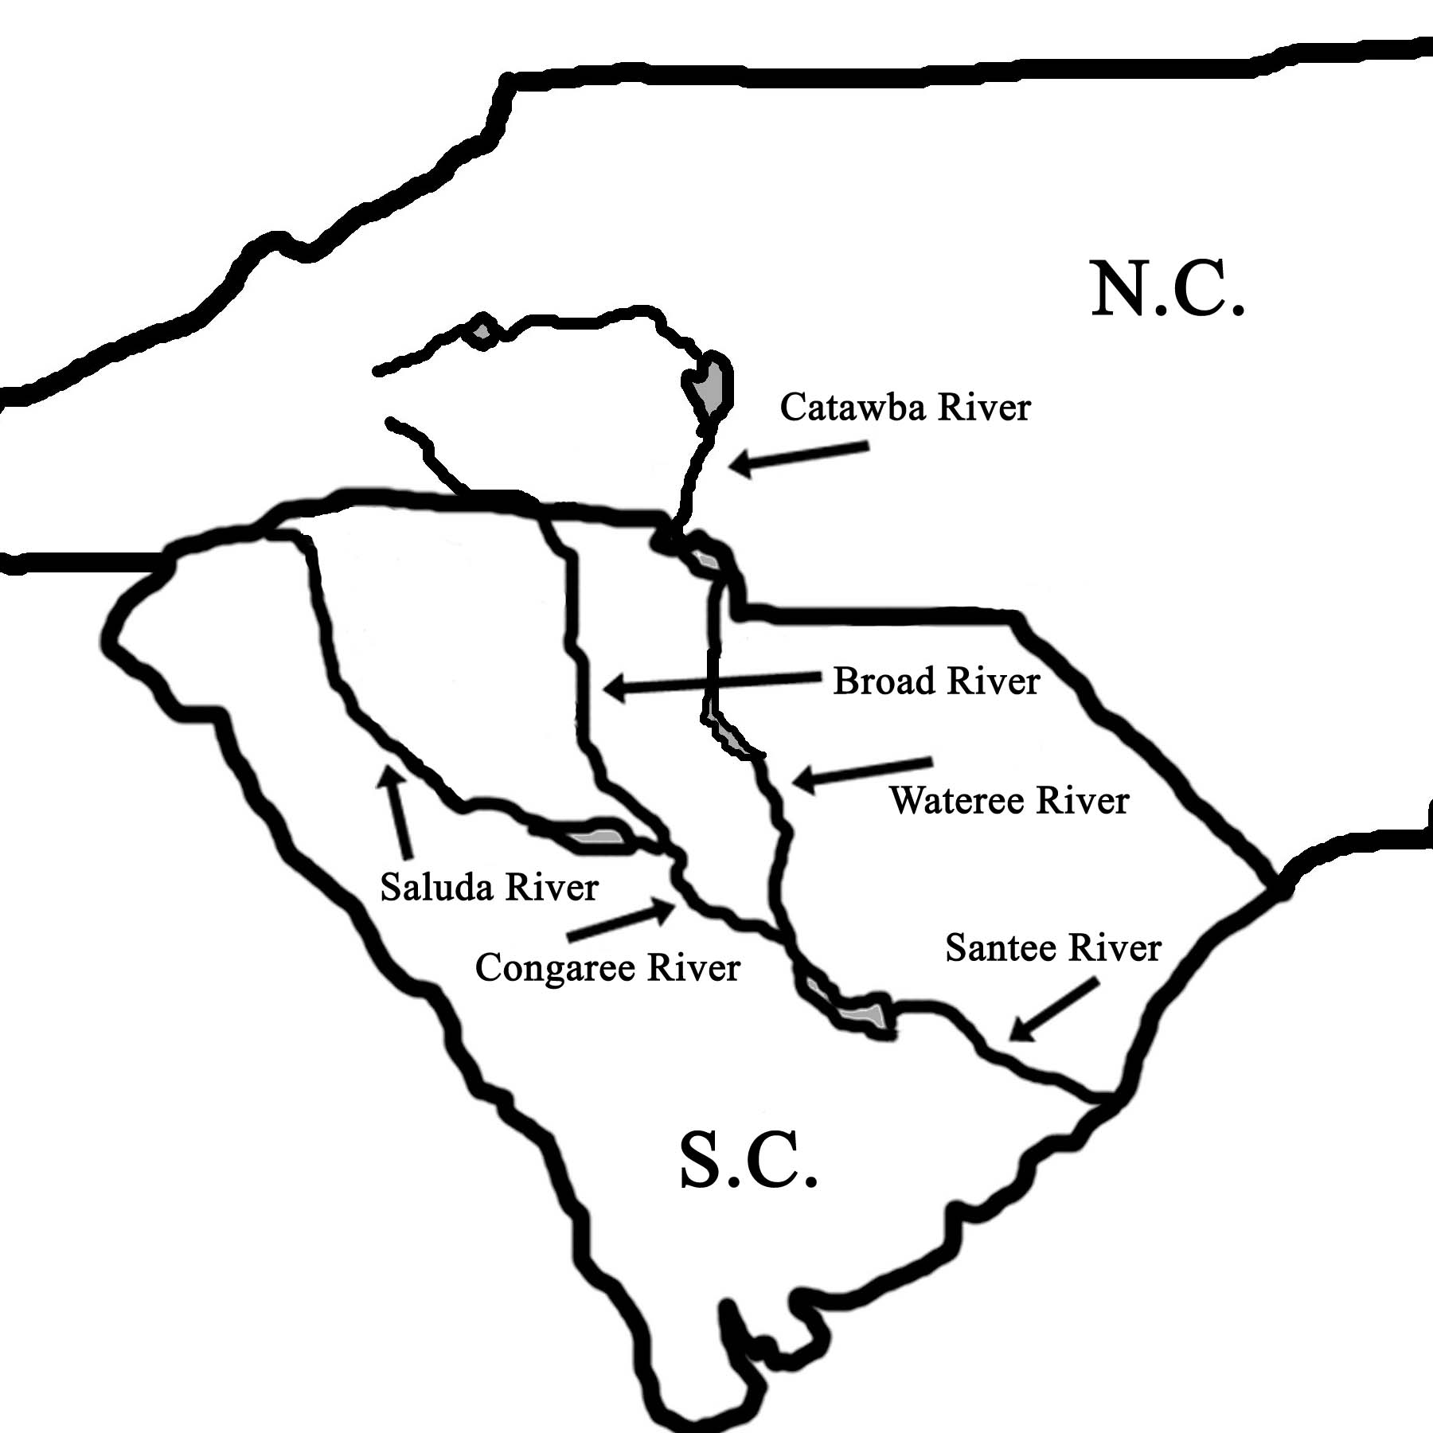

Isolated mountain peaks generate a radial pattern of drainage because water drains down the slope in many different directions at the same time. On the other hand, the landscape features of Karst Topography, generated through erosion by groundwater, tend to isolate portions of drainage systems into small intrabasinal networks that no longer interconnect on the surface. Distributary networks with multiple channels form in and around delta plains when a stream enters the ocean and loses all its energy and deposits its transported sediment. When one channel clogs up with silt or mud, another channel opens so that the river water is always able to reach the ocean. Occasionally, slopes are so low that channels separate and then re-connect, forming large islands in the floodplain. Additionally, elongated ridges and terrace edges can be formed from differential erosion around a resistant rock layer or from depositional events like a beach ridge marking the location of an ancient shoreline. In either of these cases, the resulting ridge forms a recognizable structure that can both block pre-existing drainage and redirect stream flow in a preferred direction.

Figure 3A-2: Common Drainage Network Patterns

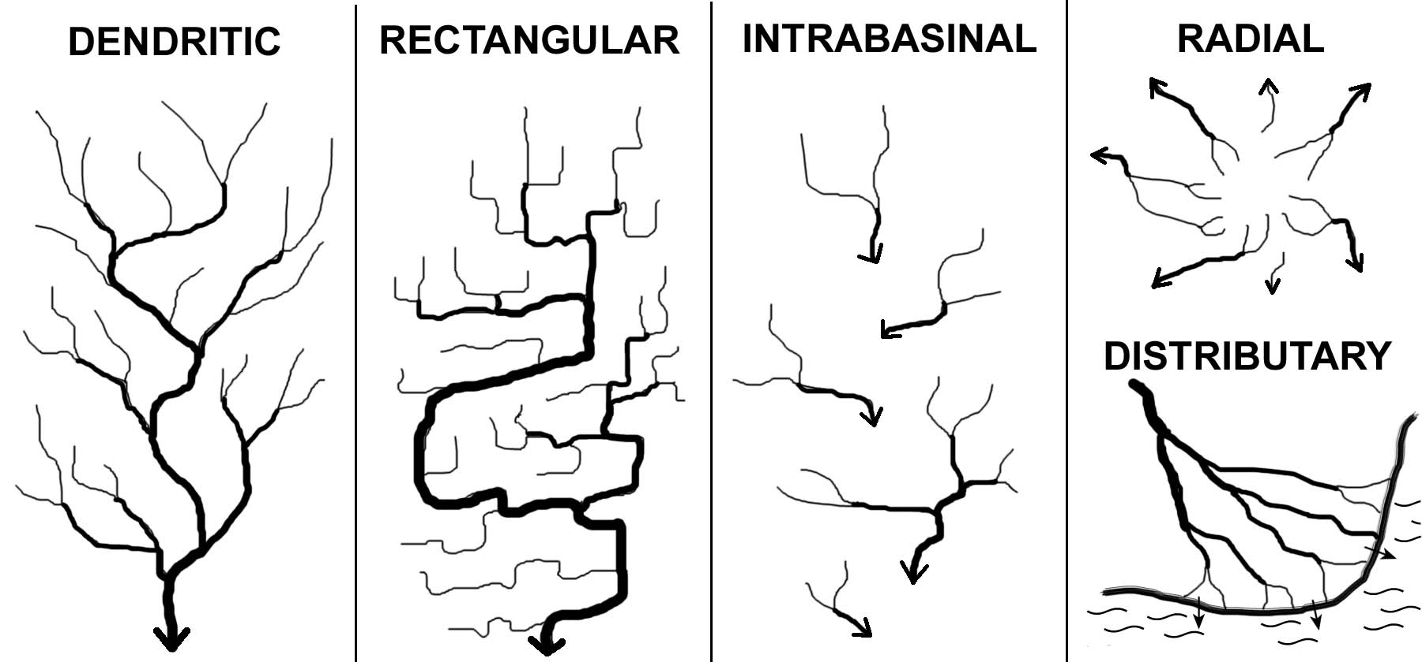

Some rivers predate the surface on which they currently flow. As erosion of the land surface gradually exposes underlying geological irregularities at the surface, a meandering river may start to cut downward into new masses or layers of rock that have different degrees of resistance to erosion. If the stream is powerful enough, it may be able to cut through even the hardest rock layers and maintain its original course. Such a river is referred to as superposed stream. However, if the streamflow energy is too low to cut through the rock, the river course will be diverted to a path of lower resistance that is more consistent with the new topography of the land.

Activity 3A-1: Landform Regions of the Southeastern USA

POWER THINKING EXERCISE - "Scenic Search"
Your state's Bureau of Tourism is concerned that not enough out-of-state visitors are coming to your area to take their vacations and spend their money. The tourism experts have heard that most families on vacation prefer to go to places that have beautiful scenery, so they have decided to print a full-color brochure that will focus on the scenic highlights of your state. But the tourism experts also discovered that they didn't know where the most scenic landscapes were located. Your job is to research the types of landforms found in your state and recommend at least three specific scenic locations that can be pictured in the brochure. Use MAP 3A, LANDSCAPES AND LANDFORMS, as your primary reference. Pay special attention to the landscape symbols explained in the legend. You may also refer to MAP 3E, POLITICAL SETTING, to reference cities, towns, rivers, or other named locations.
Once you have agreed in your group about which three scenic landscapes you want to use, sketch out a rough design of how the complete brochure might be laid out. Write a brief description (~ 50 words) of each scenic spot explaining what the scenery would actually look like and why tourists should want to visit. Be as persuasive as you can so lots of people will want to come and see the sights.
If your classroom is connected to the internet, access your state's official web site and look for pictures of the scenic attractions that you selected. Download these and print them for the brochure. Different classroom groups can research different states, or all groups can produce a brochure for the same state.

Materials
MAP 3A, LANDSCAPES AND LANDFORMS
MAP 3E, POLITICAL SETTING
Figure 3-1: "Landform Regions of the Southeast"
"Index Map of Study Areas"
Wipe-off Pens

PERFORMANCE TASKS
(Icon Key) Overview = ; Science = ; Math = ; History = ; Language Arts =

1. Trace landform region boundaries.
Use a wipe-off pen to outline, on MAP 3A, LANDSCAPES AND LANDFORMS, the boundaries of the seven landform regions that cover the southeastern United States. Be sure to label each region. Use the index map, Figure 3-1, "Landform Regions of the Southeast," as a guide. Divide into groups to look closely at the boundaries between selected regions. Describe in detail (refer to landscape features) how you would know when you crossed that boundary if you were riding in a car looking out the window.

Group I Boundary between Coastal Plain and Piedmont regions.
Group II Boundary between Piedmont and Blue Ridge regions.
Group III Boundary between Blue Ridge and Valley & Ridge regions.
Group IV Boundary between Valley & Ridge and Appalachian Plateaus region.
Group V Boundary between Coastal Plain and Valley & Ridge regions.
Group VI Boundary between Coastal Plain and Appalachian Plateaus region.

Mark on the landform map, with a wipe-off pen, the approximate locations of all 21 SE MAPS Study Areas (refer to the "Index Map to Study Areas" on the cover page for this chapter). Note which Study Areas are situated along landform region boundaries. Based on the information provided on the landform map, what major landscape features would you expect to find at each Study Area (list at least two for each Area)?

2. Distinguish between erosional and depositional landforms.
Examine the legend on MAP 3A, LANDSCAPES AND LANDFORMS, and determine which landscape features are erosional in nature and which are depositional. Examine the distribution of landforms in each of the seven landform regions and complete the following chart. Which landform regions contain primarily erosional landforms? Which landform regions contain primarily depositional landforms? List examples of each type of landform in each area.

DISTRIBUTION OF LANDSCAPE FEATURES
LANDFORM REGION | EROSIONAL FEATURES | DEPOSITIONAL FEATURES
Appalachian Plateaus

Valley & Ridge

Blue Ridge

Piedmont

Coastal Plain

Coastal Zone

Florida Peninsula

3. Determine latitude / longitude coordinates for selected study areas.
Locate and identify the latitude and longitude lines shown on MAP 3A, LANDSCAPES AND LANDFORMS. Do the latitude line numbers increase or decrease from North to South? Do the longitude line numbers increase or decrease from West to East? In what direction would you have to travel to get to the origin point of the worldwide latitude / longitude coordinate system (the 0,0 point)?

Mark on the landform map, with a wipe-off pen, the approximate centers of all SE MAPS Study Areas located in your state. Refer to the "Index Map to Study Areas" on the first page of this chapter to determine their locations. Use the map information to estimate both the latitude and longitude values of the centers of each Study Area. Express your numerical data as ordered pairs (latitude, longitude) in degrees and minutes. Remember that there are 60 minutes in one degree. Because these numbers are estimates, you may round off all values to the nearest 10 minutes.

4. Identify obstacles to transportation.
Throughout history, most communities and cultures have relied on their ability to transport goods and people to insure economic prosperity. The early European settlers in the southeastern United States were no exception to this pattern. Divide into groups and have each group select one of the southeastern states to study. Examine that state's landscape features, as shown on MAP 3A, LANDSCAPES AND LANDFORMS, and identify (list) all landforms that you think would act as barriers to easy transportation within or through that state. How do you think early settlers dealt with these obstacles? How do we deal with them in modern times? Share your results with other groups and determine which types of landforms generate the most common obstacles to travel in the southeastern United States.

5. Tell story about building Okeechobee Canal.
Read the newspaper article on page 3A-1. Note that not all landform features are formed naturally; some are produced by human effort for a specific purpose important at a particular time to that particular culture. Imagine yourself as one of the workers on the Okeechobee Canal project about 1,700 years ago. Use the information in the newspaper article to get a general idea of what you did and how you might have done the work. Also note why it was important to your community that this project be completed. With a wipe-off pen, mark the location of the Okeechobee Canal on MAP 3A, LANDSCAPES AND LANDFORMS, as closely as you can.

Most Native American cultures placed a high value on storytelling, primarily as a way of passing on the group’s history and traditions to their children so their cultural values could be maintained. A favorite time for storytelling was at night, around a campfire.

Using the newspaper article as a reference, prepare a story about how you worked on the canal and how proud you were of the finished product. You can exaggerate your importance to the project if you like, as storytellers often do. Try to make your story as interesting as possible. Each person should tell his or her story to the other people in their group, then select the best story to present to the entire class. Because storytelling is an oral tradition, you should not write down your story ahead of time, although you could jot a few notes on a piece of paper if you like. Your teacher may want to tape record the stories to share with other classes.

.

ENRICHMENT
(Icon Key) Overview = ; Science = ; Math = ; History = ; Language Arts =

1. Research official and unofficial state songs.
Many states have adopted official songs that praise the natural beauty of the state and the quality of life that its citizens enjoy. Such songs are sometimes used in radio and TV commercials to promote state tourism. Contact your state government information center (or web site) to find out if your state has an official state song. If it does not, then check out other southeastern states until you find one with an official song. Get a copy of the words and examine them carefully. List all references to either landforms or scenery and try to match these references to actual landform features as shown on MAP 3A, LANDSCAPES AND LANDFORMS. Groups should be prepared to perform their songs in front of the rest of the class. Try to classify each song into its most appropriate modern music category.

Also try to track down any popular songs you know which focus on a particular southeastern state (for example, James Taylor's song "Carolina on my Mind" or Lynyrd Skynyrd’s “Sweet Home Alabama”).

2. Compare southeast landform regions with rest of USA.
Locate a physiographic map of the entire United States. Also refer to the simple sketch map insert, showing major landform regions in the USA, that is included on MAP 3A, LANDSCAPES AND LANDFORMS. Which other states have the same landform regions as the southeastern USA? What recognizable patterns do these landform regions exhibit? How does the Interior Low Plateaus region in the central part of Tennessee differ from the Appalachian Plateaus region?

Activity 3A-2: Drainage Patterns and Watersheds

POWER THINKING EXERCISE - "Hydrophobic Horse"
You are an explorer from England arriving in one of the English colonies (choose among North Carolina, South Carolina, or Georgia) along the Atlantic Coast in the summer of 1730. Your mission is to travel from the coast, the lowest point in your colony, to Mount Mitchell, the highest point in what will one day be the southeastern United States, in order to claim that uncharted mountainous region for your colony. Mt. Mitchell (2,037 m / 6,684 ft above sea level), is located in modern-day western North Carolina along the crest of the Blue Ridge Mountains. Locate this mountain on MAP 3A, LANDSCAPES AND LANDFORMS (look about halfway between Knoxville, TN and Charlotte, NC).
You may land your ship anywhere you wish along the coastline of your chosen colony. However, you have one unexpected problem. Your horse, which you had brought with you all the way across the ocean from England, has developed an absolute hatred of water and will not cross any body of water again under any circumstances.
Find at least one route by which you can travel all the way from the coast to Mount Mitchell without crossing any water (rivers, lakes, swamps, or streams). Mark this route on the landform map using a wipe-off pen. Compare your route with those of other groups who chose that same colony and also with those who chose different colonies. Which of the three colonies probably has the shortest route to Mount Mitchell? Which colony has the best claim to the mountain?

Materials
MAP 3A, LANDSCAPES AND LANDFORMS
Wipe-off Pens
Wide-tip Wipe-off Pens

PERFORMANCE TASKS
(Icon Key) Overview = ; Science = ; Math = ; History = ; Language Arts =

1. Trace major river drainage basins (watersheds).
Use MAP 3A, LANDSCAPES AND LANDFORMS and a wipe-off pen to trace all tributaries of one of the following major river systems in the Southeastern United States. Then use a wide-tip wipe-off pen to trace along the drainage divide and outline the entire drainage basin (watershed) of your selected river system. Name all states that are drained by your selected river system. How many dams and reservoirs have been constructed on your river system? In which general compass direction does your river flow? Through which landform regions does your river flow? Into which ocean does your river flow? Name the specific bay, inlet, estuary, etc. where your river system enters the ocean.

Group I Mississippi River System
Group II Mobile (Tombigbee-Alabama) River System
Group III Apalachicola (Chattahoochee-Flint) River System
Group IV Altamaha (Ocmulgee-Oconee) River System
Group V Savannah River System
Group VI Santee (Saluda-Broad-Wateree) River System
Group VII Pee Dee River System
Group VIII Cape Fear River System
Group IX Roanoke River System

After your tracings have been completed, compare and discuss the maps as a class, and then answer the following questions. Which drainage system has the largest total watershed area in the southeastern states? Which river system has the most dams and reservoirs? Which empties into the largest estuary, bay, or sound? Which rivers form deltas at their mouths; which of these has the largest delta? Is your school in the watershed area of any of these river systems? If so which one?

As an entire class, locate the headwaters of several streams that drain through the easternmost part of Tennessee. Mark the location of each stream source with a wipe-off pen. Now, in the same way, locate the headwaters of several streams that drain eastward and southeastward into North Carolina and South Carolina and mark the location of these stream sources with a different color wipe-off pen. Draw a line separating the headwaters of the westward flowing streams from the headwaters of the eastward flowing streams. This line represents the Eastern Continental Drainage Divide. All streams on the western side flow into the Gulf of Mexico. All streams on the eastern side flow into the Atlantic Ocean. Analyze the stream patterns in Georgia and Florida and extend the Eastern Continental Drainage Divide as far south as you can. Which states drain entirely into the Atlantic Ocean? Which states drain entirely into the Gulf of Mexico? Is the Divide always located along a mountain range?

2. Trace pathway of an industrial pollutant.
If an accidental chemical spill, dumping directly into the river, occurred at each of the following locations, which other cities and towns would have to be concerned about the contamination affecting their drinking water supply? Different groups should select and trace different spills. How far away from the site of the spill do you think the effect would be noticed? Trace the pathway of your pollutant on MAP 3A, LANDSCAPES AND LANDFORMS and indicate the point at which you think that pollutant would no longer be a serious problem. Explain your answer. Each group should share its results with the rest of the class. Which river would have the greatest pollution problem? Why? How do you think the size of the river and the amount of water it carries influences the seriousness of the contamination?

Group I Shreveport, Louisiana (Red River)
Group II Vicksburg, Mississippi (Mississippi River)
Group III Tuscaloosa, Alabama (Tombigbee River)
Group IV Jacksonville, Florida (St. Johns River)
Group V Augusta, Georgia (Savannah River)
Group VI Columbia, South Carolina (Broad River)

3. Calculate gradients of stream systems.
Locate Mount Mitchell on MAP 3A, LANDSCAPES AND LANDFORMS (look about halfway between Knoxville, Tennessee and Charlotte, North Carolina). The Tennessee River system drains westward from this mountain and the Catawba-Wateree-Santee River system drains eastward. Assume each river system begins at an elevation of approximately 6,000 feet above sea level. Likewise, each river system ends at sea level, at an elevation of 0. The total energy available to a stream system is often estimated by the slope, or gradient, of that stream as it flows towards the ocean. Gradient is expressed mathematically as the ratio of height (difference between highest and lowest elevation) to distance (length of the stream system from headwaters to ocean). This ratio can either be expressed in units of feet per mile, or as a percentage. Determine a way to measure the length of each stream system and calculate its average gradient. Use the scale bar on the landform map as a reference. Which stream system has the higher average gradient? Which stream system would be expected to generate more erosion as it flows towards the ocean? Explain your answer.

4. Explain use of multiple names for major rivers.
In some parts of the country, major rivers (like the Mississippi, Hudson, Potomac, Rio Grande, and Colorado) can be traced all the way from their source to the ocean under the same name. In the Southeast, however, many rivers change names two and even three times between their source and the ocean. Examine MAP 3A, LANDSCAPES AND LANDFORMS, and locate at least three examples of river systems that undergo such name changes. Try to identify a pattern and predict where such name changes are most likely to occur in a river system. What are some advantages to a river having the same name from source to ocean? Are there any advantages to a river changing names? Explain your answer. Come up with a hypothesis to explain historically how a single river might come to possess multiple names in the first place.

5. Write a story about salamander's river journey.
Using MAP 3A, LANDSCAPES AND LANDFORMS, select any stream that begins in the Appalachian Mountains of North Carolina, Tennessee, South Carolina, Georgia, or Alabama. Pretend you are a small salamander who was living in a soda bottle that has been carelessly dropped into a mountain stream by a thoughtless hiker. During a heavy rainstorm, the bottle is pulled into the current and begins a long journey downstream toward the ocean. Using a wipe-off pen, trace your path to the ocean on the landform map. From a "salamander's eye" point of view, write a story about your trip from the mountains to the sea. Be sure to mention any obstacles or surprises you encounter on your journey. Be sure to use plenty of descriptive terms (especially adjectives) to tell others about what you see along the way. Choose a nickname for your salamander that has something to do with the events in your story. Share your story with other groups who chose different rivers. What parts of the stories are different, what parts are always the same for each trip?

ENRICHMENT
(Icon Key) Overview = ; Science = ; Math = ; History = ; Language Arts =

1. Research information on reservoirs in your state.
Examine MAP 3A, LANDSCAPES AND LANDFORMS and make a list of all reservoirs in your state. Select one of these and research when the reservoir was constructed, who did the construction, and why it was constructed.

2. Identify and locate "Wild and Scenic" rivers.
The Federal Government has certain criteria for designating rivers as "wild and scenic." Such designation carries restrictions on land use adjacent to the river as well as imposing strict environmental standards. Contact local government agencies, or consult an appropriate web site, to learn what conditions must be met for a river to obtain "wild and scenic" status. Also, obtain a list of all "wild and scenic" rivers in the southeast and locate them on MAP 3A, LANDSCAPES AND LANDFORMS.

STUDY AREA 3B: geological setting

THE GREENVILLE NEWS
October 7, 2001
Family Seeks to Expand Oil Drilling in Preserve
Big Cypress National Preserve, FL. In this area, endangered Florida panthers roam among cypress trees and oil pumps that pull up 3,000 barrels of crude a day.  That output could more than triple if a family that still owns drilling rights here wins new permits. Environ-mentalists worry about the impact of more roads, seismic surveying, drilling and pipelines.  "Because of the number of endangered species, this is not an appropriate place to have widespread drilling," said Brian Scherf, board member of the Florida Biodiversity Project.  Besides the Florida panther - only 70 are believed to remain in the wild - the 729,000- acre Big Cypress | Preserve is home to deer, alligators, black bear, wading birds and other protected animals. It's also a watershed for neighboring Everglades National Park.  Park officials can't guess at the impact of increased drilling. "We don't know what the panther can tolerate," said Don Hargrove, the preserve's environmental protection specialist.  The oil production company, Barron Collier Cos., says the current operation shows that nature and pumps can coexist.  General manager Robert Duncan pointed out saplings at a drilling site used from 1978 to the early 1980s, saying the natural return of cypress and pines shows that oil drilling has had a | minimal effect on the Big Cypress ecosystem..  He also said generators that produce electricity for well pumps can't be heard in the surrounding forests.  Environmentalists and the industry agree a spill at the well head is unlikely. The extracted oil is a slow-moving, tar-like substance that is relatively easy to contain, fields are manned continuously, and the pumps automatically shut down during a pressure problem.  The oil is piped underground for 17 miles to tanker trucks outside the preserve. The trucks take the oil to port for shipment to Gulf Coast refineries.  “This is as clean an operation as I’ve ever seen,” Duncan said.

RATIONALE

The geological makeup of a region is the single most important determining factor of how a particular landscape will develop through time. Areas underlain by igneous and metamorphic crystalline rocks tend to be the most resistant to erosion while sedimentary rocks can vary greatly in their hardness and durability. Streams cut through younger rock layers to expose older, deeper layers along the sides or bottoms of valleys. Different ages and types of rock tend to contain different fossil assemblages and mineral resources. This information can be used to infer original environments of deposition and to generate paleogeographic maps for specific geologic time periods. Occurrences of major rock units can be correlated over wide areas to make predictions about where particular fossils or mineral resources may be found. Tectonic maps divide the region into different segments based on characteristically different terranes, regions of land that contain rocks with a similar geologic history.
PERFORMANCE OBJECTIVES

1. List and compare the geologic features found in various landform regions.
2. Correlate the location of former shorelines to exposures of rock deposited in past ages.
3. Calculate the average rate of coastline migration from maximum to current sea level.
4. Evaluate the relationship between modern state boundaries and surface geology.
5. Write a short science fiction story to illustrate the geologic dangers of the past.
6. Correlate locations of major mineral deposits in region to characteristic landscapes.
7. Analyze map symbols in petroleum producing regions and determine geologic age.
8. Illustrate distribution of resources by constructing pie charts showing production rates.
9. Evaluate land use controversies between resource extraction and habitat preservation.
10.Create slogan that describes the significance of a specific geologic resource to a town.

SAMPLE ASSESSMENT RUBRICS
EXAMPLE #1 (relates to Performance Objective #2)
Give students a copy of MAP 3B, GEOLOGICAL SETTING (or a black and white photocopy of the relevant part of the map) and ask them to draw on the map the approximate position of the Atlantic Ocean shoreline during the Cretaceous Period of geologic time. They can refer to information in the legend of MAP 3B if they wish. Ask them to write the words “land” and “sea” on the appropriate sides of the shoreline line.

A (level 4) – land/sea label correct; shoreline continuous & accurate (see Fig 3B-1)
B (level 3) – land/sea label correct, shoreline continuous but with some inaccuracy.
C (level 2) – land/sea label correct, shoreline discontinuous or poorly correlated.
D (level 1) – land/sea label incorrect, shoreline discontinuous or poorly correlated.
F (level 0) – land/sea label incorrect/missing; shoreline has little or no correlation.

EXAMPLE #2 (relates to Performance Objective #6)
Give students a copy of Figure 3-3, “Simplified Geologic Map of the Southeast” and ask them to use that information to match the following five geological resources with their appropriate region. Set the question up as a matching question.

___[A]____ 1. COAL A. Appalachian Plateaus Region
_ [E]_____ 2. KAOLIN/CLAY B. Valley and Ridge Region
_[C] or [D]_ 3. GOLD C. Blue Ridge Region
_[E] or [F]_ 4. OIL & GAS D. Piedmont Region
___[B}____ 5. IRON ORE E. Coastal Plain Region
F. Coastal Zone Region
G. Florida Peninsula

A (level 4) – all five resources matched correctly with region
B (level 3) – four resources matched correctly with region
C (level 2) – three resources matched correctly with region
D (level 1) – two resources matched correctly with region
F (level 0) – one or no resources matched correctly with region

Cartographic Product Information

MAP 3B: Geological Setting

TITLE: Surface Geology of the Southeastern United States
DATA SOURCE: “Surface Geology of the Conterminous United States”, DDS-11,
United States Geological Survey, Washington, D.C.
DATE: 1973
SCALE: approximately 1:2,700,000 [1 inch ~ 43 miles] [1 cm ~ 27 kilometers]
OTHER IMPORTANT DATA:
- The geologic map shows much more detail than the legend. The map is divided
into regions representing geologic epochs (or other subdivisions of geologic
time), each with its own specific color. The legend, however, only shows the
Periods of the geologic time scale and illustrates a generic color that is most
clearly representative of the map coloration for all subdivisions of that Period.
- Most map symbols consist of a capital letter designating the geologic Period and
a small letter representing the epoch or other subdivision. For example, the
symbol “Tm” marks rocks formed during the Miocene Epoch of the Tertiary
Period. The symbol “uK3” refers to the Upper Cretaceous Period. The
symbol “Pzg2” refers to granitic rocks of the middle Paleozoic (Pz) Era
- The symbols for “intrusive igneous rocks,” “volcanic igneous rocks,” and
“metamorphic rocks” are very difficult to see on the map, but they are there.
- Fault lines are thick black lines, normal rock boundaries are thin black lines.
POINTS OF SPECIAL INTEREST:
- The large red (Ordovician Period) region in central Tennessee is part of the
Nashville Dome structure (topographically a basin), not part of the plateau.
- Several Triassic Basins (dark green) occur in east-central North Carolina.
- An angular unconformity is clearly visible in central Alabama.
OTHER FEATURES TO LOOK FOR:
- Linear patterns dominate within the Appalachian Mountains.

TITLE: Tectonic Map
DATA SOURCE: Plate 1.,Tectonic Map of the US Appalachians; The Appalachian-
Ouachita Orogen in the United States; Volume F-2 of the Geology of
North America, Hatcher et. al., Geological Society of America, Boulder, Colorado
DATE: 1990
SCALE: approximately 1:2,217,000 [1 inch ~ 35 miles] [1 cm ~ 22 kilometers]
OTHER IMPORTANT DATA:
- Colors on the tectonic map are not the same as colors on the geologic map.
- Areas marked with the same color experienced the same tectonic history.
POINTS OF SPECIAL INTEREST:
- Structural windows appear at Pine Mountain GA and Grandfather Mountain NC.
- The Brevard Fault Zone runs diagonally across the entire map region.
OTHER FEATURES TO LOOK FOR:
- The Piedmont Region is actually composed of several different tectonic terranes.
Study Area Description

Geological Patterns in the Southeast

A geologic map shows the distribution pattern of different rock units as they would appear at the surface of the earth if there were no soil or vegetation present to hide them. A geologic map that covers only a small geographic area is able to show individual formations that consist of similar rock layers formed during a particular depositional or other event in geologic history. An individual formation usually must be at least 50 feet (15 meters) thick and be traceable at the earth’s surface for long distances. For large geographic areas, such as the Southeastern United States, individual formations are grouped together into systems that correspond to the time periods used in the Geologic Time Scale (Figure 3-4). For example, the Ordovician System corresponds to all rocks formed during the Ordovician Period. Different map colors are used to represent different systems of rock. Ordovician rocks are usually portrayed in shades of red. Geologic maps often differentiate among sub-groupings of rock sequences within a system by using slight color variations in the designated system color as expressed in the legend.

In addition to displaying the ages of rock units, geologic maps also indicate the general kind of rock present, such as sedimentary, volcanic igneous, intrusive igneous, or metamorphic as well as the locations of other important features such as fault lines and igneous dikes. Correlating the patterns on the geologic map with the information in the legend provides valuable information on the geological history of the entire region. Adjacent rock outcrop patterns that are parallel to each other most likely have experienced a similar geological history. Discordant rock patterns, ones that intersect or show a very different spatial distribution pattern, likely represent areas with very different geological histories. The boundary between two discordant rock sequences is called an unconformity because it represents a gap in geologic history or a significant change in the geologic processes at work in a particular area. The unconformity line itself will appear concordant with the younger sequence of rocks while cutting or covering over the older rock pattern.

A particularly obvious example of an unconformity occurs beneath modern stream deposits such as the ones that make up the Mississippi River Alluvial Plain. Flat lying floodplain deposits cover over and hide the previous land surface along with any geologic outcrop patterns that may have existed there. A much older unconformity exists along the northern Coastal Plain boundary in Alabama where several parallel bands of tilted Paleozoic Appalachian Mountain rock units disappear suddenly underneath the younger, flatter, overlying Cretaceous rocks. In general, thin bands of color indicate the presence of high-angle tilted rock layers, while wider bands are associated with more horizontal rock layers.

In regions where erosion dominates the landscape, streams often cut through rock layers at the surface to expose one or more underlying layers of older rock. Sedimentary rocks are originally deposited horizontally, so any tilt, or dip, of the layers implies that the region has undergone some subsequent tectonic activity. In general, the dip angle points in the direction of the younger rock units. In depositional regions, or in places where streams do not carve deeply enough, geologists must drill deep holes into the rock to discover the nature of the layers beneath the surface. Data from drill holes can be matched with surface data to determine the lateral extent of various rock layers.

Tectonic Terranes of the Southeast

The North American continent has been built up slowly, over long periods of geologic time, by a series of large and small tectonic events. Any activity resulting from the interaction between two or more lithospheric plates on the earth’s surface generates tectonic forces that can uplift, deform, or metamorphose previously existing rock. Sometimes, continental landmasses, or fragments of continental landmasses, will collide as the result of plate movements. In other cases, a collision between oceanic crust and continental crust can generate tectonic forces. Many tectonic events create massive amounts of internal heat in connection with mountain building events that can lead to volcanic activity and/or underground igneous activity. Any tectonic land produced by or affected by such plate interactions is called a terrane. Rocks within a terrane are all formed within the same period of time and have a similar history, including the presence of similar structural features such as faults and folds.

Most of the tectonic activity in the Southeastern United States took place in the Appalachian Mountain Region long ago during the Paleozoic Era. The Appalachian structures seen today represent the results of several distinct phases of mountain building activity over a time span of hundreds of millions of years. On a tectonic map, the different terranes are shown in different colors, but these colors are not the same as the colors on a geologic map, and do not represent specific time intervals. Other symbols mark locations of major fault lines and fold axes.

The Central Piedmont Suture marks the boundary between the Avalon (Carolina) Terrane and the Inner Piedmont Terrane. It was along this line that one or more microcontinents collided in the Early Paleozoic Era to form the landmass that today makes up much of the Piedmont landform region in the Southeast. The Brevard Fault Zone represents much later strike-slip (sideways) fault movement that left behind a zone of easily erodable crushed rock. It is similar in many ways to today’s San Andreas Fault in California. In the Late Paleozoic Era, when the African continent collided with North America, parts of the Piedmont as well as the original North American continent were thrust westward, up and over existing rock layers, forming a series of overlapping thrust sheets. In a few places, erosion at the surface was vigorous enough to be able to remove part of a thrust sheet to expose another thrust sheet immediately below it. These locations are called windows because the buried thrust sheet is visible through the eroded hole in the upper sheet. Two well known examples are the Grandfather Mountain Window in Western North Carolina and the Pine Mountain Window in west-central Georgia. Tectonically generated thrust sheets and their associated folds extend all the way across the Appalachians to the plateau region of Tennessee.

Fossils and Ancient Environments

Almost all fossils occur in sedimentary rocks. In order to become fossilized, plants or animals must live in an appropriate depositional environment that is protected from physical and chemical attack. Most such environments are marine, although certain terrestrial environments, like lakes or river floodplains, can occasionally harbor large numbers of fossils locally. Different ages and types of rock tend to contain different fossil assemblages which can be used as both age and environmental indicators. Careful study of fossils can provide helpful information in reconstructing the ancient environments in which they once lived. The fossil record is both biased and incomplete, because fossilization is more likely to occur in organisms that possess hard parts like shells, bones, or teeth, or which were able to live in a variety of different depositional environments. Organisms that lived in non-favorable environments would tend not to be preserved at all. Also, erosion over the ages has removed much of the original fossil record of the Southeast.

Any geologic map covering an area as large as the Southeastern United States will not be able to distinguish between sedimentary rocks formed on land and those formed under the ocean. In fact, for most areas of the Southeast, it can be assumed that any geologic system of sedimentary rocks shown on the map is capable of hosting a variety of depositional environments. Most of these units also have a high probability of containing fossils in at least some of their component rock layers. Furthermore, it can be assumed that most areas associated with fossils and sedimentary rocks had to have been under water (under sea level) at the time the original sediments were deposited. An exception of course is coal, a terrestrial rock that contains fossilized land plants. In reality, sea level is a relative term, because ocean waters extended much further onto the land during certain geologic time periods than others. During times of high sea level, vast layers of sediments were deposited. During periods of low sea level, the exposed land surface underwent extensive erosion, producing widespread unconformities in the rock record.

Areas underlain by metamorphic and igneous rocks usually represent uplifted source areas, which have undergone significant erosion and generated large quantities of sediment. Particles eroded from the source area are transported and then deposited in low-lying depositional basins. Sediments are generally thickest and coarsest nearer to the source and become thinner and more fine-grained as distance from the source increases. Most of the modern day Coastal Plain and Coastal Zone sediments in the Southeast were originally derived from the Appalachian Mountains. The sedimentary rocks found in the Valley and Ridge and Appalachian Plateaus regions in turn were derived from an even more ancient source area that once existed along an axis east of the present Blue Ridge region. Some of the metamorphic rocks in the Great Smoky Mountains of Tennessee and North Carolina represent still older sedimentary rocks that were affected by various Appalachian Mountain tectonic events. By locating the upper (toward source) limit of sedimentary rock distribution for any particular time period, it is possible to estimate the approximate position of the shoreline for that time. This information can then be used to construct a paleogeographic map that identifies the locations of both the source land and the major depositional basins.

Figure 3B-1: Paleogeography During the Cretaceous Period

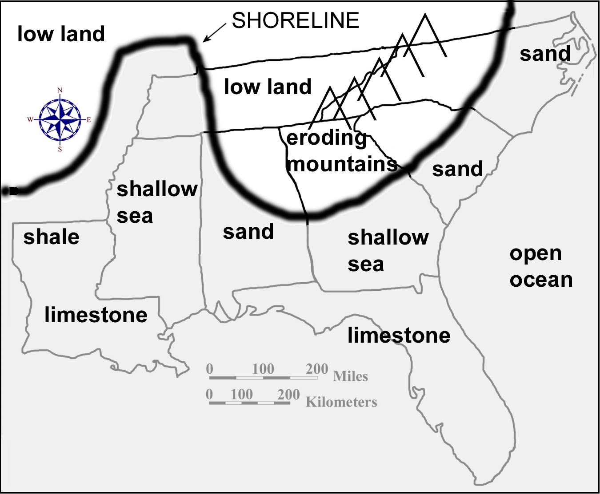

Distribution of Geological Resources

Different ages and types of rock also tend to contain different mineral and energy resources. In many cases, mineral deposits are linked to sediments formed in a particular depositional environment or to fracture zones in crystalline rock where chemical enrichment has turned the resource into an economically valuable ore. Just because a resource occurs in one part of a rock layer is no guarantee that it will occur elsewhere. Many mineral deposits are very localized and sporadic in their occurrence. For this reason, it is very difficult to pinpoint the exact locations of specific rock and mineral resources on a regional geologic map. Even such vast resources as coal and petroleum do not always extend in continuous deposits across wide geographic areas. But the rock information on a geologic map at least makes it possible to predict where similar deposits would be most likely to occur.

It is useful to make connections between certain types of geologic resources and the categories of rock in which they are commonly found. Most metallic mineral deposits and gemstones, for example, are associated with active tectonic areas in which volcanic activity and intrusive igneous activity are commonplace. Gold, silver, tin, copper, lead, mercury, tungsten, and molybdenum are mined primarily in areas of igneous and metamorphic rock. A few of these important metals, like lead and zinc, can also be found in sedimentary rocks, primarily limestone and dolostone, in the form of sulfide ore deposits. Sedimentary rocks are the primary host for oil and gas deposits, as well as for coal, phosphate rock, and certain evaporite minerals such as halite (rock salt).
The economic value of specific mineral deposits can change dramatically over time. A good example is gold mining, which became very profitable in South Carolina in the 1980s when the price of gold around the world was high. By the year 2000, the price of gold had fallen to a level where it was no longer profitable for companies to extract the gold, and all of the gold mines in the state had to shut down. Another example is the Birmingham, Alabama steel industry, which flourished until the later part of the twentieth century. The iron ore deposits are still plentiful there, but cheaper prices for imported steel have made Birmingham steel too costly in comparison. In colonial times, nearly every major village in the Piedmont operated an iron forge using locally available deposits of low-grade iron ore. With population growth, and the coming of the industrial revolution, such low-volume facilities could not begin to keep up with the demand for iron, and production shifted to major industrial centers like Birmingham.

The petroleum industry likewise responds to the economic laws of supply and demand. When oil is scarce, companies often raise prices to consumers to lower demand and to generate additional funds for exploration and research by the company. New drilling technology has reached deep oil deposits that were once considered untouchable. Once additional oil is brought into production, consumer prices may decrease again.

Figure 3B-2: Resource Production by State

Southeast Mineral and Energy Production in 2000

Nonfuel Minerals (in thousand metric tons)

 | Cement | Sand & Gravel | Crushed Stone | Lime | Salt | Peat | Feldspar | Clay
Alabama | 5,142 | 16,500 | 59,000 | 2,000 | 0 | 0 | 0 | 2,300
Florida | 5,700 | 27,800 | 98,000 | 0 | 0 | 368 | 0 | 34
Georgia | 0 | 7,900 | 159,000 | 0 | 0 | 0 | 0 | 9,000
Louisiana | 0 | 16,000 | N/A | 0 | 13,400 | 0 | 0 | 626
Mississippi | 0 | 10,600 | 2,000 | 0 | 0 | 0 | 0 | 900
N. Carolina | 0 | 14,000 | 114,000 | 0 | 0 | 0 | 394,000 | 2,400
S. Carolina | 3,200 | 10,300 | 38,000 | 0 | 0 | 0 | 0 | 1,600
Tennessee | 0 | 8,900 | 63,000 | 0 | 0 | 0 | 0 | 756

Southeast Mineral and Energy Production in 2000
Fuel Resources

Coal (thousands of tons) Oil (barrels per day) Natural Gas (billions of cubic feet)
Alabama | 19,400 | 29,000 | 359
Florida | 0 | 13,000 | 6
Georgia | 0 | 0 | 0
Louisiana | 3,592 | 288,000 | 1,443
Mississippi | 223 | 54,000 | 78
North Carolina | 0 | 0 | 0
South Carolina | 0 | 0 | 0
Tennessee | 2,949 | 1,000 | 0
A frequently overlooked fact is that building materials make up the highest volume usage of all earth resources. Sand and gravel top the list, being used primarily in the making of concrete and the paving of macadam, or asphalt, roads. Crushed stone is used as ballast for railroad tracks as well as for road construction, and various dimension stones are used in the construction of walls, floors, building foundations, and walkways. Clay deposits of many different compositions can be baked into bricks. All of these materials have very little monetary value in and of themselves, in fact, the major expense associated with utilizing most of them is transportation costs. Because they are so abundant and widespread, the economic value of the raw materials increases only when they are processed into a more useful form. For this reason, local deposits are preferred, and the particular rock type being mined (igneous, metamorphic, or sedimentary), doesn’t really matter very much in most cases. Other common resources include limestone, used in agriculture in addition to its role in making concrete, and gypsum, which is widely used in the manufacture of wallboard (gypsum board or sheetrock) and plaster of Paris.

Activity 3B-1: Interpreting Geologic History

POWER THINKING EXERCISE - "Fossil Find"
A group of curators from the State Museum of Natural History has enlisted your help to increase the number of local fossils they can put on display at the museum. They are particularly interested in three types of fossils, dinosaur bones from the Cretaceous Period of the Mesozoic Era, trilobite molds (impressions) from the Cambrian Period of the Paleozoic Era, and mastodon teeth (unaltered) from the ice-ages during the Quaternary Period of the Cenozoic Era. Use MAP 3B, GEOLOGICAL SETTING, to analyze the ages of the different rock units that crop out at the surface in your state. Use a wipe-off pen to circle areas in your state that are most likely to contain each of these three categories of fossils. Use a separate color wipe-off pen for each fossil. If your state has no suitable locations to dig for a particular fossil, find and circle the closest fossil locality in a neighboring state.
The curators also decided that it would be a good idea to display local rock samples of very different ages. Again using the geologic map and legend, mark the locations and name the age (geologic period) of the oldest and youngest rocks in your state.

Materials
MAP 3B, GEOLOGICAL SETTING
Figure 3-1: "Landform Regions of the Southeast"
Figure 3B-1: "Paleogeography During the Cretaceous Period"
Wipe-off Pens

PERFORMANCE TASKS
(Icon Key) Overview = ; Science = ; Math = ; History = ; Language Arts =

1. Make a chart listing age and geologic features of landform regions.
Use a wipe-off pen to outline, on MAP 3B, GEOLOGICAL SETTING, the boundaries of the seven landform regions that cover the southeastern United States. Be sure to label each region. Use the index map, Figure 3-1, "Landform Regions of the Southeast," as a guide. Divide into groups to study a particular region and infer its geologic history. Fill in the chart below, listing ages of rock (geologic periods), primary rock type (igneous, metamorphic, or sedimentary), other geologic features (faults, dikes, etc.), and compass orientation (trend of linear features) for your designated landform region. Note that in some cases the trend or orientation of geologic features will not be consistent throughout a region and you will have to generalize about the compass orientation rather than simply measure the direction of a feature at only one point. Finally, using data for all landform regions, as recorded on the charts prepared by other class groups, speculate as to what types of geologic events in the past could account for the features we see today in each of these landform regions. Which regions, if any, appear to have experienced similar events at about the same time?
GEOLOGIC REGIONAL DATA
Landform Region | Age (periods) | Rock Type | Other Features | Trend
Appalachian Plateaus
Valley and Ridge
Blue Ridge
Piedmont
Coastal Plain
Coastal Zone
Florida Peninsula

2. Locate position of former shoreline.
Much of the Coastal Plain Region of the Southeast is constructed from sediments that were deposited under water at a time when sea level was much higher than it is today. Probably the highest documentable sea level in this region occurred during the Cretaceous Period, when the ocean lapped up against the Appalachian Mountains in some areas of the Southeast. On MAP 3B, GEOLOGICAL SETTING, locate the Cretaceous sedimentary rocks along the upper boundary of the Coastal Plain Region. With a wipe-off pen, trace the upper limit of Cretaceous rock exposures. Where there are no Cretaceous rocks shown on the map, continue tracing along the upper limit of Tertiary rock exposures (in a few areas, the Tertiary rocks cover over and hide the Cretaceous rocks). The line you have just drawn represents a former ocean shoreline. Compare your shoreline position with the one shown in Figure 3B-1, “Paleogeography During the Cretaceous Period”.

Compare the shape of this ancient shoreline with the modern coastline. What similarities do you observe? What major differences do you notice? What geological processes or events do you think might have caused these changes in shoreline position? What percentage (approximately) of your state was under water during the Cretaceous Period? Where in general do you think the sediment come from (source of erosion) to build up the Cretaceous and Tertiary sedimentary deposits? Where in general do you think the sediment comes from today to build up modern marine sedimentary deposits?

3. Determine rate of change in shoreline position.
Use the tracing of the shoreline position for the Southeast during the Cretaceous Period (either from Performance Task #2 on MAP 3B, GEOLOGICAL SETTING, or Figure 3B-1, “Paleogeography During the Cretaceous Period”) as a reference. As sea level dropped during the Cenozoic Era, more and more land was exposed until the modern shoreline position was reached. It is possible to calculate the rate (R) of migration of the shoreline if we know the distance covered (D) (refer to the scale on the geologic map or Figure 3B-1) and the time (T) it took for the coastline position to move that far. The general formula for such a calculation is D=RxT. Approximately 100 million years has elapsed since the beginning of the Cretaceous Period. Using this information, calculate the average rate of coastline migration for Alabama, Georgia, North Carolina, South Carolina, Mississippi, and Tennessee. Express your answers in units of miles per million years. Which portion of the shoreline has shifted position the fastest? Which portion of the shoreline has shifted the slowest? Why do you think the Mississippi and Tennessee rates are so different from the other states?

4. Examine relationship between surface geology and state boundaries.
With a wipe-off pen, trace over the state boundary lines on MAP 3B, GEOLOGICAL SETTING, so they show up more clearly. Do this for the Surface Geology Map and also for the Tectonic Map Inset. Examine all three maps to look for places where the patterns of surface geology (rock ages and types, terrane boundaries, etc.) coincide with state boundary lines. List all such places and evaluate whether each match is simply a coincidence, or whether the underlying geology or tectonics of the area influenced the positioning of the state boundary. Is there any advantage to a state to include several diverse geologic or tectonic regions within its boundaries? Explain your answer. High quality geologic maps of the Southeast were not published until the middle of the twentieth century. Given this information, how likely is it that the surveyors and politicians who established most state boundary lines gave any consideration to the patterns of the underlying geology?

5. Write an adventure story about the geologic past.
The geologic past is a favorite subject for many science fiction writers who use a fictional device called a time machine to take their characters to times and places they never could get to otherwise. Write a short adventure story in which your hero or heroine uses a time machine to go back to a specific location in the Southeast during a specific geologic period. An adventure story should contain danger and some trials and tribulations, or unusual difficulties, that the lead character has to overcome. At least one of the dangers should be geologic in nature. Use lots of action verbs to keep your story interesting. Refer to MAP 3B, GEOLOGICAL SETTING to select the particular geographic location and geologic time period that you will use for your story. Your geologic danger must be consistent with the time and place you picked and the information provided on the geologic map. Exchange stories with other groups and read several of them. Are there certain plot devices that keep showing up again and again in many of the stories? Explain your answer.

ENRICHMENT
(Icon Key) Overview = ; Science = ; Math = ; History = ; Language Arts =

1. Research state rock and state fossil.
Many states have designated an official state rock and state fossil. Contact an appropriate government agency, or an appropriate web site, to find out what they are for your state. Use the library or internet to research how and why this particular rock or fossil was selected, who first requested the designation, and when the official proclamation was made. Also determine where in the state the rock and fossil might be found and whether these items have any historical significance to your state. Use MAP 3B, GEOLOGICAL SETTING for reference.

2. Compile list of stories or films that use time machines.
Many classic books and movies feature time travel as a significant part of their plot. Perhaps the most famous of these is "The Time Machine" by H.G. Wells. Compile a list of as many books and films as you can find and note how far back in time the main characters travel, and also the geographic location they visit. Pick one title from the list and either read the book or arrange to see a video of the film. If any of your selections are set in the southeastern United States, refer to MAP 3B, GEOLOGICAL SETTING for reference.

Activity 3B-2: Geologic Resources

POWER THINKING EXERCISE - "Industrial Initiative"
You are a member of President Andrew Johnson's Economic Advisory Council in the late 1860s following the end of the Civil War. As a native North Carolinian, President Johnson is very interested in re-building the economic base of the South, which was largely destroyed during the war. Your group knows that before the Civil War, iron was manufactured in many localities throughout the South, but always in small, local operations that didn't produce very much. The President wants you to identify a site somewhere in the Southeast that has the capability of becoming a major manufacturing center for iron and steel so that he can convince federal and state officials to support his project.
Fortunately, the famous 19th century geologist, John Wesley Powell, is in Washington, D.C. on business and is available to meet with your group. He informs you that an area must contain the following three geological resources, located very close to each other, to qualify as a potential large-scale iron producing site:
1. iron ore - best quality is in Silurian age sedimentary rocks
2. limestone - best quality is in Ordovician age sedimentary rocks
3. coal - best quality is in Pennsylvanian age sedimentary rocks
Use MAP 3B, GEOLOGICAL SETTING, to identify at least three areas in the Southeast that you think would meet Powell's criteria for success. Refer to the Geologic Map Legend to determine the geologic ages of rock units. Outline these potential sites with a wipe-off pen. Discuss within your group the advantages and disadvantages of each site, and then choose one location to recommend to the President. Write a brief report naming your preferred site and stating your reasons for choosing it.

Materials
MAP 3B, GEOLOGCIAL SETTING
MAP 3E, POLITICAL SETTING
Figure 3-1: "Landform Regions of the Southeast"
Figure 3-11: "Mineral and Energy Resources in the Southeast"
Figure 3B-2: "Resource Production By State"
Wipe-off Pens

PERFORMANCE TASKS
(Icon Key) Overview = ; Science = ; Math = ; History = ; Language Arts =

1. Investigate distribution of geologic resources.
Use the information given in Figure 3-11, "Mineral and Energy Resources in the Southeast," to assess the quality and quantity of geologic resources in either your own or another state. Use a wipe-off pen to mark on MAP 3B, GEOLOGICAL SETTING, the locations of major mineral deposits in that state. Then fill out the following chart using the Geologic Map Legend and Figure 3-1, "Landform Regions of the Southeast." Under the category, "rock type," list whether the predominant geologic unit on the map is igneous, metamorphic, or sedimentary.
GEOLOGIC RESOURCE DATA
Geologic Resource | Age of deposit  (geologic period) | Major Rock Type  (IGN, MET, SED) | Landform Region

2. Explain distribution of oil and gas deposits.
Refer to Figure 3-11, "Mineral and Energy Resources in the Southeast," to determine which states produce most of the oil and gas (petroleum products) in the Southeast. Locate on MAP 3B, GEOLOGICAL SETTING, the areas that produce most of this oil and gas and mark them with a wipe-off pen. In which landform region are most of the oil wells located? Many of these wells go down thousands of feet into the ground where they tap into underlying rock units that never reach the surface and therefore do not show up on the Surface Geology Map. What is the age (geologic period) of the rocks that are exposed at the surface in the petroleum producing areas? What is the likely age (geologic period) of the rocks that underlie the surface rocks and contain the major reservoirs of petroleum (refer to the Geologic Map Legend)?

Note in Figure 3-11 that many of the petroleum producing wells are actually located offshore (out in the ocean). What information does this fact give you about the geology of the rock layers comprising the sea floor? What is the likely age (geologic period) of the rocks that produce the offshore oil?

3. Construct pie chart showing resource production by state.
Use Figure 3B-2, "Resource Production by State," to determine which state produces the most of each resource listed. Divide into groups and have each group work with a different geologic resource. Locate, and mark with a wipe-off pen on MAP 3B, GEOLOGICAL SETTING, the various places where your chosen resource is produced (refer also to Figure 3-11, "Mineral and Energy Resources in the Southeast"). Construct a pie diagram to represent visually the percentage contribution of various southeastern states to the total production of your selected geologic resource.

Group I Coal.
Group II Oil.
Group III Natural Gas.
Group IV Sand & Gravel.
Group V Crushed Stone.
Group VI Clay.

4. Evaluate appropriate land uses for wildlife preserves.
Read the newspaper article on page 3B-1. Who wants to expand the oil drilling? Who wants to prevent any increase in drilling? List at least two logical reasons to support the position of each group. Your group has been chosen to make the final decision, but first you need to investigate the situation further. Locate the Big Cypress National Preserve on MAP 3E, POLITICAL SETTING (it’s not labeled, but it occupies the uppermost part of the large green area at the southern tip of Florida - just east of the towns of East Naples and Marco). Locate the same area on Figure 3-11, “Mineral and Energy Resources in the Southeast.” What major energy resource is found in this area? Explain why it is reasonable for oil deposits to occur here also. Based on the information in the news story, what port city do you think is the destination for the oil that comes out of the preserve? Justify your answer.

Write a second newspaper article about this controversy, based on your final decision about the expanded drilling request. Be sure to pick a catchy headline that will get people to want to read your story. Report your decision clearly and factually, but also include likely comments from both sides based on how they might react to your decision. Include possible quotations from some of the same people who were interviewed for the first story. Share your newspaper articles with other groups and discuss as a class the different options presented and different reactions observed.

5. Create slogan highlighting city's geologic resource.
Several towns across the Southeast have been named for a dominant rock or geologic resource that is mined in the immediate area and is important to the local economy. Select one of the following towns, locate it on the Surface Geology map on MAP 3B, GEOLOGICAL SETTING, and create a slogan that highlights the significance of the local rock or geologic resource. Make sure your slogan is short enough so that it can be placed on a roadside sign at the entrance to the town, and interesting enough so that people will want to read it as they drive by. Explain why slogans are important to the economic and social life of a town or a community. Use MAP 3E, POLITICAL SETTING, to help you locate the towns referenced below.

Group I Irondale, Alabama (central AL, just east of Birmingham).
Group II Limestone, Florida (south-central FL, just north of Arcadia).
Group III Flintside, Georgia (southwest GA, between Cordele and Albany).
Group IV Sulphur, Louisiana (southwest LA, near Lake Charles).
Group V Oil City, Mississippi (west-central MS, just south of Yazoo City).
Group VI Marble, North Carolina (far southwest NC, just west of Andrews).
Group VII Graniteville, South Carolina (west-central SC, just west of Aiken).
Group VIII Copperhill, Tennessee (southeast corner TN, southeast of Cleveland).

ENRICHMENT
(Icon Key) Overview = ; Science = ; Math = ; History = ; Language Arts =

1. Trace economic impact of mining through time.
Refer to an almanac, or contact your state Chamber of Commerce, to determine how the economic impact of mining has varied over the years in your state. Which rocks and minerals have declined in economic importance? Which have increased in importance? Research one of these categories to determine why the economic impact changed the way it did over time. Locate the major mining sites in your state for these resources on MAP 3B, GEOLOGICAL SETTING. Explain how the change in economic value affected the local economy of those areas.

2. Research origin of mineral deposits.
Select one of the mineral resources listed on Figure 3-11, "Mineral and Energy Resources in the Southeast," and investigate how that mineral formed within the earth. Consult several sources and write a brief report explaining the geologic origin of that mineral deposit. Locate all occurrences of your chosen mineral on MAP 3B, GEOLOGICAL SETTING.

STUDY AREA 3C: landscape patterns

THE DAILY MESSENGER
March 27, 2002
Smokies, Everglades Make List of All Threatened Parks
By Christopher Thorne  WASHINGTON (A.P.) – Pollution has helped put the Great Smoky Mountains and the Everglades on an advocacy group’s list of the nation’s most-threatened national parks.  The “Top 10” list released Monday by the nonprofit National Parks Conservation Association also includes Yellowstone National Park, the country’s first park, and Federal Hall, the site in lower Manhattan where George Washington was sworn in as president.  The Smokies park, the nation’s most-visited, was on the group’s list for the second straight year because pollution from Tennessee Valley Authority power | plants threatens more than 30 species of plant life.  Also making last year’s list were the Everglades and Big Cypress parks in south Florida, where the group said water levels and pollution continue to pose significant problems. All-terrain vehicles were also singled out for causing damage to the Big Cypress.  The list was released just three days after the Interior Department released its own list, detailing projects it said are needed to improve conditions in 12 national parks.  “Parks have so many important projects going on across America that we couldn’t keep it to the usual ‘top 10’ list,” Interior | Secretary Gale Norton said in a prepared statement  “We are working to aggressively fix the nation’s parks,” she added.  The parks association already is lobbying Congress to appropriate more money to hire more employees, such as archaeologists and biologists, and to catch up on a substantial maintenance backlog.  David Barna, a spokesman for the National park Service, said the agency appreciates the attention the NPCA has drawn to the national parks.  But whether the park service would be able to address all the problems on the group’s list is another matter, he said.

RATIONALE

The ability to view the actual surface of the earth from 800 km (480 miles) above the ground provides a clear indication of the areal extent of landscape patterns and a coherent look at how these regions interrelate. Satellite imagery gives a very different perspective from ground-based imagery and includes features that are difficult to portray on regional maps. The Advanced High Resolution Radiometer (AVHRR) gathers information at several different spectral bandwidths, but is most sensitive to the presence and condition of vegetative cover over large land areas. AVHRR images can be used to monitor vegetation distribution and seasonal changes on a global scale. Shaded relief images demonstrate the advantages of using computers to handle large amounts of data. Digital elevation models typically contain millions of terrain-height data points. The computer software assigns each of these points a brightness value corresponding to its simulated reflectivity for a particular sun-angle.
PERFORMANCE OBJECTIVES

1. Locate specific sites and landform regions on different types of map products.
2. Predict possible stream locations by examining patterns of erosion and deposition.
3. Calculate the surface area of a geographic region.
4. Analyze map images for evidence of alteration of the landscape by civilization.
5. Describe, using written directions, how to find a specific location on a map or image.
6. Evaluate cartographic products to determine which best illustrates specific patterns.
7. Explain why high mountain ranges often trap and concentrate aerial pollutants.
8. Use cloud shadows to estimate position of Sun in the sky and time of day of image.
9. Compare state boundaries to structural features visible on map or image.
10. Outline cooperative strategies that are helpful in constructing a mosaic.

SAMPLE ASSESSMENT RUBRICS
EXAMPLE #1 (relates to Performance Objective #6)
Give students a copy of both a computer generated digital elevation shaded relief map (like the shaded relief map on MAP 3C) and a satellite image (like the AVHRR image on MAP 3C or any of the NALC images, for example on IMAGE 6B). Ask the students to study each product carefully and then identify the product that best shows evidence of human alteration of the landscape. Tell the students to justify their answer and explain why that product is better able to reveal evidence of human activity.

A (level 4) – Correct product is chosen (satellite image) and explanation is correct.
B (level 3) – Correct product is chosen but explanation is only partly correct.
C (level 2) – Correct product is chosen but explanation is confusing or inadequate.
D (level 1) – Incorrect product is chosen but explanation is partly correct
F (level 0) – Incorrect product is chosen and explanation is wrong or lacking.

EXAMPLE #2 (relates to Performance Objective #8)
Give students an aerial photograph at a large enough scale so that individual shadows of trees or buildings can be seen (one example is the Downtown Columbia NAPP on IMAGE 7D; another is the Stone Mountain air photo on IMAGE 7A). Ask students to orient the photograph so that north is facing up (refer to compass rose), select a particular building, tree, or other feature that is high enough to cast a shadow, and infer the position of the sun that would be necessary to produce a shadow oriented in that direction. Tell students to express their answer as the time of day the picture was taken (be sure to include AM or PM designation). Also tell students to explain their answer, and in particular, explain how they arrived at their answer.

A (level 4) – Correct time given (+/- 1 hour) and explanation is clear and concise.
B (level 3) – Correct time given (+/- 2 hours) and explanation is clear and concise.
or Correct time given (+/- 1 hour) and explanation is not as clear.
C (level 2) – Correct time given (+/- 2 hours) but explanation is not clear, or
AM/PM designation only is correct, explanation otherwise adequate
D (level 1) – AM/PM designation only is correct, and explanation is not clear, or
AM/PM designation wrong, explanation shows some understanding
F (level 0) – Time not given or completely wrong and/or explanation is missing
or shows no logical thought.
Cartographic Product Information

MAP 3C: Landscape Patterns

TITLE: AVHRR Mosaic of the Southeastern United States
DATA SOURCE: Advanced Very High Resolution Radiometer (thermal infrared data);
NOAA Series Weather Satellite
DATE: 1999
SCALE: approximately 1:3,500,000 [1 inch ~ 56 miles] [1 cm ~ 35 kilometers]
OTHER IMPORTANT DATA:
- Colors on this mosaic are false colors that have been assigned to highlight land
surface features. The green areas represent water and wetland regions.
The white spots are clouds. AVHRR images generally include ocean data,
but this has been removed to emphasize the shoreline configuration.
- Because this image is a mosaic, you can see where segments have been joined
(the most obvious match line shows along the Georgia-Alabama state line).
POINTS OF SPECIAL INTEREST:
- The Mississippi River alluvial plain and Appalachian Mountains show up clearly.
- The agriculturally rich Black Belt region of Mississippi and Alabama shows up
as an elongated, curved feature of lighter coloration
OTHER FEATURES TO LOOK FOR:
- Coastal Plain river floodplains can be traced to the Fall Line Zone, especially in
North and South Carolina. They show up in a brighter reddish color.

TITLE: Shaded Relief Image of the Southeastern United States
DATA SOURCE: U.S. Geological Survey Map I-2206, Thelin, G.P., and Pike,
R.J., “Landforms of the conterminous United States – A digital shaded-
relief portrayal”
DATE: 1991
SCALE: approximately 1:3,500,000 [1 inch ~ 56 miles] [1 cm ~ 35 kilometers]
OTHER IMPORTANT DATA:
- Lakes and reservoirs do not show up on this map, because the computer treats
water surfaces like any flat land surface and cannot distinguish it from land.
- Elevation is the only data used to create this map. Vegetation, rock type, land
use, and land cover make no difference to the computer and are not shown.
POINTS OF SPECIAL INTEREST:
- The Appalachian Plateaus region is especially clearly represented on this map.
- Lookout Mountain of Alabama and the Sequatchie Valley of Tennessee show up.
- Crowleys Ridge is the raised line in the upper part of the Mississippi River valley
- Pine Mountain in Georgia sticks out above the surrounding Piedmont region.
OTHER FEATURES TO LOOK FOR:
- Structures in the Appalachian Mountains show up particularly well on this map.
Look especially for fracture patterns in the Blue Ridge region and
parallelism of features within the Valley and Ridge region.

Study Area Description

Satellite Imagery

Satellite images not only bring a new perspective to the study of landscapes and landforms, but also provide a vehicle by which people can construct a much more accurate mental image of the world they live in. The analysis of remotely sensed images, not only of earth but also of other planets, uses concepts of scale, patterns of change, and other common themes of global significance to the earth system. Satellite imagery provides an excellent means of contrasting ground cover during different seasons and tracking changes in regional snow cover or cloud cover on a daily or monthly basis. Images taken at different time intervals also can capture evidence of global changes resulting from the action of climatic and seasonal cycles. Monitoring the growth of the Ozone Hole over the South Pole by satellites can document global change over time. Likewise, thermal infrared measurement of ocean temperatures can be used to plot the progressive development of critical climatic phenomenon such as El Nino and La Nina.

The most common and readily available remote sensing instrument is the human eye. But visual observations usually provide only a limited view of landscapes, both in terms of overall field-of-view and in terms of the wavelengths of light being processed. Ground-based photographs generally display only side views, or cross-sections, of landscape features. This is the perspective through which most people perceive and interact with their world. Such images over-emphasize edges and corners and give a limited and distorted view of the spatial extent of landforms. People also tend to favor “close-up” snapshots of persons or objects which tend to block out or obscure their connections with the surrounding landscape.

Satellite imagery provides a broad overview that emphasizes the regional patterns, networks, and systems that make up composite landscapes. Most satellite images are generated by mechanical scanners that record the relative amount of reflected light coming from each point on the surface. Each sensor records data from different wavelengths of light within the electromagnetic spectrum, including visible, radar and thermal infrared. Different earth materials and land surface features reflect quite differently under these different wavelength conditions. Data from particular sensors can be selected in such a way as to magnify the differences in reflectance values for a particular surface or landform. In addition, data from several different sensors can be combined and manipulated by computers to generate distinctive false-color images that highlight certain types of ground cover or surface material.

Advanced Very High Resolution Radiometer

The Advanced Very High Resolution Radiometer (AVHRR) is a special detector that is sensitive to electromagnetic radiation in four spectral regions, visible red, reflected infrared, short-wave thermal infrared, and long-wave thermal infrared. The National Oceanographic and Atmospheric Administration (NOAA) included this instrument on every weather satellite launched as part of the NOAA-6 through NOAA-12 missions. Each of these satellites follows a polar orbit (meaning that each and every orbit crosses over both the north and south poles of the earth) at an altitude of 833 km (521 miles). Because these are polar-orbiting satellites, and because the satellites move at such a high velocity - 14 daily earth orbits – and have such a wide field of view, they can record a series of images that span the entire globe twice during each 24-hour day. The primary mission of AVHRR is to provide information on vegetation distribution and seasonal changes on a regional to continental scale.

Each standard AVHRR image covers a huge portion of the earth’s surface, cutting a swath about 2,400 km (1,500 miles) wide, which is much larger than the area covered by a single Landsat image (185 km [114 miles] wide). Such wide coverage causes significant image distortion, due to the curvature of the earth, at distances far from the center of the image, so several segments of different images are frequently combined into a mosaic which offers a more uniform consistency of coverage throughout the image. The mosaic also makes it possible to create a regional image with almost no cloud cover or other image flaws. The standard ground resolution for regional AVHRR mosaic images is 4 km (2.5 miles). While nowhere near as good as the 30 meter (100 feet) resolution of most Landsat images, the AVHRR resolution is adequate for the scale required by such a wide coverage area. At this scale, most human activity is not visible to the observer. Natural drainage distinctions, however, such as river floodplains and wetlands, do show up clearly.

AVHRR images are classified as “false-color” images because the colors they show are not the same as the colors that are actually reflected from the surface of the earth. Because the AVHRR sensors are tuned to detect only the red light portion of the visible spectrum, it would be impossible to produce a true-color image of any region. To generate the false-color mosaic, the red visible light is printed as either green or blue, while areas with high infrared reflectivity are printed in varying shades of red, yellow, and brown. The end result is documented in the color key illustrated below. Because AVHRR also contains a thermal infrared sensor, these images may be valuable in determining water surface temperatures, snow cover, soil moisture content, volcanic eruption temperatures, and the extent of dust and sandstorm influence. But the primary use of AVHRR imagery remains the mapping of different categories of vegetation. In general, light-toned areas are higher and drier, while dark-toned areas are lower and wetter. In the image used for SE MAPS, satellite data for ocean areas is not included, but in most other AVHRR images, the color can be used to estimate the amount of sediment in the water as well as the actual temperature differential.

Figure 3C-1: Color Interpretation Chart for AVHRR Images

COLOR INTERPRETATION CHART - AVHRR
Green | wetlands, water in rivers, lakes, and reservoirs (not oceans)
red | heavily vegetated, river floodplains, naturally forested areas
yellow-green | agricultural areas, cropland
brown | higher, drier heavily forested areas
white | clouds, snow (water in ocean bays and sounds is not recorded)

Digital Shaded Relief Maps

The United States Geological Survey (USGS) has mapped virtually every inch of the United States at least once at some time during its history. The resulting series of topographic maps, at a variety of different scales, has in common the inclusion of contour line information that makes it possible to determine the approximate elevation of any point within the area shown on the map. To convert this map data to a digital format, the desired map area is divided up into a series of pixels, or small points on a grid, and each pixel or point is associated with an elevation above sea level. The specific elevation assigned to each pixel is an average value based on the elevation distribution within the pixel coverage area. For the particular digital shaded relief map used in SE MAPS, elevation data was derived from the 1:250,000 series of USGS topographic maps. Over 2,400 cells in the east-west direction and over 1,900 cells in the north-south direction make up the area covered by the Southeastern United States map. The true distance between cells, or pixels, on the ground is 805 meters (.5 miles). This distance translates into .23 mm (.01 inch) on the map, which is small enough to produce a crisp, clear, high resolution image at the designated scale.

Special image-processing software generates hypothetical brightness values (simulating the amount of sunshine that is reflected) for each pixel based on an assumed relationship between amount and direction of ground slope versus a theoretical sun angle. It is these differences in brightness that produce the shading characteristic of this category of map. After several attempts using trial-and-error methods, researchers found that the best way to illustrate surface relief (differences in elevation) over the entire United States was to designate a sun angle of 25 degrees from the west-northwest corner of the map. In reality, such a sun angle would never actually occur, but it was used anyway because it produced the most realistic representation of both smooth and high-slope topography. The lightest areas of the map indicate fully illuminated steep slopes; the medium gray tones indicate areas of gently sloping topography; and the darkest areas indicate areas with steep slopes that are in shadow. To make the visual effect more prominent, the entire map is printed with a vertical exaggeration of 2.0, meaning that mountains appear twice as high as they really are and valleys appear twice as deep. As a result, it is possible to distinguish landscape features as small as 1,600 meters (1 mile) across. It is also important to realize that the resulting graphic is actually a derived map rather than a real image of the land surface.

Digital shaded relief maps are most useful for highlighting structural features in an area. Certain linear features associated with sudden changes in elevation, like fault lines and escarpments, are especially clear when they extend in a direction perpendicular to the hypothetical sun angle. Areas of high relief, such as mountain ranges, are also emphasized because of the contrast between sun-facing slopes and slopes that are in shadow. Large areas of flat topography are also conspicuous on the map because of their lack of detail. Stream drainage networks are often well demarcated, even though there is no actual designation for water. Because elevation is the only factor being considered, variations in underlying geology, land cover, or land use do not influence the appearance of the map and the structural information comes across clearly and cleanly.
Activity 3C-1: Erosional & Depositional Surface Features

POWER THINKING EXERCISE - "Alien Assignment"
Before the United States could launch spacecraft to land on the moon, NASA scientists first had to study remotely sensed images and photographs of the moon's surface to decide on the best landing sites. Imagine that you are part of an alien group of scientists from a planet in another solar system. You have been studying earth for a long time using telescopes, but have decided that it is now time to try to land a spacecraft on our planet. One of your space probes has sent back to you images similar to those recorded on MAP 3C, LANDSCAPE PATTERNS. Use this information to recommend a landing site for first contact.
Before you begin the selection process, discuss in your group what the criteria should be for choosing a landing site. What factors should be considered most important for the successful landing of a spacecraft? What type of map information was most useful to you in determining the best site? What surprises would your group of aliens find when you landed on earth (what unexpected things would you find that the maps and images didn't show you)? Why would the sensors and telescopes not have recorded such "surprises?"

Materials
MAP 3A, LANDSCAPES AND LANDFORMS
MAP 3C, LANDSCAPE PATTERNS
"Index Map to Study Areas"
Transparent Grid Overlays
Wipe-off Pens

PERFORMANCE TASKS
(Icon Key) Overview = ; Science = ; Math = ; History = ; Language Arts =

1. Investigate relative prominence of seven landform regions.
With a wipe-off pen, name and outline the seven major landform regions of the Southeast on the Shaded Relief Image on MAP 3C, LANDSCAPE PATTERNS. Use the index map, Figure 3-1, "Landform Regions of the Southeast," as a guide. Which region boundaries are easiest to transfer to the map? Which region boundaries are the most difficult to transfer correctly? Which landform region is the most mountainous? Which is the flattest? Which has the highest relief (most extreme elevation differences)? What determines whether a landform region is prominent (easy to distinguish) on the Shaded Relief Image? List the seven regions in decreasing order of their prominence. Which landform regions are most prominent on the AVHRR Mosaic? Are these the same ones that are prominent on the Shaded Relief Image? (The Shaded Relief Image and the AVHRR Mosaic can both be found on MAP 3C.)

Mark on the Shaded Relief Image and on the AVHRR Mosaic, with a wipe-off pen, the approximate locations of all 21 SE MAPS Study Areas (refer to the "Index Map to Study Areas" on the cover page of this chapter). Which are easiest to place in their proper position on the Shaded Relief Image? Which are easiest to locate on the AVHRR Mosaic? What map features make it easy or difficult? Explain your answer.

2. Recognize erosional and depositional patterns of rivers.
The Shaded Relief Image on MAP 3C, LANDSCAPE PATTERNS, is a computer-generated image based on elevation values for millions of data points. It does not show streams or lakes directly, but it is nevertheless possible to identify the positions of river channels by recognizing the patterns of narrow valleys they produce as a result of prolonged erosion. Stream deposition patterns are more difficult to recognize, but can sometimes be identified by the presence of wide flat floodplains or, in a few cases, the occurrence of a delta at the river mouth.

Examine carefully the stream erosion patterns displayed on the Shaded Relief Image, and, with a wipe-off pen, trace the probable paths of the major rivers of the Southeast on this map. When you finish, check your work by comparing your stream patterns to the ones visible on the AVHRR Mosaic or the Landform Map on MAP 3A, LANDSCAPES AND LANDFORMS. Which stream systems were easiest to trace correctly? Explain why. Which were most difficult? Explain why. How could you recognize a lake or a reservoir on the Image? What conclusion can you make about the relationship between the size of a river and the width and length of its valley?

3. Estimate numerical value of surface area of Southeast.
There are several methods by which the area of a geographic region can be calculated. Two of those methods are listed below. Divide into groups so that half the groups are using each method and determine the surface area of the landscape shown on the Shaded Relief Image on MAP 3C, LANDSCAPE PATTERNS. When all groups have finished, compare answers and discuss which method is the simplest to carry out, which is the quickest, which is most accurate, and which gives you the most precise answer. Which method would probably be more consistent (likely to give the same answer every time you worked the problem)? Figure out at least one way that each method could be improved upon to provide greater accuracy and precision.

Method I Estimate using transparent grid overlay
Use the transparent grid overlay to estimate the surface area. Count the number of whole squares that correspond to the land surface as well as fractions of squares where appropriate. Refer to the scale bar on the map to find the information necessary to calculate the number of square miles in one square unit of the overlay. Report your final area estimate in units of square miles.

Method II Estimate using area of geometric shape
The geometric shape of the Southeast can be made to approximate a rectangle. Use a wipe-off pen, and a trial-and-error method, to draw a rectangle on the Shaded Relief Image in such a way as to make the amount of land outside the rectangle (for example, the southern part of Florida) equal to the amount of water inside the rectangle (for example, along the coastlines of Alabama and South Carolina). Refer to the scale bar on the map to determine the length and width of your rectangle. Use the formula for calculating the area of a rectangle (AREA = LENGTH X WIDTH) to determine your final answer. Report your final area estimate in units of square miles.

4. Detect human activity visible on satellite image.
Civilizations have thrived in the Southeast for many thousands of years. In the last one-hundred years in particular, large cities have sprung up all over the region and people have altered the natural landscape in a variety of very noticeable ways. Examine the AVHRR Mosaic on MAP 3C, LANDSCAPE PATTERNS, to document and list all features visible on that image that provide evidence of civilization, and in particular represent the activity and impact of people on the natural environment. Make a second list of features that you expected to find, but couldn't. Compare your lists with the lists of other groups. What is the single most important determining factor in whether or not a structure is visible on an image from space?

5. Write set of directions using references to landscape patterns.
When writing a set of directions to guide people to a specific location, it is important that the instructions be precise enough so that the reader can understand them completely and arrive at the designated site successfully. Divide the class into working groups. Each group should select a particular point on the Shaded Relief Image on MAP 3C, LANDSCAPE PATTERNS, and write a set of descriptive directions that rely only on the physical characteristics shown by features on that Image. There are no place-name labels on the map, so proper names of locations should not be used. The directions should be generic enough so that the location can be reached from any starting point on the image, but specific enough so that your exact location can be pinpointed by someone whose only reference is the Shaded Relief Image. Exchange your set of directions with other groups and see how close they can get to your location while you see how close you can get to theirs. Follow this exchange up with a class discussion in which you identify words or sets of words that were especially effective in giving good directions. What do these words have in common?

ENRICHMENT
(Icon Key) Overview = ; Science = ; Math = ; History = ; Language Arts =

1. Research how DEM generates shaded relief image.
The Shaded Relief Image on MAP 3C, LANDSCAPE PATTERNS, is an example of a computer-generated representation of a digital elevation model (DEM) that produces a distinctive map with the appearance of topographic relief. Research how this translation is accomplished and explain the role of the computer in organizing the data. Prepare a poster for your classroom that graphically and pictorially represents the process in a way that your classmates can understand.

2. Research how AVHRR satellite system works.
The AVHRR Mosaic on MAP 3C, LANDSCAPE PATTERNS, was generated by piecing together images taken by a single NOAA weather satellite at different times and different places. Research the history of the AVHRR program and explain all of the different kinds of images (and spectral bandwidths) that can be obtained from this remote sensing system. How are the images transferred to earth? What happens to them once they reach the ground receiving station? In how many different ways can this data be displayed? Write a short report summarizing your findings.

Activity 3C-2: Structural Geology Influences Topography

POWER THINKING EXERCISE - "Poster Pick"
Your local NASA product distribution center has offered your science teacher a box of free posters, suitable for framing, if your school will promise to hang a poster in every science classroom. All the posters in the box are of the same scene, and the school is allowed to receive only one box. NASA has sent you a preview of the two possible images you have to choose from. They are the AVHRR Mosaic of the Southeastern USA and the Shaded Relief Image of the Southeastern USA, both included on MAP 3C, LANDSCAPE PATTERNS. Your task is to study carefully both images and decide which would make the better poster for the science classrooms in your school.
Before you make your final decision, generate a list of the pros and cons of selecting either of these images. What types of features does the AVHRR Mosaic show best? What types of features does the Shaded Relief Image show best? What criteria will you use to determine which image is best for display in a science classroom? List them. How did you decide on these criteria? Which image meets your criteria best? Would your answer be different if it were a mathematics classroom, or a social studies classroom? Explain your reasoning.

Materials
MAP 3A, LANDSCAPES AND LANDFORMS
MAP 3B, GEOLOGICAL SETTING
MAP 3C, LANDSCAPE PATTERNS
Wipe-off Pens

PERFORMANCE TASKS
(Icon Key) Overview = ; Science = ; Math = ; History = ; Language Arts =

1. Compare and contrast representation of structural features.
Many of the landscape patterns in the Southeast can be related to the presence of underlying structural features, including faults, folds, unconformities, and terrane boundaries. Investigate the features listed below and briefly describe how they look on each of the following maps: AVHRR Mosaic and Shaded Relief Image on MAP 3C, LANDSCAPE PATTERNS; Surface Geology Map and Tectonic Map on MAP 3B, GEOLOGICAL SETTING; and MAP 3A, LANDSCAPES AND LANDFORMS. Indicate which map you would use to get the best visualization of each of these features.

Brevard Fault Zone (labeled on Tectonic Map; runs from GA to NC through SC)
Sequatchie Valley Breached Anticline (labeled on Landform Map; central TN)
Fall Line Zone (labeled on Landform Map; central GA through SC)
Cretaceous unconformity over older rock (shown on Geology Map; central AL)
Pine Mountain Thrust Fault (labeled on Landform Map, central TN at KY border)
Yazoo Basin (labeled on Landform Map, northwestern MS)
2. Explain why pollution is trapped in Smoky Mountains.
Read the newspaper article on page 3C-1. In your group, discuss the major points of the article and explain why the author thought this issue was important enough to write about. Which parks listed in the article are in the Southeastern United States? Write a single sentence that summarizes the threat to the Great Smoky Mountains National Park, based on the information provided in the newspaper article.

Locate Great Smoky Mountains National Park on MAP 3F, CULTURAL HERITAGE and also on the AVHRR Mosaic on MAP 3C, LANDSCAPE PATTERNS. Draw the approximate park boundary on MAP 3C with a wipe-off pen. Next, refer to Figure 3-6, “The Tennessee Valley Authority System” and locate all of the power plants shown on that diagram. With a different color wipe-off pen, mark the positions of these power plants as closely as you can on MAP 3C. How far are the Smoky Mountains from the nearest power plants? What do you think is the exact source of the pollution? What specific pollutant(s) do you think might come from a power plant? How do you think the pollutant(s) reached the park? Why do you think pollutants reaching a mountainous area would tend to remain in the air longer than in an area with flat topography? Be able to explain your answers in a class discussion. (HINT: review the topography of the Smoky Mountains on the Shaded Relief Image on MAP 3C.)

3. Estimate time of day by examining cloud shadows.
The AVHRR Mosaic on MAP 3C, LANDSCAPE PATTERNS, shows a large number of small clouds, especially over Georgia. Each of these clouds projects its own shadow onto the ground. The ground area within this shadow is slightly cooler than surrounding areas in the sun and therefore shows up as green instead of red on the false-color thermal infrared image. Examine the positions of the shadows relative to the clouds carefully and use this information to estimate the position of the sun in the sky at the time the original images were obtained. What time of day (round off to the nearest hour) in Georgia would correspond best to this sun position?

4. Describe alignment of state boundaries with structural features.
With a wipe-off pen, draw the boundaries of your state on both the AVHRR Mosaic and the Shaded Relief Image on MAP 3C, LANDSCAPE PATTERNS. Which part of the boundary was easiest to draw on each of these maps? Which part of the boundary was the most difficult to put in the right place? What parts (if any) of your state boundary line match landscape or structural features shown on these two maps? What would be the benefits of lining up a state boundary with structural features? Would there be any reasons to avoid this type of alignment?

5. Describe characteristics of a mosaic.
Study the color patterns on the AVHRR Mosaic on MAP 3C, LANDSCAPE PATTERNS. There are several places where two or more separate images have been joined together to create the mosaic effect. Find and mark at least two of them, using a wipe-off pen. These patches can usually be recognized by looking for long straight-line boundaries that don’t match up with any known landform features. Those lines are not there in the real world, but simply represent a slightly different color contrast in the two images that were joined. How can the distribution of clouds help you locate these boundaries? Would you have discovered these patch lines if you weren’t looking for them? Explain your answer.

A mosaic model is commonly used in various types of communications media including music and art, but it is especially important whenever a group writes a research report. Each writer has a different perspective on the problem and a different style of writing and it is the editor’s job to select the best writing from each person’s report and make it fit together so it reads like one single report.

If you are working in a group of four, select two people to analyze the AVHRR Mosaic on MAP 3C and have the other two people analyze the Shaded Relief Image on MAP 3C. If your group has more or fewer than 4 members, divide up the assignments as evenly as possible. Each person should examine his or her assigned map carefully and independently and write six complete sentences describing the landscape patterns they see. When everyone has finished writing, the entire group should read all of the sentences and combine the best descriptions to create a mosaic report that describes the landscape patterns of the Southeastern United States in a way that sounds like one person wrote it. You must use at least one sentence from each person’s list. Exchange your finished product with other groups in your class and decide which report is the best mosaic.

ENRICHMENT
(Icon Key) Overview = ; Science = ; Math = ; History = ; Language Arts =

1. Compare Space Shuttle photographs with satellite image.
Many astronauts have taken photographs of earth from the Space Shuttle. The majority of these photographs are true-color representations of the earth's surface. Contact NASA either directly or through their web site to access samples of Space Shuttle photography of the Southeastern USA. Examine these carefully and compare the pictures to the AVHRR Mosaic on MAP 3C, LANDSCAPE PATTERNS. Which type of picture is easier to understand and interpret? Why don't satellites routinely take pictures on regular color film?

2. Analyze astronaut descriptions of earth.
Many astronauts have written narrative descriptions of their view of earth from outer space. Contact NASA or your local library to access some of this written material. Read how several astronauts have described the earth and then look at the AVHRR Mosaic on MAP 3C, LANDSCAPE PATTERNS. Do you see the same types of features that the astronauts described? Would you have described anything differently? Explain your answer.

STUDY AREA 3D: TOPOGRAPHY AND CLIMATE

THE HERALD
April 28, 2002
From King Cotton to King Pine
By Billy Westbrook  ROCK HILL, SC.  When I was a boy, cotton was still king all throughout the South. For hundreds of years, cotton had been grown in the Coastal Plains, the Sandhills and the red clay of the Piedmont.  Growing cotton was hard work. For the first 200 years, much of the work was done by slaves. Every spring, men headed to the fields with mules and plows to turn the soil and make ready the land for another crop. Cotton was planted in late spring after the soil was good and warm. Good soil grows grass and weeds just as well as it does cotton, so workers were in the fields early chopping out the weeds and grass. | My father and uncle were both cotton farmers and owned a cotton gin. That old diesel engine and those two Murray gins would run from daylight until way into the night to finish that last load of cotton. It took about 1,300 pounds of raw cotton to produce a 500-pound bale. The rest was cottonseeds. These were sold to the gin owners to pay the cost of ginning.  Much of the cotton in the era of my childhood was grown by sharecroppers. A landowner would provide a small house and land, and the sharecropper and his family would provide the labor. Sharecroppers usually had their own garden. At the end of the season, the cash from the crop was divided. | In the ‘60s and ‘70s, the Department of Agriculture offered landowner incentives to take marginal land out of cotton production and into forest and pasture land.  Modern machinery and good credit have taken a lot of the sweat out of logging. I visited with Tommy Barnes and David Cox of Ideal Logging on Rocky Creek near I-77. In half an hour, I watched a giant boom loader put more pulpwood on one 18-wheeler than an old four-man crew and chain saw could haul all day.  Many paper companies have mills across the Southeast. Good forest management practices help ensure an adequate supply of paper and other timber products for the future.

RATIONALE
Elevation above sea level is one of the key factors determining land use and land cover in any geographic region. Climate indicators such as temperature and precipitation are heavily influenced by elevation differences, and these conditions in turn affect the type of vegetation likely to predominate in a given area. Higher elevations receive greater annual snowfall and have shorter growing seasons. Land slope characteristics and regional relief are two additional topographic features that play major roles in land use decisions, especially regarding agriculture. Large plantations generally occupy low-lying flatlands, while smaller family farms are the rule in higher, hillier terrain. Elevations are almost always referenced to sea level and can be determined by standard ground surveying techniques as well as by satellite based global positioning systems (GPS). Mountains and other high points are easily recognized by travelers and are often used as landmarks for land and air navigation. Such dominant features are often named in honor of famous local or national personalities.
PERFORMANCE OBJECTIVES

1. Determine the relationship between landform region boundaries and elevation.
2. Locate an escarpment and generate an explanation for its production.
3. Use statistics to analyze elevation data and evaluate usefulness of this data.
4. Analyze map information to generate a list of criteria for naming a landform feature.
5. Use map information to propose an informal name for an unnamed map feature.
6. Determine the correlation between land elevation and the type of agricultural products.
7. Determine relationship between land elevation and temperature/precipitation patterns.
8. Calculate average slope between highest and lowest points in any region.
9. Analyze influence of regional topography on shape and size of counties (parishes).
10. Explore use of metaphor in describing land use and land cover features.

SAMPLE ASSESSMENT RUBRICS

EXAMPLE #1 (relates to Performance Objective #6)
Give students a copy of MAP 3D, TOPOGRAPHY AND CLIMATE and ask them to correlate land elevation with the occurrence of several major agricultural crops. Set the question up as a matching question.

agricultural crop color on MAP 3D
[A]or[B]or[C] 1. PEANUTS A. Dark Green (0-50 meters)
__ [A]_____ 2. ORANGES B. Yellow (51-100 meters)
__[C] or [D]_ 3. PEACHES C. Orange (101-200 meters)
_____[A] ___ 4. RICE D. Light Green (201-300 meters)
E. Dark Blue (301-400 meters)
F. Other Colors (above 400 meters)

A (level 4) – all four agricultural crops matched correctly with elevation
B (level 3) – three agricultural crops matched correctly with elevation
C (level 2) – two agricultural crops matched correctly with elevation
D (level 1) – one agricultural crop matched correctly with elevation
F (level 0) – no agricultural crops matched correctly with elevation

EXAMPLE #2 (relates to Performance Objective #9)
Give students a copy of MAP 3E, POLITICAL SETTING with a very regular (preferably square or almost square) county outlined with a wipe-off pen (or use a black and white sketch map of any area showing outlines of counties – with a nearly square county highlighted) and ask them to infer and describe the topography that is most likely present in that area. Also ask them to justify their answer.

A (level 4) – flat topography mentioned, and reasoning is logical
B (level 3) – flat topography mentioned, but reasoning is unclear – but not wrong
C (level 2) – flat topography mentioned, but reasoning is incorrect; or
flat topography not mentioned, but reasoning has a logical basis
D (level 1) – flat topography not mentioned, and reasoning unclear – but not wrong
F (level 0) – flat topography not mentioned, and reasoning is incorrect or absent.

Cartographic Product Information

MAP 3D: Topography and Climate

DIGITAL ELEVATION MAP OF THE SOUTHEASTERN UNITED STATES
DATA SOURCE: Several digital elevation databases from the United States Geological
Survey. Composite map produced by Burgess Howell at the Global
Hydrology and Climate Center at the University of Alabama in Huntsville.
DATE: 1997
SCALE: approximately 1:2,650,000 [1 inch ~ 42 miles] [1 cm ~ 26.5 kilometers]
OTHER IMPORTANT DATA:
- The elevation scale on the legend changes three times. The lowest elevation
levels (dark green and yellow) change every 50 meters. The next three
categories (orange-brown, light green, and dark blue) change every 100
meters. The remaining categories change color every 200 meters.
- Several colors on the legend are almost impossible to tell apart, for example the
light purple (601-800) and the dark purple (1001-1200). When looking at the
map, always be aware of what color is below the purple and what color is
above. For example, if the purple area is bordered by orange and light blue, it
must represent elevations between 601 and 800 meters. If the purple area is
bordered by light blue and light green, then it must represent elevations
between 1001 and 1200.
- Color patterns in the high peaks of the Appalachian Mountains are very difficult
to decipher. The second highest legend category, dark orange, occurs in so
few places that it is essentially undetectable and the highest category, dark
blue, does not occur at all, as the highest mountain in the Appalachian
Range is Mt. Mitchell with an elevation of only 2,037 meters.
- Most lakes do not show up on this map, but a few, like Lake Ponchartrain in
Louisiana, that are near or connected to the ocean, are shown in white (water).
POINTS OF SPECIAL INTEREST:
- Clingman’s Dome (highest mountain in Tennessee) and Sassafrass Mountain
(highest mountain in South Carolina) are both located right on their respective
state borderlines with North Carolina. Because North Carolina already has a
higher mountain all to itself (Mount Mitchell), Tennessee gets to claim
Clingman’s Dome and South Carolina gets to claim Sassafrass Mountain.
OTHER FEATURES TO LOOK FOR:
- River valleys are visually prominent at lower elevations where the land is gently
sloping. River valleys are harder to pinpoint in higher elevation, higher slope
mountainous areas. River valleys cannot be seen at all in the lowest
elevation, lowest slope region bordering the ocean.
- The yellow pattern in the central part of the Florida peninsula represents ancient
beach ridges formed when sea level was higher and the shoreline was here.
Study Area Description

Elevation and Climate Patterns

The elevation of an area above sea level has a significant long-term influence on both its local weather and the regional climate. Temperature is perhaps the most obvious example of a climatic factor that is affected by elevation. Because air absorbs only small amounts of solar energy directly, the vast majority of heat in the atmosphere must come from the earth’s surface. Both land and water absorb large quantities of solar radiation and then re-radiate this energy at infrared wavelengths. Atmospheric gases, especially carbon dioxide and water vapor, trap and hold these wavelengths, thereby heating the air. Because the lower atmosphere, the troposphere, is heated from below, rather than above, the air temperature is warmest at sea level and decreases gradually with increasing elevation. In addition, air at higher elevations is under lower atmospheric pressure, a situation that causes air masses to expand and cool as they rise. As a general rule, air cools about 10 degrees Celsius for every 1,000 meters of elevation rise (about 6 degrees Fahrenheit for every 1,000 feet), so mountain air is almost always significantly cooler than air closer to sea level.

When rising air masses cool and expand, clouds begin to form as water vapor within the air condenses into ice crystals or small rain droplets. Once a critical mass is reached, these clouds can no longer hold all this moisture and precipitation begins to fall as rain or snow. Any topographic features within a region that cause the air to rise rapidly will generate above normal precipitation levels in that area. Some local areas within the Appalachian Mountains receive nearly 250 cm (100 in) of rainfall per year, nearly double the regional average of about 125 cm (50 in) per year. In the southeastern United States, prevailing winds from the southwest typically pick up moisture from the warm waters of the Gulf of Mexico, move inland over the coastal plain and piedmont, and then run into the mountains, forcing the air to rise and clouds to form. Not all elevation changes are associated with mountain ranges, however. Sudden changes of elevation can occur along linear trends of land commonly referred to as escarpments or scarps. Such features occur in several different landform regions and likewise can influence local weather conditions and precipitation patterns.

Although elevation is considered a primary characteristic of all landscapes, two related secondary factors, relief and slope, are of critical importance when describing the overall topography of an area and its influence on climate and land use. Relief is the geologic term used to express the difference in elevation between adjacent high and low points within a local area. For example, a typical hill in the Coastal Plain region might rise 10 meters (30 feet) above a neighboring floodplain while a typical mountain peak in the Blue Ridge region might rise 100 meters (300 feet) or more above an adjacent river valley. As a general rule, regions that are higher in average elevation tend to display higher relief because streams are more energetic in these locations and downcutting is the primary erosive process at work. In contrast, landscapes dominated by depositional processes tend to display very low relief.

Figure 3D-1: Major Escarpments in the Southeast

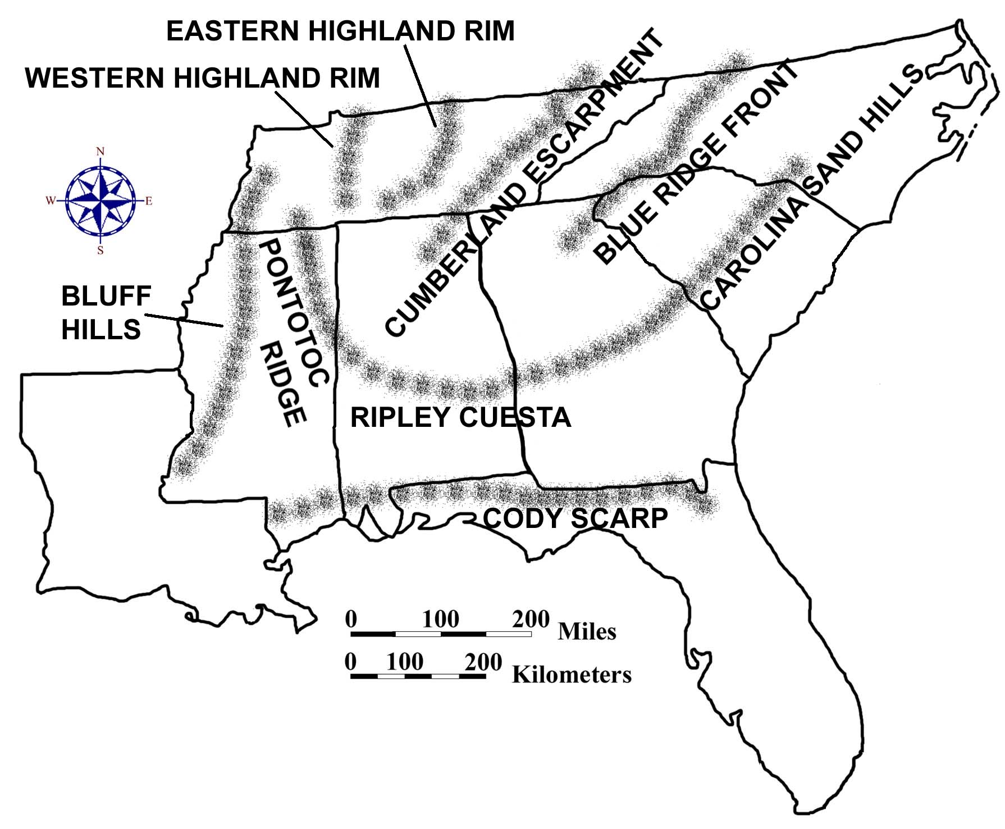

Slope describes the steepness of the land surface in a particular area and is calculated by dividing the elevation difference between two features or points by the horizontal distance separating those points. It is usually expressed as a percentage or as a ratio with units such as meters per kilometer or feet per mile. Slope can also be expressed as an angle by using the trigonometric tangent function. Although areas of higher relief usually exhibit higher slope angles, this connection is not automatic. Landscape features such as sinkholes or salt-dome hills in the Coastal Plain region may possess very steep sides while still exhibiting relatively low relief overall. Some regions display uniformly consistent slope angles, while others exhibit great variability. The Appalachian Plateaus region appears fairly flat over much of its area but has very steep slopes along the sides of its characteristically deeply cut river valleys.

Topography, Soils, and Agriculture

Land elevation levels in general, along with differences in local relief and slope values in particular, exert a profound influence on soil development within a region as well as on the subsequent patterns of agricultural development. In response to these differences, farmsteads in the southeastern United States vary considerably in their size, shape, and geometric plan from region to region. Soil characteristics within a region can be related to climate and topography, as well as to the original rock type from which the soil was formed. At the most basic level of classification, soils can be broadly characterized as residual (formed by in-place weathering of rock) or transported (deposited and weathered at some distance away from the source). Regions of generally high elevation, such as the Appalachian Plateaus and Blue Ridge, tend to produce thin covers of minimally weathered residual and transported soil. Many Blue Ridge soils form on top of colluvial material left by landslides and other mass wasting processes. Lower elevation regions like the Coastal Plain or Piedmont tend to produce much thicker layers of soil that have been much more highly weathered. Transported soils are commonly associated with river floodplains, exposed lake beds, or delta deposits.

Differences in elevation throughout a region often determine the preferred location of farmsteads and the feasibility of other agricultural land uses. Low lying coastal areas, typical of the Coastal Zone region and parts of the Florida Peninsula, often have very poor drainage, making the land unsuitable for most agricultural purposes. Ditches and canals can be dug to drain the swamplands, but such large undertakings require vast resources and coordinated management. As a result, farms in these areas are usually quite large and are often run cooperatively. In the Coastal Plain region, most agricultural land is located on the higher interstream divide areas, avoiding the swampy, forested floodplains. The low relief and generally flat terrain along these divides permits the establishment of the large tracts of farmland necessary for a plantation dominated agricultural system. In the Piedmont region, the best farmland is located along river floodplains, called bottomlands, although many small farms also occupy the less fertile, but better drained uplands. Slope angles are usually sufficient to ensure good drainage, but soil erosion problems are an ongoing concern. In mountainous topography, farms are generally small and closely packed within the confines of narrow river valleys. In some higher parts of the Appalachian Plateaus region, groupings of small family farms also occupy the flatter interstream divide areas.

Some agricultural land-use patterns also have historical connections. Most of the land contained in the original thirteen colonies was settled before 1800. The main roads of that time usually followed Indian trails that carved out winding paths through the forest so as to take advantage of favorable slopes and convenient stream crossing locations. Randomly spaced farmlands were attached to these main roads on either side and generally had irregular outlines. As a result, the landscape resembled a patchwork quilt mosaic made up of individual farm fields of various shapes and sizes. After 1800, much of the new land opened up for settlement was first surveyed into square townships that were six miles long on each side. Each township was then divided into 36 sections, each one mile square and containing 640 acres of land. In these newer settlements, roads and property lines tended to follow the rectangular survey lines, resulting in a highly predictable checker-board pattern of fields and farms. Regularly shaped fields, like rectangles or squares, are usually more efficient to plow, plant, and irrigate using modern agricultural machinery and techniques.

Surveying and Global Positioning Systems

Most digital elevation maps use a variety of different color patterns to display the relative elevation changes that occur across the area of interest. The interval described in the map legend, which expresses numerically the range between adjacent elevation categories, or colors, is selected to best show the topographic variations of the area. Maps depicting areas of low relief normally use small elevation intervals to maximize the number of color bands and to highlight small differences in topographic relief. Maps depicting mountainous areas of high relief normally use very large elevation intervals to avoid forcing too many multiple color bands into small areas of the map. The elevation values of the actual data points, marking positions along a rectangular grid, are extrapolated from contour line data sets based on information contained within topographic quadrangle maps published by the United States Geological Survey (USGS).

The original contour line elevation data printed on most topographic maps is based on ground surveys conducted over the years by scientists and engineers working for the USGS and other state and federal agencies. Only a relatively few points are actually measured to determine their exact elevation. Once these reference points, known as benchmarks, are located on the base map, elementary surveying methods are used to approximate the positions of the surrounding contour lines and the height of nearby hills or mountains. Each surveyed elevation in turn can be used as the basis for a whole new set of measurements until the entire map area has been charted. Each elevation value listed on a topographic map gives that point’s height above or below a standard reference level, usually chosen to be mean sea level.

Figure 3D-2: Basic Surveying Methodology

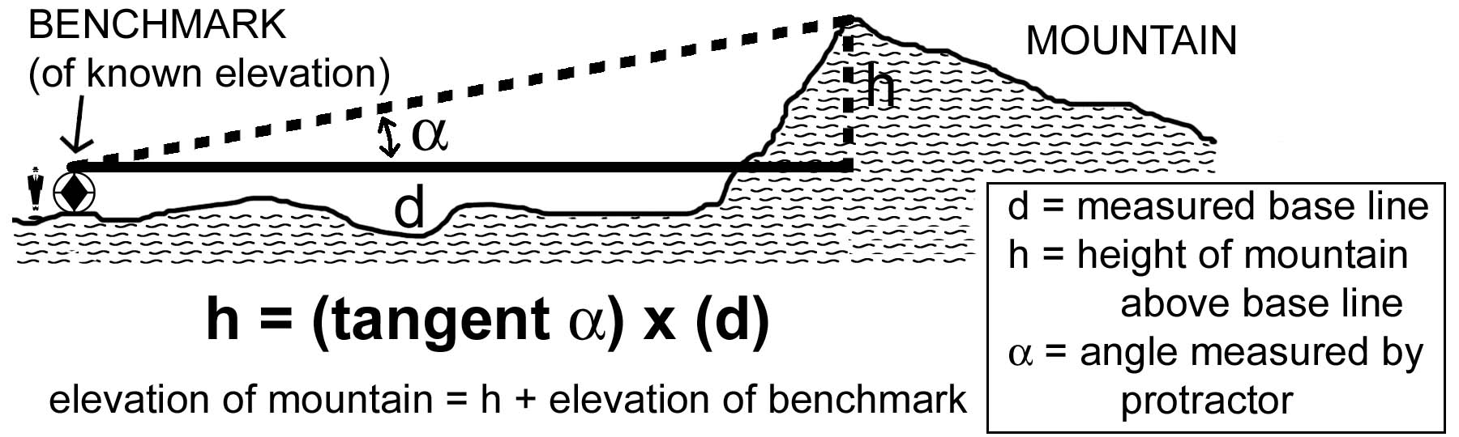

A simple instrument called an Abney Level (also known as a pocket altimeter) combines a level and a protractor to set up a trigonometric relationship that enables the elevation of a point to be calculated as long as the distance to that point is known. Aneroid barometers provide an alternate way of measuring altitude. Atmospheric pressure decreases at a known rate as elevation increases. An index needle connected to a vacuum chamber records these changes in pressure and converts the data to units of elevation above or below sea level. Surveying a large map area on the ground is an extremely time-consuming and labor-intensive task, so geologists now use stereo aerial photography whenever possible to help estimate contour line positions and related elevation values. Nevertheless, benchmark elevations must still be obtained on site to provide the proper reference information to topographic map makers.

The Global Positioning System (GPS) is a fairly new technology that enables people to determine how high they are above sea level and exactly where on the earth’s surface they are located. A GPS system has three major components: satellites, ground stations, and receivers. There are currently 24 GPS satellites orbiting the earth twice per day at an altitude of 20,250 km. (12,660 miles). Each orbit is different and independent of the others, but none is inclined more than 55 degrees from the equator. Although no orbits go directly over the poles, a great many orbits normally can be seen from the poles or from anywhere else on the earth. The goal of the system is to always provide at least 4 satellites somewhere above the horizon, in the visible portion of the sky, from any location on earth. In practice there are usually many more satellites than this, but occasionally there are short periods of time when fewer than four satellites will be visible. Under those conditions, GPS receivers will not work properly until a fourth satellite enters the field of view.

Five ground stations located around the globe monitor the GPS satellites, checking both their operational health and their exact position in space. Things like the gravitational pull of the moon and the sun do change the satellites' orbits very slightly over time, but the Department of Defense constantly monitors each satellite and can adjust its computer signal to correct any significant position changes. A GPS receiver held by a person on the ground, anywhere in the world, collects data from several satellites simultaneously and computes the receiver’s location based on information it gets from the satellites. Any person who owns a GPS receiver can determine his or her precise longitude, latitude, and altitude anywhere on the planet to a matter of meters. With advanced GPS technology, measurements are accurate to the nearest centimeter. The distance to a satellite is determined by measuring how long a radio signal traveling at the speed of light takes to reach the receiver from that particular satellite.

The main principle behind GPS technology involves triangulation from satellites. Triangulation is a basic geometric principle that allows an observer to find a particular location if its distance from other, already recognized locations is known. The geometry behind this is very easy to understand in two dimensional space. As an example, consider a hiker who is somewhere in the Southeast but has become totally lost – the hiker has no clue where he or she is. The hiker might ask someone they meet, “Where am I?” and that person would respond “You are 138 miles from Atlanta, Georgia.” The hiker now has a piece of information about his or her location, but this piece of information in not really that useful by itself. The hiker could be anywhere along the circumference of a circle around Atlanta that has a radius of 138 miles.

So the hiker might ask another person they meet, who responds with the answer “You are 180 miles from Nashville, Tennessee.” Now, it is clear that the hiker is somewhere along the circumference of the second circle as well. Combining the Nashville information with the Atlanta information generates two circles that intersect. The hiker must be at one of two points, the points of intersection.
If the hiker then asks a third person, who responds that the hiker is located 309 miles from New Orleans, it is now possible to figure out exactly which of the two previous intersection points represents the hiker’s true position. Based on all the data presented, it is clear that the hiker’s exact location is somewhere near Birmingham, Alabama.

Figure 3D-3: Triangulation with Global Positioning Systems
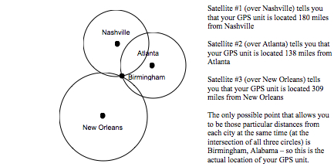

Unfortunately, triangulating with circles only works on a flat, two-dimensional surface. Because of variations in topography, specifically involving height differences above the earth’s surface, it is necessary to determine the hiker’s elevation above sea level in addition to his or her spatial coordinate position. The process of triangulation works in three-dimensional space as well, but the geometry involves spheres instead of circles, and a total of four spheres is required instead of three circles to determine an exact location. By very, very accurately measuring the hiker’s distance from four satellites, it is possible to "triangulate" his or her position and elevation from anywhere on the earth.

Both traditional surveying methods and global positioning systems technology are useful for establishing the position and elevation of high mountains, town centers, or other natural and cultural landmarks. Such features can often serve as useful navigational references for both local and regional travelers and can also draw attention to an area for purposes of enhancing tourism. States or counties often brag about having the highest mountain or the tallest waterfall in their jurisdiction. Naming such prominent features provides a way for communities to honor local heroes or other famous or noteworthy individuals whose actions the public would like to commemorate. Even artificial landforms can achieve special notoriety. For example, Space Mountain in the Disney World Theme Park is considered by many to be the third highest elevation in the state of Florida.
Activity 3D-1: Elevation Patterns and Landscapes

POWER THINKING EXERCISE - "Drastic Detour"
Your uncle is an amateur airplane pilot who has entered a contest to commemorate the Wright Brothers’ first successful powered air flight in 1903 from Kitty Hawk, North Carolina. The contest is actually set up as a race, using historic single-engine aircraft, from the Atlantic Ocean to the Mississippi River through North Carolina and Tennessee. You have agreed to go along with your uncle as co-pilot and navigator of the plane.
While going over the proposed route, your uncle is surprised to learn that he will have to fly over the Appalachian Mountains. You don't understand why this is a problem until your uncle tells you that he has a health problem (sinus and inner ear related) that prevents him from flying more than 1,000 meters (3,300 feet) above sea level in an un-pressurized plane. An additional concern is that the rules of the contest specifically state that all aircraft must fly at least 200 meters (660 feet) above the ground, except for take-off and landing.
Your task is to use the information on the Digital Elevation Map on MAP 3D, TOPOGRAPHY AND CLIMATE, to plot a route through the Appalachian Mountain range that will keep the altitude of your uncle's plane below 1,000 meters while complying with all the rules of the contest. Flying around the mountains to the south through Georgia will not work because that route is too far out of the way and would cause your uncle to lose the race for sure.
Compare your route to those selected by other groups in your class. In a group discussion, come to a consensus on which route gives your uncle his best chance of winning the race.

Materials
MAP 3A, LANDSCAPES AND LANDFORMS
MAP 3C, LANDSCAPE PATTERNS
MAP 3D, TOPOGRAPHY AND CLIMATE
Figure 3-1: "Landform Regions of the Southeast"
Wipe-off Pens

PERFORMANCE TASKS
(Icon Key) Overview = ; Science = ; Math = ; History = ; Language Arts =

1. Correlate elevation data with landform regions.
With a wipe-off pen, name and outline the seven major landform regions of the Southeast on the Digital Elevation Map on MAP 3D, TOPOGRAPHY AND CLIMATE. Use the index map, Figure 3-1, "Landform Regions of the Southeast," as a guide. Which regional boundaries correlate most closely with elevation patterns? Which regional boundaries correlate least with elevation? Refer to the colors (elevation intervals) in the legend to estimate a numerical value for the median elevation of each region. Rank (from 1 to 7)) the seven regions in order of increasing elevation. What information would you need to calculate an actual 'average elevation' for each region?
2. Speculate about straightness of escarpment.
Locate and examine the green/yellow color boundary along the Gulf of Mexico from Florida to Louisiana on the Digital Elevation Map on MAP 3D, TOPOGRAPHY AND CLIMATE. What is the approximate elevation of that boundary, according to the map legend? Notice that if you eliminate the valleys of the major rivers that flow across it, the boundary forms essentially a straight line all the way across the map. In many places, the elevation change is very noticeable at ground level and is referred to as an escarpment, for example, the Cody Scarp in the panhandle of Florida. Review the geologic history of the Coastal Plain Region and speculate about what geologic process or series of processes could have produced such a long, straight feature with such uniform elevation. Present your hypothesis to the class and discuss the likelihood of it being the most reasonable answer.

3. Evaluate appropriateness of statistical analysis.
Read through the boxed list entitled "Highest Point in Each State" on MAP 3D, TOPOGRAPHY AND CLIMATE, and locate the position of each of those points on the Digital Elevation Map. The total data set consists of these eight points with their corresponding elevation values. Do a standard statistical analysis of this set of numbers. Note the maximum and minimum values in the set, and also calculate the median and mean. Are the median and the mean approximately equal? Would you expect them to be equal in this data set? Explain your answer. Read through the statements below and evaluate the appropriateness of each one based on the statistical information you have to work with. In general, how useful is the statistical information you derived from the data set of highest points? Explain your answer.

The average mountain elevation in the Southeast is equal to your mean value.
The average elevation of land in the entire Southeast is equal to your mean value.
Half the mountains in the Southeast are higher than your median value.
Half the states in the Southeast have elevations higher than your median value.
The median elevation in each state is greater than or equal to your median value.

4. Explain why highest point in Florida has no name.
Look through the boxed list entitled "Highest Point in Each State" on MAP 3D, TOPOGRAPHY AND CLIMATE, and locate the highest point in Florida. Note that this is the only highest point on the list that does not have a name. How high does a hill or mountain have to be before it is given a name? Why do you think the hill in Florida was not named? What factors other than height determine whether a landform feature receives a name or not? List these factors and rank them in importance. Share your list with the rest of the class and give some examples of named and unnamed landscape features from your local area to prove your point.

5. Propose name for highest point in Florida.
Look through the boxed list entitled "Highest Point in Each State" on MAP 3D, TOPOGRAPHY AND CLIMATE, and locate the highest point in Florida, which is unnamed. Also locate this point on MAP 3A, LANDSCAPES AND LANDFORMS, and on the two images on MAP 3C, LANDSCAPE PATTERNS. Every important location should have a name, so your group's task is to brainstorm ideas for a name for this hill. Once you have considered at least ten names, select one and write up a brief statement explaining why you chose that name. Consider the landscape surrounding the area when suggesting names for the hill and writing your justification.

ENRICHMENT
(Icon Key) Overview = ; Science = ; Math = ; History = ; Language Arts =

1. Research famous people for whom highest mountains were named.
Look through the boxed list entitled "Highest Point in Each State" on MAP 3D, TOPOGRAPHY AND CLIMATE, and identify the mountains on this list that you think were named after famous people. Pick one of these famous names and research his or her life story and accomplishments. Why was this particular person honored in the state that named the mountain after him or her?

2. Investigate how mountaintop elevations are determined.
Look through the boxed list entitled "Highest Point in Each State" on MAP 3D, TOPOGRAPHY AND CLIMATE, and note that elevations are given to the nearest meter. Today, we use technological advances like global positioning systems (GPS) and altimeters to determine our elevation. Look up information about each of these instruments and list some advantages and disadvantages of using them to determine the elevation of a high mountain. What is the normal precision of such instruments? Geologists used to use surveying tools to figure out elevations of landscape features. Look up information about surveying instruments and techniques and list some advantages and disadvantages of using them to determine the elevation of a high mountain. What is the normal precision of surveying instruments?

Activity 3D-2: Climate and Agriculture

POWER THINKING EXERCISE - "Legend Logic"
You are one of the editors for a book company that publishes a variety of school curriculum materials, including maps and charts. One of your assistants has brought you a map to review that she thinks has a major mistake in the legend. She wants to be sure that everything is correct before she prints thousands of copies for distribution and sale. The map is the Digital Elevation Map on MAP 3D, TOPOGRAPHY AND CLIMATE, and the legend is the color-coded elevation scale on the right hand side of the map.
Your assistant points out that the two lowest elevation categories (dark green and yellow) change color after only 50 meters of elevation gain, while the next three categories (brown, light green, and dark blue) change color every 100 meters. Furthermore, the remaining categories change color every 200 meters.
You agree with your assistant that most legends of this type have a constant interval between successive categories, but you also know that the mapmaker has always been very careful about accuracy and is unlikely to have made such a major mistake. It would hold up the publication schedule too much if you tried to contact the mapmaker personally, so you decide to look at the map carefully to see if you can figure out his reason for setting up the legend this way.
What would be the result if the legend color changed every 200 meters for the entire map? Draw some of the new category boundaries onto the map with a wipe-off pen. Would the legibility of the map be improved or worsened by this change? What would be the result if the legend color changed every 50 meters for the entire map? Draw in some of the new boundaries and indicate whether the legibility of the map would be improved or worsened by this change. Finally, consider the result if legend color changed every 100 meters for the entire map. Again, draw in some of the new boundaries and indicate if the legibility of the map would be improved or worsened.
Which legend interval do you think produces the most useful map, 50 meters, 100 meters, 200 meters, or the mixture that is actually shown on the map legend? Which printing recommendation do you make to your assistant? Justify your answer so she will understand your reasoning.

Materials
MAP 3D, TOPOGRAPHY AND CLIMATE
MAP 3E, POLITICAL SETTING
Figure 3-8, "Average Annual Precipitation for the Southeast"
Figure 3-9, "Average Annual Temperature for the Southeast"
Figure 3-10, "Agricultural in the Southeast"
Magnifying Glasses
Wipe-off Pens

PERFORMANCE TASKS
(Icon Key) Overview = ; Science = ; Math = ; History = ; Language Arts =

1. Correlate major agricultural regions with elevation patterns.
Refer to Figure 3-10, "Agriculture in the Southeast," and the Digital Elevation Map on MAP 3D, TOPOGRAPHY AND CLIMATE, to investigate whether any correlation exists between major agricultural products and elevation patterns. For each major crop listed in the table below, indicate whether or not a correlation exists. If you recognize a possible correlation, briefly describe it. Compare your completed table with the results of other groups in your class and discuss which of your correlations are clear and obvious enough to be considered true.

CORRELATION OF AGRICULTURAL PRODUCTS WITH ELEVATION
AGRICULTURAL  PRODUCT | CORRELATION  (YES / NO / MAYBE) | BRIEF DESCRIPTION  OF CORRELATION
Cattle
Rice
Peanuts
Cotton
Tobacco
Corn
Poultry
Peaches

2. Relate average rainfall and temperature data to elevation differences.
Use a wipe-off pen to draw and label the contour lines from Figure 3-8, "Average Annual Precipitation for the Southeast," onto the Digital Elevation Map on MAP 3D, TOPOGRAPHY AND CLIMATE. Also draw and label the contour lines from both parts of Figure 3-9, "Average Annual Temperature for the Southeast," onto the same map, using different color wipe-off pens. Which of the following correlations best describes the relationships between precipitation and elevation, between January temperatures and elevation, and between July temperatures and elevation? Fill out the chart below with your conclusions.

- positive correlation = higher values tend to occur around the same locations as
higher elevations, and lower values tend to occur
around the same locations as lower elevations

- negative correlation = higher values tend to occur around the same locations as
lower elevations, and lower values tend to occur
around the same locations as higher elevations

- no correlation = there is no noticeable correlation between the pattern of contour
lines and the color pattern on the digital elevation map.
Higher values occur in locations that have many different
elevations, and lower values occur in locations with many
different elevations

CORRELATION OF CLIMATE DATA WITH ELEVATION
CLIMATE  DATA | CORRELATION  (YES / NO / MAYBE) | BRIEF DESCRIPTION OF CORRELATION [positive or negative]
Precipitation
January temperatures
July temperatures

Why do you think there is more variation in winter temperatures (January) in the Southeast compared with summer temperatures (July)? Explain your reasoning. Combine your temperature and rainfall data with elevation data to generalize about the following relationships. How does a change in elevation affect the temperature? How does a change in elevation affect the amount of precipitation that falls? Locate the following two capital cities, Columbia, South Carolina (elevation = 79 meters [259 feet]) and Atlanta, Georgia (elevation = 322 meters [1,057 feet]) on the Political Base Map on MAP 3E, POLITICAL SETTING. Predict answers to the following questions.

- Which will probably be hotter on average (yearly average), Columbia or Atlanta?
- Which will probably be wetter on average (yearly average), Columbia or Atlanta?

Propose a scientific explanation for why you believe your prediction will be correct.

3. Calculate slope from highest elevation to lowest.
Select one of the eight Southeastern states outlined on the Digital Elevation Map on MAP 3D, TOPOGRAPHY AND CLIMATE. Locate both the highest and the lowest points in that state and record the elevation value of each (refer to table of Highest Points in Each State). For states bordering the ocean, the lowest point will always be sea level (0 meters). For Tennessee, estimate the numerical value of the lowest elevation by using the color-coded legend. Calculate the total relief (elevation difference) between the highest and lowest elevation points.

SLOPE CALCULATIONS
NAME OF  STATE | TOTAL  RELIEF (m) | SHORTEST DISTANCE (km) | SLOPE  (m / km) | SLOPE  (ft / mile) | SLOPE  (%) | CATEGORY  (steep, etc.)
Alabama
Florida
Georgia
Louisiana
Mississippi
N. Carolina
S. Carolina
Tennessee

Using the scale of kilometers on the Digital Elevation Map, measure the shortest distance ("as the crow flies") between your highest and lowest points. To calculate the average slope across this distance, you must divide the total relief by the shortest distance. Use units of meters per kilometer. Convert your answer into units of feet per mile and also into a percentage. Based on your personal experience with slopes, would you classify your slope as "steep," "moderate," or "gentle?" Compare your results with other groups. Rank the states in order of greater to lesser slope.

4. Relate size and shape of county (parish) to topography.
Locate your own state on MAP 3D, TOPOGRAPHY AND CLIMATE and also on MAP 3E, POLITICAL SETTING. Count the total number of counties (parishes) in your state (refer to MAP 3E). Use the symbols and colors referenced in the list below to mark the selected counties with a wipe-off pen on MAP 3E. Determine a quick and simple method of estimating sizes and shapes of counties (parishes). Pick and mark ten counties (parishes) for each category below.

- place a green dot in each of the ten counties that seem to have the largest area
- place a red dot in each of the ten counties that seem to have the smallest area
- place a blue “X” in the ten counties that seem to have the squarest shape
(the straightest boundary lines and the most right angle corners)
- place a black “X” in the ten counties that seem to have the most irregular shape

Analyze the distribution of symbols on MAP 3E. If there is a recognizable pattern for any category, try to describe it and enter your data in the chart below based on the correlation of each category with the elevation data on MAP 3D. If the distribution of symbols appears to be random, leave that part of the chart blank. Why and how do you think the size and shape of political jurisdictions like counties might be influenced by the elevation or topography of a region? Give examples to justify your answer.

SYMBOL  CATEGORY | HIGH  ELEVATION | INTERMEDIATE  ELEVATION | LOW  ELEVATION
largest counties
smallest counties
squarest counties
most irregular counties

mark “x” in each column that represents a correlation between category and topography

5. Examine use of metaphorical language in land use terminology.
Read the newspaper article on page 3D-1. The title of the article refers to “King Cotton” and “King Pine” even though the author certainly knows that both cotton and pine trees are plants and can’t really be “king” of anything. What point do you think the author is trying to get across by calling cotton and pine trees “king?” The use of such technically incorrect descriptions illustrates one type of metaphorical language, sometimes referred to as a “personification,” in which the attribute or description of one object is used to describe a second object to which it normally would not apply.

The by-line of this newspaper article, just below the author’s name, is Rock Hill, South Carolina. Locate this city (north of the capital city Columbia and almost at the North Carolina border) on MAP 3E, POLITICAL SETTING, and then mark its approximate location, with a wipe-off pen, on MAP 3D, TOPOGRAPHY AND CLIMATE. What is the approximate elevation of the city of Rock Hill? The higher elevations and steeper slopes of the Piedmont region produced a lot of erosion that carried away most of the good topsoil that the cotton crop needed. The eroded landscape was then good only for growing pine trees.

Write a short newspaper article about how you think erosion caused the decline in cotton production. Use as much metaphorical language as you can to describe the erosion process and the effect it had on cotton as “king.” Choose a catchy title for your article that also uses at least one example of personification. Read your story to another group and ask the members how well they understood the metaphorical references. Which personification label was most successful? Explain why you think that term worked so well to make your point.

ENRICHMENT
(Icon Key) Overview = ; Science = ; Math = ; History = ; Language Arts =

1. Explain pixilation pattern on map.
Look carefully at the boundary lines between regions of different color on the Digital Elevation Map on MAP 3D, TOPOGRAPHY AND CLIMATE. A magnifying glass will help you see the pattern even more clearly. Notice that the boundary is marked by a convergence of differently colored small squares. In fact each colored area is actually composed of millions of these small squares (pixels) that look solid because adjacent squares all have the same color. Almost all computer-generated maps are printed by assigning each pixel a certain color based on the physical characteristics of the area contained in that pixel. Research the way that computers assign color to pixels and how this process is affected by the resolution of the map. What happens if the area covered by one pixel contains land with two very different physical traits? How would the boundaries look different if the map used four times as many pixels in the same area? How would they look different if the map used only one fourth as many pixels in the same space?

2. Locate historical references to topography of farmland.
Use library resources or appropriate web sites to research the history of either large plantations on the Coastal Plain or small family farms in the Piedmont and Mountains. Look for references to topography, especially in regards to elevation and climate patterns. Locate your references as closely as possible on the Digital Elevation Map on MAP 3D, TOPOGRAPHY AND CLIMATE. How did the elevation of the land and the local climate affect the productivity of the farm? How did it affect the type of crops that were grown in the area?

STUDY AREA 3E: POLITICAL SETTING

SARASOTA HERALD-TRIBUNE
March 12, 2002
Bullet Train Decision Delayed a Year
By Gary Fineout  TALLAHASSEE, FL. -  Despite a deadline to begin construction on a new bullet train by November 2003, legislators appear content to wait another year before deciding whether to actually build it or how to pay for it.  In 2000 Florida voters passed a constitutional amendment calling for a state high-speed rail system to be under construction by next year. But instead of deciding when work on the train will begin, the legislators created an authority last year to study how it could be built. Polk County lawmakers who have backed high-speed rail wanted to give the High Speed Rail Authority. | additional power, but after opposition from other legislators, they have agreed to scale back their request.  “We’re halfway to where we need to go,” said Rep. Dennis Ross, R-Lakeland, who has sponsored high-speed-rail legislation for two straight years. “It’s important we get through a bill this year because it shows a sincere effort by the state to fulfill its constitutional mandate,” he said.  The legislation now moving ahead in both the Senate and the House would allow the High Speed Rail Authority to go ahead with a ridership study and ask for proposals from companies that might be interested in designing, building or | operating a system  But the authority would not be allowed to approve a contract to build a train, nor is there any plan that spells out who would pay for a bullet train, which would cost more than $1 billion for just the first segment between St. Petersburg and Orlando.  The compromise was enough to help Ross’s bill (HB 1515) start moving last week after remaining stalled most of the session. A House panel approved it last Friday, so it could come to the House floor this week. Sen. Jim Sebesta, R-St. Petersburg and chairman of the Senate Transportation Committee, insisted that this approach makes sense.

RATIONALE
Political boundaries divide a geographic region into manageable legal entities, such as states, cities, counties, or parishes which share a common historical or economic framework, or contain other natural or social characteristics that tend to unify the people living there. Boundary lines often follow recognizable geographic features such as rivers or drainage divides. They can also be laid out arbitrarily along lines of latitude or longitude, or as straight lines connecting designated landmarks. Efficient movement of people and trade goods within and between political jurisdictions is a necessary requirement for sustained economic growth. Transportation routes tend to focus on areas of commercial or industrial activity and avoid natural obstacles such as mountains or swampland whenever possible. Historical patterns of settlement and expansion were highly dependent upon such transportation corridors. The switch from water travel routes to land-based roads and railroads opened up vast new territories of land for settlement and economic development.
PERFORMANCE OBJECTIVES

1. Analyze landscape factors that affect location of transportation routes and facilities.
2. Identify obstacles encountered in the building of overland transportation networks.
3. Compare modern rates of travel with map-based estimates of rates of historical travel.
4. Compare the locations of major roads of the early 1800s with modern highways.
5. Compare and contrast writing styles of today with historical documents.
6. Analyze state boundary lines and classify them as either natural or political.
7. List advantages and disadvantages of using a drainage divide as a state boundary line.
8. Locate geographic center of a state and its distance from that state’s modern capital.
9. Identify reasons why many state capitals have been moved inland since colonial times.
10. Invent descriptive names for cities that would be divided by state boundary lines.

SAMPLE ASSESSMENT RUBRICS
EXAMPLE #1 (relates to Performance Objective #2)
Give students MAP 3E or another map showing interstate highways in the Southeastern United States. Also give students MAP 3A or another map showing major topographic features of the region. Ask them to identify (either by marking the spot on the map with a wipe-off pen or describing the site in writing) a location where a natural landscape feature might have created an obstacle to the construction of the highway. Explain briefly the problem encountered and suggest a way that problem was overcome.

A (level 4) – Location reasonable; problem described well; solution makes sense.
B (level 3) – Location reasonable, problem described well, solution not logical; or
Location reasonable; problem misdiagnosed; solution makes sense.
C (level 2) – Location reasonable; problem misdiagnosed, solution not logical; or
Location not sensible; problem described well, solution makes sense.
D (level 1) – Location not sensible, problem described well; solution not logical or
Location not sensible, problem misdiagnosed; solution makes sense.
F (level 0) – Location not sensible, problem misdiagnosed, solution not logical.

EXAMPLE #2 (relates to Performance Objective #6)
Give students MAP 3E or another map showing counties in your state. Outline or otherwise highlight and identify the county you want the students to examine. Ask the students to divide the county boundary lines into logical segments and predict (based on the shape and regularity of the line) whether each boundary line segment is natural (follows topographic features) or political (follows surveyed lines). Ask students to justify their answer for each boundary segment.

A (level 4) – All segments logical; identified correctly; justified clearly.
B (level 3) – All segments logical; identified correctly; justified poorly; or
Most segments logical; identified correctly; justified clearly.
C (level 2) – Most segments logical; identified correctly; justified poorly; or
Most segments logical; identified incorrectly; justified clearly; or
Some segments logical; identified correctly; justified clearly.
D (level 1) – Some segments logical, identified correctly, justified poorly; or
Some segments logical; identified incorrectly; justified clearly; or
Most segments logical; identified incorrectly; justified poorly.
F (level 0) – Few if any segments logical; identified incorrectly; justified poorly.
Cartographic Product Information

MAP 3E: Political Setting

TITLE: Political Base Map of the Southeastern United States
DATA SOURCE: United States Census Bureau, TIGER/94 Data, via Tiger Map Server (Topologically Integrated Geographic Encoding and Referencing system)
<http://tiger.census.gov>
DATE: 1994
SCALE: approximately 1:2,650,000 [1 inch ~ 42 miles] [1 cm ~ 28 kilometers]
OTHER IMPORTANT DATA:
- This map outlines, but does not name, counties in all eight SE MAPS states.
- Only larger cities and towns are shown on this map to save space.
- Rivers, lakes, and reservoirs are shown in blue, but are not named.
POINTS OF SPECIAL INTEREST:
- Major metropolitan areas such as Atlanta, Jacksonville, Birmingham, and Nashville are also major hubs for interstate highways and major railroads.
- Most capital cities are located near the geographic center of their state.
OTHER FEATURES TO LOOK FOR:
- Major highways tend to follow the same routes as major railroad lines.
- Very few major highways or railroad lines run close to the shoreline, except along the eastern coast of Florida.

TITLE: The Southeastern United States before 1800
DATA SOURCE: Composite sketch made from data obtained from several historical atlases of the United States.
DATE: various
SCALE: approximately 1:7,000,000 [1 inch ~ 110 miles] [1 cm ~ 70 kilometers]
OTHER IMPORTANT DATA:
- Both Louisiana and Florida alternated between French and Spanish control during colonial times. Likewise, the western land claims of the various states changed from year to year depending on the political climate of the country.
POINTS OF SPECIAL INTEREST:
- Watauga Settlements, which were the first significant English towns west of the Appalachian Mountains. People migrated into the region from the Shenandoah Valley of Virginia, not from coastal North Carolina.
- Isolated towns like Nashville, Huntsville, Memphis, Vicksburg, Pensacola, Biloxi, Baton Rouge, Natchez, and Natchitoches which were little more than frontier forts in the wilderness and had few permanent residents at this time.
- The earliest capital cities, which were located along the coast, at that time the center of population density.
OTHER FEATURES TO LOOK FOR:
- Only the eastern boundaries of North Carolina, South Carolina, and Georgia had been fixed at this time. Most of the western parts of these states were designated as “Indian Territory” and were occupied by Native Americans.
Study Area Description

Natural Features as Effective Political Boundaries

Rivers have long been used as boundaries between counties, states, countries and even individual land holdings. Where rivers are primarily erosional, such as in most mountainous regions, channels and riverbanks tend to be fairly stable and form easily recognizable boundaries. An obvious advantage is that everyone knows where the river is located without having to hire a surveyor. A disadvantage is that a town might be able to control land use on its own side of the river but have little or no control over what another political unit did on the other side of the river, a situation that could result in major pollution or other problems. Rivers flowing in a depositional mode, as for example in the Coastal Plain region, create a variety of special boundary problems because their channels don't remain in one place, but meander continually over wide floodplains. There are several examples of parcels of land that once belonged to landowners in Mississippi, which are now located on the Louisiana side of the Mississippi River. After a few more shifts of the river channel, those same landowners might even find themselves back on the Mississippi side of the river. Although most river-based boundary lines are defined by the centerline of the main channel, sometimes one bank of the river is designated as the border of a political unit, leaving complete control of the river to a different jurisdiction. Another boundary problem typically occurs near the ocean, where a river may divide into several channels of approximately equal size, creating confusion over which one represents the real border.

Oceans and large lakes at first may seem like perfect boundary lines, but even here similar problems may arise. Although nobody disputes where the ocean begins, most beaches tend to shift position as sand is gradually eroded and re-distributed along the shoreline. Tidal inlets also tend to migrate through time. Hurricanes and other major storms can cause rapid changes in shoreline configurations. Lakes are temporary features that gradually fill up with sediment. When new land is produced, it is not always clear to whom it belongs or to whom the tax bill should be sent. When private land adjacent to a river or ocean is removed through erosion, the owners of that land may request compensation for their loss.

The final type of natural feature commonly used as a political boundary line is the drainage divide. A divide is a ridgeline that separates two or more major watersheds and is relatively easy to locate in areas of moderate to high relief, although it is not always clearly visible to the untrained observer. Drainage divides are well-defined topographic features, and all surface water runoff remains on the same side of the divide as it originally precipitated. Therefore, there is little chance of water pollution crossing such a border. In mountainous areas, the irregular shape and rugged topography of drainage divides often makes them difficult to survey and locate precisely. One solution is to simply define a straight line connecting two easily identifiable landmarks as the border. Drainage divides have served historically as effective cultural barriers. Because of easy transportation up and down river systems, local customs tended to spread within drainage basins much more quickly than across them. As a result, it was often advantageous politically to place as much of a watershed as possible within the same administrative unit or subdivision.

Historical Reasons for Placement of State Boundaries

The original borders of most of the southeastern states actually encompassed a much larger surface area than what each state occupies today. The 1665 Carolina land grant given by King Charles II of England to the eight Lords Proprietors, noblemen in the King's court, included all the land in North America between twenty-nine degrees north latitude and thirty-six and one half degrees north latitude. It also stretched all the way from the Atlantic Ocean to the Pacific Ocean. By 1729, however, the Carolina colony had been split into northern and southern halves and in 1732, the colony of Georgia was established. By the close of the Revolutionary War, the newly formed states of North Carolina, South Carolina, and Georgia had all staked claims from the Atlantic Ocean to the Mississippi River.

Similar land claims were made by other colonial powers. Spanish Florida originally extended westward all the way to the Mississippi River, and the Louisiana Territory, purchased from France in 1803, was itself nearly as large as all of the rest of the United States east of the Mississippi River. Such large states would have been impractical and politically ungovernable because of the sparse population and limited transportation options. The present-day state boundaries in the Southeast were essentially finalized in 1819 when the state of Alabama was carved out of previously disputed land. Tennessee and Mississippi had been admitted to the Union earlier, as had Louisiana, after it had been separated from the rest of the western Territory. Latitude lines were often used to define the northern and southern boundaries of these states as well as the position of various county lines within the states.

Some of the present southeastern state boundaries, in particular the one separating North and South Carolina, are irregular in shape because of a series of surveying errors and later corrections. According to the original agreement in 1735, the Carolina boundary was to start at a point thirty miles southwest of the mouth of the Cape Fear River and was to extend diagonally northwest until it reached the thirty-five degree latitude line. At that point the boundary would follow the latitude line westward to the Pacific Ocean. Unfortunately for South Carolina, the surveyors missed their mark by about eleven miles, and the boundary was run incorrectly all the way to the Catawba River. During the later westward extension of this boundary, surveyors tried to compensate South Carolina by running the line about seventeen miles north of the thirty-five degree latitude line. Although this line was straight, it was not perfectly parallel to the latitude line. The final surveying of the extreme northwestern boundary of the state was completed in 1815 when Andrew Ellicott ran a straight line from the ridgeline near Sassafrass Mountain to the point where the Chattooga River crosses the thirty-five degree latitude line.

Early Transportation Systems

Transportation is the lifeblood of every growing and successful political and economic system. Before 1800, most commercial travel was by water, and the economic interests of the newly created United States of America remained closely tied to foreign trade through port cities along the Atlantic Ocean. Several of these port cities served as early capitals for states located on both the Atlantic and Gulf coasts. Although the center of commerce was along the coast, most of the crops and other trade goods were produced far from the ocean. Inland travel was risky at best, and the roads of the day were scarcely more than paths or trails through the forest. Various Native American nations controlled much of the land away from the coast, and European trade followed these “Indian Trails” to a number of frontier outposts and trading sites. Even along the major rivers, however, convenient transportation existed only from the ocean to the Fall Line Zone, where rapids and shoals marked the transition from the Coastal Plain region to the Piedmont. Boats had to be loaded and unloaded to get around the rapids. Towns quickly sprang up along the Fall Line Zone to meet the need for these services, and many of these towns eventually became capital cities as the need for a more centrally located state government became obvious to political leaders.

Figure 3E-1: Major Canals and Waterway Projects
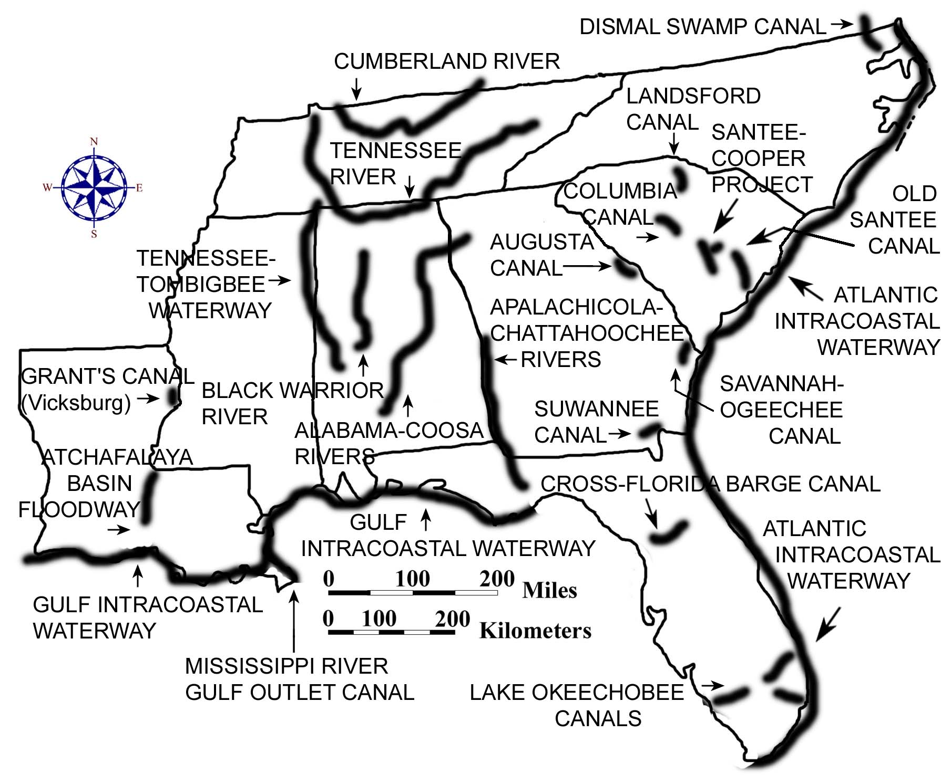

The War of 1812 demonstrated the inadequacy of the nation’s internal transportation system, and American leaders like Henry Clay and John C. Calhoun pushed for the building of canals all across the country. Some of these canals simply bypassed the rapids of the Fall Line Zone, while others created shortcut links between two entirely different river drainage systems. In a number of instances, the rivers did not always have enough water for navigation, and the canal system in the southeastern states was never very successful. Plantation owners continued to struggle to find more reliable ways of getting their products to market. With the advent of railroads, the majority of the canal system became obsolete and fell into disuse. Later efforts, with the possible exception of the Tennessee-Tombigbee project and the Intracoastal Waterway, were directed more towards water management issues than in providing transportation. Examples include the Tennessee Valley Authority reservoirs, the Santee-Cooper Project in South Carolina, and the Lake Okeechobee Canals in Florida. Although most of the canals and waterways in the Southeast were designed and built originally for commercial trade, today, personal watercraft compose most of the boat traffic on these routes, especially along the Gulf Coast and Atlantic Intracoastal Waterways.

Figure 3E-2: Major Roadways, 1800
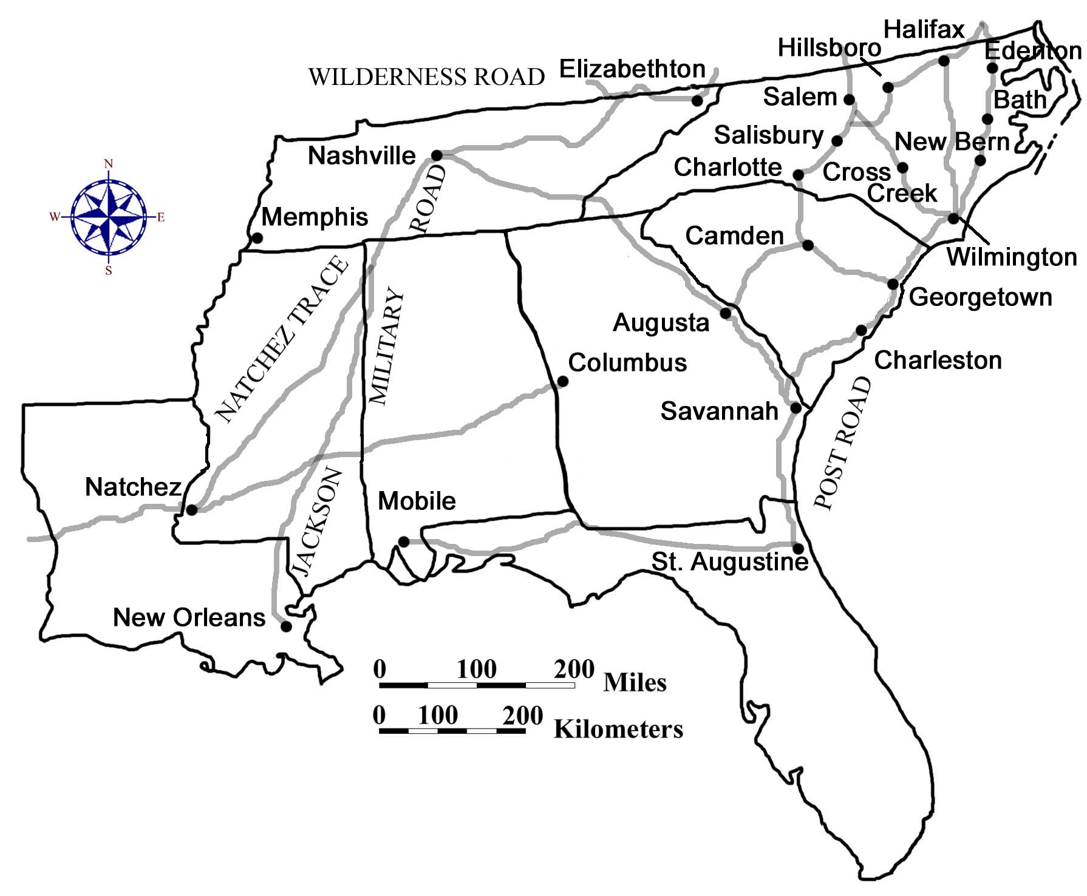

In 1800 it was easier and quicker to travel from New York City to Savannah, Georgia by boat than it was to travel from Atlanta, Georgia to Savannah by road. Nevertheless, a surprising number of settlers entered the region by road either on foot or with their horses and wagons. The Great Philadelphia Wagon Road was one example of a major immigration route, primarily for German and Scotch-Irish settlers. It stretched seven hundred miles from Philadelphia, Pennsylvania, extending through the Carolina Piedmont, and ended at Augusta, Georgia. It was German settlers living in Pennsylvania who had developed a special type of covered wagon, known as the Conestoga, which was used extensively on this road. This heavy wagon was constructed of hardwoods and required six horses to pull it. It was covered by a canopied top that was called a "poke bonnet" due to its similarity to a woman's bonnet. When fully loaded, these wagons could still travel approximately thirty miles a day, even on the unpaved, rutted pathways that passed for roads at that time. During the last years of the colonial period, the Great Philadelphia Wagon Road was one of the most heavily traveled roads in America.

Other major highways of the time included the famous Wilderness Road associated with Daniel Boone, a coastal Post Road that connected major port cities, and another major inland road that followed the Fall Line Zone through the Carolina sandhills. Other roads, such as the Natchez Trace and General Andrew Jackson’s Military Road, crossed the western wilderness using a combination of old trails blazed by Native Americans. But with continued population growth, it wasn’t long until a full network of highways, characterized by ‘farm-to-market’ roads, became commonplace in the region. Some of these roads followed rivers and streams, while others followed ridges or drainage divides to avoid the numerous stream crossings that would have required the building of bridges. Most modern highways follow the same routes as these early trails and roads that connected the communities that once were the mainstay of local economic growth and cultural expression.

President George Washington's Southern Tour

"Nothing would give me more pleasure than to visit all the Southern States" was the reply President Washington made to the invitation extended to him by Governor Charles Pinckney of South Carolina. George Washington had just been inaugurated as the first president of the United States in 1789, but he had never been south of his home state of Virginia. Washington wanted to promote the new federal union and hoped that his personal popularity would help to unite the newly formed country.

President Washington traveled in a cream colored coach pulled by four horses. He was accompanied by a two-horse baggage wagon, four horses for his outriders, and a white riding horse for himself. He had originally planned to compensate tavern keepers for food and lodging, but even then southern hospitality was the custom. He accepted many invitations to dine and lodge with plantation owners primarily because there were few lodging houses along his route. Washington kept a journal describing the people he met on his journey, personal comments on the landscape, and the time and distance he traveled. Washington liked to get up early and be on his way by sunrise. He would usually travel about 10-20 miles before stopping for breakfast. The following account of his southern tour is excerpted from Washington’s diary.

Diary of the First Presidential Visit to the South
Washington's Southern Tour Through the Sandhills
Excerpted from a pamphlet prepared by A.S. Salley,
a former South Carolina State Historian
[ ] Indicates editorial notes inserted by SE MAPS authors
( ) Indicates editorial notes inserted by A.S. Salley
Highway numbers given in the editorial notes are included for reference only. There were no numbered highways in the 1700's.

From May 12-21, 1791, George Washington toured Georgia, visiting Savannah, Waynesboro, and Augusta, before entering South Carolina on May 21, 1791 on his way to Charlotte, North Carolina.

Entry for Saturday, May 21, 1791
Left Augusta about 6 o'clock, and takg. leave of the Governor & principal Gentlemen of the place at the bridge over Savanna River, where they had assembied for the purpose, I proceeded in Company with Col. Hampton & Taylor, & Mr. Lithgow a committee from Columbia, (who had come on to meet & conduct me to that place) & a Mr. Jameson from the Village of Granby on my Rout.
Editorial Notes
[A three gun salute was fired as George Washington entered South Carolina from Augusta over Hampton's Bridge, spanning the Savannah River Washington's party left North Augusta on US Hwy. 25 and dined at Pine House Tavern just west of Trenton. From Trenton, Washington passed through Batesburg and Leesville on his way to Columbia.]

Entry for Sunday, May 22, 1791
Rode about 21 miles to breakfast, and passing through the village to Granby just below the falls in the Congaree (which was passed in a flat bottomed boat at a Rope Ferry,) I lodged at Columbia, the newly adopted Seat of the Government of South Carolina about 3 miles from it, on the No. side of the river, and 27 miles from my breakfasting stage.
The whole Road from Augusta to Columbia is a pine barren of the worst sort, being hilly as well as poor.--This circumstance added to the distance, length of the stages, want of water and heat of the day, foundered one of my horses very badly.
Beyond Granby 4 miles I was met by sevl. Gentlemen of that place & Wynnsborough [Winnsboro]; and on the banks of the River on the No. side by a number of others, who escorted me to Columbia.
Editorial Notes
[Washington's diary is not clear where he lodged at night or ate breakfast.
At sunset, Washington crossed the Congaree River at Fridig's Landing, located south of Granby. Records indicate that crowds lined the Congaree River on both sides anxiously awaiting the President's arrival.
A procession formed as President George Washington mounted his white charger followed by his cream-colored coach drawn by four bay horses. The coachman and footmen were all formally dressed in blanket coats, white and orange liveries, jockey caps, buckskins, and boots. The baggage wagon followed this procession to the State House. From there Washington was taken to a house prepared for his arrival.]

Entry for Monday, May 23, 1791
Dined at a public dinner in the State house with a number of Gentlemen & ladies of the Town of Columbia, & Country round about to the amt. of more than 150, of which 50 or 60 were of the latter.
Editorial Notes
[Washington dressed in black-velvet formal wear to greet the guests. Sixteen after-dinner toasts were made identifying hopes for the future and concerns of the times. Topics of some of these toasts were:
"A speedy establishment of a central federal city;"
"The federal legislature--may their virtues and abilities be as much admired abroad, as they are respected at home;"
"Sufficient means and speedy measures for opening the inland navigation of America;"
"Increase to our exports, and decrease to our imports;" and
"An increase of well established seminaries of learning.]"

Entry for Tuesday, May 24, 1791
The condition of my foundered horse obliged me to remain at this place, contrary to my intention, this day also.
Columbia is laid out upon a large scale; but in my opinion, had better been placed on the River below the falls.--It is now an uncleared wood, with very few houses in it, and those all wooden ones--The State House (which is also of wood) is a large and commodious building, but unfinished--The Town is on dry, but cannot be called high ground, and though surrounded by Piney & Sandy land is, itself, good--The State House is near two miles from the River at the confluence of the Broad & Saluda. From Granby the River is navigable for Craft which will, when the River is a little swelled, carry 3000 bushels of Grain--when at its usual heighth less, and always some.--The River from hence to the Wateree below which it takes the name of the Santee is very crooked; it being, according to the computed distance near 400 miles--Columbia from Charleston is 130 miles.
Editorial Notes
[The original State House was a wooden structure located with the front side facing the Congaree River. It was burned during the Civil War.]

Entry for Wednesday, May 25, 1791
Set out at 4 o'clock for Camden--(the foundered horse being led slowly on)--breakfasted at an indifferent house 22 miles from the town, (the first we came to) and reached Camden about two o'clock, 14 miles further, when an address was recd. & answered.--Dined (late with a number of Gentlemen & Ladies at a public dinner.--The Road from Columbia to Camden, excepting a mile or two at each place, goes over the most miserable pine barren I ever saw, being quite a white sand & very hilly.--On the Wateree within a mile & half of which the town stands and lands are very good,--they Culture corn, Tobacco & Indigo.--Vessels carrying 50 or 60 Hhds. of Tobo. come up to the Ferry at this place at which there is a Tobacco Whare-house.
Editorial Notes
[Washington left Columbia on the Old Camden Road. In Camden, dinner was held in his honor and he toasted the memory of General Nathanael Greene and Baron de Kalb, who were local heroes of the Revolutionary War.]

Entry for Thursday, May 26, 1791
After viewing the british works about Camden I set out for Charlotte--on my way--two miles from Town--I examined the ground on wch. Genl. Green & Lord Rawdon had their action.--The ground had but just been taken by the former--was well chosen--but he not well established in it before he was attacked; which by capturing a Videt was, in some measure by surprise--Six miles further on I came to the ground where Genl. Gates & Lord Cronwallis had their Engagement wch. terminated so unfavourably for the former.
Camden is a small place with appearances of some new buildings.--It was much injured by the British Whilst in their possession.
After halting at one Sutton's 14 m from Camden I lodged at James Ingrams 12 miles farther.
Editorial Notes
[Washington toured several Revolutionary War battlefields, evaluating the tactical performance of his wartime generals. Leaving Camden, Washington stayed with James and Margaret Ingram on their 2000-acre plantation near the Hanging Rock Battlefield.]

Entry for Friday, May 27, 1791
Left Ingrams about 4 o'clock, and breakfasting at one Barr's 18 miles distant lodged at Majr. Crawford's 8 miles farther--About 2 miles this place I came to the corner where the No. Carolina line comes to the Rd.--from whence the Road is the boundary for 12 miles more.--At Majr. Crawford's I was met by some of the chiefs of the Catawba nation who seemed to be under apprehension that some attempts were making, or would be made to deprive them of part of the 40,000 Acres wch. was secured to them by Treaty and wch. is bounded by this Road.
Editorial Notes
[Washington listened to the Catawba Chiefs' grievances; however, he did not act on them. It is thought that Washington knew Congress had already placed such matters in the hands of the states.
On Saturday, May 28, 1791, Washington left South Carolina. As his cavalcade crossed the boundary line, Washington was again riding his white charger. A party of militiamen from Salisbury was there to greet him. From there he went to Charlotte, where hundreds had camped in wagons and tents to catch a glimpse of the first President of the United States of America, General George Washington.]

The Coming of the Railroads

The South Carolina railroad from Charleston to Hamburg (located across the Savannah River from Augusta, Georgia) was the first major railroad project attempted in the southeast. Completed in 1833, this 136 mile long route attempted to entice farmers from the upstate regions of South Carolina and Georgia to export their crops through the port at Charleston instead of through the port at Savannah, Georgia. For a little while, this railroad line was the longest one in the world. Construction of new routes accelerated greatly in the decades that followed, linking most major cities in the region. As railroad lines interconnected more and more of the larger population centers, the affected areas experienced a renewed spurt of economic growth. Private companies and investors were responsible for most of this railroad construction, but the states aided the railroads by buying stock or guaranteeing bonds.

One truly disastrous railroad enterprise was the multi-state Blue Ridge Railroad project to connect Savannah, Georgia, Charleston, South Carolina, and Wilmington, North Carolina with Cincinnati, Ohio. Several states risked millions of dollars on this failed project. Rather than run the rails over the mountains in northwestern South Carolina and western North Carolina, the engineers planned to run the trains through three tunnels into extreme northeastern Georgia. The first tunnel was called Saddle Tunnel and was to have been 616 feet long. Workers, mostly Irish immigrants, began cutting through hard blue granite with sledge hammers from both ends in 1856. They were within 200 feet of each other when the work was halted. The second, the 385 foot Middle Tunnel, was completed. Stumphouse Tunnel, the third and longest at 5,863 feet, was not far from completion when lack of money halted work in 1859. The Civil War broke out before additional funds could be raised, and following the war none of the states was in a position to resume work, ending for many years the dream of crossing the Appalachians by rail from the Carolinas.

The growth of Atlanta, Georgia, Charlotte, North Carolina, and other major southeastern Piedmont cities exemplifies the importance of railroads to the development of the region. Between 1850 and 1860, several of these towns more than doubled their population as railroad connections provided new opportunities for jobs and services. But following the Civil War, the railroad system was left in poor condition. Engines and cars were worn out, and miles of track and trestle had been destroyed. Rebuilding the railroads proved costly, and several corporations went bankrupt in the effort. Finally between 1873 and 1880, new railroad regulations permitted companies to reorganize and refinance. This reorganization produced an emphasis on repairing infrastructure and resulted in marked improvements in rails, bridges, station accommodations, and the speed and frequency of trains. By 1880, one could travel from Charlotte, North Carolina to Raleigh, North Carolina in under five hours. Nearly 5,000 miles of railroad track criss-crossed the southeast and transported over two million passengers and carried over three million tons of freight per year. This growth continued so that by 1910, trains made it possible for statewide newspapers, printed in the capital city, to be available in most local towns around the state before breakfast the next day.

Modern Transportation

The automobile has been a major influence in modern culture and has changed the way most Americans travel and do business. Prior to 1940, every small town had its own small commercial center where city dwellers could fulfill their basic shopping needs with a short walk or by using local rapid transit systems. Mill villages contained company stores, schools, churches, and recreation facilities, and provided all the services and comforts that were needed by the local population all within walking distance of most residents. Farm families usually didn’t have the time or the opportunity to travel much. In fact, the majority of both rural and urban Americans seldom traveled far for either business or pleasure. When any long distance travel was required, most people took the train. Only wealthy families had their own car. Industries selected their locations based on the availability of power (either water power or electrical power), and access to a railroad line. Almost all shipping was done by rail. The extensive rail network made it possible for small industries and commercial centers to spring up in widely scattered areas across the Southeast, but especially within the Piedmont Region. Travel by air was a glamorous novelty that only the very wealthy could afford.

Figure 3E-3: Interstate Highways in the Southeast, 2000

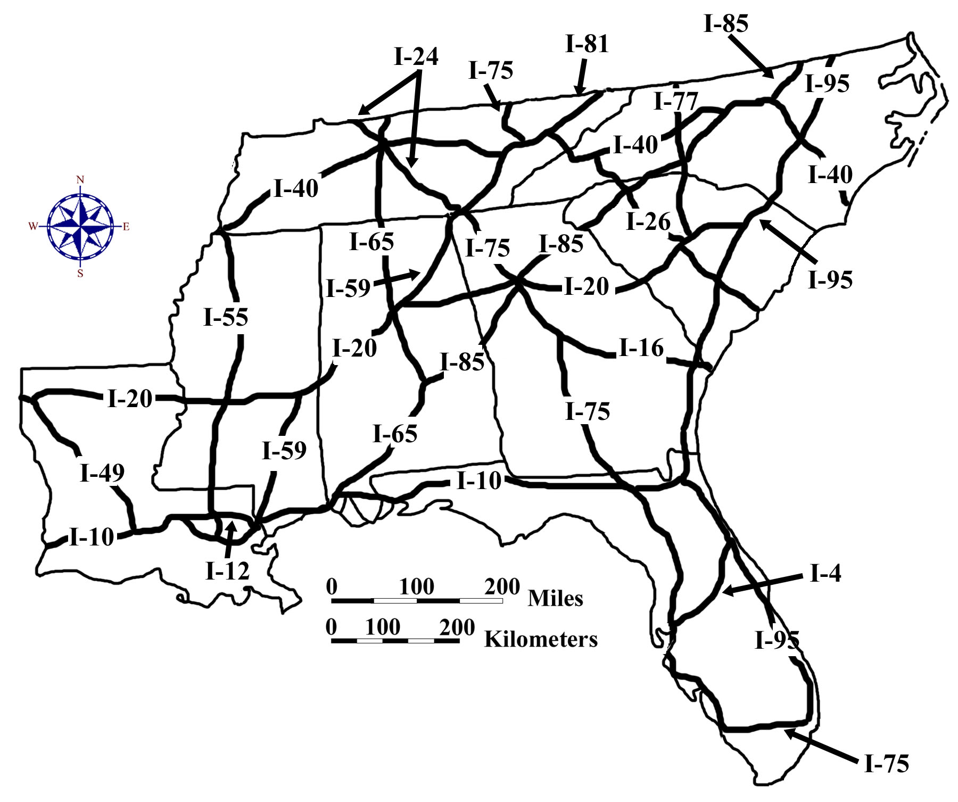
Construction of the Interstate Highway System started in the 1950's under the leadership of President Dwight D. Eisenhower. Begun as an emergency transportation route for national defense purposes, the Interstate Highway System has expanded into all parts of the United States and now provides fast, efficient transportation for cars and trucks, especially those traveling long distances. Interstate highways running primarily north-south are designated by odd numbers, while east-west routes are designated by even numbers. Beltlines around major cities are identified by placing an even number in front of the interstate route number (such as 295 around Jacksonville, Florida, or 440 around Raleigh, North Carolina). Spur routes that branch off an interstate and then dead end are identified by placing an odd number in front of the interstate route (such as 185 to Columbus, Georgia, or 510 to New Orleans, Louisiana). In places where interstates bypassed city centers, an abundance of shopping malls, commercial facilities, and industrial parks followed, until an entire suburban culture sprang up like a series of satellites around the town center. Most people preferred to use their cars and shop in large suburban stores, a practice which forced former commercial districts in town or city centers, faced with a major loss of business, to either close completely or make drastic changes in their operations. As a result, many people in both rural and urban areas now had to pay more or travel a lot farther to do their shopping, an inconvenience for both poor people and those who do not drive or own a car.

The commercial and industrial development along Interstate highways is a prime example of cultural and land use changes brought about by the introduction of a major new transportation network. Interstate 85, for example, links the major southeastern urban areas of Charlotte, North Carolina, and Atlanta, Georgia. It follows approximately the route of the Norfolk Southern Railroad main line and passes through or near the major cities of Gainsville, Georgia, Greenville and Spartanburg in South Carolina, and Gastonia, North Carolina. New businesses and industries have sprung up all along this route, mostly around major interchanges. New malls and housing subdivisions have followed closely behind. Although these developments have brought a newfound prosperity to the communities in the Interstate 85 corridor, they have also siphoned off business from other towns and cities that are not as near to an interstate highway.

Partly as a result of America’s increasing reliance on the automobile for the vast majority of business and leisure travel, traffic levels have grown faster than road capacity, and bottlenecks have become common occurrences in many urban areas of the southeast. In addition, air pollution levels have risen substantially and urban sprawl has threatened to reduce the quality of life for both urban and rural residents. In the past, the preferred solution has been to simply build more roads or add more lanes to existing highways. In some urbanized areas, these solutions are no longer financially affordable or feasible. Many transportation engineers believe that a multi-modal transit model is the only solution to sustainable growth and environmental preservation. Under such a system, air travel would be the preferred mode for distances over 500 km (300 miles); high-speed rail lines would serve major population centers less than 500 km (300 miles) apart; and bus lines, local rapid transit systems, or “park-and-ride” facilities would carry passengers from their homes to the nearest transportation hub. Each transit mode would link seamlessly to others at terminals or stations designated as transfer points for passengers.

Figure 3E-4: Passenger Rail Lines in the Southeast, 2000
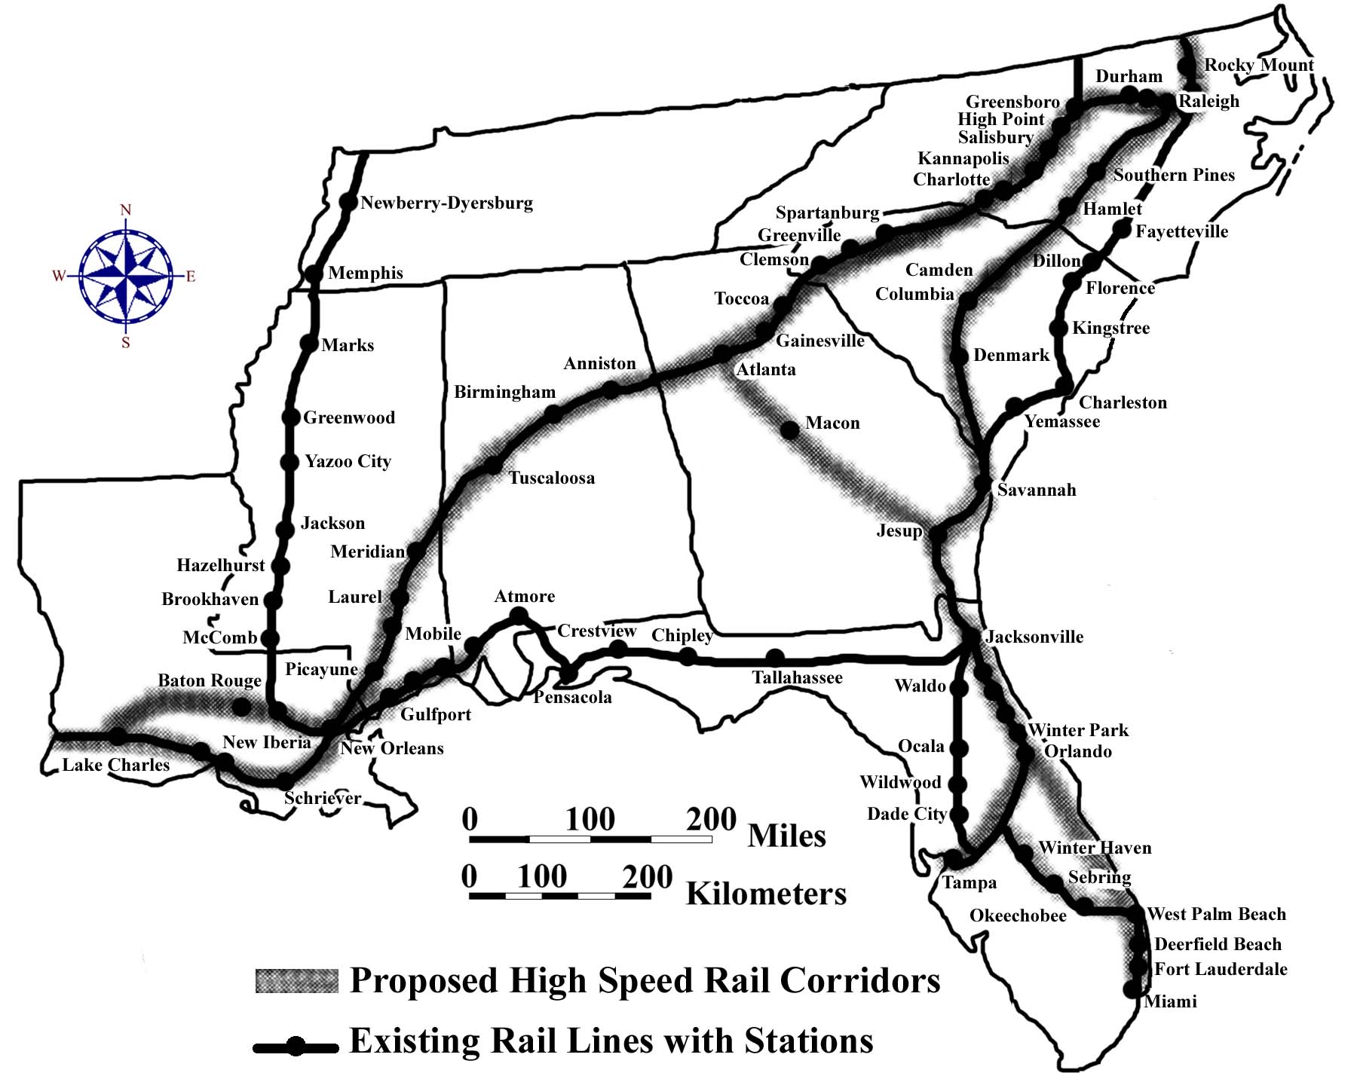

Activity 3E-1: Transportation Systems

POWER THINKING EXERCISE - "Canal Connections"
In the early 1800s, the Tennessee River was the only readily available transportation route for the rapidly growing towns of Knoxville, TN, Chattanooga, TN, and Huntsville, AL. As the population in this area grew, the need for markets for agricultural products and other trade goods increased dramatically. The year is 1805, and you are a grain merchant in Knoxville, Tennessee, who has negotiated trade agreements with several European countries. It is important that you get your product to one of the major ocean ports, such as New Orleans, LA, Biloxi, MS, Mobile, AL, Savannah, GA, Charleston, SC, or Wilmington, NC as quickly as possible. At the moment, your only option is to send your products down the Tennessee River to the Ohio River and then all the way down the Mississippi River to New Orleans. With a wipe-off pen, trace this route onto the Political Base Map on MAP 3E, POLITICAL SETTING. Refer to MAP 3A, LANDSCAPES AND LANDFORMS, if you need help identifying these rivers. You know that you could sell a lot more of your product at cheaper cost if you had a shorter route to the ocean.
Your task is to examine the Political Base Map (and the Landform Map if needed) and find the best location to build a canal which would connect the Tennessee River with one of the rivers flowing eastward or southward towards the Atlantic or Gulf coasts. Which port city mentioned above is the closest to Knoxville (straight-line distance)? Is the shortest distance necessarily the best route for a canal? Explain your answer. Consider several possible routes, keeping in mind the numbers of dams, reservoirs, or locks you might need to keep the canal navigable for barge traffic. Once you decide on the best route, mark it on MAP 3E with a wipe-off pen and make a brief presentation to the class, explaining your reasoning for selecting it.

Materials
MAP 3A, LANDSCAPES AND LANDFORMS
MAP 3E, POLITICAL SETTING
Figure 3-1: "Landform Regions of the Southeast"
Figure 3E-1: "Major Canals and Waterway Projects"
Figure 3E-2: "Major Roadways - 1800"
Figure 3E-3: "Interstate Highway System - 2000"
Figure 3E-4: "Passenger Rail Lines - 2000"
"George Washington's Diary"
Wipe-off Pens

PERFORMANCE TASKS
(Icon Key) Overview = ; Science = ; Math = ; History = ; Language Arts =

1. Analyze distribution of transportation routes.
The Political Base Map on MAP 3E, POLITICAL SETTING shows the distribution networks of three major means of transportation, highways, railroads, and rivers, plus the location of major commercial airports. Which transportation modes tend to have similar distribution patterns? Explain your answer. Study the patterns represented by each transportation category and answer the following questions

Group I Interstate Highways
What factors determine where an interstate highway is located? Which city or town (big enough to be included on MAP 3E) in your state is farthest away from an interstate highway? How far away is it? Are there any places in your state that you believe need another interstate highway? Defend your answer. Refer to Figure 3E-3, "Interstate Highway System - 2000," to find out the route numbers of the interstate highways that run through your state. In which direction do even-numbered highways usually run? In which direction do the route numbers increase? In which direction do odd-numbered highways usually run? In which direction do these route numbers increase? How are beltline routes around cities numbered?

Group II Railroads
What factors determine where major railroad routes, called mainlines, are located? Which city or town (big enough to be included on MAP 3E) in your state is farthest away from a major railroad line? How far away is it? Refer to Figure 3E-4, "Passenger Rail Lines - 2000," to determine which of the mainline railroad routes is used to transport people through your state. Why do you think so many of the railroad mainlines are no longer used as passenger routes? Are there any places in your state that you believe need another passenger railroad line? Defend your answer.

Group III Rivers
What factors determine which rivers are navigable and how far upstream boats can travel without running aground? Trace on MAP 3E, with a wipe-off pen, all of the rivers in your state you believe are navigable for cargo ships. Explain your answer. What major cities or towns in your state lie along these waterways? What are some major advantages of water travel compared to other modes? What are some major disadvantages? Refer to Figure 3E-1, "Major Canals and Waterway Projects," and add these canals to MAP 3E with a wipe-off pen. Are there any places in your state that you believe need another canal? Why do you think trucks today carry so much more bulk freight than boats and barges? Defend your answer.

Group IV Airports
What factors determine where commercial airports are located? Which city or town in your state is farthest away from a major commercial airport? How far away is it? Pick five commercial airports in your state and mark their location on MAP 3E. For each one, use a drawing compass and a wipe-off pen to draw the largest circle possible, with the airport in the center, that does not include another airport. Record your distances (radius of circle you drew) and calculate an average for the five airports you selected. What is the average distance between airports in your state? Does this distance seem fairly consistent throughout your state, or are there large differences for different airports? Explain your answer. Are there any places in your state that you believe need another commercial airport? Defend your answer.

2. Identify landscapes that present obstacles to travel.
Each landform region presents different obstacles to overland travel. When new highway and railroad routes are designed, these landscape obstacles must be dealt with in a cost-effective manner, or the route will have to be built somewhere else. Study the routes of interstate highways and railroad mainlines on the Political Base Map on MAP 3E, POLITICAL SETTING. Also refer to Figure 3-1, "Landform Regions of the Southeast," and MAP 3A, LANDSCAPES AND LANDFORMS. Divide into groups so that each group works with a different landform region. Make a list of all obstacles you think were encountered in each region and devise at least one possible way of dealing with each problem successfully. Share your results with the class.

Group I Appalachian Plateau region
Group II Valley and Ridge region.
Group III Blue Ridge region.
Group IV Piedmont region.
Group V Coastal Plain region.
Group VI Coastal Zone region.
Group VII Florida Peninsula region.

3. Compare travel times for Washington's trip versus today.
Read the article "George Washington's Diary" starting on page 3E-9. With a wipe-off pen, trace the President's route as closely as you can on the Political Base Map on MAP 3E, POLITICAL SETTING, and mark the places he spent the night. Use the scale bar on the map to determine how far he traveled each day; then estimate his rate of travel (in miles per day) for each segment of his trip. Did he travel at the same rate each day? List some reasons why his travel rate might have been slower on some days than others. What was his average rate of travel for the days mentioned in the diary? Estimate the average daily rate of travel (stay within the speed limit) for a modern-day President traveling essentially the same route today.

4. Trace routes of early roads.
Refer to Figure 3E-2, "Major Roadways - 1800," and trace, with a wipe-off pen, the routes of these early roads onto both the Inset Map, "The Southeastern United States Before 1800," and the Political Base Map on MAP 3E, POLITICAL SETTING. Explain why you think these roads were located where they were. Who do you think primarily used these roads? Do any of these roads follow or run parallel to modern highways? Make a list of those that do. Refer to Figure 3E-3, "Interstate Highway System - 2000," to determine route numbers of highways. Read the article "George Washington's Diary" starting on page 3E-9. On which specific roads did the President travel? Describe the general condition of the roads in that time.

For each of the following city-pairs, plot, on MAP 3E, with a wipe-off pen, your most likely overland route in 1800 and, in a different color wipe-off pen, your most likely route today, using interstate highways. What differences would you notice in your method of travel? Suggest one possible reason why an interstate highway today might not necessarily follow an earlier historic travel route.
a. Charleston, South Carolina, to the Watauga Settlements (Elizabethton), Tennessee.
b. St. Augustine, Florida, to Hillsboro (west of modern Durham), North Carolina.
c. Natchez, Mississippi, to Nashville, Tennessee.
d. New Orleans, Louisiana, to Columbus, Georgia.

5. Analyze President George Washington's writing style.
Read the article "George Washington's Diary" starting on page 3E-9. With a wipe-off pen, trace the President's route as closely as you can on the Inset Map, "The Southeastern United States Before 1800," on MAP 3E, POLITICAL SETTING, and mark some of the locations he visited. As you read the diary, make a comparison between Washington's writing style and that of modern journalists. Identify differences in sentence structure. List changes in spelling, punctuation, and common abbreviations. Compare his journal entry format with formats in use today. How has this type of literature changed over the last 200 years? Rewrite one or more days of Washington's journal entries in your own words. Be sure to make mention of the same landscape features that Washington described.

ENRICHMENT
(Icon Key) Overview = ; Science = ; Math = ; History = ; Language Arts =

1. Research famous people mentioned in Washington's diary.
Read the article "George Washington's Diary" starting on page 3E-9 and make a list of all the famous people he met along this portion of his journey. Mark, with a wipe-off pen, on the Map Insert, "The Southeastern United States Before 1800," on MAP 3E, POLITICAL SETTING, each place that he met someone important. Select one name from Washington's diary and use resources in your local library, or appropriate internet sites, to find out as much as you can about this person. Write a short report or present the results of your research to the class as an oral report.

2. Compare passenger rail routes in mid 1900s to today.
The middle years of the twentieth century are sometimes referred to as the "Golden Age" of passenger trains. Before air travel was available to the general public, almost everyone traveled by train. Contact Amtrak (National Railroad Passenger Corporation) or other appropriate railroad or government agency to determine what passenger rail routes were in service in your state during the 1950s. Plot these routes on the Political Base Map on MAP 3E, POLITICAL SETTING. Which of those routes (if any) still run passenger trains today? Refer to Figure 3E-4, “Passenger Rail Lines – 2000.”

Read the newspaper article on page 3E-1. Explain why voters and legislators in Florida would be asking for a high-speed rail system in their state. The City of Lakeland is located in Polk County. Locate the city of Lakeland on MAP 3E, POLITICAL SETTING. Why do you think this particular area would be especially interested in an alternate method of transportation? Contact the Lakeland and/or Polk County Chamber of Commerce and ask about the high-speed rail plan. Evaluate how close your opinion came to the real reasons.
Activity 3E-2: Establishment of Political Boundary Lines

POWER THINKING EXERCISE - "Querulous Quandry"
You are the Mayor of Rodney Island, Louisiana, a small unincorporated farming community along the Mississippi River in the early 1900s. Until last year, your community was just a normal part of Tensas Parish in Louisiana (just north and across the river from Natchez, Mississippi). However, during the last large flood, the Mississippi River cut through the neck of a meander bend and now flows along the west side of Rodney Island, cutting it off completely from the rest of Louisiana. Locate this site on the Political Base Map on MAP 3E, POLITICAL SETTING, (the second small loop north of the airport symbol north of Natchez) and mark it with a wipe-off pen. Your only road access to the rest of the world is now a muddy dirt road leading around an oxbow lake into the state of Mississippi.
The residents of your community are very upset about the situation. Because of the river shift, there is no longer any way to travel directly by car to the rest of Louisiana. Schools, community facilities, and local government offices are no longer easily accessible. You have called a community meeting that you hope will produce some good ideas for how to deal with this unforeseen situation. The following citizens have already signed up to speak at the meeting. Divide up these parts within your group and do a short role-playing activity in which each person presents his or her idea and then participates in a debate. Discuss the pros and cons of each idea. Write a brief summary of each testimony and rank the recommended solutions (resulting from debate) from most feasible to least feasible.

Mr. Stu Dent (high school class president) Wants community to stay part of
Louisiana at any cost. Doesn't want to have to change schools.
Wants a bridge to be built over the Mississippi so he can continue to
play on sports teams and hang out with all his Louisiana friends.

Ms. Ima Taxpayer (owns vegetable stand) Wants community to become part
of Mississippi. She knows Louisiana will have a hard time providing
police and fire protection and other services, while Mississippi could
now provide all those services easily and conveniently.

Mr. Zip Code (older gentleman) Does not want community to become part
of Mississippi because he doesn't want his address to change. He
sees it as a heritage issue. All of his family were born in Louisiana,
he has lived his entire life there, and he wants it to stay that way.

Ms. Ada "Auntie" Bellum (historian at museum) Wants community to join
Mississippi because old museum documents show that Rodney
Island was once a real island in the Mississippi River and was part of
Mississippi. She says it should never have become part of Louisiana.

Ms. Penny Pincher (Treasurer of Tensas Parish) - Is not particularly
concerned with how the issue is handled, but wants everybody to
know that any solution which costs money will definitely raise
everyone's taxes, whether they end up in Louisiana or Mississippi.

Materials
MAP 3A, LANDSCAPES AND LANDFORMS
MAP 3E, POLITICAL SETTING
Cardboard
Scissors
Pencil
Wipe-off Pens

PERFORMANCE TASKS
(Icon Key) Overview = ; Science = ; Math = ; History = ; Language Arts =

1. Determine categories of state boundary lines.
Study carefully the state boundary lines shown on the Political Base Map on MAP 3E, POLITICAL SETTING. Pay special attention to the boundaries of either your home state, or another selected state in the Southeast. Which parts of the boundary line follow natural geographic features (example: along a river)? Which are obviously political in nature (example: straight-line boundaries)? Which parts of the state border are you not sure about? Speculate about how these lines might have been established. What types of natural features do you think make the best boundary lines? Explain your answers. Are there types of natural features that might not make very good boundary lines? Explain your answers. When are "straight-line" political borders the most appropriate for a state boundary line?

Count the number of counties in your selected state (as shown on the Political Base Map). How many of them have at least part of their border along a river or other natural landscape feature? What percentage of counties in your state have natural borders making up at least a portion of their total boundary? Does the county (or Parish if you live in Louisiana) containing your school have any natural boundaries?

2. Investigate use of drainage divide as state boundary.
Study carefully the state boundary lines shown on the Political Base Map on MAP 3E, POLITICAL SETTING. There are only two places in the Southeast where borders follow major drainage divides. One is in northwestern South Carolina, where a portion of the state line follows the Eastern Continental Divide (separating Atlantic drainage from Gulf of Mexico drainage). The other is the Tennessee-North Carolina border that for a while follows the Eastern Continental Divide, north of the town of Boone, and in other places follows local drainage divides. Locate these two borders on the Political Base Map and trace some of the river patterns (with a wipe-off pen) on either side to prove that the border really does follow a drainage divide.

List some of the advantages and disadvantages of using a drainage divide as a boundary line? Trace, with a wipe-off pen, the rest of the Eastern Continental Drainage Divide onto the Political Base Map. How many county boundary lines follow this drainage divide? Why do you think counties are more likely to use drainage divides as boundaries than states are?

3. Locate the center of a state.
Several different procedures can be used to determine the center of a geographic region. Almost all of them involve some form of mathematical calculation, but the answers may not be exact because the term "center of the state" may mean slightly different things to different people. Two such procedures are outlined below. Other methods are possible as well. Use the Political Base Map on MAP 3E, POLITICAL SETTING, to help you determine your answer. Students should pick a state, divide into groups, select the method they will use, and compare their results during a class discussion. Many states moved their capitals to be near the center of the state. Locate the capitals of each Southeastern state and determine how close that city is to the exact center of the state. How did you determine where the center is? Which state has its capital city closest to its center? Which state capital is farthest away?

Group I: Determine Center of Geometric Shape
The shape of most states can be described by a comparison to a geometric form, such as a circle, triangle, rectangle, rhombus, trapezoid, etc. Once you have decided which geometric form best fits the shape of your selected state, draw that polygon on the Political Base Map. Look up the best way to determine the center of that particular polygon. For example, the center of a rectangle can be determined by drawing two diagonals and marking where those two lines intersect.

Group II: Determine Center of Mass of State
Cut out the shape of your selected state from a piece of stiff cardboard. Use the same scale as on the Political Base Map. Try to balance the cut piece of horizontal cardboard on the sharp tip of a pencil held vertically. Keep moving the position of the pencil relative to the cardboard until you are successful at achieving balance. Mark this balance point on the cardboard and mark a corresponding point on the Political Base Map with a wipe-off pen. That point is the center of mass of your state.

4. Explain reasons for moving capital.
When the American colonies were first established by Europeans, the economic and political centers were almost always seaports, and it was inevitable that the earliest capital cities were located along the ocean. Refer to the Inset Map, "The Southeastern United States Before 1800," on MAP 3E, POLITICAL SETTING, to verify the placement of capital cities along the coast. Now locate the modern capital cities as shown on the Political Base Map. Does any state have the same capital now as it did before 1800? Speculate about the reasons why states would have wanted to move their capitals inland towards the center of the state. Include economic, political, social, and health reasons. How many of these new capital cities ended up along the Fall Line Zone? What advantage would this give a capital city? Explain your answer.

5. Invent name for border city.
Occasionally a state boundary line, particularly a straight-line boundary, will pass right through an existing settlement. More often, a settlement springs up later, and the city ends up being in two states. Perhaps the most famous such city in the United States is Texarkana, on the border of Texas and Arkansas. Suppose you were a developer who wanted to build a city right on a state boundary line. Invent a name for this new city using pieces of the names of the two states. Locate your new city on the Political Base Map on MAP 3E, POLITICAL SETTING. Divide into groups and share your results with the rest of the class. Take a vote to see which is the best-sounding name. What is it about names that make some names sound better than others?

Group I New city on border of Mississippi and Tennessee.
Group II New city on border of North Carolina and Tennessee.
Group III New city on border of Louisiana and Mississippi.
Group IV New city on border of Alabama and Florida.
Group V New city on border of North Carolina and South Carolina.
Group VI New city on border of Georgia and Alabama.
Group VII New city on border of Georgia and Florida.

ENRICHMENT
(Icon Key) Overview = ; Science = ; Math = ; History = ; Language Arts =

1. Research boundary line disputes.
Several states have had long-standing disputes about the exact positions of their borders. Most of these cases involve rivers that have gradually shifted position from where they were when the boundary lines were first drawn. Two such famous cases involved South Carolina and Georgia, and Mississippi and Louisiana. Use your local library resources, or appropriate internet web sites, to find out the details of each of these border disputes. Summarize what the problem was, and how it was settled. Locate the exact position of the disputed line on the Political Base Map on MAP 3E, POLITICAL SETTING. Share your findings with the rest of the class.

2. Document location of capital cities along Fall Line Zone.
In addition to the Southeastern states which moved their capital cities inland to the Fall Line Zone, states farther north did the same thing. Obtain a political map of the eastern seaboard states all the way north to New England. Locate each of the capital cities and compare their location with the position of the Fall Line Zone (Piedmont/Coastal Plain boundary) as portrayed on the Inset Map on MAP 3A, LANDSCAPES AND LANDFORMS. Do any eastern states not have their capital located along the Fall Line Zone?

STUDY AREA 3F: CULTURAL SETTING

THE TELEGRAPH
April 14, 2002
Historic Indian Mounds Stand in Way of Macon Development
MACON, GA. (A.P.) - A push to build a segment of freeway between two historic Indian mounds has landed the Ocmulgee Monument on a list of the 10 most endangered national parks in the country.  The proposed 215-mile Fall Line Freeway would run between the Great Temple Mound and the Lamar Mounds, earth structures built by highly organized Indian tribes. Almost half of the road – which would connect Columbus to Augusta – is already open or under construction. Larry Justice, former Bibb county Commission chairman, pushed hard for the project while in office. He wanted the road to run through the city – not around it. | But opponents say the road would destroy the “Southeast’s version of the pyramids.” Stan Cartwright, whose grandmother was Creek Indian, questions the wisdom of sacrificing the past for the future.  “Unless we listen to the voices these winds are bringing us, there’ll be nothing left of our history for our grandkids to see,” Cartwright said. “We are building highways faster and faster and leaving our history behind.”  Macon officials say the project is needed to revitalize an area that has seen little population growth and provides few jobs for its residents. The pull of the interstates has emptied many of Macon’s businesses. | The mounds are preserved in separate sections of the national monument with about a mile of privately owned forest, wetlands and overgrown fields between them. According to the State Department of Transportation, the route is the most direct way to connect the city’s dying industrial heart to a key transportation corridor.  But Alan Cook, the former Muscogee (Creek) Nation tribal historian, said the mounds are like the Gettysburg Battlefield – a monument for people “who died on both sides but is also a part of the expression of Americans’ history.” Blazing a road between them will destroy traces of history and more, he said.

RATIONALE
Although the physical geography of the natural landscape influences the type of land use and historical development of an area most directly, variations in cultural influence and settlement patterns can affect the ultimate destiny of a region profoundly. Native American philosophies regarding stewardship of land and wise use of natural resources were often quite different from those of the European settlers who displaced them. The skills and traditions of African slaves, as well as those of more willing immigrants from all over the globe, introduced a diversity of talents and knowledge which helped make possible the economic growth and development of the southeast. Wars and a variety of other economic and political conflicts in the region have also shaped and been shaped by the cultural landscape. Although many of these early cultures and traditions have changed considerably over time or may have been lost altogether, their memories live on through folklore and legends, and through place names given to towns, rivers, hills, and other notable landscape features.

PERFORMANCE OBJECTIVES

1. Classify list of names by grouping similar items under broad categories.
2. Correlate list of geographically based names to characteristics of landform region.
3. Construct bar graph to analyze percentage distribution of categories by state.
4. Analyze frequency data to rate relative influence of Native American cultural groups.
5. Evaluate appropriateness of selected suffix relative to importance of subject.
6. Examine battlefield distribution pattern to assess relative impact of war within region.
7. Infer influence of landscape barriers in limiting expansion of colonial influence.
8. Analyze census statistical data to plot population distribution on regional map.
9. Discuss possible causes for the decline in Native American culture and land holdings.
10. Examine changes in the meanings of certain words over time.

SAMPLE ASSESSMENT RUBRICS

EXAMPLE #1 (relates to Performance Objective #3)
Give students a copy of a map that lists at least twelve (12) cities but not more than twenty-four (24). [If the map has too many cities listed, either crop the map or draw a rectangle around a portion of the map the student is to use.] Ask students to think about the name of each city and assign it to one of the categories listed in the data table below. Students should then record the total number of city names in each category and construct a bar graph to express this data visually. Be sure that the axes of the graph are labeled appropriately.

LIST OF CATEGORIES UNDER WHICH CITIES ARE NAMED
famous person geographic term Native American reference other
.
| | | | |

A (level 4) – data values correct, bar graph accurate, axes appropriately labeled.
B (level 3) – data values correct, bar graph accurate, axes not properly labeled; or
data values correct, bar graph has errors, axes properly labeled.
C (level 2) – data values correct, bar graph has errors, axes not properly labeled; or
data values incorrect, bar graph accurate for data, axes appropriate.
D (level 1) – data values incorrect, bar graph accurate for data, axes not proper; or
data values incorrect, bar graph has errors, axes appropriate.
F (level 0) – data values incorrect, bar graph has errors, axes not proper, or missing

EXAMPLE #2 (relates to Performance Objective #6)
Give students a copy of MAP 3F, CULTURAL SETTING with the locations of ten (10) famous battlefields circled with a wipe-off pen. Also give students a sheet of paper listing those same ten (10) battlefields. Ask them to mark which war each battlefield is associated with by writing a letter (Civil War = C; Revolutionary War = R; War of 1812 = W) next to the name on the paper.

A (level 4) – nine or ten correct associations between battlefield and war
B (level 3) – seven or eight correct associations between battlefield and war
C (level 2) – five or six correct associations between battlefield and war
D (level 1) – three or four correct associations between battlefield and war
F (level 0) – less than three correct associations between battlefield and war
Cartographic Product Information

MAP 3F: Cultural Setting

TITLE: Cultural Base Map of the Southeastern United States
DATA SOURCE: United States Census Bureau, TIGER/94 Data, via Tiger Map Server (Topologically Integrated Geographic Encoding and Referencing system)
<http://tiger.census.gov>
DATE: 1994
SCALE: approximately 1:2,650,000 [1 inch ~ 42 miles] [1 cm ~ 26.5 kilometers]
OTHER IMPORTANT DATA:
- Only larger cities and towns are shown on this map to save space.
- Rivers, lakes, and reservoirs are shown in blue, but are not named.
- Points of interest are printed as close as possible to their real location but may not be situated in exactly the right spot due to space limitations.
POINTS OF SPECIAL INTEREST:
- The four National Parks in the region are Great Smoky Mountains National Park in Tennessee and North Carolina; Congaree Swamp National Park in South Carolina; Biscayne National Park in Florida; and Everglades National Park in Florida. The Blue Ridge Parkway runs through western North Carolina, and the Natchez Trace National Parkway runs through Mississippi.
- The National Seashores in the region are Cape Hatteras and Cape Lookout in North Carolina; Cumberland Island in Georgia; Canaveral in Florida; and the Gulf Islands National Seashore in Mississippi and Florida.
OTHER FEATURES TO LOOK FOR:
- Battlegrounds are not evenly distributed throughout the region.
- Only five (5) states contain Native American (Indian) Reservations.
- Every Southeastern state has one or more military bases or other federal facilities.

TITLE: Native American Cultures and Early Settlement Patterns in the Southeast
DATA SOURCE: Composite sketch made from data obtained from several historical atlases of the United States.
DATE: various
SCALE: approximately 1:7,000,000 [1 inch ~ 110 miles] [1 cm ~ 70 kilometers]
OTHER IMPORTANT DATA:
- The red, green, and yellow lines mark only the approximate limits of French, Spanish, and British influence during the colonial period. In reality, some areas interacted strongly with two or even all three of these European powers.
- Faint, dashed lines represent approximate boundaries of regions inhabited by major Native American cultural groups, when these boundaries are known.
POINTS OF SPECIAL INTEREST:
- The land claimed by the Cherokee contains most of the Appalachian Mountains.
OTHER FEATURES TO LOOK FOR:
- Total land areas occupied by Native American cultural groups were significantly larger than the total land areas occupied by European colonial settlements.
Study Area Description

How Places Get Their Names

In many cases, cities, counties, towns, and other places are named after famous people, local or otherwise. For example, Charleston, South Carolina was originally named for King Charles of England, who gave out land grants in the Carolina colony; Jackson, Mississippi was named for the most famous military figure in the War of 1812, Major General Andrew Jackson; and Mount Mitchell, North Carolina was named for its discoverer, Dr. Elisha Mitchell, the head of the North Carolina Geological Survey. Sometimes the spelling of a town's name will change through time, such as with Mobile, Alabama (originally Mobille), St. Augustine, Florida (originally St. Augustin), and Charleston, South Carolina (originally Charles Towne). Many communities are named by simply adding a suffix like "ville," "burg," "boro," “city,” or "town" to a person's name. Well known examples include Knoxville, Tennessee; St. Petersburg, Florida; Waynesboro, Georgia; Elizabeth City, North Carolina; and Morristown, Tennessee.

How Kingstree, South Carolina Got Its Name
Taken from History of Williamsburg by William Willis Boddie

Some explorer, whose name has been lost long before 1780, laboriously rowed from Winyaw Bay up the sinuous channel of Black River to a large white pine tree on the north bank, which he marked and called the "King's Tree". This explorer went no further westward up the river but returned to Charleston and reported to the Colonial Governor that he had worked his way up the Wee Nee River for more than a hundred miles to a place where he found a white pine tree, one like those growing on the New England hills, and that he had chopped into the sap of this "King's Tree" a broad arrow just as the King's trees in New England had been marked. This explorer told wonderful tales about the King's Tree, and the "King's Tree" became a basal point in the "back country."
White pine trees grow normally only on highlands in Northern latitudes. It was purely by chance that this white pine tree, christened by that nameless explorer the "King's Tree," grew in Williamsburg County. Only to the poet's mind can its history be known. Possibly some Indian brave, coming southward from the Great Lakes, camped on this bluff on the Wee Nee River and unwittingly dropped the seed that grew into the King's Tree. Or did some old bald eagle, bloody from his battle in the mountains, rest a while on this spot, and in a cooling shower, have washed from his matted feathers the little bit of life that grew into the King's Tree?
This white pine tree on the Wee Nee River possibly caused King George to reserve in every grant of land in these parts all white pine trees forever as the sole property of the King. In those days of sailing ships, white pine made the best masts available, and the King kept them for his own. Few of these white pines trees had ever grown in Williamsburg County, and none of them ever went into a ship flying a Royal Banner.
Other towns are named for local features, such as Rocky Mount, North Carolina; Crystal Springs, Mississippi; Crestview, Florida; and Myrtle Beach, South Carolina. Still others are named for far away places, such as York, South Carolina (from a town in Pennsylvania and in England), Athens, Tennessee (from a Greek city), and Abbeville, Louisiana (from a town in France). However, the most commonly used "foreign" words are actually Native American in origin, including state names like Tennessee and Mississippi. The arrival of the Europeans in the 16th century had a dramatic impact upon these Native American peoples and their cultures. Wars and the introduction of new diseases greatly reduced their numbers. However, many places in the region still carry the names and perpetuate the memories of these long-vanished communities.

Perhaps the most interesting names belong to places with unique local legends. Cape Fear, North Carolina received its name because of scary stories from sailors about its treacherous waves and ocean currents. Rock Hill, South Carolina was given its name by frustrated railroad workers who complained about having to blast through the hard granite rock outside of town. Under certain circumstances, place names can be changed, usually under pressure from local residents. Cape Canaveral Florida, home of the Kennedy Space Center (run by the National Aeronautics and Space Administration), was re-named Cape Kennedy in 1963 to honor the memory of President Kennedy. Ten years later, however, the Florida legislature voted to restore the original name, Cape Canaveral.

Native Americans

When European explorers first came to North America beginning in the 1500's, they encountered a variety of native peoples, whom they mistakenly called Indians. Although often lumped together as one group by some early reports, Native Americans did not function as a single cultural group, but instead practiced a wide variety of customs and traditions. Over 100 different nations (formerly called tribes) lived in over 1,000 villages and communities in the area known today as the southeastern United States. Many of these cultures, later to be classified as Woodlands Indians, learned to use the seasonal diversity of their environment. They planted corn, squash, beans, pumpkins, and tobacco in the spring. They practiced intensive food gathering in the fall, especially collecting nuts and berries. Hunting and fishing served to supplement their agricultural and food-gathering activities. Most of the people lived in semi-permanent villages surrounded by agricultural fields. Fire was apparently used to clear many of these lands. Nations held land for communal use, rather than conferring individual ownership rights.

The Native Americans were described by the early Europeans as a people at a stone age technological level, lacking knowledge of metallurgy, the wheel, pack animals, sails, and animal husbandry but possessing instead agricultural skills and relatively sophisticated political and social organizations and customs that emphasized voluntary rather than coerced behavior. The earliest pattern of trade relations between the two groups centered on deerskins and European goods like firearms, pots, pans and other metalware. This earliest interaction was characterized by wariness on the part of both parties: it brought great profit to the Europeans and terrible disease epidemics (smallpox, measles, etc.) to the Native Americans. Many historians have viewed the native people as environmental purists. Reality demands a more balanced perspective. The truth is that they quickly exploited and depleted the deer of the Carolina woods for trading purposes, with more than 40,000 skins going through Charles Towne's harbor in 1690. This number reached a maximum of 150,000 a year during the 18th century.

Participation in the “white-man’s” economy, however, could not protect Native Americans from the land hunger that was exhibited by the Europeans as they moved out slowly along the coast and up the rivers. However important the trade in deerskins may have been to Europeans, it was always secondary to the desire for more land. In the hands of the Europeans, trade was a useful club that forced various nations into alliances with either the English, the French, or the Spanish. As a result, Native Americans often fought other Native Americans on behalf of their new trading partners. Smaller nations were forced to either seek the protection of more powerful neighboring tribes or risk extermination. The end result of such behavior was that a small number of whites, only 1500 men in 1715, managed to force virtually all Native Americans out of the Atlantic Coastal Plain by 1730. After that date, only large, powerful nations such as the Cherokees, Creeks, Seminoles, Choctaws, Chickasaws, and Catabaws remained a major obstacle to the continuous westward migration of settlers.

Following the Revolutionary War a series of minor skirmishes marked an uneasy truce between the remaining Native American nations and their white neighbors. The Creek War of 1813-1814 in Alabama was the most notorious of these uprisings. When Florida came under American control in 1819, land-hungry settlers tried to push the territory’s remaining Native Americans, now known as Seminoles, southward, sparking still more fighting. On May 28, 1830, President Andrew Jackson signed the Indian Removal Act that authorized military force to move all Native Americans living east of the Mississippi River to a newly established “Indian Land,” later to be known as Oklahoma. After more conflicts and even some legal challenges, most Native Americans were eventually relocated westward, but a small number managed to evade the army and remained in hiding for years. The United States government later established permanent Indian Reservations, and the remaining Native Americans were given the option of moving to these Reservations or becoming absorbed into the prevailing American culture. In Florida, the final peace treaty was not signed until 1935.

Early Explorers and Settlements

Beginning early in the 16th century, Europeans from England, France, and Spain came to explore and colonize the coastal areas of the southeastern United States. Most of these expeditions followed the coastline, with the men remaining on board ship as much as possible and stopping on land only long enough to replenish food stocks and acquire drinking water. A few expeditions, like the ones led by Spaniards Tristan de Luna and Juan Pardo, ventured inland through Alabama and South Carolina. But Spain’s best claim to the inland areas of the southeast rested on the explorations of Hernando de Soto in 1539. De Soto led a force of approximately 600 soldiers from the Tampa Bay area of Florida on a four-year journey that was to take them through parts of all eight southeastern states before entering Mexico. Unfortunately, De Soto died a short time after crossing the Mississippi River, and his successor, Luis de Moscoso, had his men construct a fleet of boats by which they sailed down the river all the way to the Gulf of Mexico. The exact route taken by De Soto has been debated over the years, although recent advances in archeology have produced a fairly strong consensus.

Figure 3F-1: Early Exploration Routes

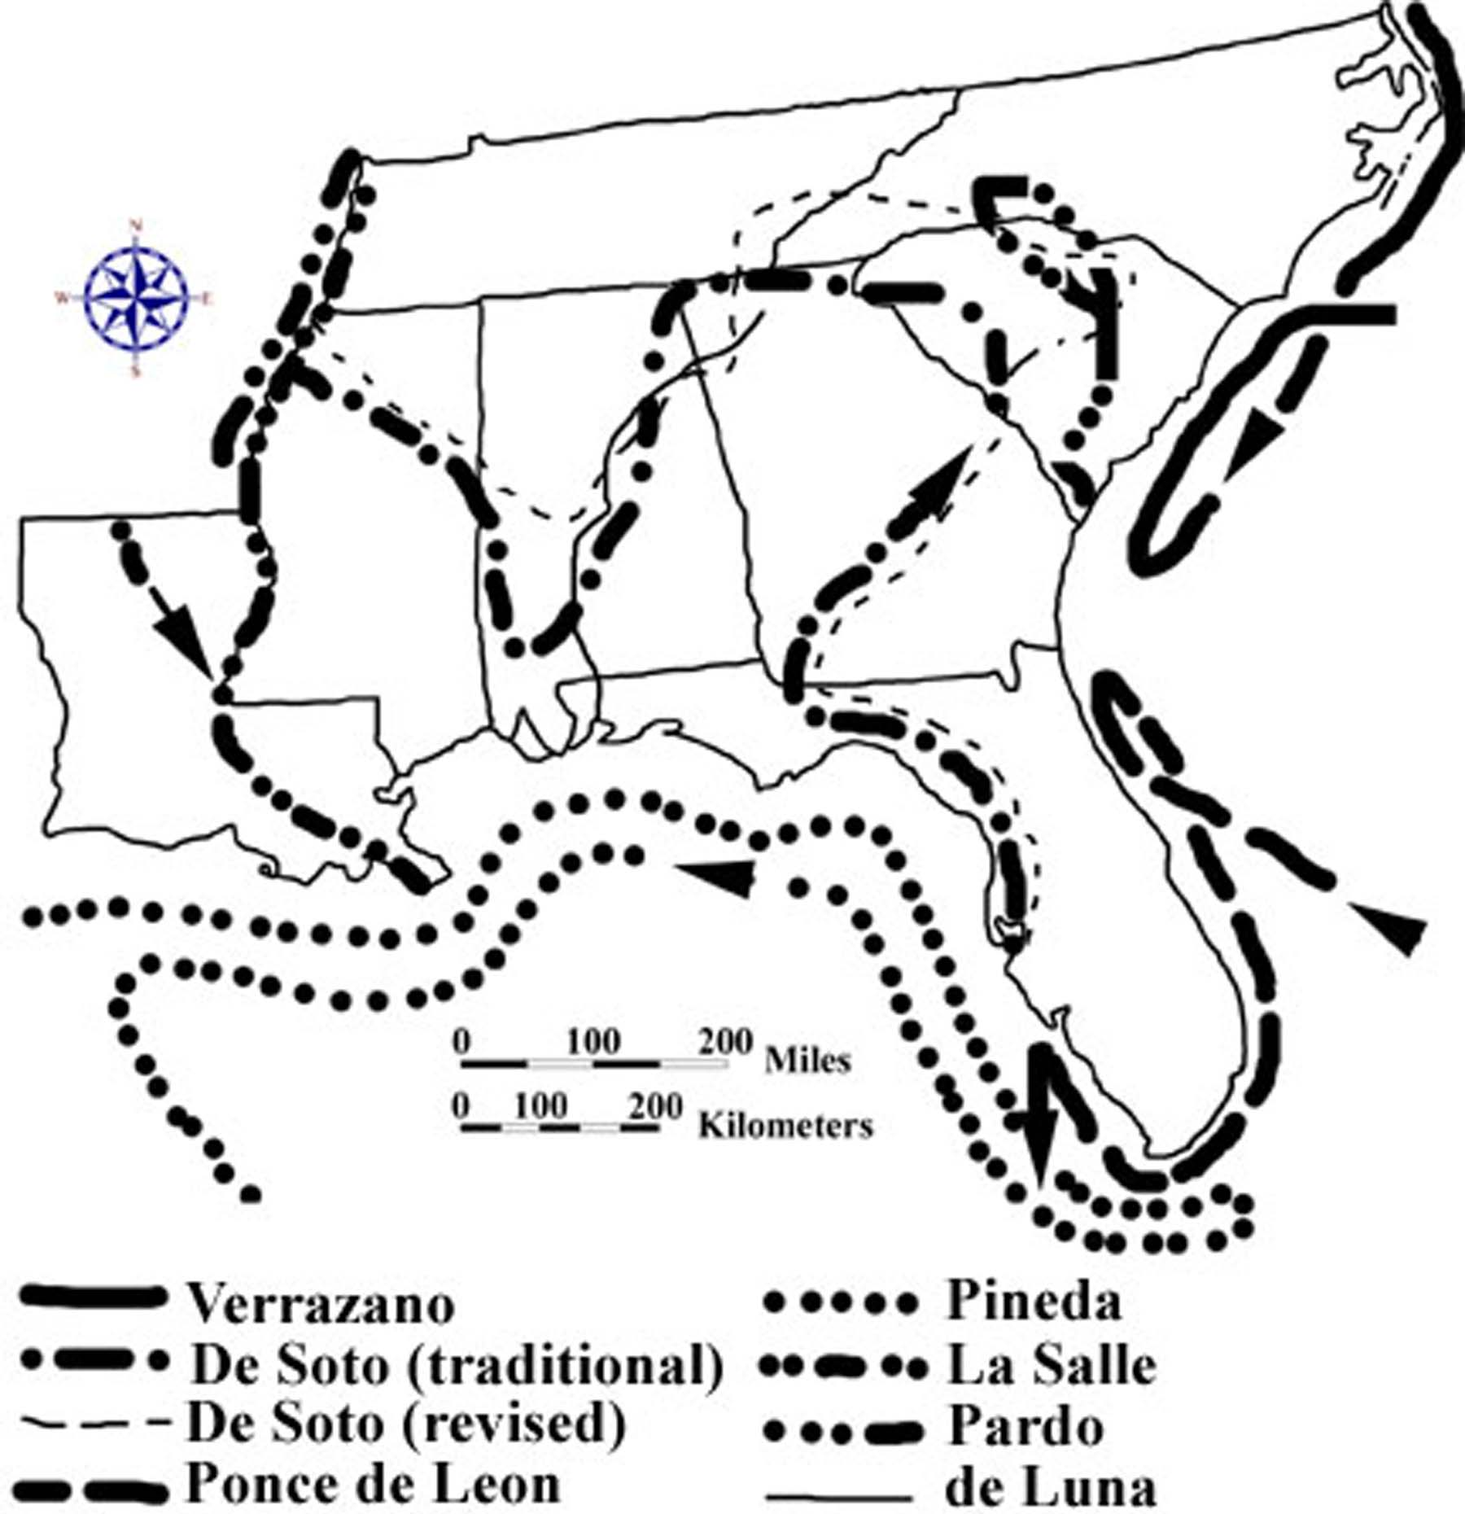

Although the Spanish probably compiled the most extensive record of exploration in this region, they were unable to sustain any permanent settlements until 1565 when Pedro Menendez de Aviles founded the oldest city in the United States, St. Augustine, Florida. The Spanish did, however, manage to set up a series of Missions in Native American villages across Florida and up the Atlantic coast as far as South Carolina. One or more Catholic priests, who were charged with converting the native inhabitants to Catholicism, headed each mission. Missions also had political, economic, and cultural functions to perform. In particular, they served as an effective buffer against English influence to the north and French influence to the west.

French explorers were not so much interested in founding settlements as they were in building forts and exploiting the riches of the new world, particularly those riches being shipped from Mexico and Peru back to Spain along the southern coast of Florida. French corsairs became well known for their acts of piracy in the seas off Florida. In 1562 French Huguenots tried but failed to establish a colony at Port Royal in South Carolina. This attempt, in conjunction with the building of Fort Caroline at the mouth of the St. Johns River in northern Florida, helped pressure Spain into renewing its own colonization efforts in an attempt to help protect the fleets of ships that were loaded with Spanish treasure. The explorations of La Salle (actually Rene Robert Cavelier, Sieur de La Salle), traveling down the Mississippi River in 1682, resulted in the founding of many French forts in that region and the establishment of an enduring French presence along the river plain all the way to the Mississippi Delta. The French-speaking Acadian exiles arrived in Louisiana from Nova Scotia in 1755.

Figure 3F-2: First Settlements in the Southeast

STATE | FIRST PERMANENT SETTLEMENT | DATE | COLONIAL POWER RESPONSIBLE | DATE ADMITTED TO UNION
Alabama | Mobile | 1702 | France | 1819
Florida | St. Augustine | 1565 | Spain | 1845
Georgia | Savannah | 1733 | England | 1788
Louisiana | Iberville | 1699 | France | 1812
Mississippi | Natchez | 1716 | France | 1817
North Carolina | Albemarle | 1650 | England | 1789
South Carolina | Port Royal | 1670 | England | 1788
Tennessee | Fort Loudon | 1757 | England | 1796

On the basis of detailed exploration, England had perhaps the weakest claim to the Atlantic coastal zone in the Southeast, but it put the most effort into establishing permanent settlements. In 1585, Sir Walter Raleigh sent seven boatloads of settlers to Roanoke Island in North Carolina to found the first English settlement in the new world. After two years, the governor sailed back to England to get more supplies, but was unable to return. Three years later, a search party found that the colony had been abandoned. It was not until 1607 that the English tried to establish a colony again, this time successfully, at Jamestown, Virginia. North Carolina did not get its first successful settlement until 1650, when a colony was established at Albemarle. In 1670, King Charles II of England granted a charter to a group known as the Eight Lords Proprietors to found a settlement in what is now South Carolina. The colony was named "Carolina" in honor of the King (Charles's name in Latin was Carolus). Colonial dissatisfaction with proprietary rule led to a revolt against the proprietors in 1719. In 1729, after ten years of negotiation with the proprietors, Carolina became a Royal Colony and was divided into separate North and South Carolina sections. Georgia was first settled in 1733 when boatloads of former prisoners landed at the present site of the city of Savannah.

English colonial towns in the Southeast did not grow quickly compared with those of other regions, particularly New England. Coastal settlements were placed in accordance with the plantation system, which had little use for centralized towns or villages. Plantations were located along navigable streams and were essentially self-sufficient. Every planter of means owned at least one wharf that could be reached by ocean-going ships. The colonial prosperity of Carolina, in particular, was first built upon the cultivation of rice and indigo. Rice cultivation was confined to the freshwater swamps along the coastal rivers. Indigo was first successfully produced in similar environments. Both crops were labor intensive and led to increased reliance on African slavery in the colony. Tobacco and corn were the major crops further north.

Impact of Wars and Regional Conflicts

Throughout its history, the southeastern United States has had to deal with conflict from both within and without. During the colonial period, wars in Europe almost always spilled over to the New World in one form or another. Native Americans battled each other periodically over land disputes or as part of alliances with one or more colonial powers. Because of the small European population in the southeast, the geographical extent of these battles was usually limited to the coast. Similarly, most Revolutionary War campaigns in the southeast occurred around a few major population centers and along major transportation routes. The fighting never directly impacted the vast majority of communities, unless they had sent soldiers off to fight, or were unlucky enough to lie at a rendezvous point for the two opposing armies.

After the Revolutionary War, the new country continued to expand westward, and conflicts with Native Americans increased and intensified. The war against the Creek Nation coincided roughly with the War of 1812 against England. Again, the geographic extent of these campaigns was extremely limited, affecting primarily the Mississippi Territory along the Alabama and Coosa rivers and the Gulf Coast between Pensacola and New Orleans. Of course, Atlantic port cities like Charleston and Savannah were impacted by the British naval blockade until the end of the war.

Figure 3F-3: Major Battlegrounds (Pre Civil War) in the Southeast

FRENCH & INDIAN WARS  (1739-1742) | REVOLUTIONARY WAR  (1775-1781) | CREEK WAR / WAR OF 1812  (1812-1815)
Bloody Marsh  (Ft. Frederica, GA) | Guilford Court House, NC | Horseshoe Bend, AL
 | Kings Mountain, SC | New Orleans, LA
 | Cowpens, SC
 | Camden, SC
 | Eutaw Springs, SC
Figure 3F-4: Major Civil War Battlegrounds in the Southeast

(1861-1862) | (1863) | (1864-1865)
Fort Sumter, SC | Port Hudson, LA | Fort Morgan, AL
Port Royal, SC | Vicksburg, MS | Sabine Cross Roads, LA
Savannah, GA | Stones River, TN | Nashville, TN
Shiloh, TN | Chattanooga, TN | Franklin, TN
Fort Henry, TN | Chickamauga, GA | Kennesaw Mountain, GA
Fort Donelson, TN |  | Atlanta, GA
 |  | Fort Fisher, NC

By the time of the Civil War, conflicts with Native Americans had pretty much ended, as the vast majority of them had been removed to lands west of the Mississippi River, and the rest had been confined to a number of Indian Reservations located in out-of-the-way places. As the Union and the Confederate States geared up for war, the Union battle plan was to isolate the Confederacy by taking control of river and rail routes of transportation and thereby disrupt the South economically. First the Atlantic port cities were blockaded and later occupied, then the Mississippi River Valley and the Great Valley of Tennessee were brought under control of the North. Finally, Union General William T. Sherman marched from Atlanta to Savannah, effectively cutting the Confederate states in half. Just as in previous wars, direct military action was limited to a few specific corridors, leaving most of the region relatively untouched and unscathed, at least from a physical standpoint. The cost in human lives was of course much greater and had an impact on cities, towns, and rural areas throughout all the Confederate states.

Ethnic and Racial Distribution

The United States government is required by the constitution to conduct a census every ten years to determine the population distribution among the states so that Congress can be reapportioned to guarantee equal representation for all citizens, no matter what state they live in. In addition to simply counting people and noting where they live, census takers usually gather information about racial and ethnic categories, income level and economic status, and other personal information that can be useful to public planning agencies. Tracking this kind of data over many decades helps define the cultural influence of various ethnic groups within the area and can help identify migration patterns that can impact the economic development of a region.

Since the first European colonists arrived in the southeast, African Americans have constituted a large percentage of the population in both the Coastal Zone and the Coastal Plain regions. Even today, there remain many counties throughout the southeast in which African Americans are in the majority. Upper-class English immigrants favored the plantation system of agriculture and therefore also settled preferentially in the coastal areas of the region. Scotch-Irish settlers tended to settle in more mountainous areas that were similar in landscape to the lands they had left behind in Europe. The Cajun culture in Louisiana represents a combination of the original French heritage in New Orleans coupled with the influence of the Acadians transplanted there from French Canada. Many other ethnic and cultural groups have settled in the area and contributed to the diverse cultural landscape across the southeast

Spanish speaking peoples have played a much greater role in the region since World War II. Mexican immigrants have taken advantage of the many migrant worker jobs now available in agricultural areas, while Cuban refugees now populate a large portion of Southern Florida. Although the mixing of different cultures can sometimes lead to misunderstanding and conflict, it also has the potential to infuse new energy into the economy and stimulate growth and development in an area. Interaction between long time residents of an area and newcomers is most successful in regions where traditions are respected and lines of communication are kept open.

A prime example of such mixing is the influx of large numbers of northern retirees (often referred to as Yankees) moving to planned communities in the mountains and foothills of the Carolinas and Georgia. Most of these folks come to take advantage of the warmer climate, the four distinct seasons, and the higher quality of life (less pollution, congestion, and crime) compared with their former neighborhoods. The newcomers have effectively changed the political, social, religious, and cultural climate of many of the areas in which they have settled. But, in turn, their own viewpoints and traditions have likewise been altered by their interaction with the existing population.

Activity 3F-1: Place Names and Geography

POWER THINKING EXERCISE - "Nebulous Name"
The Southeast Regional Board of Tourism and Economic Development has hired your consulting group to solve a recently identified problem. The Board is supposed to promote business and leisure travel to major cities in the region, but it has run into a dilemma when publishing advertisements for the city of Greenville. It seems that seven of the eight Southeastern states each have a city named Greenville (one is spelled Greeneville) that they all want to advertise but potential customers are being confused. Examine the Cultural Base Map on MAP 3F, CULTURAL HERITAGE, and circle, with a wipe-off pen, all seven cities named Greenville (or Greeneville). Which state does not contain a city named Greenville? Why do you think this city name is so popular in the Southeast? Why do you think one town added an extra “e” to its name?
The Board has called a meeting of all the Greenville mayors to discuss re-naming all their cities to avoid any future confusion. The mayors have agreed to consider this solution as long as every city name is changed, to avoid any appearance of favoritism. Based on your knowledge of the region, as well as information gathered from MAP 3F and MAP 3A, LANDSCAPES AND LANDFORMS, come up with at least one suggestion of a new name for each of the seven Greenvilles listed on the Cultural Base Map. Write a brief paragraph for each city justifying your suggestion of its new name and be prepared to present your findings orally to the conference of mayors.

Materials
MAP 3F, CULTURAL SETTING
MAP 3A, LANDSCAPES AND LANDFORMS
Figure 3-1: “Landform Regions of the Southeast”
Wipe-off Pens

PERFORMANCE TASKS
(Icon Key) Overview = ; Science = ; Math = ; History = ; Language Arts =

1. Classify city names into categories.
Divide into groups and examine all city names in your selected state that are listed on the Cultural Base Map on MAP 3F, CULTURAL HERITAGE. Notice that some of these cities are named for famous people, others have names taken from the Native American (Indian) tradition, and the rest fall into other categories or general groups. Fill out the following chart by first determining what other major categories (up to four) should be added, then writing these titles in the spaces provided, and counting the number of cities in your selected state that fall into each category. Some of the name categories will be easy to determine; others may be very difficult. Categories with only one or two entries may be combined to form an ‘other’ category before entering your data on the chart. Be prepared to justify your selection of categories.

CLASSIFICATION OF CITY NAMES BY STATE
(entries indicate number of city names that fall under that category)
STATE | FAMOUS  PEOPLE | NATIVE  AMERICAN
Alabama
Florida
Georgia
Louisiana
Mississippi
North Carolina
South Carolina
Tennessee

2. Correlate city names with landform regions.
With a wipe-off pen, trace the boundaries of the major southeastern landform regions onto the Cultural Base Map on MAP 3F, CULTURAL HERITAGE. Use Figure 3-1, “Landform Regions of the Southeast,” as an additional resource if needed. Using a different color wipe-off pen, circle every city on MAP 3F that has a geographic reference (beach, hill, springs, etc.) in its name. Which landform regions have the most geographically-based names? Which landform regions have the fewest? How well do the city names match the landscape features of the region in which they are located? Explain your answer. Why do certain landform regions tend to generate a larger number of geographically-based city names? Explain your answer.

3. Analyze city name category distribution.
Divide into groups so that each of the eight Southeastern states is assigned to at least one group. Use the data from the chart in Performance Task #1, “Classification of City Names by State,” to construct a bar graph for your selected state. The ‘X’ axis should list the titles of the name categories. The ‘Y’ axis should indicate the percentage of city names that fit within that category. Divide the number of cities placed in a particular category by the total number of cities in the state to determine the percentage value for that particular name category. List the name categories in sequential order from highest percentage occurrence to lowest.

Compare your bar graph with those graphs representing other states. Is the sequential order of name categories the same in every state? Do some name categories display higher than average percentage values across several states? If so, explain why such a trend might exist. If not, explain why a random distribution is a reasonable expectation. Combine each group’s percentage values to construct a composite bar graph for the entire southeast region. Interpret your findings.

4. Correlate place names with Native American titles.
Consult the Cultural Base Map on MAP 3F, CULTURAL HERITAGE and the physiographic map on MAP 3A, LANDSCAPES AND LANDFORMS to locate and list every stream, city, state, or mountain with a name that appears to be Native American in origin. Circle each of these features on the map with a wipe-off pen. Now examine the inset map of Native American Cultures on MAP 3F and match as many of your marked features as possible with the tribal names listed there. For every match, use a different color wipe-off pen to place a check mark next to the circled feature on the map. Are certain Native American cultural groups more likely than others to have their influence preserved in local place names? Generate a written hypothesis about why this statement might or might not be true. Share your hypothesis with other groups and discuss whether the arguments presented are valid.

5. Evaluate information provided by suffix.
A suffix is a written fragment inserted at the end of a word to modify it and give more information about the subject. A simple example would be the suffix “less” which when added to a word indicates the subject lacks that feature (hairless, clueless, ageless, etc.). Many city names use suffixes to indicate their relative importance and size. The following list includes most of the terms commonly used in the region.

ville; a small village or isolated rural community
boro (borough); a very small town under its own political jurisdiction
town (ton); a political unit with residential areas and commercial activity
city; a very large commercial center with significant business and industry
burg; the German word for “city”, means the same

Examine the Cultural Base Map on MAP 3F, CULTURAL HERITAGE and circle, with a wipe-off pen, as many examples of towns that incorporate each of the above listed suffixes as you can find. Note that most cities listed on the Cultural Base Map have populations over 5,000, and some, like Atlanta, Georgia and Charlotte, North Carolina have populations in excess of 500,000. In your opinion, are the cities you circled on the map appropriately named, based on their suffix? Justify your answer.

ENRICHMENT
(Icon Key) Overview = ; Science = ; Math = ; History = ; Language Arts =

1. Determine reasons for names of local features.
Obtain a detailed map of your local area from your local library or school media center, or from the internet. Select several names of rivers, towns, hills, or other features that appear on the map and research how they got their names. Write a short story about how your favorite feature got its name, being sure to re-tell the events in your own words. Mark the location of your favorite feature on the Cultural Base Map on MAP 3F, CULTURAL HERITAGE with a wipe-off pen.

2. Conduct name survey of all cities in your state.
Draw the same type of chart as was used in Performance Task #1, “Classification of City Names by State” to collect data as you survey and categorize all of the cities in your state. Refer to any atlas that lists cities and towns. Calculate the percentage distribution of all categories of city name and draw a bar graph to illustrate that distribution. Compare your graph to the graph produced in Performance Task #3 and infer whether important cities have the same distribution percentage as all cities.
Activity 3F-2: Ethnic Diversity and Patterns of Settlement

POWER THINKING EXERCISE - "Contentious Claim"
In the year 1750, English, French, and Spanish settlements were all spreading inland from the Atlantic Ocean and the Gulf of Mexico towards the Appalachian Mountains in what would eventually become the southeastern United States. An area in central Georgia was actually claimed at this time by all three major colonial powers, even though it was not really occupied by any of them. Eventual control of that region would depend on which power could most quickly and effectively establish a military and economic presence in the area, and also bring large numbers of settlers into the region to confirm its claim. Locate this disputed region on the Early Settlement Patterns inset map on MAP 3F, CULTURAL HERITAGE.
Decide which major colonial power your group will represent (English, French, or Spanish), and then come up with a five-year plan for occupying and controlling central Georgia. Consider the following factors in your analysis:
- distance from existing settlements and forts
- transportation routes into the area
- number of settlers available to move into the area
- source of food, equipment, and other supplies
Write up your five-year plan in the form of a projected timetable, starting in the year 1750. Be realistic in determining how long it will take you to build forts and move large numbers of people. Mark the locations of projected forts and settlements on the inset map on MAP 3F using a wipe-off pen.
Consult with other groups in your class that represented different colonial powers. Debate the strengths and weaknesses of each five-year plan and predict which colonial power will win the race to occupy and control central Georgia.

Materials
MAP 3F, CULTURAL HERITAGE
MAP 3A, LANDSCAPES AND LANDFORMS
Figure 3F-3: “Major Battlefields in the Southeast”
Newspaper Article: Page 3F-1
Wipe-off Pens

PERFORMANCE TASKS
(Icon Key) Overview = ; Science = ; Math = ; History = ; Language Arts =

1. Analyze geographic distribution of battlefields.
Refer to Figure 3F-3, “Major Battlefields in the Southeast” to cross-reference the geographic locations of major battles with specific wars. Using a different color wipe-off pen for each major war, highlight or mark the location of every battlefield listed in Figure 3F-3 on the Cultural Base Map on MAP 3F, CULTURAL HERITAGE. Then use this information to fill in the following chart. Circle, with the appropriate color wipe-off pen, all areas that were significantly impacted by each war. Speculate as to why some areas of the Southeast seem to have never been affected directly by any of these wars. Also speculate as to why other areas appear to have been affected over and over again by warfare.

DISTRIBUTION OF BATTLEFIELDS BY WAR AND BY STATE
(entries indicate number of state battlefields that are associated with each war)
WAR  STATE | 1739-1742 WAR WITH SPAIN | 1775-1781 REVO-  LUTIONARY WAR | 1812-1815 THE WAR OF 1812 | 1861-1865  THE CIVIL WAR
Alabama
Florida
Georgia
Louisiana
Mississippi
North Carolina
South Carolina
Tennessee

2. Identify features associated with settlement limits.
Examine the inset map of Early Settlement Patterns on MAP 3F, CULTURAL HERITAGE and locate the lines designating the extent of colonial claims. Use a wipe-off pen to transfer these lines onto MAP 3A, LANDSCAPES AND LANDFORMS. Also mark on MAP 3A the locations of all major colonial settlement sites. Make a list of all physical features shown on this map that match up with or correspond to these settlement sites and boundary lines. Pay particular attention to drainage basins and drainage divides. Speculate as to how each of these physical features might have influenced colonial settlement. Which physical feature seems to have the greatest influence on settlement patterns? Justify your answer.

3. Analyze census of Native American Nations.
A census is an official count of the population. Such a census of existing Native American Nations in the Carolina Colony was completed in the so-called Indian Census of 1715. Below is an excerpt of the statistical information compiled on eight Native American groups affiliated with the Siouan Nations. Which Nation was the largest, based on the table given on the next page? Which Nation had the largest average village population? What was the average number of inhabitants in a typical Catapaw village? What percentage of this total were the woman and children? Why do you think that the census collectors divided the count into two groups, men and women/children?

Charles Towne is the early name used for Charleston, South Carolina. Locate this seaport on the Cultural Base Map on MAP 3F, CULTURAL HERITAGE and mark its location on the Native American Cultures inset map on MAP 3F. Using wipe-off pens, the map scale, and the census information given in the table on the next page, (miles and compass direction from Charles Towne), locate and label on the inset map the specific localities in which the eight Siouan Nations once lived. Make a list of all those locations that match up with the names of cultural groups listed on the inset map. Do any locations not match up with existing cultural groups? Explain your answer.

NATIVE AMERICAN CENSUS DATA 1715
Name of SIOUAN Nation | miles & direction  from Charles Towne | NO. OF  VILLAGES | nO. OF  MEN | NO. OF  WOMEN &  CHILDREN | Total  NUMBER
Catapaw | 200 northwest | 7 | 570 | 900 | 1470
Sarow | 170 north | 1 | 140 | 370 | 510
Waccomussu | 100 northeast | 4 | 210 | 400 | 610
Cape Fear | 200 northeast | 5 | 76 | 130 | 206
Santee | 70 north | 2 | 43 | 60 | 125
Congaree | 120 north | 1 | 22 | 70 | 106
Weneaw | 80 northeast | 1 | 36 |  | 57
Seawee | 60 northeast | 1

Source: South Carolina Records, British Public Record Office, VII, 238-239 cited in Chapmen T. Milling, Red Carolinians (Columbia, SC: The University of South Carolina Press, (1969) p. 222. Incomplete data extrapolated for table.

4. Investigate disappearance of Native American culture.
Read the newspaper article on page 3F-1. Locate the city of Macon (in central Georgia) on the Cultural Base Map on MAP 3F, CULTURAL HERITAGE. Also locate the Ocmulgee (Okmulgee) lands (also in Central Georgia) on the Native American Cultures map on MAP 3F. To what larger Native American cultural group do the Ocmulgee people belong? How many Native American (Indian) Reservations are located in Georgia today? Do the Ocmulgee have their own assigned reservation anywhere in the Southeast?

After gold was discovered in Northern Georgia in the mid 1800’s, most of the Native Americans in this area were forcibly moved west of the Mississippi River to the territory of Oklahoma. Yet the newspaper article quotes two people with Native American ancestry, Stan Cartwright and Alan Cook, who live in the Macon area. Speculate about what might have happened to the few Ocmulgee people who managed to stay in Georgia. Explain how they might have avoided the forced march westward and how they were able to live and function in a new and very different cultural setting. Write a short story (historical fiction) about a Native American family that remained in Macon to illustrate your ideas and speculations about how this might have happened. Include at least one reference in your story to the Indian Mounds now located in the Ocmulgee National Monument.

5. Examine changes in word meanings over time.
Locate and circle with a wipe-off pen all Native American (Indian) Reservations marked on the Cultural Base Map on MAP 3F, CULTURAL HERITAGE. The dictionary lists several possible definitions for the word ‘reservation’:
- establishment of limiting conditions in a particular situation
- arrangement or promise to hold something for someone’s use
- tract of public land assigned to special use or conditions
- objection to a planned course of action

Which of those definitions do you think was intended by the governmental agencies that first set up the Reservation system for Native Americans? Explain your answer. Do any of the other definitions apply to the conditions under which a Reservation operates? Explain your answer. At first, the word “Reservation” held a very negative meaning for most Native Americans. In modern times, the same word “Reservation” has taken on a much more positive meaning. Discuss in your group how and why words can change their meaning over time. Think of an example of another word that used to have a negative meaning, but now is viewed as positive. Make a class list of these terms and note whether they have anything in common.

ENRICHMENT
(Icon Key) Overview = ; Science = ; Math = ; History = ; Language Arts =

1. Contact nearest Native American (Indian) Reservation.
Use the Cultural Base Map on MAP 3F, CULTURAL HERITAGE to locate the Native American (Indian) Reservation closest to your school. Use internet and/or library resources to gather information about this place; specifically, find out when it was created, why it was located at that site, and how it is administered politically. Many Reservations offer visitor programs as well as written material detailing the folklore and traditions of the Native American population. Collect as much of this material as you can and prepare a short summary report for class presentation.

2. Analyze census data.
Every ten years, the United States government conducts a census of the entire population. The ethnic background of Americans is one piece of data that is collected as part of this process. By comparing census records over long time periods, it is possible to document major shifts in the distribution of ethnic groups across a region. Select a state or county of interest and look up, using library or internet resources, the population records for a particular ethnic group for two different years. Use graphs and/or pie charts to document the percentage shift in population. Also mark your location of interest on the Cultural Base Map on MAP 3F, CULTURAL HERITAGE with a wipe-off pen.

