CHAPTER 4

APPALACHIAN PLATEAUS REGION

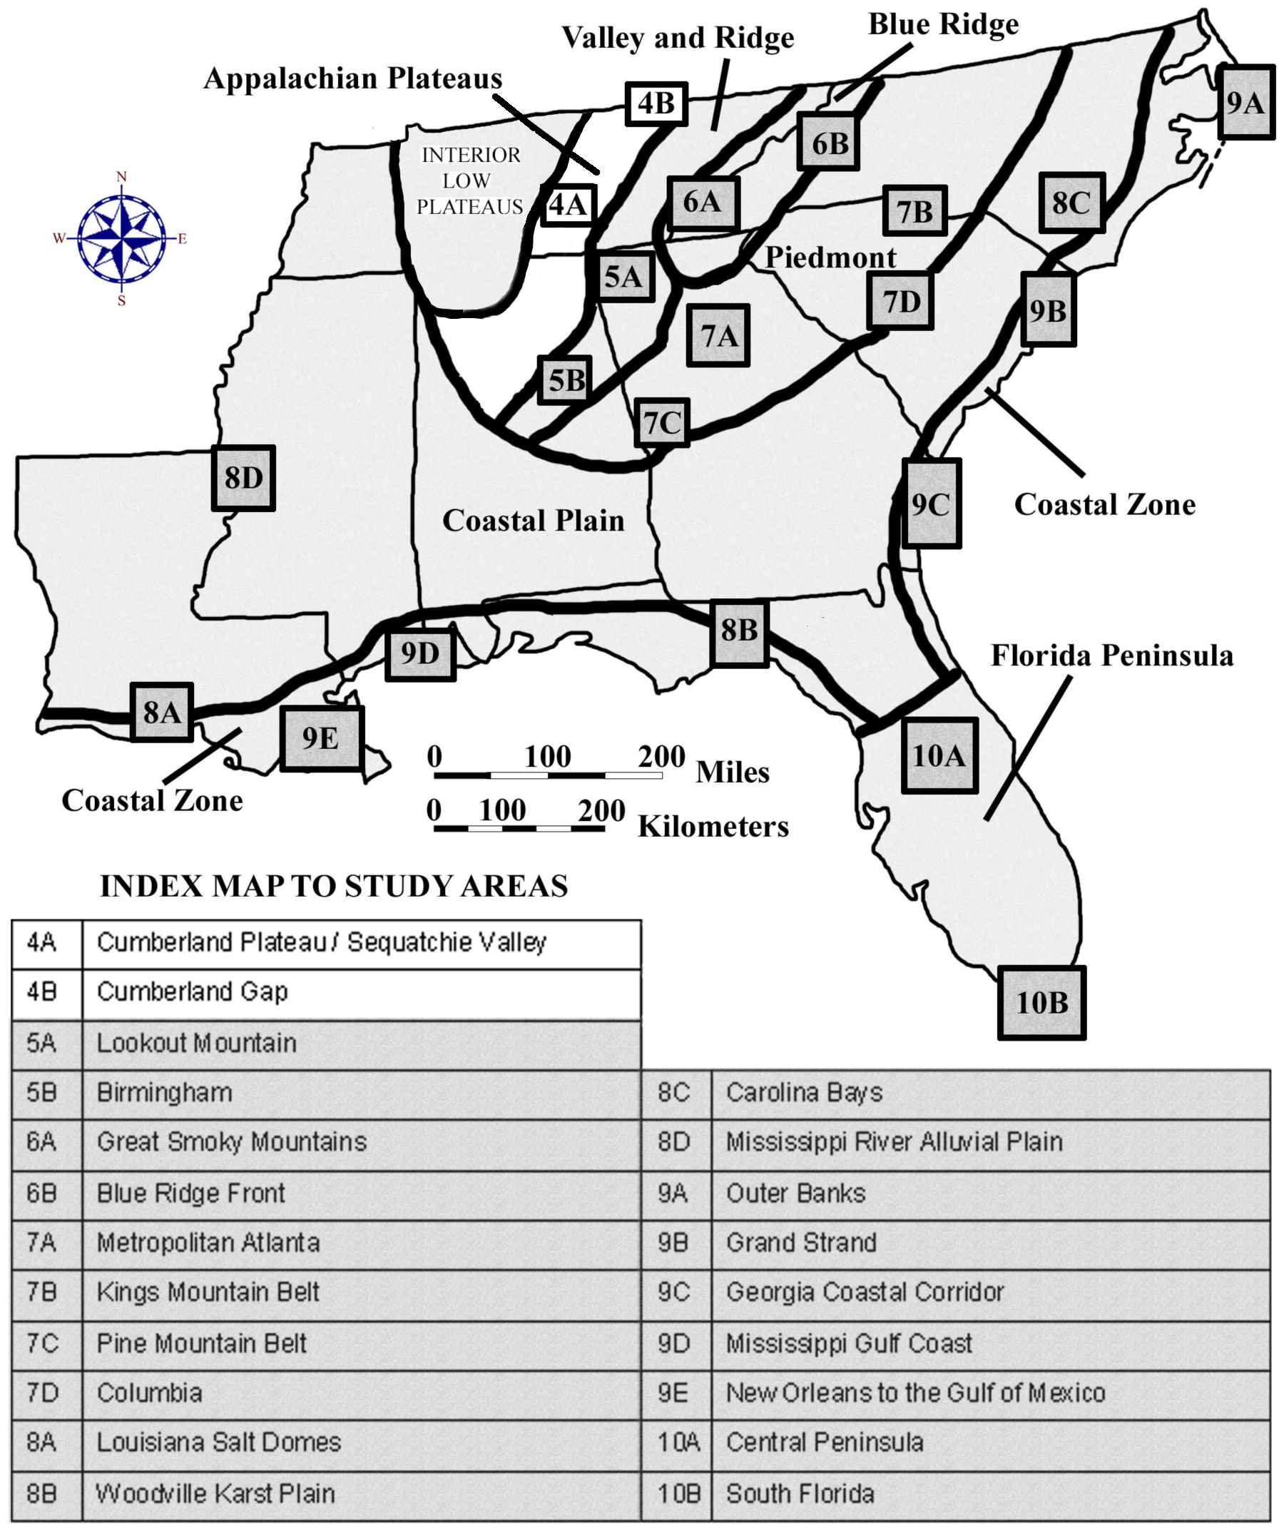

DRAFT VERSION 5/06/20

TABLE OF CONTENTS FOR CHAPTER 4

APPALACHIAN PLATEAUS REGION

G. Michael Clark and John R. Wagner

INDEX MAP TO APPALACHIAN PLATEAUS REGION STUDY AREA
TABLE OF CONTENTS FOR CHAPTER 4
BACKGROUND INFORMATION
- Description of Landforms, Drainage Patterns, and Geologic Processes
p. 4-1 . . . . - Characteristic Landforms of the Appalachian Plateaus
p. 4-1 . . . . . . . . - figure 4-1 – “Location of Cumberland Plateau in Tennessee”
p. 4-2 . . . . - Geographic Features and Localities of Special Interest
p. 4-3 . . . . - Rock Types and Geologic History
p. 4-3 . . . . . . . . - figure 4-2 – “Slope Retreat Along the Cumberland Escarpment”
- Influence of Topography on Historical Events and Cultural Trends
p. 4-4 . . . . - Folklore
p. 4-5 . . . . . . . . - story – “Bonnie Barbara Allen”
p. 4-6 . . . . . . . . - story – “Ballad of Davy Crockett”
p. 4-6 . . . . - Historical Events
p. 4-7 . . . . - Influence of Topography on Commerce, Culture, and Tourism
p. 4-8 . . . . . . . . - story – “Journal of Miss Ellen Semple”
- Natural Resources, Land Use, and Environmental Concerns
p. 4-8 . . . . - Climate and Water Resources
p. 4-8 . . . . - Soils and Agriculture
p. 4-9 . . . . - Mining, Resource Extraction, and Environmental Concerns
PLACES TO VISIT
REFERENCES AND RESOURCES

STUDY AREA 4A = Cumberland Plateau / Sequatchie Valley
- Newspaper Article
p. 4A-1 . . . . . . - story – “Cavers Kept Find Secret to Protect It”
- Rationale
- Performance Objectives
- Sample Assessment Rubrics
- Cartographic Product Information
p. 4A-3 . . . - MAP 4A: Cumberland Plateau / Sequatchie Valley
p. 4A-4 . . . - IMAGE 4A: Cumberland Plateau / Sequatchie Valley
- Study Area Description
p. 4A-5 . . . - Grassy Cove
p. 4A-6 . . . . . . . - figure 4A-1 – “Underground Water Transfer into Grassy Cove”
p. 4A-7 . . . . . . . - figure 4A-2 – “Grassy Cove Geology and Hydrology”
p. 4A-7 . . . - Sequatchie Valley
p. 4A-8 . . . . . . . - figure 4A-3 – “Geologic Cross-Section Through Sequatchie Valley”
p. 4A-9 . . . . . . . - figure 4A-4 – “Headward Erosion of the Sequatchie River”
p. 4A-9 . . . - Raccoon Mountain Pumped Storage Hydroelectric Project
p. 4A-10 . . . . . . - figure 4A-5 – “Sketch Map of Raccoon Mountain Project”
p. 4A-11 . . . . . . - figure 4A-6 – “Cross-Section of Power Generating Facilities”
- Activity 4A-1: Karst Topography
(ICONS) Overview = Sci = Math = Hist = Lang Arts =
p. 4A-12 . . - Power Thinking Exercise “Runoff Riddle”
p. 4A-12 . . - Materials
p. 4A-12 . . - Performance Tasks
p. 4A-12 . . . . . . 1. Compare and contrast plateau and valley topography.
p. 4A-13 . . . . . . 2. Relate topography to underlying geology.
p. 4A-13 . . . . . . 3. Calculate contour interval and compare relief.
p. 4A-13 . . . . . . 4. Debate repeal of permit for sewage treatment plant.
p. 4A-14 . . . . . . 5. Explain abundance of towns named ‘Springs’.
p. 4A-14 . . - Enrichment
p. 4A-14 . . . . . . 1. Explain how ‘3-D Anaglyph’ images work.
p. 4A-14 . . . . . . 2. Investigate Karst features.
- Activity 4A-2: Structural Influence on Topography
(ICONS) Overview = Sci = Math = Hist = Lang Arts =
p. 4A-15 . . - Power Thinking Exercise “Color Controversy”
p. 4A-15 . . - Materials
p. 4A-15 . . - Performance Tasks
p. 4A-15 . . . . . . 1. Compare and contrast RADAR and NALC images.
p. 4A-16 . . . . . . 2. Identify antecedent river.
p. 4A-16 . . . . . . 3. Calculate plunge angle of fold axis.
p. 4A-16 . . . . . . 4. Assess historical importance of Lookout Mountain.
p. 4A-17 . . . . . . 5. Re-write “Bonnie Barbara Allen” in modern English.
p. 4A-17 . . - Enrichment
p. 4A-17 . . . . . . 1. Research the role of Lookout Mountain in the Civil War.
p. 4A-17 . . . . . . 2. Compile examples of traditional ballads and stories.
- Activity 4A-3: Pumped Storage for Hydroelectric Power
(ICONS) Overview = Sci = Math = Hist = Lang Arts =
p. 4A-18 . . - Power Thinking Exercise “Damming Dilemma”
p. 4A-18 . . - Materials
p. 4A-18 . . - Performance Tasks
p. 4A-18 . . . . . . 1. Identify alterations to landscape.
p. 4A-19 . . . . . . 2. Sketch and analyze topographic profile across Raccoon Mountain.
p. 4A-19 . . . . . . 3. Calculate the volume of water in a reservoir.
p. 4A-19 . . . . . . 4. Speculate about historical figure.
p. 4A-19 . . . . . . 5. Write short story about Mr. McNabb.
p. 4A-20 . . - Enrichment
p. 4A-20 . . . . . . 1. Research power capacity of pumped storage projects.
p. 4A-20 . . . . . . 2. Research life of John McNabb or other local person.

STUDY AREA 4B = Cumberland Gap
- Newspaper Article
p. 4B-1 . . . . . . - story – “Cumberland Gap Tunnel”
- Rationale
- Performance Objectives
- Sample Assessment Rubrics
- Cartographic Product Information
p. 4B-3 . . . - MAP 4B: Cumberland Gap
p. 4B-4 . . . - IMAGE 4B: Cumberland Gap
- Study Area Description
p. 4B-5 . . . - The Cumberland Escarpment
p. 4B-5 . . . . . . . - figure 4B-1 – “Geologic Cross-Section at Cumberland Gap”
p. 4B-6 . . . . . . . - figure 4B-2 – “Folds and Faults Near Cumberland Gap”
p. 4B-6 . . . - The Middlesboro Basin - Meteorite Impact Structure
p. 4B-7 . . . . . . . - figure 4B-3 – “Geologic Map of Middlesboro Basin”
p. 4B-8 . . . - Daniel Boone and the Wilderness Road
p. 4B-9 . . . . . . . - figure 4B-4 – “Route of Wilderness Road”
- Activity 4B-1: The Cumberland Escarpment
(ICONS) Overview = Sci = Math = Hist = Lang Arts =
p. 4B-10 . . - Power Thinking Exercise “Happy Hikers”
p. 4B-10 . . - Materials
p. 4B-10 . . - Performance Tasks
p. 4B-10 . . . . . . 1. Locate escarpment and contrast topography.
p. 4B-11 . . . . . . 2. Determine flight path of radar-imaging airplane.
p. 4B-11 . . . . . . 3. Construct rose diagram showing mountain trend.
p. 4B-12 . . . . . . 4. Relate state boundaries to mountain crest lines.
p. 4B-12 . . . . . . 5. Discuss effectiveness of ‘Massacre Mountain’ nickname.
p. 4B-12 . . - Enrichment
p. 4B-12 . . . . . . 1. Investigate Pine Mountain overthrust belt.
p. 4B-12 . . . . . . 2. Calculate depression angle of SLAR radar pulse.
- Activity 4B-2: The Middlesboro Basin
(ICONS) Overview = Sci = Math = Hist = Lang Arts =
p. 4B-13 . . - Power Thinking Exercise “Flood Forecast”
p. 4B-13 . . - Materials
p. 4B-13 . . - Performance Tasks
p. 4B-13 . . . . . . 1. Locate and describe the Middlesboro Basin.
p. 4B-14 . . . . . . 2. Analyze geologic map of Middlesboro Basin.
p. 4B-14 . . . . . . 3. Describe geometry of Middlesboro Basin.
p. 4B-14 . . . . . . 4. Infer reasons for founding city of Middlesboro.
p. 4B-15 . . . . . . 5. Write script for newscast coverage of disaster.
p. 4B-15 . . - Enrichment
p. 4B-15 . . . . . . 1. Compare Middlesboro Basin to confirmed impact structures.
p. 4B-15 . . . . . . 2. Analyze historic food records for Middlesboro.

- Activity 4B-3: The Wilderness Road and Westward Migration
(ICONS) Overview = Sci = Math = Hist = Lang Arts =
p. 4B-16 . . - Power Thinking Exercise “Alternative Access”
p. 4B-16 . . - Materials
p. 4B-16 . . - Performance Tasks
p. 4B-16 . . . . . . 1. Trace transportation routes through Cumberland Gap.
p. 4B-17 . . . . . . 2. Explain influence of fault line in creating Cumberland Gap.
p. 4B-17 . . . . . . 3. Contrast grade of old highway with new automobile tunnel.
p. 4B-18 . . . . . . 4. Trace exact route of Wilderness Road.
p. 4B-18 . . . . . . 5. Evaluate name changes through time.
p. 4B-18 . . - Enrichment
p. 4B-18 . . . . . . 1. Research life and times of Daniel Boone.
p. 4B-18 . . . . . . 2. Investigate naming of famous roads.

BACKGROUND INFORMATION

Description of Landforms, Drainage Patterns, and Geological Processes

Characteristic Landforms of the Appalachian Plateaus

The Appalachian Plateaus landform region constitutes the westernmost portion of the Appalachian Mountain chain. It contains some of the most isolated and remote areas in the southeast and differs from other Appalachian regions in a number of ways, primarily the horizontal nature of the sedimentary rocks that make up the province, and the relatively high elevation of the land surface. The region is heavily forested, riddled with numerous small rocky streams, and endowed with extensive bituminous coal resources. Only a few large rivers cross this region, often carving magnificent gorges as they pass through. The predominant drainage pattern is dendritic. Erosion is a constant factor as rainwater rushes down the steep slopes, carrying soil and other sediment with it, while deposition is limited to isolated small floodplain areas along some of the larger streams.

A plateau is often referred to as a flat-topped mountain, which means that at least one side must rise rather steeply from the surrounding, lower elevation regions. It is important, when referring to the Appalachian Plateaus region, to recognize the plural nature of the term. Particularly in Tennessee, the landscape represents not one single plateau, but a series of plateaus stacked on top of each other, sometimes separated by deeply cut stream valleys. Each plateau is capped by a resistant rock layer which protects the underlying softer rocks from erosion. The largest and best known of these features is the Cumberland Plateau in north-central Tennessee, but other plateaus to the south exhibit a very similar set of landforms.

Figure 4-1: Location of Cumberland Plateau in Tennessee

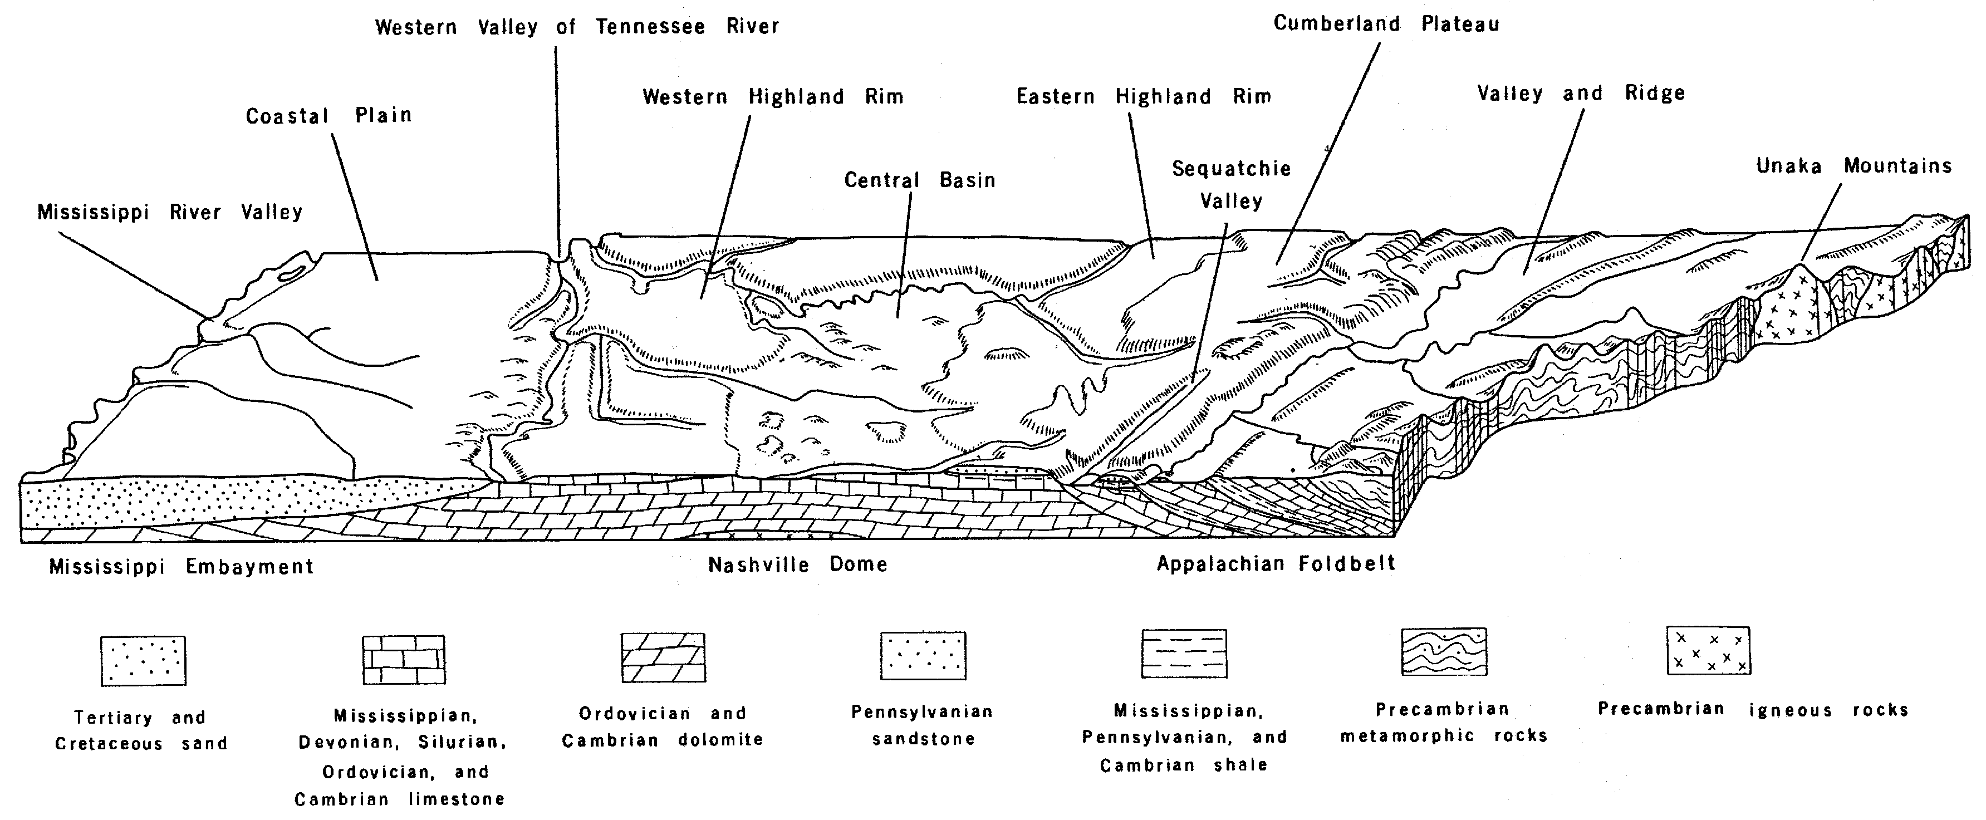
Although the central portions of each plateau tend to be relatively flat upland areas, the plateau margins are considerably dissected by deeply incised stream valleys, which often flow in V-shaped gorges. The result is a landscape that may look anything but flat to the casual observer, although it should be noted that most of the hills do rise to about the same elevation and the valleys likewise find a common level. From a more distant perspective, such as an airplane or satellite, these surface irregularities fade to insignificance, and the overall flat nature of the plateau landscape becomes more obvious. The Tennessee plateaus are almost everywhere bordered by steep breaks in slopes, or escarpments. The Cumberland Escarpment (known as Walden Ridge in the south) marks the eastern edge of the Appalachian Plateaus region in Tennessee, and the Eastern Highland Rim marks the break in slope from the plateau to the Nashville Basin to the west.

Geographic Features and Localities of Special Interest

The Appalachian Plateaus region has been subdivided in many different ways by many different researchers, but the single term Cumberland Plateau is often used to refer to the entire group of individual plateaus present in central Tennessee. Cumberland Mountain and Walden Ridge, along the eastern escarpment, rise nearly 2,000 feet (610 meters) above the adjacent limestone valleys of the Valley and Ridge province on their way to maximum elevations of over 3,500 feet (1067 meters) northwest of Oak Ridge, Tennessee. This solid ridge front continues uninterrupted across the state except for the incursion of the Tennessee River, which runs in a deep gorge west of Chattanooga, Tennessee, and fault-controlled gaps like Cumberland Gap and Pine Mountain in the northern part of the state. The western drop-off, into the Nashville Basin, is equally impressive, although the plateau here lacks the high peaks characteristic of the eastern rim.

Sequatchie Valley is a distinctive linear feature that runs parallel to the eastern escarpment from northeastern Alabama to central Tennessee. It effectively divides the Cumberland Plateau into an eastern and western half with a narrow, deep valley in between. This valley exposes the underlying carbonate rocks, like limestone, to dissolution by acidic groundwater and surface runoff, creating a distinctive landscape of sinkholes, caves, and solution valleys called Karst Topography. Several enclosed basins, also floored by carbonate rock, lie just beyond the northern end of Sequatchie Valley. Grassy Cove is the largest of these basins, many of which are connected to each other through subterranean cave systems.

The Tennessee Valley Authority maintains a set of dams and reservoirs along the Tennessee River which provide important opportunities for recreation and tourism. Within the Appalachian Plateaus region, Nickajack Lake in Tennessee and Guntersville Lake in Alabama are the most important. Waterfalls are common occurrences along the edges of plateaus. Fall Creek Falls State Park, east of McMinnville, Tennessee, is probably the best known. Virgin Falls State Natural Area and Ozone Falls are both favorite tourist sites near Crossville, Tennessee. The Middlesboro Basin, just north of Cumberland Gap, is noteworthy because of its anomalous landscape. It is a circular feature about four miles (6.4 km) wide that is thought to have been formed from a meteorite impact.

Rock Types and Geologic History

Although rock layers throughout the Appalachian Plateaus region are generally horizontal, the region as a whole exhibits the structure of a very shallow, elongated basin. Rock layers along the Cumberland Escarpment dip gently westward and rocks along the Eastern Highland Rim dip gently eastward. Sequatchie Valley represents a breached anticline structure that has brought older rock to the surface. Other minor folds appear in both Alabama and Tennessee adjacent to and parallel with the eastern escarpment. Faults do not play a major role in forming topography except for the western edge of Sequatchie Valley and the Pine Mountain overthrust area north and west of Cumberland Gap.

Bedrock geology is quite uniform throughout the Appalachian Plateaus region. The ages of most of the rock units fit into the Mississippian and Pennsylvanian periods of the geologic time scale. In the Tennessee and Alabama portion of the Appalachian Plateaus, the rocks of Pennsylvanian age are the coal-bearing rocks. These rock units often contain fossils of land plants and are dominantly clastic in nature; they are mostly shales, siltstones, sandstones, and conglomerates. The underlying Mississippian age rocks consist of a mixture of carbonate and clastic units, many of which contain marine fossils. At the edges of the plateau, water runs off the resistant Pennsylvanian clastic rocks, but tends to seep into cracks and fractures in the Mississippian limestone creating cave systems and other conduits for groundwater flow. As more and more limestone is dissolved, the underlying rock tends to weaken and break loose. The resulting loss of support creates temporary overhangs of resistant rocks which eventually break loose themselves and tumble down the slope of the escarpment. The net result of this action is to cause the rim of the plateau to gradually migrate inwards through time, while still maintaining the steep slope of the escarpment.

Figure 4-2: Slope Retreat along the Cumberland Escarpment

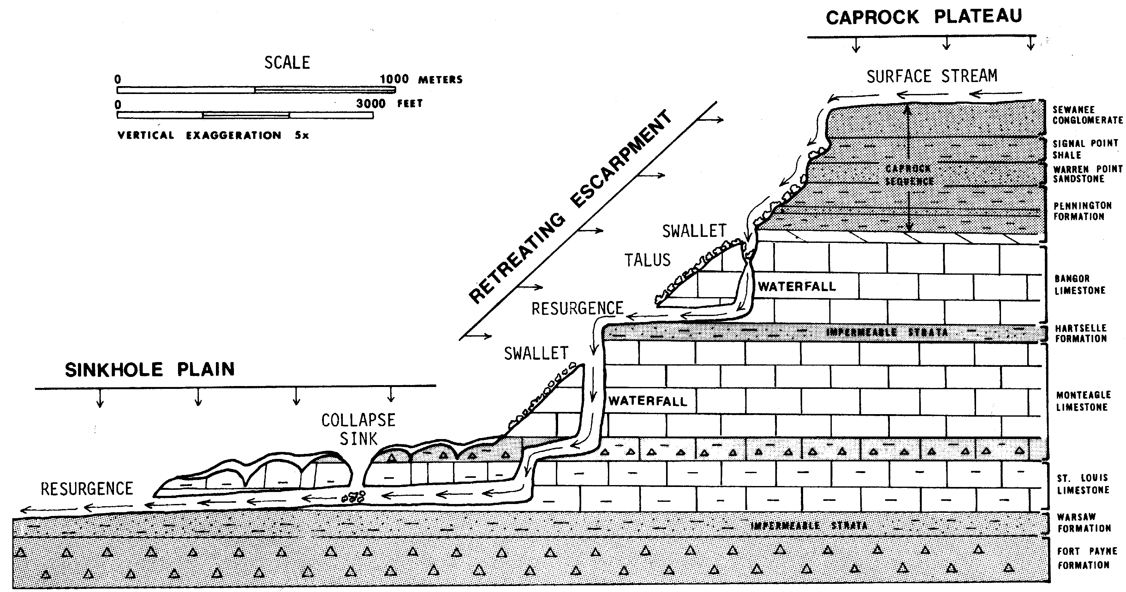

The Appalachian Plateaus region was affected by the same geological upheavals that formed the rest of the Appalachian Mountain chain, but to a lesser extent because it is located farther away from the centerline of tectonic activity and deformation. For most of the Paleozoic Era, shallow seas covered the region and thick accumulations of limestone, chert, marine sandstone, and shale filled the gradually subsiding basin. Later in the Paleozoic, with the onset of tectonic activity to the east, as the continent of Africa approached the North American continent, more and more clastic sediments were eroded from rapidly rising sourceland regions. This large volume of sediment eventually filled the basin to overflowing, pushing the coastline ever further westward and allowing stream sediments to accumulate on top of the previously deposited marine layers. It was in the swampy deltas of those stream systems that trees, shrubs, and other vegetation died and accumulated in layers that would eventually be buried and transformed into coal.

As the Alleghenian Orogeny progressed, the Appalachian area was squeezed harder and harder by tectonic forces, causing massive thrust faulting and folding deep within the earth’s crust. Regional metamorphism and volcanic activity affected the central part of the tectonic area to a much greater extent than it did the plateau region. Other than a general uplift of the land, and some gentle folding, the Appalachian Plateaus region suffered little permanent damage from this major tectonic event. During the Mesozoic Era, the Appalachian Mountains chain was a high-elevation, major erosional sourceland that supplied sediment to both the newly formed Atlantic Ocean and the Gulf of Mexico. The current landscape is the result of a more recent differential erosion process in which resistant rock holds up the tops of mountains as well as the rim of the plateau, and less resistant rock underlies valleys and other low areas. In a few instances, recent stream deposition has covered over part of the existing bedrock to form a layer of Quaternary alluvium.

Influence of Topography on Historical Events and Cultural Trends

Folklore

Much of the Appalachian Mountain region was settled by Europeans of Scotch-Irish descent. The Scots and the Irish both have long histories of strong oral tradition as shown in their collections of stories, narrative songs and ballads. Any event of general interest such as an heroic deed, a joke, a love affair, or a murder, might find its way into a ballad. The form of such ballads is usually expressed in strongly rhymed, four-syllable measures of verse, not prose. Many of these old ballads were brought to America from Europe. In most cases, the old dialects and wordings were kept, even if the people spoke modern English in their day-to-day lives. The sharing of such narrative songs provided a way to remember and maintain the old culture in a new land with new ways.

Bonny Barbara Allan
--Anonymous--

It was in and about the Martinmas time, When the green leaves were afalling,
That Sir John Graeme, in the West Country, Fell in love with Barbara Allan.

He sent his men down through the town, To the place where she was dwelling;
“O haste and come to my master dear, Gin ye be Barbara Allan.”

O hooly, hooly rose she up, To the place where he was lying,
And when she drew the curtain by: “Young man, I think you’re dying.”

“O it’s I’m sick, and very, very sick, And ‘tis a’ for Barbara Allan.”
“O the better for me ye’s never be, Tho your heart’s blood were aspilling.”

“O dinna ye mind, young man,” said she, “When ye was in the tavern adrinking,
That ye made the health gae round and round, And slighted Barbara Allan?”

He turned his face unto the wall, And death was with him dealing:
“Adieu, adieu, my dear friends all, And be kind to Barbara Allan.”

And slowly, slowly raise she up, And slowly, slowly left him,
And sighing said she could not stay, Since death of life had reft him.

She had not gane a mile but twa, When she heard the dead-bell ringing,
And every jow that dead-bell geid, It cried, “Woe to Barbara Allan!”

“O mother, mother, make my bed! O make it saft and narrow!
Since my love died for me today, I’ll die for him tomorrow.”

Many mountain folks have the reputation for being good “yarn spinners” or story tellers. Until the middle of the twentieth century, singing and story telling were about the only forms of evening entertainment available in mountain communities, and every village had its own master performer. Not all of the stories came from the old country, however. Many new folktales and songs, based on the American experience, found their way into the hearts and minds of the common culture. The legend of Davy Crockett is a good example that has persisted even up to the present time through exposure over television and promotions at various theme parks.

Davy Crockett was a real person, who was born in Tennessee and lived most of his life in that state. He was a hunter, marksman, farmer, business owner, justice of the peace, spy, congressman, and noted Indian fighter. Crockett lived a life full of adventure and died helping to defend the Alamo in Texas during the Mexican war. He probably achieved his greatest fame as a politician, although like many famous Americans, he is more revered now than when he was alive. One popular version of the “Ballad of Davy Crockett” has 20 verses. Although loosely based on historical fact, this version adds some interesting ‘facts’ to Crockett’s life history.

Ballad of Davy Crockett
--Lyrics by Tom Blackburn--
(selected verses)

Born on a mountain top in Tennessee; Greenest state in the land of the free;
Raised in the woods so he knew ev’ry tree; Kilt him a b’ar when he was only three.
Davy, Davy Crockett; King of the wild frontier.

Off through the woods he’s a marchin’ along; Makin’ up yarns an’ a singin’ a song;
Itchin’ fer fightin’ an’ rightin’ a wrong; He’s ringy as a b’ar an’ twict as strong.
Davy, Davy Crockett; The buckskin buccaneer.

He went off to Congress an’ served a spell; Fixin’ up Gov’ments an’ laws as well;
Took over Washin’ton so we heered tell; Patched up the crack in the Liberty Bell;
Davy, Davy Crockett, Seein’ his duty clear.

His land is biggest an’ his land is best; From grassy plains to the mountain crest;
He’s ahead of us all meetin’ the test; Followin’ his legend into the West.
Davy, Davy Crockett, King of the wild frontier.

Historical Events

The Appalachian Plateaus region was one of the last areas east of the Mississippi River to be explored by Europeans. Before that time, Native American nations such as the Cherokee, Creek, and Shawnee roamed through large parts of the plateaus, but never established any major settlements. Many place names in the region reflect the Native American heritage. Even during the middle of the eighteenth century, after the French had already built several forts in the Mississippi River valley, the Spanish had begun to colonize Florida, and the English had established the thirteen original American colonies, almost nothing was known of the vast interior plateaus of the Appalachians. The rugged topography made travel difficult and isolation from the outside world made settlements virtually unsustainable.

In 1763, England acquired the land west of the Appalachians from France. But, not wanting to disperse her small colonial population in Virginia and the Carolinas, the crown issued a proclamation forbidding colonists from moving westward to those new lands. Many Scotch-Irish immigrants found the seacoast colonies too crowded and the colonial life not much different than what they had left behind in the old world. Independent by nature, and seeking greater religious and political freedom, large numbers of Scotch-Irish ignored the proclamation and headed west to land that is now part of Tennessee and Kentucky. Kentucky was their preferred destination because it was free of much of the armed conflict with Native Americans which plagued areas to the north and south. Roads like the Wilderness Trail, laid out by Daniel Boone, carried over 300,000 people westward over Cumberland Gap between 1775 and 1800.

Many settlers heading for the rich interior basin of Kentucky never made it that far. Faced with continued obstacles, many simply left the road to settle in small valleys where they built cabins, grew subsistence crops, and hunted and fished. As the population outgrew the valley, new farms were established on steep hillsides, promoting deforestation and soil erosion. Even today, densely populated narrow valleys may contain more than 200 people per square mile, while the surrounding steep hills support no permanent population whatsoever. For the most part, railroads, highways, and industry have tended to avoid the Appalachian Plateaus region, contributing to a lifestyle of perpetual poverty.

Two major social initiatives of the twentieth century have had a profound impact on communities in the Appalachian Plateaus region. The WPA (Works Projects Administration), in the 1930s, began constructing “farm-to-market” roads throughout the area. Because of the improved highway system, it was now possible to consolidate schools for more effective student learning and permit traveling agricultural agents to visit homesteads to demonstrate improved farming techniques and household management practices. The TVA (Tennessee Valley Authority) was created about the same time. Through construction of a series of dams and reservoirs along the Tennessee River and its tributaries, this agency was to deal with flood control, electrical power production and distribution, navigation, and agricultural assistance to farmers. The cheap electrical power made possible by the TVA, completely transformed the lifestyle of most rural inhabitants within their service area.

Influence of Topography on Commerce, Culture, and Tourism

The steepness of the topography is the major limiting factor to commerce within the Appalachian Plateaus region. Roads and railroads are almost entirely limited to narrow stream valleys and most of the rivers are too swift and rocky to be usable for transportation. Periodic flooding is also a problem for many communities. Even in the plateau interior, where the land is flatter, the remoteness of communities makes it difficult to establish any long-term commercial linkages. The arrival of the electronic age may be able to overcome some of the historic geographic isolation by bringing internet and telephone access to those who have never had it before. Improvements in transportation have made it easier for artisans and craftspersons to sell their wares at highway stands to increasing numbers of tourists who now have easier access to recreational sites on the plateau. Even with such improvements, however, it is unlikely that these attractions will ever be able to compete successfully with resorts in more accessible areas.

The steepness of the topography also limits intercommunication among neighbors, unless they happen to live within the same narrow stream valley. For example, the Pine Mountain ridge, north and west of Cumberland Gap, is practically un-crossable for nearly 150 miles (240 km), even though it is only about a mile (1.6 km) wide. Most residents on one side of the mountain have never met anyone living on the other side, and probably have no knowledge of what is there at all. Under such circumstances, it is understandable how each community might feel isolated and alone in the world, and why family ties would become exceptionally strong in this culture. It is also possible to understand why, before the invention of radio and the telephone, these communities might have seemed totally out of touch with national and world events. Fortunately, such outdated descriptions as this one from the Geographical Journal of London are fading quickly.

Journal of Miss Ellen Semple
--monograph published in the Geographical Journal of London - 1901--

These . . . mountaineers are not only cut off from the outside world, but they are separated from each other. Each is confined to his own locality, and finds his little world within a radius of a few miles from his cabin. There are many men in these mountains who have never seen a town, or even the poor village that constitutes their county seat. . . . The women . . . are almost as rooted as the trees. We met one woman who, during the twelve years of her married life, had lived only ten miles across the mountain from her own home, but had never in this time been back home to visit her father and mother. . . . Another had never been to the post office, four miles away; and another had never seen the ford of the Rockcastle River, only two miles from her home, and marked, moreover, by the country store of the district.

Natural Resources, Land Use, and Environmental Concerns

Climate and Water Resources

The Appalachian Plateaus region has a humid, temperate climate because of its geographic location and is cooler than surrounding areas because of its higher elevation. This area usually receives some snowfall during the winter months. Hillside springs are abundant and provide an ample water supply for most needs. Many small streams have been dammed up to form reservoirs for local use, but for the most part, streams and rivers are free-flowing throughout the region. The one major exception to this statement is the Tennessee River, which has been turned into a series of interconnecting reservoirs throughout most of its length. Nickajack Lake in Tennessee and Guntersville Lake in Alabama provide flood control, hydroelectric power, and recreational opportunities for tourism. The Raccoon Mountain pumped storage project just west of Chattanooga provides clean, inexpensive electricity to meet peak power demands. The Big South Fork National River and Recreation Area, which straddles the Tennessee / Kentucky state line, features a gorge over 600 feet (183 meters) deep, and also offers river rafting tours, hiking trails, and extensive areas for hunting and fishing.

Soils and Agriculture

Although farming is the predominant occupation in the Appalachian Plateaus region, the land is barely capable of supporting the present population. Much of the soil is of sub-marginal quality, sterile, and very steep. It is not unusual to see corn growing in fields with slopes greater than 45 degrees. Many hillsides are too steep for wheeled farm equipment to be used. After several years of this type of farming, the soil has been washed out to the point where it is barely fertile at all. Even in flatter portions of the plateaus, soils are still thin and rocky. The best soils are found in the narrow floodplains bordering the larger rivers and streams, but nearly all of this fertile soil is already in use. In the northern part of the Cumberland Plateau, the average hill farm has approximately ten acres in crops, three-fourths of which is in corn. To the south, where temperatures are warmer, the growing of cotton has proved very profitable.

Logging and lumbering has never been important commercially in most areas of the Appalachian Plateaus because the roughness of the terrain made it too expensive to build logging roads and railroads to remote sites. There were always too many other nearby areas where timber could be secured more easily. Logging for local use, on the other hand, has always been a part of life on the plateau, ever since the first log cabin was built there. A surprisingly small percentage of the region has been designated as national forest land, and most of this is in Kentucky. One of the major aims of the TVA project was to conserve soil, both to benefit farmers and to prevent reservoirs from filling up with silt. Both agriculture and mining operations tend to cut down trees and expose the soil to extensive erosion. The only way to reverse this trend is to adopt land-use methods that will reduce the acreage of row crops on steep slopes and increase the percentage of land that is given over to pastures, legumes, and small grains.

Mining, Resource Extraction, and Environmental Concerns

The bituminous coal province in the Appalachian Plateaus region is the largest such reserve in the world. Nearly the entire region is underlain by coal-bearing deposits ranging from a few inches (one decimeter) to more than ten feet (3 meters) thick. Mining operations usually concentrate on coal seams at least four feet (1.2 meters) thick. For the most part, the coal is of uniform high quality. Because the rocks are nearly horizontal in most places on the plateau, the downcutting activity of streams has exposed the coal on the sides of most of the hillslopes, permitting easy and inexpensive strip mining in contrast to the complexity and expense of typical underground mining operations. In certain locations with a greater thickness of overburden, underground mining is still used.

In Tennessee, coal production has declined in recent years for a number of reasons. These include the increased availability of low-sulfur, low-fly ash coals from outside the region, the generally thin and often discontinuous nature of the readily accessible coal seams, and the difficulty of mining in the rugged terrain of the Cumberland Mountain and Cumberland Plateau sections while meeting necessary environmental regulations. Environmental concerns relate to problems of landscape destruction, slope failures and surface and groundwater pollution. Many of the problems are historical in nature, and stem from the legacies left by smaller wildcat mining operations. The Skyline Mine, on the Cumberland Plateau near Dunlap, is an example of a large operation where coal is being mined without a negative impact upon the environment. With prior arrangements, the Skyline Mine can be visited by interested groups, and can provide an educational experience for those interested in coal mining and the environment.
PLACES TO VISIT 

Big South Fork National Recreation Area. 4564 Leatherwood Road, Oneida, TN 37841. For information call (423) 569-9778 or search online at https://www.nps.gov/biso/index.htm

Cumberland Gap National Historical Park. 91 Bartlett Park Road, Middlesboro, KY 40965. For information call 606-248-2817 or search online at http://www.nps.gov/cuga/index.htm

Cumberland Mountain State Park. 24 Office Dr., Crossville , TN 38555. For information call 931-484-6138 or search online at https://tnstateparks.com/parks/cumberland-mountain

David Crockett State Park.1400 West Gaines St., Lawrenceburg, TN 38464. For information call 931-762-9408 or search online at https://tnstateparks.com/parks/david-crockett

Daniel Boone Homestead. 400 Daniel Boone Road, Birdsboro, PA 19508-8735. For information call 610-582-4900 or search online at https://www.phmc.pa.gov/Museums/Historic-Homes/Pages/Daniel-Boone-Homestead.aspx

Fall Creek Falls State Park. 2009 Village Camp Road, Spencer, TN 38585. For information call 423-881-5298 or search online at https://tnstateparks.com/parks/fall-creek-falls

Mammoth Cave National Park. 1 Mammoth Cave Parkway, Mammoth Cave, KY 42259. For information call 270-758-2180 or search online at http://www.nps.gov/maca/index.htm

Russell Cave National Monument. 3729 County Road 98, Bridgeport, AL 35740. For information call (256) 495-2672 or search online at https://www.nps.gov/ruca/index.htm

The Museum of Appalachia. 2819 Andersonville Hwy. Clinton, TN 37716. For information call 865-494-7680 or search online at https://www.museumofappalachia.org/

TVA’s Raccoon Mountain Pumped Storage Visitor Center. Highway 41, Chattanooga, TN 37419. For information call 423-825-3100 or search online at https://www.visitchattanooga.com/listing/raccoon-mountain-pumped-storage-facility-visitors-center/3875/

Tuckaleechee Caverns. 825 Cavern Road, Townsend, TN 37882. For information call 865-448-2274 or search online at https://tuckaleecheecaverns.com/

Wilderness Road State Park. 8051 Wilderness Rd., Ewing, VA 24248. For information call (276) 445-3065 or search online at http://www.dcr.virginia.gov/state_parks/wil.shtml - location
REFERENCES AND RESOURCES

SELECTED PRINT RESOURCES

Abramson, R. and Haskell, J., eds. (2006). Encyclopedia of Appalachia. Knoxville, TN: University of Tennessee Press.

Caudill, H. M. (1963). Night Comes to the Cumberlands: A Biography of a Depressed
Area. Boston, MA: Little and Brown.

Curran, H.A, Young II, Drew M., Justus, Philip S., Graver Jr, John B. (1984). Atlas of
Landforms (Third Edition). West Point, NY: John Wiley and Sons, Inc.

Draper, E. S. (1938). The Scenic Resources of the Tennessee Valley. Knoxville, TN:
Tennessee Valley Authority.

Dunaway, W. A. (2003). The African-American Family in Slavery and Emancipation.
New York, NY: Cambridge University Press.

Eller, R. D. (1982). Miners, Millhands, and Mountaineers: Industrialization of the
Appalachian South 1880-1930. Knoxville, TN: The University of Tennessee
Press.

Fenneman, N.M. (1938). Physiography of the Eastern United States. New York: McGraw-Hill Book Company.

Gillespie, P. F. (1982). Foxfire 7. Garden City, NY: Anchor Press/Doubleday.

Hargrove, E.C., Conkin, P.K. (1983). TVA: Fifty Years of Grass-Roots Bureaucracy.
Knoxville, TN: The University of Tennessee Press.

Hillard, Sam B. (1984). Atlas of Antebellum Southern Agriculture. Baton Rouge, LA:
Louisiana State University Press.

Johnston, W.D. Jr. (1930). Physical Divisions of Northern Alabama. Geological Survey of Alabama. Bulletin 38.

Krug, J.A. (1948). Mineral Resources of the United States. Washington, D.C: Public
Affairs Press.

Noe, K. W., Wilson, S.H. (1997). The Civil War in Appalachia. Knoxville, TN: The
University of Tennessee Press.

Rothblatt, D. N. (1971). Regional Planning: The Appalachian Experience. Lexington,
MA: Heath Lexington Books.

Shaffer, L.N. (1992). Native America Before 1492: The Moundbuilding Centers of the Eastern Woodlands. Armonk, NY: M. E. Sharp Press.

Wilson, C. R., Ferris, W., Abadie, A. J., and Hart, M. L., Editors (1989). Encyclopedia
of Southern Culture. Chapel Hill, NC: The University of North Carolina Press.

SELECTED INTERNET RESOURCES (all sites were functional and accessible in 2020)

http://fermi.jhuapl.edu/states/states.html
This site gives the user access to maps of any state in the United States. Users can access Shaded relief maps, Satellite images, state maps with the counties outlined, and also a map of the area from 1895.

https://www.tva.com/about-tva/our-history
This link gives an overview of the TVA. The site is complete with a history of the TVA in a timeline format by decade.

http://www.infoplease.com/ce6/history/A0848169.html
This provides a history of the TVA project and an overview of what the TVA does.

http://southernappalachianvitalityindex.org/employment/agriculture
This site gives a history of agriculture in the Southern Appalachians from the time that the region was settled up to the Civil War. It describes the crops that were grown as well as the livestock that was raised. There are also links on the left side of the page that will lead to additional information about the region.

http://www.worldatlas.com/webimage/countrys/namerica/usstates/tnland.htm
This site gives a lot of information on the Appalachian Plateau with respect to Tennessee. It outlines the Appalachian Plateau region in the state and also given other information about key characteristics of the state.

https://www.thisappalachialife.com/single-post/2017/04/27/WhatWhereWho-is-Appalachia
This site gives an overview of the culture of Appalachia. It talks about the geography of the area, about the people that settled the area, and about the industries that are present within the region.

http://geomaps.wr.usgs.gov/parks/cave/karst.html
This teacher’s guide to karst topography is supplied by the United States Geological Survey. Included in the site is an introduction to karst topography, as well as potential questions that can be posed to students.

https://www.virginia.org/Listings/OutdoorsAndSports/WildernessRoadStatePark/
This site gives an overview of the Wilderness Road in Virginia that aided in the early migration and settlement of America. The site gives a timeline, heritage information, as well as a map showing the locations of the trails.

https://www.psi.edu/sites/default/files/newsletter/summer04/Summer04.pdf
This article details the importance that an impact crater had on the western migration and settlement of America.

https://www.tva.com/energy/our-power-system/hydroelectric/raccoon-mountain
This site gives information about the Raccoon Mountain pumped storage plant in SE Tennessee, TVA’s largest hydro facility. This facility generates peak-power electricity.

https://www.rivers.gov/rivers/west-fork.php
This site (Sipsey Fork Wild & Scenic River) in north-central Alabama features steep canyon walls, cascading waterfalls, and sandstone bluffs on the edge of the plateau.

STUDY AREA 4A: CUMBERLAND PLATEAU / SEQUATCHIE VALLEY

Far Shores News
June 6, 2002
Cavers Kept Find a Secret to Protect It
Spencer, TN. In the dark world of cave exploration, secrecy can be golden. That is especially true when it comes to a rare discovery like the 20-story-tall Rumble Room in a cave underneath Fall Creek Falls State Park.  But the silence maintained by a small group of cavers for the past three years has blown up in controversy as concerns mount that the almost completed sewage treatment plant in nearby Spencer, Tennessee will harm the delicate life in the cave, which is reputed to have the second-largest known domed cave chamber in the country. | “Everyone wants to get Spencer a better treatment system, not stop them,” says John (Fred) Hutchison, 50, of White House, Tennessee, a cave explorer for 30 years. “We just want them to have one that is better for the cave and better for the city.”  Hutchison found the cave system entrance almost five years ago, though it wasn’t until almost two years later that another caver ferreted out the gargantuan Rumble Room itself. The height of the room is over 200 feet and a rock dropped from the top of the pit takes over four seconds to reach the bottom. | The reasons for keeping mum are many. Cavers don’t want a herd of others coming in and tromping through an area until it’s fully documented. Also, visitors might vandalize, taking formations or even killing the bats, which can wreck the cave ecosystem  The cavers went public when they learned that the planned sewage plant would dump its effluent into Dry Fork Creek, which flows into the cave system. The state has issued a permit for the plant and maintains that the treated water will do no harm. The cavers plan to appeal the permit.

RATIONALE

Sequatchie Valley and Grassy Cove are well known landscape features in the Cumberland Plateau of central Tennessee. They differ significantly from typical plateau features because of their abundance of limestone rock and the subsequent development of Karst Topography. Extensive cave systems and an abundance of springs point out the importance of groundwater hydrology in this region. Grassy Cove is an enclosed basin with no surface outlet for runoff. Sequatchie Valley formed as the result of thrust faulting, tectonic uplift, and the un-roofing of resistant sandstones to expose the easily eroded limestone layers below. Both of these features exhibit spectacular scenery and a history of cultural development and land use that is very different from the typical Cumberland Plateau style. The Raccoon Mountain area straddles the Tennessee River gorge through Walden Ridge and features a pumped-storage hydroelectric generating facility as well as topographic features more typical of the plateau. The reservoir at the top of Raccoon Mountain boasts the largest rock-fill dam ever built by the Tennessee Valley Authority (TVA) and has become a tourist attraction as well as a source for clean peak-load power.

PERFORMANCE OBJECTIVES

1. Relate topography of Cumberland Plateau & Sequatchie Valley to geologic structure.
2. Use anaglyph 3-D maps and topographic contour lines to determine elevation of sites.
3. List & explain background behind famous historic sites and persons from this region.
4. Explain the many occurrences of springs in areas underlain by Karst Topography.
5. Compare and contrast writing style of traditional ballads versus modern folk tales.
6. Compare and contrast topographic features shown on RADAR, NALC & 3-D photos.
7. Debate public policy options related to pollution issues in Karst Topography areas.
8. Construct topographic profiles to differentiate landscapes of plateaus versus valleys.
9. Explain operation and environmental impact of pumped storage power plants.
10. Estimate the volume of water contained in a reservoir.

SAMPLE ASSESSMENT RUBRICS
EXAMPLE #1 (relates to Performance Objective #4)
Ask students to give a geologic explanation for why springs are so common in areas of Karst Topography.

A (level 4) – Water flows underground through limestone rock until it reaches an underlying impermeable rock layer and then must flow sideways until the impermeable layer intersects the land surface; forming a spring at that site.
B (level 3) – Underground flow through limestone is mentioned; but impermeable rock layer is not. Route of water to ground surface described reasonably.
C (level 2) – Underground flow is mentioned, but limestone is not. Route of water to ground surface is described poorly, and/or incompletely.
D (level 1) – Underground water mentioned, but no explanation of flow patterns. Only a marginal description of how water reaches the ground surface.
F (level 0) – No mention of how water flows underground and/or a complete lack of understanding of how that water reaches the ground surface in a spring.

EXAMPLE #2 (relates to Performance Objective #9)

Give students a copy of the anaglyph 3-D map [found on MAP 4A]; including a pair of 3-D glasses) and ask them to search out and identify another topographically suitable location (besides Raccoon Mountain) somewhere on that map to construct a second pumped storage power generation plant. Students should mark their proposed site on the map using a wipe-off pen and write a short rationale (~25 words) for why they selected that location.

A (level 4) – Location meets criteria (high elevation flat area drained by stream that can be easily dammed up; near large lake or other body of water) and explanation demonstrates a clear understanding of these criteria.
B (level 3) – Location meets criteria, but explanation is not clear; or explanation is clear but location does not meet those criteria very well.
C (level 2) – Location only partially meets criteria and/or explanation is poor.
D (level 1) – Location does not meet criteria at all and explanation is poor.
F (level 0) – Location does not meet criteria at all and explanation is wrong.
Cartographic Product Information

MAP 4A: Cumberland Plateau / Sequatchie Valley

TITLE: 3-D Topographic Section Map: Sequatchie Valley, TN (anaglyph map)
DATA SOURCE: Ambroziak Infinite PerspectiveTM 3-D Shaded Relief Topographic Map; created by Ambroziak Third Dimension Technologies, Inc., Princeton NJ
DATE: 1998
SCALE: 1:100,000 [1 inch ~ 1.6 miles] [1 cm ~ 1 kilometer]
OTHER IMPORTANT DATA:
- This map is a red and cyan (blue-green) image which must be viewed through red/cyan glasses with the red filter over the left eye.
- Vertical exaggeration is proportional to viewing distance (5x at distance of 12 in)
- The contour interval of this map is 50 meters.
POINTS OF SPECIAL INTEREST:
- Sequatchie Valley (left half of map).
OTHER FEATURES TO LOOK FOR:
- Typical plateau topography (upper left-hand corner of map).
- Tennessee River Gorge through Lookout Mountain (bottom center of map).

TITLE: Grassy Cove, TN (anaglyph map)
DATA SOURCE: Ambroziak Infinite PerspectiveTM 3-D Shaded Relief Topographic Map; created by Ambroziak Third Dimension Technologies, Inc., Princeton NJ
DATE: 1998
SCALE: 1:90,000 [1 inch ~ 1.6 miles] [1 cm ~ 1 kilometer]
OTHER IMPORTANT DATA:
- This map is a red and cyan (blue-green) image which must be viewed through red/cyan glasses with the red filter over the left eye.
- The contour interval of this map is 50 meters.
POINTS OF SPECIAL INTEREST:
- Grassy Cove (center of map).
OTHER FEATURES TO LOOK FOR:
- Disappearing streams (water exits cove through underground passages).

TITLE: Raccoon Mountain, TN (topographic map)
DATA SOURCE: Wauhatchie & Chattanooga USGS 1:24,000 Quadrangles
DATE: 1976
SCALE: 1:24,000 [1 inch = 2,000 feet] [1 cm ~ 250 meters]
OTHER IMPORTANT DATA:
- The contour interval of this map is 20 feet.
POINTS OF SPECIAL INTEREST:
- Raccoon Mountain Pumped Storage Project (center of map).
OTHER FEATURES TO LOOK FOR:
- Tennessee River (Nickajack Lake) gorge through plateau.
Cartographic Product Information

IMAGE 4A: Cumberland Plateau / Sequatchie Valley

TITLE: Sequatchie Valley, TN (SLAR [radar])
DATA SOURCE: Chattanooga USGS 1:250,000 Radar Mosaic
DATE: 1984
SCALE: 1:250,000 [1 inch ~ 3.2 miles] [1 cm ~ 2 kilometers]
OTHER IMPORTANT DATA:
- Dark bands along ridges are shadows cast by mountains that blocked radar beam.
- Rivers show up black because the radar beam is deflected away from the sensor.
POINTS OF SPECIAL INTEREST:
- Sequatchie Valley (center of image).
- Grassy Cove (upper-center of image - north of Sequatchie Valley)
OTHER FEATURES TO LOOK FOR:
- Typical plateau topography (left portion of image).

TITLE: Sequatchie Valley, TN (NALC [satellite])
DATA SOURCE: EPA & USGS NALC Pathfinder WRS 2 Path 20 Row 35
DATE: 1990
SCALE: 1:170,000 [1 inch ~ 2.7 miles] [1 cm ~ 1.7 kilometers]
OTHER IMPORTANT DATA:
- This image is a false-color infrared images, so all true colors have been shifted.
- This is a summer image, with leaves on trees, so forested areas look red.
POINTS OF SPECIAL INTEREST:
- Sequatchie Valley (center of image).
- Grassy Cove (upper-center of image - north of Sequatchie Valley).
OTHER FEATURES TO LOOK FOR:
- Contrast land use in valleys (Sequatchie Valley) and plateaus (left side of image).

TITLE: Grassy Cove, TN (NHAP [air photo] triplet)
DATA SOURCE: NHAP CIR Photographs 95-12, 95-13, and 95-14
DATE: 1989
SCALE: 1:60,000 [1 inch ~ 1 mile] [1 cm ~ .6 kilometers]
OTHER IMPORTANT DATA:
- This is a stereogram triplet photo that is best viewed through a 3-D stereoscope.
- As with any stereoscopic view, only the center will display 3-D (sides will not).
POINTS OF SPECIAL INTEREST:
- Grassy Cove
OTHER FEATURES TO LOOK FOR:
- Contrast land use in Grassy Cove versus the surrounding mountains.
Study Area Description

Grassy Cove

Grassy Cove is an example of a large karst (solution) valley produced by the dissolving away of soluble rocks (in this case, limestones) by a combination of surface and underground water. The cove is about eight miles (13 km) long and nearly three miles (7 km) wide and is completely surrounded by mountains. No surface stream or river ever enters or leaves it. The floor of Grassy Cove is a nearly level, elongate basin about four miles (7 km) long and about a mile and a half (1 km) wide with very low local relief. The lowest and highest elevations within the Cove floor are separated by a vertical distance of only about 100 feet (30 m). Houses located in Grassy Cove are either situated on small rises within the Cove floor or on the gentle sideslopes of the mountains bordering the Cove. Bedrock higher up on the slopes, above the cave-bearing Mississippian age limestones, is composed of Mississippian shales. Above these rocks are younger Pennsylvanian age siltstones, shales, sandstones, and a series of conglomerates that underlie the upper slopes and mountain crests that rim the Cove. The lowermost parts of Grassy Cove may become flooded after heavy rains, but once the rain stops, the floodwaters slowly disappear and the ground dries out. The reason why the Grassy Cove basin does not become a lake after all that rainfall may seem mysterious at first, but the geologic reasons are quite simple.

The bedrock composing the floor and lower side slopes of Grassy Cove consists of horizontal to gently dipping porous limestone that facilitates the development of both cave systems and springs. Springs occur wherever the groundwater table intersects the land surface level. The water itself can come from great distances away and, after traveling through porous rock underground, eventually encounters an impermeable rock layer that directs the flow out onto the ground. Springs provide a significant amount of water to the cove while direct precipitation provides the rest. Cave systems initially form from cracks or fractures in carbonate rock and gradually enlarge as groundwater flows through these conduits and dissolves more and more of the surrounding limestone. One of the largest caves in Grassy Cove, Saltpeter Cave, has been extensively studied and mapped. This cave lies on the western interior slope of Grassy Cove and is far enough above the groundwater table to be dry most of the time. Bat populations have long taken advantage of this cave’s accessibility for nesting purposes and it is their droppings, accumulating over many years, which have given the cave its characteristic name. Many other caves are present in the limestone layers beneath the floor and around the perimeter of Grassy Cove. Cave passageways at several levels and their connecting vertical shafts are mapped by speleologists (cave scientists), in order to determine the full extent of the cavern system and the routing of water flow beneath the surface.

Studies have shown that the water entering a nearby cave system in Little Cove emerges at Bristow Spring in Grassy Cove. Additionally, most geologists think that water that enters caves in Grassy Cove eventually re-surfaces through springs in Sequatchie Valley to the south. Many cavern entrances occur on and near the floor of Grassy Cove, and the presence of such porous openings, known as swallets, is crucial to understanding why Grassy Cove only experiences standing water after major wet seasons or major rainfall events. The main drainage artery, Cove Creek, discharges into Mill Cave Swallet on the northwest edge of the cove floor. Floodwaters may carry large amounts of woody plant material such as leaves, twigs, and brush, as well as sediment in the form of clay, silt, sand, pebbles, and cobbles derived from the weathering of rocks in the drainage area of the cove. Some of the sediment may have even been recycled from other coves that drain underground into Grassy Cove. Occasionally, the mouths of caves and the floors of swallets become partially clogged by this debris, but periodic heavy rains and the resulting floodwaters usually manage to flush enough material through the system to drain the cove completely in a matter of days to weeks.

Figure 4A-1: Underground Water Transfer into Grassy Cove

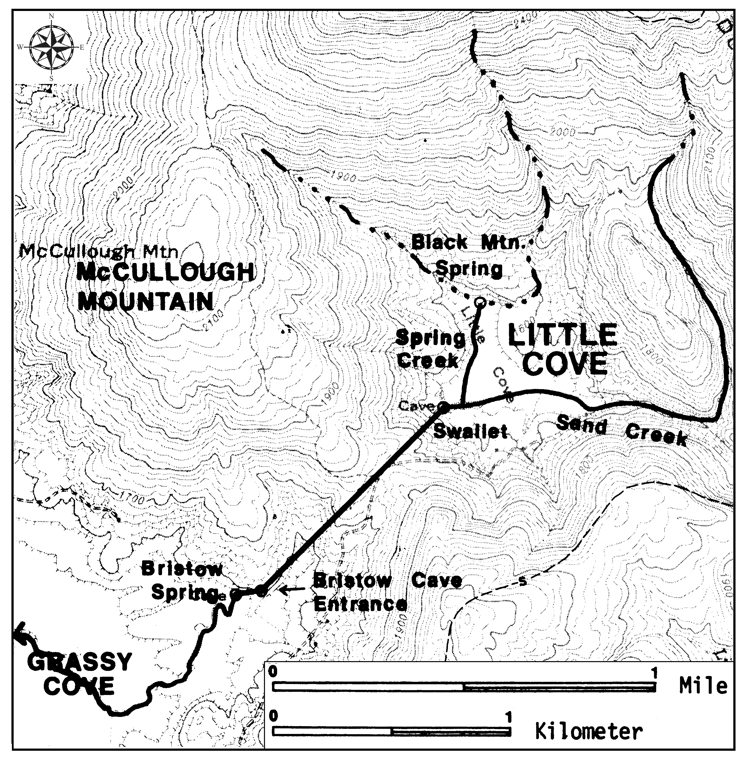
Thick black lines represent drainage pathways
Line from Little Cove Swallet to Bristow Spring represents underground flow

Because the rock underlying this portion of the Cumberland Plateau is horizontally layered, the direction of water flow is always going towards the cove floor that has been eroded to a lower elevation. The Little Cove Swallet is located at the 1580 foot contour line elevation. Bristow Spring in Grassy Cove is also located at that same elevation of 1580. In between these two locations, the water is flowing underground within the limestone layer in an essentially horizontal path. Water may also seep downward into lower porous limestone layers through vertical shafts.

Figure 4A-2: Grassy Cove Geology and Hydrology

Thick solid black lines represent surface water flow in Grassy Cove
Thick dashed black lines represent underground water flow in Grassy Cove
Mp, Mb, Mh, Mm, Msl, Mw, Mfp represent Mississippian Period sedimentary rock layers
Black letter “X” in lower left segment of map marks position of Saltpeter Cave
Map Scale ~ 1:32,000

With all of this limestone present beneath the cove floor, it may seem surprising that surface streams can exist at all within Grassy Cove. Most of the cove streams actually flow over deposits of loose sediment (alluvium) that were eroded from the mountain slopes that rim the cove and then left behind on the cove floor as the stream flow slowed down and deposited its load. Because this sediment is mostly derived from resistant sandstones and shales, it does not dissolve in water the same way limestone does, and therefore will tend to support stream flow on the ground surface. Grassy Cove must have been in existence for a very long time in order to account for the extensive amount of erosion that has taken place on the side slopes and the subsequent growth of the wide floodplains that have been deposited on the cove floor.

Sequatchie Valley

Sequatchie Valley, Tennessee (which continues southward as Browns Valley in Alabama) is a narrow, linear feature that cuts through a large portion of the Cumberland Plateau and seems almost out of place among the high elevation, flat lying rocks typical of the plateau region. It averages about four miles (6.5 km) in width. The northeast trend, tilted rock layers, and exposed thrust faults seem to fit in better with the Valley and Ridge landscapes to the southeast. The exposure of Ordovician Period limestone in the valley is likewise very typical of Valley and Ridge rocks. The similarity in landscape patterns reflects both the underlying bedrock geology and a long history of weathering, erosion, and tectonic uplift

Figure 4A-3: Geologic Cross-Section Through Sequatchie Valley

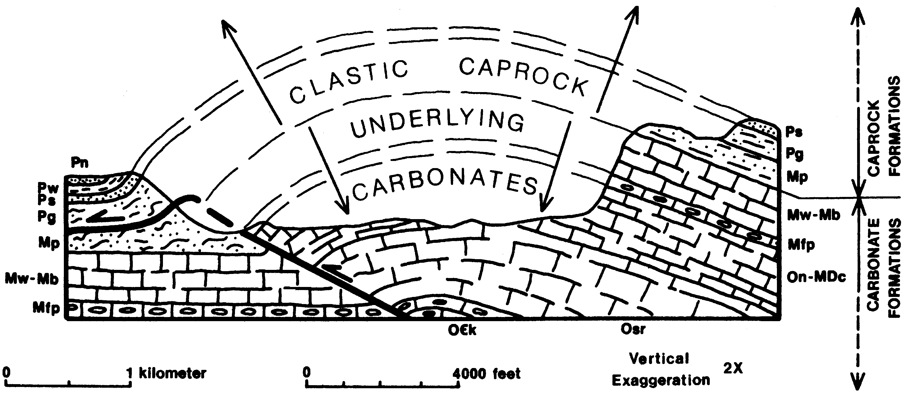

Sequatchie Valley (and Browns Valley) are underlain by a great structural up-arching in which the originally horizontal sedimentary rock units have been upfolded into a long, northeast-plunging, anticline structure that parallels regional geologic trends for more than 200 miles (320 km) through Tennessee and Alabama. This great fold has been detached from underlying layers of rock along a great low-angle thrust fault that underlies much of the plateau, usually at a depth ranging from one to several miles. However, along the west side of Sequatchie Valley, 1,600-feet (488 meters) of vertical erosion has exposed a sled-runner-like upward splay of the thrust sheet that is named the Sequatchie Valley Thrust Fault.

For millions of years following the uplift, the geological processes of weathering and erosion have been continually stripping away most of the up-arched portions of the resistant sedimentary formations, primarily sandstones, that were located on top of the anticline structure. Once the resistant cap rocks were removed, the underlying weaker siltstones, shales, and limestones were exposed at the surface and differential erosion began to form the valley. The part of the valley underlain by weaker rocks tended to erode at a much faster rate, causing the relief between the valley bottom and the higher plateau to increase through time. Once limestone rocks are exposed at the surface, dissolution by ground water also becomes an important erosional process. Removal of the surface limestone, and enlargement of underground conduits, undermines the overlying shales, siltstones, and sandstones on the valley sides. When the underlying rock is dissolved or flushed out, these overlying rocks collapse and break up into successively smaller fragments that move downslope, under the influence of the pull of gravity, and are eventually washed into streams and transported out of the valley.

The gradual deepening of the Sequatchie Valley is undoubtedly related to the overall erosional history of the Tennessee River system, which has drained this region for millions of years. The path of the modern river cuts through Walden Ridge, west of Chattanooga, Tennessee, in a deep gorge before entering Sequatchie Valley. It then follows the valley southward for about 60 miles (96 km) before leaving the valley, just as abruptly, to flow westward across the Alabama plateau. Originally, the Tennessee River probably meandered across a relatively level region of flat-lying sedimentary rocks. With tectonic uplift, the erosive power of the river increased to the point where it could cut through even the resistant sandstones that cap the Cumberland Plateau, forming spectacular gorges in the process. In this way, the main river was able to maintain its original course even though the surrounding landscape changed drastically. Tributaries draining resistant rock tended to be short and small, while tributaries flowing through less resistant rock, like limestone, tended to lengthen and expand more quickly through the process of headward erosion. In the case of Sequatchie Valley in Tennessee, a significant portion of the flow of the headwater reaches of the Sequatchie River is contributed by underground springs. Very little water enters the valley over the eastern or western rim, because the surrounding land surface on the plateau tilts away from the valley on both sides.

Figure 4A-4: Headward Erosion of the Sequatchie River

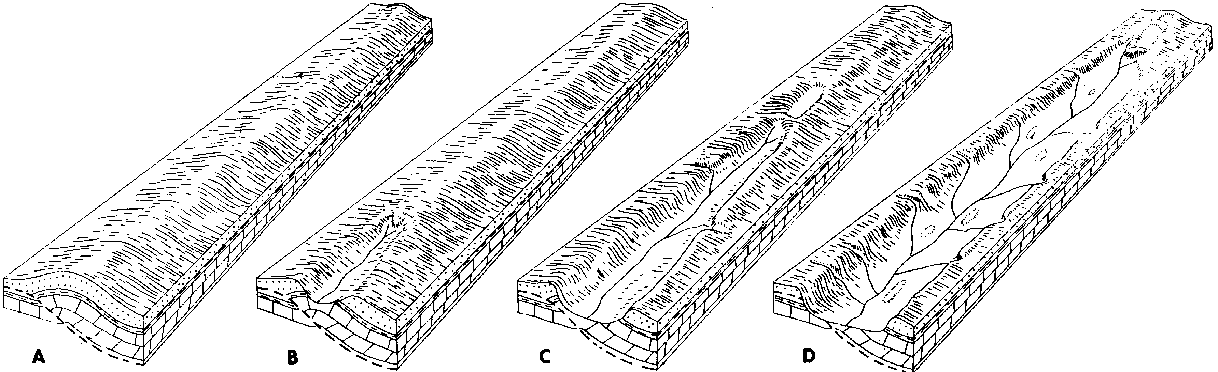

Raccoon Mountain Pumped Storage Hydroelectric Project

Hydroelectric power (using the power of falling water to turn turbines and generate electricity) has been used as a clean and relatively inexpensive source of electrical energy for many decades. But at this point, most of the rivers that are suitable for hydroelectric power generation have already been dammed and are actively producing electricity. In the early 1970s, many power companies began to explore a new concept in hydroelectric power, the pumped-storage process. Water is pumped uphill to a storage reservoir during times of low energy demand and later released to flow downhill through turbines to generate electricity during times of peak power demand. As a result, cheap power is available exactly when and where it is needed, and nothing is wasted. Most pumped-storage projects are able to produce over twice as much power as conventional hydroelectric units, but this energy is only available for short periods of time.

Figure 4A-5: Sketch Map of Raccoon Mountain Project
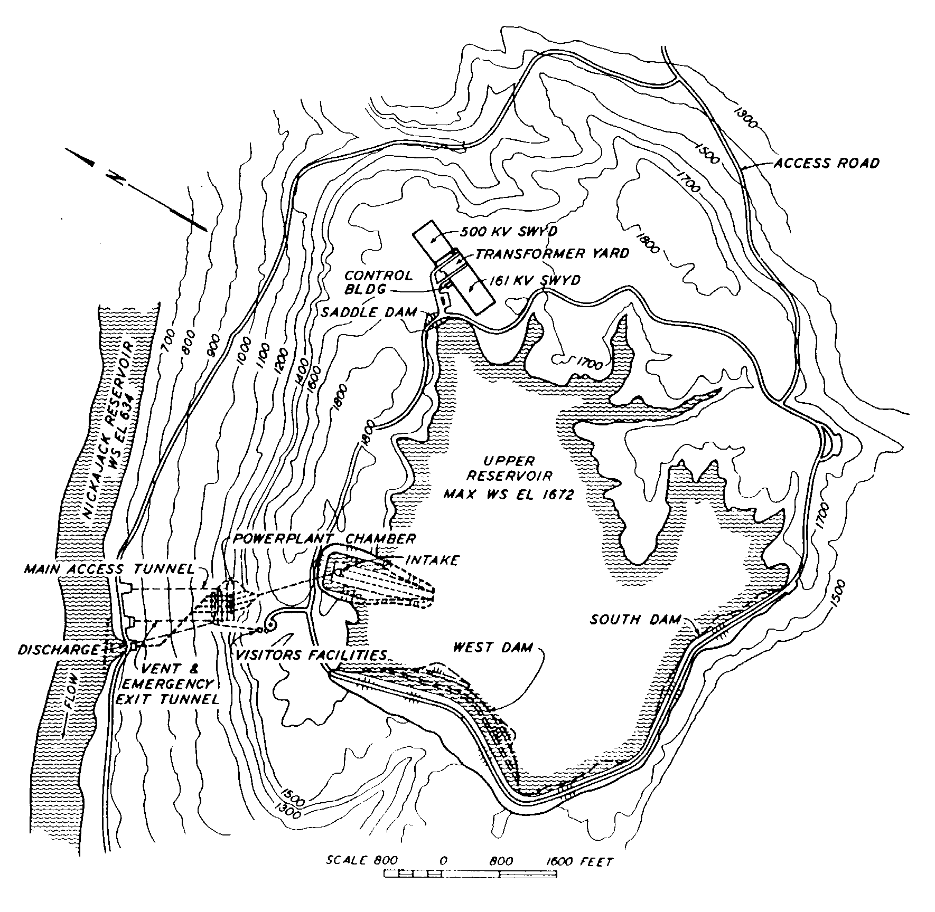

The Raccoon Mountain Project was started in 1970 but did not begin generating electricity at full capacity until 1979. To construct the reservoir, engineers had to dam up two small streams with separate rockfill dams. Those two dams were later joined to form one continuous unit which, at 230 feet (70 meters) high and 8,500 feet (2,591 meters) long, represented the largest rockfill dam ever built by the Tennessee Valley Authority (TVA). Its construction required over 10 million cubic yards (7.8 million cubic meters) of rock and dirt material. At full pond, the reservoir covers 528 acres (214 hectares), is 172 feet (52.4 meters) deep, and can provide continuous electrical generating capacity for 20 hours for a total of 1.6 million kilowatts. Following maximum drawdown, it requires 27 hours to completely refill the reservoir. The entire project is estimated to have cost around $180 million.

Water released from the upper reservoir flows through a slotted concrete intake structure and into a large concrete-lined passageway leading 990 feet (302 meters) downward inside Raccoon Mountain to the underground power plant. After passing through turbines, the water exits to Nickajack Lake through a 35 foot (10.7 meter) diameter pipe. Water level in the upper reservoir tends to fluctuate greatly, so recreational activities are not permitted. The lower reservoir (Nickajack Lake) must be much larger than the upper reservoir to avoid noticeable water level changes during pumping or power generation cycles.

Figure 4A-6: Cross-Section of Power Generating Facilities
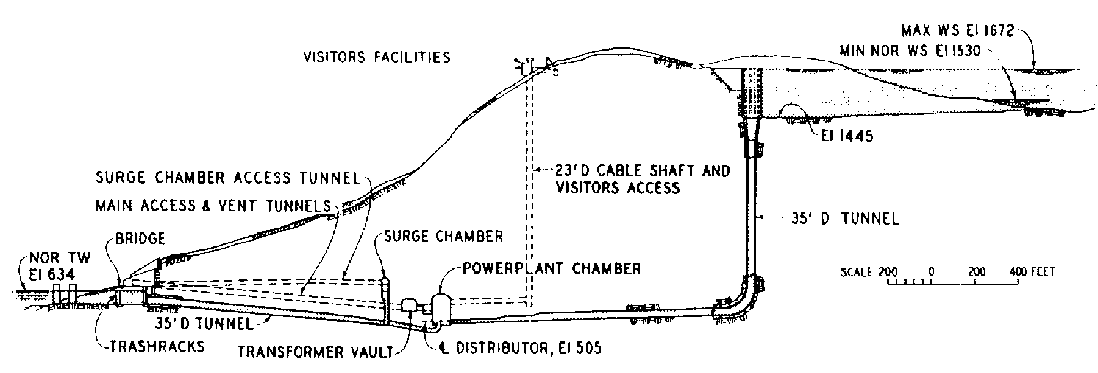

The geology of Raccoon Mountain makes it an ideal site for locating a pumped-storage project. The top of the mountain is underlain by a 75 foot (23 meter) thick layer of sandstone, which provides a good foundation for the upper dam and prevents water from seeping into the mountain. Limestone rock layers lying much deeper within the mountain are much softer, a fact that makes it relatively easy to construct both tunnels and the large underground chambers that are needed to house the generating equipment and main transformers.

Producing electricity is only part of the job faced by utility companies. To be useful, power must be transferred to where people live and work. Almost all electricity travels at velocities close to the speed of light over high voltage (44,000 - 525,000 volts) transmission lines that connect the power plants to regional substations. Transformers at these substations reduce the voltage level to amounts that are safe to transmit along highway power lines (4,160 - 24,940 volts). Still another set of transformers must be used before the voltage level is safe for use in homes or businesses (120 - 240 volts). The major advantage of using higher voltages is that electricity can be transferred greater distances with less loss of power. The disadvantage is that high voltage lines must be placed high off the ground and away from trees and buildings. This requires the complete clearing of a corridor of land before a power line can be constructed across the area.

Whenever a new power line is needed, planning engineers look for the best corridor site to achieve reliable electrical service to an area at reasonable cost while addressing local environmental and aesthetic concerns. Siting and construction are particularly difficult in wilderness areas or other places with limited access for heavy machinery and other equipment. Usually planners will route power lines along highways or railroads to reduce environmental impact. Sometimes the power company will purchase the land, but in most cases it is more effective to simply purchase a “right-of-way” that allows the company to run its power lines across other people’s property. Normally neutral paint colors (grays and greens) are used on the metal towers, which helps them blend with the natural landscape. Planting trees adjacent to the cleared corridor helps to control erosion and also helps to hide the lines. At the Raccoon Mountain site, most of the transmission facilities on the mountaintop are screened by forest, and the powerhouse is located underground. So only the discharge structure and tunnel portals are visible to the casual observer.

Activity 4A-1: Karst Topography

POWER THINKING EXERCISE - "Runoff Riddle"
While on a school field trip to visit an old farmstead in the small town of Grassy Cove, Tennessee, your class has just discovered an unexpected mystery. It has been raining hard all day, but there is no water flowing out of Grassy Cove. It is completely surrounded by mountains and high hills and no streams can leave the area. In fact, there are very few streams at all, and the ones that do exist simply end near the center of the basin. There is a lot of water coming into Grassy Cove, but none seems to be leaving. And yet the basin is not filling up with water.
Examine carefully both the anaglyph map of Grassy Cove (the town is in the center of the map) on MAP 4A, CUMBERLAND PLATEAU / SEQUATCHIE VALLEY and the Grassy Cove Stereo Triplet on IMAGE 4A, CUMBERLAND PLATEAU / SEQUATCHIE VALLEY to see if you can solve the mystery of the missing water. You will need the special 3-D glasses to view the anaglyph map and special stereoscopic glasses to view the stereo triplet in 3-D. Share your theories with other groups in your class.

Materials
MAP 3B, GEOLOGICAL SETTING
MAP 4A, CUMBERLAND PLATEAU / SEQUATCHIE VALLEY
Newspaper Article, “Cavers Kept Find A Secret To Protect It”
3-D Viewing Glasses
Wipe-off Pens

PERFORMANCE TASKS
(Icon Key) Overview = ; Science = ; Math = ; History = ; Language Arts =

1. Compare and contrast plateau and valley topography.
Examine the topography of Sequatchie Valley and the surrounding plateau using the 3-D viewing glasses and the 3-D Topographic Section Map: Sequatchie Valley on the left half of MAP 4A, CUMBERLAND PLATEAU / SEQUATCHIE VALLEY. Sequatchie Valley is the low elevation area running diagonally through the left part of the map. Compare and contrast the landform features you see in the valley with what you see on the surrounding plateau. In which direction do streams flow on the plateau? In which direction do they flow in Sequatchie Valley? How much relief (elevation difference) is present on the floor of the valley? How much relief is present along the top of the plateau? What features characteristic of Karst Topography do you see on this map? Which would you expect to see at this particular scale?

Look carefully at the Grassy Cove anaglyph on MAP 4A, CUMBERLAND PLATEAU / SEQUATCHIE VALLEY and locate the closed basin surrounding the small town of Grassy Cove. Is the topography of this basin more like Sequatchie Valley or more like the surrounding plateau? Explain your answers. Describe the features you see.
2. Relate topography to underlying geology.
Locate Sequatchie Valley on MAP 4A, CUMBERLAND PLATEAU / SEQUATCHIE VALLEY and also on MAP 3B, GEOLOGICAL SETTING. On the geology map, the valley corresponds to the thin red band of Ordovician Period rocks (surrounded by blue Mississippian Period rocks) trending northeastward just above the spot where the states of Tennessee, Georgia, and Alabama come together. The red Ordovician rocks are actually limestone, a rock that weathers very quickly in the moist southeastern climate. The blue Mississippian rocks are mostly resistant sandstone, as are the dark yellow overlying rocks of the Pennsylvanian Period. Because this location is in the Appalachian Plateaus region, the rock layers are generally horizontal, but in certain places like Sequatchie Valley the rock layers have been bent or folded slightly upwards. Once the overlying sandstone had been worn away, the exposed limestone began to erode much more quickly than the surrounding rock. How deep do you think Sequatchie Valley will get before the erosion finally stops? Will the sandstone erosion rate ever catch up to the limestone erosion rate? What determines the limit of downward erosion of a landscape? Explain your answer.

3. Calculate contour interval and compare relief.
Not every contour line on a topographic map is labeled because of the lack of space on the map to put all the numbers. Instead, only every fourth or fifth line is numbered. These special contour lines print darker and are referred to as index contours. To calculate the contour interval, find a place on either 3-D anaglyph map, on MAP 4A, CUMBERLAND PLATEAU / SEQUATCHIE VALLEY, where two differently numbered contour lines are close to each other [you will need the 3-D glasses to read the contour numbers clearly]. Subtract the smaller index contour number from the larger and divide the result by the total number of contour line steps needed to get from the smaller contour line to the larger. Write this number down for reference. A point in between two contour lines will have an intermediate elevation.

‘Relief’ is a geologic term referring to the difference in elevation between the highest point and the lowest point of an area. Calculate the relief in Grassy Cove by estimating elevations of the highest adjacent mountain and the basin floor. Also estimate the elevation of the plateau west of Grassy Cove. Finally, calculate the relief in the north end of Sequatchie Valley (surrounding the town of Burke to the southwest of Grassy Cove) by estimating elevations of the highest side of the valley and the valley floor. Which is higher, the floor of Grassy Cove or the plateau surface to the west? Which is higher, the eastern rim or western rim of Grassy Cove? Which is higher, the eastern or western valley wall of Sequatchie Valley?

On the 3-D Anaglyph Map of Sequatchie Valley, estimate the elevations of the eastern and western valley rim and the valley floor. Which rim side is higher? How much higher? Calculate the relief for both the eastern and western sides of the valley. Which section of Sequatchie Valley is lower, the northern end by Grassy Cove or the southern end, near the town of Sequatchie?

4. Debate repeal of permit for sewage treatment plant.
Locate the town of Barkertown on the 3-D Anaglyph Map of Sequatchie Valley [look in the far upper-left corner of the map]. You will need 3-D glasses to be able to read the town names clearly. Then read the newspaper article “Cavers Kept Find A Secret To Protect It” on page 4A-1. The town of Spencer is actually located 25 miles north of Barkerstown (just above the top margin of the map), but the topography of the two areas is very similar. Land-use planners often have to make judgments about social needs projects (such as improved sewage treatment systems) versus the need to preserve the natural environment (such as protecting the cave ecosystem). Divide your class into groups so that at least two groups speak in favor of permitting the sewage plant construction to proceed and at least two groups speak in favor of protecting the cave. Make a list of reasons to allow the permit and another list of reasons to deny the permit. After a full-class discussion, see whether anyone can come up with a way to solve the problem by building the sewage plant while still protecting the cave.

5. Explain abundance of towns named ‘Springs’.
Using the special 3-D glasses, locate and list all of the small towns along the floor of Sequatchie Valley that are shown on the 3-D Anaglyph Map of Sequatchie Valley on MAP 4A, CUMBERLAND PLATEAU / SEQUATCHIE VALLEY. How many towns did you find? How many town names contained the word "Springs?" Why would a town incorporate that word into its name? Why would the Sequatchie Valley be a favorable location for springs to occur? Why would early settlers tend to congregate around springs and start towns there?

Many other town names make reference to the geology or topography of the area in which they are located. Study both anaglyph maps carefully and locate at least five other towns (not in Sequatchie Valley) whose names reflect the landscape. Share your list with other groups in your class and start a class list of geologic town names
.

ENRICHMENT
(Icon Key) Overview = ; Science = ; Math = ; History = ; Language Arts =

1. Explain how 3-D anaglyph images work.
Anaglyph maps provide a spectacular way to view topography in three dimensions. The special glasses work the same way with maps as they do with 3-D movies. Research the science behind anaglyph drawings and be able to explain to the class how this optical illusion is created. Use MAP 4A, CUMBERLAND PLATEAU / SEQUATCHIE VALLEY to demonstrate your findings.

2. Investigate Karst features.
Most limestone regions display some form of Karst Topography. Obtain some local topographic maps of Grassy Cove, Tennessee (at a larger scale than used on MAP 4A, CUMBERLAND PLATEAU / SEQUATCHIE VALLEY), or any other area underlain by limestone rock. Identify as many Karst-related landform features as you can and explain how groundwater dissolution contributed to their formation.

Activity 4A-2: Structural Influence on Topography

POWER THINKING EXERCISE - "Color Controversy"
Having learned all about reading and interpreting color infrared images, you are surprised to find two differently colored infrared products on IMAGE 4A, CUMBERLAND PLATEAU / SEQUATCHIE VALLEY. The Sequatchie Valley NALC image is a color infrared satellite image and the Grassy Cove Triplet is a NHAP color infrared photograph. Although the images are obtained at very different elevations and are printed at different scales, you nevertheless expect reddish colors to indicate vegetation on both products. Note that Grassy Cove is visible on the Sequatchie Valley NALC near the center of the upper half of the image. Focus on the Grassy Cove area and list and describe all of the colors you see on each image. Use the background information in Chapter 2 to help you interpret what you are seeing.
Both images are printed correctly, so you must find another explanation for how two infrared images of the same feature can display such different colors. Once you have constructed an hypothesis, write it down and share it with another group in your class and see if they find it believable. Do any of your hypotheses agree with published data?

Materials
MAP 3E, POLITICAL SETTING
MAP 4A, CUMBERLAND PLATEAU / SEQUATCHIE VALLEY
IMAGE 4A, CUMBERLAND PLATEAU / SEQUATCHIE VALLEY
Story, “Bonnie Barbara Allen”
3-D Viewing Glasses
Wipe-off Pens

PERFORMANCE TASKS
(Icon Key) Overview = ; Science = ; Math = ; History = ; Language Arts =

1. Compare and contrast RADAR and NALC images.
Examine the Sequatchie Valley SLAR and the Sequatchie Valley NALC images on IMAGE 4A, CUMBERLAND PLATEAU / SEQUATCHIE VALLEY. Which image shows the topography more clearly? Which image shows land use more clearly? Why does all water show up as black on the SLAR but show up as several different colors on the NALC? Why are there shadows behind the mountains on the SLAR, but not on the NALC? Which image shows highways more clearly? Which image shows cities and towns more clearly?

Compare both the SLAR and NALC images of Sequatchie Valley to the 3-D Anaglyph Map on MAP 4A, CUMBERLAND PLATEAU / SEQUATCHIE VALLEY. The very top area of the anaglyph map corresponds to the very bottom area of the SLAR and NALC images. Can you identify any features common to both areas? If so, what? What types of features show up best on the anaglyph map?

2. Identify antecedent river.
Antecedent rivers are those that existed in an area before the modern topography (and modern rivers) developed. The pathway of antecedent rivers often is very different from more recently formed rivers. One of the most startling features on the 3-D Anaglyph Map of Sequatchie Valley, on MAP 4A, CUMBERLAND PLATEAU / SEQUATCHIE VALLEY, is the large river (Tennessee River) at the bottom of the map that appears to cut through the high plateau in a series of canyons. How deep are some of these canyons? Compare the channel pattern of this river to the pattern of streams that flow over the high plateau. In what ways are these patterns different? In what ways are they alike? In what type of landscape would you normally expect to see a stream pattern like that of the Tennessee River develop? How can you explain this river cutting down through the resistant sandstone layers of the plateau instead of staying in the limestone valley to the east of the city of Chattanooga?

3. Calculate plunge angle of fold axis.
Examine the Sequatchie Valley NALC on IMAGE 4A, CUMBERLAND PLATEAU / SEQUATCHIE VALLEY. The Sequatchie Valley feature is essentially a linear region of gentle upward folding in which the uppermost sandstone layers have been eroded away to expose the soft limestone underneath. The sides of the valley represent the edges of the sandstone cover. A fold that is horizontal (the fold axis is horizontal) will produce a valley that is everywhere the same width, so long as the erosion takes place among relatively flat lying rocks. A fold that is plunging (the fold axis is tilted) will produce a valley that tapers from a wide width to a very narrow width, as erosion removes more of the sandstone cover from the higher elevation end of the fold structure.

On the NALC image, the Sequatchie Valley appears to be of even width along its entire length, but this relationship can be demonstrated mathematically to establish for certain whether the fold axis is horizontal or plunging. On a piece of graph paper, designate the X axis as the distance from the upper end of the Sequatchie Valley; and let the Y axis represent the width of the valley. Use a ruler and take at least ten measurements of the valley width at distances no less than one inch apart. Enter your data on the graph and plot the "best fit" line through those points. The slope of that line represents the plunge angle of the fold. What is the plunge angle for the Sequatchie Valley fold axis?

4. Assess historical importance of Lookout Mountain.
Locate the city of Chattanooga, Tennessee on MAP 3E, POLITICAL SETTING and note its close proximity to the Tennessee River. This river was the only convenient water transportation route across the Cumberland Plateau connecting Knoxville Tennessee and the North with Huntsville, Alabama and the South. Locate these same features on the 3-D Anaglyph Map of Sequatchie Valley on MAP 4A, CUMBERLAND PLATEAU / SEQUATCHIE VALLEY. Because of its strategic position, Chattanooga played a pivotal role in the Civil War, especially in regard to the transport of materials and supplies to the army of the Confederacy.

Just south of Chattanooga, a large ridge of Pennsylvanian Period sandstone guards the big bend of the Tennessee River just before it enters the deep gorges of the Cumberland Plateau. This ridge was given the name Lookout Mountain. Find this ridge on the anaglyph map (just east of the town of Tiftonia). Why was this vantage point better than another location further downstream into the plateau? How far (refer to map scale) do you think scouts could see from the top of Lookout Mountain?

5. Re-write “Bonnie Barbara Allen” in modern English.
Examine the Sequatchie Valley NALC image on MAP 4A, CUMBERLAND PLATEAU / SEQUATCHIE VALLEY to distinguish areas that seem to be readily accessible from areas which appear much more remote and hard to reach. From the time the first immigrants came to Tennessee, there has been a significant cultural difference between those who settled in the valleys and those who settled in the mountains. Those who settled in the mountains tended to maintain the old language, customs, and traditions, while those who settled in the valleys tended to modify their culture in response to continual contact with people from different backgrounds. Why was it so much easier for folks to intermingle in the valleys?

The ballad, "Bonnie Barbara Allen" (page 4-5) is an example of a traditional Scots-Irish song that was brought to the Appalachian Mountains in the late 1700s. In many areas of the Cumberland Plateau, this song has kept its old dialects and wordings. The sharing of such narrative songs was a way to remember and maintain the old culture in a new land with sometimes strange ways. Read through the traditional version of the ballad and re-write two or three verses in more modern English to produce a version which might be more like the one sung by people living in the valley.

ENRICHMENT
(Icon Key) Overview = ; Science = ; Math = ; History = ; Language Arts =

1. Research the role of Lookout Mountain in the Civil War.
Use your local library collections or the internet to search for references to the city of Chattanooga or Lookout Mountain during the Civil War. Report back to the class on what types of materials and supplies were usually shipped back and forth on the Tennessee River, and how blockades were used to halt river traffic from time to time. Use the 3-D Anaglyph Map of Sequatchie Valley on MAP 4A, CUMBERLAND PLATEAU / SEQUATCHIE VALLEY to illustrate your points.

2. Compile examples of traditional ballads and stories.
There are lots of traditional mountain ballads and stories from the Scots-Irish culture (like the ballad of "Bonnie Barbara Allen") that still live on in the Cumberland Plateau and other isolated areas of the Appalachian Mountains. Contact a local folklore society or locate an appropriate web site to obtain copies or recordings of some of this old music and samples of storytelling styles. Pay close attention to the words and note any references to landscapes or landforms. If you find any, try to place them at an appropriate location on one of the Sequatchie Valley images on IMAGE 4A, CUMBERLAND PLATEAU / SEQUATCHIE VALLEY.
Activity 4A-3: Pumped Storage for Hydroelectric Power

POWER THINKING EXERCISE - "Damming Dilemma"
You are the chair of the Public Utilities Board for the City of Chattanooga and have just been informed by your office that, due to an expected increase in peak electrical demand over the next 20 years, the city will have to construct another pumped storage facility, in addition to Raccoon Mountain, in the near future. Examine the Raccoon Mountain Topographic Map on MAP 4A, CUMBERLAND PLATEAU / SEQUATCHIE VALLEY, to get a quick idea of the type of landscape you need to look for. Use the 3-D glasses and the 3-D Topographic Section Map of Sequatchie Valley (also on MAP 4A) to explore for an appropriate site to locate the new dam and reservoir.
When you have found the best site, circle it on the map with a wipe-off pen and make a list of landscape modifications that will have to take place before the site can be used. Be prepared to argue your case in front of the class with other groups who will be presenting other options. After all groups have presented their site analyses, the class should vote on the best place to build the new facility.

Materials
MAP 4A, CUMBERLAND PLATEAU / SEQUATCHIE VALLEY
3-D Viewing Glasses
Wipe-off Pens

PERFORMANCE TASKS
(Icon Key) Overview = ; Science = ; Math = ; History = ; Language Arts =

1. Identify alterations to landscape.
Locate the Raccoon Mountain pumped storage dam and reservoir on the Raccoon Mountain topographic map on MAP 4A, CUMBERLAND PLATEAU / SEQUATCHIE VALLEY. Also locate this same site in the lower middle part of the 3-D Anaglyph Map of Sequatchie Valley (also on MAP 4A). Note that the 3-D map is older and shows the landscape before construction began on the dam and reservoir. Compare the contour lines on the 3-D map with the contour lines on the topographic map. Note that the 3-D map contour lines are scaled in metric units. What is the contour interval of each map? Locate and identify the following features on the topographic map: the dam, the water intake in the reservoir, the underground power house, the water outflow into Nickajack Lake (Tennessee River), and the construction road that was used to bring bulldozers and other equipment to the top of the mountain. Where do you think the dirt and rock came from to build the dam on the western and southern sides of the reservoir? What is the approximate elevation of the water level in the reservoir? What is the elevation of the top of the dam? How much dirt and rock (height) had to be added to the western and southern edges of the reservoir to be able to hold back the water in the reservoir? Why is the dam shaped the way it is ("V"-shaped)?

2. Sketch and analyze topographic profile across Raccoon Mountain.
Pumped storage hydroelectric projects require a certain topographic pattern or profile to be successful, and Raccoon Mountain provides an excellent example of this type of land surface. Use the contour information on the Raccoon Mountain topographic map on MAP 4A, CUMBERLAND PLATEAU / SEQUATCHIE VALLEY, as the basis for constructing a topographic profile. Draw your cross-section line from the "Gaging Station" on Nickajack Lake to the "Athletic Field" in Lookout Valley (just above the legend box with the National Science Foundation logo). Draw your profile grid with no vertical exaggeration. Only use information from index contour lines (bold lines with elevation numbers). When you cross the lake, make some educated guesses about the elevation of the lake bottom (you can refer to the 3-D Anaglyph Map of Sequatchie Valley - also on MAP 4A - to get information), and draw your profile line with dashes. When your topographic profile is complete, study it carefully and write a short description of the ideal mountain profile that will fit the requirements of future pumped storage projects. Compare your profile to that of other groups in your class.

3. Calculate the volume of water in a reservoir.
Locate the Raccoon Mountain pumped storage reservoir on the Raccoon Mountain Topographic Map on MAP 4A, CUMBERLAND PLATEAU / SEQUATCHIE VALLEY. Calculate the total volume of water in this reservoir (at full pool) by approximating a geometric shape for the surface area and inferring an average or a maximum depth (depending on the method). Each group should select one of these four options.

triangular solid Volume = ¹/₂ b h l (area of triangle times depth)
rectangular solid Volume = l w h (surface area times depth)
hemisphere Volume = ²/₃  r³ (surface area times average depth)
cylinder Volume =  r² h (surface area times depth)

Groups should write down their answers and share them with other groups in the class. Discuss the results and decide which geometric approximation is the best choice for this type of calculation. Defend your selection.

4. Speculate about historical figure.
Examine the eastern shoreline of Nickajack Lake (Tennessee River) in the middle left part of the Raccoon Mountain Topographic Map on MAP 4A, CUMBERLAND PLATEAU / SEQUATCHIE VALLEY. Locate McNabb Spring, McNabb Cemetery, McNabb Road, and the stream called John McNabb Draw. Directly across Nickajack Lake is another McNabb Cemetery. Although we do not know very much about Mr. McNabb, apparently he was well known in this area. What would a person have to do to achieve this much local fame? There are not enough geographic features to name something after everybody, in fact very few people have things named after them. When do you think Mr. McNabb lived? When do you think these features acquired his name? Why do local people tend to name geographic features after a local person rather than, for example, honor a famous national or Tennessee war hero?

5. Write short story about Mr. McNabb.
Several geographic features along Nickajack Lake (Tennessee River) are named for a Mr. McNabb (see Performance Task #4). Locate these features on the Raccoon Mountain Topographic Map on MAP 4A, CUMBERLAND PLATEAU / SEQUATCHIE VALLEY. Speculate about the life and times of Mr. McNabb and write a short story that includes the reason why all these features were named for him. Be sure to include references to landscape features in your story.

ENRICHMENT
(Icon Key) Overview = ; Science = ; Math = ; History = ; Language Arts =

1. Research power capacity of pumped storage projects.
Write to the Raccoon Mountain pumped storage office, or to another power company that runs a pumped storage facility in your state. Ask about specifications for the construction of the dam and reservoir, and ask about the power capacity of the generators at that site. Find out when peak electricity loads are experienced in that region and how often the pumped storage unit is used.

2. Research life of John McNabb or other local person.
A lot of people like John McNabb are not well known outside their own local area, but it may still be possible to find out something about the person through court records or old newspapers. Use your local library or the internet to look up archived files or newspapers to see what you can dig up about either Mr. McNabb or someone in your local area who has had landforms named after them.
.

STUDY AREA 4B: CUMBERLAND GAP

Lexington Herald-Leader
October 13, 1996
Cumberland Gap Tunnel
Cumberland Gap, TN. Seventeen years in the making, the Cumberland Gap tunnel project has spurred highway expansion in three states, hopes for tourism in communities near the Gap, and dreams of restoring the wilderness trail that Daniel Boone blazed in the 1700s. The tunnel is “the most significant thing that has happened there since Daniel Boone began to bring settlers through the Gap,” said U.S. Rep. Hal Rogers, whose district includes parts of southeastern Kentucky. The Cumberland Gap project cost the federal government about $280 million, more than twice the estimate from | the early ‘80s, Rogers said. That’s mainly because the mountain yielded some surprises for engineers, including a system of underground streams, he said. The twin tubes - one southbound, one northbound - are located in Tennessee and Kentucky. Each state will spend about $1 million a year to maintain the tunnel, and about 40 people will work there.  The tubes replace a dangerous, 2.3-mile stretch of U.S. 25E, which links the town of Middlesboro, Ky. to Cumberland Gap, Tenn. Over the years, the highway has picked up an unpleasant nickname - Massacre | Mountain - because of the number of motorists killed along it. To Kentucky officials, the new tunnel means not just a safer route into Tennessee but also a magnet for tourists.  Partly because of the tunnel, the number of cars passing through the Gap is expected to double from 18,000 a day to 35,000 a day by the year 2020. The park currently gets 1.2 million visitors a year. The tunnel will boost that number, not just because it’s safer but also because tourists will be attracted to the restored wagon trail that will replace the old U.S. 25E over the mountain.

RATIONALE

The Cumberland Gap Study Area provides a classic example of how geology has influenced modern land use as well as the historical patterns of human expansion. The Cumberland Escarpment marks the topographic boundary of the Appalachian Plateaus region, but also serves to divide the highly populated farming country of the Valley and Ridge Region from the wilder, more rugged lands of the Cumberland Plateau. Cumberland Gap technically refers only to a 1,600 foot deep notch through the Cumberland Mountain ridge, but the surrounding area boasts many other noteworthy topographic features such as fault-controlled valleys, linear outcroppings of resistant rock layers, and possible meteorite impact structures associated with the Middlesboro Basin. The ‘Gap’ was one of the few places where westward traveling pioneers could easily ascend to the heights of the plateau, following the path of Daniel Boone’s Wilderness Road, to reach westward flowing rivers leading to the fertile valleys of Kentucky. Travelers still pour through the gap today, but the main road now passes underneath the mountain, through a tunnel. The National Park Service is reclaiming the old highway route to restore the Wilderness Road to its original condition.
PERFORMANCE OBJECTIVES

1. Describe the topography and underlying geologic structures at Cumberland Gap.
2. Correlate the locations of fault lines with various topographic landform features.
3. Construct rose diagrams to document primary orientations of landform features.
4. Compare and contrast old versus new transportation routes through Cumberland Gap.
5. Write a television script to document the occurrence of a natural disaster.
6. Describe the unique geology and topography of the Middlesboro Basin.
7. Evaluate theories of origin for unique features in the Middlesboro Basin.
8. Calculate grade (slope) of modern versus older highways.
9. Determine degree of correlation between state/county boundaries and natural features.
10.Explain reasons for nicknames and name changes to highways and other map features.

SAMPLE ASSESSMENT RUBRICS
EXAMPLE #1 (relates to Performance Objectives #6 and #7)
Give students a copy of the Geologic Map of Middlesboro Basin (Figure 4B-3) and a copy of the Cumberland Escarpment Topographic Map (on MAP 4B) and ask them to identify any two geologic and/or topographic features that support the meteorite origin hypothesis for the basin and also to explain how each feature supports the theory. [Some sample correct answers would include: faults (rocks broken by impact event); circular shape (reflecting spherical shape of meteorite); low elevation (broken rock is more easily and quickly eroded); core of older rocks in center (highly deformed by impact); alluvial deposits cover basin (many streams flow into basin, but only one flows out - due to high elevation rim surrounding the basin)].

A (level 4) – two correct answers given and correct explanations provided
B (level 3) – two correct answers given but only one explanation is correct.
C (level 2) – only one correct answer given and the explanation is correct.
D (level 1) – only one correct answer given, but explanation is not correct.
F (level 0) – no correct answers or explanations are given.

EXAMPLE #2 (relates to Performance Objective #9)
Give students a copy of the Cumberland Escarpment Topographic Map (on MAP 4B). Ask them to locate four specific different boundary lines (selected by the teacher) between different states or counties. [At least one boundary should follow a river or stream; at least one other boundary should follow another topographic feature, such as a mountain ridgeline, and at least one boundary should be a ‘straight line’ that does not follow any natural feature] For each boundary, students will determine whether the boundary follows a ‘natural topographic feature’ or not.

A (level 4) – all four boundaries are determined correctly
B (level 3) – three of the boundaries are determined correctly
C (level 2) – two of the boundaries are determined correctly
D (level 1) – one of the boundaries is determined correctly
F (level 0) – none of the boundaries is determined correctly

Cartographic Product Information

MAP 4B: Cumberland Gap

TITLE: 3-D Cumberland Escarpment, TN (topographic map)
DATA SOURCE: Corbin and Johnson City USGS 1:250,000 Quadrangles
DATE: Corbin = 1956 (photorevised 1965); Johnson City = 1957 (photorevised 1966)
SCALE: 1:250,000 [1 inch ~ 3.2 miles] [1 cm ~ 2 kilometers]
OTHER IMPORTANT DATA:
- This map shows both typical plateau and Valley & Ridge topography.
- The contour interval of this map is 100 feet.
POINTS OF SPECIAL INTEREST:
- Cumberland Gap (upper center of map)
- The Middlesboro Basin (upper center of map)
OTHER FEATURES TO LOOK FOR:
- The Cumberland Escarpment runs diagonally through upper part of map.
- Pine Mountain Overthrust (upper center of map).
- Jacksboro Fault (lower-left section of map).

TITLE: Cumberland Escarpment, TN (satellite image)
DATA SOURCE: EPA & USGS Pathfinder, WRS2 Path 19 Row 35
DATE: 1992
SCALE: 1:250,000 [1 inch ~ 3.2 miles] [1 cm ~ 2 kilometers]
OTHER IMPORTANT DATA:
- This image is a false-color infrared image, so all true colors have been shifted.
- This is a summer image, with leaves on trees, so forests will appear as red color.
POINTS OF SPECIAL INTEREST:
- Cumberland Gap (upper center of image).
- The Middlesboro Basin (upper center of image).
OTHER FEATURES TO LOOK FOR:
- Pine Mountain Overthrust (upper-left section of image).
- Jacksboro Fault (lower-left section of image).

TITLE: Cumberland Gap National Historical Park (National Park Service map)
DATA SOURCE: National Park Service GPO
DATE: 1999
SCALE: 1:62,500 [1 inch ~ 1 mile] [1 cm ~ .7 kilometers]
OTHER IMPORTANT DATA:
- Trails and overlooks are marked and labeled.
POINTS OF SPECIAL INTEREST:
- Cumberland Gap (left-center area of map).
- Highway tunnel under Cumberland Gap (left-center of map; US Route 25E)
OTHER FEATURES TO LOOK FOR:
- Route of the Wilderness Road (US Route 58).

Cartographic Product Information

IMAGE 4B: Cumberland Gap

TITLE: 3-D Cumberland Escarpment, TN (radar image)
DATA SOURCE: Johnson City USGS 1:250,000 Radar Mosaic
DATE: 1984
SCALE: 1:170,000 [1 inch ~ 2.7 miles] [1 cm ~ 1.7 kilometers]
OTHER IMPORTANT DATA:
- Dark bands along ridges are shadows cast by mountains that blocked radar beam.
- Brighter areas are facing source of radar beam and have stronger returns.
POINTS OF SPECIAL INTEREST:
- Cumberland Gap (upper center of image).
- Pine Mountain Overthrust (upper-left area of image)
- Middlesboro Basin (left-center area of image)
OTHER FEATURES TO LOOK FOR:
- Contrast in plateau topography and Valley & Ridge topography.

TITLE: Cumberland Gap, TN (topographic map)
DATA SOURCE: Middlesboro South, KY-TN-VA USGS 1:24,000 Quadrangle
DATE: 1974 (photorevised 1991)
SCALE: 1:24,000 [1 inch = 2,000 feet] [1 cm ~ 250 meters]
OTHER IMPORTANT DATA:
- The contour interval of this map is 20 feet.
POINTS OF SPECIAL INTEREST:
- Cumberland Gap (center of map)
- City of Middlesboro (upper-left corner of map).
OTHER FEATURES TO LOOK FOR:
- Route of Old Wilderness Road (US Route 25E) over Cumberland Mountain

TITLE: Cumberland Gap, TN (stereo aerial photograph)
DATA SOURCE: NHAP CIR Photographs 539-53 and 539-54
DATE: 1984
SCALE: 1:62,500 [1 inch ~ 1 mile] [1 cm ~ .6 kilometers]
OTHER IMPORTANT DATA:
- This image is a stereo-pair photo that is best viewed through a 3-D stereoscope.
- As with any stereoscopic view, only the center will display 3-D (sides will not).
- Line dividing the two images is hard to see (runs top to bottom near center).
POINTS OF SPECIAL INTEREST:
- Cumberland Gap (center of stereo section).
- Middlesboro Basin (lower-center of image).
OTHER FEATURES TO LOOK FOR:
- Route of Old Wilderness Road (US Route 25E) over Cumberland Mountain.

Study Area Description

The Cumberland Escarpment

The long, nearly unbroken ridgeline of Cumberland Mountain and the steep drop-off along its southern exposure, referred to as the Cumberland Escarpment, are the most notable landform features associated with the transition from the Valley and Ridge to the Appalachian Plateaus. This part of the Appalachian Mountain range, where the states of Virginia, Kentucky, and Tennessee all come together, well illustrates the fact that geological boundaries are often diffuse, rather than sharp. The steep folding and the surface geologic expression of thrust faulting which were the hallmark of the Valley and Ridge region gradually die out over the space of several mountain ranges as the traveler ascends through Cumberland Gap into the Middlesboro Basin and finally the Cumberland Plateau. The steep dip, or tilt, of the sedimentary rock layers also decreases towards the northwest until, on the top of the Plateau, the layers become nearly horizontal. In general, the linear summits of the major mountain ridges are held up by ledges of resistant rock layers, while valleys in-between are underlain by exposures of less resistant rocks or weakened zones which are the traces of fault lines.

Figure 4B-1: Geologic Cross-Section at Cumberland Gap
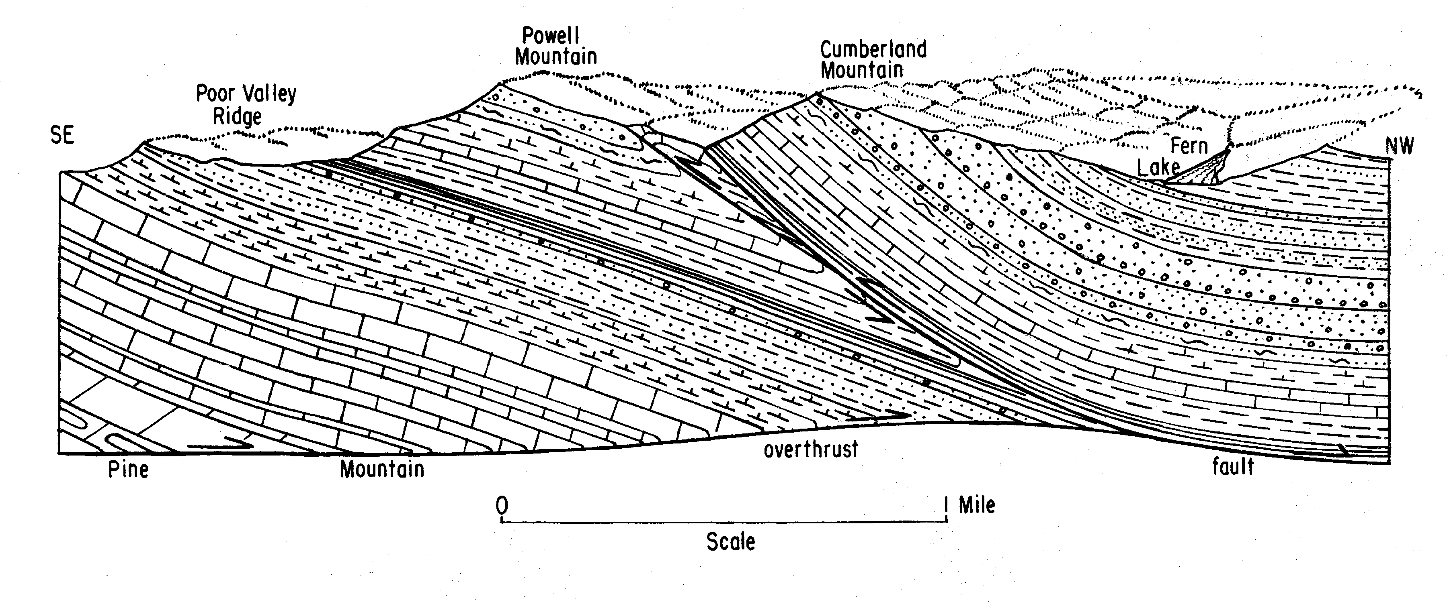
The plate-tectonic collision of the northwestern edge of the African Plate with the southeastern edge of the North American Plate during the late Paleozoic Era produced most of the folding and faulting seen in this area today. Another result of the collision of the two plates was the uplifting of the Earth’s crust throughout the entire Appalachian region, so that many layers of rocks formed from sediments originally deposited near or below sea level became raised into mountains and plateaus. This is why marine fossils are sometimes found at such high elevations. Subsequently, long periods of weathering and erosion of these uplands produced the rugged landscapes of hills and valleys that we see today. The mountain ridges and plateau uplands are mainly underlain by sandstones, which are more resistant to weathering and erosion than most other rocks in the region. The valleys, including the Middlesboro Basin, are mainly underlain by siltstones and shales, which are more easily weathered and eroded.
It is not coincidence that Cumberland Gap formed in this particular place. For many miles east and west of this site, the sandstones and conglomerates of Cumberland Mountain stretch out to form an almost impenetrable rock ridge. But here, at the gap, a fault line cuts across the mountain, offsetting the rock layers and creating a zone of structural weakness. The brittle rocks shatter during fault movements, allowing the chemical and biological agents of weathering to enter cracks easily and break down resistance. Once weathered, these rocks are easily eroded and removed from the steep mountain slopes. Thus the once long linear mountain ridges that would otherwise have formed barriers to early explorers and settlers developed sags or gaps in their crests over time. Other faults in the area also produced distinctive topographic features such as long, straight valleys. The Pine Mountain Fault marks the furthest limit of overthrusting in the plateau, while the Jacksboro Fault illustrates the lateral extent of the resulting offset.

Figure 4B-2: Folds and Faults Near Cumberland Gap

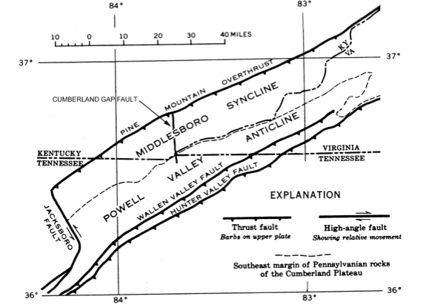

The Middlesboro Basin - Meteorite Impact Structure

An unusual, circular-shaped basin underlies the city of Middlesboro just northwest of Cumberland Gap. In contrast to the erosional nature of most of the Cumberland Plateau, the Middlesboro Basin is low and level enough to permit periodic deposition of loose, water-laid sediments over much of its area. The broad, flat expanse of the basin seems strangely out of place among the surrounding steep mountain peaks that rise to almost 2,000 feet above the basin floor. Geologists at first ascribed the existence of the basin to movement along a series of faults, but recent evidence points to a more exotic origin, a meteorite impact event. Both the geometry of the basin and its abundance of shattered and deformed rocks lend credibility to this theory.
Figure 4B-3: Geologic Map of Middlesboro Basin

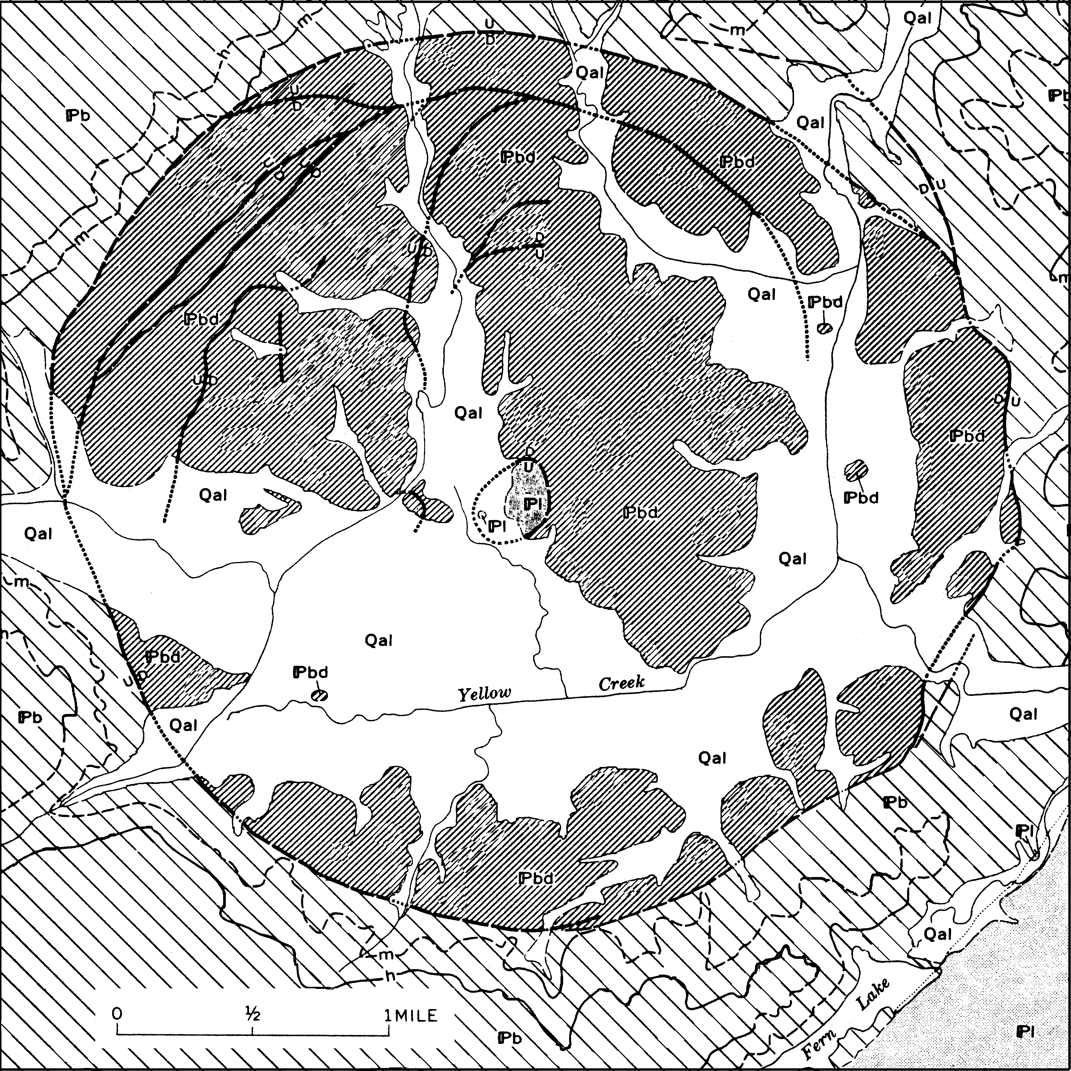

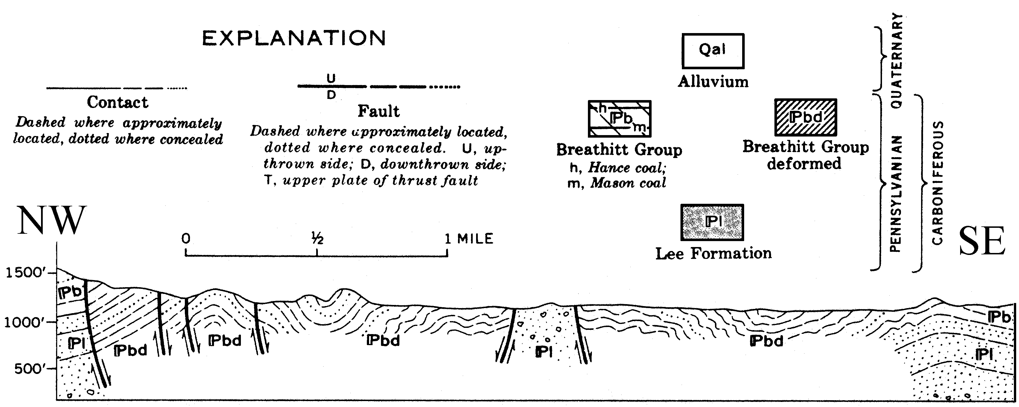

Meteorite impact events not only produce circular impressions and deformed rock, but often display a raised and highly broken core of older rock in the center of the structure. The Middlesboro Basin shows this exact same pattern, with a small circular mass of older, highly deformed Lee Formation rocks separated from younger Breathitt Group rocks by nearly vertical fault lines in the center of the basin. Rocks outside the basin are continuous and flat-lying beds of undeformed sedimentary rock. Stream courses are not deflected when they enter the basin, indicating that deformation occurred before the streams began flowing here, not after. The alluvial floodplain sediment is likewise much younger than the impact event. It is very difficult to pinpoint an exact date for the event. The best we can say is that it is older than the streams, but younger than the Pennsylvanian Period rocks that were deformed by the impact.

The Middlesboro Basin is prone to serious flooding because several streams bring in water from large mountainous watersheds while only one small stream leaves the basin, through a steep, narrow, rocky channel. Large rainstorms put far more water into the basin than can be removed immediately by the outlet stream. As waters back up, the water velocity decreases and sediment carried by the water begins to drop out and settle in the basin as alluvial or floodplain deposits. Despite the flood dangers, Middlesboro quickly became a prosperous city because of the otherwise favorable topography, flat and wide, as well as its proximity to the coal-bearing strip mines of the Cumberland Plateau. However continued growth, accompanied by more paving for streets and parking lots, will only make the flooding situation that much worse by increasing the amount of runoff after a rainstorm.

Daniel Boone and the Wilderness Road

The Cumberland Gap, a 1600-foot deep notch through Cumberland Mountain, provided one of the few places where traders and other travelers could easily cross the Cumberland Escarpment to gain access to the vast Cumberland Plateau. Native Americans took advantage of this route for centuries before Europeans began to explore the vast backcountry west of the Appalachian Mountains. Once the new settlers passed through the Gap, they could chose alternative routes that led either to the Bluegrass country of Kentucky or the Nashville Basin of Tennessee. The most famous of these routes, called the Wilderness Road, followed the famous Warrior’s Path of Kentucky, which was referred to as Athawominee (Path of the Armed Ones), by Native Americans.

The Cumberland River (the name was later also applied to Cumberland Mountain and the Cumberland Gap) was named by Dr. Thomas Walker to honor the Duke of Cumberland, second son of King George II, whom Walker had met during a trip to England. Walker was involved with the Virginia Loyal Land Company, which held a grant to eight hundred thousand acres of land west of the Allegheny Mountains, in a land known as “Kentakee.” With five companions, he set out to find and claim this land for his company. Walker kept a journal of his trip across the plateau to the headwaters of the Kentucky River. His notes indicate that during their travels, a bear bit one of his dogs while an elk killed another and rattlesnakes bit his horses. He also noted that the exploration party had killed a total of 13 buffaloes, 8 elks, 53 bears, 20 deer, and 150 turkeys for food.

Despite Walker’s efforts, the explorer most often associated with the Wilderness Road was actually Daniel Boone. Best known for his settlement activities in Kentucky, he also played an important role in opening Tennessee to settlement and visited both areas many times during his life. In 1769, Boone made his first trip through Cumberland Gap with five other men and followed the Warrior’s Path into Kentucky. After several years of living in the wilderness, Boone returned home to bring his family and friends to Kentucky in 1773. During an attack by Native Americans, Boone lost several members of his party, including his oldest son, James. Discouraged, Boone’s party returned to North Carolina where he became a land agent for the Transylvania Company.

In spite of such setbacks, interest in establishing settlements in Kentucky remained high. A North Carolina Judge, Richard Henderson, was also a noted land speculator. In March of 1775, Henderson arranged a special conference with the leaders of the Cherokee People at Sycamore Shoals in what is now Tennessee. In the Treaty of Sycamore Shoals, the Cherokee Nation ceded all the lands between the Kentucky and Cumberland Rivers to Henderson in exchange for trade goods and money. He named the colony he planned to establish Transylvania. Several years later, the claims of Henderson would be voided by the states of Virginia and North Carolina on the grounds that an individual had no legal right to make a treaty with Native Americans.

Later in 1775, Henderson sent Daniel Boone with a company of thirty axe men to blaze a trail for the settlers to his new colony in Kentucky. Boone and his men cleared a narrow horse path that started in southwestern Virginia and ran through Cumberland Gap, across the Appalachian Mountains, into the Bluegrass country of Kentucky. The result was a 208 mile long trail that eventually became known as the Wilderness Road. The first settlers who traveled this trail generally rode on horseback and drove herds of cattle and hogs along with them. Provisions for the people and horses had to be transported by pack train. Each person required around thirty pounds of flour and half a bushel of cornmeal. Fresh meat was obtained by hunting along the trail. In 1796, the trail was widened enough to allow Conestoga Wagons to travel it, and from that time on it became known officially as the Wilderness Road.

The Wilderness Road actually began at the Block House, located on the North Fork of the Holston River, near the present-day site of Kingsport, Tennessee. It was here that early roads and trails from the Shenandoah Valley of Virginia merged with those from the Wautauga and Yadkin valleys of North Carolina. In the late 1700s, the Watauga Settlements in this region were considered by Europeans to be the farthest outposts of English civilization in the American colonies.

Although the Wilderness Road was one of the best constructed roads of its time, complaints about potholes and poor maintenance surfaced periodically. Kentucky born author and educator James Lane Allen is reported to have made the following statement about the Wilderness Road in the late 1800s; “Despite all that has been done to civilize it since Boone traced its course in 1790, this honored historic thoroughfare remains to-day as it was in the beginning, with all its sloughs and sands, its mud and holes, and jutting ledges of rock and loose boulders, and twists and turns, and general total depravity . . .”

Figure 4B-4: Route of Wilderness Road

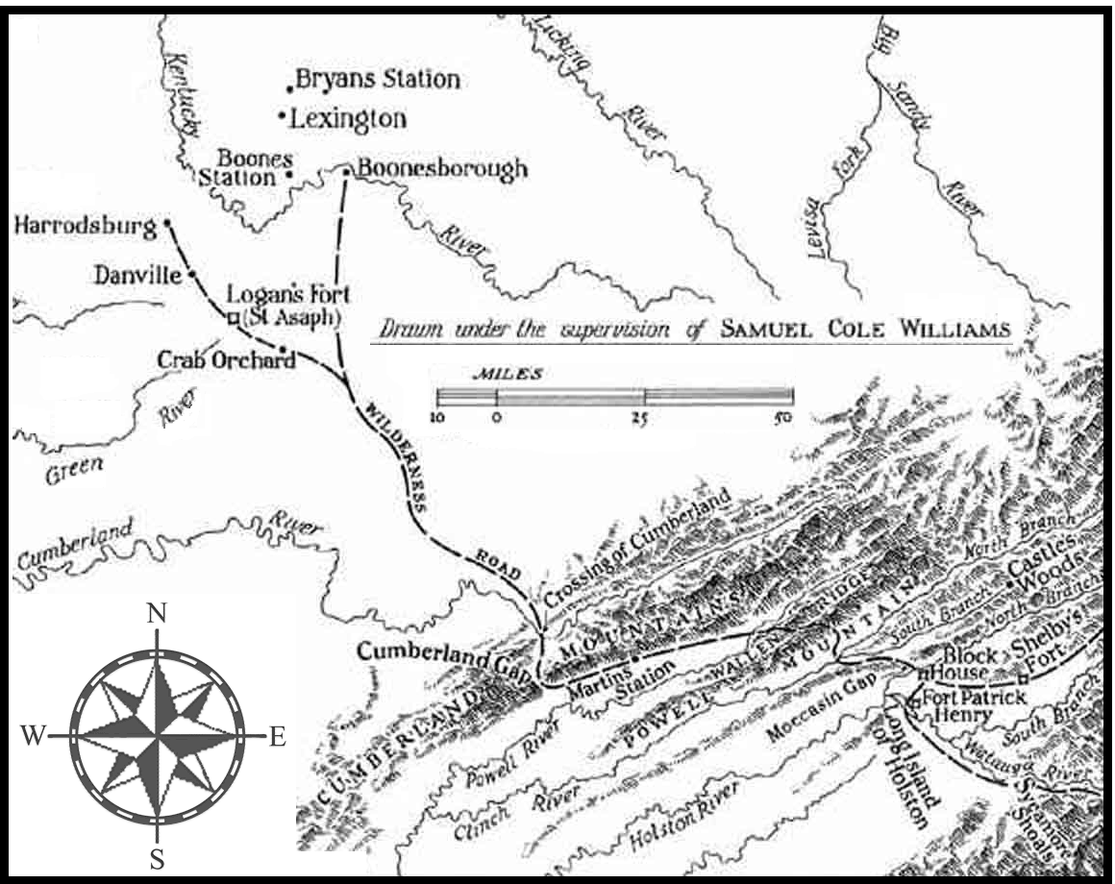

The memory of Daniel Boone lives on today in the names of several Kentucky towns, like Boonesborough (Boonesboro), one of the original endpoints of the Wilderness Road, Boones Station, Boone, and Fort Boonesborough. Also in Kentucky are the Daniel Boone Parkway (toll road), the Daniel Boone National Forest, and Daniel Boone’s gravesite, near the state capital of Frankfort. North Carolina and Tennessee also have towns named Boone located along the routes of historic trails. Warrior’s Path State Park, near Kingsport, Tennessee, commemorates the original Native American trail that Boone and others followed westward.

Activity 4B-1: The Cumberland Escarpment

POWER THINKING EXERCISE - "Happy Hikers"
The Activities Director at Cumberland Gap National Historic Park has discovered from park surveys that many visitors would like to hike to the top of Cumberland Mountain (west of the actual gap) where they can see a scenic view of Fern Lake and the city of Middlesboro. However, comments on the surveys also indicated that these hikers thought the existing Cumberland Trail (find this trail on the park map on MAP 4B, CUMBERLAND GAP) was too long to walk and too hard for them to climb. So the Director has asked you to determine the best route for a new hiking trail that will allow visitors to get where they want to go and stay happy.
After reading through some of the surveys, you realize that distance is not so much of a problem for these hikers as the steepness of the climb to the top. The Director has given you two options; you can either start your trail at the Bartlett Park Picnic Area on the Kentucky side of the mountain, or you can start from the town of Tiprell on the Tennessee side of the mountain. Find each of these locations on the park map on MAP 4B, CUMBERLAND GAP and also on the Cumberland Gap topographic map on IMAGE 4B, CUMBERLAND GAP. In either case, your trail must end at the top of the ridge crest of Cumberland Mountain.
You must first determine if Cumberland Mountain is symmetrical. In other words, are both sides of the ridge equally steep, or is one side steeper than the other? Refer to both the Cumberland Gap topographic map and the NHAP stereopair on IMAGE 4B, CUMBERLAND GAP to help you get your answer. Once you decide on which side of the mountain to place the trail, you should sketch on the topographic map, with a wipe-off pen, the exact route you want your trail to follow. Use the NHAP stereopair to help find the route with the lowest slope.
Compare this trail with the trails sketched by other groups in the class and determine which routing is least steep and therefore will make the hikers happiest.

Materials
MAP 3B, GEOLOGICAL SETTING
IMAGE 4B, CUMBERLAND GAP
MAP 4A, CUMBERLAND GAP
Newspaper Article, “Cumberland Gap Tunnel”
Figure 4B-2, “Folds and Faults Near Cumberland Gap.”
3-D stereoscopes
Wipe-off Pens

PERFORMANCE TASKS
(Icon Key) Overview = ; Science = ; Math = ; History = ; Language Arts =

1. Locate escarpment and contrast topography.
Find Cumberland Mountain (running diagonally from left to right through the upper portion of the map) on the Cumberland Escarpment topographic map on MAP 4B, CUMBERLAND GAP. That particular ridge forms the Cumberland Escarpment in this part of the Southeast and serves as the boundary between the Valley and Ridge landform region and the Appalachian Plateaus. Locate this same ridge on the NALC satellite image on MAP 4B. Compare and contrast the topography on either side of the escarpment. Describe differences in mountain shapes and drainage patterns.

Several distinctive landscape features in the Cumberland Gap region are associated with geologic fault zones. Locate Cumberland Gap on MAP 3B, GEOLOGICAL SETTING and trace, with a wipe-off pen, all fault lines that affect this area. Now trace these same faults onto both the topographic map and NALC image on MAP 4B. What topographic features are associated with these fault lines? How do you think such landscape features are formed, geologically speaking?

2. Determine flight path of radar-imaging airplane.
Examine the SLAR radar image on IMAGE 4B, CUMBERLAND GAP and take special note of the distribution patterns of the light and dark bands. Remember that SLAR radar images are generated from a “side-looking,” “airborne” radar system in which the radar beam approaches the ground surface at an acute angle. Land surfaces facing the radar source will reflect many radar pulses back to the detector. Land surfaces facing away from the radar source will reflect almost nothing back to the detector. Use this information to locate the ridge crest line of several mountain ranges (trace the ridge lines on the SLAR image with a wipe-off pen) and to infer the flight path (compass heading) of the airplane carrying the radar system. Explain how you used the image data to determine the airplane’s probable position and heading.

3. Construct rose diagram showing mountain trend.
The trend of a geographic or geologic feature is usually represented as a specific compass direction. Most maps contain a “compass rose” symbol that tells the reader which way on the map is north. Locate Cumberland Mountain (running diagonally from left to right through the upper portion of the map) on the Cumberland Escarpment topographic map on MAP 4B, CUMBERLAND GAP and also locate the compass rose symbol for that map. With a wipe-off pen, mark an “X” at the spot where Cumberland Mountain meets Interstate Highway 75 (about ten miles west of the city of La Follette near the left edge of the map) Place a ruler along the ridge line of Cumberland Mountain, with the zero mark at the “X” you drew, and make a mark on the map for every inch on the ruler until you reach the right edge of the map. Number these marks from 1 through 15 so you can properly reference your data.

With a protractor, measure the compass direction (in degrees) of the trend of the ridge crest line of Cumberland Mountain for each point marked on your map. Refer to the compass rose symbol to be sure you orient your protractor correctly. You will plot your data on a special kind of graph called a “rose diagram.” Divide a piece of graph paper into four equal quarters by drawing an “x-axis” and a “y-axis” so that the origin point is in the center of the graph paper. Label the axis endpoints “north,” “east,” “south,” and “west” in a clockwise direction. Transfer each data point from the map to the rose diagram by drawing a one-inch line, starting at the origin, at the proper angle. If two lines are drawn at exactly the same angle, be sure to darken the line accordingly to indicate this fact. Also record your data in a data table.

Examine your rose diagram and note the dominant compass direction (in degrees) shown by your data. Also calculate the average value of the angles in your data table. Do these two determinations give the same answer (angle)? Which answer is more accurate? Explain why. Which answer is easiest to understand? Explain why. Do most other mountains shown on the map follow the same trend? Explain why?

4. Relate state boundaries to mountain crest lines.
Trace, with a wipe-off pen, the state boundaries of Tennessee, Kentucky, and Virginia onto the Cumberland Escarpment topographic map on MAP 4B, CUMBERLAND GAP. Note which boundaries follow the ridge crest lines of mountains and which do not. What are some advantages of having boundaries follow ridge lines? What are some disadvantages? Why doesn’t every state border follow a ridge line?

Locate the Tennessee towns of Manring, Bryson Mountain, Reliance, Fork Ridge, and Motch, along state highway 132 a few miles southwest of Middlesboro, Kentucky. Although the residents of these towns are citizens of Tennessee, all of their contact with the outside world is through Kentucky. What difficulties do you think this situation creates for the folks living there? Explain your answer. Do you think the state border should be moved to put these towns in Kentucky? Why or why not?

5. Discuss effectiveness of ‘Massacre Mountain’ nickname.
Read the newspaper article, “Cumberland Gap Tunnel,” on page 4B-1. Why do you think the area through which the original main road passed [Cumberland Gap] was given the nickname “Massacre Mountain?” How did supporters of the tunnel project use that nickname to help convince people that building the tunnel was an important thing to do? Explain why place nicknames usually have more influence on people than official geographic names. Trace, with a wipe-off pen, the original U.S. Highway 25-E route through the mountain on the Cumberland Gap topographic map on IMAGE 4B, CUMBERLAND GAP. Locate at least one spot along the highway where you think the nickname “Massacre Mountain” might be especially justified. Explain your reasoning to the class. Why did the mapmaker not print the title “Massacre Mountain” on the map?

ENRICHMENT
(Icon Key) Overview = ; Science = ; Math = ; History = ; Language Arts =

1. Investigate Pine Mountain overthrust belt.
A section of the Cumberland Plateau has actually been pushed up and over itself near Cumberland Gap. The Pine Mountain Fault Zone marks the furthest limit of this movement. Locate this fault line on MAP 3B, GEOLOGICAL SETTING and on Figure 4B-2, “Folds and Faults Near Cumberland Gap.” Use appropriate library or internet resources to obtain geologic cross-sections of the Pine Mountain overthrust region. Explain the geologic history of this fault and how it influences the overall topography of the area? How would you recognize this fault zone if you were walking across it?

2. Calculate depression angle of SLAR radar pulse.
Examine the SLAR radar image on IMAGE 4B, CUMBERLAND GAP and note that every mountain range appears bright on the side facing the radar source and dark on the side facing away. The mountain casts a radar shadow in much the same way that it would cast a sun shadow on a sunny day. The depression angle is defined as the angle the incoming radar pulse makes with the ground surface (assuming flat ground). In general, both a lower sun angle and a lower depression angle will produce a longer shadow. By measuring the length of the shadow and the height of the mountain, it is possible to calculate the angle of the incoming radar beam (the depression angle) using simple trigonometric relationships. Select any mountain range that shows a distinct shadow on the SLAR image. Measure the length of the shadow using the scale bar. Determine mountain height by referencing your location on the Cumberland Escarpment topographic map on MAP 4B, CUMBERLAND GAP. Use the tangent function to calculate the depression angle. Diagram your results.

Activity 4B-2: The Middlesboro Basin

POWER THINKING EXERCISE - "Flood Forecast"
A new industry that recycles coal waste wants to locate in Middlesboro, Kentucky so it can be close to the coal mines of the Appalachian Plateaus. The company is considering buying the property shown at the extreme upper left-hand corner of the Cumberland Gap topographic map on IMAGE 4B, CUMBERLAND GAP. This land lies adjacent to Yellow Creek and contains a building shaped (on the map) like a large, upside-down letter “T.” Locate this property on the map and on the NHAP aerial photograph. Also, locate its approximate position on the park map on MAP 4B, CUMBERLAND GAP, and on Figure 4B-3, “Geologic Map of Middlesboro Basin.” The owner is ready to close the deal, but has heard rumors that the area is prone to severe flooding. She is asking you to check out the potential for flooding and make a recommendation whether or not to build there.
Locate the Middlesboro Basin on the Cumberland Escarpment topographic map on MAP 4B, CUMBERLAND GAP. With a wipe-off pen, trace on the map the course of every stream that enters the Middlesboro Basin. Use a different color wipe-off pen to trace the course of the stream that leaves the Basin. Use a broad-tip wipe-off pen to trace the outline of the total watershed area (drainage basin) that drains into the Middlesboro Basin and estimate its size (in square miles) using the transparent grid overlay. Examine the outflow stream and describe the shape and size of its valley. How much water do you think the outflow stream could carry away in one day. What do you think would happen if there was a really big rainstorm, perhaps ten inches of rain? Where would the excess water have to go?
Examine Figure 4B-3, “Geologic Map of Middlesboro Basin.” The symbol “Qal” denotes the distribution of old floodplain deposits in the Basin. Based on the geologic history of floods and on your own streamflow analysis, what advice will you give to the owner of the company about building in Middlesboro?

Materials
IMAGE 4B, CUMBERLAND GAP
MAP 4A, CUMBERLAND GAP
Figure 4B-3, “Geologic Map of Middlesboro Basin”
3-D stereoscopes
Wipe-off Pens

PERFORMANCE TASKS
(Icon Key) Overview = ; Science = ; Math = ; History = ; Language Arts =

1. Locate and describe the Middlesboro Basin.
Locate the city of Middlesboro in the upper center of the Cumberland Escarpment topographic map on MAP 4B, CUMBERLAND GAP. The city is located within an almost circular feature called the Middlesboro Basin. Use the topographic map as a reference to locate the Middlesboro Basin on the NALC satellite image (also on MAP 4B), and on the SLAR radar image and NHAP aerial photograph on IMAGE 4B, CUMBERLAND GAP. What features make the Middlesboro Basin easily recognizable on each type of image? How does the topography of the Basin differ from the topography of the surrounding areas? What kind of natural process might form such an oddly shaped feature? Share your hypothesis with other groups.

2. Analyze geologic map of Middlesboro Basin.
Examine Figure 4B-3, “Geologic Map of Middlesboro Basin.” What is the geologic age (period name) of the rocks in the small circle near the center of the Basin? What is the geologic age (period name) of most of the remaining rocks exposed in the Middlesboro Basin? Which rock unit is older? How can you tell? The “Qal” symbol represents alluvial (floodplain) deposits. Explain how the distribution pattern of this unit correlates with the locations of streams. Is the “Qal” unit older or younger than the other Basin rocks? How can you tell?

Use the legend to locate the positions of faults on both the map and the cross-section diagram. Which side of the Basin has experienced the most fault activity? One theory about the formation of the Middlesboro Basin hypothesizes a meteorite impact as the cause of both the deformed rock and the faulting. If that hypothesis were true, based on the principles of geology, how old is the impact structure (during which geologic period did it form)? Explain how you determined your answer. Based on the distribution of the fault lines, from which direction did the meteor most likely come? Explain your answer.

3. Describe geometry of Middlesboro Basin.
Examine the shape and size of the Middlesboro Basin on each of the maps and images on MAP 4B, CUMBERLAND GAP and IMAGE 4B, CUMBERLAND GAP. On which product does the Basin appear most circular? On which does it appear least circular? Why do you think the shape is more circular on some products than others?

Now look at Figure 4B-3, “Geologic Map of Middlesboro Basin.” Use a drawing compass to draw (on tracing paper or plastic overlay) the circle that most closely approximates the actual geologic boundary of the Basin? What is the radius of the circle? What is its diameter? What is its circumference? What would be the volume of a spherical meteor that had this same radius? Use a piece of string and the scale bar to measure, on Figure 4B-3, the actual circumference of Middlesboro Basin. How close is this measured number to the calculated value of the circumference? How close to a perfect circle is the Middlesboro Basin structure? Explain your answer.
.
4. Infer reasons for founding city of Middlesboro.
Locate the city of Middlesboro in the upper center of the Cumberland Escarpment topographic map on MAP 4B, CUMBERLAND GAP. Notice that Middlesboro is the largest town for many miles around and is, in fact, larger than most cities shown on this map. Remember that you can determine city size on a topographic map by looking at the relative size of the letters used to name that city. Why do you think it is normally difficult to build large cities in the Appalachian Plateaus landform region? What features does the Middlesboro site have that make it different from most others?

Most cities in the Appalachian Plateaus region depend on industries and businesses that are related to the natural resources of the area. Examine the Cumberland Gap topographic map and NHAP aerial photograph on IMAGE 4B, CUMBERLAND GAP to find evidence for land use relating to coal mining, the biggest resource in the region.

5. Write script for newscast coverage of disaster.
If the Middlesboro Basin actually originated from a meteorite impact, the meteor’s approach and subsequent collision must have been a spectacular sight to see. Meteors are sometimes called “shooting stars” because they burn brightly as they pass through the atmosphere. In addition, any collision big enough to form a basin several miles wide would have to throw tons of debris into the air and be accompanied by shock waves, earthquakes, and other thunderous noises.

Assume that you work for a television station in Middlesboro, Kentucky, and that astronomers predicted that a meteorite impact event, similar to the one that created the Middlesboro Basin, would occur next month in the Log Mountains just northwest of Middlesboro. Locate this area on the Cumberland Escarpment topographic map on MAP 4B, CUMBERLAND GAP. The Log Mountains are uninhabited, so you and a team of camera operators will have to set up nearby (but not too close) to film the event. Mark on the topographic map the location at which you will observe the event.

When television news departments cover natural disasters, they want to make their presentation as exciting as possible so viewers don’t change channels. Write up an outline script of what you will say on the air and what you want the camera operators to film while you’re saying it. Assume that this new meteorite impact event will create the same audio and visual impressions as the previous collision did. Make sure your proposed script communicates the disaster event well and has maximum impact upon the viewers. Use lots of adjectives in your descriptions.

ENRICHMENT
(Icon Key) Overview = ; Science = ; Math = ; History = ; Language Arts =

1. Compare Middlesboro Basin to confirmed impact structures.
Scientists have direct evidence that meteor craters and other impact structures exist around the world. The most famous is probably Meteor Crater in Arizona. Use library and internet resources to investigate Meteor Crater and a few other confirmed impact sites. Compare their shape and size to the Middlesboro Basin structure. Refer to Figure 4B-3, “Geologic Map of Middlesboro Basin,” and the maps and images on MAP 4B, CUMBERLAND GAP and IMAGE 4B, CUMBERLAND GAP as needed. Do you think the evidence is strong enough to definitely link the Middlesboro structure with a meteorite impact? Defend your answer.

2. Analyze historic flood records for Middlesboro.
Use library and internet resources to look up flood records for Middlesboro, Kentucky for the past fifty years. Which years experienced the worst flooding? Where and how did scientists measure flood levels? Is there any pattern to the flooding events, or do they appear to happen at random intervals? How did the city respond to severe flooding events? Was anything done to try and minimize flood damage? Point out any flood control measures that appear on either the topographic map or NHAP aerial photo on IMAGE 4B, CUMBERLAND GAP. What was involved in cleaning up the city after a flood? Have the floods created any long-term problems for the city? Explain your answer.

Activity 4B-3: The Wilderness Road and Westward Migration

POWER THINKING EXERCISE - "Alternative Access"
As part of the Cumberland Gap Tunnel project, the old highway (Route 25E) across the gap will soon be torn up and removed, so that this part of the National Historical Park can be restored to a natural condition similar to what it was at the time of Daniel Boone. Although this change is expected to boost tourism, a group of local truckers is not happy because certain types of hazardous material are not allowed in the tunnel. These truckers routinely carry dynamite and other explosives from Knoxville to Middlesboro, and the closing of the route through Cumberland Gap will add lots of miles and hours to each trip. They are asking the government to provide an alternative transportation route so they can stay in business. You have been chosen to meet with them and negotiate a fair solution.
To understand the truckers’ complaint, you must first verify the problem. Locate Middlesboro, Kentucky and Knoxville, Tennessee on the Cumberland Escarpment topographic map on MAP 4B, CUMBERLAND GAP. Trace, with a wipe-off pen, the shortest route between those two cities going through Cumberland Gap. Be sure to use only state or federal highways that are numbered on the map. Refer to the graphic scale on the map to estimate the one-way distance a trucker would cover using this route. Also estimate the average speed limit on these roads and calculate an approximate one-way time of travel for the average trip.
Now, using a different color wipe-off pen, trace the shortest route from Middlesboro to Knoxville that does not cross Cumberland Gap. Again, be sure to use only numbered highways. Estimate this new one-way distance, as well as the average speed limit and one-way time of travel for the average trip. Do you think the truckers have a valid complaint? Justify your answer.
Several truckers want you to build another road over Cumberland Mountain, to the west of Cumberland Gap. Using another color wipe-off pen, trace a possible route for this new highway. What are the major obstacles to building such a road? Explain your answer. If you do not build the new highway, is there any other way to solve the truckers’ problem? Compare your ideas with those of other groups.

Materials
IMAGE 4B, CUMBERLAND GAP
MAP 4A, CUMBERLAND GAP
MAP 3B, GEOLOGICAL SETTING
MAP 3E, POLITICAL SETTING
MAP 3F, CULTURAL SETTING
Figure 4B-4, “Route of Wilderness Road”
3-D stereoscopes
Wipe-off Pens

PERFORMANCE TASKS
(Icon Key) Overview = ; Science = ; Math = ; History = ; Language Arts =

1. Trace transportation routes through Cumberland Gap.
Locate Cumberland Gap on both the Cumberland Gap topographic map and the NHAP aerial photograph on IMAGE 4B, CUMBERLAND GAP. What exactly is meant by the word “gap” when applied to a mountain? How can you use the contour lines to determine the exact location of the gap on the map? How can you use the stereo image to determine the exact location of the gap on the photo? Trace the old route 25E through the gap, using a wipe-off pen, on both the topographic map and the aerial photo. With a different color wipe-off pen, trace (on map and photo) the route of the railroad through the gap. With yet another different color, trace (on map and photo) the route of the electric power line through the gap. Finally, using a fourth color pen, and information from the park map on IMAGE 4B, trace the route of the new Cumberland Gap automobile tunnel on both the map and the aerial photo. Explain why each routing was the best choice for that particular transportation mode.

2. Explain influence of fault line in creating Cumberland Gap.
Locate Cumberland Gap on both the Cumberland Escarpment topographic map and the NALC satellite image on MAP 4B, CUMBERLAND GAP, and on the SLAR radar image on IMAGE 4B, CUMBERLAND GAP. Also locate the approximate position of Cumberland Gap on MAP 3B, GEOLOGICAL SETTING and note the short fault line running southward from the town of Pineville through the gap. Use a wipe-off pen to carefully trace this fault line, in its proper position, onto each of the three cartographic products (topographic map, NALC image, and SLAR image). Be sure to check each scale bar to be sure your line is the correct length. What topographic features are associated with this fault line? How do these features show up differently on each product? How did presence of the fault line help to form these landform features (cite the specific geologic processes that were involved)? How long do you think it took to form Cumberland Gap?

3. Contrast grade of old highway with new automobile tunnel.
Locate the original route of highway 25E through Cumberland Gap as marked on the Cumberland Gap topographic map on IMAGE 4B, CUMBERLAND GAP. Then refer to the park map on IMAGE 4B to get information on the exact location of the new tunnel and access roads. Notice that the park map does not show the old route at all. With a wipe-off pen, trace onto the topographic map, as closely as you can, the position of the new highway route. Draw in all access roads as well as the tunnel. Locate the intersection of the old and new routes on the Kentucky side of the mountain and mark that location on the map with a dot labeled “X.” Locate the intersection of the old and new routes on the Tennessee side of the mountain and mark that location on the map with a dot labeled “Y.” Locate the highest point along the old highway, mark its location on the map with a dot labeled “Z,” and determine its elevation (the contour interval of this map is 20 feet).

Use a string and the scale bar to measure the length of the new route between points “X” and “Y.” Notice that the new tunnel route is almost completely level, staying close to an elevation of 1300 feet along its entire length. The gradient, or grade, of this highway is close to zero (vertical change divided by horizontal distance). Next use the string and scale bar to measure the length of the old route between points “X” and “Z” and between points “Y” and “Z.” Also determine the change in elevation between points “X” and “Z” and points “Y” and “Z.” Use this data to calculate the grade of the old highway on the Kentucky side of the mountain (between points “X” and “Z”) and the grade on the Tennessee side (between points “Y” and “Z”). Why do you think highways with steep grades are generally more dangerous than level roads? Justify your answer.

4. Trace exact route of Wilderness Road.
Refer to Figure 4B-4, “Route of Wilderness Road,” to determine the exact position of this early highway to the frontier west. Then sketch this route, with a wipe-off pen, onto both the Cumberland Escarpment topographic map and the NALC satellite image on MAP 4B, CUMBERLAND GAP. What natural topographic features did the Wilderness Road follow most of the time? Why was the road not straighter? Explain your answers. Why was Cumberland Gap such an important location to settlers heading west? Is it more or less important to travelers in modern times? Explain your answer.

5. Evaluate name changes through time.
In part, the Wilderness Road followed the old Native American path that was called “Athawoninee” (Path of the Armed Ones). Do you think this was a good descriptive name? Why? Do you think Native Americans ever used this trail for other purposes than warfare? Use Figure 4B-4, “Route of Wilderness Road,” as a reference to locate the approximate position of the Wilderness Road on the Native American Nations inset map on MAP 3F, Cultural Setting. Which nations controlled travel along the “Athawoninee” path? Who do you think gave it that name? Why do you think the settlers who later used this road gave it a different name? What meaning do you think the name “Wilderness Road” conveyed to early travelers? What meaning does it convey to travelers today? Explain your answers.

Today we usually give major highways route numbers instead of names (although all state and federal highways must be given street names when they pass through towns). Occasionally we do name a long stretch of rural highway after a famous person or noted landscape feature (such as the Blue Ridge Parkway in North Carolina or the Daniel Boone Parkway in eastern Kentucky). What different name would you give to the Wilderness Road today if you wanted to encourage people to travel it more? What different name would you give to that same road if you wanted people to stay away? Explain your answers. Are there any problems that might occur as a result of changing the name of a well-known highway? Give an example. List any examples in your local community of roads that have had their names changed.

ENRICHMENT
(Icon Key) Overview = ; Science = ; Math = ; History = ; Language Arts =

1. Research life and times of Daniel Boone.
Daniel Boone is usually given credit for scouting out and establishing the Wilderness Road. Use appropriate library and internet resources to research the life and times of Daniel Boone. Prepare a brief biographical presentation for the class focusing on Boone’s connections to the Wilderness Road. Refer to Figure 4B-4, “Route of Wilderness Road,” and sketch this route with a wipe-off pen onto MAP 3E, POLITICAL SETTING. Also discuss with the class what supplies Daniel Boone and other early settlers would have needed to carry with them on a trip down the Wilderness Road.

2. Investigate naming of famous roads.
Contact your state highway department to obtain a list of state highways that have been given special names. Determine which ones were named for people and which ones were named for other reasons. Pick one example to research and report on. The report should tell when, where, and why that highway was given its special name. Use a wipe-off pen to trace the route of the highway you selected onto MAP 3E, POLITICAL SETTING.

