CHAPTER 5

VALLEY AND RIDGE REGION

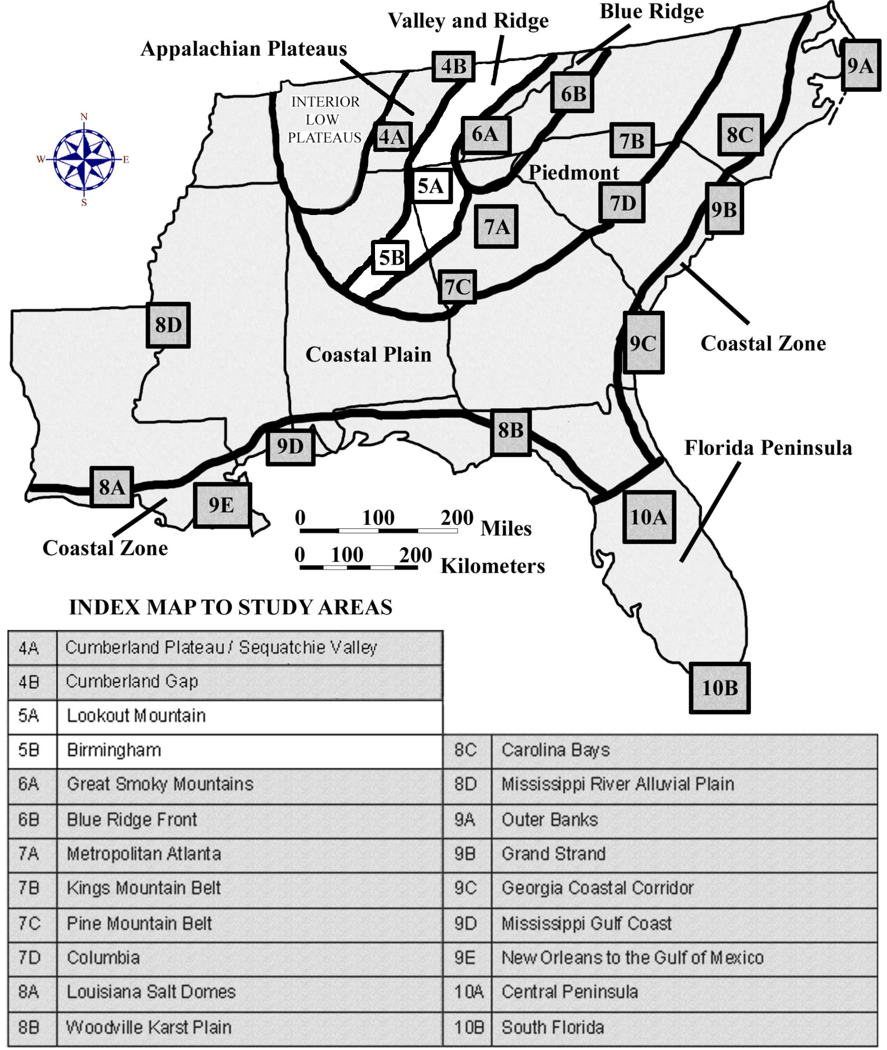

DRAFT VERSION 5/06/20

TABLE OF CONTENTS FOR CHAPTER 5

VALLEY AND RIDGE REGION

Gregory Cox, G. Michael Clark, Larry Greer, Jim Hunt, and John R. Wagner

INDEX MAP TO VALLEY AND RIDGE REGION STUDY AREA
TABLE OF CONTENTS FOR CHAPTER 5
BACKGROUND INFORMATION
- Description of Landforms, Drainage Patterns, and Geologic Processes
p. 5-1 . . . . - Characteristic Landforms of the Valley and Ridge Region
p. 5-1 . . . . . . . . - figure 5-1 – “Generalized View of Structure and Topography”
p. 5-2 . . . . . . . . - figure 5-2 – “Formation of Trellis Drainage Pattern”
p. 5-2 . . . . - Geographic Features and Localities of Special Interest
p. 5-3 . . . . . . . . - figure 5-3 – “Major Ridges and Valleys in Alabama and Georgia”
p. 5-3 . . . . - Rock Types and Geologic History
p. 5-4 . . . . . . . . - figure 5-4 – “Folding and Faulting in the Birmingham Area”
- Influence of Topography on Historical Events and Cultural Trends
p. 5-5 . . . . - Folklore
p. 5-6 . . . . . . . . - story – “Joe Magarac”
p. 5-6 . . . . - Historical Events
p. 5-7 . . . . - Influence of Topography on Commerce, Culture, and Tourism
- Natural Resources, Land Use, and Environmental Concerns
p. 5-8 . . . . - Climate and Water Resources
p. 5-9 . . . . - Soils and Agriculture
p. 5-9 . . . . - Mining, Resource Extraction, and Environmental Concerns
PLACES TO VISIT
REFERENCES AND RESOURCES

STUDY AREA 5A = LOOKOUT MOUNTAIN
- Newspaper Article
p. 5A-1 . . . . . . - story – “Bloody Alabama Battle in 1540 Changed the South”
- Rationale
- Performance Objectives
- Sample Assessment Rubrics
- Cartographic Product Information
p. 5A-3 . . . - MAP 5A: Lookout Mountain
p. 5A-4 . . . - IMAGE 5A: Lookout Mountain
- Study Area Description
p. 5A-5 . . . - Topographic Patterns
p. 5A-5 . . . . . . . - figure 5A-1 – “Thrust Faults in the Southern Valley and Ridge”
p. 5A-6 . . . . . . . - figure 5A-2 – “Plunging Folds in the Southern Valley and Ridge”
p. 5A-7 . . . - Little River Canyon
p. 5A-8 . . . - Historical Connections with Topography
p. 5A-9 . . . . . . . . - story – “Two Accounts of De Soto’s Travels Through Alabama”
- Activity 5A-1: Topographic Patterns
(ICONS) Overview = Sci = Math = Hist = Lang Arts =
p. 5A-11 . . - Power Thinking Exercise “Bewildering Boundaries”
p. 5A-11 . . - Materials
p. 5A-11 . . - Performance Tasks
p. 5A-11 . . . . . . 1. Distinguish between plunging and horizontal folds.
p. 5A-12 . . . . . . 2. Investigate boundary of Valley and Ridge with Coastal Plain.
p. 5A-12 . . . . . . 3. Compare map and oblique views of Lookout Mountain DEM.
p. 5A-12 . . . . . . 4. Compare population density of ridges and valleys.
p. 5A-13 . . . . . . 5. Design brochure to attract more tourists to Lookout Mountain.
p. 5A-13 . . - Enrichment
p. 5A-13 . . . . . . 1. Estimate viewing angle of oblique DEM images.
p. 5A-13 . . . . . . 2. Research how Digital Elevation Models are created.
- Activity 5A-2: Little River Canyon
(ICONS) Overview = Sci = Math = Hist = Lang Arts =
p. 5A-14 . . - Power Thinking Exercise “Preserve Predicament”
p. 5A-14 . . - Materials
p. 5A-14 . . - Performance Tasks
p. 5A-14 . . . . . . 1. Compare land use on west and east sides of Little River Canyon.
p. 5A-15 . . . . . . 2. Explain drainage patterns of the Little River.
p. 5A-15 . . . . . . 3. Graph longitudinal profile of Little River Canyon.
p. 5A-15 . . . . . . 4. Evaluate placement of Little River Canyon Parkway.
p. 5A-16 . . . . . . 5. Write letter to the editor regarding Little River Canyon Preserve.
p. 5A-16 . . - Enrichment
p. 5A-16 . . . . . . 1. Research hearings and land-use plan developed for Preserve.
p. 5A-16 . . . . . . 2. Investigate geology of Lookout Mountain and Little River Canyon.
- Activity 5A-3: Historical Connections with Topography
(ICONS) Overview = Sci = Math = Hist = Lang Arts =
p. 5A-17 . . - Power Thinking Exercise “Constricted Corridor”
p. 5A-17 . . - Materials
p. 5A-17 . . - Performance Tasks
p. 5A-17 . . . . . . 1. Trace De Soto’s possible routes through Northern Alabama.
p. 5A-18 . . . . . . 2. Determine best places for highways to cross ridges.
p. 5A-18 . . . . . . 3. Estimate average daily distance traveled by De Soto’s army.
p. 5A-18 . . . . . . 4. Analyze effect of topography on Civil War battles.
p. 5A-18 . . . . . . 5. Identify landscape references in travel accounts.
p. 5A-19 . . - Enrichment
p. 5A-19 . . . . . . 1. Research De Soto’s defeat at the Battle of Mabila.
p. 5A-19 . . . . . . 2. Research De Soto’s entire campaign through the Southeast.

STUDY AREA 5B = BIRMINGHAM
- Newspaper Article
p. 5B-1 . . . . . . - story – “Vulcan Statue, Often the Butt of Jokes, is Well-Loved”
- Rationale
- Performance Objectives
- Sample Assessment Rubrics
- Cartographic Product Information
p. 5B-3 . . . - MAP 5B: Birmingham
p. 5B-4 . . . - IMAGE 5B: Birmingham
- Study Area Description
p. 5B-5 . . . - Mining Activities
p. 5B-6 . . . . . . . - figure 5B-1 – “Location of Mineral Resources Around Birmingham”
p. 5B-7 . . . . . . . - figure 5B-2 – “Annual Tonnage from Mines near Birmingham”
p. 5B-8 . . . - The Growth and Decline of a Steel Mill Town
p. 5B-8 . . . . . . . - figure 5B-3 – “Diagram of Operation of Blast Furnace”
- Activity 5B-1: Mining Activities
(ICONS) Overview = Sci = Math = Hist = Lang Arts =
p. 5B-11 . . - Power Thinking Exercise “Quarry Quandry”
p. 5B-11 . . - Materials
p. 5B-11 . . - Performance Tasks
p. 5B-11 . . . . . . 1. Locate quarries in Birmingham area.
p. 5B-12 . . . . . . 2. Estimate dip angle of Red Mountain Formation.
p. 5B-12 . . . . . . 3. Estimate surface area of strip mine.
p. 5B-13 . . . . . . 4. Explain effect of economic pressures on mining operations.
p. 5B-13 . . . . . . 5. Add another verse to Joe Magarac ballad.
p. 5B-13 . . - Enrichment
p. 5B-13 . . . . . . 1. Compare benefits and drawbacks of quarries vs subsurface mines.
p. 5B-13 . . . . . . 2. Debate importance of maintaining domestic steel industry.
- Activity 5B-2: Growth and Decline of a Steel Mill Town
(ICONS) Overview = Sci = Math = Hist = Lang Arts =
p. 5B-14 . . - Power Thinking Exercise “Preservation Predicament”
p. 5B-14 . . - Materials
p. 5B-14 . . - Performance Tasks
p. 5B-14 . . . . . . 1. Locate landmarks and mining sites connected with steel industry.
p. 5B-14 . . . . . . 2. Interpret details on false-color infrared image.
p. 5B-15 . . . . . . 3. Examine ordered-pair street naming system and locate origin.
p. 5B-15 . . . . . . 4. Investigate highway and railroad patterns.
p. 5B-16 . . . . . . 5. Analyze interest level of newspaper article.
p. 5B-16 . . - Enrichment
p. 5B-16 . . . . . . 1. Take virtual tour of Sloss Furnaces National Historic Landmark.
p. 5B-16 . . . . . . 2. Identify famous statues located in your city or region.

BACKGROUND INFORMATION

Description of Landforms, Drainage Patterns, and Geological Processes

Characteristic Landforms of the Valley and Ridge Region

The Valley and Ridge landform region is one of the most distinctive and easily recognizable parts of the Appalachian Mountain chain. The region appears on satellite images and regional maps as a series of long, linear, sinuous but nearly parallel features. Although averaging only about 60 miles (96 km) in width, this land of alternating mountain ridges and flat valleys stretches nearly 1,000 miles (1600 km) from New York state all the way to central Alabama, before disappearing underneath the sediment cover of the Coastal Plain. Topographically, it is a low-lying region in comparison with the higher Appalachian Plateaus to the west and the much higher Blue Ridge mountains to the east. Along most of its length, the eastern half of the region consists of a wide, flat limestone valley (generally referred to as the “Great Valley”) that is given different names in different states. The Shenandoah Valley of Virginia is perhaps the best known example. In Alabama, this valley is called the “Coosa Valley”. The western half of the region consists of a number of parallel, relatively narrow, elongate ridges of uniform elevation that can be quite rugged in places. These mountain ridges owe their existence to surface exposures of very resistant rock, mostly sandstones and conglomerates, that do not occur in the Great Valley. The alternating ridges and valleys reflect how differently the underlying belts of sedimentary rock have responded to weathering and erosion over tens of millions of years.

Figure 5-1: Generalized View of Structure and Topography

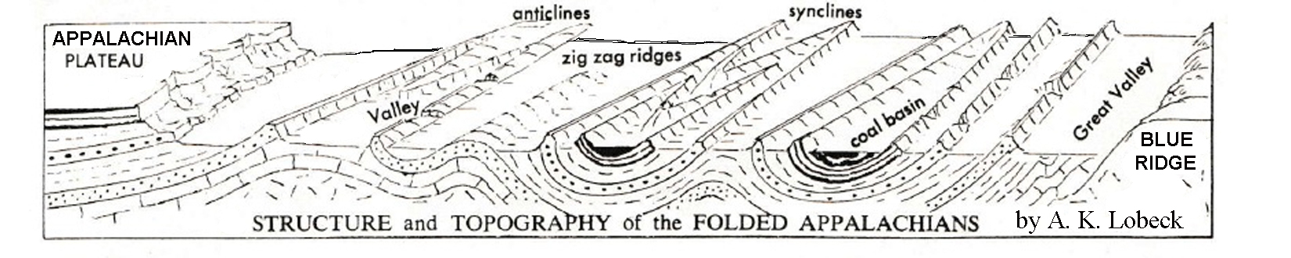

Moving north and south along and through the linear valleys is quite easy as travelers will encounter very few obstacles besides the occasional river to cross. Traveling east to west, however, is a much more difficult task. Fortunately, in certain locations, ancient rivers that were much older than the modern landscape have managed to maintain their original course as the Appalachian Mountain region gradually rose beneath them. Most geologists attribute this uplift to isostatic rebound of the land as rock and soil are removed from higher elevations and carried to the ocean. In general, continental rock like that found in the Appalachian Mountains has lower than average density and therefore will tend to rise with time in the same way that an ice cube dropped into a glass of water will rise to the top of the glass (this happens because the ice is less dense than the water). The rate of such tectonic uplift is highly variable, but most Geologists accept that a typical rate of uplift for the Appalachian Mountains averages around 1 inch (2.5 cm) per 1000 years. If an existing river has enough erosive energy, it will continue to cut through even the resistant rocks of the rising ridges and produce a passage through the mountain known as a water gap. If the land rises too quickly, or the stream loses too much of its energy, only a partial cut through the mountain will be achieved and the resulting dry passage is known as a wind gap, even though the wind had nothing to do with creating it.

Other than the major rivers that are able to downcut through the ridges, most other rivers and streams in the Valley and Ridge region follow a trellis drainage pattern. Very small, usually straight streams drain the steeper mountain ridge slopes and then flow into larger streams which meander through the long valleys depositing sediment in wide floodplains. These streams cannot escape the confines of the valley until they reach one of the major rivers that is able to exit through a water gap. Also, because many of these valleys are formed in areas underlain by limestone rock, landform features typical of karst topography (sinkholes, caves, disappearing streams, etc.) often develop locally.

Figure 5-2: Formation of Trellis Drainage Pattern
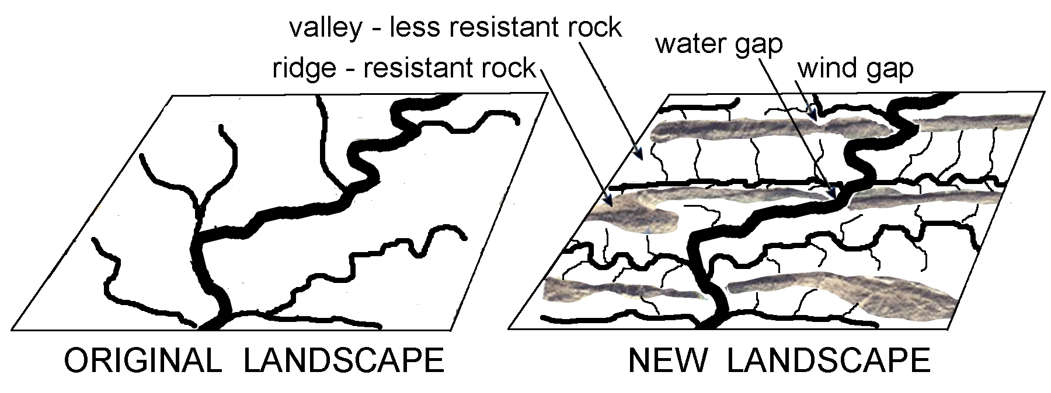

Geographic Features and Localities of Special Interest

The boundaries of the Valley and Ridge region are in many places quite clear and distinctive, but in northeastern Alabama and northwestern Georgia, the exact location of the western boundary with the Appalachian Plateau region has long been debated. Some geologists consider Lookout Mountain to be an outlier of the Plateau, while others see this feature as just an unusually wide ridge separating the Coosa Valley from the Wills Valley. Likewise, the eastern boundary between the Valley and Ridge and the Piedmont in Alabama and Georgia, while officially defined by the change in rock type from metamorphic (Piedmont) to sedimentary (Valley and Ridge), is not as obvious topographically as is that same eastern boundary farther north in Tennessee where the Valley and Ridge borders the Blue Ridge Mountains.

Lookout Mountain has a particularly interesting structure not only because the top of that ridge is wider and flatter than most other ridges in this region, but also because the center of the ridge is topographically lower than its outer edges. In addition, the Little River, flowing along the top of Lookout Mountain, has cut one of the deepest gorges east of the Mississippi River. Most of the other ridges in this area are narrower in width and are asymmetrical in shape; the southeastern facing slopes are generally more gentle and the northwest facing slopes are generally steeper. Several of these narrower ridges near the Georgia-Alabama state line offer spectacular examples of water and wind gaps.

Figure 5-3: Major Ridges and Valleys in Alabama and Georgia

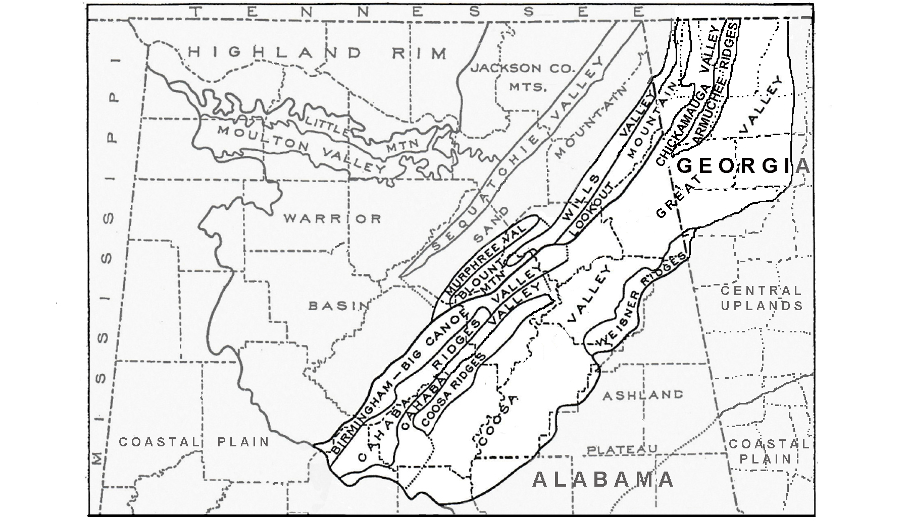

The diversity of rock types in the Birmingham, Alabama region, while typical of the entire Valley and Ridge region, has gained even greater significance here because several high-quality deposits of ores and other important mineral resources lie in close proximity to each other. Easy access to a variety of raw materials has allowed Birmingham to become a major industrial center for the Southern states. Also, its location along established transportation routes, such as the nearby Coosa Valley, enabled the city to grow into a major railroad and economic center and helped bring commercial success to the region.

Rock Types and Geologic History

The rocks exposed in the Valley and Ridge region are of sedimentary origin and were deposited originally in broad, often shallow, seas or other basins of deposition during the Paleozoic Era (between about 550 and 250 million years ago). Sediments were laid down as loose layers of clay, silt, sand, and as soft deposits of calcium carbonate and magnesium carbonate muds and larger fragments. Much of the carbonate sedimentation formed as products of organic activity in shallow marine seas, and fossils in these deposits are a common occurrence. Individual units of deposition of these sediments - now turned into sedimentary rock following burial and compression - range in thickness from a few inches (millimeters) to many feet (meters). Sequences of similar units (beds) are usually grouped together into formations that are then assigned names by geologists (e.g. “Chattanooga Shale”). Such formations typically range from tens to hundreds of feet in thickness and are laterally extensive enough to be shown on a regional geologic map.

Although the original sedimentary basins were generally quiet during times of deposition, periodic tectonic events to the east caused occasional uplift and erosion of this region, removing previously deposited rock layers and creating gaps in the depositional record called unconformities. But the major tectonic event to affect this region, the Alleghenian Orogeny, occurred at the end of the Paleozoic Era when continental drift brought the continent of Africa into contact with North America. This major episode of mountain-building, probably lasting tens of millions of years, raised up the Appalachian Mountains and deformed the Valley and Ridge region by folding the originally flat-lying rock layers. [Up-folds are anticlines, down-folds are synclines.] Subsequently, many of these folds were broken by a series of thrust faults, often sliding along layers of weaker rock. Movement to the northwest along these faults was on the order of many tens of miles (kilometers) and repeated movements caused slabs of identical rock formations to pile up on top of each other. This is why the same rock formations appear over and over again when traveling across the Valley and Ridge region from east to west.

Figure 5-4: Folding and Faulting in the Birmingham Area
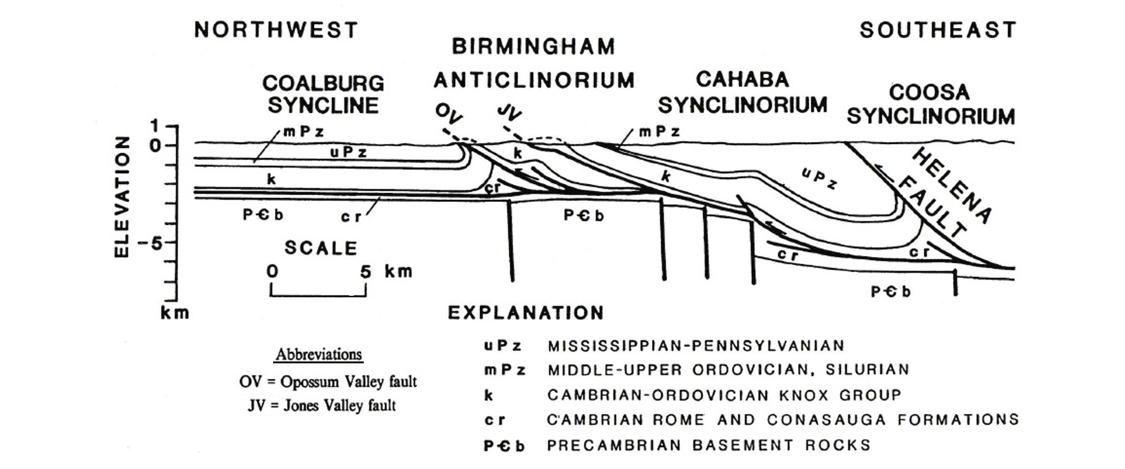

Over the last two hundred million years, the original topography formed by the Alleghenian Orogeny has been replaced by a very different topography that we see today. Most of the mountain ridges in the region are held up by layers of conglomerates, chert, or sandstones, rock types which are very resistant to both physical and chemical weathering. Most valleys are underlain by weaker rocks such as limestones and shales. Shale in particular weathers both physically and biochemically and are easily eroded by hillslope and stream processes. Because the rock layers are tilted, not horizontal, one of the ridge slopes will normally be angled in the same direction as the dip angle of the resistant rock layer. That side typically will have a lower, more gentle slope. The other side of the mountain will usually be much steeper and more irregular because it has to cut across many different rock formations of varying resistance. Therefore, most linear ridges in this region appear asymmetrical in shape.

Influence of Topography on Historical Events and Cultural Trends

Folklore

The Valley and Ridge region in the South was home to many Native American nations before the area was opened up to white settlers in 1745. Most of the new arrivals, predominantly of Scotch-Irish descent, traveled south from Pennsylvania and Virginia and settled in the valleys, hoping to find fertile farmland where they could support themselves and raise their families. Unfortunately, not all valleys were created equal; the limestone valleys produced rich soil and quickly became prosperous, while folks living in valleys underlain by shale rock had a much harder life because of the poorer soil that yielded fewer and lower quality crops. Stretching from southwestern Virginia into northeastern Tennessee, there are two such valleys, one named “Rich Valley”, the other named “Poor Valley”, separated only by the high ridge of Clinch Mountain. The A.P. Carter family of country music fame grew up in this particular Poor Valley in the early 1900’s and many of their songs and ballads referenced life in that geographic setting: “My Clinch Mountain Home,” “Mid the Green Fields of Virginia,” and “My Old Cottage Home.” The Valley and Ridge region has produced many other well known bluegrass and folk musicians and balladeers, including guitarist and songwriter Norman Blake, who was born in Chattanooga, TN. One of his most popular songs is titled “Last Train from Poor Valley.”

For the most part, folks living in the Valley and Ridge region didn’t travel much and had to provide their own entertainment and make their own work tools. Church and gospel songs were often sung on back porches. Those living in the prosperous limestone valleys could participate in town and city life and many achieved commercial success. But if you lived in the mountains and you needed something like a garden rake or a soup ladle, you carved one yourself out of a chunk of wood. If you needed a blanket, you made a quilt by sewing together old rags. One of country singer Dolly Parton’s greatest hits, titled “Coat of Many Colors,” tells of how poor her family was growing up in Sevierville, TN and how her mother made her a quilted coat. Children’s toys were likewise hand made. The Southern Highland Craft Guild was formed in 1929 to produce and market mountain crafts to tourists in hopes of making some money for the predominantly poverty stricken population living in the hills.

Life in the big cities of the region was very different. Cities like Knoxville and Chattanooga, both located in the Great Valley of Tennessee, had railroad connections and access to the Tennessee River, and therefore became major distribution centers and hubs for both commerce and industry. The increase in good jobs, particularly during the mid twentieth century, led many workers to leave their farms and work in the cities, where they could make more money. Birmingham, AL led the industrial boom in the south with many labor-intensive industries. Most residents worked in the steel mills, the mines, or for the railroad. As is often the case with such workforces, tall tales, legends, and songs grew up around their trade or work. You likely have heard of Paul Bunyan (lumberjack) or John Henry (railroad worker), but the steel mill workers had their own ‘superhero’, a man named Joe Magarac. Although less well known, Joe also merited his own song.

Joe Magarac
--traditional ballad as recorded by the Phoenix Singers and the Mike St. Shaw Trio--

I was born in a mountain of red iron ore
I was raised in the furnace by the blast and the roar
I got no time for sleeping, give me food I can't eat
Hot steel soup, and cold ingots for meat
CHORUS: Mighty Joe, mighty Joe, mighty Joe Magarac
Mighty Joe, mighty Joe, mighty Joe Magarac
Red hot steel running down my back
Mighty Joe, mighty Joe, mighty Joe Magarac
Now if you doubt my word don't you call me a liar
When you play with me, yeah, you play with fire
I'm solid steel and the good lord he knows
If you're tired of living, just step on my toes
I was pulling that shift for twenty nine men
And I had that furnace eating out of my hand
But the blasted furnace wouldn't get hot enough
So I jumped right in, ‘cause I'm made that tough
Now when you see a building climb a mile high
And you see a bridge reach across the sky
There's a little bit of steel and a whole lot of man
In every girder, in every span

Historical Events

Because of relatively easy travel, particularly over routes in the Great Valley, this area has always had a higher population density, and therefore a more extensive history, than either of the adjoining regions. Native Americans established the first trade routes in the region using major rivers or going through valleys. The earliest undisputed European explorer known to pass through this region was Hernando De Soto in 1540. De Soto stayed for a month at a Native American Village near the site of present day Rome, GA, before heading down the Coosa Valley towards the Gulf coast at Mobile Bay. However, tradition holds that an earlier exploration, in 1170, led by Welsh Prince Madoc ab Owain Gwynedd, landed at Mobile Bay and traveled north to Lookout Mountain before settling nearby. The ruins of three major fortifications along their route have been discovered by archeologists. Tennessee governor John Sevier met with a Cherokee chieftain named Oconosota in 1782 and was told that that the fortifications were “built by the White people who had formerly inhabited the country . . .” and that “. . . they were a people called ‘Welsh’ and they had crossed the Great Water.” Nobody really knows what happened to the colonists, but rumors persist that they intermarried with the Native Americans and eventually moved much further west and became known as the Mandan Tribe of Missouri.
The largest city in the region, Knoxville, TN, got its start when James White built a fort there in 1786. The fort was later picked to be the capital of the Southwest Territory, and the city, named for Secretary of War Henry Knox, was officially established in 1791. The second largest city, Chattanooga, TN, was a Cherokee town until 1838, when the United States government forced all Native Americans out of the southeastern states in what was to be known as the “Trail of Tears.” The next year the town was renamed “Chattanooga” from the Muskogean words meaning “dwelling place” and “rock.” The city grew quickly and became a boom town following the arrival of the railroad in 1850. It soon became known as the place “where cotton meets corn” referring to its pivotal location between the cotton growing states to the south and the corn growers in the mountains of Georgia and Tennessee. The city of Birmingham (named for an industrial city in England) was founded in 1871 with the merger of four small farming villages. A few years later, James Withers Sloss realized that the city offered great potential for the production of iron and steel, and was able to begin commercial production soon thereafter.
Both Knoxville and Chattanooga were important cities during the American Civil War, because whichever side controlled the railroad routes through the Great Valley also controlled the movement of food and other supplies to troops in the field. This railroad line was the only connection north of Atlanta between the eastern and western parts of the Confederacy Several important battles were fought in this area, including the Battle of Chickamauga in September, 1863 (won by the Confederacy) and the Battle of Chattanooga, centered on Missionary Ridge, in November, 1863, won by Union armies that pushed the Confederate armies back into Georgia for the duration of the war.

After the end of the war, Knoxville was able to rebuild its economy quickly because of its key location along the Tennessee River. Other industries, including the aluminum company Alcoa, flocked to the area because of its easy access to hydroelectric power. In 1933, during the Great Depression, the TVA (Tennessee Valley Authority) began damming up the Tennessee River and many of its tributaries all over eastern Tennessee and northern Alabama to generate electric power. Such a massive increase in the availability of electricity brought many other new industries to the area and made possible the Rural Electrification Project, a government effort to improve the lives of rural Americans by providing electricity to as many homes as possible. In 1942, Oak Ridge TN was selected as a production site for the Manhattan Project - the venture that developed the atomic bomb. In part because of the continued operation of the Oak Ridge National Laboratory, this area has become home to many other science and technology companies.

Influence of Topography on Commerce, Culture, and Tourism

Although the TVA reservoirs had some serious negative effects like flooding a lot of excellent farmland and displacing thousands of families from their land, they also provided many new opportunities for recreation and tourism that boosted the local economy greatly. Some lucky farmers who had been making only a modest living from selling produce from their fields suddenly became the owners of lakefront property. Fishing, boating, and swimming opportunities brought new money and greater prosperity into many rural communities. But away from the Great Valley, up into the mountain ridge communities, not much had changed. Some ridges were steep and virtually un-crossable for miles. As a result, many residents may have traveled extensively up and down the valley they live in, but may had never actually seen the other side of their mountain.

The proximity of the region to the high peaks of the Appalachian Mountains, especially the Great Smoky Mountains National Park, brings in busloads of tourists every year for hiking, rafting, and sightseeing. A major highlight for many park visitors is a car ride through Cades Cove to view the abundant wildlife and historic cabins. Tuckaleechee Caverns in Townsend, Tennessee, and other nearby caves also attract many visitors. Just north of the Smoky Mountains, the towns of Gatlinburg and Pigeon Forge, Tennessee have developed a variety of show theatres, museums, restaurants, amusement parks, and other tourist-friendly establishments capped by the expansive theme park Dollywood, named for local celebrity Dolly Parton. In 1982, Knoxville hosted a World's Fair that drew 11 million visitors. The theme of the fair, "Energy Turns the World," reflected the city's prominent role in fostering engineering and new technology.

Farther south, the Lookout Mountain/Chattanooga area and the Battlegrounds at Chickamauga and Missionary Ridge attract their share of tourists as well. Billboards and signs painted on barn roofs all along southern highways entice travelers to “See Rock City,” a fascinating mix of spectacular natural rock formations and some more ‘touristy’ attractions located atop Lookout Mountain. On a clear day, visitors can see into seven states from the top of the mountain. Many of the more isolated woodlands, away from the prime tourist areas, are prime areas for hiking, hunting, whitewater rafting, and fishing

Natural Resources, Land Use, and Environmental Concerns

Climate and Water Resources

The southern Valley and Ridge is located in the Humid Subtropical Climate Zone, a mid-latitude zone where polar and tropical air masses interact. Sub-tropical air from the Gulf of Mexico dominates the region, but is occasionally interrupted by invasions of cold continental air during the winter months. In springtime, the clash of such different air masses can generate severe storms. Because of the high moisture content of the air, rainfall is normally sufficient for agricultural needs and is distributed evenly throughout the year, although occasional droughts do occur. Rivers are abundant and there is plenty of water for industry and agriculture. Average annual precipitation ranges from 50 to 54 inches (1270 to 1370 mm) per year and the growing season lasts about 200 days.

In Alabams, the mean annual air temperatures vary in the range of about 60 to 62 ºF (15.6 to 16.7 ºC), but summer temperatures can reach 100 ºF (38 ºC) and winter, temperatures often dip below freezing. Tennessee has a similar climate pattern, except that, because elevations are higher, the growing season is shorter. The average valley temperatures run about 10 ºF (6 ºC) colder, and in areas dominated by higher mountain ridges, temperatures will be lower still and winter snows are quite common.
Soils and Agriculture

Soils in the Valley and Ridge come in all ages and levels of maturity. Youthful soils, where soil profile layers have not had sufficient time to develop, are common in the valleys along major rivers and streams. Such floodplain deposits are quite fertile and provide prime locations for farming activities. Because the entire region is slowly rising in elevation, streams will periodically cut down through their floodplains and leave behind flat river terraces on the sides of the valleys. These terrace deposits will form more mature soils over time and are also excellent locations for agriculture. Most mountain ridges display significant outcroppings of rock that generate only a very shallow soil that is often eroded before it has time to mature. In the far northwestern part of the region, on a few nearly flat-topped mountain ridges, are areas of deeply weathered soils showing well-formed soil horizons. Valleys floored by limestone rock are usually the most fertile.

With such a wide variety of soils and landscapes available, there was and is a great range in the kinds of crops that could be grown by farmers and the relative yield of those crops. The earliest settlers practiced subsistence farming, growing grain crops, fruits and vegetables for home and local use. They tilled the soil with horse- and mule-drawn implements made with hand tools. In the modern era, using more scientific farming methods, farmers are able to grow many crops commercially, especially corn and hay. Livestock production, especially dairy, beef, and pork, is also an important commercial enterprise in many parts of the region. Although forests are abundant on the mountain ridges, lumber production is not a major industry here, but is done primarily for local use.

There have been many important changes in land use in the Valley and Ridge region over the past fifty years. In areas near larger cities, urbanization has increased and many farm properties have been sold to developers for the construction of subdivisions and commercial businesses. Traffic on narrow rural highways has increased to the point that major widening and straightening projects have been undertaken for safety reasons.

Mining, Resource Extraction, and Environmental Concerns

Because of the presence of a great diversity of rock types from different geological time periods, the Valley and Ridge contains a variety of mineral resources that have made mining operations an important industry throughout the region. Lead and zinc deposits are common in many of the limestone formations underlying the valleys. Barite (a heavy sulfate mineral) has been mined at several locations in Alabama. Minor quantities of oil and gas have been recovered from a variety of rock types. The limestone and associated dolostone deposits themselves are also quarried for gravel and dimension stone, as are some of the sandstones and conglomerates associated with the mountain ridges. Also, a great number of sand and gravel quarries have been sited along the floodplains and terrace deposits of rivers. Birmingham, AL is probably the only place on earth where high-quality deposits of coal, iron ore, and limestone occur within a thirty-mile radius of each other. These are the three resources that are required to make iron and steel, and by the end of the nineteenth century, full-scale smelting operations and steel production were under way and the entire city seemed surrounded by quarries of one type or another.
In areas where the resource lies close to the surface, the preferred method of mining is to strip off the overlying soil and surface rock and dig a quarry. Where deposits lie deeper within the earth, underground mining is more practical. Environmental concerns associated with mining in the Valley and Ridge region are relatively minor, compared to most other regions. Abandoned surface quarries normally generate very little pollution as they are often filled back in with waste rock and planted in grass and trees. Some abandoned quarries may partially fill with water and become very dangerous places to play or swim. Underground mine workings always face a small risk of collapse, and can sometimes contaminate groundwater unless proper precautions are taken.

The industrial plants in the region, however, present different environmental problems. The processes these companies use to manufacture their final commodities, be it steel, aluminum, or nuclear power, can contribute to significant air and water pollution. New regulations have helped to control emissions from smokestacks and to treat contaminated water before it is released into a river or lake. As a result, many industries have achieved reductions in the amount of both particulate matter and carbon dioxide released into the air, although the problem of long-term storage of nuclear waste has yet to be solved.

PLACES TO VISIT 

Alabama Mining Museum. 120 East St., Dora, AL 35062. For more information call 205-648-2442 or search online at https://www.birminghamal.org/listings/alabama-mining-museum/.

Brierfield Ironworks Historical State Park. 240 Furnace Parkway Brierfield, AL 35035. For information call 205-665-1856 or search online at http://www.brierfieldironworks.com/.

Chickamauga and Chattanooga National Military Park. 3370 LaFayette Road, Fort Oglethorpe, GA 30742. For information call 706-866-9241 or search online at https://www.nps.gov/chch/index.htm.

Cloudland Canyon State Park. 122 Cloudland Canyon Park Road, Rising Fawn, GA 30738. For information call 706-657-4050 or search online at https://gastateparks.org/CloudlandCanyon.

DeSoto Caverns Park. 5181 DeSoto Caverns Parkway, Childersburg, AL 35044-5607. For information call 256-378-7252 or search online at http://desotocavernspark.com/.

De Soto National Memorial. 8300 De Soto Memorial Hwy, Bradenton, FL 34209. For information call 941-792-0458 or search online at http://www.nps.gov/deso/index.htm.

Little River Canyon National Preserve. Park Headquarters 2141 Gault Avenue, North
Fort Payne, AL 35967. For information call 256-845-9605 or search online at http://www.nps.gov/liri/index.htm.

Rickwood Caverns State Park. 370 Rickwood Park Rd., Warrior, Alabama 35180-3568. For information call 205-647-9692 or search online at http://www.stateparks.com/rickwood_caverns.html.

Ruffner Mountain Nature Center. 1214 81st Street South, Birmingham, AL 35206-4599. For information call 205-833-8264 or search online at http://bham.net/ruffner/index.html.

Sloss Furnaces National Historic Landmark.Twenty 32nd Street, North Birmingham, AL 35222. For information call 205- 254-2025 or search online at http://www.slossfurnaces.com/.

Southern Environmental Center. 900 Arkadelphia Road Box 549043, Birmingham, AL 35254. For information call 800-523-5793 or search online at http://www.bsc.edu/sec/.

Tannehill Ironworks Historical State Park. 12632 Confederate Parkway, McCalla, AL 35111. For information call 205-477-5711 or search online at http://www.tannehill.org/.

Vulcan Park and Museum. 1701 Valley View Drive, Birmingham, AL 35209. For information call 205-933-1409 or search online at https://visitvulcan.com/.

REFERENCES AND RESOURCES

SELECTED PRINT RESOURCES

Abramson, R. and Haskell, J., eds. (2006). Encyclopedia of Appalachia. Knoxville, TN: University of Tennessee Press.

Callahan, Nancy. (1980). Trails To Take: Alabama’s Little River Canyon. Backpacker, Issue: April-May, p 44.

Cozzsens, Peter. (1994). The Shipwreck of their Hopes, the Battles For Chattanooga. Chicago: University of Illinois Press.

Daniel Jr., T.H., and Coe, William. (1973). Exploring Alabama Caves. Geological Survey of Alabama, University of Alabama.

Deacon, Richard. (1966). Madoc and the Discovery of America: Some New Light on an Old Controversy. New York. George Braziller, Inc.

Easton, Thomas. (2007). Taking Sides: Clashing Views on Environmental Issues. McGraw Hill/Dushkin.

Hubbard-Brown, Janet. (2005). Hernando De Soto And His Expeditions Across the Americas. Chelsea House Publications.

Johnston, W. D. Jr. (1930). Physical Divisions of Northern Alabama. Geological Survey of Alabama, Bulletin 38, 48 p.

Kelly, Martyn. (1988). Mining and the Freshwater Environment. Kluwer Academic Publishing.

Lewis, W.D. (1994). Sloss Furnaces and the Rise of the Birmingham District: An Industrial Epic. University of Alabama Press.

Marshall, Suzanne and Gregg, Kelly. (1997). Little River Canyon National Preserve Historic Resource Study. Jacksonville, AL. Jacksonville State University Press.

Mayer, Robert. (2008) When the Children Marched: The Birmingham Civil Rights Movement. Enslow Publishers.

McDough, James Lee. (1985). Chattanooga – A Death Grip on the Confederacy. Knoxville. University of Tennessee Press.

Raven, Peter H. (2007). Environment. Hoboken, NJ: John Wiley & Sons, Inc.

Utz, Karen. (2009). Sloss Furnaces (Images of America). Arcadia Publishing.

Warren, Kenneth. (2008). Big Steel: The First Century of the United States Steel Corporation 1901-2001. University of Pittsburgh Press.

Weatherford, Carole Boston. (2007). Birmingham, 1963. Wordsong Publishing.
SELECTED INTERNET RESOURCES (all sites were functional and accessible in 2003)

www.slossfurnaces.com/
This website gives the history of Sloss Furnace, and also posts the current events that are being held at the Sloss Furnace National Historic landmark.

http://en.wikipedia.org/wiki/Birmingham,_Alabama
This website gives a history of Birmingham, Alabama. It also provides additional links to the additional sites of interest about Birmingham such as: the American Civil Rights Movement, current and historic census data, and the culture of Birmingham.

https://www.biography.com/explorer/hernando-de-soto
This website gives a history of Hernando De Soto’s life and travels in the form of an interview with De Soto himself.

https://www.history.com/topics/american-civil-war/battle-of-chattanooga
This website has an excellent summary of the battle and contains several maps and other graphics that relate this Civil War battle to its geographic context.

https://www.history.com/topics/american-civil-war/battle-of-chickamauga
This website has an excellent summary of the battle and contains several maps and other graphics that relate this Civil War battle to its geographic context.

http://ngeorgia.com/naturally/lookout_mountain.html
This website gives a history of Lookout Mountain, complete with historical photos of the mountain and surrounding areas.

http://fermi.jhuapl.edu/states/states.html
This site gives the user access to maps of any state in the United States. Users can access Shaded relief maps, Satellite images, state maps with the counties outlined, and also a map of the area from 1895.

http://www.georgiaencyclopedia.org/nge/Article.jsp?id=h-1163
This article from The New Georgia Encyclopedia describes the topography, geologic traits, and history of formation of the valley and ridge geologic province. Additional suggested reading is also provided, as well as related links.

http://www.georgiaencyclopedia.org/nge/Article.jsp?id=h-2560
This article from The New Georgia Encyclopedia describes Lookout Mountain. Additional suggested reading is also provided, as well as related links.

http://www.encyclopediaofalabama.org/article/h-1597
This article outlines the history of the steel industry in Birmingham and has useful links.

http://www.floridahistory.com/inset999.html
This site has many references to De Soto’s route through the Southeastern states.

https://mineralseducationcoalition.org/k-12-education/education-resources-database/
This website, part of the Mineral Information Institute, provides teaching packets available for download as aids in the classroom. Topics such as “Everyday uses of Minerals”.

STUDY AREA 5A: LOOKOUT MOUNTAIN

ALABAMA NEWSCENTER
November 6, 2016
Bloody Alabama Battle in 1540 Changed the South
By Justin Fox (Bloomberg)  In late September 1540, Hernando De Soto and his troops reached Talisi [a Native American town] in Central Alabama. It must have been an impressive sight: 600 Spanish soldiers, many on horseback, along with servants, attack dogs; plus the chief and other important personages from the Coosa people to the north, with whom De Soto had visited previously.  Food was plentiful and De Soto and his army stuck around for 17 days before venturing out into the neighboring territory of Chief Tascaluza. They soon encountered Tascaluza, and | held him hostage as they traveled westward through his lands. Then, on Oct. 18, came the cataclysm. At a small walled village called Mabila, the Spanish were surprised by a native army much larger than their own. The village was torched and the heavily armored Spanish army killed more than 2,500 of their foes. This battle was the deadliest conflict on what was to become U.S. soil until the Civil War.  Although the Spanish reported losing only 20 men, many more were wounded and many of their supplies were destroyed in the fire.  Their original plan to head south to the Gulf of Mexico | was dropped and the expedition had to venture north and then west in a not-all-that-successful search for food and supplies; a trip during which De Soto himself died.  The Battle of Mabila was a pretty big deal! It’s also one of the great mysteries of archaeology, as nobody knows exactly where it happened. There have been many attempts to map the explorer’s exact path through Alabama, but experts have not been able to reach agreement. The Battle of Mabila thwarted what could have been a serious Spanish attempt to colonize the Southeast.

RATIONALE

The Lookout Mountain area displays both typical Valley and Ridge topography and also some rather unique landscapes that are not typically associated with that region. The Little River has cut its way down through the middle of Lookout Mountain to form a canyon that is considered the deepest gorge east of the Mississippi River. There was much heated debate in the local community over land use and public access when this area received protected status as a National Preserve in 1992. The long linear valleys of this region provided ideal north-south transportation routes, but convenient east-west travel depended on finding the infrequent gaps in the long mountain ridges where a few rivers had been powerful enough to erode through the slowly rising landscape over long periods of time. The route through Chattanooga has provided the major transportation link between Alabama and Virginia from the times of the early Spanish explorer, Hernando De Soto to modern times. Two major Civil War battles, the Battles of Chickamauga and Chattanooga, were fought over control of this crucial corridor.

PERFORMANCE OBJECTIVES

1. Interpret land use / land cover patterns visible on color infrared aerial photographs.
2. Use DEM (Digital Elevation Models) to interpret landscape patterns.
3. Recognize types of folds and faults from rock outcrop patterns on maps.
4. Estimate distances traveled by groups of explorers and Civil War regiments.
5. Analyze effects of topography on the development of travel routes.
6. Compare and contrast references in different versions of travel logs.
7. Construct longitudinal profile graph of river system.
8. Identify patterns and explain development of various drainage patterns.
9. Evaluate pros and cons of preserving environmentally sensitive landscapes.
10. Assess impact of using persuasive words and phrases in writing.

SAMPLE ASSESSMENT RUBRICS
EXAMPLE #1 (relates to Performance Objective #5)
Ask students answer the following three questions: 1) Name the river drainage pattern that is most common in the Valley and Ridge region? [trellis]. 2) Describe the geometric pattern [long, parallel streams in valleys]. 3) What topographic feature would early settlers look for when they needed to build a road across a long, high mountain ridge? [water gap or wind gap].

A (level 4) – All three questions answered correctly
B (level 3) – Name not correct, but other questions answered correctly.
C (level 2) – Name correct, but description wrong, and question 3 correct; or Name correct, description correct, but question 3 incorrect
D (level 1) – Name incorrect, but one of the other questions is answered correctly; or Name correct, but other two questions answered incorrectly.
F (level 0) – None of the three questions is answered correctly.

EXAMPLE #2 (relates to Performance Objective #10)
Give students the following two descriptions taken from tourist brochures.
DESCRIPTION #1 = “See fabulous rock formations and spectacular views from the cascading waterfall at the top of Long Canyon”
DESCRIPTION #2 = “See a lot of big rocks and nice views from the top of the waterfall at the beginning of Long Canyon”
Ask students to select the description that they think is most persuasive [#1] to get tourists to visit Long Canyon. Also ask them to name the part of speech that provides the most persuasive words [adjectives] and give one example of such a word [‘fabulous’, ‘spectacular’, ‘cascading’]

A (level 4) – Description #1 selected; adjective identified; correct word picked.
B (level 3) – Description #1 selected, adjective identified, incorrect word picked.
C (level 2) – Description #1 selected; adjective not chosen; correct word picked.
D (level 1) – Description #1 selected; adjective not chosen; incorrect word picked;
or Description #1 not selected; adjective identified; correct word picked.
F (level 0) – Description #1 not selected; adjective not identified.
Cartographic Product Information

MAP 5A: Lookout Mountain

TITLE: Lookout Mountain, AL-GA (topographic map)
DATA SOURCE: Rome USGS 1:250,000 Quadrangle
DATE: 1958 (photorevised 1966)
SCALE: 1:250,000 [1 inch ~ 3.2 miles] [1 cm ~ 2 kilometers]
OTHER IMPORTANT DATA:
- This map shows clearly defined linear ridges and valleys typical of this region.
- The contour interval of this map is 100 feet.
POINTS OF SPECIAL INTEREST:
- Little River Canyon (near lower-left corner of map).
- Lookout Mountain (along left side of map)
- Missionary Ridge (Civil War battlefield just southeast of Chattanooga).
OTHER FEATURES TO LOOK FOR:
- Water Gaps and Wind Gaps where rivers and highways cross ridges.
- Evidence of plunging folds (V-shaped ridges), where two ridges meet.

TITLE: Little River Canyon, AL (topographic map)
DATA SOURCE: Little River USGS 1:24,000 Quadrangle
DATE: 1967 (photorevised 1986)
SCALE: 1:24,000 [1 inch = 2,000 feet] [1 cm ~ 250 meters]
OTHER IMPORTANT DATA:
- This map shows alternating ridges and valleys (Shinbone Ridge and Valley)
- The contour interval of this map is 20 feet
POINTS OF SPECIAL INTEREST:
- Little River Canyon.
- Johnnies Creek Falls (near mouth of Little River Canyon)
OTHER FEATURES TO LOOK FOR:
- Water Gaps and Wind Gaps in Shinbone Ridge
Cartographic Product Information

IMAGE 5A: Lookout Mountain

TITLE: Lookout Mountain, AL-GA (TM [satellite])
DATA SOURCE: EOSAT Landsat Thematic Mapper
DATE: 1993
SCALE: 1:200,000 [1 inch ~ 3.2 miles] [1 cm ~ 2 kilometers]
OTHER IMPORTANT DATA:
- This image is a false-color infrared image, so all true colors have been shifted.
- The thick black lines along ridges represent shadows cast by the ridges.
POINTS OF SPECIAL INTEREST:
- Lookout Mountain (along left half of image)
- The Little River Canyon (near lower left-hand corner).
- City of Chattanooga (light bluish area near upper-left hand corner)
OTHER FEATURES TO LOOK FOR:
- The linear valleys and ridges characteristic of this region.
- Plunging folds (where two ridges come together in a ‘V’-shape.

TITLE: Little River Canyon, AL (NHAP [air photo] mosaic)
DATA SOURCE: NHAP CIR Photographs 9-145, 9-146, 9-147.
DATE: 1985
SCALE: 1:60,000 [1 inch ~ 1 mile] [1 cm ~ .6 kilometers]
OTHER IMPORTANT DATA:
- This image is a false-color infrared image, so all true colors have been shifted.
- This is a winter image, before leaves came out, so forested areas are not red.
POINTS OF SPECIAL INTEREST:
- Little River Canyon (lower half of image)
OTHER FEATURES TO LOOK FOR:
- Very different land-use patterns on top of Lookout Mountain compared to sides.

TITLE: Lookout Mountain, AL-GA (DEM [digital elevation model]) - Map/Oblique View
DATA SOURCE: 1:250,000 DEM (digital elevation model) data, EROS Data Center.
DATE: 1998
SCALE: 1:250,000 [1 inch ~ 3.2 miles] [1 cm ~ 2 kilometers]
OTHER IMPORTANT DATA:
- The scale on the oblique views is distorted and not accurate.
- Shaded areas represent sharp drop-offs in elevation.
POINTS OF SPECIAL INTEREST:
- Little River Canyon is a prominent feature in all views.
OTHER FEATURES TO LOOK FOR:
- Plunging folds (where two ridges come together in a ‘V’ pattern).
- The unusually flat topography on top of Lookout Mountain
Study Area Description

Topographic Patterns

Lookout Mountain stretches eighty-four miles from the city of Chattanooga, TN to Gadsden AL, on the way crossing through a part of Georgia. Its highest elevation is 2,393 feet (730 meters). It is a very wide, nearly flat ridge that is very different in many ways from the more typical elongate narrow ridges of the Valley and Ridge region. In addition to the differences in geometry, the age of the rocks holding up this mountain is much younger than the age of rocks holding up other ridges in the region. Highly resistant Pennsylvanian age sandstones and conglomerates, very similar to rock formations found in the Appalachian Plateaus region, are exposed on both side rims of the ridge. Millions of years of weathering and erosion have exposed many large outcroppings of bare rock and also created the many strangely-shaped boulders that give Rock City its name. Lying beneath the resistant sandstones are Mississippian age limestone formations that contain many large caves. Ellison’s Cave in Georgia is the deepest known cave east of the Mississippi River and other caves stretch out for miles in all directions beneath the mountain.

Figure 5A-1: Thrust Faults in the Southern Valley and Ridge
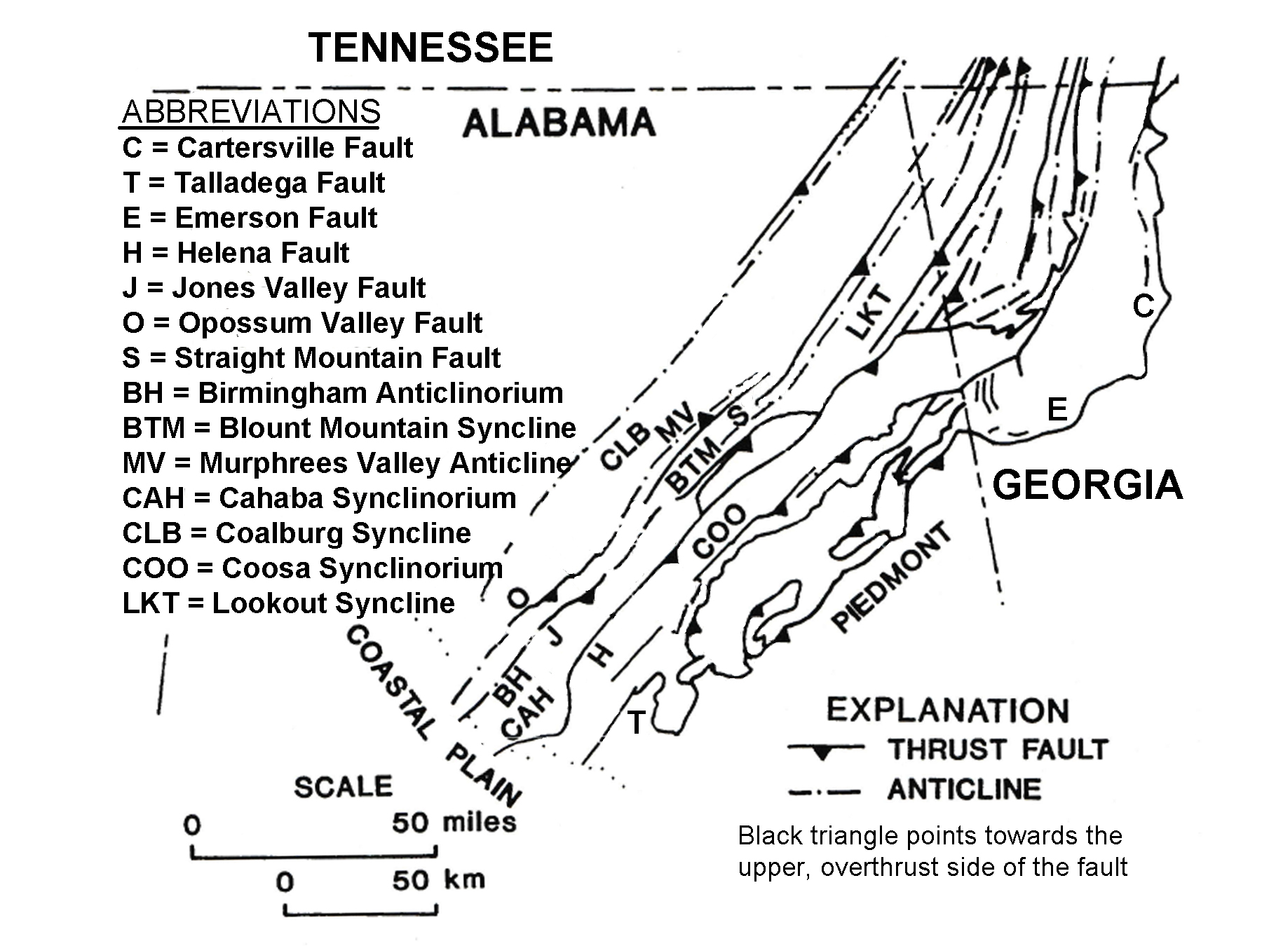

For these reasons, some geologists consider Lookout Mountain to actually be an outlier of the Appalachian Plateaus region instead of a part of the Valley and Ridge. A similar problem exists when deciding where to place the eastern boundary of the Valley and Ridge region. Several thrust faults parallel many of the ridges in Georgia and Alabama, and detailed geologic studies have concluded that some parts of the Piedmont region have been pushed up and over top of a large section of the Great Valley. Three of the major thrust faults in this area are the Talladega Fault in Alabama and the Cartersville and Emerson Faults in Georgia. Further north, the Great Smoky Thrust Fault in Tennessee has pushed Blue Ridge rocks up and over the Great Valley in a similar manner. A good example of such ‘out-of-place’ Piedmont rocks showing up in the Valley and Ridge is Choccolocco Mountain, a part of the Weisner Ridges complex, that stretches from southwest of Rome GA to near Anniston, AL.

One of the most unusual topographic patterns found in the Valley and Ridge is the curved or “V”-shaped mountain ridges that are so common in the Georgia and Alabama portions of this region. These patterns can be recognized on nearly any map, but are especially noticeable on computerized digital elevation landform models. These zig-zag landforms are the modern surface expression of the complex structural folds that affected this region in the distant past. While some folds, especially those farther north in the Valley and Ridge, possess a simpler geometry in which the fold axis (centerline of the fold) parallels the land surface, many folds in Georgia and Alabama have undergone additional tectonic warping that has tilted the fold axes away from the horizontal at angles up to 20 degrees. Such folds are referred to as plunging folds. As a result, in a tilted anticline structure, resistant rock formations may crop out high above the ground on both sides of a ridge at one end of a mountain, but then gradually get lower in elevation and closer together until the two sides merge together. Here, the mountain ends as the formation disappears underground. For anticlines, the convergence direction of the rocks always points in the same direction as the dip angle of the fold axis. For a plunging syncline, the resistant formations get farther apart in the direction of the fold axis dip.

Figure 5A-2: Plunging Folds in the Southern Valley and Ridge

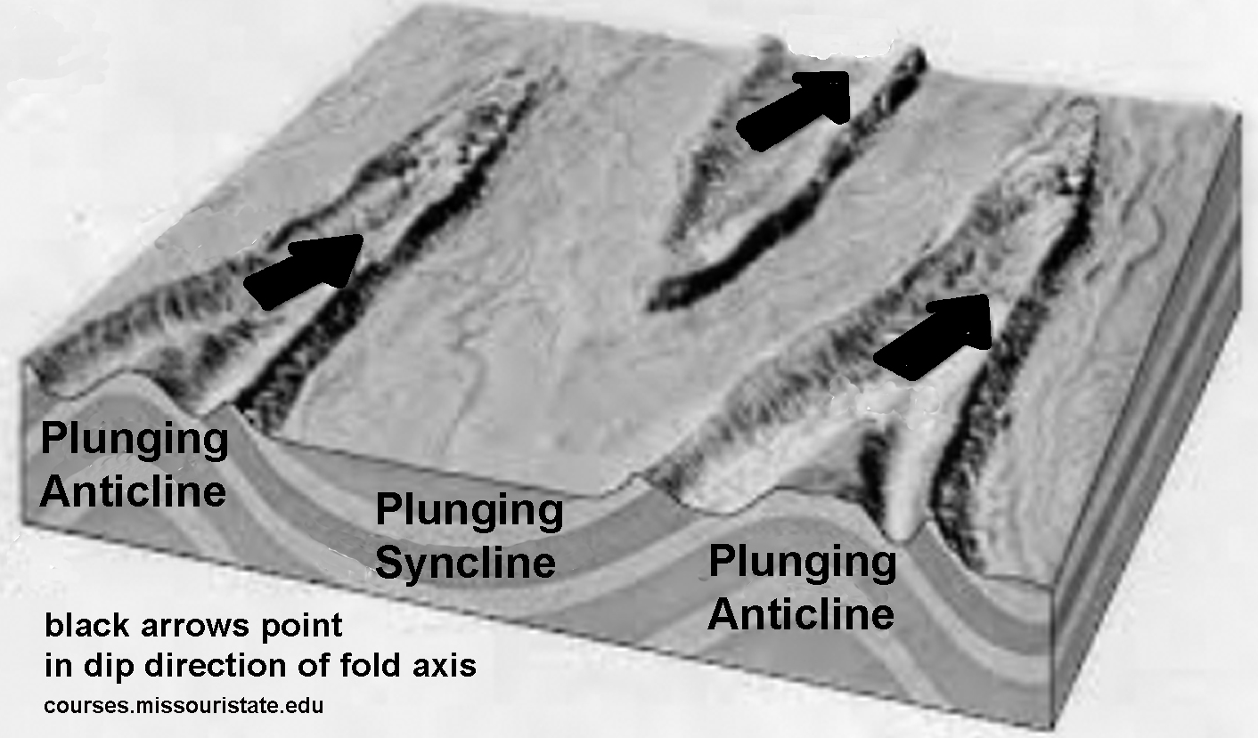
Little River Canyon

The Little River is the only major river in the Appalachian Mountain chain that flows for most of its course on top of a mountain. Its watershed (drainage basin) area is confined entirely to the top of Lookout Mountain and the river itself flows more than 50 miles (80 km) before making a sharp right-angle bend to the left, finally leaving the mountain to emerge in the Coosa Valley. Because Lookout Mountain is structurally a syncline, a wide relatively flat valley has formed on the top of the ridge. And because the northern end of Lookout Mountain is higher in elevation than the southern end, the water drainage on the mountain flows southward. The canyon itself begins at Little River Falls, where water plunges over a sandstone ledge and then gradually deepens its gorge until it reaches a maximum depth of nearly 600 feet (180 meters) beneath the towering sandstone cliffs that rise up on both sides of the river. Like most canyons, it has been growing longer and deeper over time as the river continues to erode the landscape. In addition, the position of Little River Falls has likely migrated upstream over time as well.

The Little River has a reputation for being among the cleanest and wildest rivers in the South. This river was the first waterway in Alabama to be declared an Outstanding National Water Resource under the Federal Clean Water Act, and in 1992, the canyon area received National Preserve status. In addition to the canyon itself, other features in the Preserve include forested uplands, waterfalls, great hiking, hunting, and fishing sites, and De Soto State Park, a recreational area constructed by the Civilian Conservation Corps in the late 1930s. A scenic highway, known as Little River Canyon Rim Parkway, follows the canyon’s western rim for 23 miles (37 km) and offers many scenic views. The northern half of this road was constructed with Federal dollars as part of the New Deal WPA (Works Project Administration) program. Local authorities funded construction of the southern half of the highway.

Creating the preserve status for this area was not an easy or quickly accomplished feat. The canyon had long been used as an illegal dumping ground which created hazards for the native animals, polluted the water, and drastically reduced the enjoyment of the area by hikers and campers. Local citizens organized annual Canyon Clean-up days during which military helicopters were used to lift items as large as eighteen-wheeler trucks from the canyon floor. These same citizens later formed a political-action committee to pressure their representatives in Congress to extend federal protection for the canyon area. Besides writing letters, many committee members gathered extensive information about water quality in the river and inventoried wildlife and plant species found there. Environmentalists pushed preservation to prevent commercial development, while tourism officials also favored the plan because they thought it would bring in much needed tourist dollars.

Not everyone, however, wanted the Little River Canyon to become a national preserve. Some simply didn’t want the government controlling land that had always been theirs to use freely. Hunters and fishermen questioned whether the new status would add additional regulations. Local residents living on Lookout Mountain were concerned about the possibility of restrictions on their land, homes, and businesses, and whether this was a wise use of tax money. After many public meetings, an agreement was reached which was acceptable to both sides. No private land would be taken by the government and special provisions were enacted to insure strong public participation in developing a management plan for the Preserve. Following the announcement of the decision, Alabama Senator Richard Shelby declared “Enactment of this legislation will ensure that one of Alabama’s most beautiful natural resources is protected for the enjoyment of this generation and generations of Alabamians to come.”

Historical Connections with Topography

Although De Soto State Park, on Lookout Mountain, AL, is named for the famous Spanish explorer who passed through this area in 1540, the park also contains the remains of a much older fort that archeologists have puzzled over for years, because the design is unlike any known Native American construction. Surprisingly, the fortifications most similar in terms of the setting, layout, and method of construction are found in the country of Wales in Great Britain. Although we have no written record of Welsh colonists traveling to North America, well before the time of Christopher Columbus, there are certain oral traditions circulated within various Native American cultures and other pieces of purely circumstantial evidence that might lend some truth to the legend.

But the first thoroughly documented visit of Europeans to Alabama remains the expedition of Hernando De Soto, who thought he would find gold and other riches in North America the same way he had found them in South America when he had accompanied Francisco Pizarro in the conquest of the Inca nation in Peru. De Soto set out from Spain in April 1538 with 10 ships, 700 men, over 200 horses and a herd of several hundred pigs. After a stop in Cuba, the expedition landed at the site of present-day Tampa, Florida in May 1539. After spending over a year wandering through parts of Florida, Georgia, South and North Carolina and Tennessee, De Soto and his armies finally crossed into Alabama in the Fall of 1540. For the most part, they followed well-established trails through the mountains. Throughout their long journey, the expedition had extensive encounters with the Native American nations then living in the Southeast. De Soto requested assistance from many of the villages he encountered and got his needed supplies either through negotiations or by simply having his army take what they wanted. Following the disastrous battle at Mabila, De Soto led his troops north and west to the Mississippi River where in May 1542, he died of a fever in modern-day Louisiana.

Much controversy still surrounds the exact route taken by De Soto through Alabama. Researcher Donald E. Sheppard has suggested two possible paths, based on his compilation of information from four existing first-hand accounts of De Soto’s travels, three written by officers and a fourth written by a Spanish author who interviewed several expedition survivors after they returned to Spain. One account places De Soto’s route to the west of Lookout Mountain, while another account has the expedition traveling east of Lookout Mountain, through parts of Georgia, before reaching the Coosa Valley near the present-day location of Weiss Lake and the town of Cedar Bluff, AL.

Two Accounts of De Soto’s Travels Through Alabama
--loosely excerpted from Donald E. Sheppard’s published accounts—
[ ] Indicates editorial notes inserted by Sheppard

ACCOUNT #1
“On Tuesday we crossed another [the Tennessee River, in order to avoid the steep ridges on the river’s south bank] and on Wednesday another river [the Tennessee River again near Moccasin Bend] and we slept in Tasqui (in Lookout Valley, TN). On Thursday we went to another small town and passed other small towns . . . and on Friday the Governor (De Soto) entered Coosa (near Fort Payne, AL in Wills Valley), one of the best and most abundant provinces we found. The Governor rested in Coosa for twenty-five days, then set out on Friday, August 20, to look for a province called ‘Tuscaloosa’.”

ACCOUNT #2
“On Tuesday we crossed another river [South Chickamauga Creek, GA] and on Wednesday another large river [West Chickamauga Creek] and we slept in Chisca [near Lafayette, GA] . . . On Thursday, we went to another small town [near Trion, GA] and passed other towns, and on Friday the Governor entered Coosa [near Summerville, GA] . . . one of the best and most abundant provinces we found . . . The Governor rested in Coosa for twenty-five days, then set out on Friday, August 20, to look for . . . Tuscalusa . . . . We departed from here [Coosa] toward the west and southwest [following the Chattooga River] . . . and we spent that night beyond Talimuchusiour. The next day, we spent the night in Itaba [Cedar Bluff, AL], a large town near a good river. We stayed there for six days because a river [Coosa River], which ran hard by the town, was swollen.”

During the Civil War, this same transportation corridor was the scene of two major battles, the Battle of Chickamauga, won by the Confederacy, and the Battle of Chattanooga, won by the Union. By September 1863, after a series of minor skirmishes, Union General Rosecrans had pushed all Confederate forces out of Chattanooga to take control of this vital railroad link to the north. About a week later, Rosecrans was tricked into believing that the Confederate forces were retreating farther into Georgia, and he decided to pursue them. However Confederate General Bragg had not ordered his forces to retreat. Instead he had arranged a rendezvous with reinforcements from the Army of Northern Virginia, led by Lieut. Gen. James Longstreet, and together they set up an ambush at Chickamauga Creek and waited for the Union soldiers to arrive. Chickamauga was one of the bloodiest battles of the war. The two sides were evenly matched, each side bringing over 60,000 troops to the battle, and casualties were also about even as each side lost over 16,000 men. Although the Confederate army won the battle, it was a costly victory. Union General George Thomas earned himself the nickname “The Rock of Chickamauga” by making a desperate stand at Horseshoe Ridge, despite repeated assaults from Confederate forces, until nightfall when the Union survivors were able to retreat back to Chattanooga under cover of darkness. General Bragg’s army followed at a distance and set up their positions about six miles outside Chattanooga on the high ground of Lookout Mountain and Missionary Ridge.
With the Union army under siege and running out of supplies in Chattanooga, President Abraham Lincoln decided to replace General Rosecrans with Major General Ulysses S. Grant. Grant arrived in October, refortified the city of Chattanooga, re-opened the supply lines, and began to make plans to end the Confederate siege. Lincoln also sent additional troops, led by Generals Joseph Hooker and William T. Sherman, to reinforce the Union army. On November 23, 1863, Grant began the battle by ordering General Thomas to attack the center of the Confederate line located in front of Missionary Ridge. General Sherman was to attack the north end of Missionary Ridge and General Hooker’s troops were to attack the Confederate troops on Lookout Mountain. The Lookout Mountain battle is often referred to as the “Battle Above the Clouds” although the battle was actually fought in a dense fog that arose from the Tennessee River far below. After midnight, the Confederate soldiers on Lookout Mountain withdrew and moved eastward to provide much-needed reinforcements to the troops fighting on Missionary Ridge.

At daylight on November 25, General Sherman again led an attack at the north end of Missionary Ridge. The slope of the ridge was so steep that the Confederate soldiers found it difficult to shoot downhill on the attacking troops, so they rolled down boulders and threw down artillery shells with lighted fuses. Nevertheless, the Confederate line held and Sherman’s forces were beaten back. The turning point of the battle occurred at 3:30 PM on November 25. General Thomas’ troops were ordered to capture the rifle pits at the base of Missionary Ridge. This they did, but then, without orders, they fought their way to the top of the ridge and routed the Confederates. Within the hour, the center of the Confederate line had been broken and General Bragg’s shattered army had fled the field of battle, eventually retreating all the way to Dalton, GA, where the army set up winter quarters.

The two major components of the Union’s western strategy were the capture of Vicksburg, MS and Chattanooga, TN. Both were of strategic value due to their topography and rail connections. Vicksburg and Chattanooga both fell to the Union in 1863, contributing mightily to the ultimate defeat of the Confederacy.

Activity 5A-1: Topographic Patterns

POWER THINKING EXERCISE - "Bewildering Boundaries"
While the Valley and Ridge region contains many unique and characteristic landform patterns that are easily recognizable, geologists and geographers have long argued over where exactly to place the northwestern and southeastern boundaries of this region. One problematic example involves the Cahaba and Coosa Ridges east of Birmingham, AL (refer to Figure 5-3). Both of these ridges contain rock formations with coal deposits that look like they belong in the Appalachian Plateaus region. Also, Lookout Mountain, both geologically and structurally, is more typical of the Plateau region. Another example is seen in the Weisner Ridges, located just east of the Coosa Valley (refer to Figure 5-3). This ridge is composed of crystalline rocks typically found in the Piedmont region. Locate each of these examples on the following maps and decide whether you would include them in the Valley and Ridge region, or not, based on the information contained on the map. Try to reach a consensus within your group and be able to defend your answers to the class by referring to specific data from each map.
MAP 3A, LANDSCAPES AND LANDFORMS
MAP 3B, GEOLOGICAL SETTING
MAP 3C, LANDSCAPE PATTERNS
MAP 5A, LOOKOUT MOUNTAIN (Lookout Mountain Topographic Map)
IMAGE 5A, LOOKOUT MOUNTAIN (Lookout Mountain Satellite Image)

Materials
MAP 3A, LANDSCAPES AND LANDFORMS
MAP 3B, GEOLOGICAL SETTING
MAP 3C, LANDSCAPE PATTERNS
MAP 5A, LOOKOUT MOUNTAIN
IMAGE 5A, LOOKOUT MOUNTAIN
Figure 5A-2: “Plunging Folds in the Southern Valley and Ridge”
Wipe-off Pens

PERFORMANCE TASKS
(Icon Key) Overview = ; Science = ; Math = ; History = ; Language Arts =

1. Distinguish between plunging and horizontal folds.
Examine carefully the topography of the listed mountain ridges visible on the Lookout Mountain topographic map on MAP 5A, LOOKOUT MOUNTAIN. Also locate these same mountain ridges on the TM Satellite Image on IMAGE 5A, LOOKOUT MOUNTAIN. Based on information provided on Figure 5A-2, and the “background information” section, determine as best you can whether each of these ridges is part of an anticline or a syncline and whether the fold axis dips (plunges) or is horizontal (no plunge). Refer to specific map or image features to justify your answers.

RIDGE  (and location) | ANTICLINE/  SYNCLINE | PLUNGE  (yes or no) | DIRECTION  (north/south) | JUSTIFICATION
Rocky Face Mt
Dalton, GA
Bogan Mt.
Chattoogaville GA
Taylor Ridge
Summerville, GA
Pigeon Mt.
La Fayette, GA

2. Investigate boundary of Valley and Ridge with Coastal Plain.
Locate the southern end of the Valley and Ridge region on the Surface Geology Map on MAP 3B, GEOLOGICAL SETTING. Note that every rock formation in this region seems to just come to an end when it hits the boundary with Coastal Plain rocks. Refer to the Geologic Map Legend to determine which region has the older rocks (Valley and Ridge or Coastal Plain). Because younger rocks almost always lie on top of older rocks, is it more likely that the Valley and Ridge rocks continue underneath the Coastal Plain or that the Coastal Plain rocks continue beneath the Valley and Ridge? How likely is it that the Valley and Ridge rocks all just end when they reach that exact same location line? Justify your answers.

3. Compare map and oblique views of Lookout Mountain DEM.
Locate the DEM (Digital Elevation Model) images of Lookout Mountain on IMAGE 5A, LOOKOUT MOUNTAIN. What landform differences do you notice between the two image perspectives shown by the map view and oblique view? How do images of specific landforms on the oblique views of Lookout Mountain change as the landscape is viewed from different angles? What information do shadows give you to assist with your interpretation of the landscape? How do the shadows change as the viewing angle changes? Which end of Lookout Mountain do you think is higher in elevation, the northeastern or southwestern portion? Explain in detail how you determined your answer to this question.

4. Compare population density of ridges and valleys.
Examine the Lookout Mountain Landsat Thematic Mapper (TM) image on IMAGE 5A, LOOKOUT MOUNTAIN. Note that this is a ‘false-color’ image in which the infrared reflections of forests, agricultural fields and any other vegetation captured by the satellite are printed in various shades of red or pink. The more solid and continuous patterns of darker red usually indicate forests. The patchwork pattern of lighter reds and pinks usually represents agricultural areas. Other wavelengths of light are color-shifted as well. The milky blue areas can represent water, bare fields, or urban areas like cities and towns. Find several examples of each pattern on the satellite image and locate these same spots on the Lookout Mountain Topographic Map on MAP 5A, LOOKOUT MOUNTAIN. Use your data to determine whether, in this region, more people live in the valleys or on the ridges. Refer to specific map features to explain how you made this determination.

5. Design brochure to attract more tourists to Lookout Mountain.
After visiting Rock City, the most well-known attraction on Lookout Mountain, you stop at a local Visitor Center and learn that several of the park’s other attractions are concerned about a recent drop in the number of visitors to the area. A group has been formed to try and change that trend. They have just announced a contest, complete with a cash prize, to see who can design the most attractive brochure highlighting all the things to see and do on Lookout Mountain. Your brochure should be printed front and back on one sheet of paper. Use library or internet resources to research both the natural scenic beauty of the area as well as the many opportunities available for outdoor recreation. Display your brochures in your classroom or media center and have your class vote on which brochure should win the prize.

ENRICHMENT
(Icon Key) Overview = ; Science = ; Math = ; History = ; Language Arts =

1. Estimate viewing angle of oblique DEM images.
Oblique views of DEM (Digital Elevation Model) images make it look like the viewer is situated at a certain distance above the ground; similar to the view one might get of the landscape from the top of a mountain. A normal map view would place the observer directly above the landscape, and the viewing angle would be 90º. A profile view would place the observer on the ground where a side-view of the landscape would be obtained. The viewing angle in this case would be 0º. Study the oblique view DEM images on IMAGE 5A, LOOKOUT MOUNTAIN and try to estimate the viewing angle that the computer is simulating. Be prepared to explain your reasoning to the rest of the class.

2. Research how Digital Elevation Models are created.
Digital Elevation Models (DEM) provide an impressive way to use computer graphics techniques to view landforms and landscapes. Refer to library or internet resources to learn what type of data is required to produce these images and how the computer software manipulates that data to generate the final product. Search the internet for other published DEM images and compare these to the images on IMAGE 5A, LOOKOUT MOUNTAIN.

Activity 5A-2: Little River Canyon

POWER THINKING EXERCISE - "Preserve Predicament"
Before the establishment of the Little River Canyon Preserve in 1992, many public meetings were held where various concerns could be heard and then addressed in the final land-use plan. Many compromises had to be made before the plan was allowed to proceed. Your class will be divided into six teams, each team representing one of these six interest groups.
Team 1 = Local Rafting/Kayaking Company Wants to Run Tours
Team 2 = Local Hiking Club Wants Trails in Wilderness Areas
Team 3 = Developer Wants to Open Private Campground
Team 4 = Historical Society Wants to Build a Small Museum
Team 5 = Hotel Chain Representative Wants to Build Hotel
Team 6 = Wildlife Preservation Group Wants to Limit Impact
Each interest group does favor establishment of the Preserve, but only under regulations that will best accommodate their particular use of the land. Each team should prepare a list of requests that they think their interest group should present at the public hearings and then share those lists with the entire class. Refer to the Little River Canyon topographic map on MAP 5A, LOOKOUT MOUNTAIN and the Little River Canyon air-photo mosaic on IMAGE 5A, LOOKOUT MOUNTAIN to gather data that will support your requests. After all teams have presented their case, the entire class should engage in a debate process that considers both pros and cons related to each group’s requests. One member from each team will be chosen to serve on a committee to draft a comprehensive plan for land use within the Preserve. The final plan should specify which locations in the Preserve would have specific restrictions and which would not.

Materials
MAP 5A, LOOKOUT MOUNTAIN
IMAGE 5A, LOOKOUT MOUNTAIN
string
Wipe-off Pens

PERFORMANCE TASKS
(Icon Key) Overview = ; Science = ; Math = ; History = ; Language Arts =

1. Compare land use on west and east sides of Little River Canyon.
Examine the land-use patterns on the Little River Canyon photo mosaic on IMAGE 5A, LOOKOUT MOUNTAIN and the Little River Canyon topographic map on MAP 5A, LOOKOUT MOUNTAIN. Remember that these photos are false-color infrared images and therefore the reds and pinks represent live vegetation. Forests tend to show up in bluish-gray colors because the photographs were taken in winter, when most deciduous trees lose their leaves. Note that the west side of the canyon shows the most human activity (farm fields, etc.). After comparing the topography on each side of the canyon, explain why you think the western side is more populated.

2. Explain drainage patterns of the Little River.
Trace, with a wipe-off pen, the course of the Little River and all its tributaries on the Lookout Mountain topographic map on MAP 5A, LOOKOUT MOUNTAIN. Does the drainage pattern of this river change when it enters the canyon? Why or why not? Does this fact give you any clues about whether the canyon is older than the river or the river is older than the canyon? Explain your answer. A strange feature of this canyon is the sharp left turn the river makes near the canyon exit when it leaves Lookout Mountain. Speculate about why this might happen and propose at least one possible scientific reason for why you think that sharp turn exists.?

3. Graph longitudinal profile of Little River Canyon.
Find the location marked ‘Cradle Rock’ at the extreme top right corner of the Little River Canyon topographic map on MAP 5A, LOOKOUT MOUNTAIN. Use contour line information to estimate the elevation of the water surface in Little River at that point. Next, find the location marked ‘Gauging Station’ just past the exit of Little River from Lookout Mountain. Use contour line information to estimate the elevation of the water surface in the Little River at that point. Subtract the lower elevation number from the higher elevation number to get an estimate of the total vertical drop in elevation of the river in this part of the canyon. Record these numbers. Also use contour line information to estimate the elevation of the top of the canyon at ‘Cradle Rock’ and also at the highest point on Lookout Mountain at the location where the river exits the canyon. Subtract these numbers to get an estimate of the total vertical drop in elevation of the canyon rim. Record these numbers.

Lay a piece of string along the course of the river from ‘Cradle Rock’ to ‘Gauging Station’ and place the string over the map scale to estimate the total length of Little River from one point to the other. Record this number. On a piece of graph paper, set the ‘y’ axis to represent elevation and the ‘x’ axis to represent distance. Use an appropriate vertical scale. Plot your ‘Cradle Rock’ river point as zero distance and your recorded elevation. Plot your ‘Gauging Station’ point as total river length and your recorded elevation. Draw a straight line connecting these two points on your graph and then calculate the slope of this line. In a different color pen, plot your two ‘top-of-canyon’ elevations on the same graph paper (using the same vertical scale) and calculate the slope of this line. Compare the two slope values. Can you draw any conclusions about the geometry of the canyon from this graph?
4. Evaluate placement of Little River Canyon Parkway.
Locate the Little River Canyon Parkway, a road running along the west side of the canyon on the top half of the Little River Canyon topographic map on MAP 5A, LOOKOUT MOUNTAIN. Considering all the twists, bends, and turns required for this road as shown on the map, why didn’t they build the highway on the eastern side of the canyon, where the road would have been much straighter? Use information from the map to justify your answer.
5. Write letter to the editor regarding Little River Canyon Preserve.
Before the establishment of the Little River Canyon Preserve, there was much debate among local citizens over whether to make this area a preserve or not. Assume that you are a landowner on the top of Lookout Mountain living close to the canyon. Write a letter to the editor of your local newspaper expressing either support or opposition to the proposed change based on how it would affect you personally. You can refer to the Little River Canyon topographic map on MAP 5A, LOOKOUT MOUNTAIN and the Little River Canyon air-photo mosaic on IMAGE 5A, LOOKOUT MOUNTAIN for additional information to include in your letter. The letter should use words and phrases that are persuasive and convey emotion. You should also give the letter a title that would attract the attention of readers.

ENRICHMENT
(Icon Key) Overview = ; Science = ; Math = ; History = ; Language Arts =

1. Research hearings and land-use plan developed for Preserve.
Use your local library collections or the internet to search for references to the hearings and debates that occurred before the 1992 decision to award the Little River Canyon its current National Preserve status. For example, an article by Steven Stiefel, printed in the Times-Journal newspaper (in Fort Payne Indiana) on October 22, 1992, documents some of the political maneuvering carried out by local politicians to get the preserve authorization approved. Summarize your findings in a brief written report documenting how preservation and land-use concerns were balanced in the final bill.

2. Investigate geology of Lookout Mountain and Little River Canyon.
The Alabama Geological Survey and several other state agencies have published many geologic and topographic maps of the Little River Canyon area, including land-cover maps, soil-survey maps, and geologic cross-section diagrams. Consult these resources to learn more about the rocks and soils in this area, how the Little River Canyon formed, and how the drainage patterns on Lookout Mountain developed.

Activity 5A-3: Historical Connections with Topography

POWER THINKING EXERCISE - "Constricted Corridor"
The Valley and Ridge region seems to have gotten more than its expected share of visitors throughout history. From frequent activity along Native American trading routes to expeditions of early European explorers to important Civil War battlefields, this region has seen an inordinate amount of history. Your social studies class has studied all of these historical events, but you still don’t understand why locations in the Valley and Ridge region get referenced so often.
Your science class has been studying geology and landforms using MAP 3A, LANDSCAPES AND LANDFORMS, so you get the bright idea to see if this map can help answer your questions. With a wipe-off pen, draw a line on MAP 3A all around the Blue Ridge region. Refer to the “Index Map to Southeastern Regional Study Area” (see the first page of this chapter) to help you outline this region. Also, with a wipe-off pen, draw a line on MAP 3A all around the Appalachian Plateaus region (again refer to the Index Map if you need help outlining the region). Both the Blue Ridge and the Appalachian Plateaus regions are characterized by high mountain ranges and terrain that is extremely difficult to travel through. If you lived in Mississippi, Alabama, or western Georgia and wanted to travel to Virginia or other more northern states, being sure to avoid the mountainous regions, what routes would still be available to you? Draw these routes on MAP 3A with a different color wipe-off pen. Which of these routes do you think would be the quickest and simplest to take? Refer to topographic features on the map to defend and explain your answer.

Materials
MAP 3A, LANDSCAPES AND LANDFORMS
MAP 5A, LOOKOUT MOUNTAIN
IMAGE 5A, LOOKOUT MOUNTAIN
newspaper article, “Bloody Alabama Battle in 1540 Changed the South
story, “Two Accounts of De Soto’s Travels Through Alabama”
Wipe-off Pens

PERFORMANCE TASKS
(Icon Key) Overview = ; Science = ; Math = ; History = ; Language Arts =

1. Trace De Soto’s possible routes through Northern Alabama.
Read the story, “Two Accounts of De Soto’s Travels Through Alabama” on page 5A-9. Make note of the similarities and the differences between the two accounts. Trace, with a wipe-off pen, as closely as possible, the two routes (use a different color for each route) on the Lookout Mountain topographic map on MAP 5A, LOOKOUT MOUNTAIN. Remember that De Soto’s expedition had no maps and they tended to name places for Native American Chiefs that controlled that area. As a result, the name “Coosa” could refer to any one of several different towns in the area, all controlled by the same Chief. From the information provided, do you see any reason to favor one route over the other as being the actual route taken by De Soto?

2. Determine best places for highways to cross ridges.
Study the route patterns of the major highways on the Lookout Mountain topographic map on MAP 5A, LOOKOUT MOUNTAIN. Note that many highways run north to south in the valleys, but a lot fewer run east to west across the ridges. Usually the most convenient place to cross a ridge is at a water gap or wind gap. Locate the following highways in Georgia and count how many water gaps and how many wind gaps the road passes through on its way from one city to the other.
INTERSTATE 75 BETWEEN DALTON, GA AND CHATTANOOGA, TN
(look in northeastern corner of Lookout Mountain topographic map)
US HIGHWAY 27 BETWEEN ROME, GA AND SUMMERVILLE, GA
(look just below center section of Lookout Mountain topographic map)

3. Estimate average daily distance traveled by De Soto’s army.
Read through the story, “Two Accounts of De Soto’s Travels Through Alabama” on page 5A-9, and note that, in each account, the army spent Wednesday night in a named town (Tasqui or Chisca). Also in each account, they entered the town named Coosa on Friday. We can assume it took De Soto two full days to travel from the Wednesday night location to Coosa. Because this travel took place during the Fall of the year, we can assume a daylight travel time of ten hours per day (the army had to have time to set up camp before dark and couldn’t break camp until after sunrise). Use the scale bar on the map to measure the approximate distance from Tasqui to Coosa (according to account #1) and also measure the approximate distance from Chisca to Coosa (according to account #2). Divide each distance by ‘2’ to calculate the approximate number of miles traveled each day. Then divide that number by the travel time of 10 hours/day to arrive at an estimate in units of miles per hour. Compare your results for each route. How similar or different are your results for each account of De Soto’s route through Alabama? How quickly do you think you could make the trip today, driving on existing highways?

4. Analyze effect of topography on Civil War battles.
The Battle of Chickamauga and the Battle of Chattanooga both were heavily impacted by the landscape surrounding the battlefields. Read through the descriptions of these battles starting on page 5A-9. Then locate the major battle sites (Chickamauga Ridge, Missionary Ridge, and Lookout Mountain) on the Lookout Mountain topographic map on MAP 5A, LOOKOUT MOUNTAIN. What advantages would armies occupying the ridge have in defending their position? What disadvantages would attackers have faced in trying to capture positions on the ridges? Do you think a mountain slope could ever be too steep to allow the defenders to take advantage of the landscape? Explain and defend your answer.

5. Identify landscape references in travel accounts.
Read through the story, “Two Accounts of De Soto’s Travels Through Alabama” on page 5A-9. Several references are made to landscape features and natural events that the army encountered. Make a list of all the words you find that make such references.

Plan a similar trip that you might take today from Chattanooga, TN to Dalton, GA, driving on Interstate Highway 75. Write a brief travel journal that describes the landscape you are driving through. Refer to the Lookout Mountain topographic map on MAP 5A, LOOKOUT MOUNTAIN to trace the route of Interstate 75.

ENRICHMENT
(Icon Key) Overview = ; Science = ; Math = ; History = ; Language Arts =

1. Research De Soto’s defeat at the Battle of Mabila.
Use your local library collections or the internet to search for references to the Battle of Mabila (described in the Newspaper Article on page 5A-1). Speculate about what might have happened if De Soto had taken a different route through Alabama, or if he had not treated the Native American peoples so harshly. Consider the impact that this type of first contact between Europeans and Native Americans might have had on future relations between these two groups.

2. Research De Soto’s entire campaign through the Southeast.
The latest research on De Soto’s expedition indicates that he and his army traveled through Florida, Georgia, South Carolina, North Carolina, and Tennessee before reaching Alabama. Use your local library collections or the internet to search for references and maps that document the entire journey, and prepare a short synopsis of his travels to present to your class.
.

STUDY AREA 5B: BIRMINGHAM

Los Angeles Times
April 12, 2015
Vulcan Statue, Often the Butt of Jokes, is Well-Loved
Birmingham, AL. The statue goes by just one name: Vulcan. Around this polite Southern metropolis, he’s famous for his oversized head, blacksmith’s apron, manly beard, and fearsome spear that he raises toward the sky. Named for the Roman god of fire and forge, Vulcan wears only an apron, with greenish buns of steel bared for all to see.  Residents know that Vulcan stands for the region’s work ethic and natural resources; a figure who hammers steel from the earth’s raw materials. Birmingham’s Iron Man. But they have always wondered why Vulcan doesn’t wear pants.  Gary Bostany, docent at a city museum, has an answer: | “Because they didn’t have air-conditioning and it got real hot near the forge when you made steel.  Italian immigrant Giuseppe Moretti designed the statue for display at the 1904 World’s Fair in St. Louis. He made 21 separate clay molds and sent them by train from New Jersey to Alabama, where the parts were cast in steel. The parts were then railroaded to St. Louis and assembled just in time for the fair, where Vulcan won a grand prize.  On the way back to Birmingham, disaster struck: Someone misplaced Vulcan’s spear, which was never found. A smaller spear was forged, but it made Vulcan look more comical than masculine. | During the Depression, the city fell back in love with Vulcan. They muscled him up to the top of nearby Red Mountain. In 1946, as part of an auto safety program, they replaced the spear with a neon torch. On days with a highway fatality, the torch burned red. On days when nobody died in a car wreck, the torch burned green.  Over time, Vulcan began to fall apart, this time naturally. Officials worried his arm would drop off, so they raised $40 million to renovate Vulcan; and even forge a new spear that matched the original in size. Vulcan became a new man, standing higher than ever atop a 124-foot-tall base. Today, he’s the most popular figure in town..

RATIONALE

Birmingham and its surroundings are defined by an abundance of mineral resources that allowed the city to grow into a successful steel mill town and become the major heavy industrial center of the South. The geologic structures underlying the Valley and Ridge Region brought many different rock types with extensive deposits of coal, limestone, and iron ore into close proximity with each other. Unfortunately, many of these same geological factors also contributed to quality issues with these raw materials that would eventually limit productivity and undermine the competitiveness of Birmingham Steel versus that of steel companies in the north. Impurities in some of these resources also created pollution problems around the city that are still being dealt with today. Under the leadership of James W. Sloss, founder of the Sloss Furnace Company, the city of Birmingham grew up around the steel mill, and the small mill town grew into a prosperous city and a major railroad hub that would supply steel and other industrial commodities to the post Civil War South.
PERFORMANCE OBJECTIVES

1. Locate quarries and other mining sites on topographic maps and aerial photographs.
2. Use cross-section sketches to infer dip angle of resistant rock formation.
3. Estimate surface area covered by object on map or aerial photograph.
4. Explain economic factors that determine whether to mine on surface or underground.
5. Recognize references to objects connected to mining or manufacturing in ballads.
6. Locate buildings and other landmarks connected to industry or manufacturing in city.
7. Interpret color-shift changes on infrared aerial photographs.
8. Investigate use of ordered-pair grid system for street naming in cities.
9. Evaluate efficiency of hub network for transportation systems.
10.Recognize literary conventions and expectations for writing newspaper articles.

SAMPLE ASSESSMENT RUBRICS
EXAMPLE #1 (relates to Performance Objectives #2)
Give students a copy of this cross-section diagram that cuts through a north-south running mountain ridge. Tell students the ridge is held up by a resistant sandstone layer. Based only on information shown, in what compass direction does the resistant rock formation dip (slant downwards toward)? [east] Ask students to briefly explain their reasoning. [because most of this region is underlain by folded sedimentary rock, we can assume the resistant rock is a tilted layer. The eastern slope of the ridge is very straight and uniform, which makes it more likely that the slope is controlled by the surface of this rock layer. The western slope is more jagged and irregular which implies that several different types of rock layers are likely exposed on that side.]

A (level 4) – correct answer given and correct explanation provided
B (level 3) – correct answer given but explanation is not clear, but also not wrong.
C (level 2) – correct answer given but explanation is not correct; or incorrect
answer is given but explanation shows some understanding of the concept.
D (level 1) – correct answer not given, but explanation shows some understanding.
F (level 0) – correct answer not given and explanation shows no understanding.

EXAMPLE #2 (relates to Performance Objective #5)
Give students a copy of the Ballad of Joe Magarac (page 5-6) and ask them to list four objects, terms, or references in the song that have a connection to the iron/steel industry of Birmingham [some acceptable answers are: iron ore, furnace, blast, roar, steel, ingots, fire, shift, girder, span].

A (level 4) – four references named correctly
B (level 3) – three references named correctly
C (level 2) – two references named correctly
D (level 1) – one reference named correctly
F (level 0) – no references are named correctly
Cartographic Product Information

MAP 5B: Birmingham

TITLE: Birmingham, AL (topographic map)
DATA SOURCE: Birmingham North, Birmingham South, Irondale, and Cahaba Heights USGS 1:24,000 Quadrangle maps.
DATE: 1959 [photorevised in 1970 and 1978]
SCALE: 1:24,000 [1 inch = 2,000 feet] [1 cm ~ 250 meters]
OTHER IMPORTANT DATA:
- This map shows most of the city of Birmingham and its surrounding suburbs.
- The contour interval of this map is 20 feet.
- Topographic maps show highways and railroads coming in to the city from all directions, making the city a major transportation hub for the South.
- Many quarries and other mining sites are shown on this map representing locations where iron ore, limestone, and coal were mined.
- Within the city, some streets are named, but many are not.
- Most of the metropolitan area in the valley is highly developed; most of the land on the mountain ridges is much less developed.
POINTS OF SPECIAL INTEREST:
- Sloss Furnaces National Historic Landmark. [at 1st Avenue N & 32nd Street N]
- The Red Mountain Expressway Road Cut. [near Homestead & English Village]
- The Vulcan Statue site. [at 16th Avenue S & 19th Street S]
OTHER FEATURES TO LOOK FOR:
- The Birmingham Municipal Airport is located in one of the wide valleys.
- All of the mountain ridges in the city are oriented in the same direction.
- Several limited access highways are shown as ‘under construction’.

Cartographic Product Information

IMAGE 5B: Birmingham

TITLE: Birmingham, AL (NHAP [air photo] mosaic)
DATA SOURCE: NHAP CIR Photos #83-43, 83-45, 83-48, 81-145, 81-147, 81-149
DATE: 1988
SCALE: approximately 1:24,000 [1 inch = 2,000 feet] [1 cm ~ 250 meters]
OTHER IMPORTANT DATA:
- This map shows most of the city of Birmingham and its surrounding suburbs.
- Urban areas show up as a steel-gray-blue color due to the abundance of concrete, asphalt, and light-colored rooftops. Areas with trees show up in red colors.
- Many quarries show up as areas with no vegetation cover.
- Several golf courses can be seen; fairways show up pink, greens show up red.
- Most of the metropolitan area in the valley is highly developed; most of the land on the mountain ridges is much less developed.
POINTS OF SPECIAL INTEREST:
- Sloss Furnaces National Historic Landmark. [at 1st Avenue N & 32nd Street N]
- The Red Mountain Expressway Road Cut. [near Homestead & English Village]
- The Vulcan Statue site. [at 16th Avenue S & 19th Street S]
OTHER FEATURES TO LOOK FOR:
- The Birmingham Municipal Airport is located in one of the wide valleys.
- All of the mountain ridges in the city are oriented in the same direction.

TITLE: Sloss Furnaces National Historic Landmark (NAPP [air photo])
DATA SOURCE: “NAPP Photograph #9693-42
DATE: 1997
SCALE: 1:5,000 [1 inch ~ 416 feet] [1 cm ~ 50 meters]
OTHER IMPORTANT DATA:
- At this scale, individual railroad cars can be seen on tracks and cars on highways.
- The photo shows the Sloss Furnaces buildings before restoration occurred.
- Note abundance of railroad tracks in vicinity of Sloss Furnaces site.
POINTS OF SPECIAL INTEREST:
- The two long rectangular buildings are where the actual furnaces were located.
OTHER FEATURES TO LOOK FOR:
- Compare photo to a recent Google EarthTM image to see changes to Sloss site.

Study Area Description

Mining Activities

The Birmingham mining district contains abundant deposits of iron ore, coal, and limestone, all of which are required to produce iron and steel. While iron is a pure chemical element, steel is an alloy made by mixing iron with carbon and sometimes other metals. Steel is both harder and stronger than pure iron. In order to separate iron from its ore, the ore must be heated to very high temperatures in furnaces; in conjunction with added fluxing agents like limestone or dolostone. Coal is used both to fuel the furnaces and to provide the carbon necessary to produce some steel alloys. In earlier times, iron-makers burned charcoal, produced by heating wood to high temperatures in the absence of oxygen. They mixed iron ore and limestone in stone furnaces, using bellows to force air into the furnace to raise the temperature of the fire to the melting point of iron (2,800ºF or 1,538ºC). The molten iron was then channeled into molds and allowed to cool into whatever shape was desired. The leftover material, called slag, was discarded or in more modern times was used as a source of ballast rock that was placed under railroad tracks as support for the rails. In the 1870s, a heating process was developed that was able to turn coal into a much more efficient fuel, called coke.

There are two primary iron ores used to make iron, hematite and limonite. In earlier days, limonite (also called bog iron ore or brown iron ore) was the most readily available ore and could be found in most areas of the Southeast. Although local ironworks operated on a very small scale, they were able to produce a variety of iron farm implements ranging from rakes to horseshoes. Limonite usually forms from the weathering of hematite, pyrite, magnetite and certain other iron-bearing minerals. It can also form when iron-rich acidic groundwater reaches the surface and mixes with the oxygen in the air. At Birmingham, just east of the city, large quantities of the iron-oxide mineral hematite (also called red iron ore) are exposed in the eroded sedimentary rocks of Red Mountain. Hematite was originally deposited in shallow seas during the Silurian Period of geologic time and was later incorporated into thick sedimentary rock formations that are unusually rich in iron content. Some of the iron seams on Red Mountain exceed 30 feet (10 meters) in thickness and can be traced for great distances. The high concentration of iron in these rocks is probably due to a variety of chemical and biological processes that were at work in the ancient seas that once covered this area.

Carbonates, in particular limestone and dolostone, are sedimentary rocks that also originally formed in shallow oceans as great thicknesses of limy muds accumulated on the ancient sea floor. After burial, heating, and compression turned the ooze into rock, later episodes of uplift and erosion have now exposed these formations at the surface. The carbonate formations that underlie many of the valleys in and near Birmingham are primarily of Cambrian and Ordovician age. Many of these formations contain fossils that provide a detailed record of invertebrate life in those early seas. Many of the local deposits that were mined contain over 50% calcium carbonate (or over 50% calcium-magnesium carbonate), which makes them ideal fluxing agents.
The coal used to heat furnaces in Birmingham probably originated as organic-rich terrestrial swamp deposits during the Pennsylvanian Period. These swamps were likely associated with large river deltas along a low coastal plain landscape. The sediments were eventually buried deeply enough to reach high enough pressures and temperatures to convert the organic material into coal. There are three grades of coal that are used for fuel in the United States: Anthracite (hard) coal is found primarily in Pennsylvania, has sustained the greatest amount of metamorphism, and burns the cleanest. Bituminous (soft) coal, considered a sedimentary rock, is much more common, but does not burn as cleanly. Lignite coal is a low-grade coal typically found in the western United States. It burns less efficiently than the other grades and is considered the dirtiest to use. Three major local coalfields, the Cahaba and Coosa just southeast of Birmingham, and the Warrior Coal Field just west of the Birmingham Valley produced more than enough coal to satisfy the needs of the iron industry. Coal is also used to make coke, a product that burns much hotter than regular coal and is much preferred by the iron industry for fuel. Coke is formed by burning bituminous coal in sealed kilns or pits, in the absence of oxygen. It is a much more efficient fuel because most of the volatile components and impurities in the original coal have been driven off during the combustion process.

Figure 5B-1: Location of Mineral Resources Around Birmingham
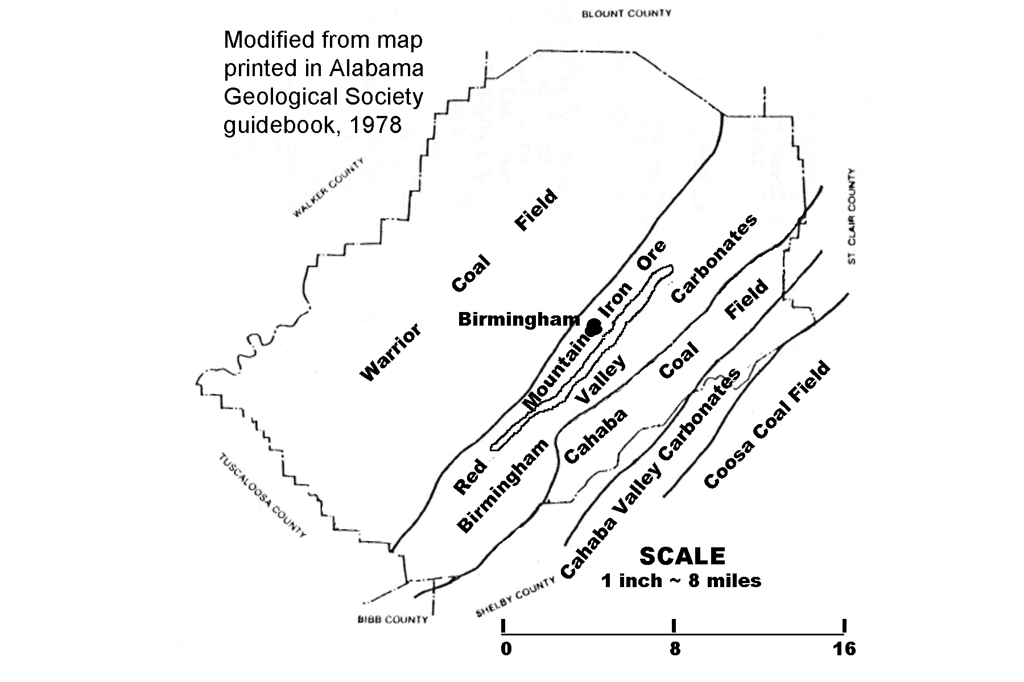
Early iron makers did not think that the red (hematite) iron ores were suitable for iron manufacture, so the Red Mountain ores were not utilized for this purpose until 1840. The thickness of the Red Mountain Formation near Birmingham ranges from 184 ft to 440 ft. (56 to 134 meters). The best ores occur in several large seams that were mostly accessed through surface strip mines, although two underground mines were used for a time. The ore beds are exposed on the west slope of Red Mountain, but continue eastward underground. Rock, soil, and other overburden had to be removed from the mountain in order to reach the buried ores. In 1976, the last iron ore was mined commercially in the Birmingham area. Steel companies discovered it was cheaper to import ore from South America than to mine local deposits. The U. S. Bureau of Mines estimates that this area still contains over 300 million tons (270 metric tons) of recoverable iron ores that would be available if the need arose. Most mining of limestone, dolostone, and coal is also done in open-pit quarries, although a few underground mines do exist near Birmingham. Mining operations for these other resources are still commercially successful because the raw materials are needed not just by the steel mills, but also by a variety of other customers throughout the state, especially railroad companies and the construction industry. Alabama ranks 14th in coal production among coal-producing states.

Figure 5B-2: Annual Tonnage from Mines near Birmingham
(data source: Alabama Department of Industrial Relations,
Office of Safety and Inspection, 1970 – 1976)

YEAR | LIMESTONE and DOLOSTONE | IRON ORE
1976 | 4,511,200 short tons | 0
1975 | 4,694,100 short tons | 42 long tons
1974 | 5,153,800 short tons | 114 long tons
1973 | 4,651,800 short tons | 271 long tons
1972 | 4,509,800 short tons | 327 long tons
1971 | 4,198,400 short tons | 4156 long tons
1970 | 4,786,600 short tons | 1,231 long tons

Although mining was and still is a major industry in the Birmingham area, some issues arose concerning the quality of the available raw materials that increasingly created problems for the local steel mills, especially when compared to the richer and purer resources that were available to northern steel companies. The original iron ores were mined at or near the surface, where weathering processes had leached out many of the impurities and made the ores richer. The deeper ores had not been weathered and therefore contained so much silica that three tons of mined ore had to be pre-processed to make one ton of usable ore. Even then, the amount of slag produced in the furnaces was more than expected, meaning more slag had to be transported off site and dumped. Some of the hematite ore also contained unacceptable levels of phosphorous, an element that had to be removed before the ore could be refined properly.

Even the coal deposits in the vast Warrior Coal Fields had problems. It was high in sulfur, an element that interferes with the combustion process in blast furnaces. Steel mills had to invest in huge ‘washing’ machinery in order to remove as much of the sulfur as possible before burning the coal to make coke. The Warrior coal seams also were inter-bedded with many thin beds of shale, an impurity that generated a lot of ash when the coal was burned. An additional problem for workers in the coal fields was the large amount of explosive methane gas contained in many of the coal seams, making mining extremely dangerous.

The Growth and Decline of a Steel Mill Town

Birmingham was just a collection of small farming communities until the iron and steel mills changed the entire character of the city. In 1876, Levin Goodrich conducted experiments at the Oxmoor Furnaces to demonstrate the feasibility of iron making in Alabama. Four years later, Henry DeBardelaben built two blast furnaces on the west side of Birmingham, but neither of these endeavors produced much iron. In 1881, James Withers Sloss, the son of an Irish farmer and already a successful businessman and railroad executive, founded the Sloss Furnace Company. Two blast furnaces opened in 1882 and began selling iron commercially. James Sloss retired in 1886 and sold his company to Joseph Forney Johnston, future U. S. Senator and Alabama Governor.

A blast furnace is a cylindrical steel vessel, lined with heat-resistant brick. The iron ore, carbonate rock, and coal, or coke, is carried by a conveyor and discharged into the top of the furnace. Super-hot air is then blasted upward from the bottom of the furnace. The blast of hot air burns the fuel, coal or coke, releasing gases that react with the iron ore. The carbonate rock acts as a flux or cleansing agent, removing impurities from the ore. Now, heated to its melting point and freed of most of the impurities, the molten iron collects in the bottom of the furnace, where it is drawn off and poured into molds so it can solidify and cool into the desired shape of the final product. The impurities, known as slag, are also in a molten state, and likewise accumulate at the bottom of the furnace. But because the specific gravity of slag is less than that of iron, the liquid slag accumulates on top of the liquid iron, where it can be drawn off without disturbing the pure iron. In addition to the furnaces, an iron-making plant also consists of many auxiliary machines and structures, including blowers to pump the blast of air; stoves to heat the air; boilers to produce steam to drive equipment, and a network of pipes that carry steam, water, and gas. Also needed are coke ovens to process raw coal into coke.

Figure 5B-3: Diagram of Operation of Blast Furnace

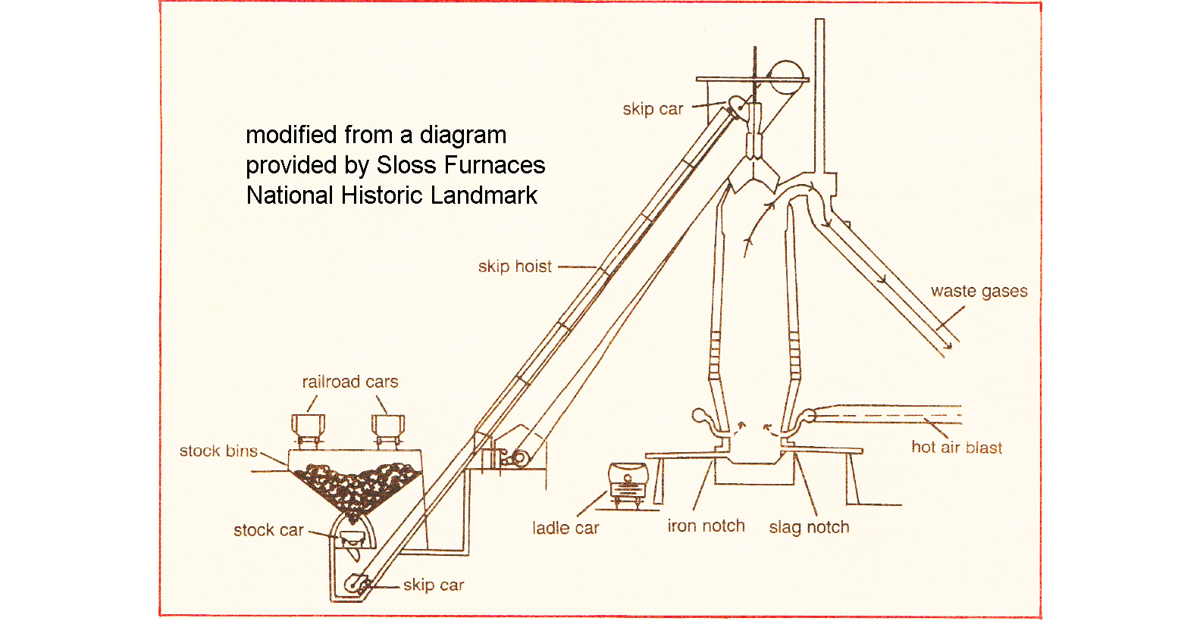

Johnston reorganized the Sloss Furnace Company into the Sloss Iron and Steel Company and rapid growth followed. The company acquired two new furnaces in North Birmingham and purchased extensive tracts of property that would be used to mine coal and iron ore. In 1888, Thomas Seddon took over as President of the company. Under his direction, the Sloss Company bought twelve smaller companies, including iron ore and coal producers, added three more furnaces and became the second largest company in Birmingham. In 1899, the company was re-named the Sloss-Sheffield Steel and Iron Company. During this transition, the furnaces were rebuilt and new structures added.

Big technological changes occurred between 1927 and 1931. The original furnaces were dismantled and completely replaced. Mechanical loading systems were installed at each furnace and the mechanization of other components of the iron-making process was improved. The United States Pipe and Foundry Company bought out the entire Sloss-Sheffield Company and continued to produce pig iron (crude or wrought iron) until 1971 when the company was sold again, to the Jim Walker Corporation, and the original furnace site, at the First Avenue North Viaduct was shut down. Hoping to preserve the historical value of the site, the owners deeded the property to the Alabama State Fair Authority, which announced plans to dismantle the furnaces. But public outcry, the formation of the Sloss Furnace Association, and support from city officials, provided enough interest and money to make preservation a reality. In 1983, the Sloss Furnace National Historic Landmark opened to the public. The iron and steel age finally came to an end in Birmingham in 2002, when the company filed for bankruptcy and its assets were purchased by Nucor Corporation, another steel producer headquartered in Charlotte, NC. Nucor is currently the largest steelmaker in the United States, however they use electric-arc furnaces to melt scrap steel instead of using blast furnaces to melt iron.

The same civic pride that helped preserve the original Sloss furnace site has long been evident in this city. An important symbol of this support is the famous statue of Vulcan, Roman god of fire and of the forge. Built by the city of Birmingham for display at the 1904 St. Louis World’s Fair as an exhibit in the Palace of Mines and Metallurgy, Vulcan was, and probably still is, the world’s largest cast metal statue. After being displayed for years at the state fairgrounds, Vulcan returned to Birmingham in 1937 and was placed on top of Red Mountain, the very place from which his iron body had been mined. The city also hosts Ruffner Mountain Nature Center, both a park and museum, where visitors can learn about the region’s mining history. Iron ore was mined at Ruffner Mountain until the 1950s and the remnants of ore crushers, rail lines, mines and quarries can still be seen here.

The success of the iron industry fueled growth and prosperity in Birmingham for several decades. The city became a thriving railroad center because of all the freight traffic bringing in raw materials and leaving the city with finished iron and steel products. As the city grew, many of the quarries that were originally located outside the city now found themselves within city limits surrounded by commercial centers and residential subdivisions. Three major interstate highways, 20, 59, and 65, converge at Birmingham and handle an ever increasing amount of truck traffic. The Red Mountain Expressway was constructed in the 1970s to connect growing southern suburbs to the city center. The route was originally conceived of as a tunnel under Red Mountain, but that idea proved to be too expensive and instead a huge roadcut was blasted through the mountain, exposing a spectacular sequence of sedimentary rock layers, including a large seam of iron ore. This roadcut was designated a National Natural Landmark in 1987.

Although Birmingham became known as the heavy industry capital of the American South, it never achieved world class status or even the same level of success reached by steel companies in the northern states. With the advent of a more world-wide economy, in which builders could buy steel from anywhere in the world, Birmingham’s production could not remain competitive. When mining local ores ceased to be profitable, the company imported foreign ore for a while, but even that drastic measure could not save the company from bankruptcy.

Although Birmingham thrived for a long time because of the steel-driven economy, several industrially related environmental problems affected the quality of life in the city. The furnaces and coke ovens emitted toxic fumes and great quantities of airborne ash that settled over the city, affecting air quality and dirtying buildings, cars, and roads. In latter years, technological improvements were invented that captured most of the smokestack pollutants, but installing such devices was expensive and contributed to the decline of profitability for the company.

Activity 5B-1: Mining Activities

POWER THINKING EXERCISE - "Quarry Quandry"
You are the owner of the Village Park Limestone Quarry located in North Birmingham at the intersection of 22nd Avenue North and 24th Street North, right next to Village Creek. When your grandfather started this quarry almost a hundred years ago, the quarry was surrounded by farmland. Now, the city has expanded all around you and several business interests have approached you about buying the quarry land from you, filling it in, and constructing a major shopping center. Your quarry has always made a modest profit, but the developers have offered you a lot of money for your land. You need to study many factors and consider several alternatives before giving the developers your final answer
You must first locate your quarry on the Birmingham topographic map on MAP 5B, BIRMINGHAM (in the left-center portion of the map). Also use the map information to locate your quarry on the false-color air-photo mosaic on IMAGE 5B, BIRMINGHAM (the area marked in black is the quarry). Study carefully the current land use in the vicinity of your quarry. Are there ways that the current land use helps your business? Make a list of these items. Also make a separate list of ways the current land use might be causing difficulties for your business. Note that there is plenty of limestone in the Birmingham Valley and if you choose, you could purchase other land far away from the city and start another quarry. Once you make your final decision, be prepared to defend your reasoning.

Materials
MAP 5B, BIRMINGHAM
IMAGE 5B, BIRMINGHAM
SE MAPS Transparent Plastic Grid
Story, “Joe Magarac”
Figure 5B-1, “Location of Mineral Resources Around Birmingham.”
Figure 5B-2, “Annual Tonnage from Mines near Birmingham”
Figure 5B-3, “Diagram of Operation of Blast Furnace”
Wipe-off Pens

PERFORMANCE TASKS
(Icon Key) Overview = ; Science = ; Math = ; History = ; Language Arts =

1. Locate quarries in Birmingham area.
Locate every quarry you can find on the topographic map, MAP 5B, BIRMINGHAM. Refer to the table of Topographic Map Symbols in SE MAPS Chapter 2 (Figure 2-2) or other source if you do not remember the standard symbol for strip mines. Circle the location of each quarry with a wipe-off pen. Also locate these same quarries on the false-color air-photo mosaic on IMAGE 5B, BIRMINGHAM, and circle them too. The map was photo-revised in the 1970s, the air photo is from 1988. Are any of the mines you marked on the map not visible on the air photo? If so, propose an explanation for what happened to them. Compare your marked map with the Jefferson County geologic map in Figure 5B-1, “Location of Mineral Resources Around Birmingham”. Make an informed guess as to which mines are producing iron ore (use a wipe-off pen to label these mines with the letter ‘I’); which mines are producing limestone (use a wipe-off pen to label these mines with the letter ‘L’); and which mines are producing coal (use a wipe-off pen to label these mines with the letter ‘C’).

2. Estimate dip angle of Red Mountain Formation.
Locate Red Mountain on the topographic map on MAP 5B, BIRMINGHAM (runs diagonally from southwest to northeast through the center of the map). Locate the three specific locations listed in the chart below and use contour line information to determine the elevation (in feet) of the highest point on Red Mountain at each site. Also calculate the slope of the mountain, both for the northwestern and southeastern side, at each site. [Slope is calculated by subtracting 800 feet from the highest elevation and then dividing the result by the linear distance (in feet) (use map scale to measure) from the top of the mountain to the closest location along the 800 foot contour line.] Express the number calculated for each slope as a percentage.
LOCATION #1 = Brooke Hill School [between Forest Park and Mountain Brook]
LOCATION #2 = TV towers (WBRC/WAPI) [16th Avenue S & 15th Street South]
LOCATION #3 = Between letters ‘D’ and ‘E’ [“RED MT” at far-left map edge]

LOCATION  NUMBER | HIGHEST ELEVATION | NW LINEAR DISTANCE | SE LINEAR DISTANCE | NW SLOPE  % | SE SLOPE  %
1
2
3

Which side of Red Mountain is steeper, northwest or southeast? For most mountains in the Valley and Ridge region, the more gentle slope side correlates with the dip angle of the rock layer that holds up the ridge, in this case the Red Mountain Formation. Therefore you should conclude that the resistant layer of iron ore dips under the ground surface on which side of Red Mountain?

3. Estimate surface area of strip mine.
Locate the irregularly shaped strip mine (a coal mine) in the extreme upper-left corner of the topographic map on MAP 5B, BIRMINGHAM. If the strip mine area formed a regular geometric shape (square, triangle, or circle), we could use a mathematical formula to calculate the surface area (for example, the area of a triangle is ½ the length of the base multiplied by the height of the triangle). Because the shape is irregular, the best we can do is to estimate the approximate surface area. Use the SE MAPS TRANSPARENT PLASTIC GRID and place the corner of the grid that has the small squares over the location of the quarry on MAP 5B. Make sure that the entire quarry area is covered by the small grid squares. Count the number of small squares that cover the area of the quarry. If over half of the square covers the quarry, count it. If less than half of the square covers the quarry, don’t count it. Note that the verbal scale of MAP 5A is 1 inch = 2,000 feet. First calculate the area (in square feet) represented by one small square on the grid. Then multiply that area by the number of squares you counted to get the estimated surface area of the mine.
4. Explain effect of economic pressures on mining operations.
Study the chart showing average yearly output of local iron ore and limestone mines (Figure 5B-2, “Annual Tonnage from Mines near Birmingham”). Note that iron and steel production in the city did not stop until 2002 when the blast furnaces were shut down for the last time. How was the factory able to continue to make steel for another twenty-six years after the last Alabama iron ore mine shut down in 1976? Note that the limestone output of the local mines held steady during this same time period. Explain how limestone quarries were able to remain economically profitable whereas the iron ore mines could not compete successfully?

5. Add another verse to Joe Magarac ballad.
Read the story ballad, “Joe Magarac,” on page 5-6. Also reference the operational diagram in Figure 5B-3, “Diagram of Operation of Blast Furnace.” Use objects or items mentioned in Figure 5B-3 to add realism to a new verse that your group will write. Use the same poetic style and meter for your new verse as is used in the original verses. Each group should either read or sing their new verse to the class. Did any of the verses that were presented use the same blast-furnace references? Are there certain items or procedures mentioned in the diagram that are more interesting to use in a story or ballad? If so, which ones?

ENRICHMENT
(Icon Key) Overview = ; Science = ; Math = ; History = ; Language Arts =

1. Compare benefits and drawbacks of quarries vs subsurface mines.
Although most of the mining operations visible on the topographic map on MAP 5B, BIRMINGHAM are surface mines (strip mines or quarries), some iron ore, limestone, and coal in this area has been obtained from underground mines as well. Use your local library resources or the internet to research the benefits and drawbacks of each type of mine and the conditions under which each method is preferred. Then go back to MAP 5B and identify one location at which you think an underground mine would be the better choice.

2. Debate importance of maintaining domestic steel industry.
Over the last twenty years, imported steel has become widely available and is usually cheaper than steel produced domestically in the United States. Our steel industry, not just in Birmingham, but in northern states as well, has fallen on hard economic times. More and more businesses and industries are importing not just raw steel, but also basic fabricated steel products, such as sheet and tube steel, from other countries. Divide your class into groups. Assign half the groups to ‘policy position 1’ and the other half to ‘policy position 2’. Have each group research their position and present its findings to the class. Then vote to see which policy position has the most support.
POLICY POSITION #1 = “Using cheaper imported steel lowers prices on many
goods and allows the consumer to purchase more and stimulate the economy.”
POLICY POSITION #2 = “Imported steel puts our companies out of business and
our workers out of jobs. If supplies should be cut off, we would be out of luck.”
Activity 5B-2: Growth and Decline of a Steel Mill Town

POWER THINKING EXERCISE - "Preservation Predicament"
You are on the Birmingham City Council in 1971 when the original Sloss Furnaces site was shut down for the last time and the property was deeded to the Alabama State Fair Authority. The Fair Authority has presented a plan to the Council to dismantle all the buildings on the Sloss site and build a community center and green space park area for local residents to use. Other groups have made an alternate presentation; to preserve the original buildings and equipment as a historical landmark, build a visitor center, and attract lots of tourists to the site.
Both presentations seem like good ideas and good uses of the property, but obviously the Council cannot approve both. Locate the Sloss Furnace site on IMAGE 5B, BIRMINGHAM and study the different land uses that currently surround the site. Make a list of pros and cons for each land-use plan for the property, and then write a brief narrative to City Council explaining how you will vote, and why.

Materials
IMAGE 5B, BIRMINGHAM
MAP 4b, BIRMINGHAM
Newspaper article, “Vulcan Statue, Often the Butt of Jokes, is Well-Loved”
Wipe-off Pens

PERFORMANCE TASKS
(Icon Key) Overview = ; Science = ; Math = ; History = ; Language Arts =

1. Locate landmarks and mining sites connected with steel industry.
The Sloss Furnace site is probably the most significant landmark in the city of Birmingham. Use the boxed inset photo on IMAGE 5B, BIRMINGHAM to help you locate the Sloss site on the aerial photo mosaic and also on the topographic map on MAP 5B, BIRMINGHAM. Why do you think there are so many railroad tracks in and around this site? The most well-known landmark, however, is probably the statue of Vulcan that sits atop Red Mountain. Trace the path of Red Mountain until it crosses the exact center of the map. Just below the mountain is the community of ‘English Village’. Move about two inches to your left and you will see a black square marked “statue”. That is the location of the Vulcan statue. Survey the entire area of MAP 5B and list any locations from which residents would NOT be able to see the statue.

2. Interpret details on false-color infrared image.
Examine the false-color infrared aerial photo mosaic on IMAGE 5B, BIRMINGHAM. Review the basics of the infrared photo color shift and its interpretation in Chapter 2 if you need to reference this information. Locate the following places on both IMAGE 5B and MAP 5B, BIRMINGHAM, then use your color-interpretation skills to answer the following questions.
- Why does Red Mountain show up in mostly red colors on the photos?
Explain your answer:
- Why does downtown (near Sloss site) show up in mostly blue-gray colors?
Explain your answer:
- During what part of the year (summer or winter) were these photos taken?
Explain your answer:
- Is Birmingham Municipal Airport’s main runway made of concrete or asphalt?
Explain your answer

3. Examine ordered-pair street naming system and locate origin.
Locate the Sloss Furnaces site on MAP 5B, BIRMINGHAM (use inset photo on IMAGE 5B, BIRMINGHAM to help you locate the site). Notice that the main street bordering the site to the northwest is named “1st Ave N”. Continuing in that same direction we come to “2nd Ave N”, “3rd Ave N”, etc. [note that not every street is labeled on the map]. Also notice that the first main street bordering the site to the southeast is named “1st Ave S”. Continuing in that same direction we come to “2nd Ave S”, “3rd Ave S”, etc. [again, not every street is labeled on the map]. Based on graphing principles, there should be a “Zero Avenue” somewhere between the two main streets (“1st Ave N” and “1st Ave S”). Does a “Zero Avenue” exist? What map feature is visible in the area in which you might expect to find a “Zero Avenue?” Does this make sense to you? Explain your answer.

Now examine the streets running in the other direction (northwest to southeast). The street bordering the Sloss site to the northeast is named “32nd Street N”. If you follow that street in a southeasterly direction you will see the label “32nd Street S”. Examine some of the other streets running in this same direction. Note that the street numbers get higher as you move towards the northeast and get lower as you move towards the southwest. Again, based on graphing principles, there should be a “Zero Street” somewhere on this map. Follow the decreasing street-name numbers until you reach the place at which you would expect to find a “Zero Street” [again, not every street is labeled on the map]. Does a “Zero Street” exist? If so, does it have a name?

Use a wipe-off pen to mark, as closely as you can, the origin point for the street naming system of Birmingham. Why do all the streets not line up perfectly with the grid (some are angled differently, and some streets are missing in some places)?

4. Investigate highway and railroad patterns .
Use a wipe-off pen to trace the routes of all interstate highways, and other limited-access divided highways, that are visible on MAP 5B, BIRMINGHAM. Include any highways shown as being “under construction”. With a different color wipe-off pen, trace the routes of all railroad lines visible on MAP 5B. You have just traced the pattern of transportation associated with Birmingham. The term “hub city” gets its name from the pattern seen in a wagon wheel where various spokes of the wheel all come together at the center, or ‘hub’. Does Birmingham fit this ‘hub’ pattern? Explain your answer.

5. Analyze interest level of newspaper article.
Read the newspaper article, “Vulcan Statue, Often the Butt of Jokes, is Well-Loved”, on page 5B-1. Note that the Newspaper this article appeared in was the “Los Angeles Times”. Why would a newspaper in Los Angeles, California, want to print an article about a statue in Birmingham, Alabama? What part of the article did you find most interesting? What part of the article did you find least interesting? Is writing an article for a newspaper different from writing a report for school? Explain your reasoning. How important is the wording of the title in getting you to read an article in a newspaper or magazine? Did you notice anything in the title of this article that made you want to read more?

ENRICHMENT
(Icon Key) Overview = ; Science = ; Math = ; History = ; Language Arts =

1. Take virtual tour of Sloss Furnaces National Historic Landmark.
Although the black & white photo insert on IMAGE 5B, BIRMINGHAM shows the buildings at the Sloss Furnaces site, a much better (clearer and closer-up) view can be obtained using the Google EarthTM computer app. Using a computer that has Google EarthTM downloaded, zoom in on the Sloss Furnaces site. Also access the “Virtual Tour” on the Sloss Furnaces official website, <https://www.slossfurnaces.com/virtual-tour/>.

2. Identify famous statues located in your city or region.
Birmingham has its Vulcan Statue, New York City has its Statue of Liberty, the City of Philadelphia, PA has a statue of its founder, William Penn, on top of its City Hall. Use local library resources or the internet to identify any famous statues that are located in your city or region. Pick one of these and write a brief report on why that statue was erected and the person or event that it was intended to memorialize.

