Image Registration

Anshul Chowdhary
Department of Electrical & Computer Engineering
Clemson University
Clemson, SC 29631

Abstract
Image registration is the process of overlaying images of the same scene taken at different times, from different viewpoints, and/or by different sensors. In other words it is a process of finding a transformation that aligns one image to another. This report aims at presenting a comparative review of all the significant classical and modern image registration methods. The paper describes the four steps of registration process (feature detection, feature matching, mapping function design, and image transformation and re-sampling.) and nature of registration method (area based and feature –based).The report also discusses the pros and cons of all the image registration methods.

1. Introduction
Image registration (also known as image fusion, super-imposition or matching) is a fundamental task in image processing. It is used to match two or more pictures taken, for example from different source, different sensors or from different viewpoints. Virtually all large image analysis systems which evaluate images use image registration techniques as the intermediate step.

Problem: Due to the diversity of images to be registered and due to various type of degradations it is impossible to design a universal method applicable to all registration tasks. This is one of the most fundamental issues underlying the design of image analysis.
Goal & Effort: Every method has its pros and cons. Hence it is very important to find the best method or the best possible combination of methods to a registration task. I studied the various techniques and methods of image registration in depth and in this paper I describe them, their pros and cons, and their best possible application.

The first step is to find a correspondence between pixels in the source image with the pixels in the target image. More precisely the goal of image registration is to fine a correspondence function or mappingthat takes each spatial coordinate and returns a coordinate for source image. Now we have
Once the Transformation function is obtained, the source image may be brought in to registration with the target image by warping the source using interpolation as shown in the figure 1.

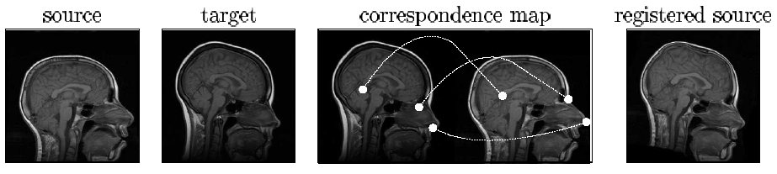
Fig 1: The goal of registration is to find corresponding points between source and target images. Column 3 shows the corresponding points in the eye, nose and corpus colossus region. In the last figure shows the registered source, obtained by warping the source image by correspondence map.

Next section of this paper describes the image registration methodology. It describes the four basic steps of image registration methodology viz. a) Feature Detection b) Feature matching c) Transfer modal estimation d) Image re-sampling and transformation. Third section of this paper describes application of image registration. Then in the Fourth section evaluation of the image registration accuracy is described and compared with different methods.

2. Image Registration Methodology
Due to the diversity of images to be registered and due to various type of degradations it is impossible to design a universal method applicable to all registration tasks. Every method should take into account not only the assumed type of geometric deformation between the images but also radiometric deformations and noise corruption, required registration accuracy and application dependant data characteristics.

Nevertheless Majority of the registration methods consists of the flowing four steps Fig 3.
- Feature detection: Salient and distinctive objects (closed boundary regions, edges, contours, line-intersection, corners etc.) are manually or preferably automatically detected.
- Feature matching: In this step, the correspondence between the features detected in the sensed image and those detected in the reference image is established.
- Transform model estimation: The type and parameters of the so-called mapping functions, aligning the sensed image with the reference image, are estimated.
- Image re-sampling and transformation: The sensed image is transformed by means of the mapping functions. Image values in non-integer coordinates are computed by the appropriate interpolation technique.

Fig 3 shows the steps described above
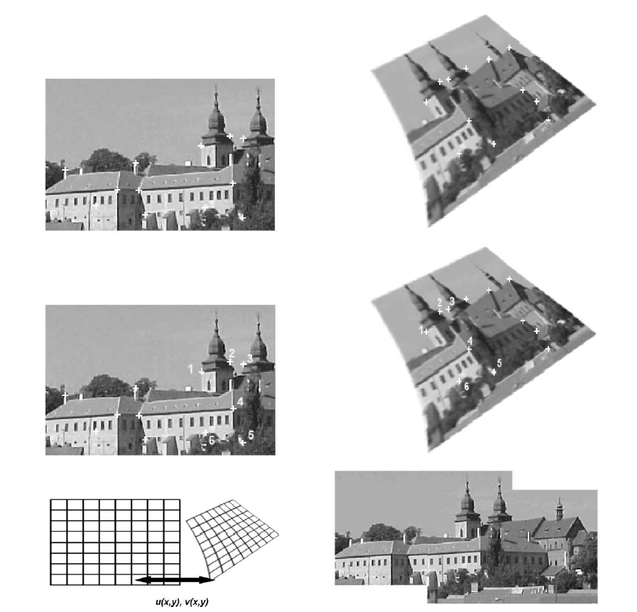

Fig.3. Four steps of image registration: Top row—feature detection (corners were used as the features in this case). Middle row—feature matching by invariant descriptors (the corresponding pairs are marked by numbers). Bottoms left—transform model estimation exploiting the established correspondence. Bottom right: - image resampling and transformation.

The implementation of each registration step has its typical problems. First, we have to decide what kind of features is appropriate for the given task. The features should be distinctive objects, which are frequently spread over the images and which are easily detectable. Usually, the physical interpretability of the features is demanded. The detected feature sets in the reference and sensed images must have enough common elements. The detection methods should have good localization accuracy and should not be sensitive to the assumed image degradation. In the feature matching step, problems caused by incorrect feature detection or by image degradation arises. Physically corresponding features can be different due to different imagine condition and/or due to different spectral sensitivity of the sensors. The choice of feature description and similarity measure has to consider these factors. The feature descriptor should be invariant to the assumed degradation and simultaneously they have to be distrainable enough to be distinguished among different features. The matching algorithm should be robust and efficient. The type of mapping functions should be chosen according to the priori knowledge about the acquisition process and expected image degradation. If no priori information is available, the model should be flexible and general enough to handle all possible degradation which might appear. Finally, the choice of the appropriate type of resampling technique depends upon the trade- off between the demanded accuracy of the interpolation and the computational complexity.

Below each of the four phases are described in detail
1. Feature Detection
This approach is based on the extraction of salient features /structures in the image. Significant regions, lines or points are considered.
1.1 Region features:
The region-like features can be projections of general high contrast closed-boundary regions of an appropriate size like water reservoirs, lakes, and buildings. The regions are often represented by their centers of gravity, which are invariant with respect to rotation, scaling, and skewing and stable under random noise and gray level variation. Region features are detected by means of segmentation methods. The accuracy of the segmentation significantly influences the resulting registration.
1.2 Line features:
The line features can be the representations of general line segments, object contours, coastal lines, roads or elongated anatomic structures in medical imaging. Standard edge detection methods, like Canny-edge detector or a detector based on the Laplacian of Gaussian, are employed for the line feature detection.
1.3 Point features:
The point features group consists of line intersections; road crossings etc which are detected using the Gabor wavelets, inflection points of curves.

2. Feature Matching
In the following section two major categories, Area based and Feature based methods, are further classified into subcategories according to different methods and advantage and disadvantage.
2.1 Area based methods
These methods deal with the images without attempting to detect salient features. Windows of predefined size or the entire image are used for the correspondence estimation. Area-based methods are preferably applied when the images have not many prominent details and the distinctive information is provided by gray levels/colors rather than by local shapes and structure. From the geometric point of view, only shift and small rotation between the images are allowed when using area based methods. To speed up the searching, area-based methods often employ pyramidal image representations and sophisticated optimization algorithms.
The limitations of the area-based methods originate in their basic idea. Firstly, the rectangular window, which is most often used, suits the registration of images which locally differ only by a translation. If images are deformed by more complex transformations, this type of the window is not able to cover the same parts of the scene in the reference and sensed images. Classical area-based methods like cross-correlation (CC) exploit for matching directly image intensities, without any structural analysis. Consequently, they are sensitive to the intensity changes, introduced for instance by noise, varying illumination, and/or by using different sensor types.
2.1.1 Correlation like methods
The classical representative of the area-based methods is the normalized CC and its modifications described by W.K Pratt (Ref Paper 1)

This measure of similarity is computed for window pairs from the sensed and reference images and its maximum is searched. The window pairs for which the maximum is achieved are set as the corresponding ones (Fig. 4). If the sub pixel accuracy of the registration is demanded, the interpolation of the CC measure values needs to be used. Although the CC based registration can exactly align mutually translated images only, it can also be successfully applied when slight rotation and scaling are present.

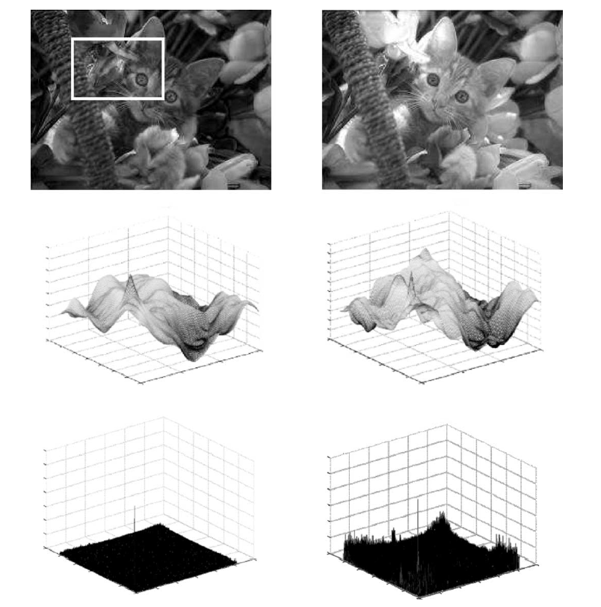

Figure4. Area-based matching methods: registration of small template to the whole image using normalized cross-correlation (middle row) and phase correlation (bottom row). The maxima identify the matching positions. The template is of the same spectral band as the reference image and of different spectral band. Graphs represent channel matching.
Advantages and Disadvantages of CC like methods:
Two main drawbacks of the correlation-like methods are the flatness of the similarity measure maxima and high computational complexity but they are still often in use, particularly because of their easy hardware implementation, which makes them useful for real-time applications.
2.1.2 Fourier method:
If an acceleration of the computational speed is needed or if the images were acquired under varying conditions or they are corrupted by frequency-dependent noise, then Fourier methods are preferred rather than the correlation like methods.
2.1.3 Mutual information method
They are the leading technique in multimodal registration. Registration of multimodal images is a difficult task, but often necessary to solve, especially medical imaging. The comparison of anatomical and functional images of the patient’s body can lead to a diagnosis, which would be impossible to gain otherwise. The MI, originating from the information theory, is a measure of statistical dependency between two data sets and is particularly suitable for registration of images from different modalities. The method is based on the maximization of MI (Fig. 5). MI was maximized using the gradient descent optimization method.

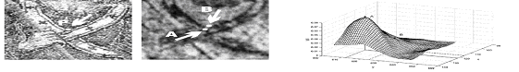

Figure5. MI criterion is computed in the neighborhood of point P between new and old photographs of the mosaic. Maximum of MI shows the correct matching position (point A). Point B indicates the false matching position selected previously by the human operator. The mistake was caused by poor image quality and by complex nature of the image degradations.

2.2 Feature based methods
We assume that two sets of features in the reference and sensed images. Feature-based matching methods are typically applied when the local structural information is more significant than the information carried by the image intensities. They can handle complex between-image distortions. The aim is to find the pair wise correspondence between them using their spatial relations or various descriptors of features as follows:
2.2.1 Method using spatial relations
This method is applied if detected features are ambiguous or if their neighborhoods are locally distorted. For every pair of CP’s from both the reference and sensed images, the parameters of the transformation which maps the points on each other are computed and represented as a point in the space of transform parameters. The parameters of transformations that closely map the highest number of features tend to form a cluster, while mismatches fill the parameter space randomly.
2.2.2 Method using invariant descriptor
Here the correspondence of features can be estimated using their description, invariant to the expected image deformation. The description should fulfill several conditions like invariance, uniqueness, stability, and independence. However, usually not all these conditions have to be satisfied simultaneously and it is necessary to find an appropriate trade-off.
2.2.3 Relaxation method
A large group of the registration methods is based on the relaxation approach, as one of the solutions to the consistent labeling problem (CLP): to label each feature from the sensed image with the label of a feature from the reference image, so it is consistent with the labeling given to the other feature pairs. The process of recalculating the pair figures of merit, considering the match quality of the feature pairs and of matching their neighbors, is iteratively repeated until a stable situation is reached.

The common drawback of the feature-based methods is that the respective features can be hard to detect or unstable in time. The crucial point of all feature-based matching methods is to have discriminative and robust feature descriptors that are invariant to all assumed differences between the images.

3. Transform model estimation
After the feature correspondence has been established the mapping function is constructed. It should transform the sensed image to overlay it over the reference one. The corresponding CP pairs should be as close as possible after the sensed image transformation is employed in the mapping function design. The task to be solved consists of choosing the type of the mapping function and its parameter estimation. The type of the mapping function should correspond to the assumed geometric deformation of the sensed image, to the method of image acquisition (e.g. scanner dependent distortions and errors) and to the required accuracy of the registration.

3.1 Global Mapping Model
One of the most frequently used global models uses bivariate polynomials of low degrees. Similarity transform is the simplest model—it consists of rotation, translation and scaling only

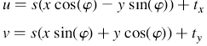
This model is often called ‘shape-preserving mapping’ because it preserves angles and curvatures and is unambiguously determined by two CP’s.
3.2 Local Mapping Modal
However, a global polynomial mapping cannot properly handle images deformed locally. This happens, for instance, in medical imaging and in airborne imaging. The least square technique averages out the local geometric distortion equally over the entire image which is not desirable. Local areas of the image should be registered with the available information about the local geometric distortion in mind.
3.3 Elastic registration
Another approach to the registration of images with considerable complex local distortions is not to use any parametric mapping functions, where the estimation of the geometric deformation is reduced to the search for the ‘best’ parameters. This idea called elastic registration. The images are viewed as pieces of a rubber sheet, on which external forces stretching the image and internal forces defined by stiffness or smoothness constraints are applied to bring them into alignment with the minimal amount of bending and stretching. The feature matching and mapping function design steps of the registration are done simultaneously. This is one of the advantages of elastic methods. Disadvantage of elastic registration is in situations when image deformations are much localized. This can be handled by means of fluid registration. Fluid registration methods make use of the viscous fluid model to control the image transformation. The reference image is here modeled as thick fluid that flows out to match the sensed image under the control of the derivative of a Gaussian sensor model. This approach is mainly used in medical applications. The weakness of this approach is blurring introduced during the registration process.

4. Image resampling and transformation
The mapping functions constructed during the previous step are used to transform the sensed image and thus to register the images. The transformation can be realized in a forward or backward manner. Each pixel from the sensed image can be directly transformed using the estimated mapping functions. This approach, called a forward method, is complicated to implement, as it can produce holes and/or overlaps in the output image (due to the discretization and rounding). Hence, the backward approach is usually chosen. The registered image data from the sensed image are determined using the coordinates of the target pixel and the inverse of the estimated mapping function. The image interpolation takes place in the sensed image on the regular grid. In this way neither holes nor overlaps can occur in the output image.

Application:
Registration is required in a many fields such as remote sensing, Multi-spectral classification, environmental monitoring, image moseying, weather forecasting, creating super resolution images, integrating information in to geographical information system (GIS). In medical image analysis, to study tumor, in functional magnetic resonance imaging many magnetic resonance (MR) images are taken of the brain in quick succession and need to be registered to a high resolution anatomic images which in turn registered with an atlas image. Other application includes labeling and segmentation. In computer vision, target localization, automatic quality control, shape reconstruction, motion tracking, stereo mapping, character recognition etc.

Evaluation of Image registration accuracy
Estimation of accuracy of registration algorithms is a substantial part of registration process. Without quantitative evaluation, no registration method can be accepted for practical utilization. In this Section, we review basic error classes and methods for measuring the registration accuracy.
Localization error
Displacement of the CP coordinates due to their inaccurate detection is called localization error. Localization error can be reduced by selecting an ‘optimal’ feature detection algorithm for the given data but usually there is a tradeoff between the number of detected CP candidates and the mean localization error. Sometimes we prefer to have more CP with higher localization error rather than only few of them, yet detected more precisely.
Matching error
Matching error is measured by the number of false matches when establishing the correspondence between CP candidates. It is a serious mistake which usually leads to failure of the registration process and should be avoided. Fortunately, in most cases it can be ensured by robust matching algorithms. False match can be identified by consistency check.
Alignment error
By the term alignment error we denote the difference between the mapping model used for the registration and the actual between-image geometric distortion. Alignment error can be evaluated in several ways. The simplest measure is a mean square error at the CP’s (CPE). Although commonly used, it is not good alignment error measure. In fact, it only quantifies how well the CP coordinates can be fitted by the chosen mapping model.

Conclusion
It’s been shown that Image registration is one of the most important tasks when integrating and analyzing information from various sources. It is a key stage in image fusion, change detection, super-resolution imaging, and in building image information systems, among others. This report gives describes classical and up-to-date registration methods, classifying them according to their nature as well as according to the four major registration steps. Here I have described pros and cons of all the methods and how can they be integrated to generate the optimal solution for a particular application.
Future Work:
Although a lot of work has been done, automatic image registration still remains an open problem. Registration of images with complex nonlinear and local distortions, multimodal registration, and registration of N-D images (where N >2) belong to the most challenging tasks at this moment.

References
1. W.K. Pratt, Correlation techniques of image registration, IEEE Transactions on Aerospace and Electronic Systems 10 (1974)
2. B Reddy, B.N Chatterji, An FFT based technique for translation, Rotation and scale –Invariant Image Registration. IEEE transaction Aug, 1998
3. P. Viola, W.M. Wells, Alignment by maximization of mutual information, International Journal of Computer Vision 24 (1997)
4. A. Goshtasby, G.C. Stockman, Point pattern matching using convex hull edges, IEEE Transactions on Systems, Man and Cybernetics 1985.
5. R.Bajcsy, S. Kovacic, Multi resolution elastic matching, Computer Vision, Graphics and Image Processing 46 (1989).

