Facial Feature Detection and Gaze Tracking

Sameer Bhide, Arjun Seshadri, and Brian Williams
Clemson University, ECE 847

Abstract.

In this paper, we examine a robust, fast,a nd cheap scheme for locating facial features and tracking the gaze of a human eye. Many other eye-tracking and gaze-tracking methods have been presented earlier, but these methods are not both robust and fast. The method proposed uses complete graph matching from thresholded images for facial feature identification, and Longest Line Scanning and Occluded Circular Edge Matching techniques for eye tracking.

I. Introduction.

Many algorithms exist in digital image processing to identify points of interest (or feature points) on an object and track them. However facial feature detection and gaze tracking are not common point-tracking problems. The implications of the solutions of such problems are far reaching, and could provide valuable assistance to the handicapped, teachers, for gaming, and to psychological and robotic research.

Gaze detection allows a computer to not only know where a person is in a given environment, but to also know what that person is presently interested in or concerned with. Successful implementation of facial feature detection and gaze tracking will yield very few ultimate constraints, such as when a subject’s eyes are closed or when the subject turns away from the camera. There are also implications reaching into AI. As might be the case with research towards psychology, a computer could be programmed to consider why a subject is looking in a certain direction. Finally it is not unthinkable that accurate gaze detection could be used as a control device for computers, quickly replacing the mouse and keyboard.

II. Facial Feature Detection.

Before considering the image of the human face, it is important to first consider the background of the image. If the background is cluttered or noisy, we may find that our detection algorithm will run into trouble. So let us consider an image with an unobtrusive and uncluttered background, such as the image below.

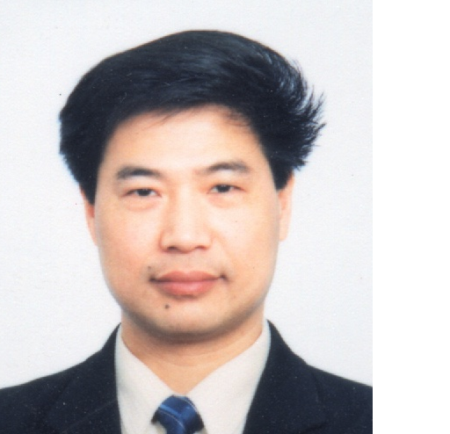Chen

Now that we have an appropriate image for detection, we can begin attempting to first identify the subject’s eyes. We perform a thresholding algorithm to achieve the image below.
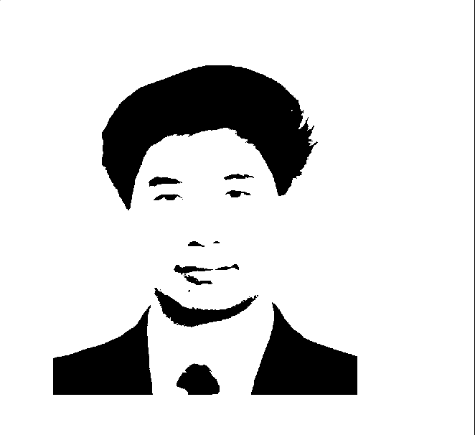
We now have a binary image of blocks which are candidates for eyes.

The first algorithm used to rule out obvious false candidates is concerned with the size of the blocks. We know to some extent that the length and width of the eye blocks will be within some given range. So we consider each block, and rule out those which fall outside of this range. (Obviously Chen’s hair will be ruled out, along with his suit and chin.)

We then look at the ratio of horizontal and vertical distances contained in the blocks. Assuming that the subject’s head is not significantly tilted to one side, the ratio of vertical length to horizontal length will be less than one. The two aforementioned conditions must be fulfilled for blocks to still be considered candidates.

We then want to consider employing graph matching to find the two blocks which are most similar to each other. These will be our final candidates.

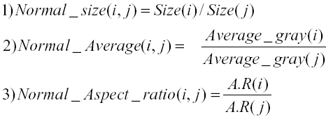
The aforementioned equations come from (1). Normal_size refers to the ratio of the areas of two blocks (area being the number of pixels. Normal_average refers to the similarity between two blocks in the original image. (We use the block in the binary image to reference pixels in the original image, then look at their gray scale value.) Normal_Aspect_Ratio is the ratio between the vertical/horizontal ratios (as mentioned before) of each block. Once we have compared all the remaining blocks, the two blocks whose sum of these three variables is closest to three will be our final eye candidates. We then have identified the eyes.

The nose and mouth are found based on geometry. We define a region below the eyes to search for the nostrils and lip corners. If our thresholding algorithm is good enough, then we find the two nostrils easily by searching for the candidate blocks which are first to spring up below the eyes.

After the nostrils are found, we locate the corners of the mouth as maximum and minimum horizontal pixels from the candidate block.

III. Gaze Tracking.

To study gaze tracking, we set up an experiment such that a subject was asked to look at a grid of 9 boxes (a 3x3 grid, approximately 2 feet in length and width). With the camera focused solely on the subject’s eye, we shot calibration frames of the subject looking at each portion of the grid.

To identify the subject’s IRIS, we first employ an edge detection algorithm by way of a Canny filter. (A Sobel filter was tried as well.) We then approximate the iris by fitting as best we can a circle to it. However to approximate a subject’s gaze we must find the center of the iris. We utilize two algorithms presented in (2) to do this. The first is called Longest Line Scanning (LLS).

IV Longest Line Scanning (LLS).

LLS is a algorithm based on the following useful property: the center of an ellipse lies on the center of the longest horizontal line inside the boundary of the ellipse. Though we do fit a circle to the iris, it will appear as an ellipse in the image if the subject is not looking directly into the camera. So we simply scan the iris from top to bottom, each time plotting a horizontal line between the edges. The longest line found will give us a candidate for the center of the iris. See Figure 1. below.

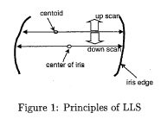

We take the candidate center from the LLS algorithm, and use it as an input to our next algorithm, Occluded Circular Edge Matching.

V. Occluded Circular Edge Matching (OCEM).

Unfortunately, the LLS algorithm may not be ideal due to the presence of eyelids. The longest line may actually be hidden by the subject’s eyelids. Although the LLS method detects the center of the iris, the following problems arise: intra-iris noise and rough iris edge. Obviously, if the edge of the iris is noisy, the horizontal line drawn in LLS will not be easily defined.

OCEM takes both the candidate center of the iris and the edge image as inputs, and approximates the shape of the iris with a circle. The center of that circle is our chosen center for the iris.

VI. Results

Our results for facial feature tracking were satisfactory in finding the eyes, however there exist caveats. As previously mentioned, the background needs to be uncluttered, or other candidate blocks will appear. Secondly, everything depends on the thresholding level. We ended having to choose the thresholding value based on the image itself. We were unsuccessful in creating an algorithm that would itself calculate the needed threshold value.

Our code worked more on faces of persons of Asian descent. We attribute this to the fact that the distance between the eyes and eyebrows in Asians is significantly larger than in non-Asians, i.e. images of non-Asians had eyebrows and eyes detected as the same block.
Below is the image of Chen that was output from our code.
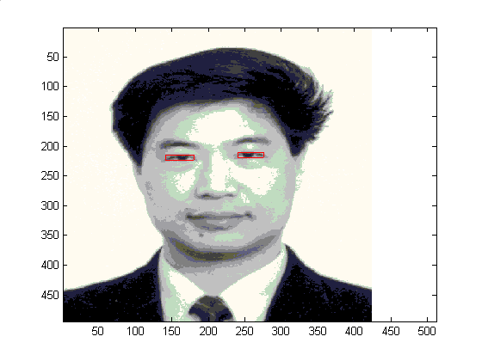
As can be seen above, our code successfully detected the eyes. We did not feel the need to extend this to finding the nostrils and mouth (though this would not be a difficult task, as the geometry of faces is common).

Below are the calibration images we used in study of gaze tracking.

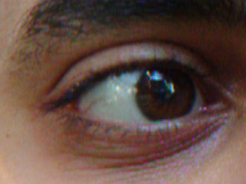
(Bottom left of grid)

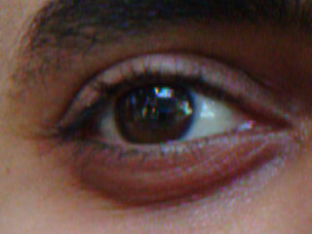
(Bottom right of grid)

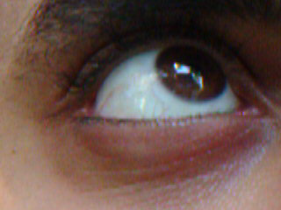
(Top left of grid)

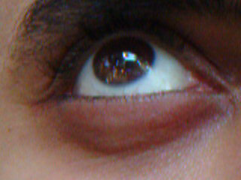
(Top right of grid)

The corresponding output images with iris center and circular approximation are seen to the right.
(Note the output images are displayed more largely so that our approximations can be more easily seen.)
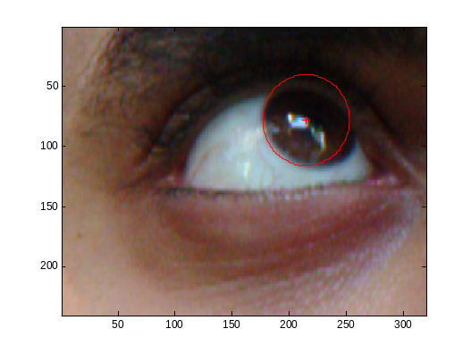
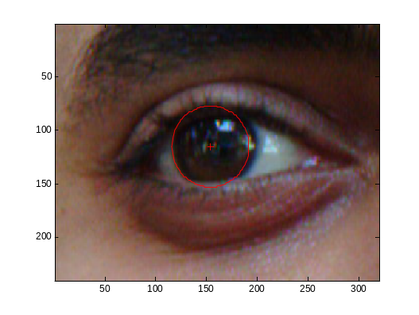
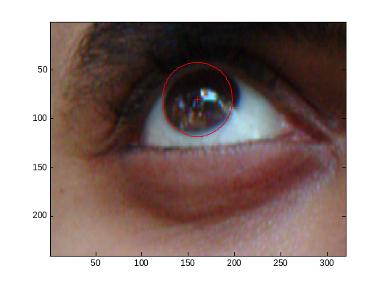

As can be seen on the previous page, our approximation is fairly accurate, even in cases where the iris is partially occluded by the eyelids.

VII. Conclusions.

The authors of (2) proposed a real-time facial feature and eye gaze tracking system. Our code did not run fast enough to be considered in a real-time system. The code processed in just under a second, which is far too slow to consider such a system.

Also, the algorithms presented seem to only work on particular types of faces. Ideally an algorithm such as this should work on a large range of face types, as well as colors.

VIII. References.

(1) Jong-Gook Ko, Kyung-Nam Kim, R.S. Ramakrishna, “Facial Feature Tracking for Eye-Head Controlled Human Computer Interface,” 1999 IEEE TENCON.

(2) Kyung-Nam Kim, R.S. Ramakrishna, “Vision-Based Eye Gaze Tracking for Human Computer Interface,” 1999 IEEE SMC.

