FINGERPRINT IMAGE
ENHANCEMENT AND MINUTIAE EXTRACTION

NIMITHA CHAMA
Dept. of Electrical & Computer Engineering
Clemson University

ABSTRACT

Automatic and reliable extraction of minutiae from fingerprint images is a critical step in fingerprint matching. The quality of input fingerprint images plays an important role in the performance of automatic identification and verification algorithms. This report presents a fast fingerprint enhancement and minutiae extraction algorithm (as described in the paper “Fingerprint Image Enhancement: Algorithm and Performance Evaluation” by Lin Hong, Yifei Wan and Anil Jain for image enhancement) which improves the clarity of the ridge and valley structures of the input fingerprint images based on the frequency and orientation of the local ridges and thereby extracting correct minutiae.

INTRODUCTION

Fingerprint based identification has been one of the most successful biometric techniques used for personal identification. Each individual has unique fingerprints. A fingerprint is the pattern of ridges and valleys on the finger tip. A fingerprint is thus defined by the uniqueness of the local ridge characteristics and their relationships. Minutiae points are these local ridge characteristics that occur either at a ridge ending or a ridge bifurcation. A ridge ending is defined as the point where the ridge ends abruptly and the ridge bifurcation is the point where the ridge splits into two or more branches. Automatic minutiae detection becomes a difficult task in low quality fingerprint images where noise and contrast deficiency result in pixel configurations similar to that of minutiae. This is an important aspect that has been taken into consideration in this project for extraction of the minutiae with a minimum error in a particular location.

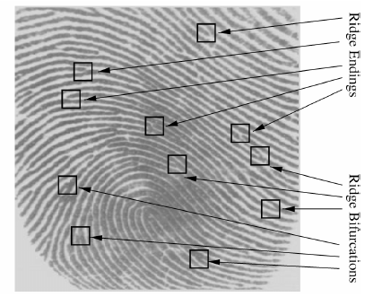

AN OVERVIEW OF THE METHOD

The whole project is divided into the following three steps.
1. Pre-Processing
2. Minutiae extraction
3. Post-Processing
The figure shown deals with the first step called pre-processing and gives an insight into the process that has been followed for the enhancement of the input fingerprint image.
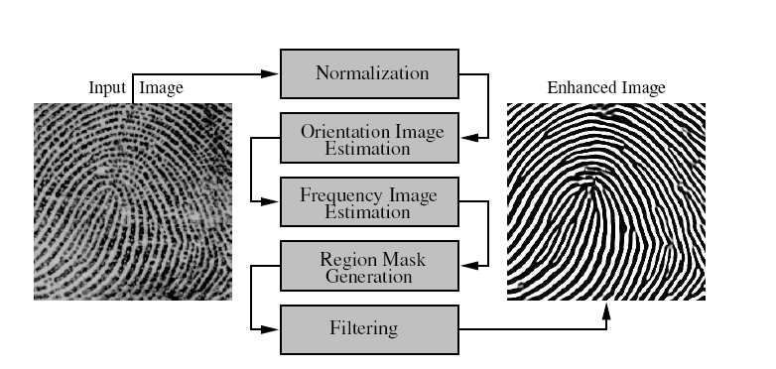

The next step deals with the extraction of minutiae. In the third step called post-processing, false minutiae are deleted from the set of obtained minutiae and hence the actual minutiae required for fingerprint matching are obtained. The following section gives the description of the steps followed in this project for the extraction of the actual minutiae.

DESCRIPTION OF THE STEPS OF
THE ALGORITHM

Pre-Processing
1. The input image is segmented from the background which ensures the removal of noise. For this, the whole image is divided into blocks of size 16×16 and the variance of each block is computed. The variance is then compared with the threshold value. If the variance of a block is less than the threshold value, then it is deleted from the original figure. This process is carried out for the whole image. The image obtained from the above step is then normalized to get the desired variance of the given image. The normalized image is given by

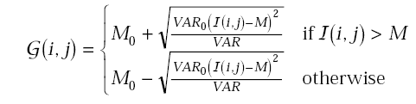
where denotes the gray-level value at pixel (i, j), M and VAR denote the estimated mean and variance of respectively and denotes the normalized gray-level value at pixel (i, j).
- andare the desired mean and variance values respectively.

2. The estimation of the orientation of the image is then carried out as the next step. The whole image is divided into blocks of size 16×16 and the local orientation in the figure is computed by
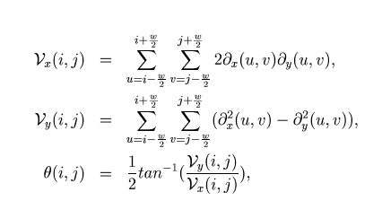
where θ(i, j) is the least square estimate of the local
ridge orientation at the block centered at pixel (i, j).

3. The angles between the blocks are then smoothened by passing the image through a low pass filter as follows.
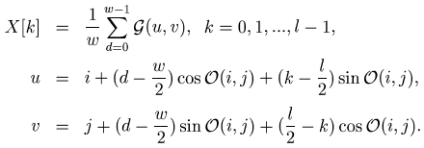

4. The following method is adopted for the calculation of the frequency of the local blocks. X-signatures of each block are computed along the direction perpendicular to the orientation angle in each block. The window used for this purpose is of size 16×32. The frequency is then computed by the distance between the peaks obtained in the X-signatures. The window for this is given by the formula
In general, the frequency of image constitutes has a certain frequency for the hole image and hence the above step can be omitted if the global frequency of the given figure is known.

5. As the next step, each block is filtered
along the direction of the orientation angle using the value of the frequency obtained for each block. A Gabor filter is used for this process and a suitable value of local variances is taken for carrying out the process of filtering.
A Gabor filter takes care of both the frequency components as well as the spatial coordinates. The inputs required to create a Gabor mask are frequency, orientation angle and variances along x and y directions. Filtering is done for each block using the local orientation angle and frequency.
Pre-processing of the image is completed by the steps as mentioned and the enhanced image is obtained.

Minutiae Extraction
The next step after enhancement of the image is the extraction of minutiae. The enhanced image is binarised first in this step. The skeleton of the image is then formed. The minutiae points are then extracted by the following method. The binary image is thinned as a result of which a ridge is only one pixel wide. The minutiae points are thus those which have a pixel value of one (ridge ending) as their neighbor or more than two ones (ridge bifurcations) in their neighborhood. This ends the process of extraction of minutiae points.

Post-Processing
The minutiae points obtained in the above step may contain many spurious minutiae. This may occur due to the presence of ridge breaks in the given figure itself which could not be improved even after enhancement. This results in false minutiae points which need to be removed. These unwanted minutiae points are removed in the post-processing stage.
False minutiae points will be obtained at the borders as the image ends abruptly.
These are deleted using the segmented mask. As a first step, a segmented mask is created. This is created during segmentation carried out in the stage of pre-processing and contains ones in the blocks which have higher variance than the threshold and zeros for the blocks having lower variance. This segmented mask contains all ones in the regions where the image is located and all zeros at the other places.
To know if a minutiae point is valid or not, a local window of size 11×11 is taken in the segmented mask at the location of the minutiae point and the total sum of the window is computed. If the sum is lesser than 121, then the point is invalid as it would be on the borders. If the sum is 121, it means that the point is not on the border and hence it has to be preserved. Thus, minutiae at the borders are removed preserving only those inside the figure.
For the deletion of minutiae inside the figure which would occur due to ridge breaks, a window of size 11×11 is taken around each minutiae point keeping it at the centre of the window and then is checked for any other minutiae that lie in the block. If other minutiae exist in that block, all the minutiae in the block are deleted. Thus, the minutiae points resulting from ridge breaks are eliminated. Though this process helps in removing false minutiae, it also poses a risk of eliminating closely placed minutiae points even though they are real.

EXPERIMENTAL RESULTS (Images obtained in each step carried out)

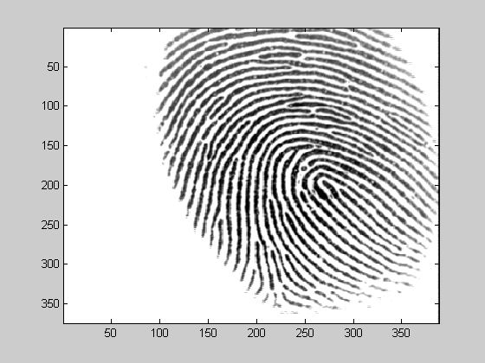
1. Original Fingerprint Image

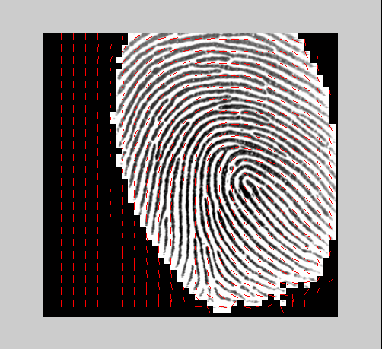
2. Segmented Image along with the orientation field


3. Normalized Image

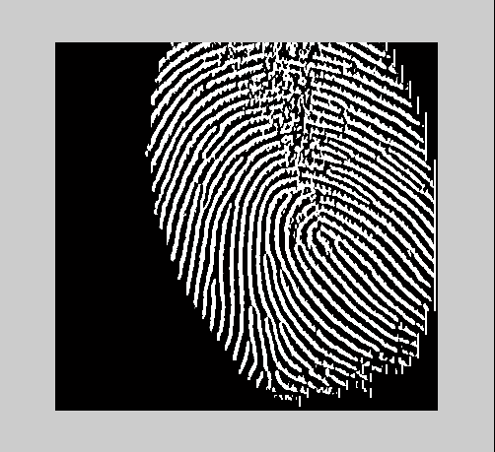
4. Gradient along x – direction

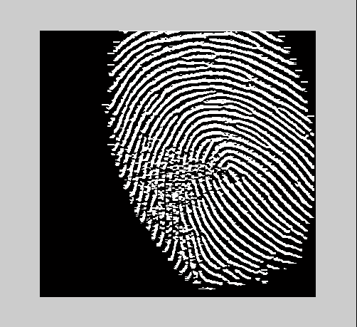
5. Gradient along y – direction


6. Enhanced Image after Gabor Filtering

7. Binary Output

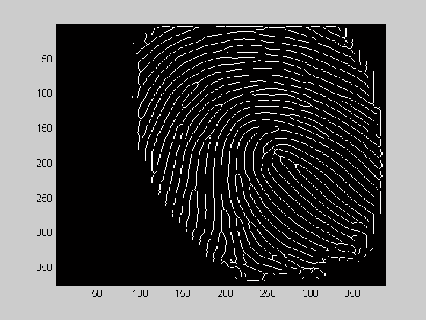
8. Thinned Binary Output

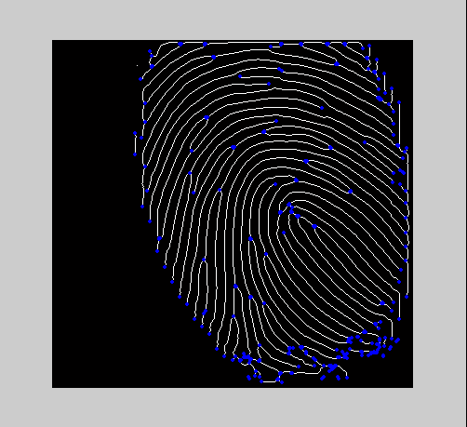
9. Thinned Binary along with all the minutiae

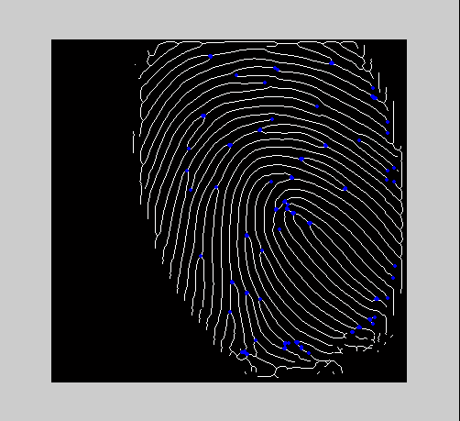
10. Minutiae obtained after deleting spurious minutiae at the borders
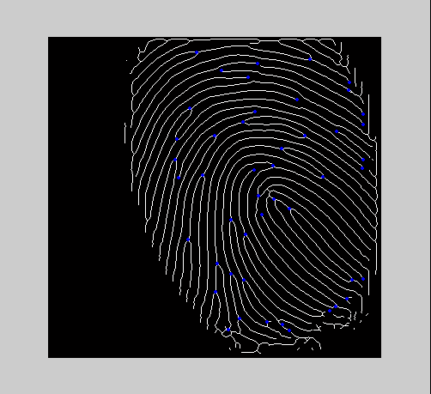
11. Final extracted Minutiae after applying the windowing technique

CONCLUSIONS

The main benefit of this algorithm is its fast running speed. It improves the verification performance too. The algorithm identifies the unrecoverable corrupted areas in the fingerprint and removes them from further processing. This is an important aspect of the algorithm as the presence of these areas would prove to be extremely harmful for the extraction of minutiae points. It helps in removing the spurious minutiae too which may also prove to be harmful in matching fingerprints correctly.

REFERENCES

[1] Lin Hong, Yifei Wan and Anil Jain. Fingerprint Image Enhancement: Algorithm and Performance Evaluation. East Lansing, Michigan.
[2] Fingerprint Minutiae Extraction, Department of Computer Science National Tsing Hua University Hsinchu, Taiwan 30043
[3] Handbook of Fingerprint Recognition by David Maltoni (Editor), Dario Maio, Anil K. Jain, Salil Prabhakar
[3] L. Hong, A. Jain, S. Pankanti and R. Bolle, Fingerprint Enhancement, Pattern Recognition, 202-207, 1996
[4] A. K. Jain, L. Hong, S. Pantanki and R. Bolle, An Identity Authentication System Using Fingerprints, Proc of the IEEE, vol, 85, no.9,1365-1388, 1997

