Participant 1 Transcription
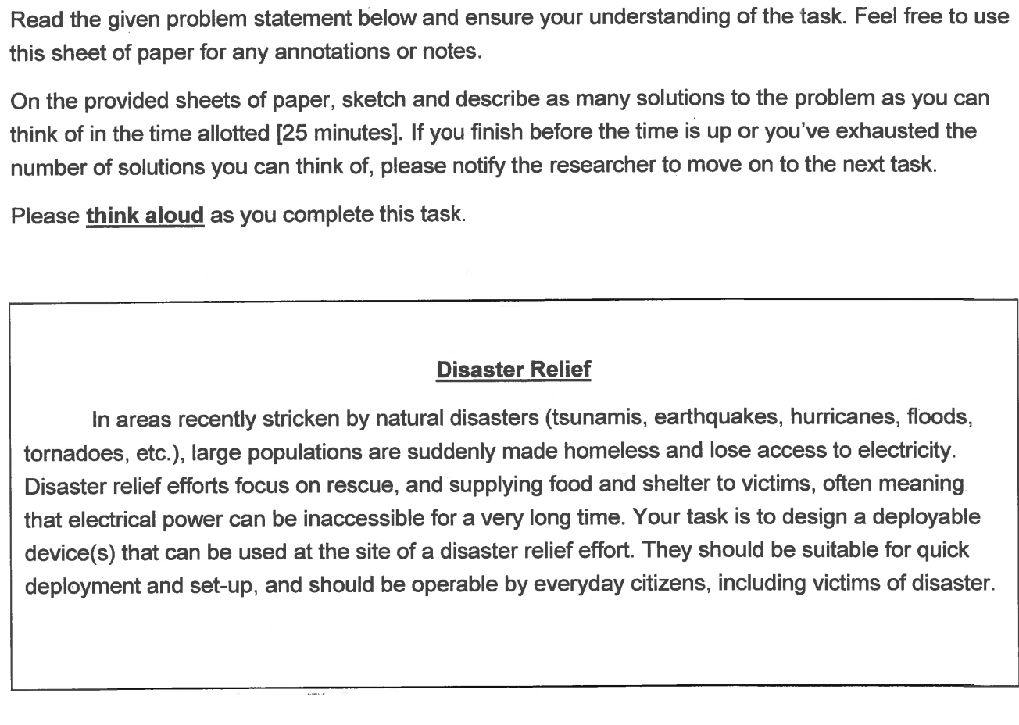
Participant: Can I ask you a question?
Researcher: Yes.
Participant: Um. It says to deploy a device. Is that a device for anything? To solve any of these problems?
R: Yes it’s up to you.
P: Ok. I guess the easiest thing being a mechanical engineering the first thing I think of is shelter without any electricity. Something like a deployable shelter for citizens.
P: The next problem you can go at. They give you electricity so it can be something like a hand crank generator. We made those in 270 so those are actually not that hard to make.
P: I’m trying to think of something that’s cheaper than a tent. A tent would be expensive for that many people, but wouldn’t be exactly a tent. Not just a tarp and a pole.
R: Can you describe what you’re thinking?
P: I went on to look at, I initially missed the rescue aspect of it. I’m trying to work through that, maybe something that’s existing but making it a little bit safer for an everyday citizen to use. For rescue, I think it’s better for people who know what they are doing to use as opposed to operable by the everyday citizen. But if it’s dire need, you want something safer to use. As far as power goes, I was thinking solar panels that are integrated into a van that they can drive to different disaster areas and people can just plug into. I don’t know a lot about solar panels, so I don’t know how possible that is, but, um. I’m trying to get a couple solutions for each of the problems. The easiest to solve is probably shelter.
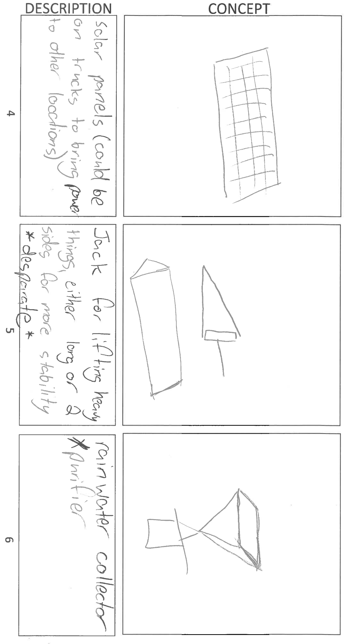
P: I think that’s about all that I got.
R: Ok so now we’re going to go for each of them one by one. I’ll give you this form to write things down while we’re talking. For each solution, we want you to write a problem statement that will allow other students to come up with the same solution you came up with. Pretend they didn’t see this before, what would they need to know to come up with this? So why don’t you start with the first one.
P: The first one was more of a shelter, just a plywood shelter with a curtain for in and out for privacy. I guess a problem statement to product that would be. Can I say anything about the disaster in the problem statement?
R: Yes.
P: For this one you can say a tornado went through town and a bunch of people are homeless. So, come up with an easy to make shelter that uses easily salvageable materials as well as keeping the need or want for privacy or I don’t know another one. Just privacy or just an area that you can stay with your family that’s not out in the open.
P: Alright so do you want me to read that?
R: No that’s okay. So how is this different than the original problem you were working with?
P: It’s taking into account one specific natural disaster. It wouldn’t probably matter if you had plywood in a ground where water is 6 feet away so um. As well as it wasn’t specified to use easily salvageable materials in the original problem statement but that’s something you want people to be able to get rather it being brought to them. I guess just a specification to think about comfort when making it since 100 families just lost their houses and they may be there for a while.
R: Okay good. So we’re going to do the same thing with the rest of them. So let’s move on to the second solution.
P: This one was just a hand crank generator. So if you’re in a region where power isn’t easily accessible we need something that anyone can easily use to provide at least a small amount of power for a short amount of time.
P: I just added the constraint that you’d want to use easy to find items because at least batteries and a small motor are a lot easier to find than a solar panel for finding power in an area where there’s no power.
R: Okay let’s go on to the third one.
P: This one is a lot the same. Along the lines as problem number one just more customizable I guess.
P: I was going to say for this one as plastic pre-made walls and you can put them together like Legos. You can make them bigger for bigger families. It’s the same shelter type idea. And um I originally was going to make a constraint that it’s lightweight but if it’s easily constructible. Guess I’m not sure if I should specify lightweight or if it falls under easily constructible. How specifically this does it need to be or can this be an option?
R: Whatever you think.
P: This one was just solar panels attached to a truck or a van to or something that you can bring to different places and sort of just plug in what you need to be plugged in. It could be a fridge for perishables and what not.
P: Um that one is a lot closer to the original one but after a natural disaster electricity is hard to come by. Just come up with a method to bring power. It doesn’t need power to run because obviously you’re bringing it to them.
P: This next one is like a jack for lifting heavy things after an earthquake or a tornado and someone is trapped under something. Maybe emergency people can get there otherwise that’s also something you want to get done as soon as possible instead of waiting for a rescue person to get to you. Jack’s are kind of dangerous if you don’t put them in the right spot and can jump back at you if you don’t get it on right. So this one has a wider base or otherwise 2 foot jack to lift bigger heavier things hopefully not dropping it on yourself.
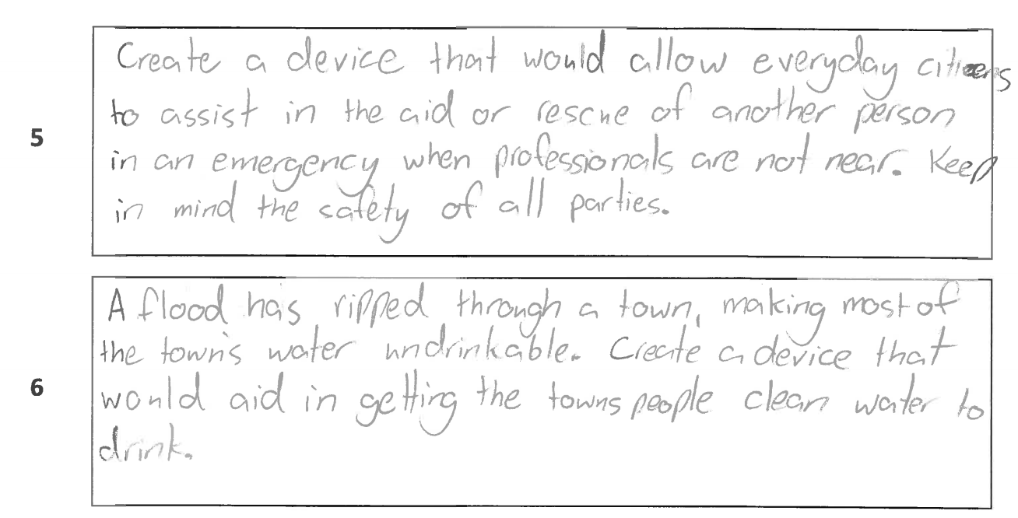
P: Um so yeah this one I just said to make something that would allow an everyday citizen to help someone in need when professionals can’t get there or aren’t there. But keeping the safety of both parties because you don’t want to hurt that person or put that person at risk. Just using a single jack, you don’t want 200 people injured instead of just one.
P: The last one is a rainwater collector. Used for like the flood victims. It’s not exactly getting food to them but water is more important.
P: That one was just a flood ripped through the town, making most of town’s water undrinkable. Create a device that would aid in getting the townspeople clean water to drink.
R: Okay good. So we’re done with that problem. I’ll take those papers from. We now are going to repeat the process with a different problem.

