SOUTH CAROLINA STUDIES Unit 5; Day 1
THEME = RESOURCES OF THE COASTAL PLAIN  MATH – ALGEBRA

LESSON TITLE: How Thick Are The Coastal Plain Sediments in South Carolina?

OBJECTIVES: Students will be able to use mathematical modeling techniques to analyze subsurface slope.

PRIMARY STANDARDS ADDRESSED: Algebra I – I.A.2; I.A.4; I.B.5; II.A.1; II.B.4; II.C.1

PRIOR SKILLS REQUIRED: ability to plot coordinate points from data sets and determine a line of
best fit from a scatter plot; ability to work with scale drawings/maps

TEACHER BACKGROUND INFO: SC MAPS Teaching Manual, pages 5-3 and 5-4

LOGISTICS: 1 @ 50-minute class – large tables or other work area – students work in cooperative groups

MATERIALS: 6 @ “laminated Coastal Plain with Grid” Student Maps; 1 @ “laminated Coastal Plain with Grid” Class Map; ‘wet-erase’ pens; rulers

PROCEDURES:
1. Stack a pile of papers (or books) on a desktop. First, ask the students to estimate the thickness of the pile from their current perspective. Then ask students how they could determine the thickness of the pile – assuming they were the size of a bug sitting on top of the stack. Evaluate each suggested method based on practicality of approach. Mention that today’s activity is designed to answer this same question for the South Carolina Coastal Plain; “How thick is the sedimentary rock cover?” in different places.
2. Divide students into six groups and give each group a laminated ‘Coastal Plain with Grid’ map, a ruler, a ‘wet-erase’ pen, and a copy of the Student Work Sheet that contains the well-log data. Assign each group one of the three well-log data sets so that at least two different groups are working with each set.
3. Tell groups to plot the location of their six assigned points on the laminated ‘Coastal Plain with Grid’ Student Map as accurately as they can – use a ‘wet-erase’ pen. They should then use a ruler to measure the map distance from each point to the Fall Line Zone boundary (make sure measurements are taken perpendicular to the Fall Line), use the scale given on the map to convert to miles, and enter this value on the Student Work Sheet. Each group should transfer their six data points onto the large Class Map.
4. Using the graph grid on the Student Work Sheet, groups should plot the positions of their six points as accurately as possible, estimate the ‘best-fit’ straight line through those points, and draw this line on the graph. [If needed, give hints about how to draw a ‘best fit’ line.] Tell groups to discuss mathematical implications of this graph for the original land surface on which coastal plain sediments were deposited. One student from each group should transfer their graph points and line onto the large Class Graph.
5. Ask a representative from each group to show their group’s results and explain the physical application of the graph to the geologic situation in the Coastal Plain region. Point out differences in slopes of the best-fit lines from each data set and ask students to speculate about what this might mean. Ask leading questions that will connect the variables represented in the graph to the real-life geologic situation.
6. Summarize the mathematical aspects of Coastal Plain geology and point out the usefulness of mathematical modeling as a tool for understanding the real world.

SAMPLE CULMINATING ASSESSMENT:
- Ask the following multiple-choice question on a unit test
Orangeburg is 50 miles from the Fall Line Zone; Summerville is 100 miles from the Fall Line Zone. Which statement is most likely TRUE about the thickness of Coastal Plain sediments?
a. thicker under Orangeburg b. thicker under Summerville c. same thickness under both places
- Have students draw a graph that shows the relationship in the above question, labeling the relative positions of Orangeburg and Summerville on their sketch.
SOUTH CAROLINA STUDIES Unit 5; Day 1
THEME = RESOURCES OF THE COASTAL PLAIN  MATH – ALGEBRA

STUDENT WORK SHEET

LESSON TITLE: How Thick Are The Coastal Plain Sediments in South Carolina?

WELL-LOG INFORMATION DATA SETS for the Coastal Plain of South Carolina

DATA SET ‘A’
WELL ID | LATITUDE | LONGITUDE | COUNTY | DEPTH TO BEDROCK (Ft) | DISTANCE FROM FALL LINE (Miles)
AIK-2448 | 33º 37' 28" | 81º 50" 59" | Aiken | 121
ALL-347 | 33º 01' 30" | 81º 23' 03" | Allendale | 1680
DOR-211 | 33º 09' 25" | 80º 31' 18" | Dorchester | 1962
JAS-426 | 32º 37' 04" | 80º 59' 45" | Jasper | 2900
LEX-844 | 33º 44' 44" | 81º 06' 28" | Lexington | 540
ORG-393 | 33º 30' 29" | 80º 51' 54" | Orangeburg | 1138

DATA SET ‘B’
WELL ID | LATITUDE | LONGITUDE | COUNTY | DEPTH TO BEDROCK (Ft) | DISTANCE FROM FALL LINE (Miles)
BRK-644 | 33º 24" 15" | 79º 56' 04" | Berkeley | 1826
DOR-037 | 32º 53' 15" | 80º 21' 25" | Dorchester | 2464
FLO-274 | 33º 51' 20" | 79º 46' 02" | Florence | 1077
RIC-543 | 33º 52' 29" | 80º 42' 10" | Richland | 544
RIC-585 | 33º 56' 56" | 80º 50' 27" | Richland | 455
SUM-340 | 33º 59" 25" | 80º 21' 32" | Sumter | 690

DATA SET ‘C’
WELL ID | LATITUDE | LONGITUDE | COUNTY | DEPTH TO BEDROCK (Ft) | DISTANCE FROM FALL LINE (Miles)
DAR-228 | 34º 27' 31" | 79º 52' 48" | Darlington | 439
DIL-121 | 34º 19' 43" | 79º 17' 02" | Dillon | 647
FLO-268 | 34º 10' 11" | 79º 47' 20" | Florence | 691
HOR-973/1165 | 33º 43' 21" | 78º 54' 12" | Horry | 1321
LEE-075 | 34º 12' 09" | 80º 10' 28" | Lee | 554
MRN-078 | 33º 51' 43" | 79º 19' 50" | Marion | 1159

GRAPH OF DATA SET

DATA SET LETTER _________ NAME OR GROUP _______________________________

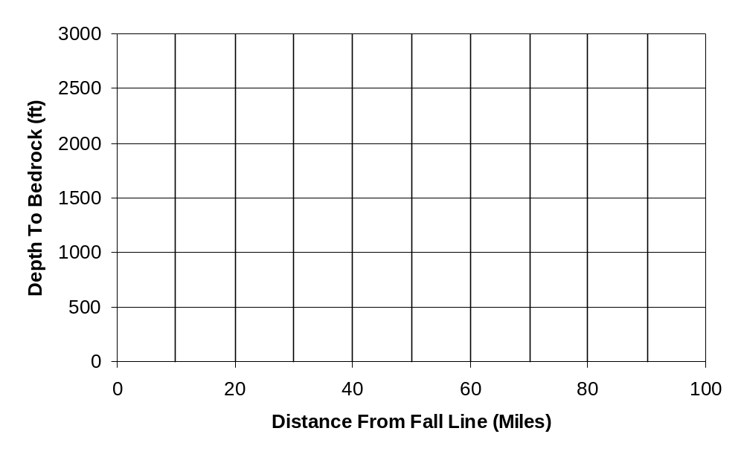

What are the major mathematical implications for this graph for the original land surface on which the coastal plain sediments were deposited? In other words, explain in writing what your graph actually means.

SOUTH CAROLINA STUDIES Unit 5; Day 1
THEME = RESOURCES OF THE COASTAL PLAIN  MATH – ALGEBRA

TEACHER ANSWER KEY

LESSON TITLE: How Thick Are The Coastal Plain Sediments in South Carolina?

1. Stack a pile of papers . . . . Evaluate each method. . . . we will be using data retrieved from wells . . . .
Try to get students to decide how to determine if a method is feasible. The preferred answer is ‘digging down through the stack and measuring’ but other answers might be possible. Tell students they will be using data retrieved from wells drilled through Coastal Plain rocks in many different parts of the state. In geology, we ‘dig down’ by drilling wells and examining the rock cuttings that are brought back to the surface. It is easy to measure the depth of a hole.

2. Divide students into six groups . . . . Assign each group one of the three well-log data sets . . . .
If you have fewer than six groups, be sure at least one group does each of the data sets so all 18 points are graphed.

3. Tell groups to plot the location . . . should transfer their six data points onto the large Class Map . . . .
You will want all points located on the ‘class map’ so you can discuss trends parallel to the coast as well as perpendicular.

4. Using graph paper . . . groups should plot the positions . . . should transfer . . . onto large Class Graph . . . .
Discuss the meaning of a ‘best-fit’ line as needed. Each group graphs 6 points which should show an approximately linear relationship. When graph is complete, line should be copied onto ‘class graph’ so differences in lines can be explored.

5. Ask . . . explain the physical application . . . ask students to speculate about what this might mean . . . . .
All three data sets (and graphs) should show a thickening of the coastal plain sediments away from the Fall Line Zone. Data Set A should show the steepest slope while Data Set C should show the least steep slope. Geologically, this means more sediment was deposited to the southwest so the crust had to subside more in that region. There are many factors that could explain this, but relative tectonic uplift along the North Carolina border is the best answer.

6. Summarize . . . point out usefulness of mathematical modeling as a tool for understanding the real world.
Note need to group data by region. An average slope for all 18 points would not have shown the difference in subsidence in different parts of the state. Students should see the power of a mathematical model to reflect physical realities.

SAMPLE CULMINATING ASSESSMENT:
- Ask the following multiple-choice question on a unit test Answer = b
Orangeburg is 50 miles from the Fall Line Zone; Summerville is 100 miles from the Fall Line Zone. Which statement is most likely TRUE about the thickness of Coastal Plain sediments?
a. sediments are thicker under Orangeburg c. sediments are same thickness under both places
b. sediments are thicker under Summerville
- Have students draw a graph that shows the relationship in the above question, labeling the relative positions of Orangeburg and Summerville on their sketch.

* Summerville
* Orangeburg

Distance from Fall Line Zone (miles)
Thickness of
Sediment Cov

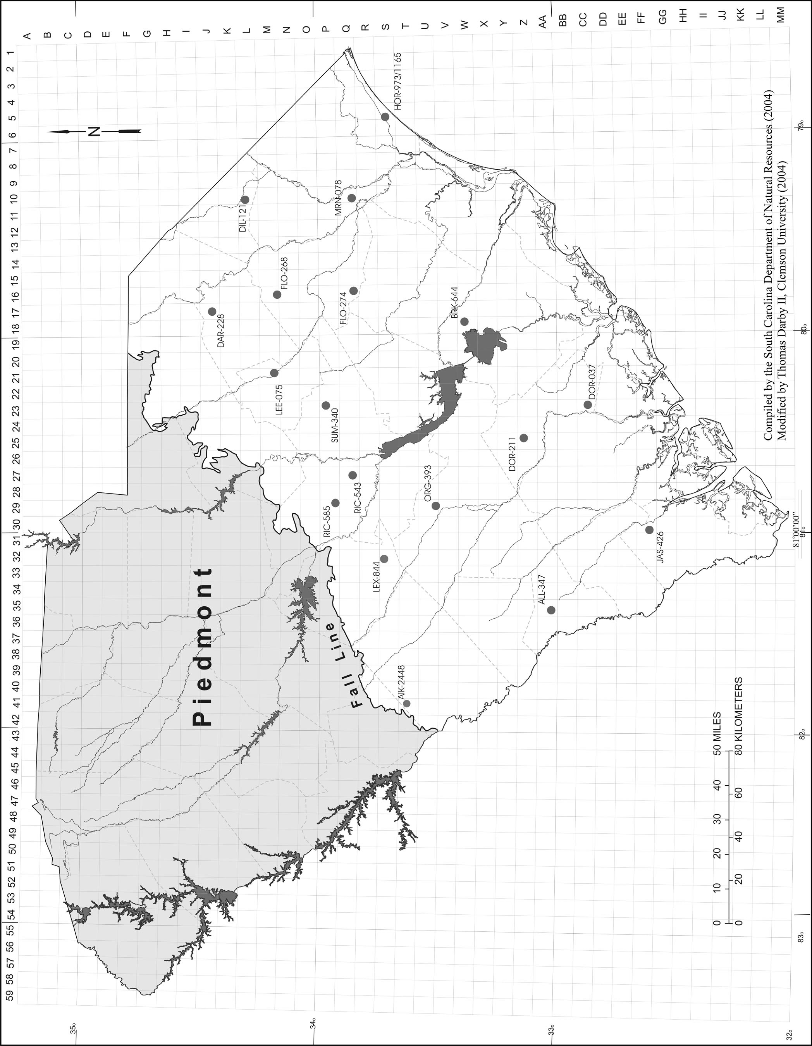
SOUTH CAROLINA STUDIES Unit 5; Day 1
THEME = RESOURCES OF THE COASTAL PLAIN  MATH – ALGEBRA

TEACHER ANSWER KEY – (continued)
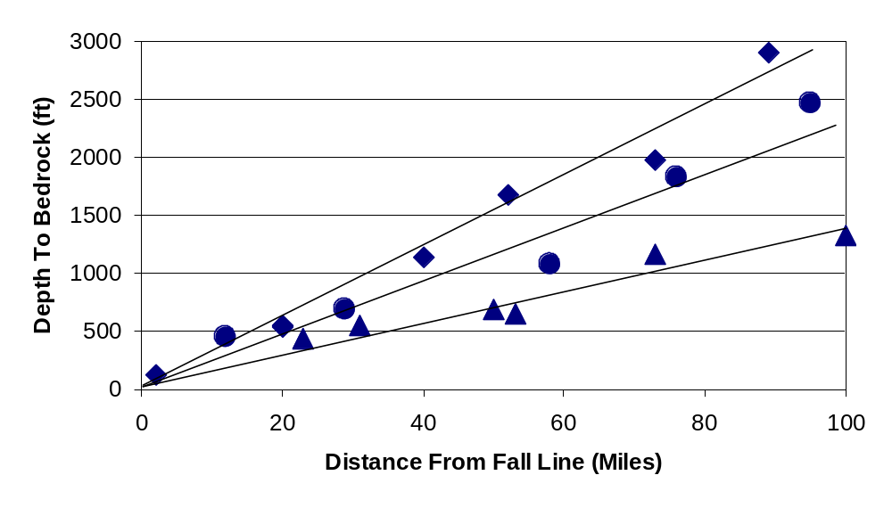
1
2
3
4
5
6
7
8
9
10
11
12
13&16
14
15
17
18
NOTE: POINTS #13 and #16 lie nearly on top of each other
# | WELL ID | LATITUDE | LONGITUDE | COUNTY | DEPTH TO BEDROCK (Ft) | DIST FROM FALL LINE (Miles)
1 | AIK-2448 | 33º 37' 28" | 81º 50" 59" | Aiken | 121 | 2
2 | ALL-347 | 33º 01' 30" | 81º 23' 03" | Allendale | 1680 | 52
3 | BRK-644 | 33º 24" 15" | 79º 56' 04" | Berkeley | 1826 | 76
4 | DAR-228 | 34º 27' 31" | 79º 52' 48" | Darlington | 439 | 23
5 | DIL-121 | 34º 19' 43" | 79º 17' 02" | Dillon | 647 | 53
6 | DOR-037 | 32º 53' 15" | 80º 21' 25" | Dorchester | 2464 | 95
7 | DOR-211 | 33º 09' 25" | 80º 31' 18" | Dorchester | 1962 | 73
8 | FLO-268 | 34º 10' 11" | 79º 47' 20" | Florence | 691 | 50
9 | FLO-274 | 33º 51' 20" | 79º 46' 02" | Florence | 1077 | 58
10 | HOR-973/1165 | 33º 43' 21" | 78º 54' 12" | Horry | 1321 | 100
11 | JAS-426 | 32º 37' 04" | 80º 59' 45" | Jasper | 2900 | 89
12 | LEE-075 | 34º 12' 09" | 80º 10' 28" | Lee | 554 | 31
13 | LEX-844 | 33º 44' 44" | 81º 06' 28" | Lexington | 540 | 20
14 | MRN-078 | 33º 51' 43" | 79º 19' 50" | Marion | 1159 | 73
15 | ORG-393 | 33º 30' 29" | 80º 51' 54" | Orangeburg | 1138 | 40
16 | RIC-543 | 33º 52' 29" | 80º 42' 10" | Richland | 544 | 20
17 | RIC-585 | 33º 56' 56" | 80º 50' 27" | Richland | 455 | 12
18 | SUM-340 | 33º 59" 25" | 80º 21' 32" | Sumter | 690 | 29

