SOUTH CAROLINA STUDIES Unit 6; Day 5
THEME = PIRATES OF THE COASTAL ZONE  SCIENCE

LESSON TITLE: Shipwrecks

OBJECTIVES: Students will be able to identify sunken ships and other objects in side-scan sonar images.

PRIMARY STANDARDS ADDRESSED: Science 8th - III.B.3.l

PRIOR SKILLS REQUIRED: ability to read and interpret side-scan sonar images

TEACHER BACKGROUND INFO: SE MAPS Teaching Manual, pages 2-20 and 2-21; seeWeek6Day4

LOGISTICS: 1 @ 50-minute class – large tables or other work area – students work in cooperative groups

MATERIALS: 6 @ Grand Strand maps from SE MAPS (MAP 9B and IMAGE 9B); ‘wet-erase’ pens;

PROCEDURES:
1. Divide students into 6 groups and hand out copies of MAP 9B and IMAGE 9B (SE MAPS) and other materials along with copies of the Student Work Sheet. Ask groups to do the side-scan sonar activities listed on the Student Work Sheet.
2. After most groups have finished the sonar questions, lead a whole-class discussion about the answers gotten by each group. Ask what some other types of objects (like a wrecked car or an old pirate ship) might look like in a side-scan sonar image and how they could recognize it.
3. [optional] Introduce the topic of artificial reefs. Explain why they are useful to fish and other marine organisms. Assign each group one of the artificial reefs listed on the chart on the Student Work Sheet. Ask the group to pick two objects listed in the chart for their reef and plot their position on their MAP 9B by marking the spot with a ‘wet-erase’ pen. Note that latitude and longitude markings are shown on MAP 9B, but students will have to interpolate to find positions in between the numbered lines.
4. [optional] Ask a representative from each group to come to the front of the room and add their points to a master copy of MAP 9B. Discuss the positioning of these artificial reefs and ask students to analyze the placement to see if there is any connection to bathymetry. Use the following questions (or others) to generate discussion:
- Are all the artificial reefs at the same water depth?
- What types of materials were used to make these artificial reefs?
- What properties do all of these reef materials have in common?
- Why did they place the artificial reefs in these particular locations?

SAMPLE CULMINATING ASSESSMENT:
- Give students a copy of a side-scan sonar image and ask them to make an educated guess as to what the object is and how big it is. Tell students that the parallel grid lines on either side of the center line are all 5 meters apart.

SOUTH CAROLINA STUDIES Unit 6; Day 5
THEME = PIRATES OF THE COASTAL ZONE  SCIENCE

STUDENT WORK SHEET

LESSON TITLE: Shipwrecks

SIDE-SCAN SONAR ACTIVITY

1. Study the four Side-Scan Sonar image insets on the IMAGE 9B – GRAND STRAND map. Read the title of each map and try to locate and identify each of these items on the image.
Remember that bright areas representing strong reflections (light color) indicate a surface that is either very hard or else tilted towards the sonar source (to provide a strong reflection). Dark areas represent weak reflections (dark color) and indicate a surface characterized by soft sediment or else tilted away from the sonar source (so reflections bounce away in another direction and are never received). Objects that stick up above the ocean floor will usually appear bright themselves, but will also cast a dark shadow behind them (because sonar waves can’t penetrate the object and never reach the shadow zone).

a. Explain (briefly) how you were able to recognize each feature:

- Bridge Pilings –

- Dock Pilings –

- Small Boat –

- Sunken Boat –

b. Which of the images could you have recognized without reading the title? Explain your answer.

c. Why is it important to know what is on the bottom, especially this close to land?

2. Use the red-line information to estimate the widths of the bridge and the dock, and the lengths of the two boats. Ignore the extra red line that appears on the left side of the centerline in each of the sonar insets.
The red parallel lines on each image represent a way to calibrate distances under water. The thick red line running down the center of the image represents the path of the boat that is carrying the sonar technology. That line can be considered to have a value of zero. Other red lines are spaced 5 meters apart and increase in value away from the center line.

- width of Bridge Piling area – - length of Dock Piling area –

- length of Small Boat – - length of Sunken Boat –
PLOT LOCATIONS OF ARTIFICIAL REEFS

1. Plot and mark the position of two structures from your assigned reef on MAP 9B (SE MAPS).
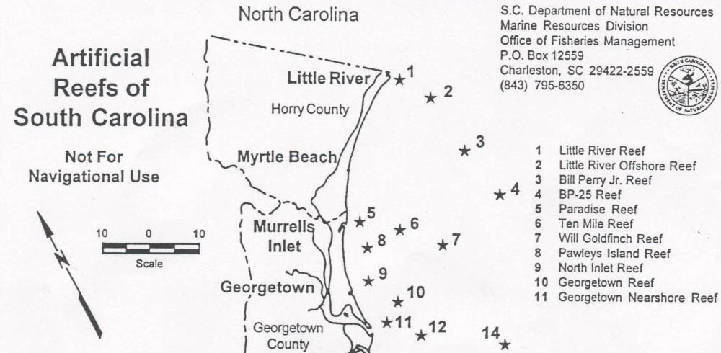

Artificial Reef Name | Structure | Latitude | Longitude
#5 – PARADISE | Reef Buoy | 33º 31.071´ | 078º 58.140´
 | Small Object | 33º 30.930´ | 078º 57.999´
 | Concrete Reef Balls | 33º 30.959´ | 078º 58.051´
#6 – TEN MILE | Northern Buoy | 33º 25.303´ | 078º 51.497´
 | Southern Buoy | 33º 26.261´ | 078º 52.706´
 | Tugboat & Barge | 33º 25.389´ | 078º 51.609´
 | 200’ Ship | 33º 26.407´ | 078º 52.807´
 | Concrete Reef Balls | 33º 26.081´ | 078º 52.239´
 | Concrete Reef Balls | 33º 26.092´ | 078º 52.201´
#8 – PAWLEY’S ISLAND | Reef Buoy | 33º 25.993´ | 079º 00.718´
 | Landing Craft | 33º 26.082´ | 079º 00.686´
 | Landing Craft | 33º 26.100´ | 079º 00.749´
#9 – NORTH INLET | Reef Buoy | 33º 20.530´ | 079º 00.910´
 | Steel Pup Tents | 33º 20.608´ | 079º 00.922´
 | Concrete Reef Balls | 33º 20.619´ | 079º 00.894´
#10 – GEORGETOWN | Reef Buoy | 33º 14.332´ | 079º 00.152´
 | 100’ Ship | 33º 14.237´ | 079º 00.025´
 | Misc. Structures | 33º 14.238´ | 079º 00.031´
 | Misc. Structures | 33º 14.318´ | 079º 00.118´
 | Barge | 33º 14.547´ | 079º 00.136´
 | Landing Craft | 33º 14.341´ | 079º 00.217´
#11 – GEORGETOWN NEARSHORE | Reef Buoy | 33º 12.716´ | 079º 00.306´
 | 130’ Deck Barge | 33º 12.727´ | 079º 00.313´
 | 62’ Lash Barge | 33º 12.760´ | 079º 00.346´
 | 62’ Lash Barge | 33º 12.730´ | 079º 00.205´

2. Use the bathymetric contour lines to determine the approximate water depth at each reef structure you located. STRUCTURE #1 water depth = STRUCTURE #2 water depth =

3. Why do you think they placed the artificial reef you studied in this particular location? Explain.
SOUTH CAROLINA STUDIES Unit 6; Day 5
THEME = PIRATES OF THE COASTAL ZONE  SCIENCE

TEACHER ANSWER KEY

LESSON TITLE: Shipwrecks

1. Ask groups to do the side-scan sonar activities listed on the Student Work Sheet.
1. Study the side-scan sonar images.
a. Explain (briefly) how you were able to recognize each feature:

- Bridge Pilings – Answers may vary. Should make reference to alternating reflective and non-reflective pattern with columnar shape. Solid black areas are acoustic shadows from pilings.

- Dock Pilings – Answers may vary. Dark shadows show up better than bright reflectors here, but note very regular pattern of markings, almost like a grid, indicating purposeful arrangement of pilings.

- Small Boat – Answers may vary. Pointed front of boat is the most obvious part of this feature, but overall shape suggests one end of a boat. The other end of the boat is buried in sediment and doesn’t show up in this image.

- Sunken Boat – Answers may vary. One end of the boat is buried in sediment and cannot be seen. The visible end of the boat has the typical pointed shape and gradually widens toward the middle.

b. Which of the images could you have recognized without reading the title? Explain your answer.
Answers may vary. If students are honest, most would say they couldn’t recognize any of these features without knowing the title. The intent of this question is to get them to realize that we can sense objects, using technology, in a way that may not look familiar to us, but with practice we can learn how to read the patterns to make sense of them anyway.

c. Why is it important to know what is on the bottom, especially this close to land?
Answers may vary. If the feature is very large, it’s possible it could pose a hazard to navigation, therefore it’s important to note where these objects appear on the ocean floor. It is also possible to locate old shipwrecks, like Blackbeard’s Ship, the Queen Anne’s Revenge, and the submarine Hundley (discovered recently off Charleston Harbor) and obtain a wealth of historical data and perhaps even some treasure.

2. Use the red-line information to estimate the widths . . . lengths of the two boats.

- total width of Bridge Piling area – approx. 9-10 meters - total length of Dock Piling area – approx. 2-3 meters
- length of Small Boat – approx. 6 meters (showing) - length of Sunken Boat – approx. 5 meters (showing)

2. Ask what some other types of objects (like a wrecked car or an old pirate ship) might look like in a side-scan sonar image and how they could recognize it.
Answers may vary. Students should indicate that any hard object would reflect brightly (and probably cast a shadow) unless it was completely buried in sediment. The shape of the object should be determinable from the sonar image, but some distortion will likely occur.

3. [optional] Introduce artificial reefs. . . . students will have to interpolate to find [exact] positions . . . .
Answers may vary. Reefs are hardbottom areas where several types of marine organisms can attach and grow. Once these colonizers are in place, they attract a wide variety of fish and other mobile sea creatures, building up a rich and diverse ecosystem. Artificial reefs provide the same type of habitat in areas that would not ordinarily support such life.
Interpolation is necessary because the latitude and longitude values in the chart are given to nearly pinpoint accuracy, but the lines on the map are spaced 9’ and 59” apart. Advanced classes might be able to do exact mathematical interpolation, but most students should be told to estimate the positions the best they can by visual inspection.
4. [optional] Discuss the positioning of these artificial reefs to see if there is any connection to bathymetry.

Artificial Reef Name | Structure | Approximate Water Depth
#5 – PARADISE | Reef Buoy | 10 meters
 | Small Object | 10 meters
 | Concrete Reef Balls | 10 meters
#6 – TEN MILE | Northern Buoy | 14 meters
 | Southern Buoy | 13 meters
 | Tugboat & Barge | 14 meters
 | 200’ Ship | 13 meters
 | Concrete Reef Balls | 13 meters
 | Concrete Reef Balls | 14 meters
#8 – PAWLEY’S ISLAND | Reef Buoy | 11 meters
 | Landing Craft | 11 meters
 | Landing Craft | 11 meters
#9 – NORTH INLET | Reef Buoy | 12 meters
 | Steel Pup Tents | 11 meters
 | Concrete Reef Balls | 12 meters
#10 – GEORGETOWN | Reef Buoy | 14 meters
 | 100’ Ship | 13 meters
 | Misc. Structures | 14 meters
 | Misc. Structures | 14 meters
 | Barge | 13 meters
 | Landing Craft | 14 meters
#11 – GEORGETOWN NEARSHORE | Reef Buoy | 12 meters
 | 130’ Deck Barge | 12 meters
 | 62’ Lash Barge | 13 meters
 | 62’ Lash Barge | 12 meters

- Are all the artificial reefs at the same water depth?
No, but most of them are fairly shallow and usually shallower than the surrounding seafloor.

- What types of materials were used to make these artificial reefs?
Almost anything will work. Sunken barges, tugboats, landing craft, ships, steel pup tents, ballast cans, concrete reef balls, old buoys, steel & tire units, old pipes, and tanks are common structures.

- What properties do all of these reef materials have in common?
Answers may vary. In general, all of the materials are hard and solid, and will take a long time to disintegrate. Some marine organisms require a ‘hardbottom’ to live and these in turn attract fish.

- Why did they place the artificial reefs in these particular locations?
Answers may vary. The locations are often fairly close to shore and favor shallower depths. Lots of fishermen anchor near these artificial reefs, so they can’t be too far from shore. Likewise, fishermen don’t want the reefs too deep either.

SAMPLE CULMINATING ASSESSMENT:
- Give students a copy of a side-scan sonar image and ask them to make an educated guess as to what the object is and how big it is. Tell students that the parallel grid lines on either side of the center line are all 5 meters apart.
Teachers can photocopy one of the side-scan sonar images in the “Additional Background Information” section of the lesson and use this as the basis of a test question. Even if the question uses the same exact questions as posed on the Student Work Sheet, the likelihood of students memorizing the answers would be slim.
SOUTH CAROLINA STUDIES Unit 6; Day 5
THEME = PIRATES OF THE COASTAL ZONE  SCIENCE

ADDITIONAL BACKGROUND RESOURCES

LESSON TITLE: Shipwrecks

SIDE-SCAN SONAR: BRIDGE PILINGS
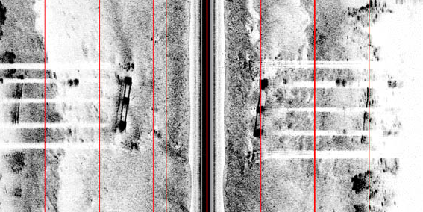

SIDE-SCAN SONAR: DOCK PILINGS
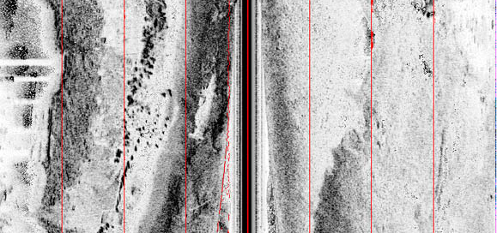

SIDE-SCAN SONAR: SMALL BOAT
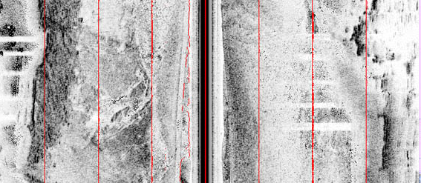

SIDE-SCAN SONAR: SUNKEN BOAT


