CHAPTER 10

FLORIDA PENINSULA REGION

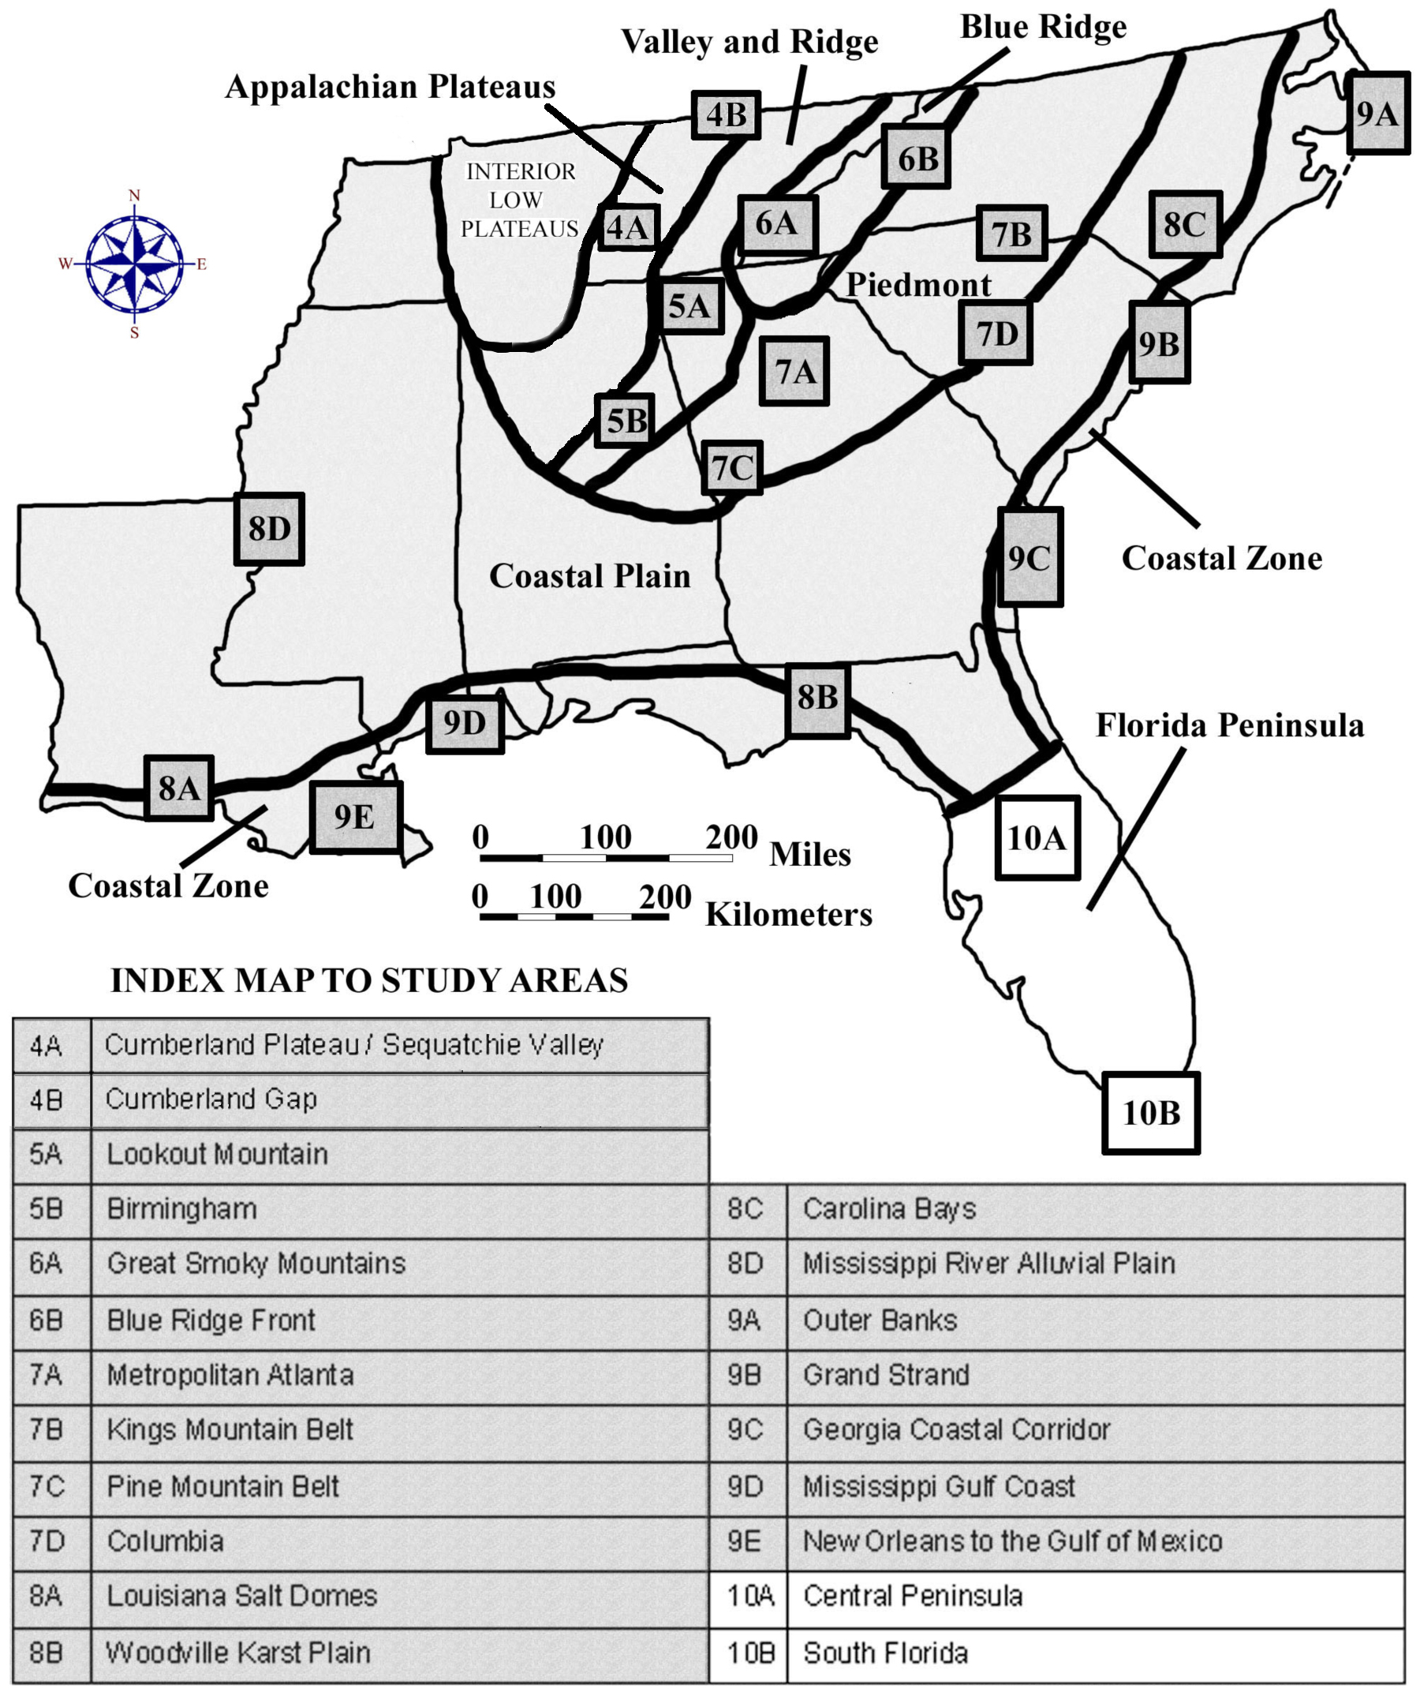

DRAFT VERSION 5/06/20

TABLE OF CONTENTS FOR CHAPTER 10

FLORIDA PENINSULA REGION

James Anderson, Jon Arthur, Carol Snell Patton, Ed Lane, and John R. Wagner

INDEX MAP TO FLORIDA PENINSULA REGION STUDY AREA
TABLE OF CONTENTS FOR CHAPTER 10
BACKGROUND INFORMATION
- Description of Landforms, Drainage Patterns, and Geologic Processes
p. 10-1 . . . . - Characteristic Landforms of the Florida Peninsula
p. 10-1 . . . . . . . . - figure 10-1 – “Geographic Extent of Florida Platform”
p. 10-2 . . . . - Geographic Features and Localities of Special Interest
p. 10-3 . . . . . . . . - figure 10-2 – “Ancient versus Modern Coastline Geometry”
p. 10-4 . . . . - Rock Types and Geologic History
- Influence of Topography on Historical Events and Cultural Trends
p. 10-5 . . . . - Folklore
p. 10-5 . . . . . . . . - story – “Two Accounts of the Fountain of Youth”
p. 10-5 . . . . . . . . - story – “In the Beginning”
p. 10-6 . . . . . . . . - story – “The Legend of Spook Hill”
p. 10-6 . . . . - Historical Events
p. 10-7 . . . . . . . . - figure 10-3 – “Native American Cultures in Florida”
p. 10-8 . . . . - Influence of Topography on Commerce, Culture, and Tourism
- Natural Resources, Land Use, and Environmental Concerns
p. 10-9 . . . . - Climate and Water Resources
p. 10-9 . . . . - Soils and Agriculture
p. 10-10 . . . - Mining, Resource Extraction, and Environmental Concerns
PLACES TO VISIT
REFERENCES AND RESOURCES

STUDY AREA 10A = Central Peninsula
- Newspaper Article
p. 10A-1 . . . . . . - story – “Disney, Orlando have had a sometimes rocky marriage”
- Rationale
- Performance Objectives
- Sample Assessment Rubrics
- Cartographic Product Information
p. 10A-3 . . . - MAP 10A: Central Peninsula
p. 10A-4 . . . - IMAGE 10A: Central Peninsula
- Study Area Description
p. 10A-5 . . . - Comparison of Gulf and Atlantic Coasts
p. 10A-5 . . . . . . . - figure 10A-1 – “Location of Beaches in Central Florida”
p. 10A-7 . . . . . . . - figure 10A-2 – “Paths of Recent Category 4 & 5 Hurricanes”
p. 10A-8 . . . - Ridges and Valleys of the Central Highlands
p. 10A-8. . . . . . . - figure 10A-3 – “Location of Lake Wales ridge and Polk Upland”
p. 10A-9 . . . . . . . - story – “One Sinkhole Begets 200 After Drilling”
p. 10A-10 . . . - Human Impacts on Landscapes
p. 10A-10 . . . . . . - story – “How Orlando Got Its Name”
p. 10A-12 . . . . . . - figure 10A-4 – “Map of Cape Canaveral and Vicinity”
- Activity 10A-1: Comparison of Gulf and Atlantic Coasts
(ICONS) Overview = Sci = Math = Hist = Lang Arts =
p. 10A-13 . . - Power Thinking Exercise “Vanished Vacation”
p. 10A-13 . . - Materials
p. 10A-13 . . - Performance Tasks
p. 10A-13 . . . . . . 1. Compare and contrast barrier islands on Gulf and Atlantic coast.
p. 10A-14 . . . . . . 2. Relate bathymetry to wave action along coast.
p. 10A-14 . . . . . . 3. Estimate sun angle from shadows of clouds.
p. 10A-14 . . . . . . 4. Plan evacuation routes in event of approaching hurricane.
p. 10A-15 . . . . . . 5. Write diary entry describing a day at the beach.
p. 10A-15 . . - Enrichment
p. 10A-15 . . . . . . 1. Research estuarine food webs.
p. 10A-15 . . . . . . 2. Research recent hurricanes that have impacted Central Florida.
- Activity 10A-2: Ridges and Valleys of the Central Highlands
(ICONS) Overview = Sci = Math = Hist = Lang Arts =
p. 10A-16 . . - Power Thinking Exercise “Bone Bonanza”
p. 10A-16 . . - Materials
p. 10A-16 . . - Performance Tasks
p. 10A-16 . . . . . . 1. Compare and contrast lakes in phosphate region and karst region.
p. 10A-17 . . . . . . 2. Identify ancient shoreline and karst features.
p. 10A-17 . . . . . . 3. Calculate surface area in terms of football fields.
p. 10A-17 . . . . . . 4. Examine how phosphate mining has altered the landscape.
p. 10A-18 . . . . . . 5. Write story about event with unintended consequences.
p. 10A-18 . . - Enrichment
p. 10A-18 . . . . . . 1. Research process of phosphate mining and uses for the product.
p. 10A-18 . . . . . . 2. Investigate scrub habitat along Lake Wales Ridge.
- Activity 10A-3: Human Impacts on Landscapes
(ICONS) Overview = Sci = Math = Hist = Lang Arts =
p. 10A-19 . . - Power Thinking Exercise “Park Placement”
p. 10A-19 . . - Materials
p. 10A-19 . . - Performance Tasks
p. 10A-19 . . . . . . 1. Document alterations to landscape associated with development.
p. 10A-20 . . . . . . 2. Evaluate environmental effects of channeling Kissimmee River.
p. 10A-20 . . . . . . 3. Calculate the ‘par’ score for golf course.
p. 10A-20 . . . . . . 4. Locate features around port of Tampa Bay.
p. 10A-21 . . . . . . 5. Identify metaphors used in newspaper story.
p. 10A-21 . . - Enrichment
p. 10A-21 . . . . . . 1. Research career of Hamilton Disston.
p. 10A-21 . . . . . . 2. Research history associated with Indian River Lagoon.

STUDY AREA 10B = South Florida
- Newspaper Article
p. 10B-1 . . . . . . - story – “’Big Water’ at historic low due to drought in Florida”
- Rationale
- Performance Objectives
- Sample Assessment Rubrics
- Cartographic Product Information
p. 10B-3 . . . - MAP 10B: South Florida
p. 10B-4 . . . - IMAGE 10B: South Florida
- Study Area Description
p. 10B-5 . . . - Everglades and Water Issues
p. 10B-5 . . . . . . . - figure 10B-1 – “Original versus Present Extent of Everglades”
p. 10B-6 . . . . . . . - figure 10B-2 – “Progressive Development of Tree Islands”
p. 10B-7 . . . . . . . - figure 10B-3 – “Salt Water Incursion into Wells”
p. 10B-7 . . . - The Florida Keys
p. 10B-9 . . . . . . . - figure 10B-4 – “Map of Dry Tortugas - Main Islands”
p. 10B-9 . . . - History and Land Use
p. 10B-10. . . . . . - story – “Swamp Safari”
- Activity 10B-1: Everglades and Water Issues
(ICONS) Overview = Sci = Math = Hist = Lang Arts =
p. 10B-12 . . - Power Thinking Exercise “Saturated Subdivision”
p. 10B-12 . . - Materials
p. 10B-12 . . - Performance Tasks
p. 10B-12 . . . . . . 1. Trace pathways of drainage canals from Lake Okeechobee.
p. 10B-13 . . . . . . 2. Explain causes for water restrictions in coastal cities.
p. 10B-13 . . . . . . 3. Calculate percentage loss of watershed area in Everglades.
p. 10B-13 . . . . . . 4. Recognize agricultural land use on various map products.
p. 10B-13 . . . . . . 5. Discuss literary concept of time-lapse storytelling.
p. 10B-14 . . - Enrichment
p. 10B-14 . . . . . . 1. Investigate efforts to restore Everglades habitat.
p. 10B-14 . . . . . . 2. Research formation and uses of peat.
- Activity 10B-2: The Florida Keys
(ICONS) Overview = Sci = Math = Hist = Lang Arts =
p. 10B-15 . . - Power Thinking Exercise “Oolite Origin”
p. 10B-15 . . - Materials
p. 10B-15 . . - Performance Tasks
p. 10B-15 . . . . . . 1. Compare and contrast features of upper and lower Keys.
p. 10B-15 . . . . . . 2. Investigate shoreline changes around Lignumvitae Key.
p. 10B-16 . . . . . . 3. Calculate width of channel between islands.
p. 10B-16 . . . . . . 4. Identify changes to landforms from 1951 to 1994.
p. 10B-16 . . . . . . 5. Investigate etymology of names used in Florida Keys.
p. 10B-16 . . - Enrichment
p. 10B-16 . . . . . . 1. Investigate Dry Tortugas National Park.
p. 10B-16 . . . . . . 2. Research fossil corals found at Windley Key Fossil Reef Park.

- Activity 10B-3: History and Land Use
(ICONS) Overview = Sci = Math = Hist = Lang Arts =
p. 10B-17 . . - Power Thinking Exercise “Keys Keeper”
p. 10B-17 . . - Materials
p. 10B-17 . . - Performance Tasks
p. 10B-17 . . . . . . 1. Interpret land use at Port Mayaca sugarcane fields.
p. 10B-18 . . . . . . 2. Trace route of Intracoastal Waterway.
p. 10B-18 . . . . . . 3. Calculate area and perimeter of sugarcane field.
p. 10B-18 . . . . . . 4. Identify historic buildings in Coconut Grove.
p. 10B-19 . . . . . . 5. Re-write “Swamp Safari” story.
p. 10B-19 . . - Enrichment
p. 10B-19 . . . . . . 1. Research Native American history in South Florida.
p. 10B-19 . . . . . . 2. Investigate famous person who lived in Coconut Grove.

BACKGROUND INFORMATION

Description of Landforms, Drainage Patterns, and Geological Processes

Characteristic Landforms of the Florida Peninsula

The Florida Peninsula spans approximately 150 miles (241 kilometers) from east to west coast. In cross section, the peninsula appears to be almost flat. The elevation reaches a mere 295 feet (90 meters) above sea level near Lake Wales and large stretches of land along the coast, including most of South Florida, are right at, or just slightly above, sea level. Yet, this strip of peninsular land supports an amazing ecological diversity. It also provides abundant resources that have attracted human beings for over 11,000 years.

The Florida Peninsula represents only the emergent portion of a much larger geographic feature called the Florida Platform, which forms a shallow, gently sloping bank between the deep waters of the Gulf of Mexico and the Atlantic Ocean. The edge of the platform is defined as the location where water depth reaches 300 feet (91 meters). On the Atlantic Ocean side, this depth is reached within 3 or 4 miles (4.8 or 6.4 kilometers) of the shoreline north of Miami; while on the Gulf side, this depth is located over 100 miles (161 kilometers) west of the Tampa coastline. Beyond the edge of the platform, water depth quickly increases to over 10,000 feet (3,048 meters).

Figure 10-1: Geographic Extent of Florida Platform

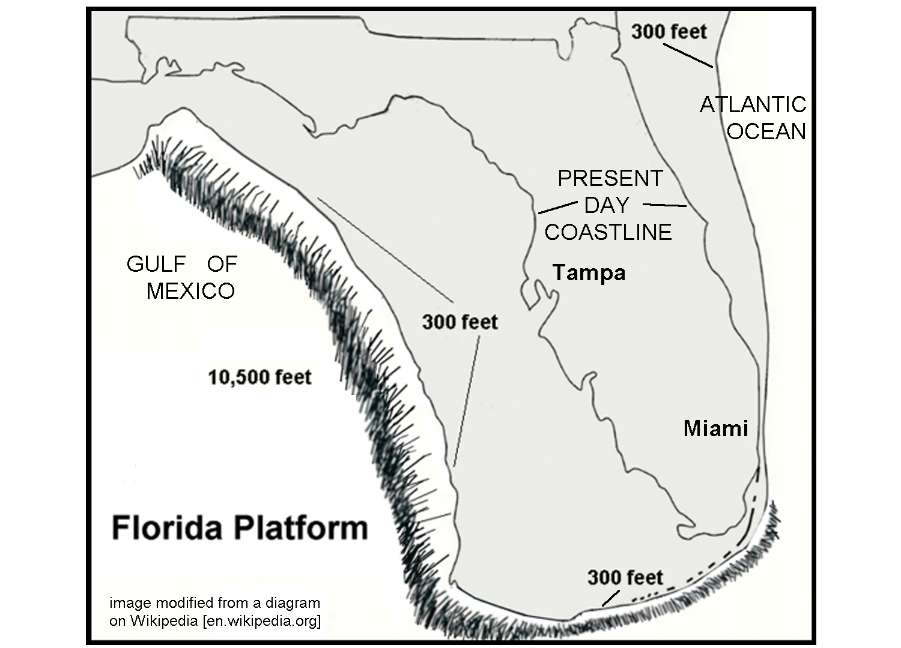
Florida’s present landscape is the result of millions of years of erosional and depositional processes. Climatic agents, such as wind, rain, and running water, along with sea level fluctuations and associated marine processes, such as waves and currents, sculpted the sediments into Florida’s present topography. Over the past 2 to 3 million years, as a result of the repeated growth and melting of continental glaciers, sea levels have fluctuated from several hundred feet above present sea level to several hundred feet below present sea level. The most recent fluctuation is a slow rise in sea level, causing a retreat of shorelines in many parts of Florida. Ancient river flows, waves, and currents created deltas, shorelines, estuaries, dunes, and sand ridges. Subsequent mechanical and chemical erosion and re-deposition reworked these sediments to produce the landscape we see today.

The higher sea levels during interglacial periods allowed longshore currents to bring tremendous quantities of sand from more northern coastal plain regions into Florida. That quartz-rich sand originated from erosion of rocks in the Appalachian Mountains and ended up blanketing most of the state, infilling any irregularities in the original limestone bedrock landscape and forming a relatively featureless sea bottom. As the seas retreated, waves shaped the sediment into a variety of relict scarps and beach ridges parallel to the modern coast. The lands in the central part of the peninsula that were not inundated by marine waters feature outcroppings of limestone that display a variety of karst features. Southernmost Florida never received the influx of quartz sand that covered the rest of the state, so carbonate deposition dominated. Where wave action sculpted the coast, broken shell fragments formed the beaches, but in protected areas behind the barrier islands and the Florida Keys, chemically precipitated carbonate muds prevailed. The area now occupied by the Everglades was a shallow marine bank, similar in form to the modern Bahama Banks. The Keys feature a mixture of living and dead coral reefs.

Geographic Features and Localities of Special Interest

There are several long, narrow ridges running north-south through the central highlands of Florida; the easternmost and highest is the Lake Wales Ridge. At one point in the past, this ridge likely extended all the way into southeastern Georgia. Along its southernmost section, the ridge is divided by a long valley containing a line of lakes. The higher ridge sections are heavily dissected by karst features, including sinkholes, solution valleys, and disappearing streams. The straight eastern edge of the Lake Wales Ridge mirrors the current shoreline to such an extent that many geologists believe this ridge actually runs along the edge of an ancient Atlantic Ocean shoreline. The lakes region extends northward to Orlando, Winter Haven and the Disney World theme park region.

Both the Atlantic and Gulf coastal areas in Central Florida feature barrier islands and other typical shoreline features similar to the Atlantic and Gulf Coastal Plains farther north. Several of the Gulf coast islands, most notably Sanibel Island (between Fort Myers and Tampa), are famed for the vast number of seashells that wash up on shore and have become tourist destinations for shell collectors. The Atlantic beaches generally have higher surf and are more heavily populated and developed. Daytona Beach is probably the most well-known location here with broad sand beaches that are so firm that they can be driven on. Cape Canaveral on the Atlantic coast is home to NASA’s primary rocket launching site.

Figure 10-2: Ancient versus Modern Coastline Geometry

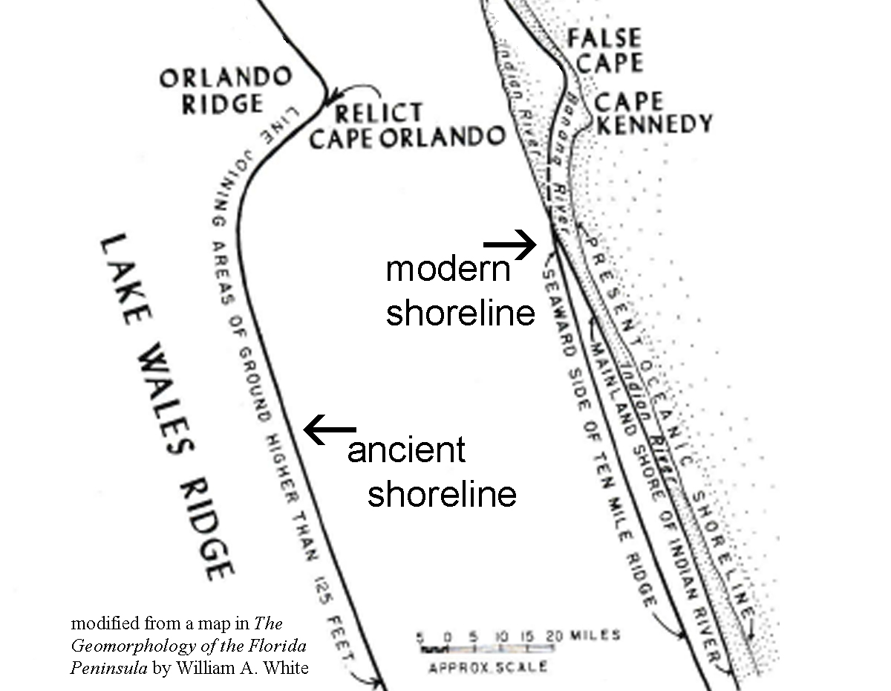

To the south of the Lake Wales Ridge is the Okeechobee Plain, an area only about 20 feet (6 meters) above sea level that extends southward to Florida Bay and the Keys. This area has perhaps the least topographic relief of any region of the country. Lake Okeechobee stretches 30 miles (48 kilometers) across the plain and occupies most of the northern portion while the Everglades comprises the southern part. Soils in the northern portion consist of insoluble clastic material on top of limestone, while in the Everglades layers of peat overlie the limestone base. Throughout this plain, the water table is either very close to, or level with, the land surface. A large volume of surface water enters the Okeechobee Plain through rivers from the north and much of the water continues to the ocean through the Everglades, providing conditions that have led to the popular description of the glades as a ‘river of grass’.

The Miami Ridge is a prominent relict sandy beach ridge north of Palm Beach, but heading southward towards Miami, the sands become more carbonate rich and oolitic in nature. Along with the compositional change, the ridge transforms into a broad low shoal a few miles wide and from 10 to 15 feet (3 to 5 meters) high. In the past, when the shoal would have been totally submerged, tidal overwash would have brought colder water from the deeper ocean into these warmer shallower areas where carbon dioxide would be released from the water causing the precipitation of calcium carbonate.
The Florida Keys are probably the most unique landforms found in the state. About 1.8 million years ago, a shallow sea covered the area along the edge of the Florida Platform. Colonies of coral became established in the warm waters along the edge and the warm subtropical climate allowed the corals to grow rapidly and abundantly. When sea level fell, the dead corals remained to form the islands of today’s Florida Keys. The modern coral reef still grows in the shallow waters seaward of the Keys. Many of the channels between Keys are formed by tidal currents moving into and out of Florida Bay.

Rock Types and Geologic History

Although ancient igneous and metamorphic rocks occur deep beneath the surface of Florida, they are inaccessible as resources and have had no effect on the geology or geography of the modern peninsula. These older rocks are found at depths of over 3,500 feet (107 meters) in the Central Peninsula, but lie more than three miles (4.8 kilometers) beneath the ground of South Florida. The only rocks exposed at or near the surface of the peninsula are relatively recent sedimentary rocks, primarily limestone, from the Cenozoic Era. Although these limestones are responsible for the development of the abundant Karst features in the Central Peninsula, throughout most of Florida the limestone has been covered by thin deposits of more recent quartz sands, silt, and clay. Recent organic deposits, primarily peat, underlie the Everglades region of South Florida.

Florida was included as part of the supercontinent Pangea that formed during the late Paleozoic Era. Tectonic and fossil evidence suggests that Florida was originally attached to northwestern Africa. When Pangea began to break apart, the rift zone, now known as the Mid-Atlantic Ridge, began pouring out basaltic rock to form the new Atlantic Ocean seafloor. The sea-floor spreading that followed separated Florida from Africa and pushed it westward along with the North American continent. As the Atlantic Ocean widened, the basaltic crust cooled and sank gradually, putting all of Florida underwater. The warm climate and shallow marine environment were perfect for the deposition of great thicknesses of carbonate rock, creating what is known as a carbonate platform. The Bahama Islands provide an excellent example of a modern analogue. Very little terrestrial sediment from North America was able to reach Florida because of the presence of a seaway that covered southern Georgia. Marine currents flowed through this seaway and carried sediments into the Gulf of Mexico, bypassing Florida completely.

The calcium carbonate which makes up most of the rocks in a carbonate platform comes from a variety of marine organisms, especially corals, which secrete limestone shells. Dead corals leave behind carbonate reefs; while the microscopic shells of certain plankton produce deposits of carbonate mud. During the Cenozoic Era, sea level fluctuated greatly and the Florida Peninsula was periodically flooded with seawater and then exposed to the air. By the time of the Pleistocene Ice Ages, the Florida Platform was almost entirely covered by various types of limestone rock. With the dramatic shoreline shifts associated with the Ice Ages, great quantities of quartz sand and other terrestrial sediment were brought southward from coastal rivers draining the Appalachian Mountains. Over the last one million years, these sands have gradually buried most of the limestones and formed most of the beaches north of Palm Beach.
Influence of Topography on Historical Events and Cultural Trends

Folklore

The earliest folktale associated with Florida began with an unknown group of Caribbean natives who told the early Spanish explorers about a so-called “fountain of youth” that existed in the mythical land of Bimini somewhere northwest of the Bahamas. Some historians believe that Ponce de Leon, first governor of Puerto Rico, heard about the magic waters and was searching for them when he discovered Florida in 1513. Others think that de Leon sailed to Florida for other reasons. Almost all agree that the mythical Bimini was probably a misplaced reference to a location in South America.

Two Accounts of the Fountain of Youth
--excerpted from accounts from Nathaniel Hawthorne and Hernando Fontaneda--

From Hawthorne’s short story “Dr. Heidegger’s Experiment”
"the famous Fountain of Youth, if I am rightly informed...in the southern part of the Floridian peninsula, not far from Lake Macaco. Its source is overshadowed by several gigantic magnolias, which, though numberless centuries old, have been kept as fresh as violets by the virtues of this wonderful water."

From the “Memoir of Fontaneda” as written by Antonio de Herrera y Tordesillas
“local tribal chiefs paid regular visits to the fountain. A frail old man could become so completely restored that he could resume ‘all manly exercises … take a new wife and beget more children.’ [the Spaniards] . . . had unsuccessfully searched every ‘river, brook, lagoon or pool’ along the Florida coast for the legendary fountain.”

Although the Spanish explorers laid claim to Florida, Spain made little effort to plant permanent colonies on the peninsula. Up until the 1800s, most of Florida remained culturally dominated by its Native American inhabitants, especially the Seminoles. The Seminole Nation still resides in the Everglades of south Florida. Animals and earth elements play a large part in their lives. Many of their necessities are obtained from animals. Out of this need, many legends have originated which even today are important to the native community. At their ceremonial festivities they gather around the campfire to listen to the old men tell strange tales about the elements and ages, long past, when supernatural animals roamed through the jungle-like forests. Here is one example.

In the Beginning
--traditional Seminole legend; version modified from https://sites.rootsweb.com--

Ages ago there was no earth, only water everywhere and no moving object except in the water. All the moving things wanted to find earth so they went deeper into the water. But their hunt was fruitless until a large crawfish, after long searching, finally found a tiny bit of earth. He told the other crawfish and they dove deeper and deeper into the water, each bringing a bit to the surface. With this earth they formed a small ball. Every day they brought up more earth and added to the ball until they had a large one. Then they did not know what to do with it.
While the crawfish had been working so industriously, the beaver had been watching, and now he came to the rescue. After they had rolled the ball of earth on to his wide, flat tail, the beaver waited patiently, begging the East Wind to help him. The East Wind blew hard, scattering the earth over the waters so that it made an island. Then the Great Father came down to earth and brought three people with him. He made a large hole in the rock between Coconut Grove and Coral Gables. A big rain came down from Heaven, filling the large rock and forming a well.
The three people camped by the well with the Great Father. They became hungry and the Great Father told them to look for something to eat. When they came back with coontie [sage palm] bread, he sent them out for more. Ever since, the coontie root has been used to make bread.

In South Florida, the cities are very cosmopolitan, comprised of retirees from northern states, Cuban refugees from the 1958 revolution, and long-time Florida residents. Since the early 1900s, most of Florida’s culture has been centered around either tourism or agriculture. Many recent legends focus on unusual events connected with places that tourists can visit and spend money. The Spook Hill site is one of the most famous. Some say the site is an optical illusion; others say it is haunted by ghosts. Locals go out of their way to promote the site as visitors lay down plenty of cash at restaurants, shops, hotels, and a nearby botanical garden.

The Legend of Spook Hill
--excerpted from Florida Urban Legends on www.floridatravellife.com--

In Lake Wales, there's a "gravity hill" that freaks out those traveling through by car. Stop your car in the right place on Spook Hill, put it in neutral and watch as your vehicle rolls UP the hill. (Just remember to turn your flashers on first; this is still an active road.) On North Wales Drive, a sign explains it: "Many years ago an Indian village on Lake Wales was plagued by raids of a huge gator. The Chief, a great warrior, killed the gator in a battle that created a small lake. The chief was buried on the north side. Pioneer mail riders first discovered their horses laboring down hill, thus naming it Spook Hill. When the road was paved, cars coasted up hill. Is this the gator seeking revenge, or the chief still trying to protect his land?

Historical Events

The first European settlement in Florida was St. Augustine, founded in 1865, however, according to the SE MAPS classification system, that location was too far north to be counted as part of the Florida Peninsula. That classification system, like most, is fairly arbitrary and subject to interpretation. Other than that city, and a few other scattered forts along the coast, the whole Florida Peninsula belonged to a variety of Native American nations until the 1800s. Although the Seminole nation is typically associated with Florida, they were not a single tribal entity, but an alliance of Florida and Georgia natives that banded together in the 1700s to fight European invaders. Because Spanish armies had already conquered the native tribes of South Florida and shipped them off to Cuba as slaves, the Seminoles were able to expand southward and are today a united sovereign nation, although their people speak two different languages and have different cultural backgrounds.

Figure 10-3: Native American Cultures in Florida

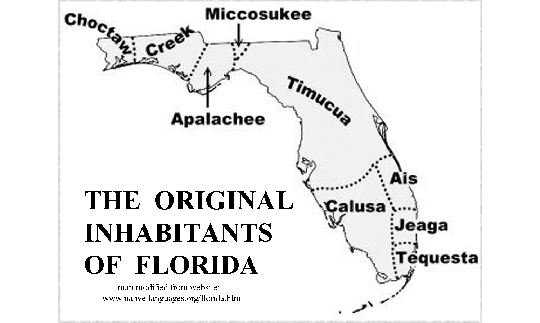

The settlement of the Florida Peninsula really began with the visit of Henry Flagler in 1878. A retired founding partner of the Standard Oil Company with John D. Rockefeller, Flagler recognized Florida’s potential for growth and built a grand hotel, the Hotel Ponce de Leon, near St. Augustine. Flagler also had his eye on developing several famous beach resorts further south and realized that all that was needed for tourist development was a reliable transportation system. Soon after, he began construction in Jacksonville on the Florida East Coast Railway, which reached Daytona Beach in 1889, West Palm Beach in 1894, Miami in 1896, and finally Key West in 1912. Flagler’s railroad handled freight as well as passengers and enabled several of these cities to become commercially viable ports for foreign trade. Flagler is also credited with starting an agricultural boom in Florida by encouraging fruit farming along his railroad line, and making many charitable contributions to build hospitals, churches and schools.

About the same time, another entrepreneur, Hamilton Disston, was also making his mark on the Florida Peninsula. Henry Sanford, a close friend, convinced him that Florida’s swampland was a bargain-priced opportunity to turn mucklands into farms and pioneer towns. Disston cut a deal with the state that allowed him to keep half of the land he reclaimed. His first goal was to clean out and deepen the Kissimmee River to Lake Okeechobee. To help the state, Disston was persuaded to buy four million acres of land at 25 cents an acre in June, 1881. The deal made him the largest landowner in the United States. Disston set up his headquarters in Kissimmee, and planned to make the St. Johns and Kissimmee River Florida’s water highways from Jacksonville to Ft. Meyers. By dredging from Lake Tohopekaliga to Lake Okeechobee and west along the Caloosahatchee River to the Gulf of Mexico, Disston was able to bring steamer travel and shipping to Kissimmee, which then became a major ship-building center. Ranchers dug smaller channels to link up with Disston’s canal system, draining marshes for pastureland in the process. As a result, groundwater levels dropped sharply. Disston also started the Florida Sugar Manufacturing Company, which planted 600 acres (243 hectares) of sugar cane around Lake Okeechobee. The last steamboat was built in 1912 after roads and railroads had replaced boat travel and shipping as preferred transportation modes.

In 1964 another major land deal was underway. The Walt Disney Company was thinking about building another theme park and while Walt Disney was flying over central Florida, he supposedly saw a large stretch of vacant land west of the intersection of Interstate 4 with the still under construction Florida Turnpike and said “This is it.” The Disney World Park opened in 1971 and soon spurred the development of various other theme parks in the Orlando-Kissimmee area, which soon formed the foundation of a lucrative tourist-based economy. Nearby Cape Canaveral was originally developed as an Air Force Test Range before being selected at the launch site for NASA rockets and manned space flight.

Influence of Topography on Commerce, Culture, and Tourism

The two pillars of commerce in the Florida Peninsula are agriculture and tourism. Some agricultural products, such as sugar cane, require a wetland landscape, but expanses of wetlands are not conducive to most other agricultural uses. Citrus growers and cattle ranchers require dry land, which is more available in the central highland areas of the state. But the mainstay of Florida’s economy remains the beaches found on both the Atlantic Ocean and Gulf of Mexico coastlines. The warm ocean waters and clean, wide, gently sloping beaches draw both tourists and locals, especially during the winter months when northerners flee to the south to avoid the cold and snow. Unique landscape features such as the Everglades and Florida Keys also draw large numbers of visitors.

Several excellent ports exist in South Florida and one of them, Miami, has become a major embarkation point for cruise lines sailing to destinations all around the world. Several National Parks in South Florida have been established to protect some of the environments that were threatened by unchecked development. Everglades National Park has been recognized as a ‘World Heritage Site’ and an ‘International Biosphere Reserve.’ Big Cypress National Preserve adjoins the northwest section of Everglades Park and helps to protect the freshwater supply that is crucial to the survival of the Everglades. Biscayne National Park is 95% water and includes the northernmost living coral reef in the continental USA. The Park extends from Key Biscayne on the north to Key Largo on the South. Dry Tortugas National Park is located 68 miles (109 kilometers) west of Key West and protects several islands, coral reefs, and associated marine life. The Cape Canaveral National Seashore protects a portion of the coastline near the Kennedy Space Center.
Natural Resources, Land Use, and Environmental Concerns

Climate and Water Resources

The climate of South Florida is classified as tropical, while the rest of the state is considered sub-tropical. Many tourism experts consider climate to have always been the state’s greatest natural resource, which is reflected in the state’s nickname, the “Sunshine State.” Summers are long and fairly warm and humid with frequent daily thunderstorms. On average, thunderstorms occur on about half of the summer days. The average July high temperature in Orlando is 92ºF (33ºC) and the average low temperature is 74ºF (23ºC). Temperatures in South Florida can get even warmer, especially away from the coastline. Florida’s humid climate is caused by the fact that no point in the state is more than 60 miles (97 kilometers) from salt water.

Winters are generally mild and frost is rare south of Orlando. The average January high temperature in Orlando is 71ºF (22ºC) and the average low temperature is 49ºF (9.5ºC). The Gulf Stream in the Atlantic Ocean and warm currents in the Gulf of Mexico also tend to keep the coastlines warmer during winter months. Southern Florida is one of the warmest places in the country during the winter.

Average annual rainfall on the Florida Peninsula is close to sixty inches (24 cm) along the coastline, but areas like the Florida Keys and interior regions around Lake Okeechobee receive much less. This region is a prime target for Atlantic hurricanes during late summer and through the fall. Torrential rainfall and storm surge flooding are of particular concern to low lying areas. Tornadoes can also affect any area of the state, but are most frequent from April through July. Florida has been called the ‘Thunderstorm Capital of the United States’ for good reason; and lightning is the state’s leading cause of weather-related death. Ecosystems responding to the relative presence of water in Central Florida vary from sandy, desert-like scrub areas in the Lake Wales Ridge to wet prairies, wooded hammocks, pine flatwoods, freshwater systems, and estuaries rich in diverse plant and animal communities.

Water is a major resource in Florida. Swamps, marshlands, coastal, and inland lakes are abundant features on the peninsula. In fact, after flying over the state or observing satellite images, one might consider calling Florida the "Water State" instead of the "Sunshine State." Water is located underground in the large Floridan Aquifer and reaches the surface through numerous springs, lakes and rivers. Places on Florida maps that end in double "e" are likely to be water-related features named by the Seminole Indians. For example, there is Okeechobee meaning "Big Water"; Kissimmee meaning "Winding Waters"; and Caloosahatchee meaning "river of the Caloosa Indians" in the Seminole language.

Soils and Agriculture

The most common soils found in the Florida Peninsula are fine sand, sand, loamy fine sand, loamy sand, sandy loam, and sandy clay. In short, the entire state is covered with various types of sandy soil. The most common type, a gray, fine soil called Myakka, is the official state soil. Sandy soils are typically loose, a trait that benefits root vegetables like potatoes, carrots, beets, and radishes. However, it is hard for sandy soil to retain water and nutrients because the quartz grains that make up the sand can’t hold on to them the same way that clay minerals do.

Florida farmers grow an astounding variety of different fruits and vegetables, but the top crops are grapefruit, oranges, cucumbers, bell peppers, tomatoes, beans, watermelon, squash, and sweet corn. The state ranks second only to California in vegetable production. Citrus fruits are grown in the lower two-thirds of the peninsula where chances of a winter freeze are less. Florida provides oranges for most of the orange juice brands sold in the country. Grapefruit, tangerines, and tangelos are other common citrus products produced in the state. Sugar cane can actually be grown anywhere in the Florida Peninsula, but the only commercially grown crops are centered around Lake Okeechobee in South Florida. Sugarcane is a tropical grass native to Asia, and it is thought that Christopher Columbus first brought the plant to the West Indies. Most Florida sugarcane is used to produce crystal or “white” sugar. The Okeechobee area has the fertile organic soil and abundant water and sunshine needed for prime growth of the crop. High labor costs prevent the industry from expanding to other areas.

Florida beef producers own over one million cows that produce a calf ‘crop’ of over 800,000 new animals a year, most of which are shipped to other states. Nearly one half of Florida’s agricultural land is used in cattle production. The inland regions provide prime grazing land and there is plenty of water available. Grass and other forage plants are renewable resources that grow naturally in the drier prairies of Florida, and birds and other wildlife populations seem to thrive on land used for cattle production. The industry also supplies a large amount of milk and dairy products for local consumption within the state. Cattle were first brought to Florida in 1521 by Spanish explorer Ponce de Leon.

Mining, Resource Extraction, and Environmental Concerns

Florida is not usually considered a mining state, but in 1990 it ranked fifth among all states in the production of non-fuel minerals. The major commodities were phosphate rock, crushed stone, and cement; however clay, heavy minerals (primarily titanium minerals), magnesium compounds, peat, and sand and gravel also provided significant economic benefit. Because of the high water table, all mining in Florida has to be done by open pit methods. Where necessary, floating dredges can be used to mine below the water table. Oil and gas, accessed by drilling, are also found in some locations in South Florida.

Florida has led the nation in phosphate production for over 100 years, providing nearly 80 percent of the world production of this important resource. Almost all phosphate produced is used to make agricultural fertilizer. The primary area for commercial production is centered along the Lake Wales Ridge region of Central Florida. The phosphate is thought to have formed in shallow water shoals near where cold nutrient-rich water was upwelling from adjacent deep-water ocean basins. The phosphate was later concentrated by wave and current action into commercially viable deposits.
Quartz sand is one of Florida’s most abundant natural resources. The majority of construction sand is mined from the ridges along the central peninsula region. This sand is used for concrete aggregate, asphalt mixtures, roadbase material, and construction fill. Cement production is widespread because all the raw materials needed: lime, silica, alumina, and iron oxide, are readily available. Sands containing heavy minerals are mined from relict beach ridge deposits far inland from the modern shoreline. Titanium-rich minerals like rutile, ilmenite, and leucoxene are the most valuable components.

Peat is formed when the rate of accumulation of dead plant material exceeds its decay rate. Waterlogged sites such as estuaries, lagoons, and coastal marshes are common environments in which peat deposits develop. Poorly drained areas like the Everglades and its surrounding marshes and swamps also tend to develop this resource. Most peat is marketed for horticultural purposes, such as soil conditioner for lawns, nurseries, and greenhouses. Some Everglades peat is left in place and used for farming.

The Florida Peninsula is not known for its oil and gas deposits, but in the extreme southern part of the state, petroleum accumulated a long time ago in porous patch reefs of Cretaceous age that were similar in form to the modern coral reefs of the Florida Keys. Wells in and around the Everglades region bring up oil and gas from these ancient rocks that lie over 10,000 feet below the land surface. Fourteen small oil fields operate in this area, but production is significant.

The Florida Aquifer underlies most of the peninsula and provides drinking water for most of the state. Unfortunately, the fact that the aquifer lies so near the surface means that it is highly susceptible to various forms of pollution, especially from landfills and areas contaminated by various types of non-point source pollution. The Karst region near the center of the peninsula features sinkholes and disappearing streams through which pollutants can enter the aquifer system. Sinkhole collapse is a common problem in central Florida, sometimes swallowing up houses, roadways, and businesses. Closer to the coast, most major cities get their water from wells. The less dense fresh water of the aquifer lies above denser salt water that seeps in from the ocean. If water is pumped from the aquifer too quickly, there is always the danger of exhausting the fresh water supply and starting to pump up salt water instead. This situation creates special problems for areas like the Florida Keys that are surrounded by salt water oceans and bays.

The Turkey Point Nuclear Generating Station is located just east of the city of Homestead next to Biscayne National Park. This site is the third largest generating station in Florida and sixth largest power plant in the country. Instead of using traditional cooling towers, the plant has a large 10 square mile (26 square kilometers) network of canals to bring in water to cool the reactors. Concerns have been raised regarding possible pollution of nearby parks or water supplies and the overheating of the water in the canals. Salt water also finds its way into the canals and can create problems. The plant was built to withstand winds of even a category 5 hurricane, but probably the most serious long-term threat is rising sea level, a situation that threatens not just the city of Miami, but low-lying Florida cities all along both the Atlantic and Gulf coasts.

PLACES TO VISIT 

Archbold Biological Station. 123 Main Dr., Venus, Florida 33960. For more information call 863-465-2571 or search online at https://www.archbold-station.org

Big Cypress National Preserve. 33100 Tamiami Trail East, Ochopee, Florida 34141. For more information call (239) 695-2000 or search online at https://www.nps.gov/bicy/index.htm

Biscayne National Park. 9700 SW 328th Street, Sir Lancelot Jones Way, Homestead, FL 33033. For more information and directions call (305) 230-1144 or search online at https://www.nps.gov/bisc/index.htm

Bok Tower Gardens/Pine Ridge Nature Preserve. 1151 Tower Boulevard, Lake Wales, FL 33853. For information call (863) 676-1408 or search online at https://boktowergardens.org/

Canaveral National Seashore Headquarters. 212 S. Washington Ave., Titusville, FL 32796. For information call (321) 267-1110 or search online at https://www.nps.gov/cana/index.htm

Daytona Beach Visitor Center. 126 East Orange Avenue, Daytona Beach, Florida 32114. For more information call 386-255-0415 or search online at https://www.daytonabeach.com/

Dry Tortugas National Park Visitor Center. 40001 SR-9336, Homestead, FL 33034. For more information call 305-242-7700 or search online at http://www.nps.gov/drto/index.htm

Everglades National Park Visitor Center. 40001 SR-9336, Homestead, FL 33034. For more information call 305-242-7700 or search online at http://www.nps.gov/ever/index.htm

John Pennekamp Coral Reef State Park. 102601 Overseas Highway (MM 102.5), Key Largo, FL 33037. For more information call 305-451-6300 or search online at https://www.pennekamppark.com/

Kennedy Space Center Visitor Complex. Space Commerce Way, Merritt Island, FL 32953. For more information call 855-433-4210 or search online at https://www.kennedyspacecenter.com/

Key West City. 1300 White St., Key West, FL 33040. For information call 305-809-3700 or search online at https://www.cityofkeywest-fl.gov/

Sanibel Island Chamber of Commerce. 1159 Causeway Road, Sanibel Island, Florida 33957. For more information and directions call 239-472-1080 or search online at https://sanibel-captiva.org/
REFERENCES AND RESOURCES

SELECTED PRINT RESOURCES

Brown, Loren (1993). Totch: A Life in the Everglades. University Press of Florida.

Burt, A. (1997). Al Burt's Florida Snow Birds, Sand Castles, and Self-Rising Crackers. Gainesville, FL: University Press of Florida

Fernald, E. A. & Purdum, E.D.(Eds.). (1998). Water Resources Atlas of Florida. Tallahassee, FL: Florida State University, Institute of Public Affairs.

Grunwald, Michael (2007). The Swamp: The Everglades, Florida, and the Politics of Paradise. Simon & Schuster.

Hacking, G.E.(date unknown). Phosphate Land Reclamation, and Introduction for Students.(Teacher and Student Study Guide).Mulberry, FL: Florida Institute of Phosphate Research and the Mulberry Phosphate Museum.

Head, C. M. & Marcus, R. B. (1998). The Face of Florida. 3rd Edition. Dubuque, IA: Kendall/Hunt Publishing Company.

Lake Wales Ridge Ecosystem Working Group. (1998). Florida's Ancient Islands: the Lake Wales Ridge. Lake Wales, FL: The Nature Conservancy.

Lane, E. (editor). (1994). Florida’s geological history and geological resources. Tallahassee, FL: Florida Geological Survey Special Publication 35.

Myers, R. L. & Ewel, J. J.(1990). Ecosystems of Florida. Orlando, FL: University of Central Florida Press.

National Aeronautics and Space Administration. (1979, October). Enviornmental Impact Statement for the Kennedy Space Center.(Final). Cape Canaveral, FL: John F. Kennedy Space Center.

Randazzo, A. F. & James, D. S.(Eds.). (1997). The Geology of Florida.Gainesville, FL: University Press of Florida Press.

Ripple, J. & Cerulean, S. (Eds.). (1999). The Wild Heart of Florida. Gainesville, FL: University Press of Florida.

Scott, Thomas (1989). Florida Phosphate Deposits (Igc Field Trip Guidebooks Series). American Geophysical Union.

Stone, R. (date unknown). Traditions - Stories of the Land, the People, the company, and the Building of a Community. Celebration, FL: Celebration Foundation.

United States Air Force and Pan American Airways, Inc. (1975). From Sand to Moondust...a narrative of Cape Canaveral, then and now. Cape Canaveral, FL: Kennedy Space Center Archives.

Williams, Joy (2003). The Florida Keys: A History & Guide Tenth Edition. Random House Trade Paperbacks, 10th edition.
SELECTED INTERNET RESOURCES (all sites were functional and accessible in 2003)

http://fermi.jhuapl.edu/states/states.html
This site gives the user access to maps of any state in the United States. Users can access Shaded relief maps, Satellite images, state maps with the counties outlined, and also a map of the area from 1895.

http://coastal.tamug.edu/am/A_Comparison_of_Beach_Replenishment_on_the_U.S._Atlantic,_Pacific,_and_GulfA_Comparison_of_Beach_Replenishment_on_the_U.S._Atlantic,_Pacific,_and_Gulf_Coasts_Coasts/index.html
This site provides a comparison of beach replenishment on the U.S. Atlantic, Pacific, and Gulf Coasts.

www.nps.gov/ever/
This site from the National Park Service offers information about the Everglades specific to teachers and students.

https://www.visitflorida.com/en-us/florida-beaches/popular-beaches.html
This site has information about the most popular beaches in Florida.

http://www.sfwmd.gov/portal/page/portal/pg_grp_sfwmd_koe/pg_sfwmd_koe_everglades
The South Florida Water Management District site has a Everglades section with links to Everglade projects & watershed sites, and the area’s restoration history. There is endless information about the ecology, biology, and hydrology of the Everglades and Florida Bay.

http://www.florida-everglades.com/totch/past.htm
This personal account of the Everglades is provided by Totch Brown. His great-grandfather, John J. Brown and grandfather C. G. McKinney were among the very first to settle in the Everglades, in 1880.

https://www.visitorlando.com/en/things-to-do/theme-parks?page=1
This site has information about several of the most popular theme parks near Orlando.

https://www.visitflorida.com/en-us/eat-drink/facts-about-florida-citrus-oranges.html
This site is full of fun and interesting facts about the Florida citrus industry.

http://www.floridaplants.com/Reprints/An%20Overview%20of%20Florida%20Sugarcane.htm
This site tells you everything about the sugar cane industry in South Florida.

www.keyshistory.org/
A virtual museum, library and encyclopedia of the geological, cultural, and natural history of the Florida Keys.

http://www.agiweb.org/geotimes/aug08/article.html?id=Travels0808.html
This article from the Geotimes magazine (Aug. 2008) gives a general description of the Keys going from Key Largo to Key West

http://www1.fipr.state.fl.us/PhosphatePrimer/0/DE30A90BA33F588485256F80007C7BC3
This site discusses Floriday’s phosphate industry and how it affects Florida’s economy. The links down the left side of the page cover a multitude of topics related to Florida’s phosphate industry.

STUDY AREA 10A: CENTRAL PENINSULA

Orlando Sentinel
September 16, 2001
Disney, Orlando have had a sometimes rocky marriage
by Mike Schneider  ORLANDO, FL. Few companies have single handedly changed a community the way Walt Disney World has since it opened the Magic Kingdom 20 years ago in a sleepy citrus and cattle town.  Orlando is now the home of seven of the world’s most popular theme parks, has more than 100,000 hotel rooms and attracts more than 40 million visitors a year.  But Disney World, which celebrates its thirtieth anniversary Oct. 1, hasn’t always acted like Prince Charming. While Disney’s presence has brought low unemployment, international name recognition, and a tax | base for local governments, it has also brought traffic jams, crowded schools and a low-wage economy.  Most local leaders argue that Disney’s presence has been well worth any social costs. “If Disney hadn’t come, would the community have gotten anything? We’d still be selling oranges and raising cattle,” said Bill Peeper, executive director of the Orlando/Orange County Convention/Visitors Bureau.  Disney chose Orlando in the 1960s because it was at the intersection of two major highways, Interstate 4 and the Florida Turnpike. Using dummy corporations to prevent land speculation, it  secretly acquired more than | 27,000 acres that eventually became the site for four major parks, eighteen hotels and three water parks.  Rollins College professor Richard Foglesong argues that Disney has received special benefits, underpaid its taxes by claiming land as agricultural instead of commercial, has competed with Orange County for bond money to expand its sewage plant, nixed plans for several community-wide rapid transit systems, and has ignored affordable housing issues affecting its workers.  Disney spokesmen respond that the park is probably the single most significant economic incentive initiative ever created.

RATIONALE

The central portion of the Florida Peninsula between Tampa Bay and Cape Canaveral displays many of the same landscape features that define the entire state of Florida. The Gulf of Mexico and Atlantic Ocean coastlines share many landforms in common, but the very different bathymetry of the two sea floors makes a huge difference in how waves, tides, and hurricanes affect the beaches and other shoreline environments. The area around Tampa Bay has been converted into a deep-water port, which is now one of the busiest in the southeast. Cape Canaveral was the location chosen for the Kennedy Space Center, and the Orlando area is home to Disney World and many other theme parks that make this the tourism center of the state.
The geologic history of Florida featured many changes in sea level. Higher sea levels left relict beaches, oriented parallel to the shoreline, all across the state. One major paleo-shoreline forms the eastern boundary of the Central Highlands region, marked by the Lake Wales Ridge with its many lakes and abundant Karst activity. Phosphate deposits, along with assemblages of fossilized bones and teeth, are abundant south of Lakeland.
PERFORMANCE OBJECTIVES

1. Compare geometry and wave behavior along barrier islands on Gulf & Atlantic shore.
2. Summarize impact of major projects like Disney World and Kennedy Space Center.
3. Explain the geological processes that formed Cape Canaveral and the nearby beaches.
4. Describe the topography and geological processes at work on the Lake Wales Ridge.
5. Compare length and velocity of dredged channel with original Kissimmee River flow.
6. Calculate surface area of both regular and irregular shapes like lakes and mining pits.
7. Identify locations where phosphate is mined and summarize economic impacts.
8. Trace optimal evacuation routes for inhabitants of coastal cities during hurricanes.
9. Explain use of metaphors in newspaper article about Disney World.
10. Write a story describing an action that has unintended consequences.

SAMPLE ASSESSMENT RUBRICS
EXAMPLE #1 (relates to Performance Objective #3)
Ask students to give a geologic explanation for how capes and barrier islands are formed along the Florida Atlantic Ocean coastline. Answer should reference ‘sediment supply’, ‘wave action’ and ‘longshore currents’ and could also reference ‘ocean currents’, ‘tidal channels’, and ‘storm or hurricane activity.’ An sample complete answer might look like: “Sand is brought into the area by longshore currents that are controlled by the direction at which waves approach the land. Deposition

A (level 4) – Answer mentions all required processes and links them correctly.
B (level 3) – Answer mentions all required processes, but links are not clear.
C (level 2) – Three processes are mentioned, but links are missing or wrong; or
Two processes are mentioned, and links are basically correct.
D (level 1) – Two processes are mentioned and links are missing or wrong; or
Only one process is mentioned, but links show some understanding
F (level 0) – No processes mentioned correctly and links show no understanding.

EXAMPLE #2 (relates to Performance Objective #9)

Give students the following short essay and ask them to list four examples of a metaphor used in the text. [metaphors in text are marked in bold type]
I was walking on the beach alone feeling blue because my best friend had broken my heart by moving away. His words had cut me like a knife. Another friend, who was like a brother to me, met me just as night fell and found me drowning in a sea of grief. He told me that hope was on the horizon and that I should grab on to it like a drowning man would grab a life preserver. He told me that life would get better, the sun would shine, and there would be nothing but clear skies up ahead for me.

A (level 4) – Four correct metaphors identified.
B (level 3) – Three correct metaphors identified.
C (level 2) – Two correct metaphors identified.
D (level 1) – One correct metaphor identified.
F (level 0) – No correct metaphors identified.
Cartographic Product Information

MAP 10A: Central Peninsula

TITLE: 3-D Central Peninsula, FL (topographic map)
DATA SOURCE: State of Florida USGS 1:500,000 Topographic Base Map
DATE: 1989
SCALE: 1:332,000 [1 inch ~ 5.25 miles] [1 cm ~ 3.4 kilometers]
OTHER IMPORTANT DATA:
- The contour interval of this map is 50 feet.
- The bathymetric contour interval of this map is 10 meters
POINTS OF SPECIAL INTEREST:
- Intracoastal Waterway is shown on both Atlantic and Gulf coastline.
OTHER FEATURES TO LOOK FOR:
- Dashed double black lines in Tampa Bay (left map edge) mark shipping channel.

TITLE: Phosphate Region, FL (aerial photograph)
DATA SOURCE: ASCS Black & White Aerial Photograph
DATE: 1952
SCALE: 1:20,000 [1 inch ~ 1.66 miles] [1 cm ~ .2 kilometers]
OTHER IMPORTANT DATA:
- The small black circles in lower left area are lakes.

TITLE: Lake Wales Ridge, FL (3-D topographic section map - anaglyph)
DATA SOURCE: Ambroziak Third Dimension Technologies, Inc., Princeton, NJ
DATE: 1998
SCALE: 1:40,000 [1 inch ~ .63 miles] [1 cm ~ .4 kilometers]
OTHER IMPORTANT DATA:
- The contour interval of this map is 5 meters (not 50 as printed on map legend).
- This map is a red/cyan (blue-green) image which must be viewed through red/cyan glasses with the red filter placed over the left eye.

TITLE: Disney World, FL (aerial photograph)
DATA SOURCE: ASCS Black & White Aerial Photograph
DATE: 1947
SCALE: 1:16,000 [1 inch ~ 1,333 feet] [1 cm ~ 160 meters]
OTHER IMPORTANT DATA:
- The irregularly shaped black areas are lakes.

TITLE: Cape Canaveral, FL (aerial photograph)
DATA SOURCE: Florida Department of Transportation Black & White aerial photograph
DATE: 1943
SCALE: 1:111,000 [1 inch ~ 1.75 miles] [1 cm ~ 1.1 kilometers]
OTHER IMPORTANT DATA:
- The light colored curved streaks across the cape represent ancient beach ridges.
Cartographic Product Information

IMAGE 10A: Central Peninsula

TITLE: 3-D Central Peninsula, FL (TM [composite satellite image])
DATA SOURCE: Landsat Composite CIR - South Florida Water Management District
DATE: 1997
SCALE: 1:332,000 [1 inch ~ 5.25 miles] [1 cm ~ 3.4 kilometers]
OTHER IMPORTANT DATA:
- This image is an infrared satellite image, so all true colors have been shifted.
- Red colors indicate woodland or other vegetation; black shows water or wetlands.
POINTS OF SPECIAL INTEREST:
- Irregular white specks over Cape Canaveral are clouds because they cast shadows
OTHER FEATURES TO LOOK FOR:
- Several ancient beach ridges show up as curved green areas on Cape Canaveral.

TITLE: Phosphate Region, FL (NAPP [infrared aerial photograph])
DATA SOURCE: NAPP CIR Photograph 6984-44
DATE: 1994
SCALE: 1:24,000 [1 inch = 2,000 feet] [1 cm ~ 250 meters]
OTHER IMPORTANT DATA:
- This image is an infrared aerial photograph, so all true colors have been shifted.

TITLE: Lake Wales Ridge, FL (NAPP [infrared aerial photograph])
DATA SOURCE: NAPP CIR Photographs 8685-66 and 8688-20
DATE: 8685-66: 1995; 8688-20: 1996
SCALE: 1:40,000 [1 inch ~ .63 miles] [1 cm ~ .4 kilometers]
OTHER IMPORTANT DATA:
- This image is an infrared aerial photograph, so all true colors have been shifted.

TITLE: Disney World, FL (NAPP [infrared aerial photograph])
DATA SOURCE: NAPP CIR Photograph 8681-102
DATE: 1995
SCALE: 1:16,000 [1 inch ~ 1,333 feet] [1 cm ~ 160 meters]
OTHER IMPORTANT DATA:
- This image is an infrared aerial photograph, so all true colors have been shifted.
- The irregularly shaped bright pinkish-red areas are golf courses.

TITLE: Cape Canaveral, FL (NAPP [infrared aerial photograph])
DATA SOURCE: NAPP CIR Photographs 6960-75 and 6960-87
DATE: 1994
SCALE: 1:136,000 [1 inch ~ 2.15 miles] [1 cm ~ 1.4 kilometers]
OTHER IMPORTANT DATA:
- This image is an infrared aerial photograph, so all true colors have been shifted.
- Bold white lines indicate boundary of area of 1943 photo coverage on MAP 10A.
Study Area Description

Comparison of Gulf and Atlantic Coasts

Florida has more coastlines than any state except Alaska. But different geologic forces at work in the Atlantic Ocean and the Gulf of Mexico have created a diverse coastline that varies from the high energy conditions that form the firm sandy Atlantic beaches at Daytona Beach to the salt marsh-estuary dominated low energy coastline found along the Gulf coast from Tarpon Springs north to Apalachicola. Barrier islands found along both coastlines are often so commercially developed that tourists are unaware that they are even on an island. Such crowding leads to concerns about evacuation during hurricane season. It also affects the water quality of the estuaries and rivers that separate the islands from the mainland and also impacts large bays like Tampa Bay. Pollutants tend to change the clarity and overall quality of the water. As a result, grass beds that used to line the bay shores and provided habitat for marine and estuarine organisms have diminished significantly in recent decades.

Figure 10A-1: Location of Beaches in Central Florida

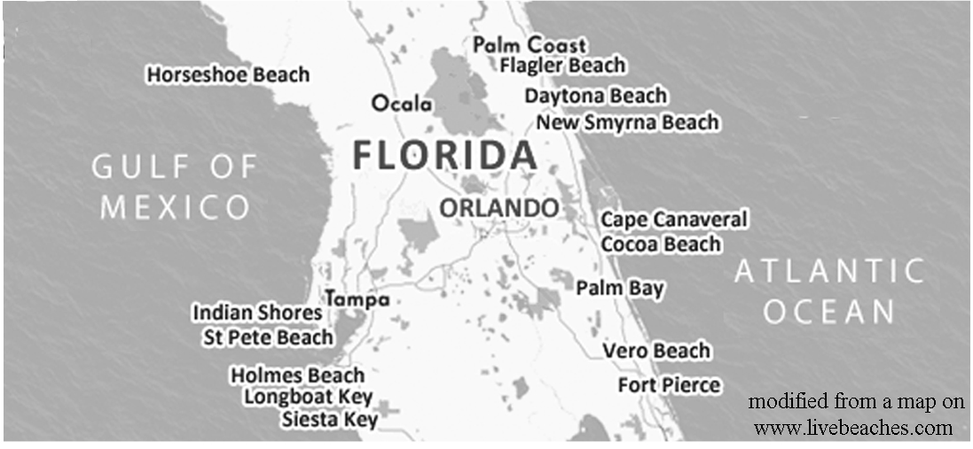

The high-energy beaches along the Atlantic coast feature better and bigger waves for surfers and others who like rougher seas. The sand is primarily composed of quartz with a few heavy minerals mixed in with it. Most of this sand originated from erosion of the rocks composing the Appalachian Mountains, transport to the ocean by rivers, and delivery to the Florida Atlantic coast by longshore currents. The sand grains are fairly large and form very firm beaches. The lower-energy beaches along the Gulf of Mexico coastline have no primary sources of sand, but have to rely on reworked sand brought to the Gulf by rivers draining the central uplands of Florida. As a result, beaches here are composed of much finer grained white powdery quartz sand that several organizations have rated as the finest in the world. Because the Gulf of Mexico is much shallower, most wave energy has dissipated by the time the waves reach shore and the water along most beaches is crystal clear. But longshore drift is still active here and the barrier islands and beaches are constantly being reformed and re-shaped by those currents.
The Gulf of Mexico coastline from Tarpon Springs northward to the Florida panhandle displays a very different morphology. Visitors to this area of the Gulf coast would find it much different than the sandy beaches along the barrier islands. There are no beaches or barrier islands present along this entire coast (there is one location named ‘Horseshoe Beach’, but there is almost no sand there to speak of). Estuaries, salt marshes, and tidal flats are the characteristic landforms found along the northwestern Gulf coastline. Two factors that contribute to the absence of beaches in this area are (1) the shallow, flat bottom profile results in little sand being scoured from the sea floor and carried landward, and (2) the small, spring fed rivers in this area carry only minor quantities of sand that could be deposited along the shore.

Where there is sufficient sand available to form barrier islands, lagoons and estuaries typically separate those islands from the more protected inland coasts. Along portions of the Atlantic coast, most of these long, narrow estuaries are just elongated lagoons, as they have no real connections to major inland rivers. A good example is the Banana River/Indian River waterway that extends almost 150 miles (241 kilometers) from New Smyrna Beach, South of Daytona Beach, to the St. Lucie Inlet south of Fort Pierce. The estuaries and lagoons on the Gulf of Mexico shoreline are much shorter and not as connected. The intracoastal waterway along both coasts takes full advantage of these estuaries and lagoons to allow boats to travel great distances without having to face the waves of the open ocean.

Estuaries, lagoons, and associated tidal flats and marshes are often referred to as the nurseries of the sea. The food web includes grazers such as the salt marsh grasshopper and marsh periwinkle, while animals like shrimp, fiddler crabs, and mullet feed directly on detritus. Less mobile organisms such as oysters, clams, and mussels filter nutrients directly from the murky water, and scavenging crabs clean up dead organic matter. Predators at the top of the food chain include such birds as clapper rails, oystercatchers, pelicans, herons, and egrets, as well as many species of fish, notably red drum, spotted seatrout, and flounder. Three-quarters of all recreational and commercially important fish and shellfish spend all or part of their lives in estuarine waters in and around salt marshes. Many species of shrimp, crabs, and fish utilize the marsh's narrow, shallow creeks as nurseries for their early larval stages. In addition to providing food and shelter for so many marine organisms, the salt marsh also filters pollutants and silt from coastal waters, and buffers adjacent highlands from wind and waves.

Hurricanes are a disruptive force that Floridians are used to dealing with. Most of the major storms that hit the United States mainland come near to or cross over parts of Florida at some point along their journey. Although the barrier islands absorb the brunt of the storm impact, the wind and storm surge can affect inland areas as well. Storm surge is an abnormal rise of water generated by a storm, over and above the predicted astronomical tides. Although the low pressure associated with the center of a hurricane can cause some sea level rise, most storm surge flooding is dependent on the strength of the wind pushing water inland. The maximum potential storm surge for a particular location depends on a number of different factors including storm intensity, forward speed, size (radius of circle of maximum winds), and angle of approach to the coast.
Other factors that can impact storm surge are the width and slope of the continental shelf and the geometry of coastal features such as bays and estuaries. A shallow slope will potentially produce a greater storm surge than a steep shelf because water will pile up near the shore and will have no available route to return to the ocean. As an example, a Category 4 storm hitting the Gulf of Mexico coastline, which has a very wide and shallow continental shelf, may produce a 20-foot (6.1 meters) storm surge, while the same hurricane in a place like Miami Beach, on the Atlantic coast, where the continental shelf drops off very quickly, might see only an 9-foot (2.7 meters) surge. The shape of a bay or estuary can also funnel the storm surge into narrow areas where the water is forced to rise because it has no easy escape route back to the ocean.

Adding to the destructive power of the floods produced by storm surge, large battering waves rising above the storm-surge sea level may cause damage to buildings directly along the coast. Water weighs approximately 1,700 pounds (771 kilograms) per cubic yard (.76 cubic meters); extended pounding by frequent wave impacts can demolish any structure not specifically designed to withstand such forces. Especially in low elevation coastal regions, the two elements work together to increase the impact on land because the height of the surge makes it possible for waves to extend far inland.

Figure 10A-2: Paths of Recent Category 4 & 5 Hurricanes
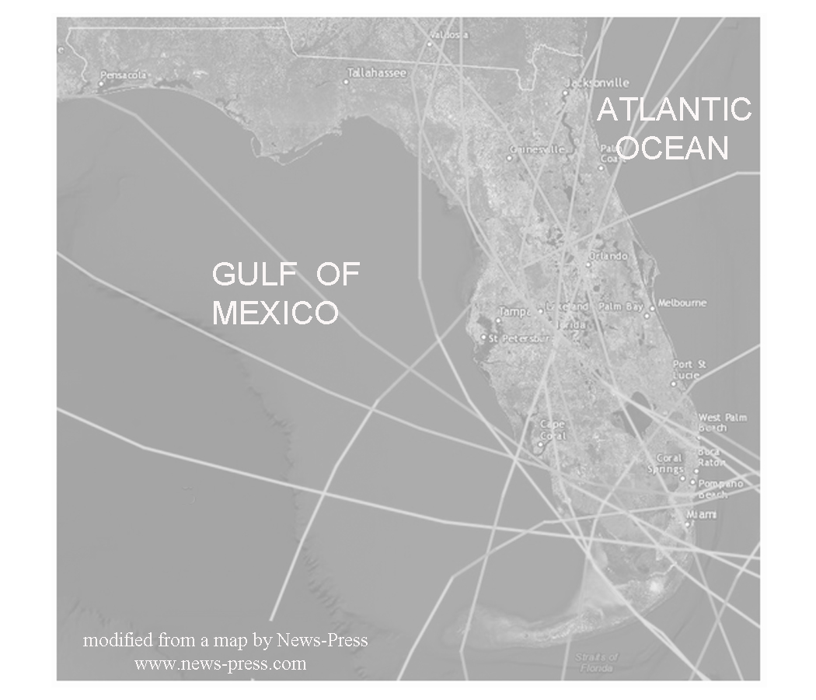
Ridges and Valleys of the Central Highlands

Through the center of Florida, a major ridge line forms a backbone of "sandhills" that is paralleled by flatlands, valleys, and gently rolling hills. These ridges form recognizable patterns that are visible on satellite images and aerial photographs. The Lake Wales Ridge is the most easterly, and the largest, running for over 100 miles (160 kilometers) though it is only a few miles wide. All the ridges run parallel to the modern Atlantic shoreline. This area is thought to represent a series of paleo-islands that dotted the shoreline at the edge of a much higher Atlantic Ocean during the mid-Cenozoic Era. In simple terms, the ridge represents a series of large sand dunes that were left behind as sea level slowly receded. The valleys represent former positions of lagoons and marshes.

Most geologists conclude that the Lake Wales Ridge has not been under water since the Mid-Cenozoic flooding episode that originally formed the line of sand dunes. Subsequent erosion has removed some of the sand deposits that covered the underlying limestone and allowed terrestrial erosion to remove much of the soluble rock now seen in the valleys. Subsequent ground water solution activity has produced a variety of karst features throughout the region. The most obvious evidence for this activity is the abundance of sinkholes and sinkhole lakes that dot the landscape, especially in the intra-ridge valley. The Polk Upland is thought to represent deposition on underwater shoals.

Figure 10A-3: Location of Lake Wales Ridge and Polk Upland

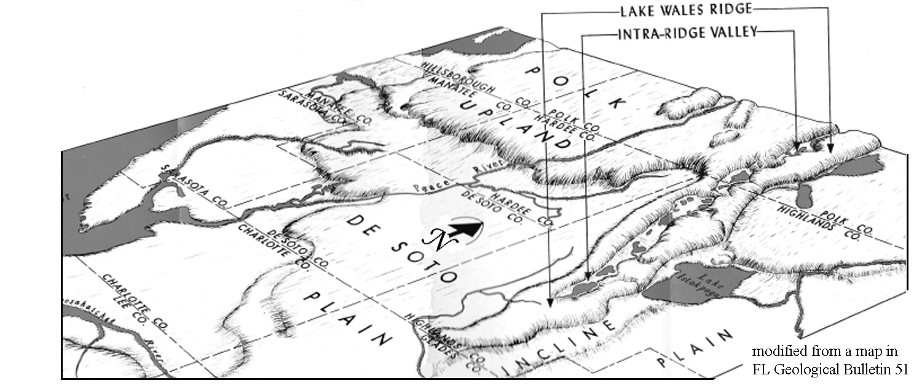

The Lake Wales Ridge features one of the most unique and under-appreciated ecosystems in the State. The flora and fauna existing on the Central Florida ridges were isolated from distant relatives during long periods of higher sea level and evolved to form one of the largest collections of rare organisms in the world. The character of the natural ecosystem is maintained by periodic wildfires, often started by lightning, that are still common events in the pine-dominated sandy habitat. The Florida Peninsula is known as one of the highest lightning strike zones in the world. One might say the Ridge environment is a relict landscape sculpted by the sea and by groundwater solution, and maintained by fire.
Early settlers discovered that the sand hills of the Central Highlands were excellent locations for citrus production and cattle ranching. Today the focus is on residential and commercial development. Approximately 85% of the dry uplands have been converted from native habitat and the remaining natural areas are stressed by habitat fragmentation. The Lake Wales Ridge area is a model of the struggle facing Florida as a whole. The citrus grower and rancher want to maintain a disappearing way of life. Developers see economic opportunity in accommodating the continuing population growth Florida is experiencing. Naturalists and ecologists see the land as the home of plants and animals found nowhere else on Earth. Many new Florida residents are now eager to maintain the natural systems just as they were when they arrived. But anyone living or working in this region needs to be aware of the ever-present danger lurking beneath the land. The same karst processes that formed the lakes are still active today and sinkholes and their accompanying ground collapse remain a constant threat.

One Sinkhole Begets 200 After Drilling
--excerpted from an article in the St. Petersburg Times, March 21, 1998--

Three weeks ago, an employee with Andy Kuka Well Drilling & Septic in Spring Hill was drilling an irrigation well for a future golf course at the new Heritage Pines development when something unexpected happened: A massive sinkhole opened up and threatened to swallow the entire drilling rig. The operator and rig made it out in time, but a crane had to be used to retrieve a truck from a 150-foot-wide, 15-foot-deep sinkhole. That wasn’t the only problem. Within 24 hours, workers identified about 200 smaller sinkholes surrounding the large hole. Most of the sinkholes were only a few feet wide, and all of them were triggered by the accident, a sinkhole expert said.
Company spokesperson Bob Fertig said. “Before we bought this property, we did a very careful geological analysis. ... We have absolutely total and complete confidence that there is no problem on this property and that this land is the safest anywhere.” As a precaution, the company agreed to conduct further ground tests. Most of the holes will be filled in, except for the larger one, which will form a lake.
Florida sinkhole expert Tony Gilboy said. “It’s very unique to have that many sinkholes in one place.” Gilboy explained that the contractor had drilled a deep hole into the Floridan Aquifer. As he was pumping air into the hole to clean it out, a large underground cavern beneath the drilling rig collapsed. The surge of several tons of dirt falling into the cavity caused a massive pressure wave through the aquifer, producing the 200 smaller sinkholes around the big hole. Gilboy added that recent heavy rains were likely also a factor.

The Polk Upland is much less affected by karst topography than the rest of the peninsula because of the abundance of sand in the underlying sediments. This area is underlain by the Bone Valley Formation, a geologic unit formed about ten million years ago by deposition of sand in wide shoals along a former coastline on the Gulf side of the peninsula. The formation is famous for its fossil content and for its abundant accumulations of phosphate minerals. The fossil bones and teeth of sharks, reptiles, and mammals found with the sedimentary deposits of phosphate ore give us a glimpse of Florida's ancient past. Phosphate deposits tend to form when the upwelling of cold, nutrient-rich, phosphorus-laden water spreads over shallow sand shoals allowing the rapid development of large populations of marine organisms such as plankton. As these organisms die and settle to the bottom, large amounts of organic material accumulate, mix with the sediments and are buried. Chemical reactions then convert the organic phosphate into mineral form. Economically significant deposits develop whenever the phosphate sediments are reworked and concentrated by current and wave action.

The Polk Upland is where 80% of the United States’ and 25% of the world's phosphate is mined. The deposits were discovered in 1881 and mining began soon afterward. Phosphate is a major component of fertilizer. Mining the phosphate deposits requires large cuts to be made in the land to uncover the ore. It is easy to detect these areas on satellite images and aerial photographs. Phosphate pits filled with water are easily distinguished from sinkhole lakes because their shape is angular rather than circular. Phosphate companies are now required to submit a plan that describes the characteristics of the land they will be mining and how it will be "reclaimed" before they can even begin to dig. Large quantities of electricity and water are required for the processing of the ore before it can be transported. Reaching decisions about balancing the use of resources, the economy, and the environmental can be difficult and perplexing.

Human Impacts on Landscapes

Ever since Henry Flagler built his railroad along Florida’s east coast, people have been moving into Florida and altering the landscape in both major and minor ways. Hamilton Disston’s channeling of the Kissimmee River turned the town of Kissimmee into a bustling inland port for a while, but destroyed many acres of wetlands in the process and caused groundwater levels in the region to drop sharply. Recent efforts by environmental agencies have spent hundreds of millions of dollars to try and change the Kissimmee River back to its original meandering course in hopes of restoring wildlife habitat and protecting the states’s fragile water supply. However, if not for Disston’s dredging work, much of central Florida would be more suitable today for mosquitos than for people and cattle. In fact, when county boundaries were first established in Florida in 1830, this area was included in the appropriately named Mosquito County. The story of the naming of the city of Orlando explains why a Native American name was not given, as was customary for so many of the towns, rivers, and geographic features of this area.

How Orlando Got Its Name
--excerpted from Tellable Cracker Tales by Annette Bruce--

In 1835, a company of U.S. soldiers was trailing a band of hostile Indians through the Lake Jessup swamp. They made camp on Sandy Beach Lake (now known as Lake Eola). After their meal, all the soldiers went to sleep except for a sentry named Orlando Reeves. In the early morning hours as fatigue was overtaking him, he thought he saw a log near some bushes move. Then he saw another log move, then another. All of the sudden they were rolling toward him. “Indians!” He gave the alarm, knowing all well it meant his death. At that moment more than a dozen poison arrows hit him. The battle was near what is now Orange, Church, and Pine Streets in the city of Orlando. When it ended the soldiers pursued the fleeing Indians. When they returned they found Reeves body and buried him beneath a tall pine. The place became known by travelers as “Orlando’s Grave.”
Five years before this battle, in 1830, the ninth county in Florida was formed -Mosquito County. It included all of what is now Orange and Seminole, most of Lake, part of Osceola, Sumter, and Volusia counties. Only seventy-three people lived in Mosquito County at that time. In 1845, the county’s name was changed to Orange, but there was still a question of what to call this new town. During a heated discussion, Judge Speer, one of the local residents, remarked that the place was often spoken of as Orlando’s Grave. He suggested that they drop the Grave and name the place Orlando. And, so it was.

Meanwhile, a different type of development was going on in Tampa Bay. In the 1880s, another railroad tycoon, Henry B. Plant, laid tracks to Tampa. This vital transportation link connected the port of Tampa to the nearby phosphate and cigar manufacturing industries and spurred rapid population growth. From fewer than 800 residents in 1880, the city boasted over 15,000 inhabitants in 1900 making it one of the largest cities in Florida. As ships got bigger and bigger, fewer and fewer of them could navigate the shallow waters of Tampa Bay, so the Army Corps of Engineers was called in to dredge out shipping lanes that they still maintain. A wealthy developer named D. P. Davis, built two artificial islands at the mouth of the Hillsborough River by dredging mud from the bottom of Tampa Bay and dumping it over two small natural islands. Several of the original structures built on Davis Islands have received national Historic Designation.

Cabo di Canaveral, or Cape Canaveral, appears on an early 16th Century Spanish map of Florida. It was one of only two geographic features identified by name. The geologic history of Cape Canaveral is evident in the beach ridge lines that mark its surface. Cape Canaveral's complex history includes Native American inhabitants, pirates, shipwrecks, hardy pioneers, US Air Force missiles, and people from around the world visiting Kennedy Space Center and viewing Space Shuttle launches. Areas not used by the Space Center are designated as a national wildlife refuge, including the Canaveral National Seashore. These areas contribute to the protection of the biodiversity of Central Florida while creating buffer zones for security at the Space Center. The area is open to the public except when testing and launch preparation are taking place.

Cape Canaveral was selected as the location for Air Force Eastern Test Range in 1948. Before that it was predominantly a farming and fishing community. It was later used as the launch site for America's Space Program, because it was isolated, relatively uninhabited, undeveloped, and more economically advantageous than comparable sites in California, Texas, and Georgia. Several nearby islands were used to house permanent tracking stations. The over-water flight range is relatively free from major world shipping lanes and groups of inhabited islands. The Cape is actually part of Merritt Island, which is separated from the mainland by the Indian River and from the Air Force Station at the Cape by the Banana River. A deep-water port was constructed for both military and commercial purposes just south of the Air Force Station in 1950. It is currently the major deep-water port on the Atlantic coast in Central Florida.
Figure 10A-4: Map of Cape Canaveral and Vicinity
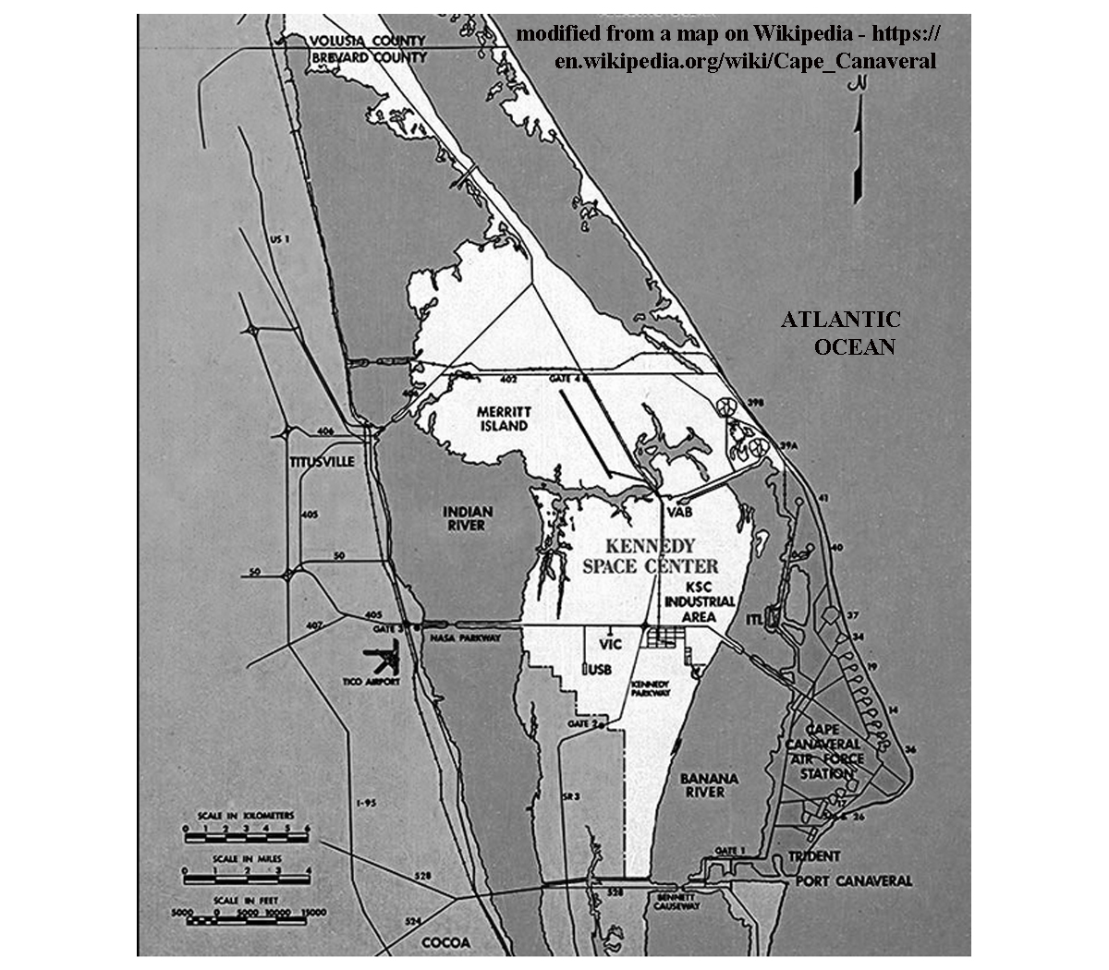

Probably the biggest human impact on Central Florida arrived with Walt Disney in 1964. Disney was looking for inexpensive property in Central Florida that could grow with his dream of a family vacation destination that offered everything right in one spot, Disney World. The intersection of Interstate 4 and the Florida Turnpike lay in the middle of cattle ranching and citrus production country; but was available for development. There was an intriguing lake with a small island on the land that would be used as a focal point for his park. The Disney Company managed secretly to acquire 27,000 acres south of Orlando before it was discovered that Walt Disney was behind the purchases. Once Disney confirmed his plans, he and his lobbyists negotiated with the Florida legislature to pass bills that would allow him receive certain tax concessions and modify the landscape.

The environmental impact of such a massive project as Disney World was considerable but unavoidable. To calm critics, Disney set aside a large tract of property called the Disney Wilderness Preserve to be managed by the Nature Conservancy. The preserve is located at the headwaters of the Kissimmee River watershed. Once the Disney Park was established, other nearby theme parks opened in quick succession, along with hotels, shopping centers, golf courses, and other tourist amenities.
Activity 10A-1: Comparison of Gulf and Atlantic Coasts

POWER THINKING EXERCISE - "Vanished Vacation"
It is your first visit in ten years to your aunt and uncle’s home near Clearwater, Florida. It looks like a perfect day for boating and a visit to the beach. The cooler is packed and you have your hat, shades, plenty of sunscreen, and you are in route to your destination, Caladesi Island State Park. You can hardly wait as you recall taking similar trips ten years ago. You remember thinking that the wide, sandy beach on the west side of the island was your idea of paradise. You also remember walking in the water and feeling the strange sensation of sand moving underneath your feet. As the boat approaches the northern tip of the island, you wonder if your memory is playing tricks on you. You don’t remember that long sand bar spit extending from the island. Even though it is a medium tide, the beach along the island is not nearly as wide as you remembered it and the Wax Myrtle bush you used to sit under is gone too. It seems like your favorite vacation spot has vanished completely. What do you think could have moved the sand around to this extent to change the shape of the island?
Find Caladesi Island State Park on the Central Peninsula topographic map on MAP 10A, CENTRAL PENINSULA (extreme upper-left corner of map). Also locate this same island on the Central Peninsula satellite image on IMAGE 10A, CENTRAL PENINSULA. How has the shape of the island changed between 1989 (map) and 1997 (image)? How would you explain the changes that have wiped out your favorite beach hangout? What events or processes are most likely responsible? Explain your answers.

Materials
MAP 10A, CENTRAL PENINSULA
IMAGE 10A, CENTRAL PENINSULA
MAP 3A, LANDSCAPES AND LANDFORMS
Wipe-off Pens

PERFORMANCE TASKS
(Icon Key) Overview = ; Science = ; Math = ; History = ; Language Arts =

1. Compare and contrast barrier islands on Gulf and Atlantic coast.
Using the Central Peninsula topographic map on MAP 10A, CENTRAL PENINSULA and the satellite image on IMAGE 10A, CENTRAL PENINSULA, identify all of the barrier islands along each coast. Compare their shape and relative size. Are all the islands parallel to the coast? Do you think their orientation is just a coincidence or are there other forces at work? Explain your reasoning. Infer which coast has a longer expanse of beachfront property. Compare the population densities of the barrier islands on both coasts. Explain how you inferred population density from the information presented on the image. Based on the infrared signatures (red color indicates vegetation), compare the amount of vegetation present on Gulf coast islands versus the Atlantic coast islands.

Also distinguish the estuarine areas on both of Central Florida’s coastlines. What evidence did you use to determine their locations? What general conclusions can you present about the location, size, and shape of estuaries along each coast? Locate the Banana River and the Indian River that separate Cape Canaveral from the mainland. Are these bodies of waters actually rivers? Explain your answer. Note that the Intracoastal Waterway is routed along the estuaries. Compare the routes of the Waterway on the Atlantic and Gulf coasts (route is marked on MAP 10A with dashed blue line. Which route is straighter? Why? Explain your answer.

Also compare the two coastlines on MAP 3A, LANDSCAPES AND LANDFORMS. Do the conclusions you reached by looking at MAP 10A and IMAGE 10A also apply to the rest of the Florida coast? Explain any differences.

2. Relate bathymetry to wave action along coast.
Compare the bathymetric contour lines along the Gulf coast with those along the Atlantic coast by examining the Central Peninsula topographic map on MAP 10A, CENTRAL PENINSULA. Which coast has the steeper underwater slope? How does the slope of the sea floor affect wave action along each coast? Explain your reasoning. Which coast would surfers be more likely to prefer. Why?

3. Estimate sun angle from shadows of clouds.
Locate several small white markings in the upper right corner of the Central Peninsula satellite image on IMAGE 10A, CENTRAL PENINSULA (over Merritt Island and Cape Canaveral). These are actually clouds. Because the clouds are below the satellite and above the land, they will cast shadows on the ground below whenever the sun is shining. Locate each cloud’s shadow and draw, with a wipe-off pen, a straight line from the center of each cloud to the center of its shadow. Compare the compass orientation of these lines to the compass rose diagram placed over the Atlantic Ocean on the lower-right portion of the image. Was this satellite image taken in the morning or afternoon? Explain your reasoning.

It is also possible to use your cloud/shadow data and some simple mathematical concepts to calculate the exact time of day the image was obtained and also the exact day of the year (there are actually two possible answers for date). In your groups, try to figure out a way to do this. Compare your methods with those of other groups.

4. Plan evacuation routes in event of approaching hurricane.
Hurricanes are often a threat to both Gulf and Atlantic coasts. Examine the Central Peninsula topographic map on MAP 10A, CENTRAL PENINSULA, to determine the most practical evacuation routes for people living in the following towns:

Floridana Beach (on Atlantic coast; lower-right corner of map)
Cocoa Beach (on Atlantic coast; center-right edge of map)
Longboat Key (on Gulf coast; lower-left corner of map)
Reddington Shores (on Gulf coast; center-left edge of map)

If these coastal towns were to be threatened by a major hurricanes and storm surge, adjoining towns on the mainland would likely be in danger of being evacuated also. Consider where the people living in nearby coastal regions would go? How far inland would be safe? What combinations of routes would best handle the increase in traffic? What inland areas would have enough facilities to support the influx of people?

5. Write diary entry describing a day at the beach.
Knowing that the beaches on the Atlantic coast are more populated and commercialized compared to the beaches on the Gulf coast, choose whether you would rather spend your vacation at Melbourne Beach (Atlantic) or Bradenton Beach (Gulf). Locate both of these beaches on the Central Peninsula topographic map on MAP 10A, CENTRAL PENINSULA and the Central Peninsula satellite image on IMAGE 10A, CENTRAL PENINSULA.

How you would spend a day at that beach if you could do everything you wanted to do? Write a diary entry summarizing your activity for the day. Share your diary entry with the class and list all the different activities that different people selected.

ENRICHMENT
(Icon Key) Overview = ; Science = ; Math = ; History = ; Language Arts =

1. Research estuarine food webs.
Estuaries make up the protected inland coasts of Central Florida’s barrier islands, waterways, and bays. Use local library or internet resources to describe the saltwater marshes and tidal flats that are typical of the estuaries in this area. Explain the ecological significance of estuaries. What is the relationship of Florida’s estuaries to recreational and commercial fishing? How do estuaries protect populations of organisms from storms? How do they assist with filtering out pollution and silt?

2. Research recent hurricanes that have impacted Central Florida.
Use local library or internet resources to research information on recent major hurricanes that have impacted the central coasts of Florida. Compare the heights of the storm surge generated by each storm. Is there a correlation between hurricane category and height of storm surge? Relate the geological factors that contribute to storm surge with the actual path and nature of each storm.

Activity 10A-2: Ridges and Valleys of the Central Highlands

POWER THINKING EXERCISE - "Bone Bonanza"
Your science teacher has taken you on a field trip to a phosphate mine near Bradley Junction, Florida. You have learned that the name of the geologic unit containing the phosphate is the Bone Valley Member of the Peace River Formation. This unit was deposited between 10 and 15 million years ago. At the mine, you and your classmates are finding an incredible variety of fossil teeth and bone fragments. Some of the teeth are from extinct Great White sharks that were at least 30 feet long. Manatee ribs, horse teeth, pieces of mammoth tusk and alligator teeth are a few of the other types of fossils being found in the deposit. While your friends are mindlessly collecting fossils, you begin to think about the apparent irony in finding remains of these creatures all mixed together in the Bone Valley. What did this part of Florida look like 10 million years ago? How could fossils of sharks, horses, mammoths, and alligators all end up in the same place? Why are there so many fossils concentrated in this one particular location? Discuss these questions in your group and share your answers with the class. Explain how you arrived at these conclusions.

Materials
MAP 10A, central peninsula
IMAGE 10A, Central peninsula
Story, “One Sinkhole Begets 200 After Drilling” on Page 10A-9
Figure 10A-3, “Location of Lake Wales Ridge and Polk Upland”
3-D Viewing Glasses
Wipe-off Pens

PERFORMANCE TASKS
(Icon Key) Overview = ; Science = ; Math = ; History = ; Language Arts =

1. Compare and contrast lakes in phosphate region and karst region.
Locate the two areas with numerous lakes near the center of the Central Peninsula topographic map on MAP 10A, CENTRAL PENINSULA. The phosphate region is located in the pink shaded area labeled “STRIP MINES” west of Bartow and Fort Meade. The karst region is located along the ridges stretching from Winter Haven to Lake Wales. Also locate these same areas on the Central Peninsula satellite image on IMAGE 10A, CENTRAL PENINSULA. Which area has the most lakes?

What differences do you observe in the size and shape of the lakes in each region? Remember that water shows up as black to light blue on the satellite image. Now make the same comparison for the lakes shown in the inset aerial photographs (PHOSPHATE REGION and LAKE WALES RIDGE) on IMAGE 10A. How are the lakes west of Bradley Junction in the Phosphate Region different from lakes shown on the Lake Wales Ridge photo? Which lakes are more likely to be natural? What are the lakes used for in each region?

2. Identify ancient shoreline and karst features.
With your 3-D glasses, examine the Lake Wales Ridge anaglyph map on MAP 10A, CENTRAL PENINSULA. Using a dark color wipe-off pen, trace the position of the ancient beach ridge. In what direction is the ridge oriented? Is the ancient shoreline completely straight? Does it form a continuous ridge, or are their breaks? Indicate at least one location that would qualify as a paleo-island (a piece of land that was well above sea level when the ocean was forming this beach ridge). How is the shape of this ‘paleo-island’ different from the topography in surrounding areas? What processes have been sculpting this landscape ever since the ocean receded to a much lower level? Examine Figure 10A-3, “Location of Lake Wales Ridge and Polk Upland” and match your tracing with the landform map. Do these maps agree? Explain your answer.

Examine the sinkhole lakes located to the west of the ancient beach ridge. Can you find a dry sinkhole? Why or why not? Where would the ancient dune field be located? Find Crooked Lake on the left-center margin of the anaglyph map. Also find Crooked Lake on the Central Peninsula topographic map on MAP 10A, CENTRAL PENINSULA. Like most lakes on the Lake Wales Ridge, this lake formed when naturally occurring acidic rain and ground water dissolved the limestone rocks deep beneath the surface and the soil and rocks collapsed into the resulting cavern. How many sinkholes do you think it took to make Crooked Lake? Explain your answer. Do you think Crooked Lake could increase in size in the future? Explain your answer.

3. Calculate surface area in terms of football fields.
Locate the large rectangular area (surrounded by roads) in the exact center of the Phosphate Region aerial photograph on IMAGE 10A, CENTRAL PENINSULA. This rectangular area has a large pond in its northwestern corner. When describing the size of a large object or area, it is sometimes helpful to use something familiar as a comparison. Your task is to represent the surface area of this rectangular region in terms of "football field" units. [Recall that a football field is 100 yards (300 feet) long and 53.3 yards (160 feet) wide]. Surface area of a rectangle is calculated by multiplying the length times the width. Express the area of the rectangle on the map as a certain number of ‘football fields’. Be prepared to show your work to explain how you handled the calculations.

4. Examine how phosphate mining has altered the landscape.
Compare features on the historic aerial photograph of the Phosphate Region on MAP 10A, CENTRAL PENINSULA with the modern aerial photograph of this same region on IMAGE 10A, CENTRAL PENINSULA. Make a list of all the pre-existing natural features that have been altered by mining operations. Which original roads still exist and which are new? How has the drainage pattern of streams been changed? Locate an area on the photograph that you think represents reclaimed land? Explain your reasoning. What is the purpose of the complex of buildings shown in the lower-left corner of the photograph?

5. Write story about event with unintended consequences.
Read the story, “One Sinkhole Begets 200 After Drilling” on Page 10A-9. The developer was attempting to complete what should have been a simple task, but a series of unfortunate events unfolded around him. Think of an event in your own life, or invent a fictional situation, in which you, or the main character, takes an action which is perfectly reasonable, but leads to a bizarre set of unintended consequences. Write a short story that recounts the experience.

ENRICHMENT
(Icon Key) Overview = ; Science = ; Math = ; History = ; Language Arts =

1. Research process of phosphate mining and uses for the product.
Use your local library collections or the internet to get more information about the phosphate mining industry. Determine how the ore is mined, how it is processed, in what form it is shipped out to retail businesses and how it is used in society.

2. Investigate scrub habitat along Lake Wales Ridge.
Plants and animals that live along the Lake Wales Ridge must be able to live in the sandy soils and survive without much water. This type of landscape is called Scrub habitat. It is fragile and many of the animals and plants that live in the Scrub are threatened or endangered species. The most important remaining patches of scrub habitat lie along the Lake Wales Ridge. Use local library or internet resources to investigate which plants and animals typically inhabit such Scrub habitat. Note which of these are considered threatened or endangered?

Activity 10A-3: Human Impacts on Landscapes

POWER THINKING EXERCISE - "Park Placement"
You are a land developer living in Winter Haven, Florida (near the exact center of the Central Peninsula topographic map on MAP 10A, CENTRAL PENINSULA). A nearby attraction, Cypress Gardens, used to be a big tourist destination before Disney World and other theme parks closer to Orlando opened. Now almost nobody comes to Winter Haven any more and the economy has suffered greatly. You have a plan to bring people back to your area by constructing a new and different kind of theme park. You have chosen a location between Auburndale and Polk City that is relatively uninhabited, but that is very close to Interstate 4. Locate this site on both MAP 10A and the Central Peninsula satellite image on IMAGE 10A, CENTRAL PENINSULA. There are several lakes already on this property.
Prepare a proposal to bring to the Winter Haven City Council. Explain what type of theme park you are proposing to build, how you will incorporate the existing lakes into your facility, and what alterations you will be making to the natural environment. Be prepared to answer questions about changes in drainage patterns, the dangers of sinkhole collapse, road improvements to handle increased traffic, and how you intend to handle expected environmental problems from various kinds of non-point source pollution. Do you think the City Council will approve your plan?

Materials
MAP 10A, CENTRAL PENINSULA
IMAGE 10A, CENTRAL PENINSULA
newspaper story, “Disney, Orlando have had a sometimes rocky marriage” on Page 10A-1
Wipe-off Pens

PERFORMANCE TASKS
(Icon Key) Overview = ; Science = ; Math = ; History = ; Language Arts =

1. Document alterations to landscape associated with development.
Three historical black and white aerial photographs are included as inserts at the bottom of MAP 10A, CENTRAL PENINSULA. Those photographs show what the landscape was like before development occurred at the Phosphate Region, Disney World, and Cape Canaveral. More modern infrared aerial photographs of the same three regions are included as inserts at the bottom of IMAGE 10A, CENTRAL PENINSULA. Choose one of these three sites to investigate and answer the following questions about that site that relate to alteration of the landscape.

- Have any noticeable changes been made to the land surface?
- Have any noticeable changes been made to the drainage pattern (streams/lakes)?
- Have any noticeable changes been made to the road/highway system?
- What structures (buildings, other features) have been added or subtracted?
- Identify any sources of pollution (point source or non-point source) that are new?

2. Evaluate environmental effects of channeling Kissimmee River.
Hamilton Disston is given credit for turning the swamplands around Kissimmee into productive land for farms and pioneer towns. He accomplished this by dredging and straightening the Kissimmee River. Locate the city of Kissimmee and Lake Tohopekaliga on the Central Peninsula topographic map on MAP 10A, CENTRAL PENINSULA (right-center of map near top border). Also locate these two features on the satellite image on IMAGE 10A, CENTRAL PENINSULA. Trace the path of the Kissimmee River (not labeled) southward from Lake Tohopekaliga through Cypress Lake and Lake Kissimmee until the river runs off the map just east of Avon Park.

Compare the path of the Kissimmee River and its tributaries to paths of other rivers further east (between cities of Kissimmee and St. Cloud and the coastline). What is different about the flow patterns of the Kissimmee River system? Do you notice anything unusual about the river’s path? How would you relate those unusual patterns to Disston’s dredging and straightening project? Explain your answer.

Why do you think environmental groups are currently trying to undo Disston’s dredging work and turn the Kissimmee River back into a meandering stream?

3. Calculate the ‘par’ score for golf course.
Locate the golf courses at the left edge of the parking lot located in the exact center of the Disney World aerial photograph on IMAGE 10A, CENTRAL PENINSULA. There are actually two separate golf courses visible here with the clubhouse located in between the two courses. Each course contains 18 holes. For each hole, the fairway shows up as a narrow bright red band, sand traps show up as white patches, and greens (the area where the actual hole is located) show up as small circles of even brighter red color. The sand traps usually are grouped around the green.

Select one of the two golf courses at this site (there are other golf courses on the right edge of the photograph, but not all those holes show up on this photograph). Calculate the par value for each hole on the golf course you selected. To do this you must use the scale bar to determine the length of each fairway on the course. Any distance less than 300 yards should be counted as Par 3. Any distance between 300 and 400 yards should be counted as Par 4, and any distance over 400 yards should be counted as Par 5. Golf course distances are usually measured in yards, but the scale bar is marked off in feet. Remember that there are three feet in one yard. Add up your answers (all 18 holes) to calculate the total par value for the course.

4. Locate features around port of Tampa Bay.
Locate the Tampa Bay harbor and port on the left side of the Central Peninsula topographic map on MAP 10A, CENTRAL PENINSULA. Also find this location on the Central Peninsula satellite image on IMAGE 10A, CENTRAL PENINSULA. Consider the features that are necessary for a major port to be successful and determine how many of these are found in the Tampa Bay area. Locate the waterway route from the Gulf of Mexico to and from the port of Tampa. What features make Tampa an especially good port? Locate the highway that crosses over Tampa Bay from Bradenton to St. Petersburg. Considering the location of this highway route, how are large ships able to enter and exit the port? Locate the two artificial islands (the Davis Islands - these are not labeled) on either side of where the Hillsborough River enters the Bay. Are there any sections of the shoreline of Tampa Bay that you think have been altered from their natural state? Mark these locations with a wipe-off pen and make a list describing these occurrences. Compare your list with other groups.

5. Identify metaphors used in newspaper story.
Metaphors are figures of speech that describe an object, person, or action in a way that is not literally true, but helps explain an idea or make a comparison. For example, in the title of the newspaper article on Page 10A-1, “Disney, Orlando have had a sometimes rocky marriage,” the term “rocky marriage” represents a metaphor. A corporation and a city can not really ‘get married’ but the intent of the reference is to let people know that the Disney Corporation and the City of Orlando have had a very close relationship over the years. The ‘rocky’ part of the reference implies that the relationship has not always been smooth or comfortable.

Read through the newspaper article on Page 10A-1 and look for other metaphors. When you find them (there are at least two more), write them down and also write a short explanation of what the reference really means and why the author used it.

ENRICHMENT
(Icon Key) Overview = ; Science = ; Math = ; History = ; Language Arts =

1. Research career of Hamilton Disston.
In addition to dredging the Kissimmee River and turning the town into a thriving seaport for a while, businessman Hamilton Disston was a shrewd land speculator. After inheriting a large fortune from his father, who manufactured saws in Philadelphia, Disston purchased four million acres of Florida land in 1881 at a cost of 25 cents per acre. That deal made him the largest landowner in the United States at that time. Disston had many other interesting business dealings. Use local library or internet resources to investigate other aspects of his career. Prepare a short oral report to share with the class.

2. Research history associated with Indian River lagoon.
The Indian River is located between Merritt Island (home of the Kennedy Space Center at Cape Canaveral) and the mainland. In reality, the Indian River is not a river at all, but a long, narrow lagoon that stretches for almost one hundred miles along the Atlantic coastline of Central Florida. It is one of the most productive estuaries in the United States and has been a vital resource for humans for many thousands of years. Fossils and human remains from hundreds of years ago have also been found nearby. Use local library or internet resources to research what resources made this area so attractive to human settlement, and what impact those settlements had on the coastline of Florida, past and present.

STUDY AREA 10B: SOUTH FLORIDA REGION

The Washington Post
February 18, 2001
‘Big Water’ at historic low due to drought in Florida
MIAMI, FL. At his tackle shop near Lake Okeechobee, Bubba Helton has grown accustomed to listening to the boaters’ grumbles this winter season. Water levels at the nation’s second-largest freshwater lake – the ‘Big Water’ of the Seminoles, the reservoir for all of southeast Florida - are critically, historically, low, and more boats are running aground than are catching crappie.  “It’s making it hard for our northern visitors - they’re trying to navigate the lake and they’re scared of it.” Helton said. “There’s not a whole lot you can say - the whole continental United States is under a drought. We don’t have no control | over the man upstairs.”  What happens up at Lake Okeechobee has a direct impact on the dense population centers of Miami-Dada, Broward and Palm Beach counties. Although much of South Florida’s immediate water supply comes from underground aquifers, Lake Okeechobee on Palm Beach County’s western edge, with its miles of canals, levees and lock systems, provides the backup during the dry season. Unfortunately, the dry season here, extending now through May, coincides with the tourist season, when thousands of additional consumers want water.  Because of the already low | water levels at Lake Okeechobee and drought conditions that are the worst since 1961, area water authorities have ordered a series of clampdowns on water use - the latest being the most restrictive.  Water levels in the Everglades are one to two feet below normal, making navigation difficult, even with airboats, (light boats that can skim over the swamp’s surface). Shallow municipal and private wells are sucking air, saltwater is creeping into well fields in southwest Florida, and officials are scrambling to keep towns around Lake Okeechobee from running out of drinking water.

RATIONALE

The landscapes of South Florida are very different from the rest of the Southeastern United States. Most of the region lies at or near sea level with the Everglades covering the majority of the land. This so-called River of Grass extends from Lake Okeechobee to the southern tip of Florida and is home to an amazingly diverse mix of plants and animals. The only living coral reefs in the mainland U.S. occur along the Florida Keys where conditions are just right for their growth and the water is warm enough year round to insure their survival. Periodic hurricanes affect the region as well.
Water has been the dominant force affecting population growth in South Florida. Early settlements like Coconut Grove and Miami were originally located along the limestone exposures of the Miami Ridge, but soon spread rapidly into the Everglades, requiring the construction of hundreds of canals to drain the wetlands. A highway and railroad route across the Florida Keys brought fame and fortune to Key West. Despite the abundance of fresh water in the area, saltwater incursion into wells has become a major environmental problem.
PERFORMANCE OBJECTIVES

1. Identify landform features of Florida Keys.
2. Correlate land use to symbols and colors on maps and aerial images.
3. Investigate causes and effects of salt water incursion into wells.
4. Explain shoreline changes over time.
5. Calculate percentage of watershed area lost due to land use changes.
6. Calculate area and perimeter of typical sugarcane field.
7. Identify location and use of historic buildings in Coconut Grove.
8. Determine type of agricultural land use from evidence on maps and aerial images.
9. Re-write factual account of events or experiences from a personal perspective.
10. Explain etymology of names used for geographic features.

SAMPLE ASSESSMENT RUBRICS
EXAMPLE #1 (relates to Performance Objective #2)
Give students a copy of MAP 10B, SOUTH FLORIDA and have them circle on both the map and the satellite image, with a wipe-off pen, the primary area for sugarcane production in South Florida. Also ask them to name one identifying factor on either the map or image that helped them identify the site.

Answer: sugarcane area is along southeastern shoreline of Lake Okeechobee; evidence on map is dense network of rectangular drainage canals; evidence on image is red color indicating healthy vegetation not part of wetland.

A (level 4) – location is correct on both map and image; explanation correct.
B (level 3) – location is correct on both map and image; explanation incorrect, or
Location correct on map or photo but not both; explanation correct.
C (level 2) – location is correct on map or photo but not both; explanation incorrect
D (level 1) – location incorrect on both map and photo, but explanation is logical.
F (level 0) – location incorrect on both map and photo, explanation is incorrect.

EXAMPLE #2 (relates to Performance Objective #3)
Ask students to name four environmental or human-induced factors that could increase the chance for salt-water incursion into a drinking-water well.

Answers could include any of the following: lack of rainfall (lowering the water table); diversion of surface water through canals; over-pumping of well (increased water consumption); expansion of agriculture (using water to irrigate plants); placing another well too close to existing well (will draw down water table).

A (level 4) – four factors are named correctly
B (level 3) – three factors are named correctly
C (level 2) – two factors are named correctly
D (level 1) – one factor is named correctly
F (level 0) – none of the factors are named correctly

Cartographic Product Information

MAP 10B: South Florida

TITLE: South Florida, FL (topographic map)
DATA SOURCE: State of Florida USGS 1:500,000 Topographic Base Map
DATE: 1989
SCALE: 1:577,777 [1 inch ~ 9.5 miles] [1 cm ~ 5.8 kilometers]
OTHER IMPORTANT DATA:
- The contour interval is 50 feet; but there are no contour lines shown on this map.
- The bathymetric contour interval is 10 meters.
- Reddish color represents national & state parks, wildlife refuges, reservations, etc
- For oceans, darker blue means deeper water; lighter blue indicates shallow water.
- Rectangular or straight blue lines on land represent canals or dredged streams.
POINTS OF SPECIAL INTEREST:
- Lake Okeechobee (not labeled) is located near center at top edge of map.
- Port Mayaca is located just off top of map on east shore of Lake Okeechobee.
- City of Miami is located at center-right edge of map on Atlantic Ocean.
= Coconut Grove (not labeled) is located between Miami and Coral Gables.
- Key West is located in the bottom left corner of the map.
OTHER FEATURES TO LOOK FOR:
- The Intracoastal Waterway is marked by dashed blue line and labeled.

TITLE: South Florida, FL (TM [satellite image])
DATA SOURCE: Landsat Composite CIR; South Florida Water Management District
DATE: 1997
SCALE: 1:577,777 [1 inch ~ 9.5 miles] [1 cm ~ 5.8 kilometers]
OTHER IMPORTANT DATA:
- This image is an infrared satellite image, so all true colors have been shifted.
- Red colors indicate forest or grassland; pink indicates highly populated areas.
- blues and greens indicate wetlands or marshes.
- black indicates clear water; milky blue colors represent sediment-laden water.
POINTS OF SPECIAL INTEREST:
- Lake Okeechobee is located along upper-center of image along top edge.
- City of Miami is located along center-right edge of map along ocean.
OTHER FEATURES TO LOOK FOR:
- Shallow shoals in Florida Bay landward of the keys are dark purplish-blue color.

TITLE: Windley Key, FL (topographic map) [actually this is Lignumvitae Key!]
DATA SOURCE: Florida Resources and Environmental Analysis Center; Fla. State Univ.
DATE: 1850 and 1999
SCALE: 1:76,000 [1 inch ~ 1.2 miles] [1 cm ~ .76 kilometers]
OTHER IMPORTANT DATA:
- The red lines represent the 1850 shorelines; white areas show 1999 shorelines.

Cartographic Product Information

IMAGE 10B: South Florida

TITLE: Port Mayaca (NAPP [infrared aerial photograph]
DATA SOURCE: NAPP CIR aerial photograph [exact frame unknown]
Exact location: Latitude = 26º 56’ 50.58” Longitude = 80º 35’ 32.66”
DATE: 1996
SCALE: approximately 1:12,000 [1 inch = 1,000 feet] [1 cm ~ 120 meters]
OTHER IMPORTANT DATA:
- This image is an infrared aerial photograph, so all true colors have been shifted.
- The map legend lists this image as an ‘orthophotoquad’. It is not.
POINTS OF SPECIAL INTEREST:
- Lake Okeechobee is not shown, but is located just beyond the left edge of image.
OTHER FEATURES TO LOOK FOR:
- The body of water in the center of the image is actually a quarry.

TITLE: Coconut Grove, FL (NAPP [aerial photograph]); 1896 Map; 1896 Historic Sketch
DATA SOURCE: aerial photograph = NAPP CIR Photograph 8954-175
1896 map = Florida Resources and Environmental Analysis Center, Fl. State Univ.
1896 historic sketch = Historical Museum of Southern Florida, Miami, Florida
DATE: NAPP = 1996; 1896 map = 1999; 1896 historic sketch = 1896
SCALE: NAPP: 1:6,000 [1 inch = 500 feet] [1 cm = 60 meters]
1896 map and historic sketch: 1:6,000 [1 inch = 500 feet] [1 cm = 60 meters]
OTHER IMPORTANT DATA:
- The NAPP image is an infrared aerial photo, so all true colors have been shifted.
- The compass rose (indicating direction of north) is different on historic sketch.
POINTS OF SPECIAL INTEREST:
- The historic sketch includes : #18 public bathhouses and #15 community trail.
OTHER FEATURES TO LOOK FOR:
- Numbered features on historic sketch are explained in legend.
- The numerous white dots in Biscayne Bay on the NAPP image are boats.

TITLE: Windley Key, FL (NAPP [aerial photograph]) and Black & White aerial photo
NOTE: photos are mislabeled - [actually this is Lignumvitae Key!]
DATA SOURCE: NAPP CIR Photographs 6962-86; 6962-88; 6962-92; 6962-94
Black & White photograph: U.S. Coast and Geodetic Survey
DATE: Black and white photo: 1951; NAPP photo: 1994
SCALE: 1:50,000 [1 inch ~ .79 miles] [1 cm ~ .5 kilometers]
OTHER IMPORTANT DATA:
- The NAPP image is an infrared aerial photo, so all true colors have been shifted.
- The NAPP red colors indicate forests and dry land; light blue areas are shoals.
POINTS OF SPECIAL INTEREST:
- Look for differences in shapes of underwater shoals between two time periods.
OTHER FEATURES TO LOOK FOR:
- Compare features on these photos with topographic map on MAP 10B.
Study Area Description

Everglades and Water Issues

The Everglades may be the flattest landscape anywhere in the world. Originally, it was a wetland that covered much of South Florida south of Lake Okeechobee. It encompassed nearly 3 million acres (1.2 million hectares) of peat soil covered mostly by tall saw grass growing in shallow water with a few higher mounds and tree islands mixed in. Whenever Lake Okeechobee was full, water overflowed the banks and moved slowly southward as a 50 mile (80 kilometer) wide, 100 mile (160 kilometer) long river, often called the River of Grass, that emptied into Florida Bay. But over the past hundred years, this drainage system has been disrupted in many ways. The Kissimmee River, primary source of inflow to Lake Okeechobee, was dredged and straightened, destroying wetlands and exposing the organic muck soil to the air. Agricultural fields, watered by irrigation ditches, gradually took over the landscape both above and below Lake Okeechobee. Flood prevention projects have altered the natural water flow patterns considerably; over 1,400 miles (2,253 kilometers) of drainage canals and levees have diverted water directly into the ocean, bypassing the Everglades completely.

Figure 10B-1: Original versus Present Extent of Everglades

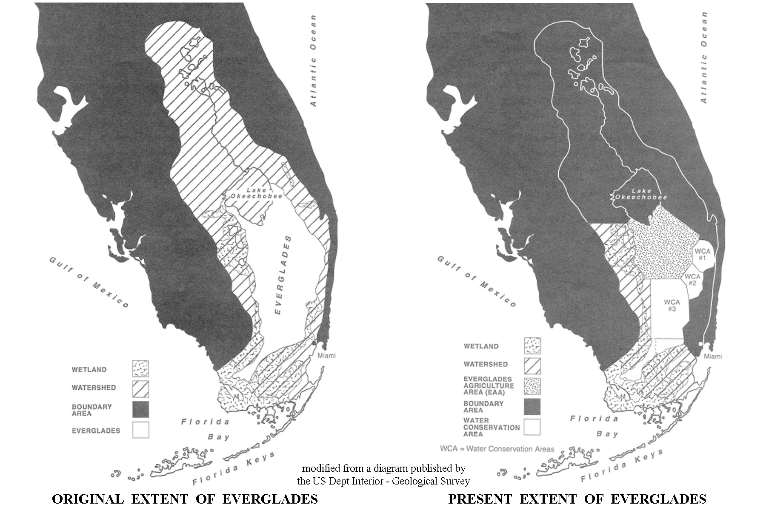

The landscape of the Everglades can be divided into three zones. The northern portion is a completely freshwater marsh consisting of a vast plain of sawgrass interrupted in a seemingly random fashion by small islands of oak, pine, and palm trees. These islands are known as hammocks, or tree islands, which rise slightly higher in elevation than the rest of the wetland. Most are of relatively recent construction and are built up by organic processes. They rarely flood and are often surrounded by areas of open water that protects the vegetation from fire. The woody shrubs and trees provide shelter for birds, mammals, and reptiles that spend part of their day feeding in the open prairie, but need shelter to hide from predators. Typical water depths are only a few feet above the peat deposits that underlie most of the Everglades, and may be only a few inches deep above limestone rock in areas without peat accumulation.

Figure 10B-2: Progressive Development of Tree Islands

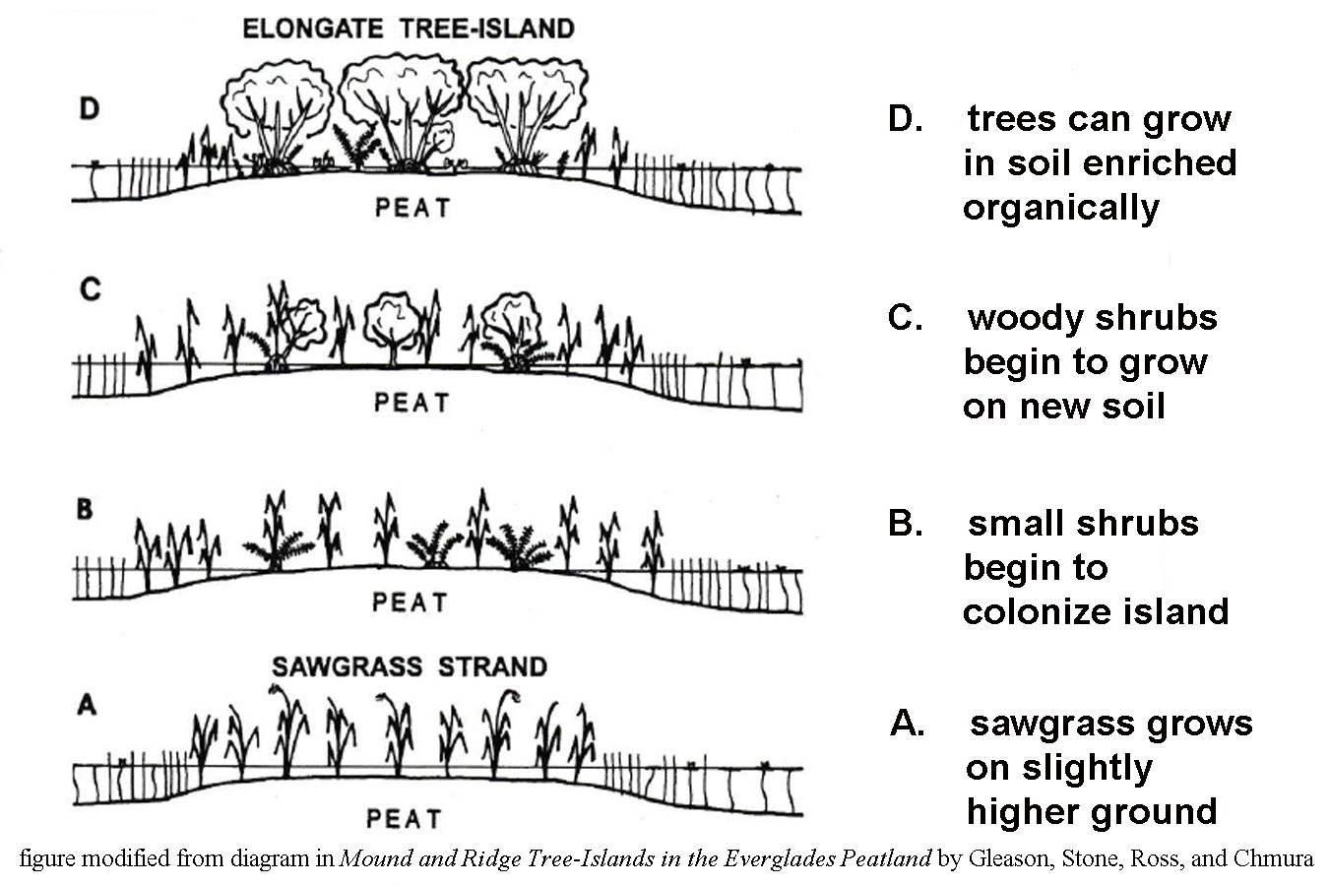

The central portion of the Everglades is a mangrove dominated estuary, meaning the area experiences a mixture of fresh and salt water habitats. The term ‘mangrove’ is often used to refer to several different species of salt-tolerant trees that thrive in this environment, not just the mangrove tree itself. Real mangrove trees can be identified by their stilt-like roots that give the appearance of rising above the water. The tangled root structures are built to withstand the harsh growing conditions in the area as well as tidal fluctuations. This habitat is a valuable nursery for a variety of recreationally and commercially important marine species. Wading birds also congregate here to feed and nest. Mangrove forests along the coast also provide a line of defense from hurricane damage by stabilizing the coastline. Florida law prevents the removal of mangroves.

The southern portion of the Everglades lies along Florida Bay and is dominated by mangrove swamps and other salt water habitats, although the salinity is lessened by the significant input of fresh water reaching that coastline. American crocodiles prefer this habitat because they like to live in saltwater and lay their eggs on sandy beaches. Loss of habitat has put this animal on the endangered list and biologists estimate there are less than 500 individuals left. The Everglades are the only place on earth where salt water crocodiles and fresh water alligators occur together in the wild.

Today, more than 50 percent of the original Everglades landscape has been destroyed by a combination of drainage for agricultural use, diversion of water for flood-control, and other land use modifications associated with expanding populations of coastal cities. These alterations to the landscape have affected both the quantity and quality of the drinking water available to South Florida. Although most of the cities get their water from wells, pollution in the Everglades can seep into aquifers through the porous limestone rock underlying the entire region. Farming operations use numerous chemicals on their crops, including fertilizers, insecticides, herbicides, and fungicides. All those pollutants find their way into both surface and subsurface waters. In addition, storm water runoff from populated areas is responsible for adding several non-point source pollutants, such as heavy metals and petroleum residue, to the mix.

Without sufficient fresh water being delivered to the Everglades, the area cannot support as much aquatic life, which causes problems for the alligators, storks, and other animals that depend on that aquatic life as a food source. The decrease in fresh water reaching Florida Bay has increased the salinity of that waterway and altered habitats there as well. Finally, the decrease in fresh water, and the increasing demand for water from growing population centers, has lowered the ground water table to the extent that salt-water incursion into wells has become a persistent problem. Normally, the less dense fresh water sits above the denser salt water, but as more and more fresh water is removed, the fresh water lens becomes thinner and thinner and the saltwater level rises in the wells.

Figure 10B-3: Salt Water Incursion into Wells

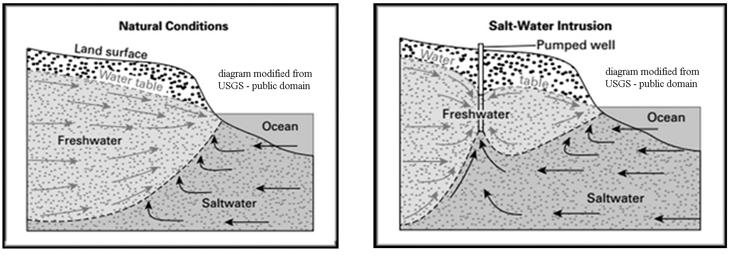

The Florida Keys

One of the most unique landscapes in the United States is located off the extreme southern tip of Florida. The Florida Keys are technically a coral-reef based archipelago of islands strung out along the southern edge of the Florida Platform, where the deep, cold water of the Atlantic Ocean meets the warm, shallow water of Florida Bay. The reefs begin just south of Biscayne Bay and extend past Key West, the westernmost inhabited island, all the way to the Dry Tortugas, a distance of almost 200 miles (322 kilometers). The Keys themselves are the dead remnants of a previous generation of coral reefs that are now stranded above sea level and undergoing erosion. Modern active coral reefs are found underwater just a short distance seaward from the coastline. Geologically, the Keys are divided into an older, higher part of the reef surface stretching from Upper Matecumbe Key to Biscayne Bay that shows minor evidence of karst development and erosion and some topographic relief; to a younger, lower reef surface extending from Lower Matecumbe Key to the western end of the archipelago. Elevations in the older section of the Keys reach 18 feet (5.5 meters). The newer reef land surfaces to the west are only half that elevation with much lower topographic relief.

Several state parks highlight both the natural and historic features of the Keys. John Pennekamp Coral Reef State Park was the country’s first underwater park. It encompasses 70 nautical square miles (240 square kilometers) in which visitors can view wide expanses of colorful living coral reefs and other marine life from the convenience of a glass-bottom boat. Several of the coral reefs are less than 10 feet (3 meters) below the sea surface. The Windley Key Fossil Reef Geological State Park, also in the upper Keys, features an historic quarry that mined a decorative coralline limestone called ‘keystone’ and exposes an extensive cross section of the ancient reef that contains examples of fossil corals and other ancient marine life. Lignumvitae Key Botanical State Park is located on a small 300 acre (121 hectare) island in Florida Bay, accessible only by boat from Lower Matecumbe Key. It features a virgin, tropical hardwood hammock, or tree-island that showcases a variety of endangered plants, protected insects, and birds.

Most of the western keys are designated as National Wildlife Refuges that provide protection to animals like the Key Deer. Shallow submerged oolitic limestone shoals cover parts of the muddy bottom of Florida Bay, landward of the Keys. The coral reefs themselves are part of the third longest barrier reef in the world. They constitute a fragile habitat that is extremely diverse, containing more varieties of life than any other marine ecosystem. Both the ocean and bay sides of the keys are fringed by mangrove forests.

The Dry Tortugas National Park is located on the westernmost islands in the Florida Keys archipelago. The seven sandy islands are technically uninhabited and can only be reached by seaplane, or by a two-hour boat ride from Key West, over 70 miles (113 kilometers) of open water. The land area of the islands make up less than 1% of the area of the park; the real attraction is the surrounding shallow shoals featuring underwater living coral reefs and crystal clear water. “Tortugas” means “turtles” in Spanish, and Ponce de Leon himself caught over 100 sea turtles during his time on the island. The name “Dry” Tortugas was later given to the island to indicate to other mariners that the land mass lacked fresh water, which was an extremely important detail for seafarers to know. The strategic location of these islands along the main shipping channel between the Gulf of Mexico, the western Caribbean, and the Atlantic Ocean brought large numbers of vessels through these waters. Fort Jefferson, on Garden Key, was constructed between 1846 and 1875 to protect the nation’s gateway to the Gulf of Mexico.
Figure 10B-4: Map of Dry Tortugas - Main Islands
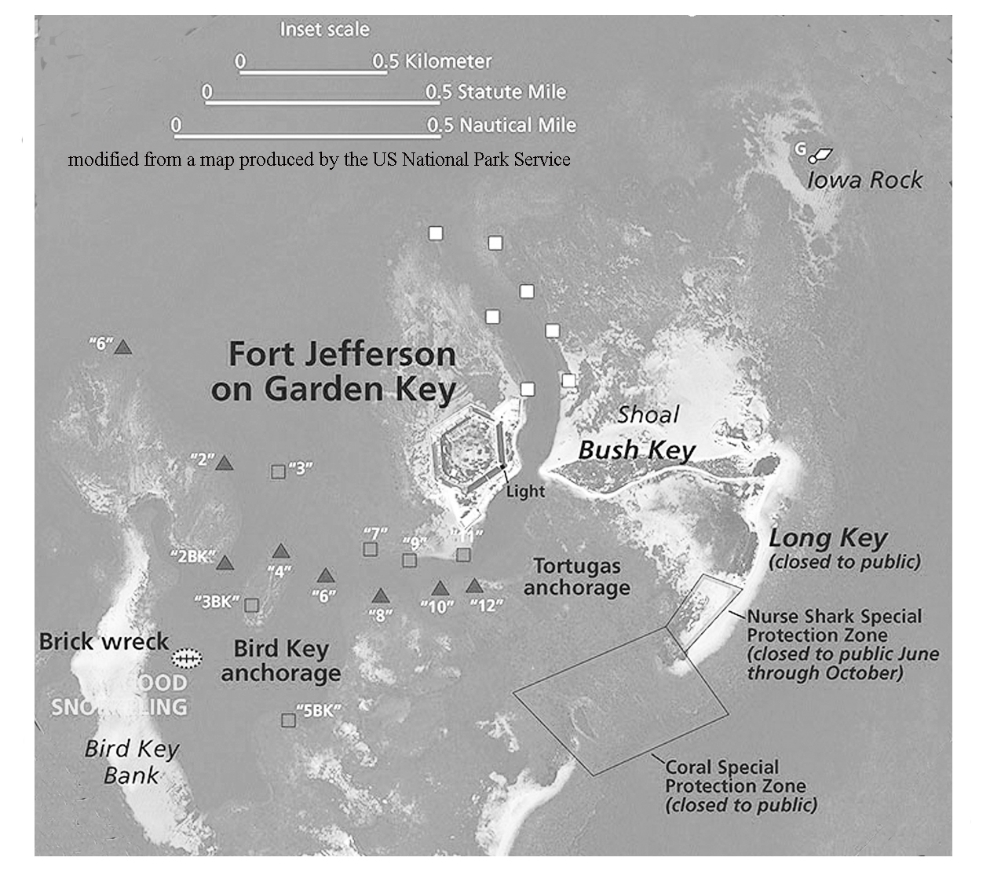

History and Land Use

The earliest known inhabitants of South Florida were the Calusa, one of the tribes that lived in the Everglades region before the arrival of the Seminoles, who migrated here later from northern and central Florida. The Calusa left behind shell mounds scattered throughout the area. Anthropologists debate about whether the mounds were built to create dry ground upon which to live, or were simply refuse heaps of discarded shells. Many other Native Americans groups in the area were enslaved and carried off to various Caribbean islands by Spanish invaders during the 1600s.

The Everglades today remains largely uninhabited, although great numbers of tourists pass through the northern part of the region along the Everglades Parkway (Alligator Alley) and the Tamiami Trail, the only two east-west highways to cross the Everglades. The Big Cypress Indian Reservation lies at the northern edge of Everglades National Park and is home to a large number of Seminoles who have opened an educational museum on site and run a variety of tourist concessions through the Everglades. The most popular are the airboat and swamp buggy rides that offer views of alligators and other native animals mixed with a large dose of Native American folklore.
Swamp Safari
--excerpted from an article by Susan Ladika (Associated Press), July 15, 2001--

As we bed down for the night in the thatched roof chickee (a traditional Seminole hut made of cypress and sabal palms), my husband notes that the top half of the door is covered only by a screen, not a shutter or curtain in sight. But it doesn’t really matter; the only things that could peek in our window are the deer, bison and other critters roaming this corner of the Big Cypress Swamp. The hut, following Seminole tradition, is elevated three feet from the ground to prevent alligators or hogs from crawling inside during the night.
Welcome to the ‘Billie Swamp Safari’, run by the Seminoles at the edge of the Everglades. The swamp safari is intended to teach visitors about the lives of the Everglades’ indigenous people. Earlier that day, our Native American guide had taken us on an airboat ride through the cattails and grasses of the wetland as he doled out nuggets of Seminole wisdom. Later we rode a swamp buggy down rutted paths that were once used to drag dugout canoes to the water’s edge, while watching for stray rattlesnakes. Wildlife was everywhere. We passed alligators sunning themselves on tangles of mangroves, wild hogs wallowing in the mud, and bison and deer watching us warily from a distance.

Southern Florida was under colonial rule by Spain, France, and England before becoming a United States territory in 1821 and a state in 1845. Much of the expansion of settlements into South Florida can be traced to the Florida East Coast Railway, constructed by Henry Flagler starting in Jacksonville in 1892 and ending up in Key West in 1912. Along the way, Flagler either started or expanded the cities of Daytona Beach, Palm Beach and Miami. When the railroad reached Biscayne Bay, Flagler dredged a channel, built streets, installed a water system, and financed the city’s first newspaper.

Flagler originally intended to end his railroad in Miami, but at the time Key West was Florida’s most populous city, with a population of 20,000, and also the closest deep water port to the nearly completed Panama Canal that would open just two years later. Flagler foresaw great opportunities for trade with Cuba and Latin America. This overseas extension, sometimes called Flagler’s Folly, employed four thousand men and took seven years to complete. The Labor Day Hurricane of 1935 effectively ended the era of the railroad when over 40 miles (64 kilometers) of track were washed away. The roadbed and remaining bridges were sold to the State of Florida, which used them to construct the Overseas Highway (now US Route 1) as a transportation link to Key West. The famous 7-mile bridge was built in 1978 to connect Knight’s Key (city of Marathon) with Little Duck Key, crossing over water averaging about 20 feet (6 meters) deep.

Key West, the southernmost inhabited point in the United States, is famous for watersports, lively nightlife, beaches, historic sites, and its unusual architecture. The town is also famous for being the residence of novelist Ernest Hemingway. The island’s history is shaped by Bahamian and Cuban influences brought in by commercial fishermen, sponge harvesters, and Cuban cigar makers. Each night a sunset celebration is held at Mallory Square, when tightrope walkers, jugglers, and animal acts perform.
Coconut Grove is one of the oldest settled towns in the Miami area. The first recorded settlers arrived in 1825, when the Cape Florida Lighthouse was constructed on the shores of Biscayne Bay. Most of the early inhabitants were wealthy Americans from the northeastern US or British and white Bahamian immigrants. Within a decade of the opening of the Bay View Inn, Coconut Grove had added a school, church, men and women’s clubs, a post office, and a small business area. The town was incorporated in 1873 by a strange mix of pioneers, artists, intellectuals, and adventurers. Famous residents have included: Williams Jennings Bryan, Robert Frost, David Crosby, Jimmy Buffett, Tennessee Williams, Alexander Graham Bell, and Madonna. Although Miami has grown up around the Grove, much of the historic district remains intact and a walking trail gives tourists the opportunity to experience the old world charm that has endured.

Of all the agricultural products grown in Florida (not counting Citrus Trees), sugarcane is the state’s most valuable crop. Approximately 400,000 acres (161,874 hectares) of sugarcane are harvested in Florida annually, producing about 1.5 million tons (1.4 million metric tons) of sugar. Almost all commercial production is centered along the southeastern edge of Lake Okeechobee. The area provides plenty of sunshine and water and fertile organic soil that supports vigorous cane growth. The warming influence of the lake provides protection from killing frosts in winter. Sugarcane planting takes place from late August through January by cutting sections of stalks from mature plants, which then sprout daughter plants. Typically a sugarcane field is replanted every two to four years. Weeds are controlled by cultivation and herbicides. If the field gets too dry, water is allowed to flow into the field through ditches that are normally used for drainage. Sugarcane farmers typically burn the fields before harvesting the cane. This removes the stalks and leaves, but can create some serious air pollution problems during the late summer and Fall months. In the past, sugarcane was hand-harvested, a labor intensive process. But by 1993, the entire South Florida sugarcane crop was harvested mechanically.

After the sugarcane fields are burned, mechanical harvesters deposit the cut cane directly into field wagons. At special ramps near the field, the cane is dumped from the wagon into highway trailers or rail cars for transport to the mills. All commercially produced Florida sugarcane is handled by one of four sugarcane mills in South Florida. At the mill, the sugarcane is crushed between heavy rollers to squeeze out the juice. The process is repeated several times to maximize the sugar extraction from the crushed stalks. The sucrose solution is concentrated by evaporating off the water until raw sugar crystals form. For each pound of sugar produced, 3 quarts (2.8 liters) of water must be boiled off. The raw sugar crystals are stored in high piles in large warehouses to await shipment to a refinery. Two refineries currently operate in Florida, one in South Bay, the other in Clewiston. The final granulated sugar product is packaged in consumer-sized bags and shipped to distributors all over the country.

Activity 10B-1: Everglades and Water Issues

POWER THINKING EXERCISE - "Saturated Subdivision"
You are a developer who wants to build a new housing subdivision west of Hollywood FL because there is a real demand for new houses In this rapidly growing area of South Florida. However, the only land in this area that is available for you to purchase is located in the Everglades just west of US Highway 27. Locate Route 820 (east-west road connecting Hollywood with Pembroke Pines) on the South Florida topographic map on MAP 10B, SOUTH FLORIDA (right-center of map along Atlantic Coast). You plan to extend Route 820 a few miles into the Everglades and build your community around this access road.
You know that most of the land west of Pembroke Pines along this highway was also originally part of the Everglades, but was developed anyway, so you know building your subdivision is possible. Because of environmental regulations, you are prohibited from bringing in any soil or fill dirt from outside your land area, and you are prohibited from removing any soil or fill dirt beyond the boundaries of your land. You can’t build on the existing land surface the way it is because the soil is completely saturated and just too wet. How will you modify the landscape to allow you to construct houses on this land? Devise the most efficient and effective method you can and then compare your plan with the plans of other groups.

Materials
MAP 10B, SOUTH FLORIDA
IMAGE 10B, SOUTH FLORIDA
Newspaper Article, “’Big Water’ at historic low due to drought in Florida”, Page 10B-1
Figure 10B-1, “Comparison of Original vs. Present Extent of Everglades”
Figure 10B-2, “Progressive Development of Tree Islands”
Figure 10B-3, “Salt Water Incursion into Wells”
transparent plastic grid
Wipe-off Pens

PERFORMANCE TASKS
(Icon Key) Overview = ; Science = ; Math = ; History = ; Language Arts =

1. Trace pathways of drainage canals from Lake Okeechobee.
Locate Lake Okeechobee on both the South Florida topographic map and the CIR satellite image on MAP 10B, SOUTH FLORIDA (located at top-center edge of map). There are five named drainage canals that exit the Lake Okeechobee area: West Palm Beach Canal; Hillsboro Canal; North New River Canal; Miami Canal, and L2 Canal. These can be recognized on the map by thin straight blue lines, and they are labeled. With a wipe-off pen, trace on the map the path of each canal from Lake Okeechobee to the end of the canal. How many of these canals can you locate on the satellite image? How could you recognize them? Do any of these canals return water to the Everglades? If so, which ones? Why were these canals constructed in the first place?

There are also three labeled east-west canals on the map: Bolles Canal (just south of Lake Okeechobee); South New River Canal (between Fort Lauderdale and Hollywood); Tamiami Canal (crossing the center of the Everglades along US Highway 41). What do you think is the primary purpose of these east-west canals?

2. Explain causes for water restrictions in coastal cities.
Read the newspaper article, “’Big Water’ at historic low due to drought in Florida” on Page 10B-1. Note especially the message in the final paragraph that says the water level in the Everglades is down by one or two feet. The article also mentions that most coastal cities get their water from wells and that water-use restrictions have been mandated. Explain why a drop in the Everglades water level would cause water problems in cities many miles away. Also refer to Figure 10B-3, “Salt Water Incursion into Wells” for additional information.

3. Calculate percentage loss of watershed area in Everglades.
Examine Figure 10B-1, “Comparison of Original vs. Present Extent of Everglades” and look specifically at the area labeled “watershed”. Place the transparent plastic grid (small-squares portion) over the ‘Original Everglades’ map and count the number of squares that cover the ‘watershed’ area (do not include the area marked “Everglades”). If more than half the square is over the designated area, count it. If less than half the square is over the designated area, do not count it.

Now use the same procedure to count the number of squares that cover the ‘watershed’ area on the “Today’s Everglades” map. Divide this number of squares by the number of squares calculated for the “Original Everglades” and convert that fraction to a percentage. What percentage of the original watershed area has been lost? What region has lost the largest percentage of ‘watershed’ area?

4. Recognize agricultural land use on various map products.
Examine Figure 10B-1, “Comparison of Original vs. Present Extent of Everglades” and note the designated “Everglades Agricultural Area” on the “Today’s Everglades” map. Use Lake Okeechobee as a reference point. Now locate this same region on the South Florida topographic map and satellite image on MAP 10B, SOUTH FLORIDA. How can you recognize this particular land use on a topographic map? What features on the map give useful clues? How can you recognize this particular land use on the satellite image? What features on the image give useful clues?

5. Discuss literary concept of time-lapse storytelling.
Some short stories and novels take place over a very short period of time; perhaps one day or one week. Others cover activities or events over a longer time span. If a story covering a long period of time were to include every single event that happened every day, or even every year; the book would be too long for anyone to actually read. So authors frequently jump from one time period to another and only recount the most interesting events that occurred. For example, a short biography of a famous person may include one event from their childhood, one event when they were a teenager, and a few important events they were involved with when they were an adult.
Examine Figure 10B-2, “Progressive Development of Tree Islands” and note that the ‘tree island’ looks different at various stages of its development. Write a short story using the ‘tree island’ as your location and an alligator as your main character. Alligators live a long time, so you should recount four visits by the alligator to the ‘tree island’ - when the alligator was little (Time A on the diagram); when it was a little bigger (Time B on the diagram); when it was full-grown (Time C on the diagram); and when it was old (Time D on the diagram). Be sure to include descriptions of the different landscape the alligator encounters each time it returns to this location. Devise a clever title for your short story that will sound interesting enough to get people to want to read it.

ENRICHMENT
(Icon Key) Overview = ; Science = ; Math = ; History = ; Language Arts =

1. Investigate efforts to restore Everglades habitat.
Restoring the Everglades begins with returning its water. A second initiative involves removing nutrients from agricultural wastewater. The third initiative is attempting to remove non-native plants that crowd out native plants and reduce wildlife habitat. Use local library or internet resources to investigate each of these three initiatives and determine how well each effort is succeeding. Prepare a brief report to present to your class.

2. Research formation and uses of peat.
Peat is a brown organic-rich deposit resembling soil formed under wet acidic conditions in bogs or swampland. Most of the Everglades region is underlain by peat, which is why so much of the area has been turned into productive agricultural land. Use local library or internet resources to learn how peat is formed and why it is such a good soil for agricultural uses.

Activity 10B-2: The Florida Keys

POWER THINKING EXERCISE - "Oolite Origin"
Your family normally vacations at Daytona Beach in Florida’s Central Peninsula, but this year you decided to visit the Florida Keys. While vacationing in South Florida, you spend most of your time swimming and sunning yourself on Miami Beach and several other beautiful beaches along the Florida Keys. But you notice that the sand is very different than the sand you remember at Daytona Beach and in fact is very different from any sand you have ever seen before. The sand in the Keys is a brilliant white color and extremely clean. You also notice that the sand grains are almost perfect spheres. One of the rangers at Long Key State Park tells you that the round grains are called oolites and that they are made of calcium carbonate that chemically precipitates from warm ocean water.
You start to wonder why the sand in the Keys is so different. Because you are on vacation, you have plenty of time to think about this question. Where did the calcium carbonate come from? How did the sand grains form and why are they so round? Why are there no quartz grains, like the ones that make up Daytona Beach, in this sand?

Materials
MAP 10B, SOUTH FLORIDA
IMAGE 10B, SOUTH FLORIDA
Wipe-off Pens

PERFORMANCE TASKS
(Icon Key) Overview = ; Science = ; Math = ; History = ; Language Arts =

1. Compare and contrast features of upper and lower Keys.
Geologists divide the Florida Keys into two sections, an older, higher set of islands stretching from Upper Matecumbe Key to Biscayne Bay and a younger, lower set of islands stretching from Lower Matecumbe Key past Key West. Locate the Florida Keys on both the South Florida map and satellite image on MAP 10B, SOUTH FLORIDA, and mark, with a wipe-off pen, the location of the inlet dividing Upper and Lower Matecumbe Keys. Compare and contrast island dimensions, shapes, and landforms in these two areas. Also note differences in the number of shoals and other islands in Florida Bay versus the number of these features on the Atlantic Ocean side of the Keys. Why do you find more shoals and islands in Florida Bay?

2. Investigate shoreline changes around Lignumvitae Key.
Examine the Windley Key inset map on MAP 10B, SOUTH FLORIDA and locate Lignumvitae Key and Shell Key. Notice the difference between the 1850 shorelines (marked by red lines) and the modern shorelines of these islands. What geological processes in this region could cause shoreline migration? Note several places where islands exist today that did not exist in 1850. Explain how those islands formed. Predict any future changes you think might affect the island shorelines in this area.
3. Calculate width of channel between islands.
Examine the Windley Key black and white photograph and the NAPP infrared color photograph on IMAGE 10B, SOUTH FLORIDA, and locate the inlet between Upper and Lower Matecumbe Islands. [Refer to the inset map on MAP 10B to see labels for all the named islands.] Use the scale bar to measure the distance between the two islands along US Highway Route 1. Look at the NAPP image and count the number of bridges that were built across this inlet for this highway. Measure the length of each bridge and add them together to get a total bridge length. What percentage of the highway route travels over bridges between these two islands?

4. Identify changes to landforms from 1951 to 1994.
Compare the Windley Key black and white aerial photograph to the NAPP infrared aerial photograph on IMAGE 10B, SOUTH FLORIDA. Make a list of all changes visible that can be documented by comparing the photographs. For each natural change, give a reason for the change; for each human-made change, explain why that change was made. Predict what changes are likely to occur in the future, and why.

5. Investigate etymology of names used in Florida Keys.
Etymology is the study of the origin of words. The cultural heritage of the Florida Keys was heavily influenced by early Native American residents, Spanish explorers, and finally by more recent English settlers. Many of the geographic features in the Keys have names that reflect one of these cultural origins. In fact, the word “Key” is a corruption of the Spanish word “cay” which translates as “island.” On a separate piece of paper, divide the sheet into three columns; label one column Native American, the second column Spanish, and the third column English. Write down all the geographic names used for the Florida Keys - including areas around Florida Bay (refer to the South Florida map on MAP 10B, SOUTH FLORIDA) in the appropriate column depending on which culture you think the name came from.

ENRICHMENT
(Icon Key) Overview = ; Science = ; Math = ; History = ; Language Arts =

1. Investigate Dry Tortugas National Park.
The Dry Tortugas are technically part of the Florida Keys although they are located 70 miles west of Key West. Use local library or internet resources to research both the natural history and human history of that site. Also investigate how you would get to the islands, as there is no road that goes there, and where you would stay.

2. Research fossil corals found at Windley Key Fossil Reef Park.
Use library and internet resources to look up information on Windley Key Fossil Reef Geological State Park near the town of Islamorda on Upper Matecumbe Key. List all the different types of fossil corals and other marine life that are preserved at that site and explain how they all fit together into the complex ecological system of a reef. How old are these fossils?

Activity 10B-3: History and Land Use

POWER THINKING EXERCISE - "Keys Keeper"
Over a period of many years, first the railroad, then a highway, was built across the Florida Keys to reach Key West. However, when you study the South Florida map and satellite image on MAP 10B, SOUTH FLORIDA, you notice that Key West is not the last key in the chain. Locate Key West on both the map and image and note several small islands located not far beyond Key West and even a fairly large pair of islands, near the margin of the map, called the Marquesas Keys. You also notice from the bathymetric contour lines on the map (and the lighter blue color on the image) that the ocean is very shallow in this area, which would indicate that building bridges would be reasonably simple from an engineering standpoint.
You would like to open a charter fishing boat business in the Keys, but Key West is too crowded and there is no space for you there. You think that if you could get the government to extend US Highway Route 1 to Marquesas Keys, you could set up your business there and make a fortune.
Discuss the pros and cons of extending the highway. Do you think the government would approve your plan? Explain why or why not. How many bridges would be needed for the new highway? Would such a highway cause any problems for Key West? List them. Why do you think the original road builders decided to stop at Key West?

Materials
MAP 10B, SOUTH FLORIDA
IMAGE 10B, SOUTH FLORIDA
Story, “Swamp Safari”, Page 10B-10
Wipe-off Pens

PERFORMANCE TASKS
(Icon Key) Overview = ; Science = ; Math = ; History = ; Language Arts =

1. Interpret land use at Port Mayaca sugarcane fields.
Examine the Port Mayaca infrared aerial photograph on IMAGE 10B, SOUTH FLORIDA. The area captured by this photo is used primarily to grow sugarcane and is located along the eastern shoreline of Lake Okeechobee. The gray line running north-south at the left edge of the photo is the main highway. The thinner white line running alongside and crossing the highway is a railroad line. The other straight white lines are unpaved roads. The straight lines dividing the sugarcane fields are drainage ditches, some have water in them, others do not. The fields are shown in various stages of cultivation and harvest. Try to identify all these features on the photograph.

The dark irregular shape in the exact middle of the photograph is actually a quarry operation, producing aggregates like sand and gravel, run by a company called Mayaca Materials. The quarry is partially filled with water. Drainage from the quarry area flows diagonally across the center and lower-center of the photograph in a narrow ditch. The area along the right edge of the photo is mostly undisturbed forested land.
2. Trace route of Intracoastal Waterway.
Locate the Intracoastal Waterway (labeled dashed blue line) on the South Florida topographic map on MAP 10B, SOUTH FLORIDA. Trace the Waterway down the Atlantic Ocean coastline from West Palm Beach to Miami. Describe in general terms the route of the Waterway and mark with a wipe-off pen any areas that do not follow natural waterways (in those places, a channel must be dredged to create an artificial waterway). Next, trace the route of the Waterway through Biscayne Bay and into Florida Bay. Again, mark with a wipe-off pen any areas that have to be dredged. Note that as the Waterway approaches Key West, it divides into several different routes. Why does it do that? Why would boaters in this area prefer multiple routes?

The Atlantic Intracoastal Waterway ends at Key West. There is no route marked along the west coastline of Florida until you reach Sanibel Island near Fort Myers. Why do you think there is no specific route specified along this coastline? At Fort Myers, the Waterway is again marked, running northward along the Gulf coastline. Trace the route from Fort Myers into Pine Island Sound. A connection can be made from the Gulf of Mexico to the Atlantic Ocean through Lake Okeechobee. This waterway was developed by digging two canals and installing locks. Most of this route runs off the top of the map, but you can trace the Waterway up the Caloosahatchee River until it disappears; but you can find it marked again in the lower part of Lake Okeechobee.

3. Calculate area and perimeter of sugarcane field.
Examine the Port Mayaca infrared aerial photograph on IMAGE 10B, SOUTH FLORIDA. Note the rectangular shape of the sugarcane fields. Why is a rectangular shape the most efficient way to plant a field? Why are most of the fields the same size? Relate the shape and size to how the crop is harvested. Using standard mathematical formulae for the area and perimeter of a rectangle, and information in the scale bar, pick one of the rectangular fields and calculate its area and perimeter.

Sugarcane farmers space their rows five feet apart. Assuming that spacing is true for the field you already measured, calculate how many rows could fit in your field.

4. Identify historic buildings in Coconut Grove.
Refer to the 1896 historic sketch of Cocoanut Grove on IMAGE 10B, SOUTH FLORIDA. Locate each of the numbered features shown in the sketch and explain whether that feature was intended for personal or public use. Examine the Coconut Grove infrared aerial photograph (also on IMAGE 10B) and identify as many of those historic features as you can. What factors might determine whether an historic building would survive until 1994? As the city of Miami grew up around Coconut Grove, what would be the advantages and disadvantages of trying to keep an historic neighborhood intact? How would the use of Biscayne Bay change over time?

Why would some street names have changed in a hundred years? Why did it make sense to build piers where streets ran into Biscayne Bay? Explain why the modern marina (at Glade Avenue and Front Street) was built at this location. Based on the photo, would you consider this part of Miami to be mostly commercial or residential?
5. Re-write “Swamp Safari” story.
Read the story, “Swamp Safari” on Page 10B-10. The account is straightforward, providing some information about the author’s experiences on her trip, but not relating many personal experiences along the way. Re-write the story from a more personal perspective, describing the author’s feelings and opinions about her travels. Try to make the account more exciting and interesting.

Once your group has written its version of the story, swap stories with another group and underline all the words that you think helped to make the story exciting and interesting. What do all these words have in common? Try to identify and list a few “rules for writing exciting stories” based on your own writing and review.

ENRICHMENT
(Icon Key) Overview = ; Science = ; Math = ; History = ; Language Arts =

1. Research Native American history in South Florida.
Examine Figure 10-3 “Native American Cultures in Florida” to review the names of the Native American communities that inhabited South Florida before Europeans arrived. Select one of these Nations and use local library or internet resources to research their history and way of life. Pay particular attention to how that community interacted with the unique landscapes of South Florida and where those people are located today.

2. Investigate famous person who lived in Coconut Grove.
The background information lists the following famous individuals who resided in Coconut Grove, at least for a short time: Williams Jennings Bryan, Robert Frost, David Crosby, Jimmy Buffett, Tennessee Williams, Alexander Graham Bell, and Madonna. Select one of these people and use local library or internet resources to learn more about them. Pay special attention to try and determine the reasons why they chose to live in Coconut Grove. Prepare a short oral report on your selected person to relate to the class.

