CHAPTER 6

BLUE RIDGE REGION

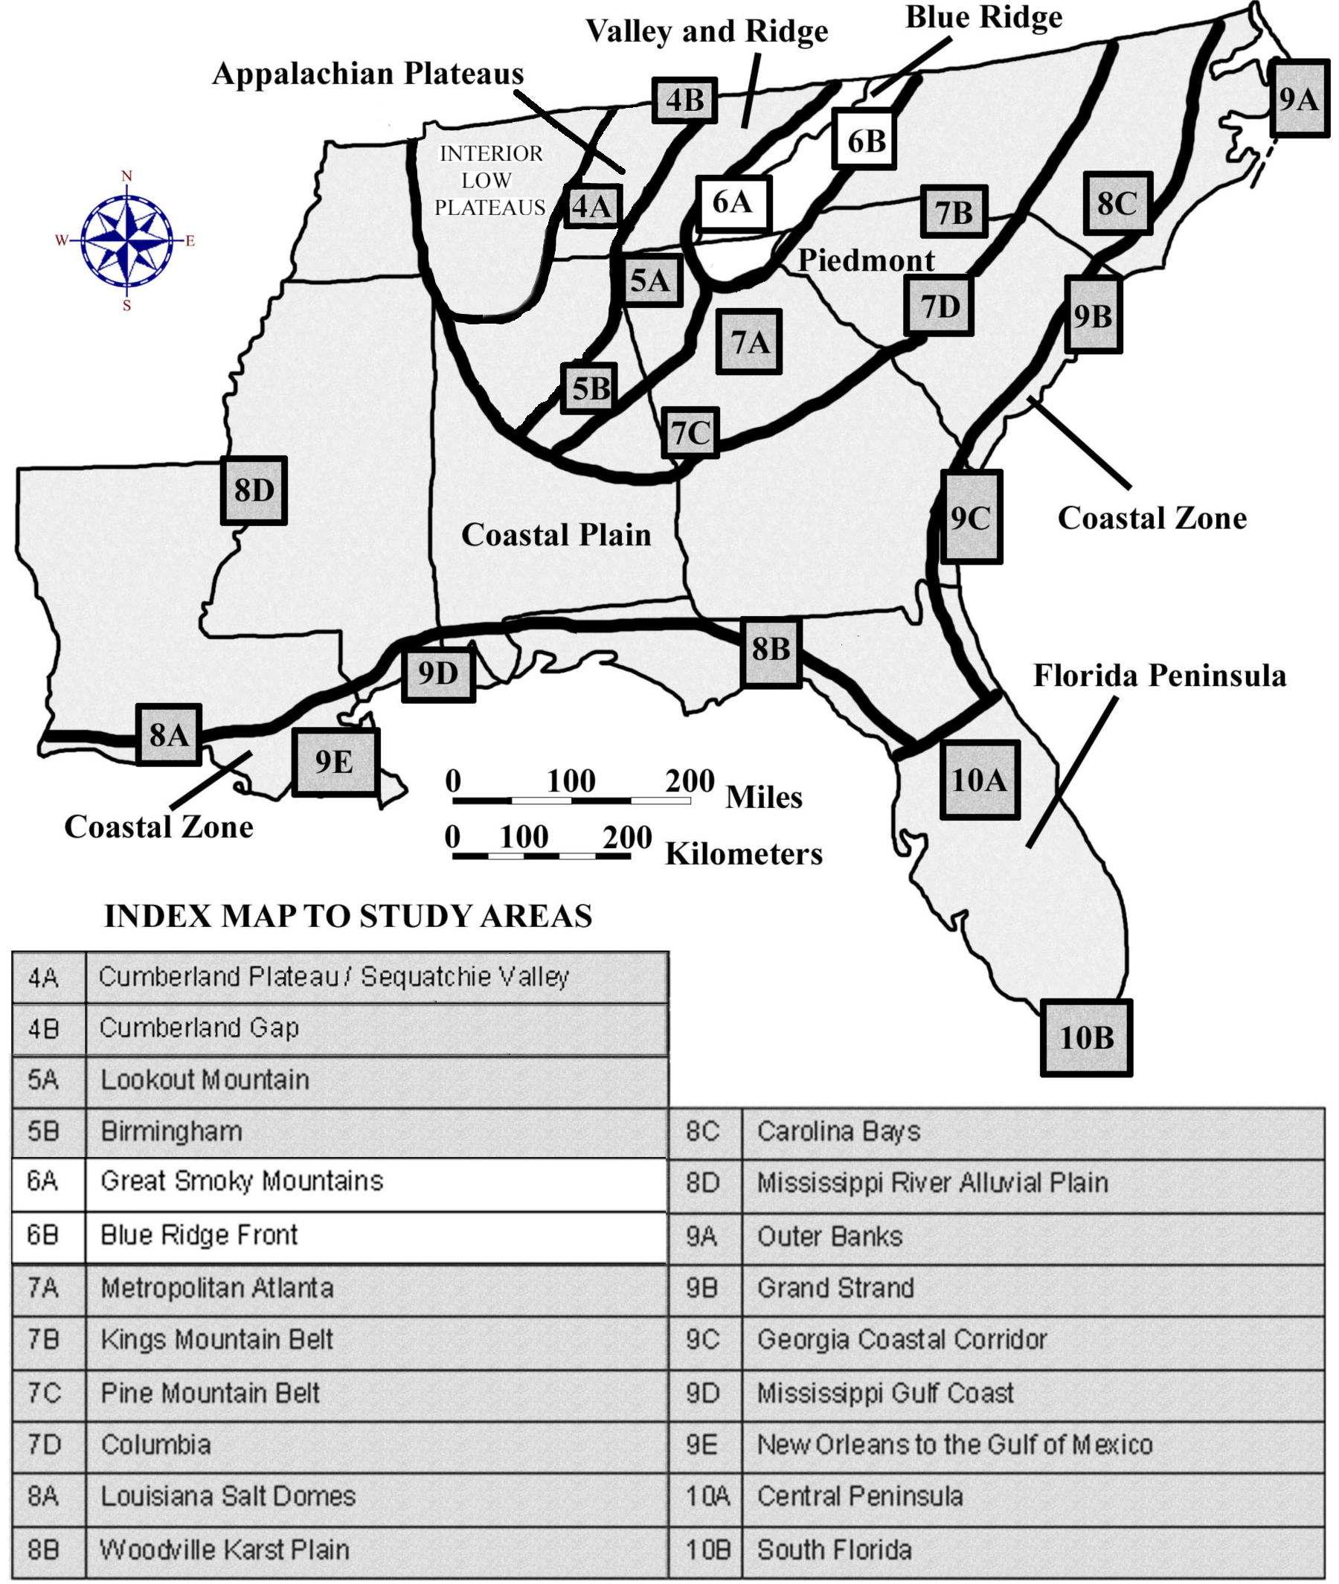

DRAFT VERSION 5/06/20

TABLE OF CONTENTS FOR CHAPTER 6

BLUE RIDGE REGION

Fred Beyer, G. Michael Clark, Marg McKinney, Larry Greer, and John R. Wagner

INDEX MAP TO BLUE RIDGE REGION STUDY AREA
TABLE OF CONTENTS FOR CHAPTER 6
BACKGROUND INFORMATION
- Description of Landforms, Drainage Patterns, and Geologic Processes
p. 6-1 . . . . - Characteristic Landforms of the Blue Ridge
p. 6-1 . . . . . . . . - figure 6-1 – “Radial and Rectangular Drainage Patterns”
p. 6-2 . . . . - Geographic Features and Localities of Special Interest
p. 6-2 . . . . . . . . - figure 6-2 – “Major Landforms of the Southern Blue Ridge”
p. 6-3 . . . . - Rock Types and Geologic History
p. 6-4 . . . . . . . . - figure 6-3 – “Overthrust Faults in the Blue Ridge”
- Influence of Topography on Historical Events and Cultural Trends
p. 6-4 . . . . - Folklore
p. 6-5 . . . . . . . . - story – “Bloody Roan Mountain”
p. 6-5 . . . . . . . . - story – “Ulagu: The Giant Yellow Jacket”
p. 6-6 . . . . - Historical Events
p. 6-6 . . . . - Influence of Topography on Commerce, Culture, and Tourism
- Natural Resources, Land Use, and Environmental Concerns
p. 6-7 . . . . - Climate and Water Resources
p. 6-8 . . . . - Soils and Agriculture
p. 6-9 . . . . - Mining, Resource Extraction, and Environmental Concerns
PLACES TO VISIT
REFERENCES AND RESOURCES

STUDY AREA 6A = GREAT SMOKY MOUNTAINS
- Newspaper Article
p. 6A-1 . . . . . . - story – “Smokies Air Quality Dropping”
- Rationale
- Performance Objectives
- Sample Assessment Rubrics
- Cartographic Product Information
p. 6A-3 . . . - MAP 6A: Great Smoky Mountains
p. 6A-4 . . . - IMAGE 6A: Great Smoky Mountains
- Study Area Description
p. 6A-5 . . . - Smoky Mountain Landscapes
p. 6A-6 . . . - Cades Cove
p. 6A-7 . . . . . . . - figure 6A-1 – “Geologic Cross-Section Through Cades Cove”
p. 6A-7 . . . - Environmental Hazards
p. 6A-8 . . . . . . - figure 6A-2 – “Debris Slides in Alum Cave Creek Watershed”
- Activity 6A-1: Mountain Landscapes
(ICONS) Overview = Sci = Math = Hist = Lang Arts =
p. 6A-10 . . - Power Thinking Exercise “Trail Troubles”
p. 6A-10 . . - Materials
p. 6A-10 . . - Performance Tasks
p. 6A-10 . . . . . . 1. Locate prominent landscape features in Smoky Mountains.
p. 6A-11 . . . . . . 2. Explain placement and routing of roads within park.
p. 6A-11 . . . . . . 3. Calculate expected drop in temperature as elevation rises.
p. 6A-12 . . . . . . 4. Analyze topography to predict location of Indian Gap.
p. 6A-12 . . . . . . 5. Debate commercialization of cultural heritage.
p. 6A-12 . . - Enrichment
p. 6A-12 . . . . . . 1. Research original road connecting Gatlinburg and Cherokee.
p. 6A-12 . . . . . . 2. Investigate Cherokee culture.
- Activity 6A-2: Cades Cove
(ICONS) Overview = Sci = Math = Hist = Lang Arts =
p. 6A-13 . . - Power Thinking Exercise “Essential Elements”
p. 6A-13 . . - Materials
p. 6A-13 . . - Performance Tasks
p. 6A-13 . . . . . . 1. Locate Cades Cove on topographic maps, photographs, images.
p. 6A-14 . . . . . . 2. Identify rectangular drainage pattern.
p. 6A-14 . . . . . . 3. Estimate elevations of three coves and infer implications.
p. 6A-14 . . . . . . 4. Suggest rationale for decision to join Union or Confederate army.
p. 6A-14 . . . . . . 5. Write acrostic to paint word picture of Cades Cove.
p. 6A-15 . . - Enrichment
p. 6A-15 . . . . . . 1. Watch TV movie “Christy” and compare with life in Cades Cove
p. 6A-15 . . . . . . 2. Write short story about life in Cades Cove in the late 1800s.
- Activity 6A-3: Environmental Hazards
(ICONS) Overview = Sci = Math = Hist = Lang Arts =
p. 6A-16 . . - Power Thinking Exercise “Traffic Transfer”
p. 6A-16 . . - Materials
p. 6A-16 . . - Performance Tasks
p. 6A-16 . . . . . . 1. Trace watersheds to predict flooding potential.
p. 6A-17 . . . . . . 2. Locate debris-slide scars on south side of Mt. Le Conte.
p. 6A-17 . . . . . . 3. Calculate surface area of the devastated area at Ducktown, TN.
p. 6A-17 . . . . . . 4. Evaluate solutions to preventing downwind pollution.
p. 6A-17 . . . . . . 5. Write letter to politician asking for anti-pollution legislation.
p. 6A-18 . . - Enrichment
p. 6A-18 . . . . . . 1. Research TVA flood prevention projects.
p. 6A-18 . . . . . . 2. Research chemical reactions contributing to acid rain formation.

STUDY AREA 6B = BLUE RIDGE FRONT
- Newspaper Article
p. 6B-1 . . . . . . - story – “Scenery Big Draw at Grandfather”
- Rationale
- Performance Objectives
- Sample Assessment Rubrics
- Cartographic Product Information
p. 6B-3 . . . - MAP 4B: Cumberland Gap
p. 6B-4 . . . - IMAGE 4B: Cumberland Gap
- Study Area Description
p. 6B-5 . . . - The Blue Ridge Parkway
p. 6B-6 . . . . . . . - figure 6B-1 – “Drainage Divides in Southern Blue Ridge Region”
p. 6B-7 . . . . . . . - figure 6B-2 – “Grandfather Mountain Structural Window”
p. 6B-8 . . . - Grandfather Mountain and Mount Mitchell
p. 6B-9 . . . . . . . - story – “Big Tom Wilson”
p. 6B-10 . . . - The Blue Ridge Escarpment
p. 6B-11 . . . . . . - figure 4B-4 – “Route of Wilderness Road”
- Activity 6B-1: The Blue Ridge Parkway
(ICONS) Overview = Sci = Math = Hist = Lang Arts =
p. 6B-12 . . - Power Thinking Exercise “Parkway Peril”
p. 6B-12 . . - Materials
p. 6B-12 . . - Performance Tasks
p. 6B-12 . . . . . . 1. Locate triple drainage divide.
p. 6B-13 . . . . . . 2. Interpret patterns of tectonic features on geologic map.
p. 6B-13 . . . . . . 3. Observe rectangular drainage pattern in Lake James.
p. 6B-13 . . . . . . 4. Evaluate metes and bounds method for defining boundaries.
p. 6B-14 . . . . . . 5. Discuss effectiveness of language used for metes and bounds.
p. 6B-14 . . - Enrichment
p. 6B-14 . . . . . . 1. Plan trip along Blue Ridge Parkway.
p. 6B-14 . . . . . . 2. Describe boundaries of school property using metes and bounds.
- Activity 6B-2: Grandfather Mountain and Mount Mitchell
(ICONS) Overview = Sci = Math = Hist = Lang Arts =
p. 6B-15 . . - Power Thinking Exercise “Varying View”
p. 6B-15 . . - Materials
p. 6B-15 . . - Performance Tasks
p. 6B-15 . . . . . . 1. Identify features on 3-D stereo photo of Grandfather Mountain.
p. 6B-15 . . . . . . 2. Propose new trail route to Raven Rocks peak.
p. 6B-16 . . . . . . 3. Measure average gradient of Big Tom Wilson Toll Road.
p. 6B-16 . . . . . . 4. Explain popularity of Big Tom Wilson Toll Road.
p. 6B-17 . . . . . . 5. Analyze writing style appropriate for newspaper articles.
p. 6B-17 . . - Enrichment
p. 6B-17 . . . . . . 1. Compare tourist facilities at Mount Mitchell through time.
p. 6B-17 . . . . . . 2. Research the history of the Linn Cove viaduct.

- Activity 6B-3: The Blue Ridge Escarpment
(ICONS) Overview = Sci = Math = Hist = Lang Arts =
p. 6B-18 . . - Power Thinking Exercise “Mountain Mystery”
p. 6B-18 . . - Materials
p. 6B-18 . . - Performance Tasks
p. 6B-18 . . . . . . 1. Infer previous position of Blue Ridge Escarpment.
p. 6B-18 . . . . . . 2. Find examples of stream capture along Blue Ridge Front.
p. 6B-19 . . . . . . 3. Calculate gradients of rivers flowing to Atlantic and to Gulf.
p. 6B-19 . . . . . . 4. Compare land use in Brevard Zone to mountain areas.
p. 6B-20 . . . . . . 5. Explain the use of nicknames for topographic features.
p. 6B-20 . . - Enrichment
p. 6B-20 . . . . . . 1. Research geologic history of New River.
p. 6B-20 . . . . . . 2. Research unique environments and habitats in mountain coves.

BACKGROUND INFORMATION

Description of Landforms, Drainage Patterns, and Geological Processes

Characteristic Landforms of the Blue Ridge

A number of fascinating landscapes occur in the Blue Ridge region. Some are individual landforms, such as isolated mountains, others are associations of extensive inter-linked ranges. Although cliffs and other sharp drop-offs are locally common along the sides of mountains and ridges, many mountain crests are gently rounded, almost domed-shaped. The higher summit ranges, such as the Great Smoky Mountains and the Unaka Mountains, tend to align in a northeast to southwest direction, more or less parallel to the compass direction of the whole province. In some places, the summit ranges in the northwest and central part of the blue Ridge are connected not only with each other but also with the crest of the Blue Ridge Escarpment to the southeast by ladder-rung-like ‘cross ranges’. Between these transverse ranges are major landscape basins with moderate floor relief; the Asheville-Hendersonville basin in North Carolina is a prime example.

Nearly all the rivers that drain this region begin near the southeastern edge. These rivers generally flow northwesterly all the way across the Blue Ridge before entering the Valley and Ridge region through deep gaps or gorges. From there, most of the drainage finds its way to the Tennessee River, and eventually ends up in the Gulf of Mexico. In parts of North Carolina, a few Piedmont rivers have ‘climbed’ the Blue Ridge Escarpment and are now draining isolated parts of the uplands. South of Virginia, no river or stream crosses the entire Blue Ridge region. Some isolated high mountain peaks, like Mt. Le Conte in Tennessee, feature a radial drainage pattern, where streams radiate out from the center of the mountain like the spokes of a wagon wheel. Another pattern, called ‘rectangular drainage’, occurs when streams follow fracture lines in the underlying bedrock. Because most sets of rock fractures intersect at nearly right angles, such streams feature a number of sharp, 90-degree bends at seemingly random intervals. Fractured rock is much weaker than solid rock, so these streams preferentially erode along these lines.

Figure 6-1: Radial and Rectangular Drainage Patterns
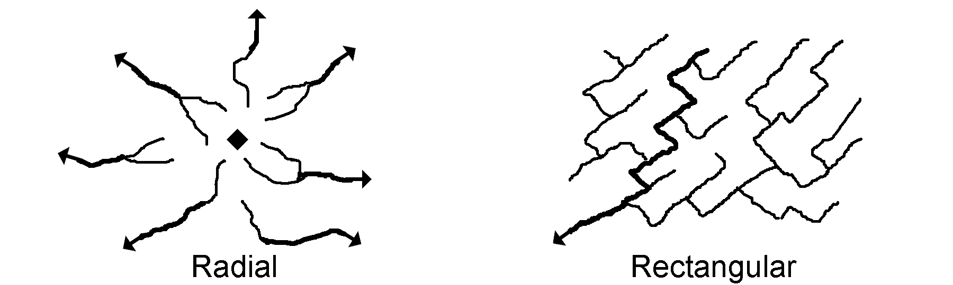
Although other regions may be hilly in places, none show the drastic elevation changes and high relief (difference in elevation between high hills and adjacent valleys) that characterize the Blue Ridge. Local topographic relief can range from a few hundred feet to more than a thousand feet from valley floor to ridge crest. Mountain streams typically flow in narrow valleys, often plunging over waterfalls or rapids. The creek beds are usually rocky and the water in the streams is typically clear and cold. The amount of water in such a stream is highly variable, depending on the amount of precipitation that has fallen recently in the upstream watershed. Small floodplain areas, called hollows or coves, may occur along flatter stretches of streams. No natural lakes occur in this region, although beavers occasionally dam up small streams to form ponds. Engineers have also constructed dams to form reservoirs for power generation and recreation.

Geographic Features and Localities of Special Interest

The Blue Ridge region is actually a composite of many different mountain ranges, but for convenience, it is usually just divided into a western and eastern province. The western half consists of the Foothills Belt, consisting of Chilhowee and Iron Mountains, and the High Western Blue Ridge, featuring the Great Smoky and Unaka mountain ranges. Most form long, narrow ridges with a northeast-southwest trend, separated by narrow valleys. The eastern province is less uniform, with the orientations of mountains and valleys being more irregular in their trend. Major features include the Intermontane Belt, the Asheville-Hendersonville Basin, the Transverse Ranges - including outliers such as the South Mountains, Brushy Mountains, and Pilot Mountain - and the Blue Ridge Front Escarpment.

Figure 6-2: Major Landforms of the Southern Blue Ridge

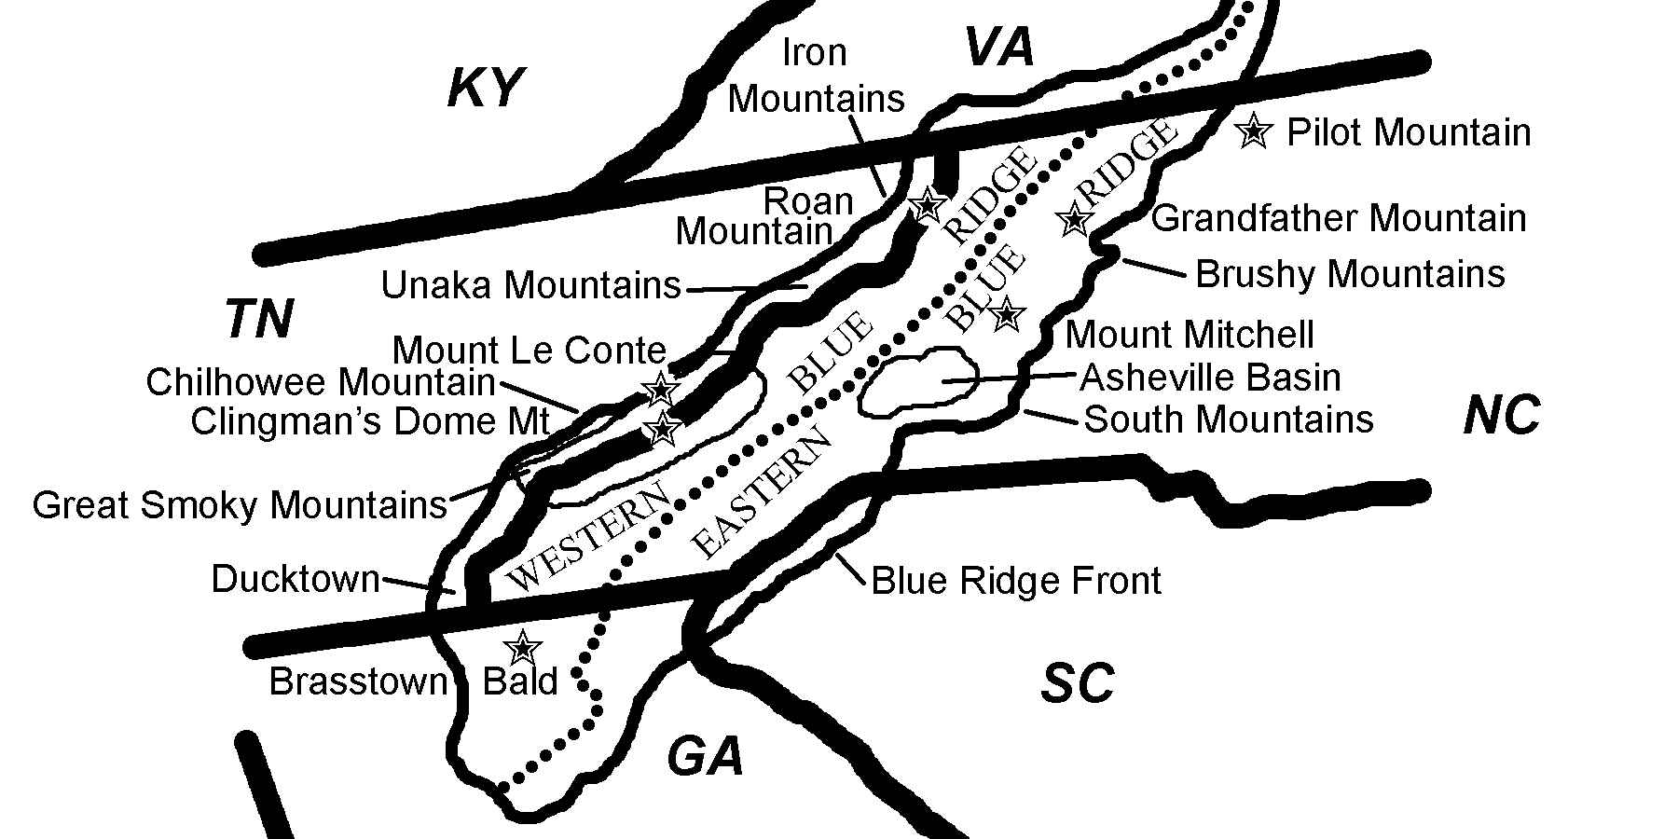

The highest point in the Blue Ridge region, at 6,684 feet (2,037 meters) is Mt. Mitchell, in North Carolina. This mountain also claims the distinction of having the highest summit elevation anywhere east of the Mississippi River. Thirty-nine other mountain peaks in North Carolina and Tennessee also rise over 6,000 feet (1,829 meters). Grandfather Mountain in North Carolina and Roan Mountain and Clingman’s Dome, both of which straddle the North Carolina/Tennessee state line are three other examples of easily accessible summits that afford spectacular scenic views. The highest waterfall east of the Mississippi River is Whitewater Falls, in southwestern North Carolina. The ‘upper’ and ‘lower’ falls combine for a total drop in elevation of 811 feet (247 meters). Other noteworthy waterfalls are Linville Falls and Dry Falls, also in North Carolina. Pilot Mountain and Hanging Rock in North Carolina are Blue Ridge outliers separated from the main mountain range by deeply eroded valleys.

The eastern boundary between the Piedmont and Blue Ridge regions is usually marked by a sharp escarpment characterized by sudden changes in elevation and slope. The higher elevation Blue Ridge landscape shows considerable relief, as indicated by huge cliffs, large waterfalls, and deeply eroded valleys. The contrast with the relatively flat Piedmont has long baffled geologists because the rock types of the two regions are fairly similar. Some have tried to relate this difference to a major vertical fault, but no direct evidence of uplift has ever been found. Another theory proposes that more than 70 million years ago the Atlantic Ocean extended westward to this area, causing extensive shoreline erosion, which affected the Piedmont but not the Blue Ridge. Again, no direct evidence of such an event has ever been found. Geologists prefer to place the boundary of the region at the Brevard Fault Zone, because of the differing tectonic histories of the rocks in the two regions, but geographers and soil scientists prefer to use the escarpment as the boundary.

The Great Smoky Mountain National Park is probably the most well-known locality within the Blue Ridge region. Because of its location near major population centers, it has the distinction of being the most visited of all National Parks in the country. The park contains several of the highest mountain peaks in the region as well as extensive low, flat valley areas called coves, each completely surrounded by a ring of mountains. The Blue Ridge Parkway begins on the southeastern side of the Park and runs for 469 miles (755 kilometers) through the heart of the Eastern Blue Ridge mountains all the way into Virginia. This road, an engineering marvel built during the Great Depression as a public works project, provided a much needed boost to the area’s travel and tourism industry.

Rock Types and Geologic History

The southern Blue Ridge is composed of rocks from several major geologic terranes (once disconnected pieces of continental crust) of many different ages. The oldest rocks are over 1 billion years old and are primarily igneous and metamorphic in origin. The overlying layers are only slightly younger and include some originally sedimentary deposits. The entire Blue Ridge region has experienced several episodes of folding, faulting, shearing, and metamorphism, including periodic intrusions of hot molten rock that eventually cooled to form granite batholiths. Although this region experienced several tectonic episodes during the Paleozoic Era, the major culminating event, at the end of the era, was the final continental collision of Africa and North America that formed the supercontinent Pangea. This impact raised up mountains comparable in height to today’s Himalayan Mountains, and also pushed segments of the Blue Ridge towards the west, up and over the younger rocks of the Valley and Ridge, in a series of parallel thrust faults.
Many Blue Ridge landforms are linked to the underlying geology of the region. In most cases, the higher elevation mountain ranges are underlain by rocks resistant to erosion, and the lower valley areas are underlain by rocks that weather and erode more easily. Some of these valleys also lie along major fault zones. The western boundary of the Blue Ridge is marked by a long, low-angle overthrust fault complex, known in Tennessee as the Great Smoky Fault. In certain places, called windows or coves, erosion has worn away the overlying Blue Ridge rocks to expose underlying rocks typical of the Valley and Ridge. The Eastern Blue Ridge section has likewise been pushed westward over top of the western Blue Ridge along another overthrust fault complex. Here too, erosion has in some places worn through the upper thrust block to expose the rocks buried underneath. The Brevard Fault Zone marks the geologic eastern edge of the Blue Ridge, however this boundary does not always line up with the topographic escarpment in North and South Carolina.

Figure 6-3: Overthrust Faults in the Blue Ridge

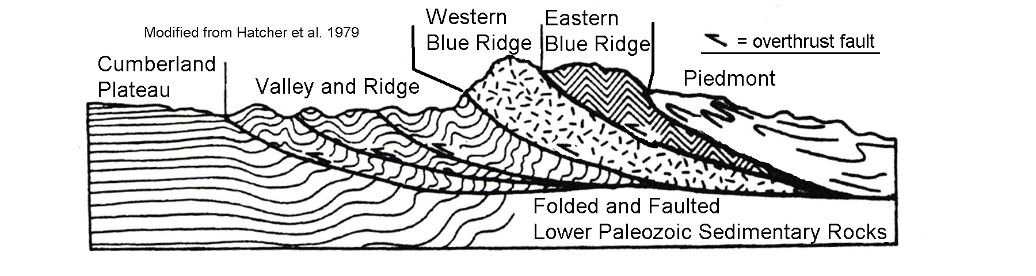
The rocks in the Eastern Blue Ridge section contain a mix of very old igneous basement rock and medium- to high-grade metamorphic rocks. Igneous intrusions are also common. The rocks in the western section were thought to have formed initially as sediments in rift basins, but after long exposure to the temperatures and pressures associated with deep burial have been changed into low- to moderate-grade metamorphic rocks. During Mesozoic and Cenozoic times, the Blue Ridge has experienced continued uplift and erosion which has finally brought many of the originally deeply buried igneous batholiths and surrounding rock near the land surface. As erosion continued to remove the overlying rock and soil, the confining pressure was gradually reduced and the granitic rock began to expand and fracture. Many of these resistant batholiths now form the high points of the mountains we see today and frequently slabs of the fractured rock litter the base of the exposed cliffs. Such bare exposures of resistant rock are frequently called ‘balds’.

Influence of Topography on Historical Events and Cultural Trends

Folklore

The earliest inhabitants of the Blue Ridge region were Native Americans. The Cherokee nation was the largest group in the American south and many rivers, mountains and other landforms in the region were given Cherokee names. The state of Tennessee even owes its name to a major Cherokee town, Tenassee, located to the west of the Great Smoky Mountains. When European settlers arrived, they brought with them many of their own native ballads, legends, and tall tales, which have been handed down through the generations. From 1904 to 1907, famed outdoorsman Horace Kephart lived among the Blue Ridge mountain people, immersed himself in the backwoods culture, and wrote about the mountaineers and their lives. Kephart didn’t just gaze at the mountains, he wrote profound books about them; the best known is Our Southern Highlanders, published in 1913. In this book, Kephart says “It is one of the blessings of wilderness life that it shows us how few things we need in order to be perfectly happy . . . ” Another ‘bigger than life’ mountain man and tracker, Big Tom Wilson, lived near Mount Mitchell, North Carolina and is reputed to have killed 113 black bears.

Several strange stories and legends have been associated with certain mountains in the Blue Ridge. Roan Mountain, a 6,285 foot (1,916 meters) peak in Mitchell County, North Carolina is a prime example. To begin with, the mountain is a bald - meaning it has a wide treeless summit. Generations of scientists have studied this mountain to try to explain why there are no trees on top, but still have found no definitive answers. But an even stranger tale is the report, repeated by many visitors to the peak, of hearing strange music, like the humming of thousands of bees. Legend says that the wind pounds the mountain so hard that it blows holes into and through the northwestern slope. The Cherokee people and other Native American nations also noticed unusual happenings at Roan Mountain and handed down their own legends about this unique place.

Bloody Roan Mountain
--Adapted from Charles Lanman, Letters from the Alleghany Mountains--

“Long ago, the Catawba Indians challenged all their enemies to fight them in a great battle at the summit of Roan Mountain. The enemies accepted the challenge and fought the Catawbas in three great battles. The Catawbas defeated their enemies, but the streams of the entire land flowed red with blood. So much blood was shed that the trees withered from the peaks of Roan Mountain and never grew back. Gradually, rhododendron took hold, but their blossoms were mostly crimson as they were nourished by the blood of the slain.”

Ulagu: The Giant Yellow Jacket
--Adapted from James Mooney, Myths of the Cherokee--

“A Cherokee village was once terrorized by a giant yellow jacket called Ulagu, who would snatch up children and carry them to his hidden lair in the side of a mountain. The Cherokee posted sentinels on the top of Roan Mountain to track Ulagu and prayed to the Great Spirit for aid. The Great Spirit sent a bolt of lightning that split off the side of the mountain where Ulagu hid. Once exposed, the Cherokee were able to destroy Ulagu. To reward the Cherokee’s initiative in uncovering Ulagu’s lair, the Great Spirit decreed that in the future the tops of all the highest mountains would be bare of timber. These bare mountains would better serve as stations for sentries should another such visitation occur. The strange humming sounds from Roan Mountain could be other such giant yellow jackets.
Historical Events

While much Native American history has been lost over the years, archeologists and historians have identified several nations that once populated the Blue Ridge mountains. The largest groups were the Cherokee, Chickasaw, Shawnee, and the Yuchi. Before Europeans arrived on the scene, all these groups survived mostly by hunting, fishing, and farming. From earliest recorded times, the Cherokee were a mountain people living on both sides of the Blue Ridge mountains. They also inhabited parts of Georgia, South Carolina, Alabama, and Virginia. Once European settlement began in the southern colonies, contact and trade between the Cherokee and the colonists increased. The deerskin trade was especially lucrative for Native Americans. In exchange for their deerskins, they received guns, gunpowder, bullets, metal tools, clothing, and rum. Unfortunately, they also unknowingly received new diseases, for which they had no immunity. An outbreak of smallpox in 1783 reduced native population numbers in the region by almost fifty percent.

During the Colonial and Revolutionary periods, the Cherokee fought several wars with the colonists and were forced to cede large portions of their land. Even after they instituted a government modeled on that of the United States and developed a new written alphabet, several states were determined to remove all Native Americans from their jurisdictions. The final straw was the discovery of gold near Dahlonega, Georgia, which led to a land rush by white settlers and the agreement by a few chiefs to vacate their lands and move to the Indian Territory (now the state of Oklahoma) set aside by the Federal government as a re-settlement site. In 1838, federal troops forcibly removed the Cherokee from their land in what has become known as the “Trail of Tears”. However, several hundred Cherokee managed to escape into the Great Smoky Mountains and eventually, in 1848, were granted permission to remain and establish the Qualla Indian Reservation near the city of Cherokee, North Carolina.

Aside from hunters, fur traders, and miners looking for gold or other riches, very few people actually settled in towns or cities in the Blue Ridge. Major transportation routes routinely detoured around the high mountain areas, and the settlements that did exist there were extremely isolated. Just before the Civil War began, a group of investors tried to build a railroad connection from South Carolina to Cincinnati, Ohio, passing through the Blue Ridge mountains, by first climbing over the Blue Ridge escarpment along the North and South Carolina border. The plan called for the construction of three tunnels, only one of which was ever completed. With the collapse of the economy following the Civil War, the company went bankrupt and the idea was never re-visited.

Influence of Topography on Commerce, Culture, and Tourism

The earliest explorers and settlers in the Blue Ridge had to travel on foot or on horseback, because there were no roads. In some areas, Native Americans had blazed trails that were later widened to accommodate wagons. In other places, very bumpy ‘corduroy roads’ were constructed by cutting down many trees and placing the logs across the road perpendicular to the direction of travel. The earliest wagon roads had to follow the landscape, which usually meant traveling along rivers or through valleys and natural gaps in the mountains. Many of today’s major highways and railroad lines follow the same routes as these early roads. Most towns in this region were originally founded as centers for lumbering or mining activities, but the difficulty of travel, both into and out of these areas, limited their success and growth.

As early as 1850, the North Carolina mountains became a tourist destination for wealthy Americans who could afford to travel. The dramatic slopes and high relief of the area provided spectacular scenery as well as a welcome respite from the summer heat of the lowlands. The Mount Mitchell area in particular was a popular destination and accommodations were constructed nearby to house the visitors. Those who made the hike to the top of the mountain were rewarded with magnificent vistas in all directions. Later, communities of summer vacation homes and rental cabins sprang up in many towns as more and more tourists sought out the change of pace provided by the quieter, more peaceful environment and slower pace of life in the region.

By the middle of the twentieth century, Americans were traveling like never before. Family camping expeditions were extremely popular, and were much more affordable than having to lodge in resort hotels. The Great Smoky Mountains National Park soon became the most visited national park in the country. Opportunities for hiking, fishing, hunting, rock-climbing, hang-gliding, photography, and white-water rafting abound throughout the Blue Ridge. Mountain crafts and collectibles await buyers in many roadside shops. Homestyle meals are served in friendly restaurants tucked into the hills. The area soon became home to many youth summer camps, music festivals, and arts-and-craft shows, as tourism quickly became the number one industry throughout the region.

Many of the picnic areas, trails, campgrounds, and park roads were constructed by the Civilian Conservation Corps (CCC) during the 1930’s. This organization was part of President Roosevelt’s New Deal and provided work for many young men during the Great Depression. The CCC workers also landscaped the area with attractive stone walls and constructed several small reservoirs. Two of the biggest projects were constructing the Newfound Gap highway (now U.S. Route 441) through the Great Smoky Mountains and the Blue Ridge Parkway, running through some of the most spectacular scenery in the country from the Great Smoky Mountains National Park to Shenandoah National Park in Virginia. Later the TVA (Tennessee Valley Authority) dammed up several Blue Ridge rivers to create large reservoirs for power generation and for recreation.

Natural Resources, Land Use, and Environmental Concerns

Climate and Water Resources

Based on its southerly latitude, the Blue Ridge lies within a climate belt called ‘humid subtropical’. However, the higher elevations and variations in landscape exposure produce a patchwork of humid, more temperate climates, especially in the higher mountain ranges. For example, westward-facing ridge crests will receive more and higher velocity winds and rain than the adjacent valleys. Higher elevations in general receive greater amounts of precipitation because as humid air masses are forced to rise, they cool and release their moisture. There is an average drop in temperature of nearly 10ºF (6.5ºC) for every 3,000 feet (1000 meters) rise in elevation. On clear, sunny days, there is a tremendous difference in the amount of sunlight reaching the sunny and shady sides of the mountain. Except for the high mountains, the average growing season is over 200 days per year and in most places precipitation is abundant, reaching over 80 inches (2000 mm) per year. Snow is common during the winter months, especially at higher elevations.

The abundant precipitation that falls in the Blue Ridge generates a large number of streams and rivers that drain the region. Rapids and waterfalls are common occurrences as the flowing water encounters resistant rock layers or plunges off exposed rock ledges. These rivers sometimes erode deep cuts into the bedrock, forming gorges. Linville Gorge, in North Carolina, drops over 2,000 feet (610 meters) through a 14 mile (23 kilometer) stretch. This densely wooded gorge is second in the United States, only to the Grand Canyon, in length and depth. Springs are quite common at higher elevations and occur whenever the water table intersects the land surface. In many cases, precipitation that falls on mountains will seep into the ground through cracks and fractures in the rock until it encounters a non-permeable layer. The water will follow that layer sideways until it crops out on the side of the mountain. Occasionally streams will disappear beneath piles of rock debris that had fallen off the mountainside and reappear as a spring in the valley below.

Soils and Agriculture

Most of the Blue Ridge features relatively young or immature soils that have only weakly developed soil layers or horizons due to the short amount of time available for soil development on the landscape. In areas with steep slopes and heavy rainfall, soil will erode almost as fast as it forms. Soils are also young within floodplains that have formed in valleys along major streams and rivers. The only really mature soils are found on fairly broad ridge tops or in relatively flat mountain coves. The Blue Ridge has a history of intense rainfall events that have triggered episodes of landslides. Interstate Highway 40 through the Great Smoky Mountains has been closed multiple times from landslides due to the combination of steep slopes and unstable rock layers that border this highway.

As might be expected from the great variety of soils and landscapes, there is also a great variety in the kinds of crops that can be grown in the Blue Ridge. The earliest farmers practiced subsistence agriculture, growing grain crops, fruits, vegetables, and tobacco for home and local use. They tilled the land with hand tools and with horse or mule drawn implements. Land that was too steep or otherwise unsuited for continuous cultivation often became severely eroded and had to be abandoned. Modern farms are also usually very small operations, with produce sold locally. Although commercial farming has not been very successful in the mountains, timber production has long been an important economic activity. Several woodlands at higher elevations have been turned into Christmas Tree farms. Because of the increase in tourism-related activities, many areas formerly used as farmland have been converted to vacation resorts, camping parks, and other commercial ventures.
Mining, Resource Extraction, and Environmental Concerns

The Blue Ridge region is known for three types of mineral resources: construction materials, non-metallic minerals, and metallic minerals. However, many of the original ore deposits have been depleted so much that commercial mining is no longer profitable. Construction materials include building stone (especially the Murphy Marble and the Henderson Gneiss), crushed stone, and sand and gravel. Non-metallic minerals include feldspar, mica, and rare-earth minerals that are mined in the Spruce Pine Pegmatite District just north of Mount Mitchell, North Carolina. The commercial mining of mica began in 1868, as mica was in great demand for use as heat-resistant windows in stoves, windows in early automobiles, and electrical insulators. A small mining town in the area even took the name ‘Micaville’. Feldspar production did not begin until much later, but western North Carolina now leads all of North America in feldspar production. This mineral is widely used in producing glazes for various glass and ceramic products. North Carolina also leads the nation in the production of olivine, an iron-magnesium silicate mineral. Olivine’s high melting point makes it an ideal substance for producing fire bricks and other refractory materials used under high-temperature conditions. Many gemstones are also mined in the Blue Ridge, and a major tourist industry has grown up around Franklin, North Carolina where visitors can pan for emerald, rubies, and garnets. These gemstones were originally eroded out of the mountain rocks before being washed down into streams and incorporated into the stream gravel.

Metallic minerals mined in the Blue Ridge include manganese, iron ore, lead, zinc, titanium, gold, and copper. The Ducktown District, in extreme southeastern Tennessee, has produced substantial quantities of copper, as well as zinc and sulfur. The large amounts of sulfuric acid that were manufactured here led to serious air pollution problems as the sulfurous gases mixed with rainfall and created a very acid liquid that destroyed most of the vegetation for miles around. The resulting denuded landscape became severely eroded to the point where the devastation became large enough to show up on satellite images. Recent reclamation efforts have helped a great deal, and much vegetation has returned to the area.

In 1911 the Federal government authorized the purchase of lands in western North Carolina for timber production. The purchased lands eventually became part of a great National Forest system. These forests offer developed recreational areas, special-interest areas, and wilderness areas that provide protection for many species of wildlife common to the region. The first school of forestry in the United States was opened in the Pisgah Forest in 1898. Today, this property is preserved as a museum, called the Cradle of Forestry, and is a national historic site. One noteworthy tree discovered in these mountains, the Fraser Fir, grows only in elevations above 3,500 feet that receive high enough rainfall (70 to 90 inches [180 to 230 centimeters] annually). Their attractive green boughs, the ability to bounce back after being bound for shipping, and their ability to retain their needles long after they are cut, have made the Fraser Fir the preferred Christmas tree for many consumers. There is some concern that when landowners plant so many Fraser Firs, they are also cutting down large tracts of the native forests.
PLACES TO VISIT 

Biltmore Estate (House and Gardens). One Lodge Street, Asheville, NC 28803. For information call (800) 411-3812 or search online at https://www.biltmore.com/

Blue Ridge Parkway. 199 Hemphill Knob Rd, Asheville, NC 28803. For information call (828) 348-3499 or search online at https://www.nps.gov/blri/index.htm

Cherokee Indian Reservation. 498 Tsali Blvd., Cherokee, NC 28719. For information call 800-438-1601 or search online at https://visitcherokeenc.com/eastern-band-of-the-cherokee/

Chimney Rock State Park. 743 Chimney Rock Park Road, Chimney Rock, NC 28720. For information call 828-625-1823 or search online at https://www.ncparks.gov/chimney-rock-state-park/home

Ducktown Basin Museum. 212 Burra Burra Street, Ducktown, TN 37326. For information call 423-298496-5778 or search online at https://ducktownbasinmuseum.com/

Emerald Village & NC Mining Museum. 331 McKinney Mine Rd, Spruce Pine, NC 28777. For information call 828-765-2761 or search online at https://www.emeraldvillage.com/mines-activities/north-carolina-mining-museum/

Folk Art Center (Southern Highland Craft Guild). 382 Blue Ridge Parkway, Asheville, NC 28815. For information call 828-298-7928 or search online at https://www.southernhighlandguild.org/contact/

Grandfather Mountain. 2050 Blowing Rock Highway, Linville, NC 28646. For information call 800-468-7325 or search online at https://grandfather.com/

Great Smoky Mountains National Park. 107 Park Headquarters Road, Gatlinburg, TN 37738. For information call 865-436-1200 or search online at http://www.nps.gov/grsm/

Linville Falls and Gorge. Forest Supervisor’s Office – 160 Zillicoa St. Suite A, Asheville, NC 28801. For information call 828-257-4200 or search online at https://www.fs.usda.gov/detail/nfsnc/specialplaces/?cid=stelprdb5188440

Mount Mitchell State Park. 2388 State Highway 128, Burnsville, NC 28714. For information call 828-675-4611 or search online at http://www.ncparks.gov/Visit/parks/momi/main.php

Pilot Mountain State Park. 1792 Pilot Knob Park Road, Pinnacle, NC 27043. For information call 336-325-2355 or search online at https://www.ncparks.gov/pilot-mountain-state-park/home

Roan Mountain State Park. 1015 Hwy 143 Roan Mountain, TN 37687. For information call 423-547-3900 or search online at https://tnstateparks.com/parks/roan-mountain
REFERENCES AND RESOURCES

SELECTED PRINT RESOURCES

Abramson, R. and Haskell, J., eds. (2006). Encyclopedia of Appalachia. Knoxville, TN: University of Tennessee Press.

Beyer, Fred. (1991). North Carolina the Years Before Man: a Geologic History. Durham, NC: Carolina Academic Press.

Bogucki, D.J. (1976) ‘Debris Slides in the Mt. LeConte Area, Great Smoky Mountains National Park, U.S.A.’ Geografiska Annaler, v. 58, no. 3, p. 179-191.

Buxton, B.M., and Beatty, S.M. (1986). Blue Ridge Parkway, Agent of Transition. Boone, NC: Appalachian State University Press.

Clark, G.M. (1987). Debris slide and debris flow, historical events in the Appalachians south of the glacial border, in Costa, J.E. and Wieczorek, G.F. (eds), ‘Debris flows/avalanches: Process, recognition, and mitigation.’ Geological Society of America Reviews in Engineering Geology, v. VII, p. 125-138.

Dykeman, W. and Stokely, J. (1978). Highland Homeland: The People of the Great Smokies. Washington, D.C.: National Park Service, Division of Publications.

Hatcher, R.D., Jr. (1978). Tectonics of the western Piedmont and Blue Ridge, southern Appalachians: Review and speculation. American Journal of Science, v. 278.

Kephart, H. (1976). Our Southern Highlanders: A Narrative of Adventure in the Southern Appalachians and a Study of Life Among the Mountaineers. Knoxville, TN: University of Tennessee Press.

King, D.H. (ed). (1986). The Cherokee Indian Nation: A Troubled History. Knoxville, TN: University of Tennessee Press.

King, P.B., Neuman, R.B., and Hadley, J.B. (1968). Geology of the Great Smoky Mountains National Park, Tennessee and North Carolina. U.S. Geological Survey Professional Paper 587. 23 p.

Mooney, James. (1970). Myths of the Cherokee (Nineteenth Annual Report of the United States Bureau of American Ethnology to the Secretary of the Smithsonian Institution 1897-98). New York: Johnson Reprint Corporation.

Tager, Miles. (1999). Grandfather Mountain: A Profile. Blowing Rock, NC: Parkway Publishers, Inc.

Walser, Richard (1980) North Carolina Legends. Raleigh, NC: North Carolina Department of Cultural Resources, Division of Archives and History.

Wilson, C. R., Ferris, W., Abadie, A. J., and Hart, M. L., Editors (1989). Encyclopedia
of Southern Culture. Chapel Hill, NC: The University of North Carolina Press.

Wyche, Tom. (1994). South Carolina`s Mountain Wilderness: The Blue Ridge Escarpment. Westcliffe Publishers.
SELECTED INTERNET RESOURCES (all sites were functional and accessible in 2020)

https://www.tva.com/about-tva/our-history/tva-heritage
This link gives an overview of the Tennessee Valley Authority (TVA) and its reservoirs. The site is complete with a history of the TVA in a timeline format by decade.

http://www.forestencyclopedia.net/p/p1
This site gives a history of agriculture in the Southern Appalachians from the time that the region was settled up to the Civil War. It describes the crops that were grown as well as the livestock that was raised. There are also other useful links on the left side of the page.

https://cradleofforestry.com/
This site features interactive exhibits and other historical information about the development of the National Forest system at the Cradle of Forestry site located in Pisgah National Forest, NC. just off the Blue Ridge Parkway.

https://visitcherokeenc.com/eastern-band-of-the-cherokee/
This site gives an historical summary of the Eastern Band of the Cherokee Nation as well as insights into their culture, art, and language. The site also has links to area activities.

https://www.ourstate.com/mineral-city/
This site is a guide to the Spruce Pine Mining District of North Carolina and is an easy to read description of the minerals mined in the district and some history behind the mines.

https://tclf.org/sites/default/files/microsites/LandscapeILove/blue-ridge-escarpment.html
This site describes the scenic features of the Blue Ridge escarpment and details some of the preservation efforts that are ongoing in North and South Carolina.

https://smokymountains.com/park/things-to-do/newfound-gap-road/
This site describes the road over Newfound Gap, the lowest drivable pass in the Great Smoky Mountains National Park and also has links to other activities in the park.

https://smokymountains.com/park/cades-cove/scenic-drive/
This site features historic sites along the Cades Cove scenic loop drive on the Tennessee side of Great Smoky Mountains National Park. It also has links to other nearby features.

https://wildwaterrafting.com/ducktown-tn-a-history/
This site give a brief history of Ducktown, TN, including documentation of the devastation left behind from copper mining and smelting activities.

http://www.ussartf.org/landslides.htm
The United States Search and Rescue Task Force describe what a landslide is, the factors that contribute to a landslide, landslide types, as well as directions for avoiding them.

http://www.grandfather.com/
The official site for Grandfather Mountain: This website provides information about the park, nature museum, and wildlife habitats.

https://www.ncparks.gov/gorges-state-park/home
This site highlights features along the Blue Ridge escarpment at Gorges State Park in southwestern North Carolina. Menu items include history, ecology, and lots of photos.

http://ncnatural.com/Parkway/BRP-History.html
This website provides links for the Blue Ridge Parkway. These links include the history of the Parkway, the cultural influence in the region, and current events.

STUDY AREA 6A: GREAT SMOKY MOUNTAINS

Knoxville News-Sentinel
July 18, 1999
Smokies Air Quality Dropping
Gatlinburg, TN. “How’s the air quality today?” The question beckons from a new kiosk at the Sugarlands Visitors Center in the Great Smoky Mountains National Park. Monitors provide the instant answer with a real-time view of the Smokies’ tallest peaks from a vantage atop the 2,600-foot Look Rock monitoring station, along with the current ozone concentration and other weather information.  Comparison scenes show the same vista on good days, when visibility stretches to nearly 100 miles, and the smog-filled bad ones, when there is no view at all. | “It’s not getting any better from the point of visibility,” Smokies Superintendent Karen Wade said.  Scientists say naturally light winds predispose the region to some of the most frequent and lengthy periods of air stagnation in North America. Jim Renfro, air-quality specialist, adds “we are downwind from a lot of pollution sources and regional population growth.” Emissions from factories and coal-fired power plants as far away as the Mississippi River and the Ohio Valley blow into the Smokies and linger, causing haze and acid rain. | So do pollutants from trucks and cars, including those of the 10 million visitors to the park annually, leading to the formation of colorless ozone that can make breathing difficult, particularly up on mountain trails.  Last summer, the Smokies for the first time began issuing public health ozone warnings when eight-hour concentrations exceeded federal and state health standards. The Smokies were named for their natural blue mist. But today, air pollution from vehicles and smokestacks hundreds of miles away muddies the sky.

RATIONALE

The Great Smoky Mountains are best known for high mountain peaks and the many recreational opportunities available to visitors both inside and outside of the Park. The Smokies have the distinction of being the most visited national park in the country. The area has been named an International Biosphere Reserve and a World Heritage Site because of its unique ecology, diversity of plant and animal species, spectacular scenery, and its widespread inventory of Appalachian cultural items including buildings from the nineteenth and early twentieth centuries. The Eastern Band of the Cherokee Nation has built a thriving community on the North Carolina side of the park. The park features many examples of landforms that have been shaped by a variety of geological processes, both on the land surface and operating deep underground. One such feature is the structural window called Cades Cove. Other surface processes have caused landslides and debris flows on the steeper mountain slopes and flooding in the narrow stream valleys. Several environmental problems have affected this region, including uncontrolled logging operations, soil erosion, and air pollution caused by nearby copper smelting operations.

PERFORMANCE OBJECTIVES

1. Compare and contrast land use and land cover in mountain areas versus cove areas.
2. Explain geographic reasons for highway route placement in the Smoky Mountains.
3. Locate debris-slide scars on maps and 3-D images.
4. Analyze impact of Cherokee culture on white immigrants and names of local features.
5. Explain underlying geologic causes of surface lineaments, ridges, and coves.
6. Locate prominent features of Smoky Mountains on a variety of maps and images.
7. Determine contour interval of map and locate lowest elevation in cove valley.
8. Use acrostic literary pattern to describe features and other items associated with cove.
9. Calculate surface area of region affected by local pollution.
10. Practice writing persuasive letters to government officials urging pollution control.

SAMPLE ASSESSMENT RUBRICS
EXAMPLE #1 (relates to Performance Objective #5)
Give students a copy of IMAGE 6A, GREAT SMOKY MOUNTAINS and ask them to sketch and label an idealized cross-section diagram starting from Chilhowee Mountain and passing through Cades Cove. [The result should look something like Figure 6A-1, but not as complicated.]

A (level 4) – Cross-section shows Great Smoky Fault emerging on NW side of Chilhowee Mt. and reaching the surface at both edges of Cades Cove.
B (level 3) – Cross-section shows a fault emerging on NW side of Chilhowee Mt. and at both edges of Cades Cove, but fault is not named correctly; or fault is named correctly, but not shown properly at both locations.
C (level 2) – Fault is indicated, name is correct, but not drawn properly at either location; or fault is indicated at only one location and name is not correct.
D (level 1) – Fault is indicated, but not named correctly, also not drawn properly at either location.
F (level 0) – No mention of a fault.

EXAMPLE #2 (relates to Performance Objective #7)

Give students a copy of the anaglyph 3-D map [found on MAP 6A]; including a pair of 3-D glasses) and ask them to locate a cove other than Cades Cove. Ask them to briefly describe how they recognized the cove [answer should include descriptions like ‘low elevation’, ‘flat’, ‘wide stream valley’].

A (level 4) – Student mentions at least three correct criteria for recognizing cove.
B (level 3) – Student mentions at least two correct criteria and no incorrect criteria.
C (level 2) – Student mentions one or two correct criteria and no more than one incorrect criterion.
D (level 1) – Student mentions one correct criterion and no more than two incorrect criteria.
F (level 0) – None of the student criteria are correct.
Cartographic Product Information

MAP 6A: Great Smoky Mountains

TITLE: 3-D Topographic Section Map: Gatlinburg, TN (anaglyph map)
DATA SOURCE: Ambroziak Infinite PerspectiveTM 3-D Shaded Relief Topographic Map; created by Ambroziak Third Dimension Technologies, Inc., Princeton NJ
DATE: 1998
SCALE: 1:110,000 [1 inch ~ 1.8 miles] [1 cm ~ 1.2 kilometer]
OTHER IMPORTANT DATA:
- This map is a red and cyan (blue-green) image which must be viewed through red/cyan glasses with the red filter over the left eye.
- Vertical exaggeration is proportional to viewing distance (3x at distance of 12 in)
- The contour interval of this map is 50 meters.
POINTS OF SPECIAL INTEREST:
- Gatlinburg (labeled) is in left-center portion of right half of anaglyph map.
- Mount Le Conte is the high peak located southeast of Gatlinburg.
- Newfound Gap (not labeled) is on highest ridge south of Mt. Le Conte (halfway between Gatlinburg and bottom of anaglyph map).
- Chilhowee Mountain is the narrow ridge running diagonally across the center of the left half of anaglyph map.
- Cades Cove is located in the lower center of left half of anaglyph map.
OTHER FEATURES TO LOOK FOR:
- Several water gaps and wind gaps cut through Chilhowee Mountain.
- The Smoky Mountain drainage divide is located in the lower-right corner of map.

TITLE: Gatlinburg, TN (NHAP [air photo] triplet)
DATA SOURCE: NHAP CIR Photographs 539-176, 539-177, and 539-178
DATE: 1984
SCALE: 1:60,000 [1 inch ~ 1 mile] [1 cm ~ .6 kilometers]
OTHER IMPORTANT DATA:
- This is a color infrared photograph, so all true colors have been color shifted.
- This is a stereogram triplet photo that is best viewed through a 3-D stereoscope.
- Because this is a stereo triplet; there are two vertical ‘joining’ lines, one toward the left edge of the photo, the other near the right edge of the photo.
- As with any stereoscopic view, only the center of your view will display 3-D images (sides will not).
POINTS OF SPECIAL INTEREST:
- Curvy thin white line near left side of the photo is US Route 441; the thin white line running diagonally across the left part of photo is Clingmans Dome Road.
- Gatlinburg is located in the upper-right corner of photo.
- Mount Le Conte is located near the center of the photo.
- Newfound Gap is located where Route 441 intersects the Clingmans Dome Road.
OTHER FEATURES TO LOOK FOR:
- White specks on south slope of Mt. Le Conte are debris slide scars.
Cartographic Product Information

IMAGE 6A: Great Smoky Mountains

TITLE: Great Smoky Mountains, TN-NC (topographic map)
DATA SOURCE: Knoxville and Chattanooga USGS 1:250,000 Quadrangles
DATE: 1957 (photorevised 1972)
SCALE: 1:250,000 [1 inch ~ 3.2 miles] [1 cm ~ 2 kilometers]
OTHER IMPORTANT DATA:
- The contour interval of this map is 100 feet.
POINTS OF SPECIAL INTEREST:
- Gatlinburg (labeled) is located in upper-right center of map.
OTHER FEATURES TO LOOK FOR:
- Newfound Gap and Mt. Le Conte (both labeled) are southeast of Gatlinburg.

TITLE: Great Smoky Mountains, TN-NC (SLAR [radar])
DATA SOURCE: Knoxville and Chattanooga USGS 1:250,000 Radar Mosaics
DATE: 1984
SCALE: 1:250,000 [1 inch ~ 3.2 miles] [1 cm ~ 2 kilometers]
OTHER IMPORTANT DATA:
- Dark bands along ridges are shadows cast by mountains that blocked radar beam.
POINTS OF SPECIAL INTEREST:
- Fontana Lake is near exact center of image.
OTHER FEATURES TO LOOK FOR:
- Rectangular drainage pattern in left center of image.

TITLE: Great Smoky Mountains, TN (NALC [satellite])
DATA SOURCE: EPA & USGS NALC Pathfinder WRS 2 Path 19 Row 35
DATE: 1992
SCALE: 1:250,000 [1 inch ~ 3.2 miles] [1 cm ~ 2 kilometers]
OTHER IMPORTANT DATA:
- This image is an infrared image, so all true colors have been color shifted.
POINTS OF SPECIAL INTEREST:
- Chilhowee Mountain is bright-red ridge running diagonally across top left corner.
OTHER FEATURES TO LOOK FOR:
- Note different land use pattern on either side of Chilhowee Mountain.

TITLE: Ducktown, TN (upper = NHAP [air photo] ) (lower = MSS [satellite image] )
DATA SOURCE: upper = NHAP CIR photograph 89-193;
lower = USGS Georgia Satellite Image Mosaic (Landsat 1)
DATE: 1988 (upper); 1974 (lower)
SCALE: 1:108,000 (upper) [1 inch ~ 315 miles] [1 cm ~ 198 kilometers]
1:560,000 (lower) [1 inch ~ 315 miles] [1 cm ~ 198 kilometers]
FEATURES TO LOOK FOR:- The ‘devastated area’ can be recognized from space,.
Study Area Description

Smoky Mountain Landscapes

The Great Smoky Mountains landscapes have a long and complex geologic history. They also have a complex, though much shorter, human history as the high mountains formed a forbidding wilderness that was very difficult to travel across. Even the Native Americans who once inhabited these lands tended to stay in the lower elevation, more easily accessible parts of the mountains. Europeans first settled Cades Cove in 1818 and relations with the Native Americans remained mostly peaceful until 1838 when the U. S. government decided to relocate the Cherokee to the Oklahoma Territory west of the Mississippi River. During this removal process, several hundred Cherokee fled into the mountains and hid from their pursuers. Those escapees became the ancestors of the modern day Eastern Band of the Cherokee Nation. Although the Cherokee were granted a reservation in North Carolina in 1848, they were granted full U. S. citizenship in 1924. Since that time, they have managed to preserve much of their cultural heritage and have built an impressive tourist village around the town of Cherokee, NC.

The Tennessee/North Carolina border follows the high central ridge of the Smoky Mountains. There are three main entrances to the National Park: Cherokee, NC, Gatlinburg, TN, and Townsend, TN. A major U. S. Highway (Route 441) runs over the top of the central ridge and connects the two sides of the park. The road from Townsend follows the Little River for most of its route and connects with Route 441 just south of Gatlinburg. The Cherokee - Gatlinburg highway started out as a dirt road that crossed the central ridge at Indian Gap, about 1.5 miles (2.4 km) west of the current crossing at Newfound Gap. A ‘gap’ is a low point in a mountain ridge. In 1872, Arnold Guyot, a Swiss geographer, measured the height of several mountains in the Smokies, including the highest peak, Clingman’s Dome, using a barometer to measure changes in air pressure. During his travels, Guyot discovered another gap, just east of Indian Gap, that was lower and easier to cross. He named it “New Found Gap.” The old highway was re-routed through this easier path and it became known as the “Newfound Gap Road,”

The National Park was established in 1934, and since then the entire economy of the region has revolved around tourism. Although summer is the peak visitation time, the park is open year round and activities like cross-country skiing are popular in the winter. The Gatlinburg entrance receives the greatest number of visitors and has become extremely commercialized, some would say over-commercialized. Almost every type of amusement park ride, restaurant, music theater, museum, and souvenir shop can be found within the city limits. The Cherokee entrance has fewer visitors, but likewise has built an entire economic culture around tourism. Townsend bills itself as “the quiet side of the Smokies”, but has the advantage of being the entrance closest to Cades Cove.

The Appalachian Trail follows the high ridges, passing through Newfound Gap, and many other trails of varying length and difficulty lead to impressive waterfalls, quiet woodlands, and spectacular mountain overlooks. One popular (but very steep) trail climbs to the top of Mt. LeConte, third highest peak in the Smokies. This trail climbs an astounding 5,301 feet (1,616 meters), over a mile, from its base near Gatlinburg, to the top. Most hikers take two days to walk this trail, spending the night either camping on the mountain or staying at the LeConte Lodge, the highest elevation guest lodge in the United States. Other favorite activities are river tubing, camping, and wildlife viewing. Black bear, deer, and elk often frequent areas with large open spaces. Early morning and late evening are the best viewing times. Cades Cove and the fields behind the Oconaluftee Visitor Center near Cherokee are the most popular viewing places. Traffic jams and delays on the highways are common as cars often stop in the road so passengers can get out and take pictures.

Cades Cove

The earliest European settlers traveled to this area from the Wautauga Settlements in northeast Tennessee in 1818 and settled in Cades Cove. The term ‘cove’ just refers to an isolated wide valley surrounded by mountains. The fertile soil, readily available timber, and abundant wildlife made the area well suited for the subsistence farming practiced by the early settlers. By 1850, the Cove’s population reached 685. The Smoky Mountains were not directly affected by the Civil War, but soldiers from the area fought for both sides. One record indicates 21 Cove residents joined the Union forces, while 12 joined the Confederates. The establishment of the Great Smoky Mountains National Park required the government to purchase the land of the citizens still living within the park boundaries, whether they wanted to sell or not. Many did not want to sell. After many lawsuits were filed, the Tennessee Supreme Court issued a compromise ruling that landowners could keep their property as long as they lived, but once they died, the land title would pass to the National Park Service.

The 11 mile (18 km) long Cades Cove Loop Road is a one-lane, one-way paved road that passes many restored historic buildings, including three churches, several log homes, a cantilevered barn, and a working mill. A visitor center has been built near the halfway point close to the water-powered mill. Although some visitors come to tour the historic buildings, most drive through the cove to see the scenic views and the wildlife. Black bears have been known to frequent the picnic area near the beginning of the Loop Road. The Cove also hosts occasional local festivals and offers horseback riding and several other activities for visitors.

In addition to Cades Cove, the western side of the Smoky Mountains features two other large coves: Tuckaleechee Cove and Wears Valley Cove. There are some specific geologic reasons why coves form in this area, mostly related to the tectonic history of the Smoky Mountains. The entire western side of the Blue Ridge region was pushed northwestward over top of younger rocks during the major mountain-building episodes that occurred in the Appalachian Region near the end of the Paleozoic Era. The movement was along a low-angle overthrust fault, called the Great Smoky Fault. Both the fault line and the overlying and underlying rocks have been slightly folded, so some sections were raised higher than others. After millennia of uplift and erosion, some portions of the fault line reached the surface and were removed, exposing the younger rocks underneath. The rocks in Cades Cove and the other major coves are all Ordovician limestone, the same rock type that occurs in the Great Valley in the Valley and Ridge region. The geologic term for such coves is ‘window’, meaning that the overlying rocks have been eroded away providing us with a window through which we can see the rocks that lie beneath the thrust sheet. The farthest cove is located 9 miles (14 km) from the western edge of the fault, so we know that the Great Smoky Fault has overridden the younger rocks at least that much. However, most geologists believe the true overthrust area is much wider than that, although debate continues about the exact distance.

Figure 6A-1: Geologic Cross-Section Through Cades Cove
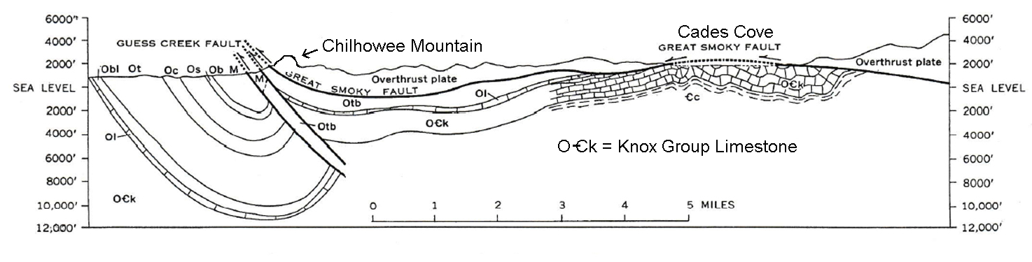
Chilhowee Mountain marks the westernmost edge of the overthrust sheet. The Great Smoky Fault is exposed all along the northwestern flank of this ridge. Even though the shape of this mountain does not really resemble the rest of the Smoky Mountains, it is included in this region because it is part of the same geologic terrane and is approximately the same age. The ridge is held up by very resistant quartz sandstone that was deposited during the Cambrian Period of the Paleozoic Era. Other later faults have created offsets in location of the Great Smoky Fault, which is why Chilhowee Mountain ends so abruptly north of Gatlinburg. One of these younger faults, the Oconaluftee Fault, crosses the mountain crest at Indian Gap and extends down the valley of the Oconaluftee River on the North Carolina side of the park. Stream erosion along these straight-line faults and related fractures in the rocks have created an easily recognizable rectangular drainage pattern in some areas.

Environmental Hazards

Two of the main reasons cited by those wishing to turn the Smoky Mountains into a National Park were to save the forests and protect the watershed. Around 1900, logging interests discovered the old growth forests of the Smokies and began clearcutting vast areas of prime timber. Although the industry brought employment and other economic benefits to the mountaineers, by 1930, over two-thirds of the current park property had already been clearcut. Hauling the huge logs out of the mountains required equipment that further damaged the landscape, increased soil erosion, and injected a lot of mud and dirt into the formerly pristine mountain streams.

Although the Smoky Mountains receive lots of precipitation, almost all of it runs off quickly because of the steepness of the slopes and the limited development of the soil. Most of the rock layers, especially near the mountain crest, are poorly consolidated slates and phyllites that break apart easily, causing slope instability and landslides. As a result, the streams leaving the mountains are full of rocks, rapids, and potholes and occasionally plunge over waterfalls. Sudden cloudbursts can dump over several inches of rainfall per hour onto local areas, especially during summer thunderstorms. Such catastrophic rainfall events are natural occurrences in wilderness areas and provide several benefits. They help cleanse the streams by sweeping away weathered rock and soil material as well as leaves, branches and other dead vegetation. They also build up local floodplain areas by depositing silt and mud along the banks of streams once the flood subsides, promoting the growth of new soil and vegetation. Landslides in the Smokies often take the form of debris slides or debris flows, where enough water seeps into an area of rock debris to destabilize the slope and promote the mass movement of dirt and rock. These features can be recognized on aerial photographs by spotting the wider debris-slide scars at the top of the landslide area and the narrower debris-flow tracks representing the flood-scoured stream channels below. One such historic rainstorm event impacted Mt. Le Conte in 1951 and caused major debris slides along Alum Cave Creek and other tributary streams. Several of the landslides triggered by that storm are still visible today.

Figure 6A-2: Debris Slides in Alum Cave Creek Watershed
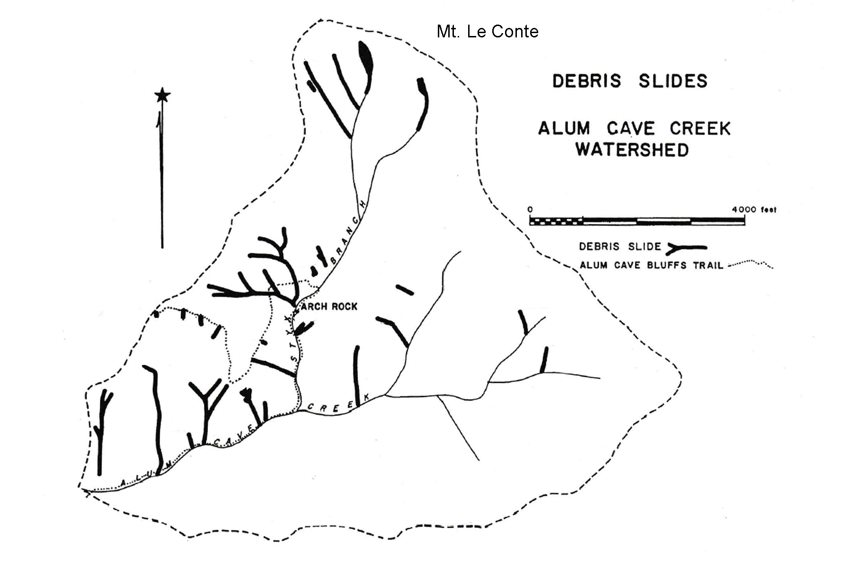
While the mountainous areas can survive such intense storms with minimal damage, once the floods overflow the main rivers that drain the mountains, they leave the park and enter more developed areas, where the results can be devastating. While the main goal of the Tennessee Valley Authority (TVA) was to build dams, create reservoirs, and generate hydroelectric power for the region, a second important goal of the project was flood control. By temporarily storing floodwaters in reservoirs, like Fontana Lake on the Little Tennessee River, and then slowly releasing the water downstream, operators were able to end the previously erratic fluctuations in river flow that plagued farmers living in the valleys below. While all drainage on the North Carolina side of the high central ridge ends up in Fontana Lake, flooding is still a major concern for the cities of Gatlinburg and Townsend, on the Tennessee side of the central ridge, where such reservoirs have not been constructed.

Pollution issues are not usually major concerns in wilderness areas, but air quality has become an important topic in the Smoky Mountains. Some pollutants, in particular ozone, are generated locally from the exhaust of many thousands of vehicles per day that use Route 441 to cross the mountains. Often, cars will stop on the highway to view wildlife and leave their engines running. A sighting of one black bear can create a jam that will back up traffic for miles. The park also lies downwind from some very heavily industrialized areas in the Tennessee Valley. The prevailing wind patterns bring this polluted air into the mountains, where it tends to settle and stagnate in the valleys between the mountains. Unfortunately, there is very little that the park can do to solve either of these problems.

An area just south of the park for a time was one of the most polluted areas in America. Ducktown, Tennessee was originally a Cherokee town named Kawana, which translates into English as “Duck Town.” In 1843, a miner panning for gold in the Ocoee River, found nuggets of native copper instead. The word spread and by 1855, there were more than 30 mining companies shipping out copper and zinc ore by mule train over the road to Cleveland, Tennessee. By 1936, most of the smaller companies had been bought out by the Tennessee Copper Company who provided housing, clothing, and a company store for its workers.

Copper cannot just be pulled out of the ground; it must be extracted from the surrounding rock, by a process called smelting, using heat as a catalyst. The first smelter was built in the Ducktown district in 1854. Because there were no nearby areas of coal, the preferred fuel, local workers chopped down every tree they could find within a 50 mile (80 km) radius around the mines. The smelting process released clouds of sulfur dioxide into the air as a by-product, which when combined with raindrops, produced a form of sulfuric acid that created a toxic acid rain that killed off most of the remaining vegetation in the area and promoted massive soil erosion. Within a few short years, the landscape was being compared to a barren red desert or even the surface of the moon. The devastated area was so large that it could even be seen on images recorded by earth-orbiting satellites.

Eventually, the mining companies discovered that there was a market for sulfuric acid and they found ways to capture the toxic gas and produce it on site. Mass copper mining finally ended in 1987, but production of sulfuric acid continued until 2000. For a time, the Ducktown area was one of the largest producers of sulfuric acid in the country. Reclamation efforts started as early as the 1940s as CCC workers planted trees, mostly fast-growing pines, to try to regenerate the forests. In addition, the soil was treated with lime to try to neutralize the excess acidity. With the cessation of the toxic emissions, the land has recovered surprisingly quickly.

Activity 6A-1: Mountain Landscapes

POWER THINKING EXERCISE - "Trail Troubles"
You are a wilderness explorer and tracker in the year 1820 living in upstate South Carolina. A group of farmers living in western North Carolina has hired you as a guide to lead them to Tennessee where they hope to join a few of their relatives who left two years ago to start a small settlement in Cades Cove in the Great Smoky Mountains. The pay seems good, so you accept the job. After meeting them near Hickory, North Carolina, you follow the trail over Roan Mountain to the Wautauga Settlements located in far northeastern Tennessee, and then continue southwest along the tributaries of the Tennessee River until you reach the outpost at Knoxville. From there, you follow the Little River southeastward, through the gap at Chilhowee Mountain, until you finally reach Cades Cove.
You are now in a hurry to get home, so you decide to take a shortcut across the mountains instead of going back the way you came. Your plan is to cross the high central ridge of the Smoky Mountains, find a river flowing southeastward, and follow it all the way home to South Carolina.
Trace your route with a wipe-off pen onto the GREAT SMOKY MOUNTAINS topographic map on IMAGE 6A. First locate the Little River (just east of the city of Maryville in the far upper-left corner of the map). Follow the Little River through the gap in Chilhowee Mountain and all the way through Tuckaleechee Cove. About a mile south of this cove, you will see a road branching westward (of course that road was not there in 1820). Follow that road into Cades Cove to complete your mission.
To take your shortcut home, you will have to leave Cades Cove and climb over the high central ridge of the mountains to find a stream flowing towards the southeast. Plot your path from Cades Cove to the top of the mountains and try to find a trail route from there that will get you home. Follow one of the southeast flowing rivers and see where you end up. Is there any other stream on this map that would lead you to a different destination if you followed it? Why won’t your shortcut idea work? Refer to the local drainage patterns in the Smoky Mountains to explain your answer.

Materials
MAP 3B, GEOLOGICAL SETTING
MAP 6A, GREAT SMOKY MOUNTAINS
image 6a, GREAT SMOKY MOUNTAINS
3-D Stereoscope Glasses
3-D Viewing Glasses
Wipe-off Pens

PERFORMANCE TASKS
(Icon Key) Overview = ; Science = ; Math = ; History = ; Language Arts =

1. Locate prominent landscape features in Smoky Mountains.
Examine the topographic map on IMAGE 6A, GREAT SMOKY MOUNTAINS and locate the following prominent landscape features. Then look for these same features on the other maps/images listed (find them on MAP 6A and IMAGE 6A). Indicate whether these features are easily identifiable or not on the other maps/images (by selecting ‘yes’ or ‘no’. Explain why certain landforms show up better on certain types of maps/images than on others.

LANDFORM  (on topo map) | SLAR (radar image)  -yes or no- | NALC (satellite image)  -yes or no- | 3-D topo section map  -yes or no-
Chilhowee
Mountain
Mt. Le Conte

Newfound Gap

Clingman’s
Dome Mt.
Fontana Lake

Cades Cove

City
of Gatlinburg
City
of Townsend

2. Explain placement and routing of roads within park.
Locate the Newfound Gap Road (U.S. Route 441) and the Little River Road (TN Route 73) on both the topographic map on IMAGE 6A, GREAT SMOKY MOUNTAINS and the Gatlinburg Stereo Triplet air photograph on MAP 6A, GREAT SMOKY MOUNTAINS. Note that the air photo includes Newfound Gap, but does not show the Cherokee end of highway 441. Trace each highway route onto both the map and the photo with a wipe-off pen. Examine the landscape around each highway’s route and note whether either highway follows specific landform features. Explain why you think each road was built to follow that particular route.

3. Calculate expected drop in temperature as elevation rises.
Atmospheric scientists have established that as you climb a mountain, the air temperature drops at a predictable rate (10ºF for every 3,000 feet or 6.5ºC for every 1000 meters). The top of Mt. Le Conte rises 5,301 feet (1,616 meters) above the city of Gatlinburg, which lies at the mountain’s base. Assuming the temperature in Gatlinburg is 40ºF (4.4ºC) what will the temperature be, at that exact same time, on the top of Mt. Le Conte? Show your calculations and be prepared to explain them.

Assuming that it is a rainy day in Gatlinburg, what type of precipitation (rain or snow) do you predict will be falling at the top of Mt. Le Conte. If it is snowing on Mt. Le Conte, at what elevation do you predict that the rain/snow dividing line will occur? Show your calculations and be prepared to explain them.
4. Analyze topography to predict location of Indian Gap.
The original dirt road that connected Gatlinburg, TN with Cherokee, NC crossed the high crest of the Smoky Mountains at a place called Indian Gap. Indian Gap is not labeled on the topographic map on IMAGE 6A, GREAT SMOKY MOUNTAINS, but we know it was located about 1.5 miles (2.4 km) west of Newfound Gap (which is labeled on the map). The gap also shows up on the 3-D topographic section map on MAP 6A. Study the contour lines along the ridge carefully and place a dot, with a wipe-off pen, at the location you think is the most likely site for Indian Gap. Compare your selected location with locations selected by other groups. Explain how you used contour line patterns and the 3-D topographic map to locate the gap.

5. Debate commercialization of cultural heritage.
The modern city of Cherokee, NC is often described as a ‘tourist trap’. In addition to hosting outdoor camping, fishing and hunting sites, the town is filled with souvenir shops featuring ‘authentic’ Native American artifacts and handmade crafts. The town also features a restored Cherokee Indian Village that visitors can tour and several show theaters where once sacred rituals and ceremonies are re-enacted before large crowds. These businesses have brought a degree of economic prosperity to the city, but some residents complain that their Native American culture is being exploited and trivialized. Some in the city are pushing for constructing a huge amusement park with rides and attractions featuring Native American themes. Other residents are saying that such a park would disrespect Cherokee traditions and that “enough is enough.” Debate this issue within your group, come to a consensus, and select a spokesperson from your group to present your arguments, for and against, to the entire class.

ENRICHMENT
(Icon Key) Overview = ; Science = ; Math = ; History = ; Language Arts =

1. Research original road connecting Gatlinburg and Cherokee.
The current highway, U.S. Route 441, that connects Gatlinburg, TN and Cherokee, NC does not follow everywhere the original route of this road. Use appropriate library and internet resources to discover the path of the original route of the first road to cross the ridge crest. Once you have done this, mark that route, with a wipe-off pen, onto the topographic map on IMAGE 6A, GREAT SMOKY MOUNTAINS and compare it to the modern route. Speculate about why the newer route changes were made.

2. Investigate Cherokee culture.
Many towns, rivers, mountains, and other landscape features in the Smoky Mountains have been given Cherokee names. Locate several of these features on the topographic map on IMAGE 6A, GREAT SMOKY MOUNTAINS and then use appropriate library and internet resources to find out the original meanings of those names.

Activity 6A-2: Cades Cove

POWER THINKING EXERCISE - "Essential Elements"
Your family is one of the original settlers in Cades Cove in 1818. Frontier life is usually thought of as very simple and uncomplicated, but there are still certain essential items, tools, and other home implements that you must have in order to be able to survive. There is good soil, abundant wildlife, and plenty of water in the cove, so you will not have to worry about obtaining food and water. But what else will you need?
Make a list of items that you consider essential to have and indicate whether you will make those items yourself, trade with the Cherokee to get them, obtain from European tradespeople (blacksmiths, tanners, etc.) or will be unable to get them at all? Three examples are provided.

ITEM MAKE TRADE WITH TRADE WITH MUST DO
YOURSELF CHEROKEE EUROPEANS WITHOUT
- wooden cabin x
- iron axe x
- diamond ring x
-
-
-
-
-
-
-
-

Materials
MAP 6A, GREAT SMOKY MOUNTAINS
IMAGE 6A, GREAT SMOKY MOUNTAINS
3-D Viewing Glasses
Wipe-off Pens

PERFORMANCE TASKS
(Icon Key) Overview = ; Science = ; Math = ; History = ; Language Arts =

1. Locate Cades Cove on topographic maps, photographs, images.
Find Cades Cove on the topographic map on IMAGE 6A, GREAT SMOKY MOUNTAINS and use information from that map to also locate Cades Cove on the SLAR Radar Mosaic (IMAGE 6A), the NALC satellite image (IMAGE 6A), and on the 3-D topographic section map (MAP 6A). Use information from all of these sources to write a brief description of the land use/land cover features that characterize Cades Cove. Contrast that land use with what you see in the surrounding mountains.

2. Identify rectangular drainage pattern.
The mountains surrounding Cades Cove are a good illustration of the control that faults and fracture zones in underlying bedrock have on topographic features. Because fractures tend to occur in parallel sets, there are lots of streams and ridge lines on the land surface that also run parallel with each other. In the Smoky Mountains, there are two major orientations of fractures and faults, southwest to northeast, and northwest to southeast. Because the two sets of fractures are nearly at right angles to one another, a rectangular drainage pattern commonly forms. The SLAR radar image on IMAGE 6A, GREAT SMOKY MOUNTAINS provides the best opportunity to visualize that pattern because the radar beam interacts with the landscape at a low angle of incidence and the orientation of each specific surface feature determines the strength of the signal that is reflected back to the receiver. Study the SLAR image carefully to observe the pattern, but don’t get your eyes too close to the image. Patterns like this often are easier to see from a distance. Use the topographic map on IMAGE 6A if you need help finding Cades Cove.

3. Estimate elevations of three coves and infer implications.
Locate Cades Cove, Tuckaleechee Cove, and Wears Cove on the topographic map on IMAGE 6A, GREAT SMOKY MOUNTAINS. To utilize contour line information, you must first calculate the contour interval of the map. Note that only the thicker index contour lines have their elevations labeled. All three coves are fairly flat, so once you know the contour interval, you should be able to estimate the elevation of the floor of each cove. Do the three coves have a similar elevation, or are these numbers noticeably different? What can you infer from your answer about the geometry of the limestone formation that forms the base of each cove? Is the limestone formation fairly level, or is it tilted or folded? Explain your answer.

4. Suggest rationale for decision to join Union or Confederate army.
Although Cades Cove was not directly impacted by the Civil War, some of the residents left home to join the Union army while others left to join the Confederate army. Note that Cades Cove is in Tennessee, one of the states that seceded from the Union. Note also that most of the settlers migrated to the Cove from more northerly states and there are no records of any resident of Cades Cove ever owning slaves.

Discuss in your group what motivations young men living in Cades Cove might have had for joining one of the two armies. Make a list of reasons to share with the class. What problems do you think might have occurred when the surviving soldiers returned home at the end of the war?

5. Write acrostic to paint word picture of Cades Cove.
An acrostic is a poem or other form of writing where the first letter in each line spells out a word or phrase when read down vertically. Design an acrostic where the first letters of each line are in order: C, A, D, E, S, C, O, V, E, and each line gives a statement or description that tells the reader something about Cades Cove. For example the first line might be “C is for ‘Caves’ that form in the limestone that floors the cove,” or “Caves likely form in the limestone rock under the cove.”
ENRICHMENT
(Icon Key) Overview = ; Science = ; Math = ; History = ; Language Arts =

1. Watch the TV movie “Christy” and compare with life in Cades Cove.
The first “Christy” was released as a TV movie in 1994. Based on the best selling novel by Catherine Marshall, the movie recounts the trials and triumphs of a young idealistic teacher who comes to the impoverished mountain region of Cutter Gap, Tennessee in the year 1912 and tries to make a positive difference in the lives of the residents. Most critics agree it gives a fairly realistic picture of mountain life at that time. Starring in the movie are Kellie Martin, Tyne Daly, and Randall Batinkoff. The movie was followed by a TV series that aired twenty episodes in the 1994-1995 season, and a second movie in 2000 entitled “Return to Cutter Gap.”

2. Write short story about life in Cades Cove in the late 1800s.
Based on your readings and other discoveries about life in Cades Cove, write a short story in the historical fiction genre that focuses on some dramatic event that might have occurred in the Cove in the late 1800s. Make your event as interesting as possible and describe the geographic setting in detail. If you need additional ideas, you could read Catherine Marshall’s best selling novel, “Christy.”

Activity 6A-3: Environmental Hazards

POWER THINKING EXERCISE - "Traffic Transfer"
One of the rangers at Great Smoky Mountains National Park was just transferred here from Glacier National Park in Montana. Glacier National Park used to have major traffic jams on its cross-park highway, but managed to get a lot of cars off that road by running free busses from one end of the road to the other all day, every hour, that stopped at every scenic overlook along the highway to pick up or discharge passengers. Park visitors and hikers could get on or off the bus as many times as they wanted all day long. That ranger has now proposed the same idea for Great Smoky Mountains National Park. She suggested that busses run from Cherokee, NC to Gatlinburg, TN, through Newfound Gap, and back, every hour. As Park Superintendent, you must either agree to try the idea, or come up with some sound reasons why the busing idea would not work here.
Great Smoky Mountains National Park definitely has traffic issues of its own, not only traffic jams, but also with pollution from car exhaust. Brainstorm the busing idea in your group and list the pros and cons of this idea. Be specific about how you would implement such a plan or as to why you think it would not be successful. Details are important. After discussing each idea thoroughly, vote within your group to determine if you will recommend trying the idea.

Materials
map 6A, great smoky mountains
image 6A, great smoky mountains
Newspaper article, “Smokies Air Quality Dropping”
Figure 6A-2, “Debris Slides in Alum Cave Creek Watershed”
3-D Viewing Glasses
Wipe-off Pens

PERFORMANCE TASKS
(Icon Key) Overview = ; Science = ; Math = ; History = ; Language Arts =

1. Trace watersheds to predict flooding potential.
One of the reasons why flooding is such a problem in the Great Smoky Mountains is that most of the mountain drainage is forced to exit through only three major rivers. Use the topographic map on IMAGE 6A, GREAT SMOKY MOUNTAINS to locate the Little River (crosses Chilhowee Mountain in a water gap just east of the city of Maryville, TN), the West Prong of the Little Pigeon River (passes through towns of Gatlinburg and Pigeon Forge), and the Little Tennessee River (exits west from Fontana Lake). Using a different color wipe-off pen for each watershed, trace on the map the path of each river, being sure to include every tributary that brings water into that system. Which watershed drains the largest area of the Smokies? In which of these watersheds have dams and reservoirs been constructed downstream from the mountains? How could water level in a reservoir be managed or controlled to prevent flooding downstream?

2. Locate debris-slide scars on south side of Mt. Le Conte.
Study the arrangement of debris-slide scars in Figure 6A-2, “Debris Slides in Alum Cave Creek Watershed.” Note that the Alum Cave Creek watershed lies between the summit of Mt. Le Conte and Newfound Gap. Use the topographic map on IMAGE 6A, GREAT SMOKY MOUNTAINS, if needed, to help you locate this same drainage basin on the Gatlinburg, TN Stereo Triplet aerial photograph on MAP 6A, GREAT SMOKY MOUNTAINS. Locate the overlap line where the left and center photo meet, and use the stereoscopic glasses to obtain a 3-D view of the Alum Cave Creek watershed area. The debris-slide scars can be identified by the small whitish areas positioned near the beginning of each stream tributary. How many of the scars labeled on Figure 6A-2 can you see on the 3-D photo? Why are the higher elevation scars easier to see?

3. Calculate surface area of the devastated area at Ducktown, TN.
Look at the Ducktown, TN images on IMAGE 6A, GREAT SMOKY MOUNTAINS. Although the images are at different scales, both show the roughly circular devastated area that is devoid of all trees and other vegetation due to copper mining and acid-rain pollution. The NHAP image shows the affected area in shades of white and blue-gray; the MSS image shows the affected area in a slightly lighter pink color than the surrounding woodlands. On either image, use a wipe-off pen to draw a circle that approximates the boundary. Then use the image scale and the appropriate geometric formula to approximate the surface area of the devastated area.

4. Evaluate solutions to preventing downwind pollution.
The newspaper article on page 6A-1 documents the fact that most of the air pollution problem in the Smoky Mountains is brought in by the wind from distant industrialized metropolitan areas to the north and west of the park. Likewise, areas of western North Carolina and northern Georgia have historically received significant amounts of air pollution generated by the toxic emissions from the Ducktown, TN copper smelting industry. It is extremely difficult for an affected community to clean up already polluted air. If any remediation is to be effective, it must occur at the source of the pollution.

In your group, propose a variety of options for cleaning up the polluted air and identify any government-imposed rules or regulations that would be required by those options. What kind of community mobilization or creation of citizen-action groups would be necessary to make your options politically viable.

5. Write letter to politician asking for anti-pollution legislation.
Read through the newspaper article on page 6A-1, “Smokies Air Quality Dropping.” Because you realize that the Great Smoky Mountain National Park has no control over pollution that drifts in from other areas, you want the Federal government to pass legislation that would require air pollution abatement at the source of the problem. Write a persuasive letter to your Congressional representative explaining how the poor air quality is ruining the outdoor experiences you and your family are used to enjoying when you visit the National Park.
ENRICHMENT
(Icon Key) Overview = ; Science = ; Math = ; History = ; Language Arts =

1. Research TVA flood prevention projects.
Use your local library or the internet to research information about flood control efforts implemented by the Tennessee Valley Authority (TVA) in the Great Smoky Mountains. Explain why certain rivers were selected for construction of dams and reservoirs and others were not. Describe how the water level in the reservoirs is managed seasonally to avoid sending too much water downstream during the wet season.

2. Research chemical reactions contributing to acid rain formation.
Most rainwater is very weakly acidic because of the interactions of water droplets with carbon dioxide gas in the atmosphere. The resulting liquid is actually a very weak carbonic acid that helps to weather rocks over a long period of time and has a very close to neutral pH value. Use your local library or the internet to research information about the chemical reactions that take place in the atmosphere between other pollutant gases, like sulfur dioxide and nitrous oxide and rain. Explain why these stronger acids kill off vegetation.

STUDY AREA 6B: BLUE RIDGE FRONT

Johnson City Press
June 14, 2001
Scenery Big Draw at Grandfather
Linville, NC. Grandfather Mountain is a prime example of what people mean when they say you often overlook the beauty that is right in your own back yard. Only an hour’s drive from Johnson City, the North Carolina scenery takes on a majestic air as the ascent up the steep, rugged mountain begins.  At an elevation of 5,964 feet, Grandfather Mountain is one of the highest mountains in the Blue Ridge and is said to possess the eastern United States’ most rugged terrain.  Grandfather Mountain has America’s highest swinging bridge (one mile up) coaxing visitors to cross it to photograph the view. | Those who insist on not stopping until they reach the top have the pleasure of experiencing a literal “mountain high.” The awe-inspiring setting moved naturalist John Muir to say that taking in the view from Grandfather Mountain was like “standing in the face of all heaven come to earth.”  On the drive back down the mountain, visitors can stop by the nature museum and the natural wildlife preserve. The museum boasts the finest quality amethyst ever mined, a giant purple crystal boulder from Lincoln County.  Along with Mildred, the black bear, and Kodiak, the cinnamon-colored bear, | visitors can see how wild eagles who have been wounded by gunshots are being protected in a natural habitat. Deer, otters and cougars are also on exhibit in the Grandfather Mountain nature preserve.  The mist coming off the top of the mountains makes for a spectacular site on overcast days, and when the bridge is fogged in by a cloud, it gives the sensation of stepping out into the unknown and walking on air.  The weather can change quickly and quietly at Grandfather Mountain, with a brief rain shower producing an ocean of clouds in the valleys with a clear blue sky above them.

RATIONALE

The Blue Ridge Front Study Area includes landscapes of geological, historical, and scenic interest, including the highest mountain in the eastern United States and one of the most ancient rivers in the Appalachian region. Although the tall mountains are the biggest draw for tourists, the area also boasts high waterfalls, deep gorges, mountain coves, and exotic mineral deposits. The high peaks exhibit alpine microclimates that support plants and animals normally found hundreds of miles to the north, and cold-water trout streams are abundant. The Blue Ridge Parkway runs along one of the highest ridges for most of its length and offers spectacular scenery as well as access to many of the most popular tourist destinations. That highway was constructed by the CCC during the Great Depression, along with many campgrounds, overlooks, and other park facilities. The Spruce Pine Pegmatite District remains an active mining region, and Grandfather Mountain hosts the Scottish Highland Games each year. The Blue Ridge escarpment in portions of the Carolinas presents a dramatic boundary with the Piedmont region and is often referred to as the “Blue Wall.”
PERFORMANCE OBJECTIVES

1. Evaluate theories of migration of Blue Ridge Escarpment over time.
2. Determine location of triple drainage divide.
3. Explain how geological processes can create a structural window.
4. Recognize occurrences of stream capture from topographic map information.
5. Calculate gradients of streams and highways.
6. Use map scale to calculate real distances between map features.
7. Examine early trends of tourism and transportation to destinations like Mt. Mitchell.
8. Compare and contrast land use in Brevard Fault Zone and the surrounding mountains.
9. Demonstrate understanding of metes and bounds method of defining boundary lines.
10.Analyze particular writing styles suitable for newspaper articles.

SAMPLE ASSESSMENT RUBRICS
EXAMPLE #1 (relates to Performance Objective #2)
Give students a copy of the Blue Ridge Front topographic map on MAP 6B, BLUE RIDGE FRONT and ask them to locate the approximate position of the triple drainage divide point (near Blowing Rock, NC) name the body of water into which these rivers eventually flow (Yadkin flows into Atlantic Ocean, New flows into Ohio River, then Mississippi, then Gulf of Mexico, Wautauga flows into Tennessee River, then Mississippi River, then Gulf of Mexico).

A (level 4) – location and destinations both correct
B (level 3) – location correct but one destination incorrect; or
location incorrect, but all destinations correct.
C (level 2) – location correct, but two destinations incorrect; or
location incorrect, but two destinations correct.
D (level 1) – location correct but no destinations correct; or
location incorrect, but only one destination correct.
F (level 0) – no correct answers or destinations are given.

EXAMPLE #2 (relates to Performance Objective #6)
Give students a copy of the Mount Mitchell topographic map on MAP 6B, BLUE RIDGE FRONT. Ask them to locate the trail running along the ridgeline from the Lookout Tower on top of Mount Mitchell to the next high peak to the north, Mount Craig. Tell students to use the map scale to determine the actual distance in feet they would have to walk from Mount Mitchell to reach the top of Mount Craig (distance = 4,500 feet).

A (level 4) – distance correct within a margin of error +/- 50 feet.
B (level 3) – distance close, but not exact; within +/- 100 feet.
C (level 2) – distance somewhat close; within +/- 300 feet.
D (level 1) – distance reasonable, but not close at all; error more than 500 feet.
F (level 0) – distance value unreasonable or not given at all.

Cartographic Product Information

MAP 6B: Blue Ridge Front

TITLE: Blue Ridge Front, NC (topographic map)
DATA SOURCE: Charlotte and Winston-Salem USGS 1:250,000 Quadrangles
DATE: 1953 (photorevised 1974, 1962)
SCALE: 1:250,000 [1 inch ~ 3.2 miles] [1 cm ~ 2 kilometers]
OTHER IMPORTANT DATA:
- The contour interval of this map is 100 feet.
POINTS OF SPECIAL INTEREST:
- Grandfather Mountain (extreme left-center of map).
- Linville Gorge (extreme left-center of map).
- Pilot Mountain and Hanging Rock State Park (far right-center of map).
OTHER FEATURES TO LOOK FOR:
- The Blue Ridge Parkway (runs from center left to top center of map)
- The New River runs across part of this map (upper-left corner).

TITLE: Mount Mitchell, NC (topographic map)
DATA SOURCE: Montreat, Mt Mitchell, Celo, and Old Fort USGS 1:24,000 Quadrangles
DATE: 1942 (photorevised 1969), 1946, 1960 (photorevised 1976), 1982
SCALE: 1:24,000 [1 inch = 2,000 feet] [1 cm ~ 250 meters]
OTHER IMPORTANT DATA:
- The contour interval of this map is 40 feet.
- The southwestern section of this map has some ‘faded out’ contour lines.
POINTS OF SPECIAL INTEREST:
- Mount Mitchell (center of map).
- Camp Alice (center of map)
OTHER FEATURES TO LOOK FOR:
- Wilson Toll Road (left side of map).
- Blue Ridge Parkway (along bottom edge of map).

TITLE: Grandfather Mountain, NC (topographic map)
DATA SOURCE: Grandfather Mountain USGS 1:24,000 Quadrangle
DATE: 1960 (photorevised 1978)
SCALE: 1:24,000 [1 inch = 2,000 feet] [1 cm ~ 250 meters]
OTHER IMPORTANT DATA:
- The contour interval of this map is 40 feet.
- The purple stippled areas are new reservoirs constructed after 1960.
POINTS OF SPECIAL INTEREST:
- Grandfather Mountain (center of map).
OTHER FEATURES TO LOOK FOR:
- The Eastern Continental Divide runs along north map edge (labeled ‘Tennessee’).
- The Blue Ridge Parkway (along right edge of map).

Cartographic Product Information

IMAGE 6B: Blue Ridge Front

TITLE: Blue Ridge Front, NC (infrared satellite image)
DATA SOURCE: EPA and USGS NALC Pathfinder, WRS2 Path 17 Row 35
DATE: 1992
SCALE: 1:250,000 [1 inch ~ 3.2 miles] [1 cm ~ 2 kilometers]
OTHER IMPORTANT DATA:
- This image is a false-color infrared image, so all true colors have been shifted.
- This is a summer image, with leaves on trees, so forested areas look red.
POINTS OF SPECIAL INTEREST:
- City of Boone (larger light-blue colored area along left-center edge of image).
- Pilot Mountain and Hanging Rock Park (solid red, far-right center of image)
OTHER FEATURES TO LOOK FOR:
- Lake James and the Catawba River (black line - through lower half of image).
- Blue Ridge/Piedmont boundary (recognize by different land-use patterns).

TITLE: Mount Mitchell, NC (infrared aerial photograph)
DATA SOURCE: NHAP CIR Photographs 227-9 and 227-48
DATE: 1985
SCALE: 1:24,000 [1 inch = 2,000 feet] [1 cm ~ 250 meters]
OTHER IMPORTANT DATA:
- This image is a false-color infrared image, so all true colors have been shifted.
- Whitish areas represent areas without trees or areas of rock outcroppings.
POINTS OF SPECIAL INTEREST:
- Mount Mitchell (in center of image).
OTHER FEATURES TO LOOK FOR:
- The Blue Ridge Parkway runs along the bottom edge of the image.

TITLE: Grandfather Mountain, NC Stereopair (infrared aerial photograph)
DATA SOURCE: NHAP CIR Photographs 545-22 and 545-24
DATE: 1986
SCALE: 1:60,000 [1 inch ~ 1 mile] [1 cm ~ .6 kilometers]
OTHER IMPORTANT DATA:
- This is a stereogram photo pair that is best viewed through a 3-D stereoscope.
- As with any stereoscopic view, only the center will display 3-D (sides will not).
- This image is a false-color infrared image, so all true colors have been shifted.
POINTS OF SPECIAL INTEREST:
- Grandfather Mountain (in center of stereo image area).
OTHER FEATURES TO LOOK FOR:
- Golf courses will show up as a group of elongated pinkish areas (the fairways).
Study Area Description

The Blue Ridge Parkway

The Blue Ridge Parkway is often referred to as having the most dramatic scenic vistas in the eastern United States. Winding 469 miles from the Great Smoky Mountain National Park to Shenandoah National Park at an average elevation of over 3000 feet (914 meters), the motor road provides easy access to many natural and cultural history features of the Blue Ridge Mountains. The idea for the Blue Ridge Parkway was born when President Franklin Delano Roosevelt visited the newly constructed Skyline Drive in Virginia in 1933. Then U.S. Senator Harry Byrd of Virginia suggested to the president the road should be extended to connect with the recently established Great Smoky Mountains National Park. Roosevelt convened the governors of Virginia, North Carolina, and Tennessee and asked that a planning team be created. On November 24, 1933, Interior Secretary Harold Ickes approved this “park-to-park” highway as a public works project and construction began in 1935.

The Blue Ridge Parkway is an engineering marvel, combining breathtaking views with feats of extraordinary engineering design to allow construction in this mountainous terrain. These accomplishments have not come without problems in maintaining the higher elevation portions of the Parkway. Road failures due to slope instability and cataclysmic rainfall events close parts of the highway each year for a few days up to several weeks. Along the way, twenty-six tunnels had to be blasted through solid rock, and ice and snow during the winter months often damage the pavement. Probably the most spectacular engineering feat visible along the Parkway is the Linn Cove Viaduct near Grandfather Mountain. The original plans called for blasting deep cuts into the eastern slope of the mountain, but Hugh Morton, owner of the land, lobbied for twelve years to find another way. Finally, the National Park Service agreed to import an innovative design from Europe that resulted in a quarter-mile long bridge that cantilevers out from the mountain, supported by concrete piers. The Linn Cove Viaduct was the last section of the Parkway to open, in 1987, fifty-two years after the start of the project.

The Parkway’s route from the Smoky Mountains to Asheville, NC follows a series of high ridges and mountain peaks called balds because one or more sides of the mountain feature large exposures of solid rock that prevent the growth of vegetation. The most well known peaks are Whiteside Mountain, near Highlands, NC and Looking Glass Rock, near Brevard, NC. West of Asheville, the Parkway reaches its highest elevation, 6,053 feet (1,845 meters) on Richland Balsam and comes close to that elevation again at Mt. Pisgah. East of Asheville, the Parkway shifts its route to the high eastern ridge of the Blue Ridge Front. For most of the rest of its path toward Virginia, the highway follows the Eastern Continental Watershed Divide, a line that separates streams flowing eastward into the Atlantic from streams flowing westward through the Blue Ridge to join the Tennessee River, and eventually through the Mississippi River to the Gulf of Mexico. Major points of interest along this divide are Mt. Mitchell, Grandfather Mountain, the Linville Gorge, the city of Boone, and the town of Spruce Pine.
Figure 6B-1: Drainage Divides in Southern Blue Ridge Region
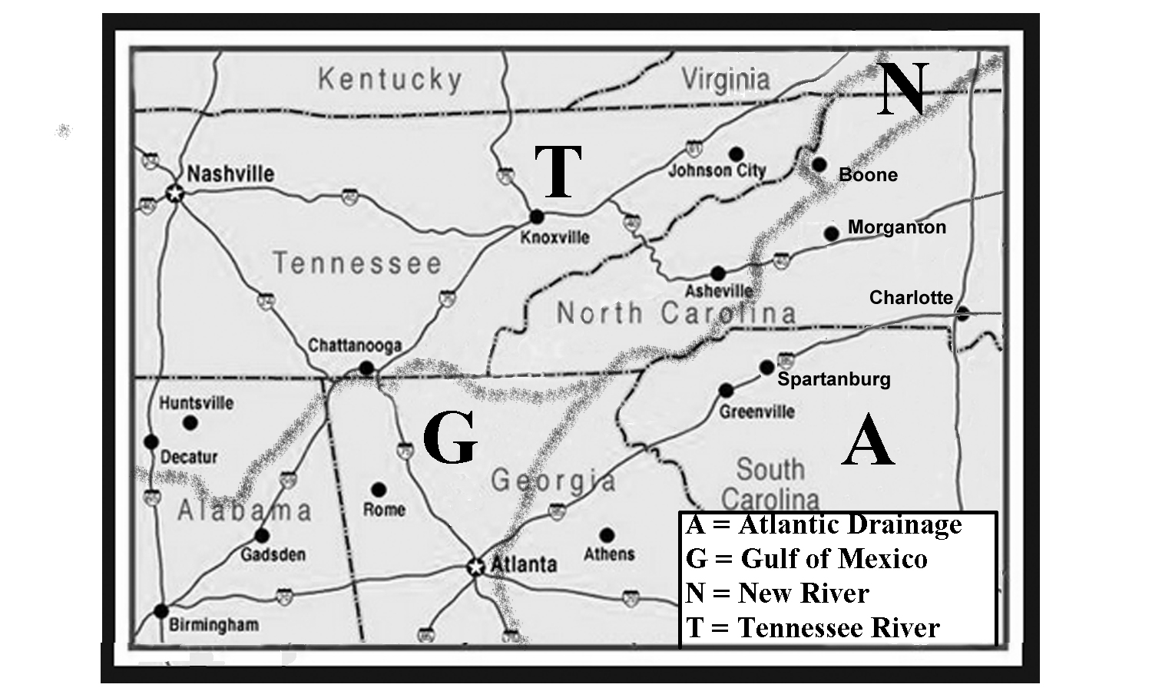

The high peaks of the Blue Ridge Front have their own microclimate, that is much more similar to regions hundreds of miles further north than it is to the surrounding lands in North and South Carolina. Precipitation is usually heavier on the windward side of these peaks because as moist air masses are blown towards the mountains, the air is forced to rise and cool, causing the water vapor to condense and fall as rain or snow. The leeward side of these mountains, including the valleys, may exist in a rain shadow and only receive about half as much precipitation. Laurel and rhododendron thickets are more common on the wetter slopes while poplar and pine trees are more abundant on the drier slopes. There is also a major difference in the amount of sunlight reaching the sunny and shaded sides of a mountain. Because of the wide range of environments, the Parkway is one of the most biodiverse parks in the National system and is able to support a number of rare, threatened, and endangered species of plants and animals.

Wind is also a major climate factor, especially at higher elevations where speeds over 60 miles per hour (97 km per hour) are common. Several of the high peaks along the Parkway provide perfect hang-gliding locations as warmer air is pushed up the windward side of the mountain, creating lift for the glider. Colder winds also may be channeled downslope, particularly into hollows or ravines. As a result, during the early morning hours, some valleys may be even colder than the mountaintops. South-facing mountain coves also offer a unique microclimate with rich soil and abundant moisture. These protected valleys host a wide range of plant and animal species as well as old-growth forests. An abundance of cold, clear, and clean mountain streams in the region provide perfect trout-fishing conditions. The timing of seasonal colors, from flowering plants to autumn leaves, is highly dependent on elevation, with mountain laurel near the top of the mountain blooming almost two months later than the same plant in the lower valleys.
The rocks forming the Blue Ridge Front are more highly metamorphosed than rocks farther west, indicating that the tectonic event that created the geologic structures was much nearer to the eastern flank of this region. Many peaks are composed of highly resistant granitic gneiss that was formed deep underground in large magma chambers. The original granite rock was later uplifted and metamorphosed with the rest of the Blue Ridge. As a result, many different types of faults and fractures crisscross the region. One impressive example is the Grandfather Mountain Window. A geologic window is a place where an overlying rock unit has been eroded completely away exposing a different rock unit underneath. In this case, a major thrust fault deep underground had first pushed older rock on top of younger rock. With continued uplift and erosion, the older rock was gradually exposed at the surface and eventually wore away completely to permit the younger rock to be seen. Just as a window is surrounded by a frame, the Grandfather Mountain Window is surrounded by older rock exposures.

Figure 6B-2: Grandfather Mountain Structural Window
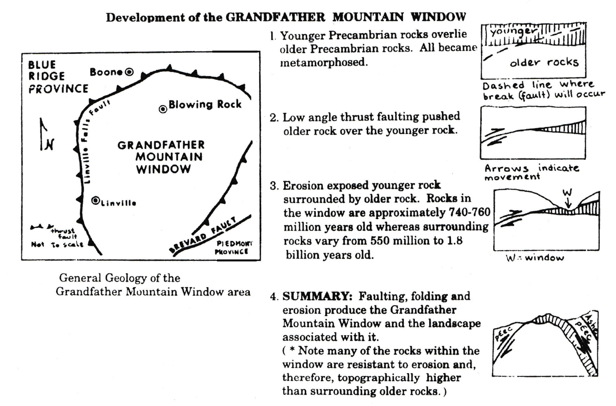

The Spruce Pine pegmatite district is located about halfway between Grandfather Mountain and Mount Mitchell, just off the Blue Ridge Parkway. It is home to some of the richest deposits of gems and rare minerals in the world. A pegmatite is a special type of igneous intrusion of molten magma into the surrounding rock that occurs deep underground. Because of high temperature and pressure, the magma cools very slowly and the crystals that form first have plenty of room to grow much larger than usual. Spruce Pine is especially famous for deposits of mica, quartz, feldspar, and rare-earth elements. The area is part of the Spruce Pine Thrust Block, the highest of several thrust-fault blocks that form the high peaks of the Blue Ridge Front. Further south, near Franklin, NC, gemstones like rubies and sapphires, originally sealed within metamorphic rocks, but later eroded out, have been mined from local stream gravels.
The Linville Gorge Wilderness Area, just south of Grandfather Mountain and accessible from the Blue Ridge Parkway, is sometimes called the Grand Canyon of the East, because of the sheer rock cliff face that rises 150 feet (46 meters) straight up from the Linville River. However, this canyon is filled with rhododendron thickets, downed trees, and low-hanging branches. The area is so inaccessible that it was spared the clear-cut logging that destroyed so many of the eastern forests of the Appalachians in the early 1900s. The Linville River begins on the southwest slope of Grandfather Mountain and enters the gorge at Linville Falls, a 90 foot (27 meter) multi-level cascade. After leaving the falls, the elevation of the river drops almost 2,000 feet (610 meters) over the next 14 miles (23 km) before entering leaving the Blue Ridge region. Nearly vertical rock outcroppings several hundred feet high border the river throughout much of the Gorge.

Grandfather Mountain and Mount Mitchell

Two of the most visited mountains in the Blue Ridge Front are Grandfather Mountain and Mount Mitchell. Both summits are accessible by road, and both afford expansive views of the surrounding mountain ranges stretching out far into the Piedmont. Mount Mitchell is the highest peak in the eastern United States at an elevation of 6,684 feet (2,037 meters), and Grandfather Mountain is the highest peak on the Front Range of the Blue Ridge at an elevation of 5964 feet (1,818 meters). Mount Mitchell was established as North Carolina’s first state park in 1916; Grandfather Mountain is privately owned and has the distinction of being the only private park in the world designated by the United Nations as an International Biosphere Reserve. Grandfather Mountain is the more developed site, featuring a mile high swinging bridge, a nature museum, animal encounters, and a restaurant. Mount Mitchell provides extensive hiking trails and a more wilderness based experience, although the summit now features an easily accessible observation deck and a small museum. Because Grandfather Mountain rises nearly 4,000 feet (1,220 meters) above the Catawba River valley, it supports sixteen different habitat types in less than 5,000 acres (2,000 hectares), including Red Spruce - Fraser Fir forests, heath balds, northern hardwood forests, and high elevation rocky summits. The habitats at Mount Mitchell are less diverse, consisting of mostly high elevation spruce-fir forests.

Mount Mitchell is named after Elisha Mitchell, who first attempted to determine the peak’s elevation as part of a statewide geological survey. He made several trips to the mountain, but his last visit, in 1857, led to his accidental death at the base of a waterfall. His grave lies near the summit of the mountain that bears his name. But probably the most famous person associated with Mount Mitchell was Big Tom Wilson, North Carolina’s most famous mountaineer. Wilson was able to follow seemingly invisible clues such as broken tree limbs and faint impressions in the dirt to find the body of Mitchell. Reports of his amazing tracking ability spread all across the state and his exploits became so well known that the U.S. Geological Survey even labeled his house on topographic maps of the area. In 1946, a nearby mountain peak was officially named “Big Tom.” In addition to being a sought after trail guide, Big Tom was also a hunter of some renown and is reputed to have killed 113 black bears over a period of several years. He raised his family of ten children on this land and, later in life, Big Tom was hired by land owners in the area to watch for game poachers.
Big Tom Wilson
--Loosely excerpted from an article written by Tim Silver—
[published in the November 1997 issue of Wildlife in North Carolina]

“Elisha Mitchell was a professor of science at the University of North Carolina who made trips to the Black Mountains in 1835, 1838 and 1844. Using a barometer to measure elevation, he determined that these mountains were the highest in eastern America. By 1844, however, he seemed unsure about which peak was tallest and exactly when he had been on it. In 1857, he went back with his son, Charles, seeking more information. Leaving Charles on the south side of the ridge, Mitchell headed off alone towards the northwest side of the mountains to the Cane River settlements. There Mitchell hoped to refresh his memory of earlier work by talking with someone who knew the route he had taken in 1835. When Mitchell failed to meet his son at the appointed time, Charles began a search that eventually took him to Big Tom Wilson’s farm. Big Tom organized a group of local woodsmen and joined the search. They picked up Mitchell’s trail and followed it to a small tributary of the Cane, where they found the professor’s body at the base of a 40-foot waterfall. Mitchell’s broken watch suggested that he lost his way in the dark and plunged to his death sometime after 8:00 PM. When Big Tom Wilson was able to lead searchers to the body of Elisha Mitchell, he cemented his reputation as North Carolina’s most famous mountain man.

Tourists began discovering Mount Mitchell in the early 1850’s and accommodations were built to house visitors near the mountain. Most visitors approached the mountain via horse trails along the southern slope. The trip became easier in 1915 when the Perley and Crocket Logging Company adapted their logging railroad to provide passenger service to the top of Mount Mitchell. The train carried passengers the 21 miles (34 km) from the present day town of Black Mountain to the upper terminus called Camp Alice. The camp provided a rustic dining hall and platform tents for overnight guests. But visitors still had to hike a difficult one-mile trail from Camp Alice to Mount Mitchell’s summit.

In 1919, Perley and Crocket halted both logging and passenger service. The railroad tracks were removed and the grade was changed to create a 19 mile (31 km) long highway called the “Mount Mitchell Motor Road.” Because the road was too narrow for cars to pass each other, traffic was restricted to going uphill in the morning and coming back downhill in the afternoon. In 1920, nearly 13,000 people drove this toll road. Not to be outdone, Edward Wilson, grandson of Big Tom Wilson, opened his own toll road starting from the Cane River side of the mountain. Both toll roads ceased operating in 1939 when the Mount Mitchell section of the Blue Ridge Parkway opened and the state of North Carolina took control of the Motor Road and removed the toll. Other members of Big Tom Wilson’s family continued to operate Camp Wilson, at the state park entrance, until 1960 when the state declared the camp an ‘eyesore’ and forced the family to sell the land. The remains of the stone foundations from Camp Alice can still be seen near the Camp Alice Trail Shelter.

The Blue Ridge Escarpment

The Blue Ridge Escarpment is a long topographic lineament that marks an abrupt change in elevation from the higher Blue Ridge region to the lower Piedmont landscapes. Vertical relief along this line varies from 1,300 feet (396 meters) to 2,500 feet (762 meters). Many waterfalls are present along the escarpment, including the much-visited Whitewater Falls in Transylvania County, NC, which drops 411 feet (125 meters) in North Carolina and another 400 feet (122 meters) in South Carolina, making it the highest waterfall east of the Rocky Mountains. The escarpment continues, essentially unbroken, from northeastern Georgia to Virginia. In North Carolina, it follows the Brevard Fault Zone in some places and in others it follows the Eastern Continental Watershed Divide. Most geologists regard the Brevard Fault as a major deep-seated structural weakness that marks a Paleozoic collision zone between the Piedmont Terrane and the original North American continent. However, the Brevard Fault Zone does not change character as it passes from Blue Ridge into Piedmont rocks; and there is abundant evidence that the exact location of the escarpment has changed over time. Many geologists have hypothesized other fault lines as being responsible for the dramatic topographic elevation shift, but none have ever been found.

The origin of the Blue Ridge Escarpment is still being debated, but several lines of evidence suggest that both the escarpment and the Eastern Continental Divide are slowly migrating northwestward due to Cenozoic tectonic uplift and the process of headward erosion by streams. One indication is the presence of several mountain ranges, very similar in geology and topography to the main part of the Blue Ridge Front, located in the Piedmont of North Carolina. These ranges, including the South Mountains, the Brushy Mountains, and the Sauratown Mountains, are all separated from the main part of the Blue Ridge Front by wide river valleys. The hypothesis states that the escarpment was once located along the eastern edge of these mountain outliers. Over time, the river systems cut back into the escarpment and gradually eroded deep valleys, cutting off the connection between these mountain ranges and the rest of the Blue Ridge.

Another theory compares the energy of streams flowing away from the Eastern Continental Drainage Divide in opposite directions. Both streams begin at the same elevation on the Blue Ridge Front, and both stream systems eventually empty into either the Atlantic Ocean or the Gulf of Mexico at sea level. The difference is that water flowing directly towards the Atlantic Ocean has a much shorter distance to travel than water crossing the Blue Ridge into Tennessee and then following the Mississippi River to the Gulf of Mexico. Under this scenario, the Atlantic streams would have a much higher slope or gradient and therefore have a lot more energy to erode more vigorously into the Blue Ridge divide. Over time, the Atlantic streams would gradually get longer through the process of headward erosion and occasionally capture smaller streams and divert their drainage in a different direction. As a result, the position of the drainage divide would migrate towards the lower-energy streams.

The New River flows north from Grandfather Mountain into Virginia and is surprisingly (given its name) thought to be one of the oldest rivers in North America. Geologists believe the river once drained this region before the Cenozoic uplift that raised the Blue Ridge Mountains to their current height. The meandering pattern shown on maps is left over from when the river slowly meandered across a fairly level flat land surface close to sea level. Once uplift began, the river possessed enough energy to continue downcutting into the bedrock and maintain its relative position, and its meanders became entrenched in a mountainous landscape where they would not normally be expected to occur. The New River is also one of the very few rivers to flow across the entire Blue Ridge region on its way to joining the Ohio River. Such a river is called an antecedent river because it existed before the current landscape was developed.

Figure 6B-3: Process of Stream Capture
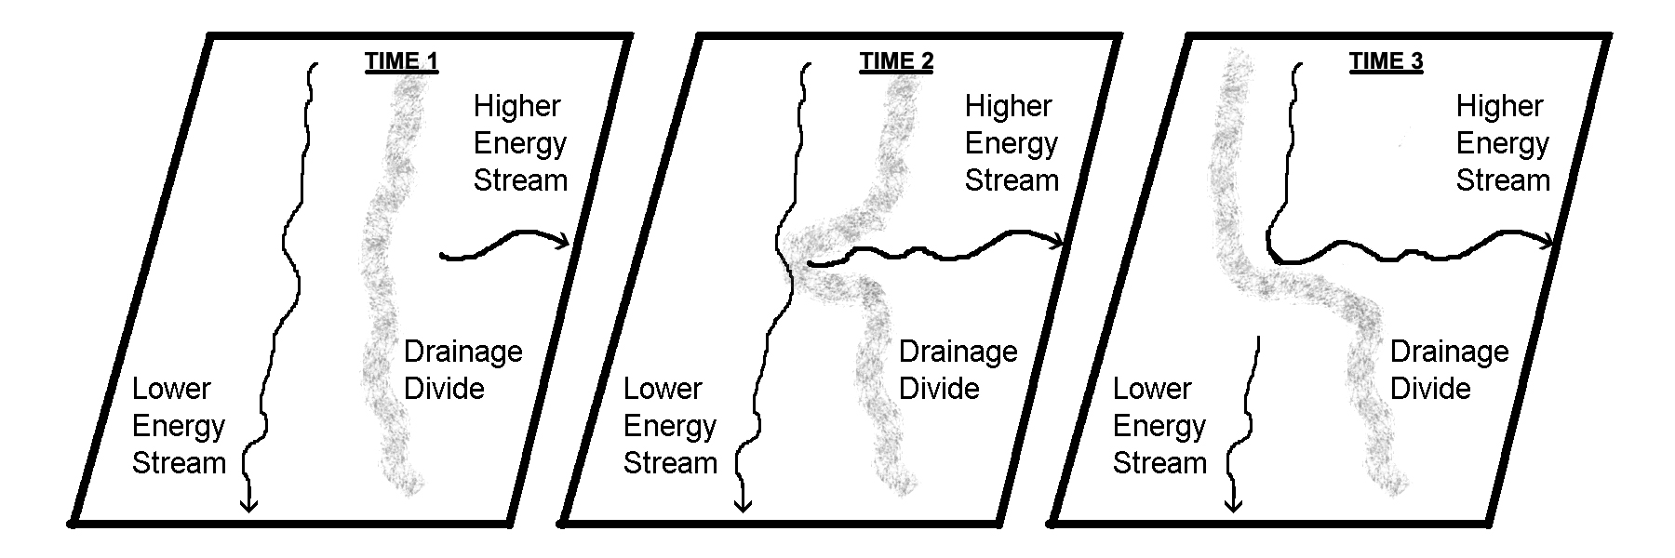

Activity 6B-1: The Blue Ridge Parkway

POWER THINKING EXERCISE - "Parkway Peril"
The National Park Service is getting tired of having to close off sections of the Blue Ridge Parkway, sometimes for weeks at a time, because of the great number of landslides that occur along the highway as it runs along the Blue Ridge Front. Previous landslides can be recognized on aerial photographs by white colored scars on steep mountain slopes. The scars are usually wider at the upper end and taper off to a thin white line at the lower end. Such landslides may cover only a short distance or may extend for a long way down a stream valley.
The Park Service is especially concerned about two sections of the Parkway in North Carolina. One section runs along the side of Grandfather Mountain and the other is located just south of Mount Mitchell. Study the topographic maps of Grandfather Mountain and Mount Mitchell on MAP 6B, BLUE RIDGE FRONT. Also locate the Parkway on the corresponding aerial photographs of Grandfather Mountain and Mount Mitchell on IMAGE 6B, BLUE RIDGE FRONT.
Identify as many landslide scars on the photos of each site as you can. Also mark the locations of these existing landslide scars on each map and make a prediction about where the next landslide will occur in each section of the Parkway. Present your findings to the class and be prepared to provide evidence from the maps or photos to support your prediction.

Materials
MAP 3B, GEOLOGICAL SETTING
IMAGE 6B, BLUE RIDGE FRONT
MAP 6B, BLUE RIDGE FRONT
Figure 6B-1, “Drainage Divides in Southern Blue Ridge Region.”
protractor
Wipe-off Pens

PERFORMANCE TASKS
(Icon Key) Overview = ; Science = ; Math = ; History = ; Language Arts =

1. Locate triple drainage divide.
There is an unusual spot in western North Carolina that marks a triple drainage divide between streams flowing eastward into the Atlantic Ocean, streams flowing westward across the Blue Ridge to the Tennessee River basin, and streams flowing northward into Virginia to the New River before crossing the Blue Ridge and ending up in the Ohio River. Consult Figure 6B-1, “Drainage Divides in Southern Blue Ridge Region” and locate the following three cities and river systems on the Blue Ridge Front topographic map on MAP 6B, BLUE RIDGE FRONT:
- Wautauga River (unlabeled, but passes Shulls Mills North of Grandfather Mt)
- New River (several tributaries begin near city of Boone, N of Grandfather Mt)
- Yadkin River (tributaries start at city of Blowing Rock – NE of Grandfather Mt)
Using wipe-off pens, trace all the tributaries of these three drainage systems (each system should be traced with a different color pen) that you can find in the vicinity of Grandfather Mountain, the city of Boone and the city of Blowing Rock. Locate the actual triple drainage divide point as closely as you can.

2. Interpret patterns of tectonic features on geologic map.
Examine the tectonic map inset on MAP 3B, GEOLOGIC SETTING and locate the Grandfather Mountain structural window and also the Brevard Fault Zone (both are labeled). Also locate these same features on the larger geologic map (not labeled on this map). Note that even though the colors on the tectonic map are not described in a legend, areas having the same color are part of the same tectonic terrane. The geologic map does have a legend, but the patterns of the igneous and metamorphic rocks seen in the Blue Ridge region are extremely complex. Without focusing on specific details of rock type or age, examine the color patterns shown on each map and answer the following questions:
1. Are any other locations in the Blue Ridge Front part of the same tectonic terrane
as the terrane exposed in the Grandfather Mountain structural window?
2. Does the Brevard Fault Zone show any consistent pattern of rock type or ages
on one side or the other of the fault.

3. Observe rectangular drainage pattern in Lake James.
Locate Lake James in the bottom-left corner of the Blue Ridge Front topographic map on MAP 6B, BLUE RIDGE FRONT. Locate this same lake on the NALC satellite image on IMAGE 6B, BLUE RIDGE FRONT. Note that the outline of the lake forms a very strange geometric pattern, with lots of short segments and right-angle bends. The original stream segments preferentially eroded along parallel sets of fault and fracture lines within the bedrock, forming a rectangular drainage pattern. Use a protractor to determine the compass orientation of each of the two preferred directions. Be sure the base of your protractor is parallel to the bottom of the map. For each compass direction, measure the orientation of at least three different stream segments and then calculate an average value. Does either direction correspond to that of other lineaments that show up on the topographic map? Explain your answer.

4. Evaluate metes and bounds method for defining boundaries.
The metes and bounds system is an old method of defining and describing the boundaries of a parcel of land. The system was developed in England centuries ago and was also used in the original thirteen colonies that eventually became the United States. The system uses descriptions of physical features to identify property lines. The term ‘metes’ refers to a specific measurement of a straight-line boundary and its compass orientation. The term ‘bounds’ refers to a more general description of a property line, often in reference to a non-natural feature, such as a road or stone wall. A simple example of a metes and bounds description would be:
“Beginning at the bridge over the creek, go due west for 500 feet, then follow the
stone wall until you reach the pine tree on the south bank of the creek. Then
follow the creek back to the starting point.”
List some benefits and problems we would encounter by using this system today.
5. Discuss effectiveness of language used for metes and bounds.
Read the description of the metes and bounds system described in the previous performance task (#4). For the system to function effectively, the descriptive words that are used must be very specific and clear. For example, in Performance Task #4, the reference to a “pine tree” is much more definitive than just a reference to a “tree.” Read through the following more complicated example and identify specific words that help make the description more clear and/or precise, and also identify words that could create confusion or ambiguity.
A typical description for a small parcel of land might read: "beginning with a corner at the intersection of two stone walls near an apple tree whose trunk is marked with red paint, on the north side of Muddy Creek road one mile above the junction of Muddy and Indian Creeks, north for 150 rods to the end of the wall bordering the road, then northwest along a line to a large rock on the corner of the property now or formerly belonging to John Smith, thence west 150 rods to the corner of a barn near a large bush, thence south to Muddy Creek Road, thence down the side of the creek to the starting point."

ENRICHMENT
(Icon Key) Overview = ; Science = ; Math = ; History = ; Language Arts =

1. Plan trip along Blue Ridge Parkway.
Refer to travel brochures or the Blue Ridge Parkway website to choose a section of the Blue Ridge Parkway that you would like to visit on a one-day trip. Identify one or two features accessible from the Parkway that you are particularly interested in seeing, and explain why. Remember that the maximum speed limit on the Parkway is only 45 miles per hour, so don’t try to cover too much territory in one day. Also allow time to pull over and stop for a while at some of the scenic overlooks, and don’t forget to stop for lunch.

2. Describe boundaries of school property using metes and bounds.
Refer to examples of metes and bounds descriptions in Performance Tasks 4 and 5; then write a narrative description of the boundary lines of your school property using that system. Compare the final narratives from each group and decide which version is the most precise.

Activity 6B-2: Grandfather Mountain and Mount Mitchell

POWER THINKING EXERCISE - "Varying View"
You and a group of your friends have decided to hike to the top of Mount Mitchell during your Spring Break. When you reach the summit, you climb the lookout tower so you can get clear views in all directions. You have taken so many pictures on your trip so far that all of your cell phones’ photo storage is full. One of your friends brought a camera, but her memory card is almost full also and she is only certain of being able to take one more picture. You want to take a photo of all of you on the tower to commemorate the event, but can’t decide in which direction to point the camera.
Examine the Mt. Mitchell topographic map on MAP 6B, BLUE RIDGE FRONT, and describe what the view from the lookout tower would look like to the north, the south, the east, and to the west. In your group, discuss which compass direction would provide the most scenic background for your photo. Use information from the topographic map to explain your decision. Compare your selection with that of other groups. Was there a consensus? If everyone agreed on the best direction, what was the deciding factor? If there was not agreement, why do you think the opinions were so diverse?

Materials
IMAGE 6B, BLUE RIDGE FRONT
MAP 6b, BLUE RIDGE FRONT
newspaper article, “Scenery Big Draw at Grandfather”
3-D stereoscopes
Wipe-off Pens

PERFORMANCE TASKS
(Icon Key) Overview = ; Science = ; Math = ; History = ; Language Arts =

1. Identify features on 3-D stereo photo of Grandfather Mountain.
Use the 3-D stereoscope to view the stereo pair photograph of Grandfather Mountain on IMAGE 6B, BLUE RIDGE FRONT. Locate and identify the following features on the image. Refer to the Grandfather Mountain topographic map on MAP 6B, BLUE RIDGE FRONT to help you locate features.
Grandfather Mountain access road mile-high swinging bridge
The Blue Ridge Parkway Linville River
Clear-cut areas on mountains Golf Course by Linville River
Explain how the vertical exaggeration portrayed in the stereo view either helps or hinders your ability to recognize these features on the photo.

2. Propose new trail route to Raven Rocks peak.
Examine the Grandfather Mountain topographic map on MAP 6B, BLUE RIDGE FRONT and locate Raven Rocks Peak (about ½ mile [1 km] northeast of the Grandfather Mountain parking lot). You want to develop another trail to this peak that does not require hikers to drive up the Grandfather Mountain access road and pay the entrance fee. You have decided to begin the trail at the north end of the golf course (in the upper-left corner of the map) where the dead-end road crosses Little Grassy Creek. You plan to have the trail follow Little Grassy Creek all the way to its source, but then you aren’t sure how to route the rest of the trail to reach the peak.

First, decide what attributes you would like the trail to have (level of difficulty, length, access to scenic views, etc.). Then examine the contour lines on the topographic map and, with a wipe-off pen, draw the route for the trail that will best meet your criteria. Compare your route with routes of other groups. Also determine whether other groups used different criteria for planning their trail.

3. Measure average gradient of Big Tom Wilson Toll Road.
Locate the Big Tom Wilson Toll Road on the Mount Mitchell topographic map on MAP 6B, BLUE RIDGE FRONT and trace, with a wipe-off pen, its route from Escota (northwest corner of the map) to Camp Alice (near center of map). Spread out a piece of string along the entire route of the toll road and then refer to the map scale to measure the total distance (in miles) from beginning to end. Refer to the benchmarks at Escota and Camp Alice to calculate the total change in elevation (in feet) from the beginning to end of the road. To calculate the average gradient of the toll road, divide the total elevation change in feet by the total distance traveled in miles). Why does this average value not really characterize the steep slopes encountered on this road? Explain why referring to average values of a measurement may not always be the best indicator of reality.

Considering the total distance traveled and the presumed conditions along the unpaved road, make an informed guess as to how long it would take a car to drive from Escota to Camp Alice. Explain your reasoning.
.
4. Explain popularity of Big Tom Wilson Toll Road.
Locate the Big Tom Wilson Toll Road on the Mount Mitchell topographic map on MAP 6B, BLUE RIDGE FRONT. Also locate the Blue Ridge Parkway (bottom of map) and the Mount Mitchell access road (from Parkway to mountain summit). The original Perley and Crocket toll road followed the old railroad grade from the town of Black Mountain (not shown on the map) to Camp Alice. Note that the Mount Mitchell section of the Blue Ridge Parkway opened in 1939 and put both toll roads out of business. Before the Parkway was constructed, why do you think tourists would choose to take the Wilson toll road, that started in the middle of nowhere (Escota), rather than take the toll road from the larger town of Black Mountain?

Assume you worked for Edward Wilson as a toll gate keeper in 1930. Make some suggestions as to what Mr. Wilson could do to compete more successfully with the Perley and Crocket toll road from Black Mountain and gain more customers.

5. Analyze writing style appropriate for newspaper articles.
Newspaper articles, like the one printed on page 6B-1, “Scenery Big Draw at Grandfather,” normally require a different style of writing than what is used for short stories or other narrative expositions. Read through the article and identify as many examples of literary devices, typical of newspaper articles, as you can find that would be worded differently if you were writing a school report about Grandfather Mountain.

Note that the title of the article is not a complete sentence. In a school report, you would probably use the title “Scenery is a Big Draw at Grandfather Mountain.” Why do you think that newspapers do not normally use complete sentences for article titles?

ENRICHMENT
(Icon Key) Overview = ; Science = ; Math = ; History = ; Language Arts =

1. Compare tourist facilities at Mount Mitchell through time.
In 1920, 13,000 tourists drove the toll road to visit Mount Mitchell. Use local library resources or the internet to investigate what the accommodations were like at that time at Camp Alice. Were there any establishments in the area that sold food or drink? Note any changes in tourist facilities that occurred when the Blue Ridge Parkway was constructed, and also when the lookout tower was built. How has the Mount Mitchell State Park changed its operations over time to become more visitor friendly?

2. Research the history of the Linn Cove Viaduct.
Probably the most spectacular engineering feat visible along the Blue Ridge Parkway is the Linn Cove Viaduct near Grandfather Mountain. The National Park Service agreed to import an innovative design from Europe that resulted in a quarter-mile long bridge that cantilevers out from the mountain, supported by concrete piers. Use local library and internet resources to find out more about the design of this viaduct and how it was constructed to conform to and protect the landscape along the eastern slope of Grandfather Mountain.

Activity 6B-3: The Blue Ridge Escarpment

POWER THINKING EXERCISE - "Mountain Mystery"
You have taken a summer intern job as Assistant to the Park Ranger at Pilot Mountain State Park in North Carolina. One of your tasks is to give evening campfire talks about the park to campers and other visitors. You want to be sure you learn all the correct information about the park so you will be able to answer correctly any questions about your presentation.
After reading one of the official park brochures, you seem to have found a problem. The brochure states that “Pilot Mountain is situated in the northwestern portion of the Piedmont physiographic province and lies in the Sauratown Mountain Range.” This confuses you because you learned in your science class that the Piedmont region doesn’t have any mountain ranges and that the Sauratown Mountains are actually part of the Blue Ridge physiographic province. You now have a mystery to solve. How can a mountain be in two different physiographic provinces at the same time?
Study the Blue Ridge Front topographic map on MAP 6B, BLUE RIDGE FRONT and also look at the NALC satellite image on IMAGE 6B, BLUE RIDGE FRONT to help you solve this mystery. How will you address this seemingly contradictory issue in your campfire presentation?

Materials
IMAGE 6B, BLUE RIDGE FRONT
MAP 6B, BLUE RIDGE FRONT
MAP 3A, LANDSCAPES AND LANDFORMS
MAP 3B, GEOLOGICAL SETTING
Figure 6B-3, “Process of Stream Capture”
Wipe-off Pens

PERFORMANCE TASKS
(Icon Key) Overview = ; Science = ; Math = ; History = ; Language Arts =

1. Infer previous position of Blue Ridge Escarpment.
One theory about the migration of the Blue Ridge Escarpment states that this topographic feature was once located far to the east of its current location. This theory also states that the South Mountains, Brushy Mountains, and the Sauratown Mountains are all outliers of the Blue Ridge region that have been left behind as the Escarpment migrated westward. Locate these three mountain ranges on the Blue Ridge Front topographic map on MAP 6B, BLUE RIDGE FRONT. With a wipe-off pen, place a dot at the easternmost extent of each mountain range. Then draw the ‘best fit’ line connecting your three dots. This line represents a hypothetical former position of the Blue Ridge Escarpment. Does this theory make sense to you? Explain your answer.

2. Find examples of stream capture along Blue Ridge Front.
Review Figure 6B-3, “Process of Stream Capture” and pay special attention to the diagnostic right-angle bend that occurs where the captured stream flows into the higher-energy stream. Locate the headwaters of the Yadkin River on the Blue Ridge Front topographic map on MAP 6B, BLUE RIDGE FRONT (look northeast of the town of Blowing Rock near Grandfather Mountain – the river follows almost the same path as U.S. Highway 321). Trace, with a wipe-off pen, the course of the river until you reach the town of Patterson. Here the Yadkin River makes a right-angle bend eastward into the main river valley. This is one example of the Yadkin River capturing a previously unnamed stream that used to flow from Blowing Rock through Patterson to points further south.

Study the topographic map carefully and find two other examples of possible stream capture of a mountain stream by a Piedmont river. Share your results with the rest of the class. Will every right-angle bend automatically indicate a stream capture has occurred? Find one example of a right-angle bend in a river that indicates something else.

3. Calculate gradients of rivers flowing to Atlantic and to Gulf.
Locate the Blue Ridge Escarpment along the South Carolina - North Carolina state boundary line (in the extreme northwestern corner of South Carolina) on MAP 3A, LANDSCAPES AND LANDFORMS. At this location, the escarpment also follows the Eastern Continental Drainage Divide. Locate the Saluda River on the South Carolina side of the divide. Use a wipe-off pen to trace this river all the way to the Atlantic Ocean. The river on the North Carolina side of the divide is the French Broad River (not labeled on the map). Use a different color wipe-off pen to trace this river all the way to the Gulf of Mexico.

Gradient is calculated by dividing the total drop in elevation by the total distance traveled by the water to get to the ocean. Both rivers begin at the drainage divide at the same elevation, approximately 3,000 feet. Both rivers empty into the ocean at sea level (zero feet elevation). Therefore the total elevation change for both rivers, from source to the ocean, is around 3,000 feet. However, the total length of each river system is very different. Use a piece of string or other method to measure the length of each river system in miles (refer to map scale). Stream gradient is also a good indicator of the erosive power of a stream. Streams with higher gradients tend to have more power and therefore will erode into the divide more quickly. Which river has the higher gradient? When erosion occurs, in which direction will the drainage divide migrate? Explain your answer.

4. Compare land use in Brevard Zone to mountain areas.
Refer to the tectonic map insert on MAP 3B, GEOLOGICAL SETTING to locate the Brevard Fault Zone. Use a wipe-off pen to draw the position of the Brevard Zone on the Blue Ridge Front topographic map on MAP 6B, BLUE RIDGE FRONT, and also on the NALC satellite image on IMAGE 6B, BLUE RIDGE FRONT. Describe the features visible on the NALC image that helped you recognize the path of the Brevard Fault Zone. Explain how the land use along the fault zone is different from land use in the surrounding mountains; and explain why that is so. Are there any clues on the topographic map that would help you identify the exact location of the fault zone?

5. Explain the use of nicknames for topographic features.
In South Carolina, the Blue Ridge Escarpment is often referred to as the “Blue Wall.” How do you think this landform feature got that name? Also in South Carolina, a sheer cliff along the shoreline of Lake Jocassee has been given the unofficial name “Jumping Off Rock.” How do you think this feature got that name? And finally, a scout camp located on top of the escarpment is informally known as “Pretty Place,” and is often rented out to wedding parties for special ceremonies. How do you think that camp got its nickname? What advantages and disadvantages can you think of for using nicknames, in place of proper names, for landscape features?

ENRICHMENT
(Icon Key) Overview = ; Science = ; Math = ; History = ; Language Arts =

1. Research geologic history of New River.
The New River is considered to be one of the oldest rivers in North America. Consult local library or internet resources to find out the geologic reasons why this is so. Prepare ‘before’ and ‘after’ maps showing the different paths of the New River before the uplift of the Appalachian Mountains and after that uplift. Explain how those differences in stream path might have occurred, in particular the influence that the Pleistocene Ice Ages had in changing parts of the course of the river.

2. Research unique environments and habitats in mountain coves.
Mountain coves are protected south-facing valleys along the Blue Ridge Escarpment that have unique environments and provide habitats for a wide variety of plants and animals. Use local library or internet resources to gather information about what kinds of plants and animals live in such coves and why there is such biodiversity. Locate at least one of these coves on the NALC satellite image on IMAGE 6B, BLUE RIDGE FRONT.

