Remembering D-Day and the American Experience in WW II

2023 Clemson in London-Paris-Normandy

*******INFORMATION MEETING: MONDAY, OCTOBER 3, 5:30-7:00PM, 308 Edwards******

Program Dates: May 9-19, 2023. Course Offered: GLCH (Global Challenge) 3980 / FR 3980 (Subst.)

For more information, contact Dr. Eric Touya, Department of Languages (etouya@clemson.edu) and Col. (Ret) Lance Young, Clemson Corps Life Emeritus (lsyoung@clemson.edu)

Study abroad Application: https://terradotta.app.clemson.edu/index.cfm?FuseAction=Programs.ViewProgram&Program_ID=10033
Website 2023 London-Paris-Normandy: https://cody92.wixsite.com/clemsonparisnormandy
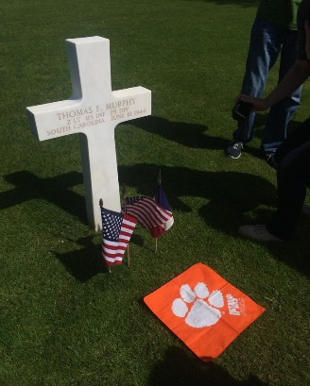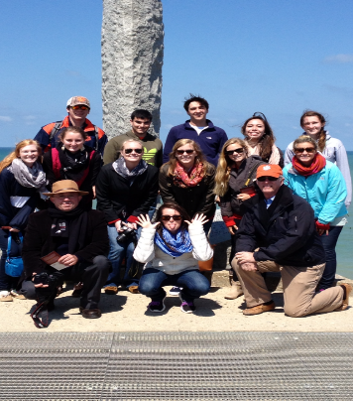

- Visit the city of London (Churchill War Rooms)
- The region of Normandy (Remembering D-Day)
- The Omaha, Utah, Gold, and Sword Landing Beaches
- The historic sites in Bayeux and Sainte Mère Eglise
- Visit of Pointe du Hoc and Mémorial de Montormel
- The American Cemetery in Colleville-sur-Mer (Omaha)
- Visit the city of Paris (WWII sites and museums)

