Threads

Threads (also called lightweight process, LWP) are the basic unit of CPU operation. A heavyweight process is one which consists of only one thread. Each thread has associated with it

- Thread ID
- Program Counter
- Register Set
- Stack

All threads of a single process share the same
- Code Section
- Data Section
- Operating System Resources

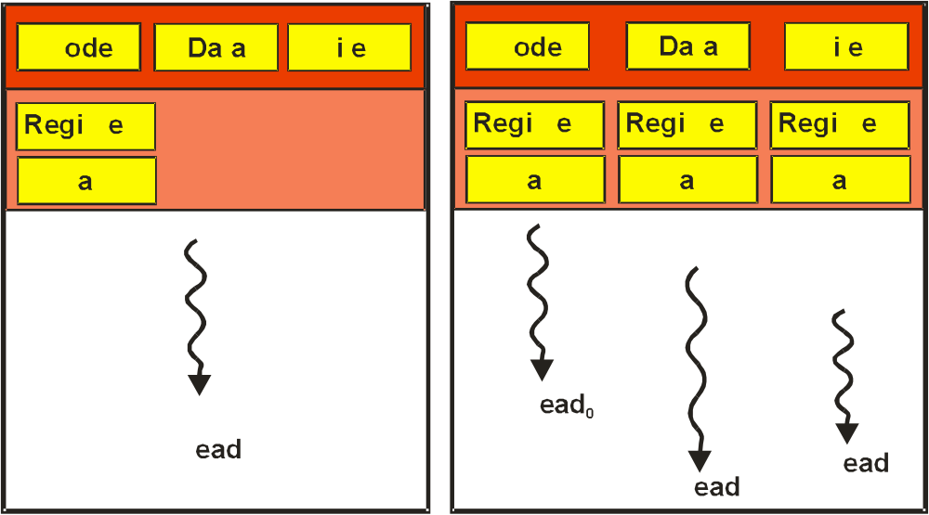

Kernel Threads are created, scheduled, and maintained by the operating system. User Threads are maintained “above” the kernel through a thread library. Kernel threads are generally more costly to maintain.
The Benefits of Multiple Threads are that they allow for:

- Responsiveness – They permit interaction with the user while other thread(s) is/are running or even blocked.

- Sharing – Since threads share memory, related threads can share/communicate data.

- Efficiency – Since threads share resources, maintaining and switching multiple threads costs less than that of multiple processes.

- Speed – A multithreaded program has the ability to run on multiple processors.

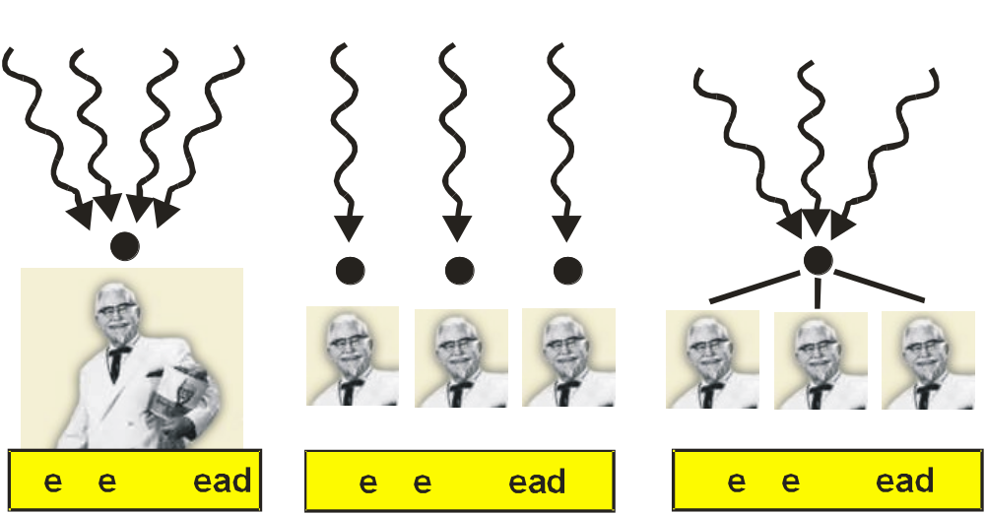

Many-to-One One-to-One Many-to-Many

In the Many-to-One design, the user can create multiple threads, but the kernel can only schedule one at a time.

In the One-to-One model, concurrency can be achieved but, the number of user threads must be limited because the burden of kernel threads relative to user threads.

In Many-to-Many systems, user can create myriads of threads which can be supported by multiple kernel threads on multiple processors.
Pthreads (POSIX standard [IEEE 1003.1c])

This standard defines a specification for an API thread interface.

Example:

#include <pthread.h>
#include <stdio.h>

int sum; /* data shared by the thread(s) */

/* The thread will begin control in this function */
void *runner(void *param)
{ int upper = atoi(param);
int i;
sum = 0;
if (upper > 0) for (i=1; i<=upper; i++) sum += i;
pthread_exit(0);
}

main(int argc, char *argv[])
{
pthread_t tid; /* the thread identifier */
pthread_attr_t attr; /* thread attributes */

if (argc != 2)
{ fprintf(stderr, “usage. a.out <value>\n”);
exit();
}
if (atoi(argv[1]) < 0)
{ fprintf(stderr, “%d must be >= 0\n”, atoi(argv[1]));
exit();
}

/* get the default attributes */
pthread_attr_init(&attr);
/* create the thread */
pthread_create(&tid, &attr, runner, argv[1]);
/* wait for the thread to exit */
pthread_join(tid, NULL);

printf(“sum = %d\n”, sum);
}
Solaris 2 Threads

UNIX SMP with real-time scheduling having Pthreads and UI Threads

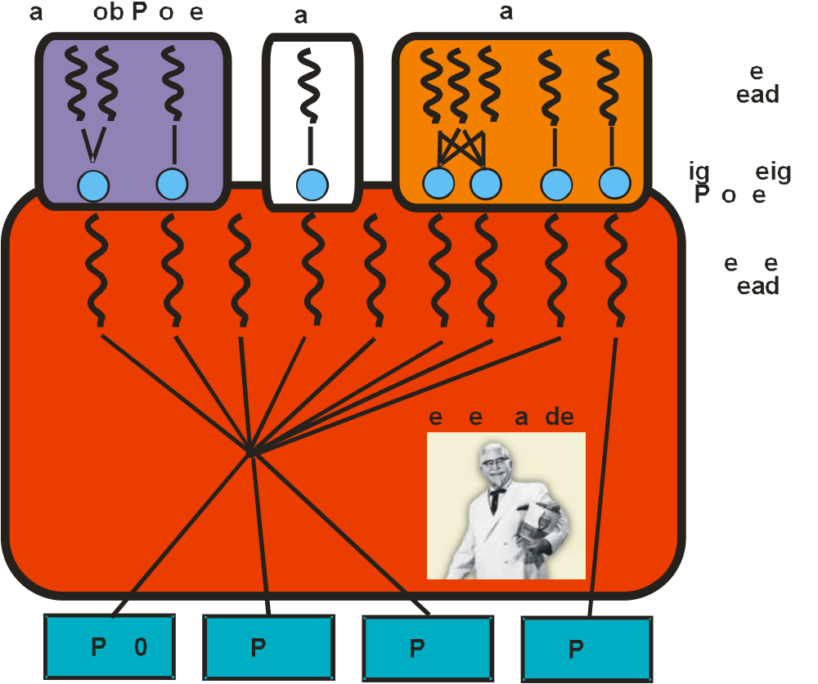

Windows Threads

The Win32 API (Windows 9X/NT/2000) allows for running each application as a separate process that may contain one or more threads. Windows 2000 uses one-to-one mapping, but provides support for many-to-many system with a fiber library.

Each thread contains the following structures:

- ETHREAD (Executive) – contains pointer to the process and its routine.

- KTHREAD (Kernel) – contains scheduling and synchronization info, and kernel stack if kernel mode thread.

- TEB – contains user mode stack and array for thread data.

Linux Threads

Linux uses the fork system call which duplicates a process (and all of its memory). Linux also uses clone to create a separate process (thread) that shares memory so only a pointer to the original process’ memory is needed. The amount of sharing is programmable.

Linux does not support multi-threading, separate data structures, or kernel routines.

Linux does support a Pthread implementation.

Both Linux processes and threads are called tasks.

Java Threads

Unlike most languages, Java supports threads at the Language Level through its JVM.

class Summation extends Thread
{ public Summation(int n)
{ upper = n;
}
public void run()
{ int sum = 0;
if (upper > 0)
{ for (int i=1; i<=upper; i++) sum += i;
}
System.out.println(“Sum of “+upper+” is “+sum);
}
private int upper;
}

public class ThreadTester
{
public static void main(String[] args)
{ if (args.length > 0)
{ if (Integer.parseInt(args[0])<0)
System.err.println(args[0]+“ must be >=0.”);
else
{ Summation thrd =
new Summation(Integer.parseInt(args[0]));
thrd.start();
}
}
else System.err.println(“Usage: Summation
<integer value>”);
}
}

